**Who is this for?**

Chefs, cooks, and hobbyists who own physical recipe cards, or a recipe book. Most digital recipe books won’t allow the user to upload their own recipes, or you must go through GitHub on a couple to upload your own recipes. This app will allow users to upload and manage their own recipes.

**Screen Mockups:**

Main Page

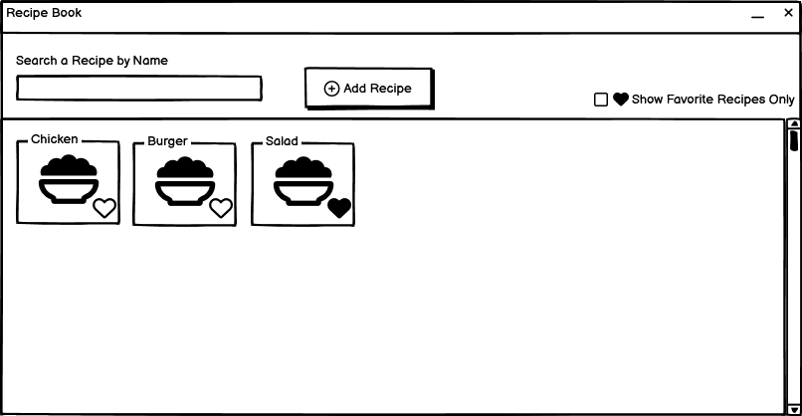

Recipe Card

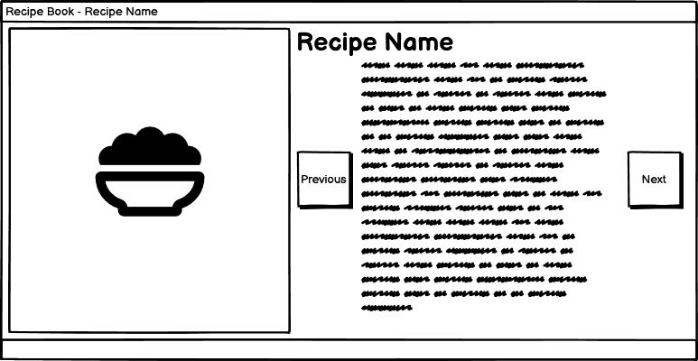

Editing the recipe

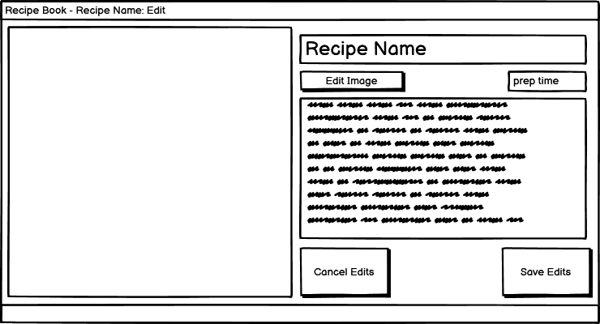

Creating a recipe

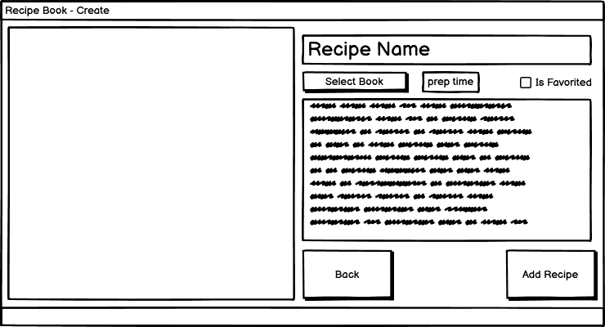

**UML Diagram:**

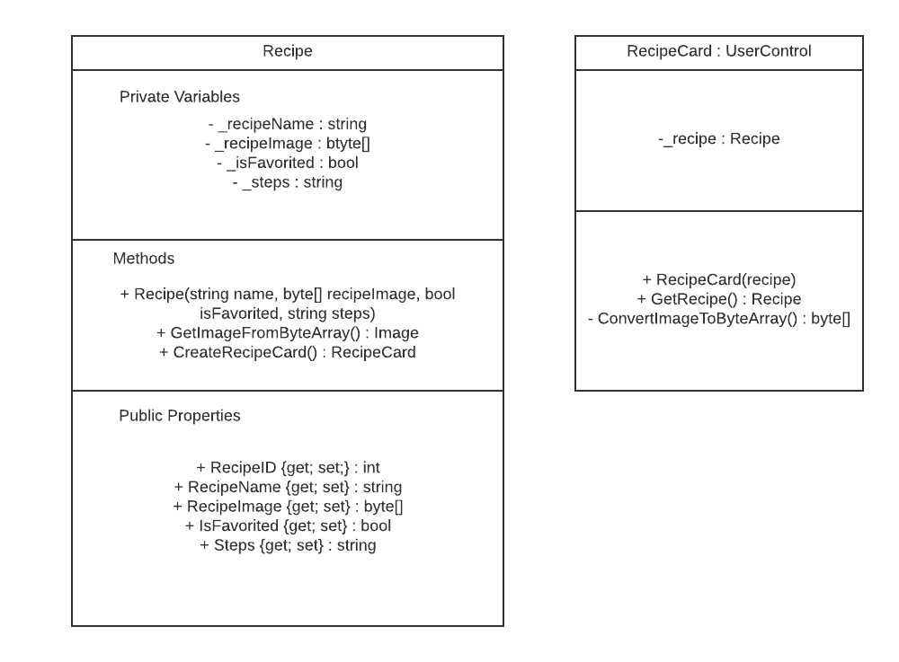

**Features:**

* Managing recipes – Users and Create their own recipes, edit a recipe, and delete a recipe. Whenever the user starts up the application it goes through a database and gets all their recipes.
* Favorites – Users can favorite a recipe where the recipe card will show a heart icon and users can filter the search on favorites only
* Text to Speech / Voice recognition – The cookbook will have a Text to Speech feature where it’ll read off the step and the user can say either “Next” to go to the next step or “Repeat” where it’ll repeat the current step.
* Recipe Cards – How users get to the detailed recipe cards is through the recipe card where it will be dynamically created upon creating a recipe