**Spring MVC and Advanced Java Programming**

FSD: Lab Guide - Phase 3



This section will guide you to:

* Use practice labs to execute all demos included in this course

This lab has two subsections, namely:

1. Starting practice labs on LMS
2. Using different IDEs and software required for Phase 3

**Step 1:** Starting practice labs on LMS

* Login to Simplilearn LMS
* Go to the respective course and click on it

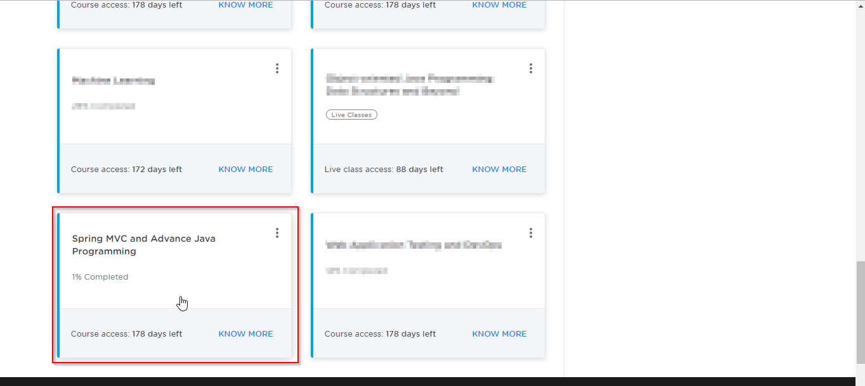

* On the left, you will find the course ToC page
* To its left, you will find the **PRACTICE LABS** tab
* Click on it

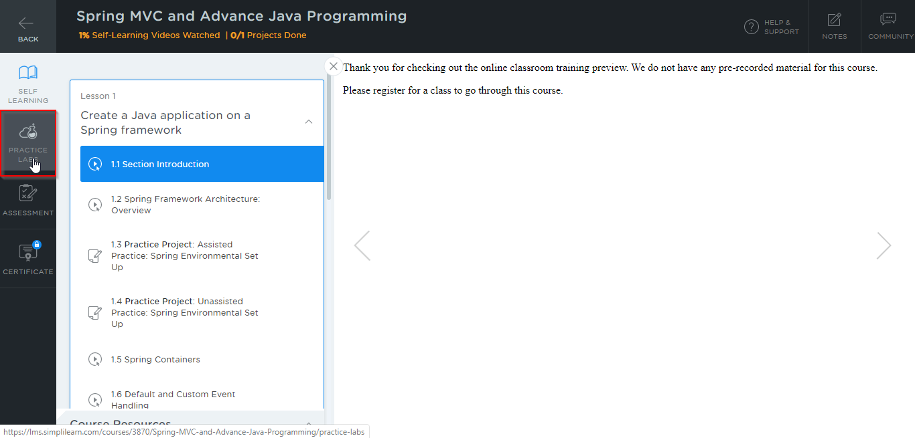

* As a new window opens, read the instructions in it and click on **LAUNCH LAB**
* This will launch the practice labs for this course

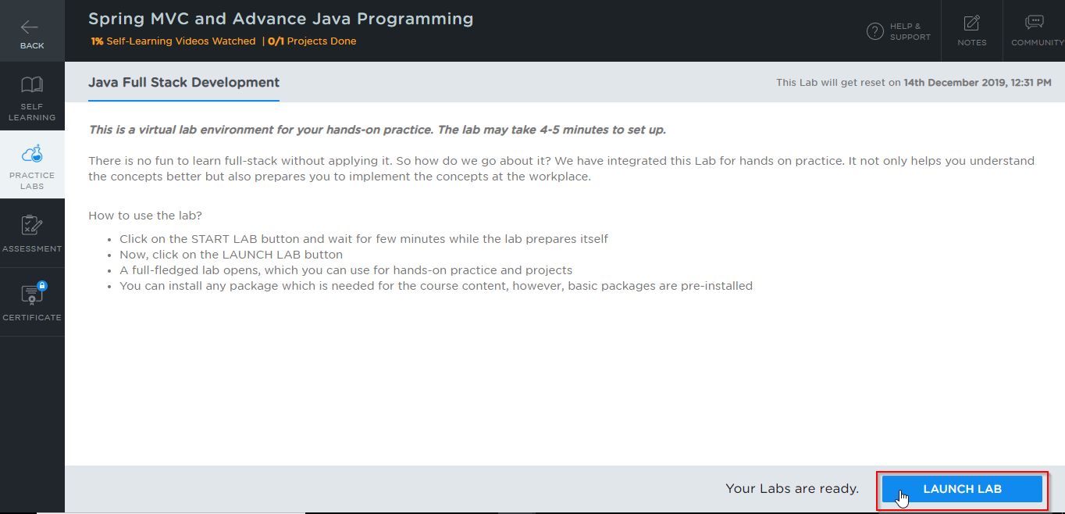

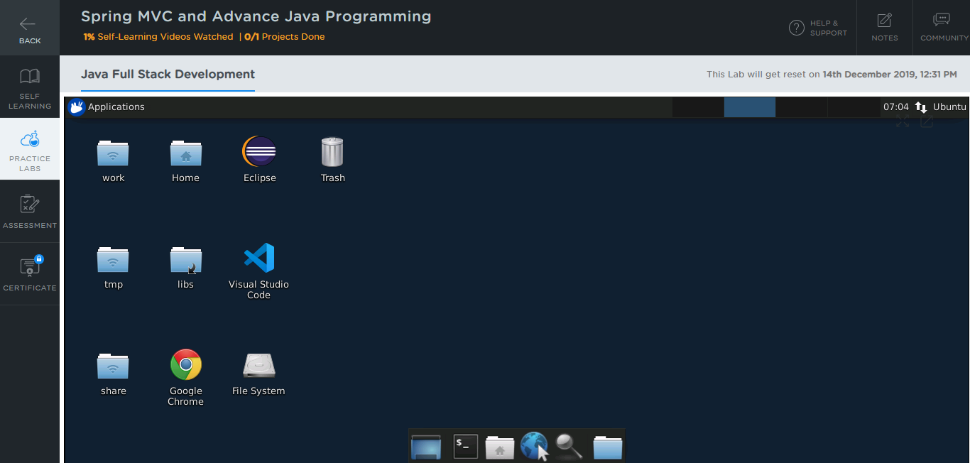

**Step 2:** Using different IDEs and software required for Phase 3

All the required IDEs and software can be accessed from the labs

**Spring Tool Suite & Spring Boot:**

Spring and its packages are already installed in your practice labs

* To verify the installation:

1. Open the Eclipse environment from your desktop
2. Go to the **Help** tab and select **Install New Software**

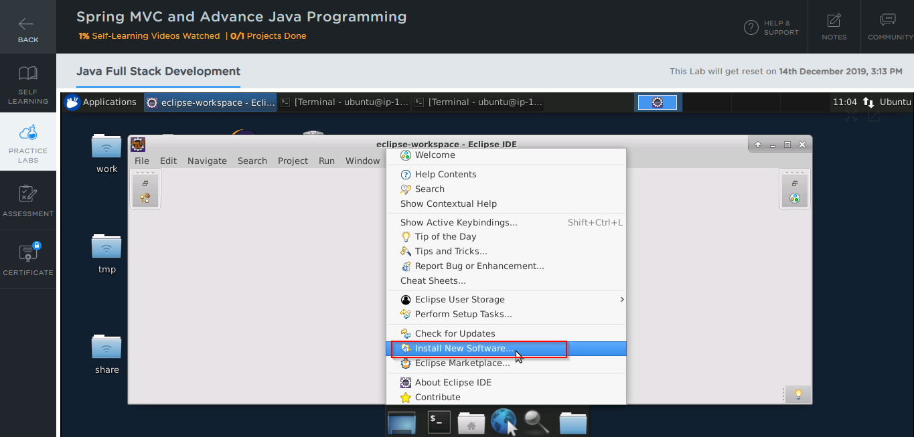

1. In the next window, click on **Already Installed**

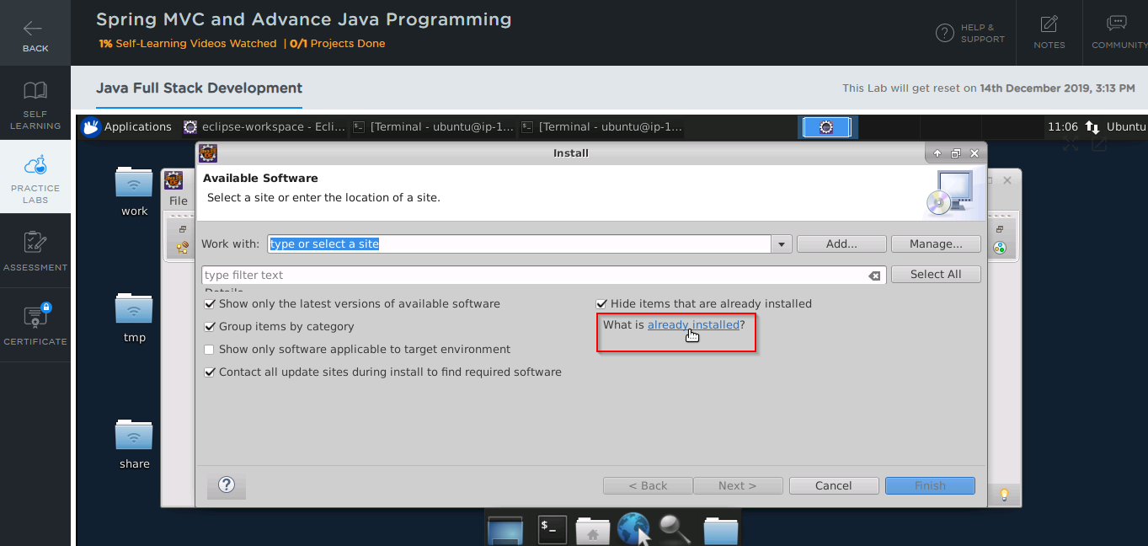

1. In the **filter text** field, type **Spring** 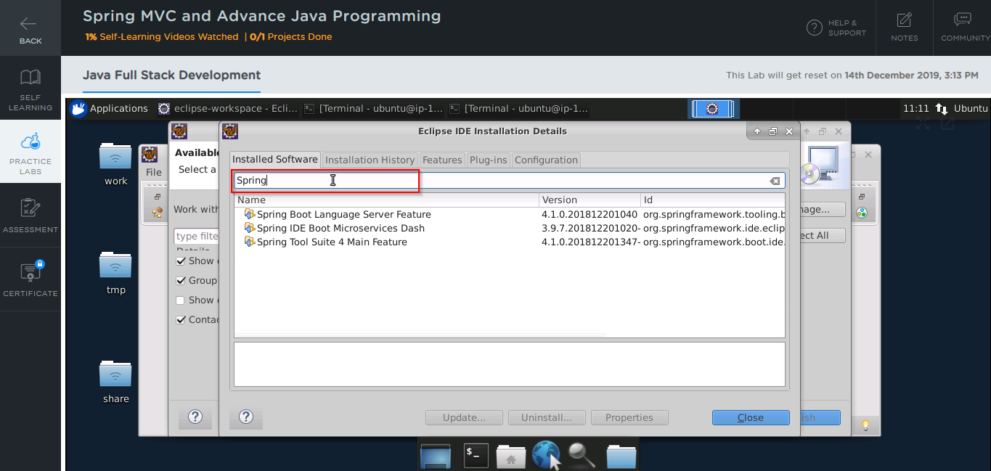

* In case Spring packages are not installed in your practice lab, you can install them following these steps:

1. Open the Eclipse environment from your desktop, go to the **Help** tab, and click on **Eclipse Marketplace**

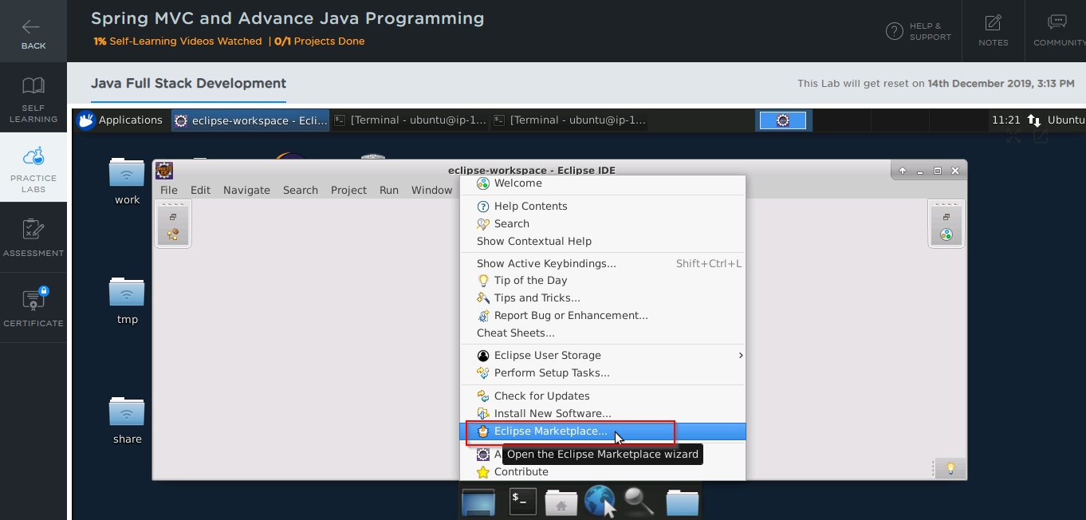

1. Type **Spring** in the **Find** field and click on **Go**
2. You’ll find Spring Tool Suite and Spring Boot listed there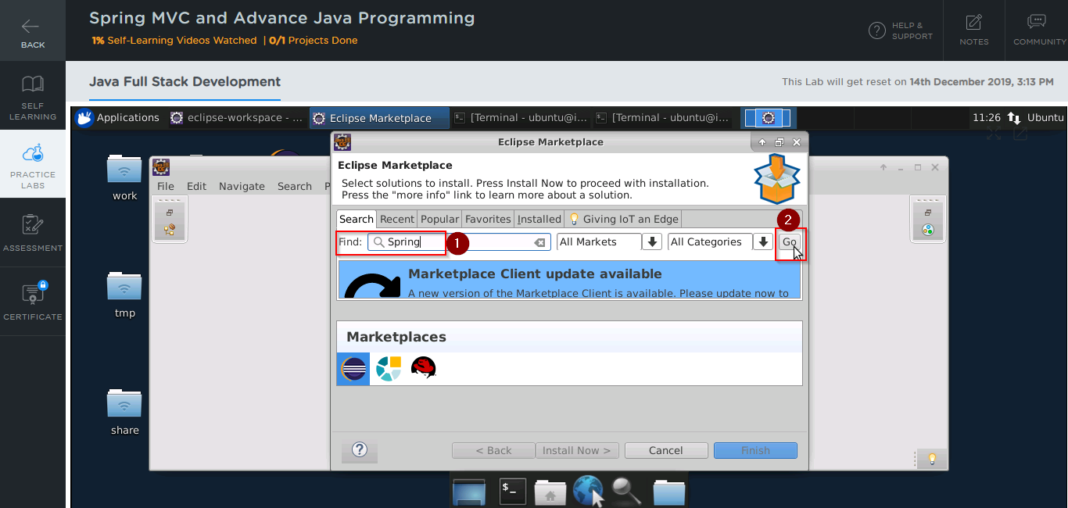
3. Click on the **install** button against the package that you want to install

**RabbitMQ:**

* You can find it in the directory **usr/lib**
* This step is shown below in the screenshot:

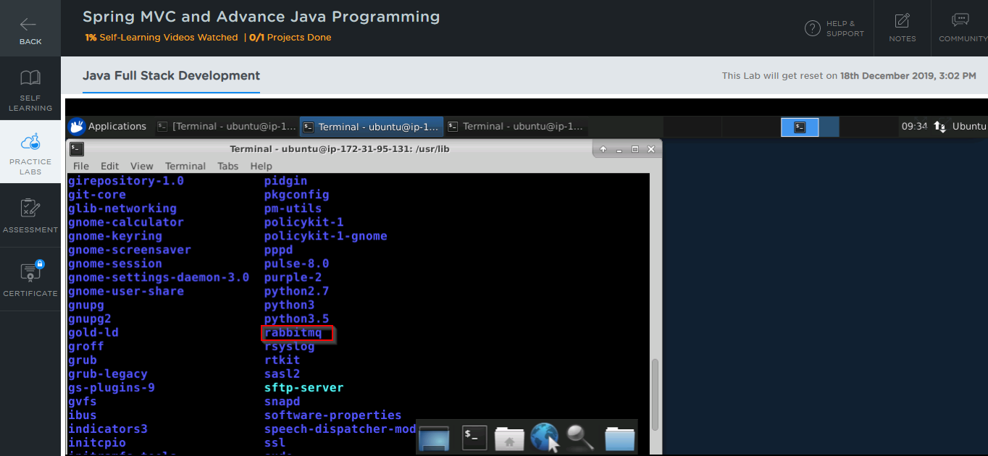

* In case RabbitMQ is not installed in your practice lab, you can install it using the commands:

*sudo apt update*

*sudo apt -y install rabbitmq-server*

**Kafka:**

You can use the following steps to install Kafka:

* Go to **https://kafka.apache.org/downloads** and download the latest binary file

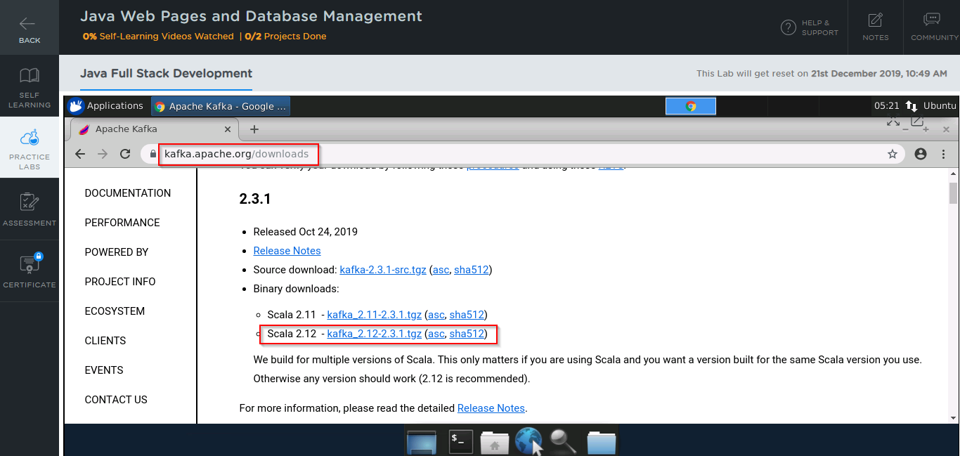

* Open the command line and navigate to the **Downloads** folder:

*cd Downloads*

* Use the following commands to extract files from the binary file you have downloaded in the previous step:

*tar xzf kafka_2.12-2.3.1.tgz*

*mv kafka_2.12-2.3.1 /usr/local/kafka*

* Start a Zookeeper instance first using the commands:

*cd /usr/local/kafka*

*bin/zookeeper-server-start.sh config/zookeeper.properties*

* Start the Kafka server using the command:

*bin/kafka-server-start.sh config/server.properties*

**JUnit:**

JUnit is already installed in your practice labs,and you can find it in the directory */usr/share/java*

* Use the following command to navigate to the above-mentioned directory:

*cd /usr/share/java/*

*ls*

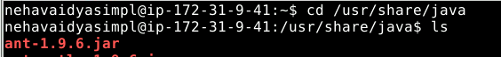



**SoapUl:**

SoapUI is already installed in your lab

* You can use the following steps to install SoapUI:
* Go to **https://www.soapui.org/downloads** and click on **Download SoapUI open source**

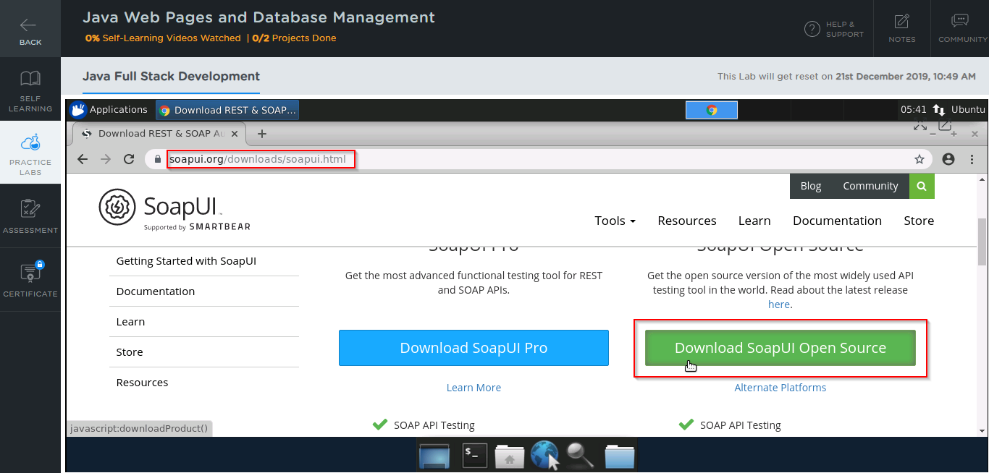

* Open the command line and navigate to the **Downloads** folder:

*cd Downloads*

* Run the following commands to initiate the installer:

*chmod 755 SoapUI-x64-5.5.0.sh*

*./SoapUIx-64-5.2.1.sh*

* Once the installer is initiated, click on **Next**

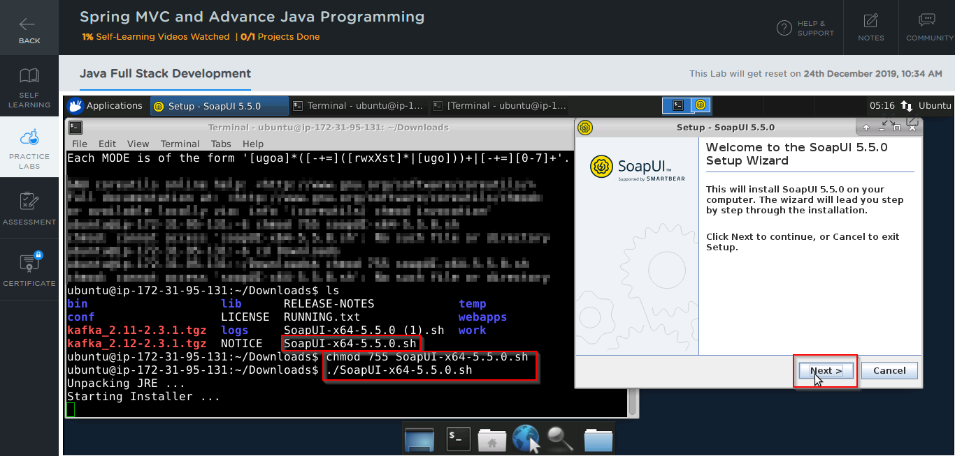

* Choose the path where you want to install SoapUI and click on **Next**

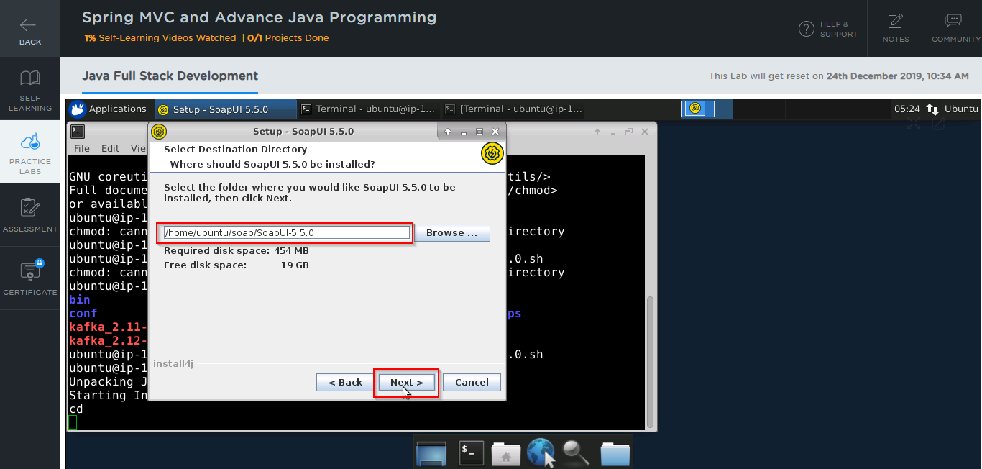

* Accept all the default settings and follow the wizard instructions to finish the installation

**Jenkins:**

Jenkins is already installed in your practice labs

* You will find it in the directory */usr/share*
* Use the following commands to navigate to the above-mentioned directory:

*cd /usr/share*

*ls*

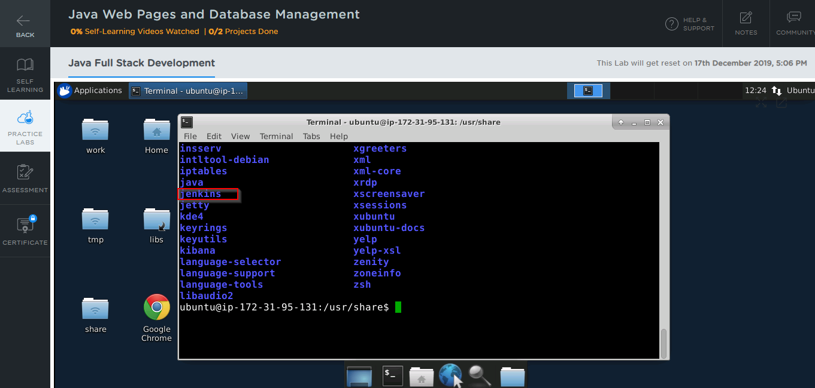

* In case Jenkins is not installed in your practice lab, you can install it using the commands:

*sudo apt update*

*sudo apt install jenkins*

**Maven:**

Maven is already installed in your practice labs

* You can use the following command to verify the installation:

*mvn -v*

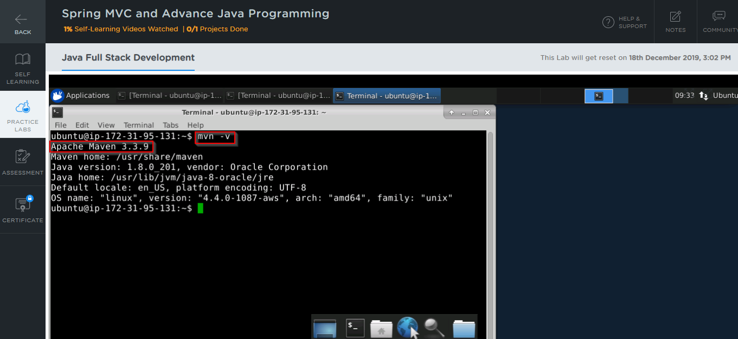

* In case Maven is not installed in your system, you can install it using the commands:

*sudo apt-get update*

*sudo apt-get install maven*