
RV COLLEGE OF ENGINEERING
Bengaluru-560 059

REPORT ON
EXPERIENTIAL LEARNING / PROJECT BASED LEARNING STRUCTURAL MECHANICS
ACY 2025-26 (Odd)
Title of the Project
Simulating the effect of heat input on the residual stress distribution in gas metal arc welding of carbon steel
Students Group

SL. No. | USN | Name | Prog.
1 | 1RV24AS057 | TREYA MOODITHAYA | AS
2 | 1RV24AS038 | R TUSHTI | AS
3 | 1RV24AS034 | OMKAR NAIK | AS
4 | 1RV24AS020 | JAYADHITYAA | AS
5 | 1RV24AS012 | CHINMAYA HEGDE | AS
6 | 1RV24AS015 | HANSEL BIJU MATHEW | AS
7 | 1RV24AS016 | HARSHITH S | AS
8 | 1RV24AS042 | RISHIT KUMAR | AS

Introduction
Gas metal arc welding (GMAW) is a fundamental technique for permanently joining metallic components, but the process introduces significant challenges due to localized heating and rapid cooling cycles. These non-uniform thermal cycles generate plastic strains that lead to the development of residual stresses and distortions. Such stresses are critical to evaluate as they can adversely affect the fatigue life, corrosion resistance, and dimensional stability of engineering components.
The magnitude and distribution of these residual stresses are primarily governed by the heat input, which influences the cooling rate and microstructural evolution within the weld and the heat-affected zone (HAZ). While experimental methods for stress determination exist, they are often time-consuming or destructive. Consequently, 3D thermo-mechanical finite element method (FEM) simulation has emerged as a powerful, cost-effective alternative for predicting residual stress levels during the design phase. This study utilizes a sequential thermal-mechanical coupling approach to analyze the thermomechanical interactions in A516 Gr 70 steel plates, employing a high-fidelity heat source model to capture the complex thermal behavior of the welding process.

Objectives

- Thermal field modelling: To compute the transient temperature field during the GMAW process using a 3D finite element model and a Goldak double ellipsoid heat source to represent the arc energy distribution.
- Residual stress prediction: To determine the distribution and the magnitude of transverse residual stress resulting from the superposition of thermal and mechanical strains after the cooling phase.

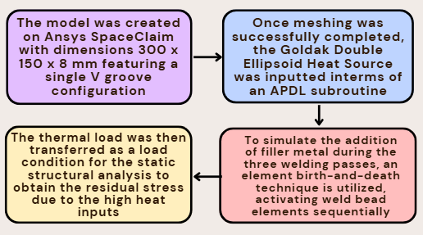
Methodology

Important Note on the APDL Code and the Goldak Heat Equation:

The Goldak Heat Equation is given by:
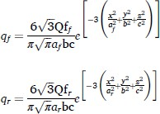

Where:

The various Q values for each pass can be calculated using the values given below from the literature:
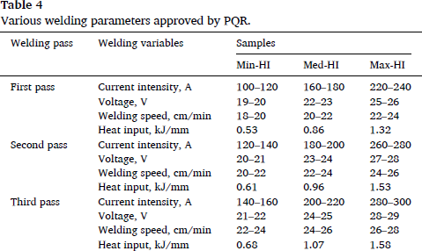

The results in this report are for Q = 2000. The APDL Code is also written for Q = 2000.

- Material Assignment (Engineering Data on Ansys)

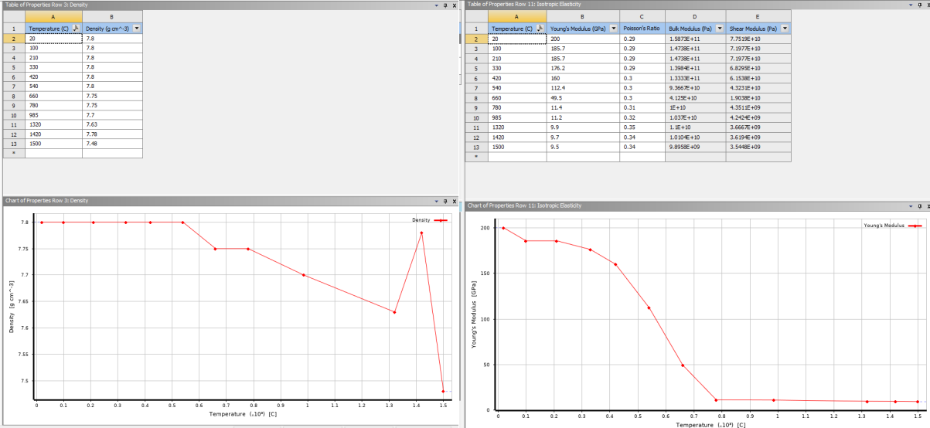
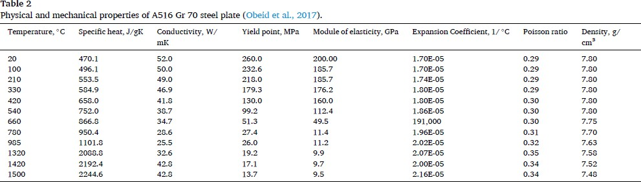
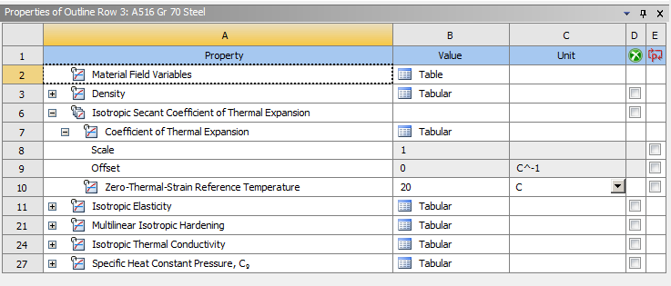

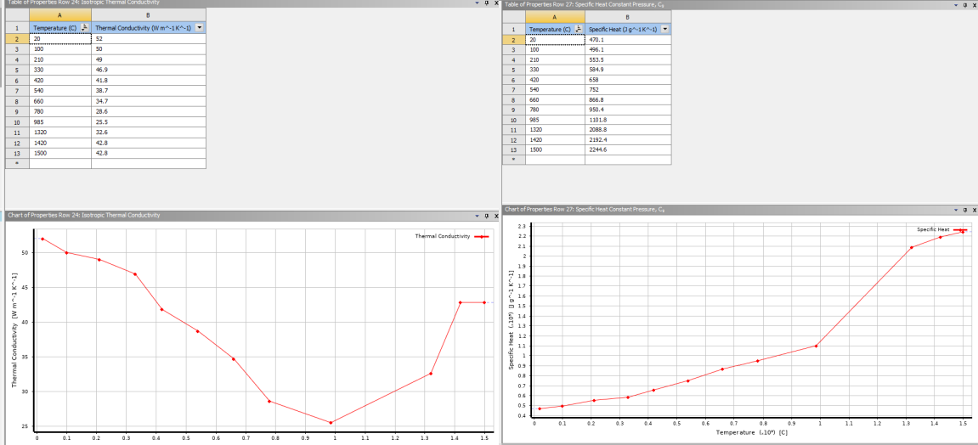

Geometry:
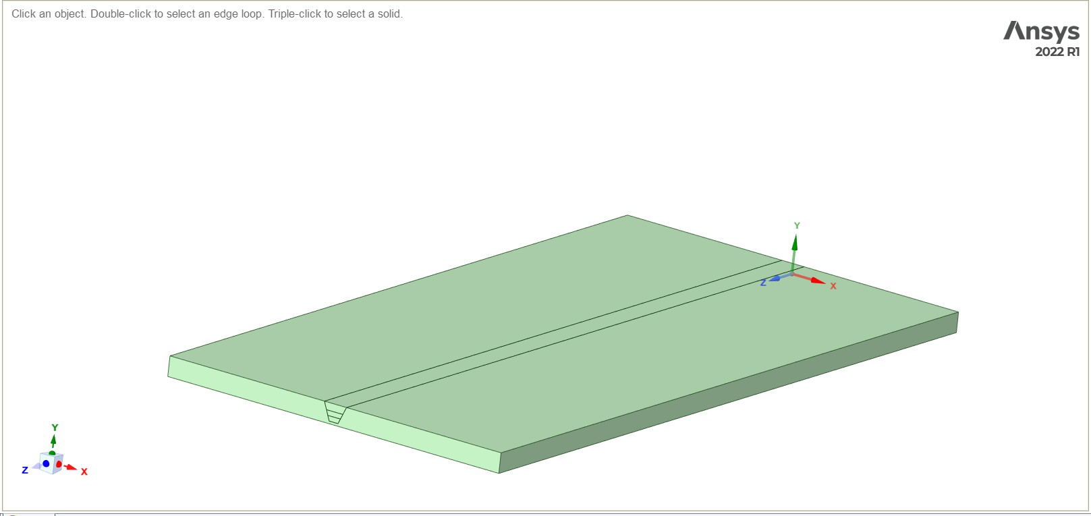

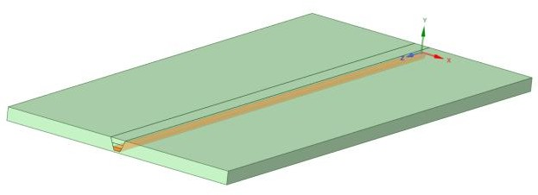
All three weld passes: Pass 1:

Pass 2:
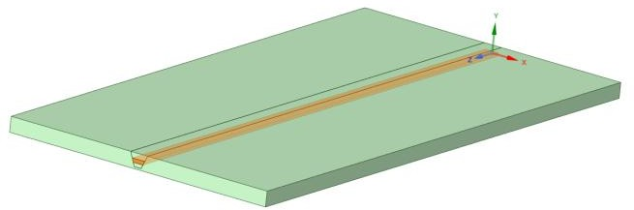
Pass 3:

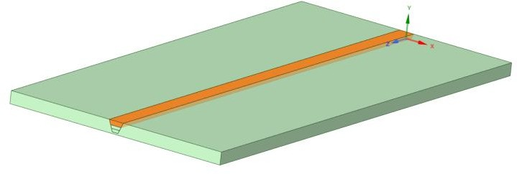

Meshing:

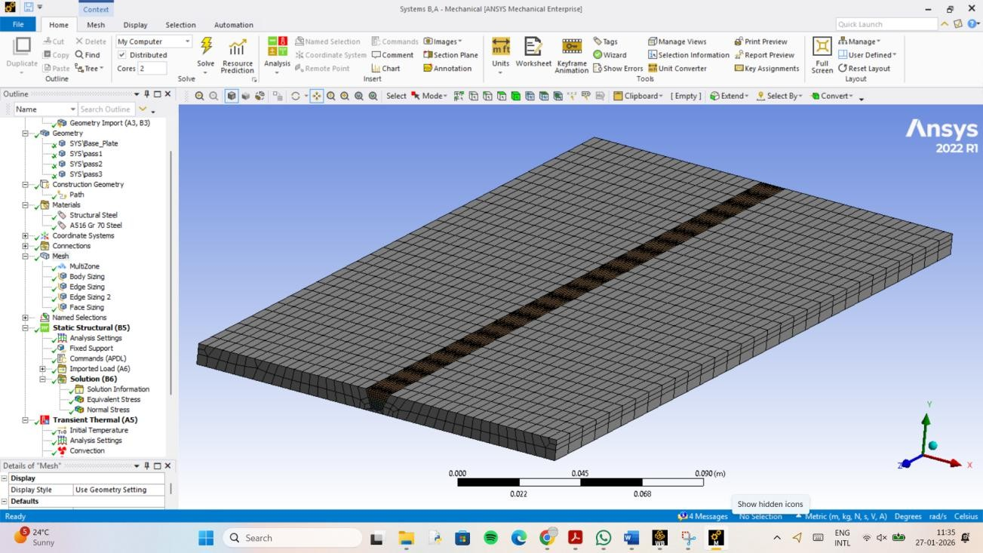

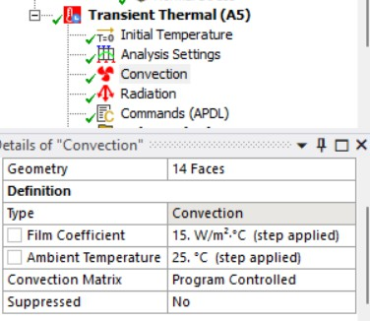
Transient Thermal Setup:
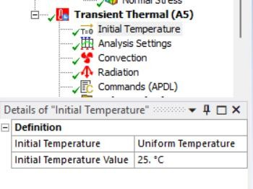
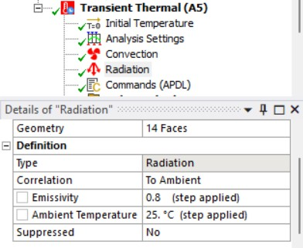

APDL CODE FOR THERMAL ANALYSIS
ALLSEL

ESEL,S,COMP,,WELD_PASS_1_CM ESEL,A,COMP,,WELD_PASS_2_CM ESEL,A,COMP,,WELD_PASS_3_CM EKILL,ALL
ALLSEL

A=0.003 B=0.004 C1=0.004 C2=0.016 TAU=0 FF=0.6
FR=1.4 Q=2000 VEL=0.001

time_inc=1 pass_dur=100 time_steps=300 pass_offset=0

NROPT,FULL AUTOTS,ON

*DO,i,1,time_steps,1 WTIME=(i*time_inc) TIME,WTIME

*IF,WTIME,LE,pass_dur,THEN CURR_PASS_CM='WELD_PASS_1_CM'
pass_offset=0
*ELSEIF,WTIME,LE,(pass_dur*2),THEN CURR_PASS_CM='WELD_PASS_2_CM'
pass_offset=pass_dur
*ELSE CURR_PASS_CM='WELD_PASS_3_CM'
pass_offset=(pass_dur*2)
*ENDIF

CMSEL,S,%CURR_PASS_CM% EALIVE,ALL

*GET,EMIN,ELEM,,NUM,MIN
*GET,EMAX,ELEM,,NUM,MAX

HCENTER = VEL*(WTIME-pass_offset)

*DO,jj,EMIN,EMAX,1
*IF,ELNEXT(jj),NE,0,THEN X=CENTRX(jj) Y=CENTRY(jj) Z=CENTRZ(jj)

CSI=-Z+(VEL*(TAU-(WTIME-pass_offset)))

*IF,Z,GT,HCENTER,THEN C_VAL=C1
F_VAL=FF
*ELSE C_VAL=C2 F_VAL=FR
*ENDIF

PART1=(6*(3**0.5)*Q*F_VAL)/(A*B*C_VAL*3.14159*(3.14159**0.5))
PART2=(exp(-3*(X/A)**2))*(exp(-3*(Y/B)**2))*(exp(-3*(CSI/C_VAL)**2)) QF=PART1*PART2

BFE,jj,HGEN,,QF
*ENDIF
*ENDDO

ALLSEL SOLVE
BFEDELE,ALL,ALL
*ENDDO

APDL CODE FOR STATIC STRUCTURAL ANALYSIS

/INQUIRE,SOLVER_DIR,DIRECTORY TREF, 25

ESEL, S, COMP, , WELD_PASS_1_CM

ESEL, A, COMP, , WELD_PASS_2_CM ESEL, A, COMP, , WELD_PASS_3_CM EKILL, ALL
ALLSEL

/INQUIRE,WELD_RTH,FILE,,rth TIME, 100
EALIVE, WELD_PASS_1_CM

LDREAD, TEMP, , , 100, , , %WELD_RTH%, rth SOLVE

TIME, 200

EALIVE, WELD_PASS_2_CM

LDREAD, TEMP, , , 200, , , %WELD_RTH%, rth SOLVE

TIME, 300

EALIVE, WELD_PASS_3_CM

LDREAD, TEMP, , , 300, , , %WELD_RTH%, rth SOLVE
TIME 1000 ALLSEL EALIVE, ALL
BF, ALL, TEMP, 25

Results:

Temperature:
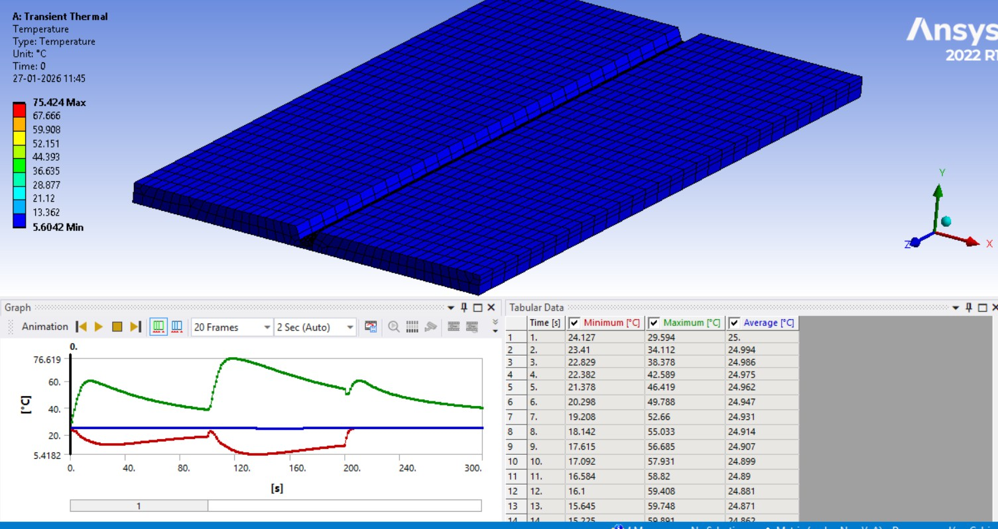

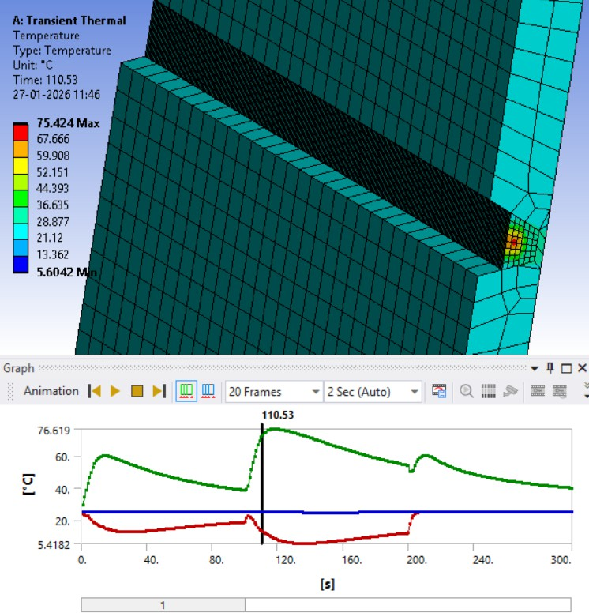
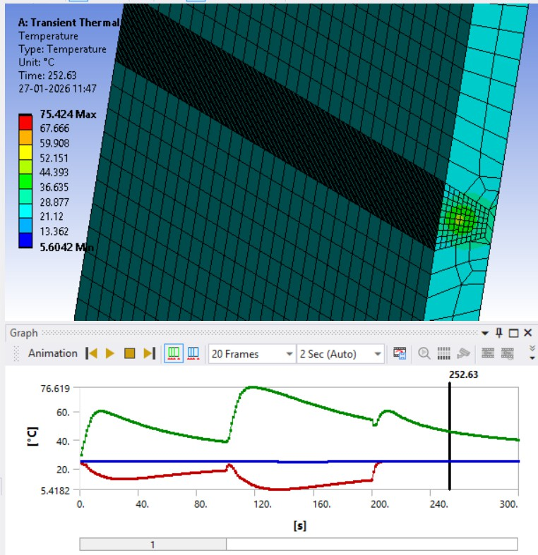

Directional heat flux (z direction i.e. direction of weld)
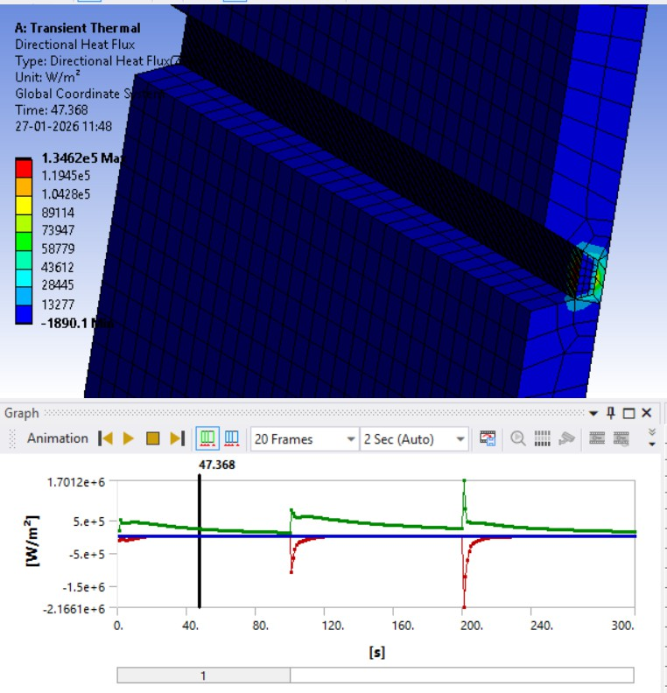
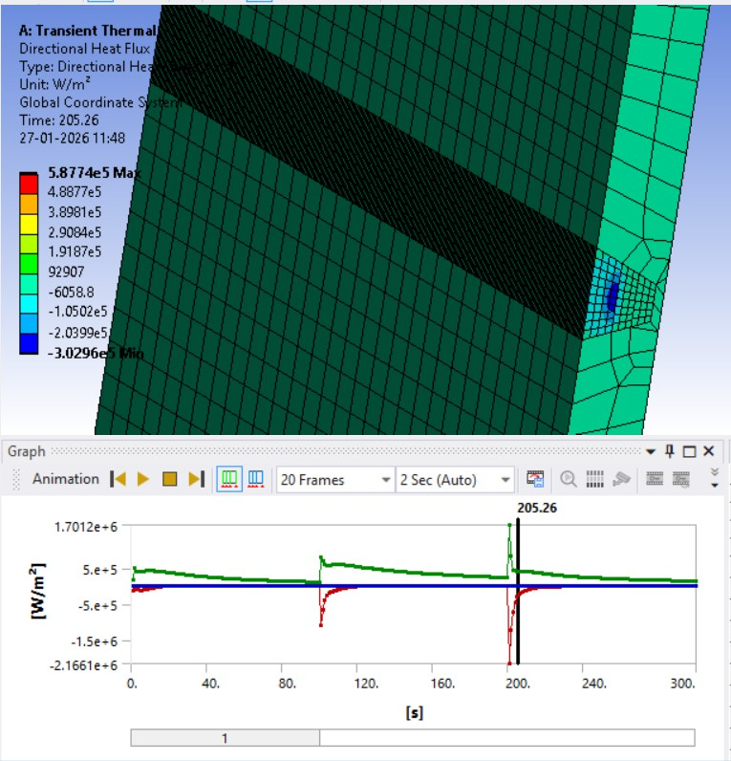

Total Heat flux:

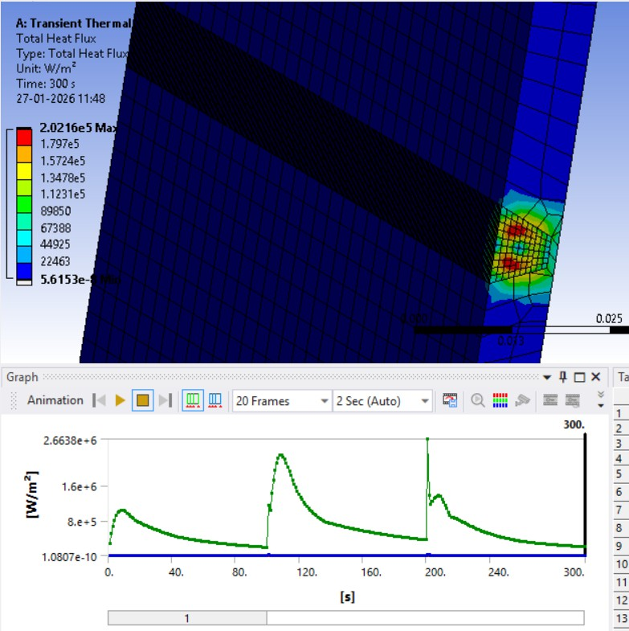

Results of Residual Stress: Normal Stress distribution:
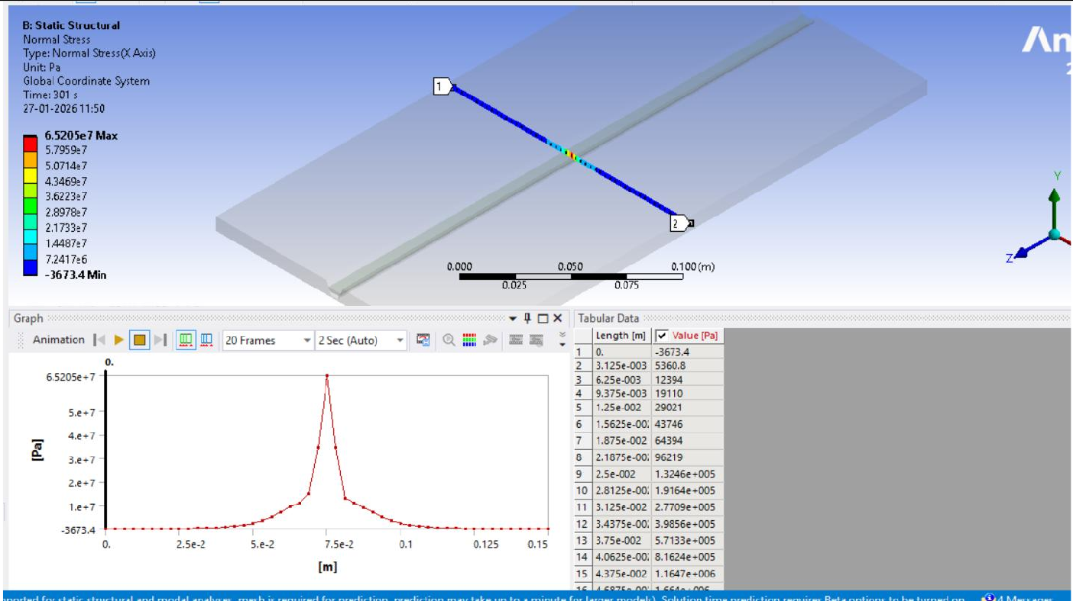

Comparison of Graph with Literature:
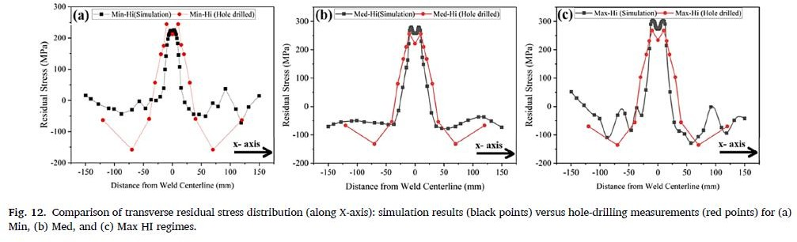

Discussions:

- The mechanical results indicate that the highest tensile residual stresses are concentrated at the weld centreline and the fusion line.
- To maintain internal equilibrium, the simulation shows a transition to compressive stresses as the distance from the weld centreline increases, matching the papers far field stress profiles.
- The tensile zone: the tensile zone is almost always located in and around the weld bead the heat affected zone. During the birth of the elements, the metal is at a melting temperature. As the the heat source moves away and the cooling step is applied, the molten metal wants to shrink significantly. The surrounding base metal, which stays relatively cool, acts like a
rigid cage and prevents the weld bead from shrinking into its natural, smaller volume. Because the weld bead is trying to “pull” inwards but it held back by the rest of the plate, it is put into a state of tension, which is represented by the positive values.
- The compressive zone: as we move further away from the weld, the stress values will drop and become negative. It is a matter of mechanical equilibrium. If the centre of the weld is pulling inward, another part of the plate must push outward to balance it. When the weld area was hot and expanding, it pushed against the base metal which causes the base to undergo slight compressive deformation. Once everything is cool, the areas flanking the heat affected zone end up being squeezed by the tension in the centre. This is translated into negative stress values by Ansys.

