
ICS Updates
Detailed Technical Design

Revision History
Date | Version | Description | Author
Jan. 6, 2003 | 0.1 | Initial draft | Marco Abundo
Jan. 9, 2003 | 0.2 | Added Mike’s performance improvement design, ICSEventLogger stuff | Marco Abundo
Jan. 13, 2003 | 0.3 | Incorporated Jim’s comments. Signed off by AAC. | Marco Abundo

Table of Contents
1. Introduction 1
1.1 Purpose 1
1.2 Scope 1
1.3 Definitions, Acronyms and Abbreviations 1
1.4 References 1
1.5 Overview 1
2. ICS System Architecture 2
3. Detailed Technical Design 2
3.1 Correlation Maintenance 2
3.1.1 Manual Merging of Persons 2
3.1.2 Manual Splitting of Persons 5
3.1.3 Logging 10
3.1.4 Scope 11
3.1.5 Task Estimates 11
3.2 ICS Tracing and Auditing 12
3.2.1 UML 12
3.2.2 User Interface Mockups 13
3.2.3 Changes 13
3.2.4 Scope 13
3.2.5 Task Estimates 14
3.3 System Log Monitoring 14
3.3.1 UML 14
3.3.2 User Interface Mockups 14
3.3.3 Changes 14
3.3.4 Scope 14
3.3.5 Task Estimates 14
3.4 ICS Person Field Validation 14
3.4.1 UML 14
3.4.2 User Interface Mockups 15
3.4.3 Changes 15
3.4.4 Scope 15
3.4.5 Task Estimates 15
3.5 ICS Search Performance 15
3.5.2 Changes 18
3.5.3 Scope 22
3.5.4 Task Estimates 22

Introduction

Purpose
The purpose of this document is to describe the detailed technical design for changes to the ICS system. The ICS is made up of a number of parts including the Person ID Service and the Identity Service. The former handles requests to add or update new Persons in the database while the later handles requests to search the database. Most of the detailed technical designs described herein pertain to the Person ID Service with a smaller number for the Identity Service.

Scope
The scope of this document pertains to:
- back-end functionality required by the ICS
- CDE user interface components

Definitions, Acronyms and Abbreviations
- PID – The facility assigned patient identifier
- Person – A correlated, uniquely identified patient
- ICS – Identity Correlation Service
- Alias – One of the known identities for a Person. Also known as PERSON_INFO in the DB.

References
ICS Software Requirements Specification from Michael Sandrof
ICS High Level Technical Design from Marco Abundo

Overview
This detailed technical design will be broken down into the 5 major parts described in the ICS Software Requirements Specification document:
- Correlation Maintenance – the ability to manually correct correlation problems
- ICS Tracing and Auditing – visibility into the correlation process for debugging correlation issues
- Performance – ICS must meet defined performance needs
- System Log Monitoring – system alerts when specific CS log events occurs
- ICS Person Field Validation – Data validation checks for ICS Person data

ICS System Architecture
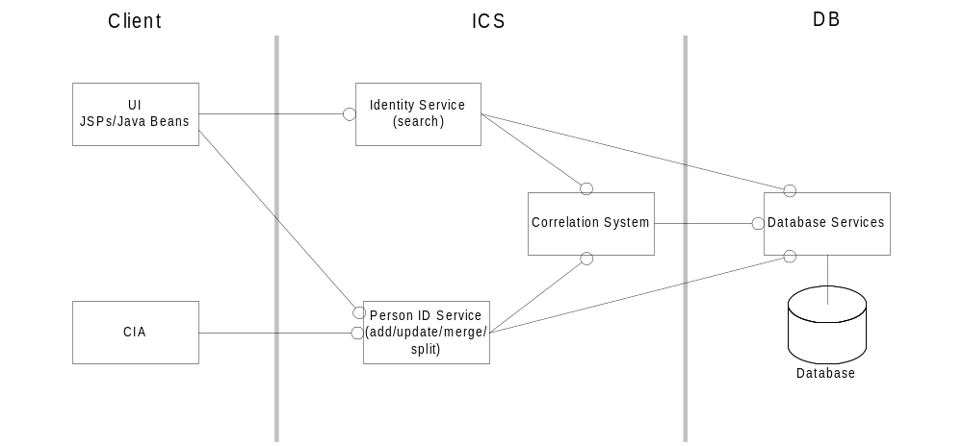

Detailed Technical Design

Correlation Maintenance

Manual Merging of Persons

UML
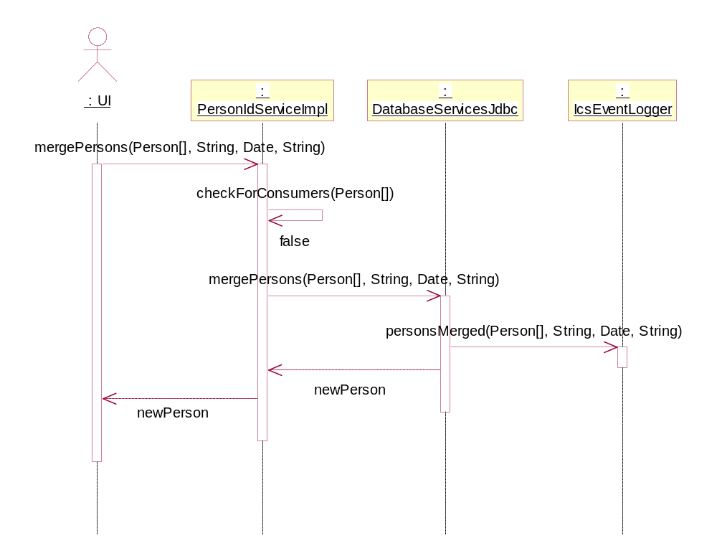

User Interface Mockups

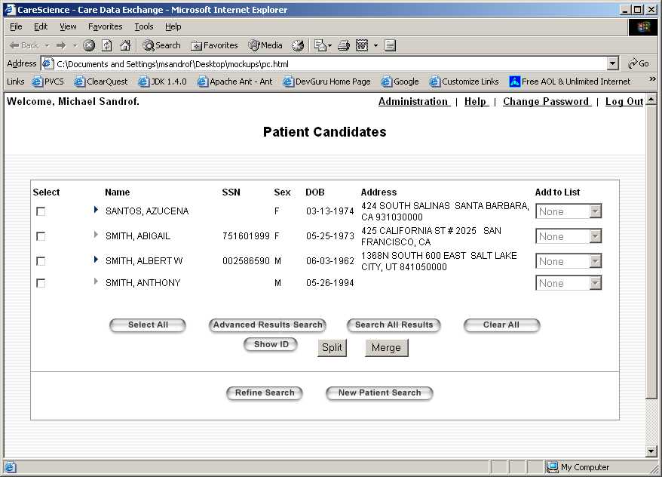
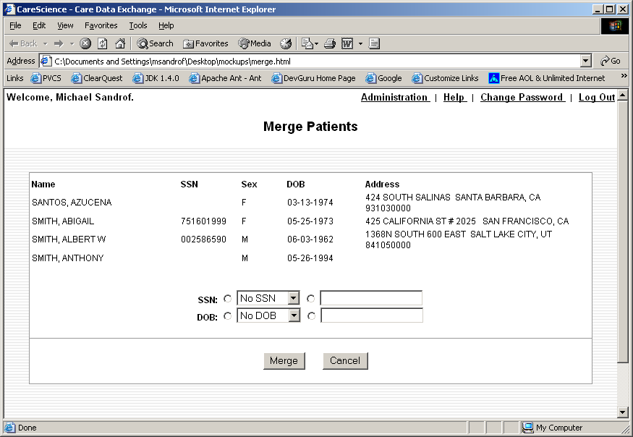

Changes

Java
New PersonIdService.mergePersons():
/**
* Merges multiple <code>Persons</code> into a single <code>Person</code> in the database.
* <p>
* @param persons array of <code>Persons</code> to be merged in the database
* @param ssn SSN for newly merged <code>Person</code>
* @param dob date of birth for newly merged <code>Person</code>
* @param userInfo the <code>UserInfo</code> for this administrator
* @param reason reason for the merge operation
* @return the merged <code>Person</code>, or null if merge failed.
* @throws java.rmi.RemoteException
* @throws PersonIdServiceException containing the original exception thrown
*/
public Person mergePersons(Person[] persons, String ssn, Date dob, UserInfo userInfo, String reason) throws RemoteException, PersonIdServiceException;

New DatabaseServices.mergePersons():
/**
* Merges multiple <code>Persons</code> into a single <code>Person</code> in the database.
* <p>
* @param persons array of <code>Persons</code> to be merged in the database
* @param ssn SSN for newly merged <code>Person</code>
* @param dob date of birth for newly merged <code>Person</code>
* @param userInfo the <code>UserInfo</code> for this administrator
* @param reason reason for the merge operation
* @return the merged <code>Person</code>, or null if merge failed.
* @throws DatabaseException
*/
public Person mergePersons(Person[] persons, String ssn, Date dob, UserInfo userInfo, String reason) throws DatabaseException;

JSPs
New MergePersons.jsp, changes to PatientResults.jsp.

JavaScript
New UI merge validation methods:
checkMerge() – Checks that 2 or more patients are selected from PatientResults.jsp upon clicking the “Merge” button.
validateMergeParameters(String SSN, Date DOB, String reason) – Validates SSN and DOB parameters if present, and requires a reason for the merge.

Command-line interface
The single-shot merge command-line interface. Note that SSN and DOB parameters are optional:
C:\> mergePersons <pid1> <pid2> -ssn=<ssn> -dob=<dob> <reason_for_merge>
The command-line interface should also support batch merges via comma-separated-value files:
C:\> mergePersons mergefile.csv

Logical Database Model
N/A

Manual Splitting of Persons
Note: This functionality has been dropped for this release.
Note: It is assumed for the purpose of splitting that a row in the document_header DB table has a corresponding entry in the person_info DB table.

UML

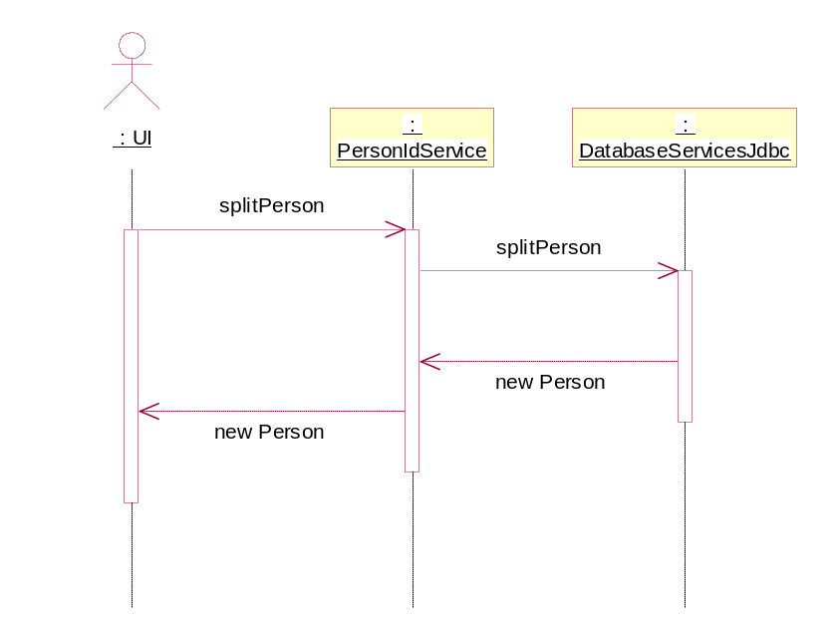

User Interface Mockups
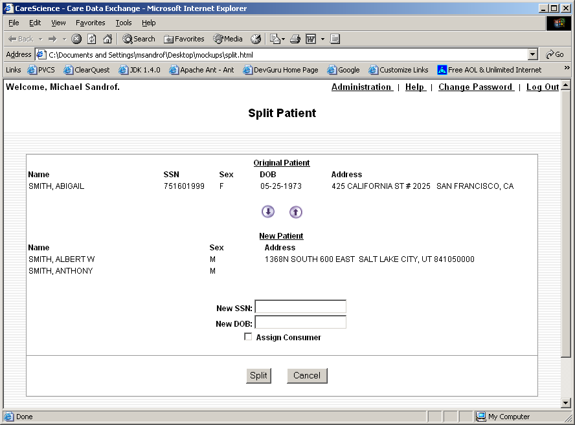

Changes

Java
New PersonIdService.splitPerson method:
/**
* Splits a <code>Person</code> into 2 <code>Persons</code> in
* the database.
* <p>
* @param person the <code>Person</code> to be split
* @param docHeaders the array of <code>DocumentHeaders</code> to be associated with the newly-created <code>Person</code>
* @param isConsumer indicates whether the Consumer attribute (if present) is to be associated with the newly-created <code>Person</code>
* @param ssn SSN for newly-created <code>Person</code>
* @param dob date of birth for newly created <code>Person</code>
* @param userInfo the <code>UserInfo</code> for this administrator
* @param reason reason for the split operation
* @return the newly created <code>Person</code>, or null if split failed.
* @throws java.rmi.RemoteException
* @throws PersonIdServiceException containing the original exception thrown
*/
public Person splitPerson(Person person, DocumentHeader[] docHeaders, boolean isConsumer, String ssn, Date dob, UserInfo userInfo, String reason) throws RemoteException, PersonIdServiceException;

New DatabaseServices.splitPerson method:
/**
* Splits a <code>Person</code> into 2 <code>Persons</code> in
* the database.
* <p>
* @param person the <code>Person</code> to be split
* @param docHeaders the array of <code>DocumentHeaders</code> to be associated with the newly-created <code>Person</code>
* @param isConsumer indicates whether the Consumer attribute (if present) is to be associated with the newly-created <code>Person</code>
* @param ssn SSN for newly-created <code>Person</code>
* @param dob date of birth for newly created <code>Person</code>
* @param userInfo the <code>UserInfo</code> for this administrator
* @param reason reason for the split operation
* @return the newly created <code>Person</code>, or null if split failed.
* @throws DatabaseException
*/
public Person splitPerson(Person person, DocumentHeader[] docHeaders, boolean isConsumer, String ssn, Date dob, UserInfo userInfo, String reason) throws DatabaseException;

JSPs
New SplitPerson.jsp, changes to PatientResults.jsp

JavaScript
New UI split validation methods:
checkSplit() – Checks that only 1 patient is selected from PatientResults.jsp upon clicking the “Split” button.
validateSplitParameters(String SSN, Date DOB, String reason) – Validates SSN and DOB parameters if present, and requires a reason for the merge. split: May simply call validateMergeParameters method.

Logical Database Model
N/A

Logging
There are several options as to which logging system to use for this task:
- Syslog – used extensively throughout CDE
- Database logging, which involves creating a class for this task (similar to ConsentLog and ViewLog)
- IcsEventLogger package, which logs specific ICS events to the database.
After analysis, it was decided that the last option would be chosen. Reasons for this choice include:
  - Consistent ICS event logging to a single DB table
  - Simple ICS event logging API
  - Relative ease of implementing ICS logging requirement

UML
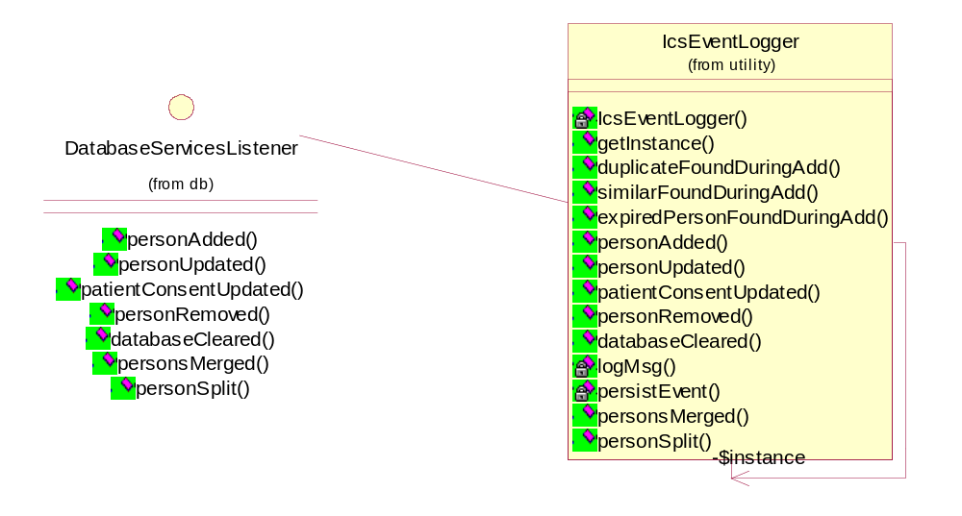

User Interface Mockups

Changes

Java
New DatabaseServicesListener.personsMerged method:
/**
* Called when <code>Persons</code> are merged in the database.
*
* @param person the merged <code>Person</code> in the database.
* @param userInfo the <code>UserInfo</code> for this administrator
* @param reason reason for the merge operation
*/
void personsMerged(Person person, UserInfo userInfo, String reason);

New DatabaseServicesListener.personSplit method:
/**
* Called when a <code>Person</code> is split in the database.
*
* @param originalPerson the original <code>Person</code> before splitting.
* @param newPerson the newly-created <code>Person</code> resulting from the split.
* @param userInfo the <code>UserInfo</code> for this administrator
* @param reason reason for the split operation
*/
void personSplit(Person originalPerson, Person newPerson, UserInfo userInfo, String reason);
These methods will be implemented in the IcsEventLogger class.

Two new events will be added to the IcsEvent class:
/** Database Services - Persons Merged */
public final static String EVENT_PERSONS_MERGED = "PERSONS MERGED";

/** Database Services - Person Split */
public final static String EVENT_PERSON_SPLIT = "PERSON SPLIT";

JSPs
N/A

JavaScript
N/A

Logical Database Model
N/A
Add USER_ID and REASON fields to ICS_EVENT_LOG database table.

Scope

Task Estimates
Create MergePerson.jsp – 8 hours (new JSP, low complexity)
Create SplitPerson.jsp – 16 hours (new JSP, medium complexity)
Modify PatientResults.jsp – 8 hours (updated JSP, low complexity)
JavaScript validation methods – 12 hours (new methods, low complexity)
Add merge and split methods to PersonIDService and DatabaseServices classes – 32 hours (updated class, medium complexity)
Update DatabaseServicesListener and ICSEvent logging classes – 8 hours (updated classes, low complexity)
Create command-line interface scripts – 8 hours (new scripts, low complexity)
New UI elements (for designer) – 8 hours (new elements, low complexity)

ICS Tracing and Auditing

UML
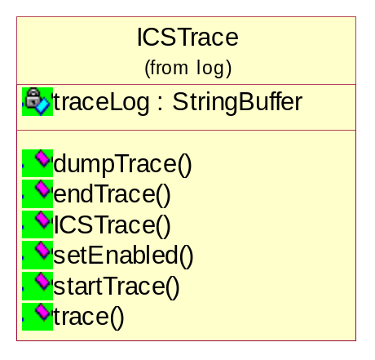
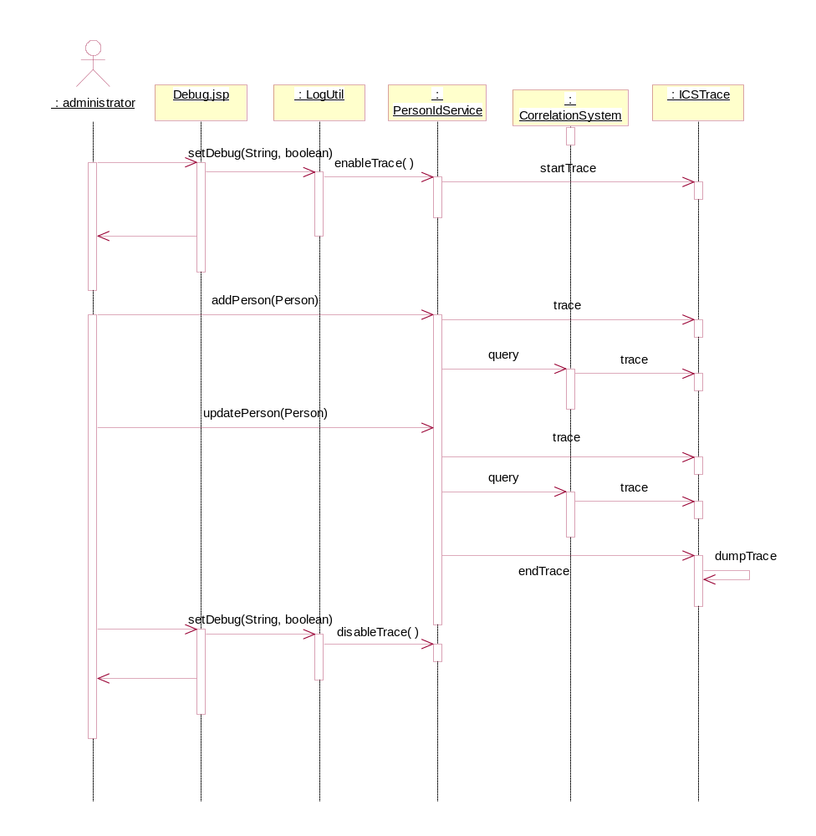

User Interface Mockups

Changes

Java
New ICSTrace class
Add tracing logic to PersonIdService, CorrelationSystem.

JSPs
Modify Debug.jsp to enable/disable this feature.

JavaScript
N/A

Logical Database Model
For now, no changes required. Trace logs will be logged to a file.

Scope

Task Estimates
Create ICSTrace class – 12 hours (new class, medium complexity)
Add tracing logic to PersonIDService, CorrelationSystem classes – 6 hours (updated classes, medium complexity)
Update Debug.jsp to enable/disable tracing – 2 hours (updated JSP, low complexity)

System Log Monitoring

UML

User Interface Mockups

Changes

Java

JSPs

JavaScript

Logical Database Model

Scope

Task Estimates
Ops has tools for log monitoring, discuss with Ops setup and determine initial set of stuff to watch for. (medium complexity)

ICS Person Field Validation

UML
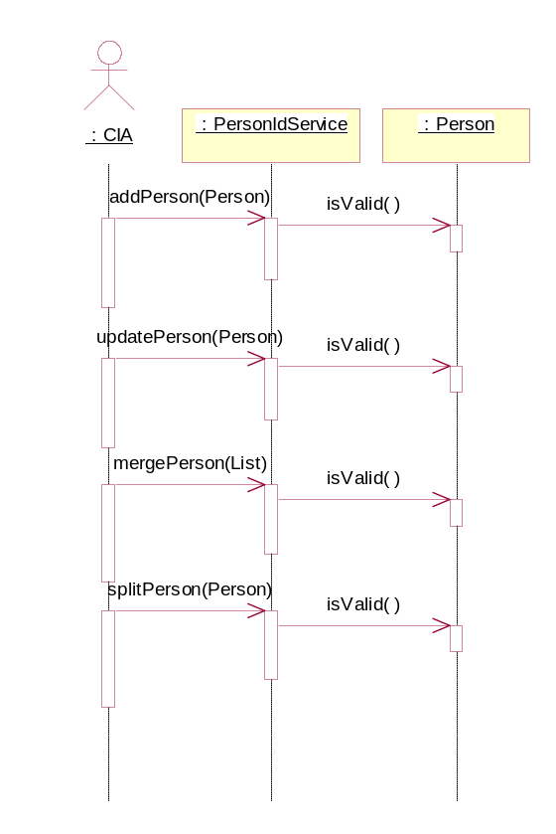

User Interface Mockups
N/A

Changes

Java
Add new method to verify internal consistency of any given Person object:
boolean isValid();

JSPs
N/A

JavaScript
Add validation methods to prevent bad SSNs, etc. in the UI.

Logical Database Model
N/A

Scope

Task Estimates
Add Person.isValid() method – 6 hours (updated class, medium complexity)
Add JavaScript validation methods – 6 hours (new methods, low complexity)

ICS Search Performance
Functionality Tracability: SRS 3.4.2 Search Performance

Searching performance issues are caused when a user enters too broad a set of search criteria as far as the system is concerned. The CorrelationSystem.lookup() method is used for this purpose and it creates a list of candidate persons based on the SSN entered (if any) and also using the name search key generate from the name entered. This latter search has the potential of returned a huge number of Persons and this will only get worse as the database grows. Current lookup() behavior is to combine the results of the name and ssn searches into a single list and then post process them to remove any names that aren’t correlatively significant. The upshot is that even if you specify and exact name and ssn to search, the system may still end up processing thousands of candidate Persons, using up a significant amount of memory, only to throw most of them out during post processing.
The correction for this involved modifying the database access methods that lookup() uses to retrieve persons. Rather than making two calls to DatabaseServicesJdbc.query() for the ssn and name keys search returning huge lists, a new method will be added that uses an Iterator to return one person at a time to lookup() for processing. Lookup will immediately check each Person for correlative quality and either keep it or discard it. Additionally, lookup() will stop processing when it reaches the predefined limit that the UI specifies. Currently, this limit is 25. So once 25 qualified Persons are found, the query end.
This solution is not a panacea. If out of the thousands of candidate persons that last 25 are qualified, we still would have had to examine all previous Persons before we get to this point. We won’t, however, need to store them all in memory during this process. On average, we should see better performance for most searches.
A more comprehensive solution would require significant architectural and tool changes to implement. At issue is that we only query the database for exact SSN match and name search keys. The later is a key range generated by the Intelligent Search Technologies (IST) toolkit. We would need to augment or replace this functionality to get better-refined searches, or add search keys for other data that might be entered by the user. Address is a likely candidate for this. Any such changes would dramatically impact the functioning of the correlation system as a whole, including the Person Id Services, and shouldn’t be attempted without more clear requirements for correlation.

UML
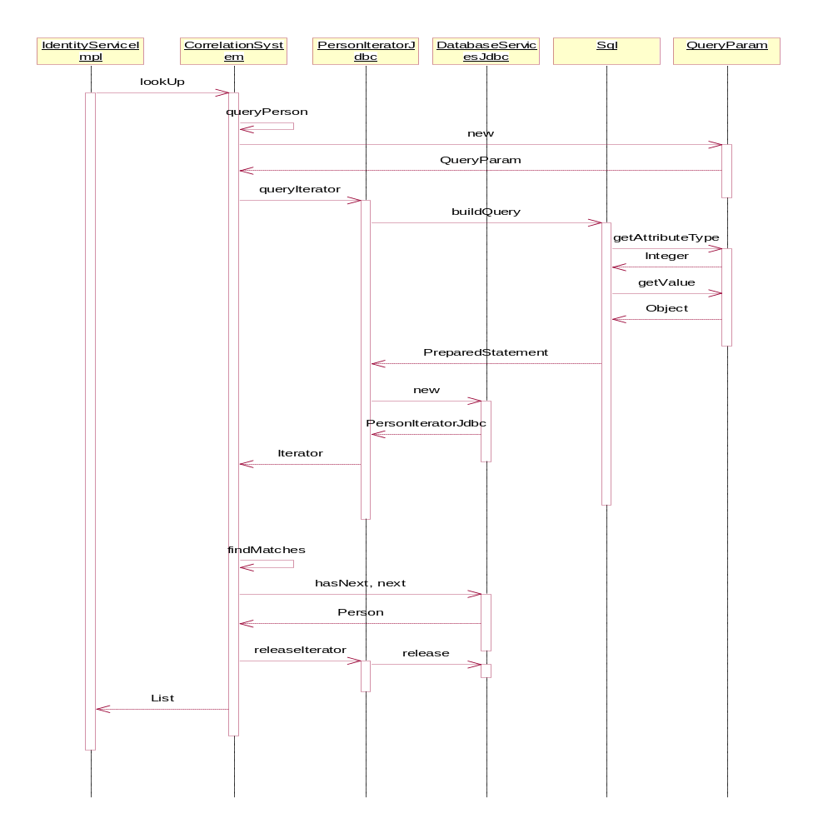
A new nested class called PersonIteratorJdbc will be created to implement the Iterator that the queryIterator() and releaseIterator() use:
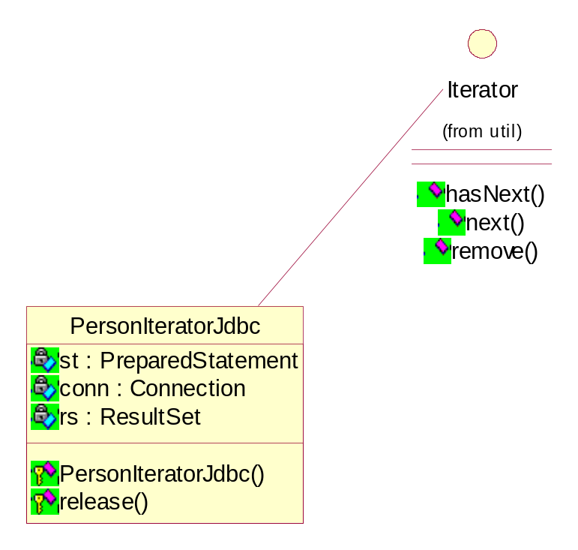
A new class QueryParam will be created to create tuples of Attribute/Value parameters for the queryIterator() method. This takes the place of explicitly sending the attributeType and value in the legacy query() method and allows a typed array of QueryParams to be used. This provides for both ordering and distinction of values. Since the save attributeType may be set with different values in one query, a Map or other interface wouldn’t suffice (a List or Collection might have been ok in the queryIterator() but I kinda wanted it explicity typed).
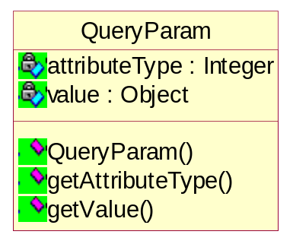
This class will use the DatabaseServicesJdbc.buildPerson() method to read and construct persons from the ResultSet.

Changes

Java
DatabaseServices.java:
/**
Returns an Iterator of Person objects that match the QueryParam array
value specified. The total result set in the iterator will include
everything that matches all of the QueryParams (thus a disjuction or OR
of QueryParams). If there are no matches an empty Iterator will be
returned. Caller must call releaseIterator() on the returned Iterator
when processing is finished.

@param params An array of QueryParam objects. These will be used
to generate the query.
@return Iterator of Person objects
@throws DatabaseException
*/
public Iterator queryIterator(QueryParam[] params)
throws DatabaseException;

/**
Called to release the iterator returned from the queryIterator()
method. This method is responsible for closing out the
query, releasing connections, etc. Once releaseIterator() has
been called, the Iterator will no longer be usable.

@param personIterator The iterator returned from queryIterator.
@throws DatabaseException
*/
public void releaseIterator(Iterator personIterator)
throws DatabaseException;

Methods changed:
query() : existing legacy query() method will be re-written using the queryIterator() method. All critical code from query() that retrieves and constructs person objects will be moved to the queryIterator() and PersonIteratorJdbc() classes. Query() will just build a return List from the Iterator returned from queryIterator().

BuildPersonList(): this will change to buildPerson() and will operate pretty much as is except reading a single Person at a time to support the PersonIteratorJdbc class. The interface will be as follows:

private Person buildPerson( ResultSet rs )
throws DatabaseException;

Sql.java:
Changed methods:

/**
Build the entire SQL statement based on the QueryParam array.
QueryParams are looked up in the IcsSql XML file and a SQL statement
is constructed with ORs between each of the parameters in the
QueryParams array.

@param icssql the helper class for reading in the IcsSQL XML File
@param params Array of QueryParams contains the search parameters
to build the where clause
@param conn The database Connection to use
@throws DatabaseException
@return The PreparedStatement ready to be executed.
*/
public static PreparedStatement buildQuery(IcsSqlXML icssql,
QueryParam[] params,
Connection conn)
throws DatabaseException;
There will be some changed to the buildWhereClause() methods to support constructing multiple part OR queries as well.

CorrelationSystem:
New and changes Methods:

/**
Queries the database for a <code>Person</code> and returns an
Iterator over the Person objects. This will query the DB using
the SSN and the name search keys generated for all of the name aliases
for the Person specified.

@param person The Person to search for in the Database.
@return Iterator of Person object or null if nothing matched
*/
private Iterator queryPerson(Person person)

/**
Finds potential Person matches based on demographic data. Given the
Person to match against it will compare this Person to each Person
in the people Iterator. Matches will be returned in the List up
to maxMatches.

Note: because of historical problems with the NeuralNet matching,
some special additional matching is done for each failed
match in the iterator. This uses the attr1, attr2, and attr3
to do a secondary check against failed matches. If this secondary
match succeeds, the Person is added to a backup list of Persons
(up to the maxMatches). If no matches are found using the
primary method (neural net) for the entire Iterator, then
this secondary list is returned.

@param person the <code>Person</code> to search for
@param people the list of <code>Person</code>s to search
@param accuracy accuracy (0 - 1) for neural net matching
@param action action to take ADD or QUERY. Used for notifying listeners
of event changes.
@param maxMatches The maximum number of matches to be returned in the
list, or 0 for unlimited.
@param attr1 One of the ATTR_* private ints for secondary matching
@param attr2 One of the ATTR_* private ints for secondary matching
@param attr3 One of the ATTR_* private ints for secondary matching
@return List of potential Person matches
*/
private List findMatches(Person person, Iterator people, double accuracy,
int action, int maxMatches,
int attr1, int attr2, int attr3)

Deleted Private Methods:

querySearchRange() (functionality in queryPerson)
findBySocialSecurityNumber() (functionality in queryPerson)
findMatchOrLookup() (functionality merged into findMatches)
CorrelationSystem.lookupByAttribute() (functionality merged into findMatches)

IdentityService:

/**
Finds a list of candidates matching a <code>Person</code>

@param person The <code>Person</code> whose attributes are to
be used in the search
@param confidence the confidence level to be used in the
search.
@param isAdmin true if this is an admin search patient consent is
to be ignored.
@param max indicates the maximum number of results to return or
zero for no limit

@return List of matching <code>Person</code> objects
@throws java.rmi.RemoteException
@throws com.carescience.cde.pids.IdentityServiceException
*/
List findCandidates(Person person, double confidence, boolean isAdmin,
int max)
throws RemoteException, IdentityServiceException;

JSPs
TBD w/Andrea, Mike – UI changes (stepping thru results JSP)

JavaScript
N/A

Logical Database Model
N/A

Scope

Task Estimates

Create benchmarks – 16 hours (new benchmarks, high complexity)

DatabaseServices
Add methods to support disjunction queries and support Person iterator - 32 hours (updated class, high complexity)
Make sure everything uses PreparedStatements – 16 hours (updated class, low complexity)

CorrelationSystem
Modify to use new DatabaseServices features – 4 hours (updated class, low complexity)

PersonIdService
Modify to use new DatabaseServices features – 4 hours (updated class, low complexity)

IdentityService
Modify to use new DatabaseServices features – 4 hours (updated class, low complexity)

Investigate parallelizing ICS requests for better throughput.
Removing serialization – 1 hour (updated class, low complexity)
Setting up parallelizing test – 7 hours (updated class, medium complexity)

