

Care Data Exchange v2.1

Identity Correlation System – Event Logging
System and Database Design

Prepared by J. Mangione
Updated On 7-Nov-26
Document Status Final
Document Location /tmp/lo/0000.doc

This information is proprietary to CareScience, Inc. As such, it is privileged, confidential and exempt from disclosure under applicable law. Any unauthorized use, duplication, or assimilation of this information is strictly prohibited.
Any use of the Material is governed by the terms of the actual license agreement between CareScience and the user. Any reproduction or redistribution, by any means – whether mechanical or electronic – without the express written permission of CareScience is strictly prohibited. The Material includes information protected by copyrights and/or patents held by CareScience.
It is understood by users of this Material that the information contained herein is intended to serve as a guide and basis for general comparisons only, and NOT as the sole basis upon which any specific action is to be recommended or undertaken. All users of this document agree to hold CareScience harmless from any and all claims, losses, damages, obligations or liabilities, directly or indirectly relating to these materials, caused thereby or arising therefrom.
CareScience assumes no responsibility for errors or omissions in these materials. CareScience does not warrant the accuracy or completeness of the information, text, graphics, links or other items contained within these materials. CareScience shall not be liable for any special, indirect, incidental, or consequential damages, including without limitation, lost revenues or lost profits, which may result from the use of these materials. CareScience may make changes to these materials, or to the products described therein, at any time without notice.
THESE MATERIALS ARE PROVIDED “AS IS” WITHOUT WARRANTY OF ANY KIND, EITHER EXPRESS OR IMPLIED, INCLUDING BUT NOT LIMITED TO, THE IMPLIED WARRANTIES OF MERCHANTABILITY, FITNESS FOR A PARTICULAR PURPOSE, OR NON-INFRINGEMENT. THE DOCUMENTS AND RELATED GRAPHICS PUBLISHED IN THIS DOCUMENT COULD INCLUDE TECHNICAL INACCURACIES OR TYPOGRAPHICAL ERRORS. CHANGES ARE PERIODICALLY ADDED TO THE MATERIAL HEREIN. CareScience AND/OR ITS SUPPLIERS MAY MAKE IMPROVEMENTS AND/OR CHANGES IN THE PRODUCT(S) AND/OR PROGRAM(S) DESCRIBED HEREIN AT ANY TIME.
Copyright © 1998-2001 CareScience, Inc., 3600 Market Street, 6th Floor, Philadelphia, PA, 19104, U.S.A. All Rights Reserved.

Table Of Contents
1. Scope Of Specification 4
1.1 References 4
2. ICS Logging - Design Components 5
2.1 Class Design 5
com.carescience.utility.IcsEventLogger 5
com.carescience.utility.IcsEvent 5
2.2 ICS_EVENT_LOG Table 7

Scope Of Specification

The ICS requires that particular activities generated from either User or BackEnd services get logged for auditing and query purposes.

For this version, logging will be done for only the current events that existed in the previous versions. These are
- CorrelationSystem – duplicateFoundDuringAdd
- CorrelationSystem – similarFoundDuringAdd
- CorrelationSystem – expiredPersonFoundDuringAdd

- DatabaseServices – personAdded
- DatabaseServices – personUpdated
- DatabaseServices – personRemoved

References
- Care Data Exchange – Product Requirements Document, 5-May-2002
- ICS_RDB_DENORM – Entity Relationship Diagram for the ICS database.

ICS Logging - Design Components

Logging events will consist of the following new components:

- com.carescience.utility.IcsEventLogger
- com.carescience.utility.IcsEvent

Components needed to be updated:

- IcsSql.xml: Contains SQL for inserting log records into database
- IdentityService: instantiates IcsEventLogger in constructor
- PersonIdService: instantiates IcsEventLogger in constructor

Class Design

All referenced classes are in Figure 2.1 below.

com.carescience.utility.IcsEventLogger
This new class will implement CorrelationSystemListener and DatabaseServicesListener, and register with the CorrelationSystem and DatabaseServicesJdbc instances.

This class is instantiated in the two public service classes: IdentityService and PersonIdService. Calling functionality outside of these will not log records.

On an event, it will create an IcsEvent and persist it.

com.carescience.utility.IcsEvent
Is a single instance of an event.

Will use the standard JdbcHelper class to obtain a database connection using the standard ICS schema and on a persist() will insert a record into the table.

This class contains constants for event_type as well as field positioning information for prepared statements from the IcsSql.xml.

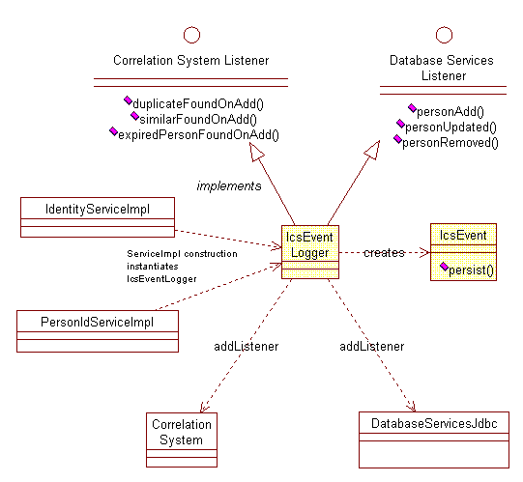
Figure 2.1. Class diagram for Ics Event Logging.

2.2 ICS_EVENT_LOG Table

Will store information relevant to the current event.

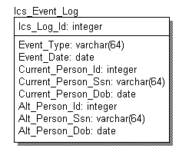

Description of fields
Ics_Log_Id: Unique ID of the LOG record
Event_Type: IcsEventLogger.DUPFOUND_ONADD (duplicate found)
IcsEventLogger.SIMFOUND_ONADD (similar match found)
IcsEventLogger.EXPFOUND_ONADD (expired person found)
IcsEventLogger.ADD
IcsEventLogger.UPDATE
IcsEventLogger.REMOVE
Event_Date: Date record was logged (inserted)
Current_Person: Attributes of the Person object being worked on
Alt_Person: Attributes of an optional Alternate Person being compared to.
Used for DUPFOUND and SIMFOUND.

