
ICS Updates
High Level Technical Design

Revision History
Date | Version | Description | Author
Dec. 13, 2002 | 0.1 | Initial draft | Marco Abundo
Dec. 18, 2002 | 0.2 | Incorporated UI mockups and task descriptions. | Marco Abundo, Michael Sandrof
Dec. 20, 2002 | 0.3 | Added more detail to tasks based on input from AAC.  Assigned complexity (low, medium, high) and new/updated modifiers to task estimates.  Removed Correlation Rules task since it was removed from the SRS. | Marco Abundo
Dec. 26, 2002 | 0.4 | Added command-line interface to Merge Person task | Marco Abundo

Table of Contents
1. Introduction 1
1.1 Purpose 1
1.2 Scope 1
1.3 Definitions, Acronyms and Abbreviations 1
1.4 References 1
1.5 Overview 1
2. ICS System Architecture 2
3. High Level Technical Design 2
3.1 Correlation Maintenance 2
3.1.1 Manual Merging of Persons 2
3.1.2 Manual Splitting of Persons 4
3.1.3 Logging 6
3.1.4 Scope 7
3.1.5 Task Estimates 7
3.2 ICS Tracing and Auditing 7
3.2.1 UML 7
3.2.2 User Interface Mockups 8
3.2.3 Changes 8
3.2.4 Scope 8
3.2.5 Task Estimates 8
3.3 System Log Monitoring 9
3.3.1 UML 9
3.3.2 User Interface Mockups 9
3.3.3 Changes 9
3.3.4 Scope 9
3.3.5 Task Estimates 9
3.4 ICS Person Field Validation 9
3.4.1 UML 9
3.4.2 User Interface Mockups 9
3.4.3 Changes 10
3.4.4 Scope 10
3.4.5 Task Estimates 10
3.5 ICS Performance 10
3.5.1 Correlation Performance 10
3.5.2 Search Performance 12
3.5.3 Changes 14
3.5.4 Scope 14
3.5.5 Task Estimates 14

Introduction

Purpose
The purpose of this document is to describe the high-level technical design for changes to the ICS system. The ICS is made up of a number of parts including the Person ID Service and the Identity Service. The former handles requests to add or update new Persons in the database while the later handles requests to search the database. Most of the high level technical designs described herein pertain to the Person ID Service with a smaller number for the Identity Service.

Scope
The scope of this document pertains to:
- back-end functionality required by the ICS
- CDE user interface components

Definitions, Acronyms and Abbreviations
- PID – The facility assigned patient identifier
- Person – A correlated, uniquely identified patient
- ICS – Identity Correlation Service
- Alias – One of the known identities for a Person. Also known as PERSON_INFO in the DB.

References
ICS Software Requirements Specification from Michael Sandrof

Overview
This high level technical design will be broken down into the 5 major parts described in the ICS SRS document:
- Correlation Maintenance – the ability to manually correct correlation problems
- ICS Tracing and Auditing – visibility into the correlation process for debugging correlation issues
- Performance – ICS must meet defined performance needs
- System Log Monitoring – system alerts when specific CS log events occurs
- ICS Person Field Validation – Data validation checks for ICS Person data

ICS System Architecture
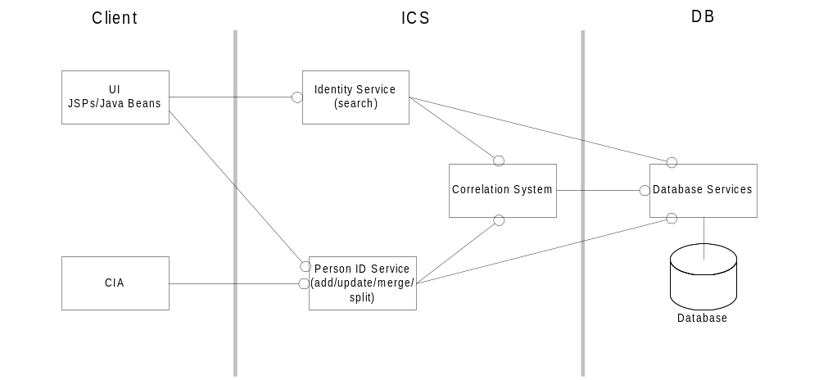

High Level Technical Design

Correlation Maintenance

Manual Merging of Persons

UML
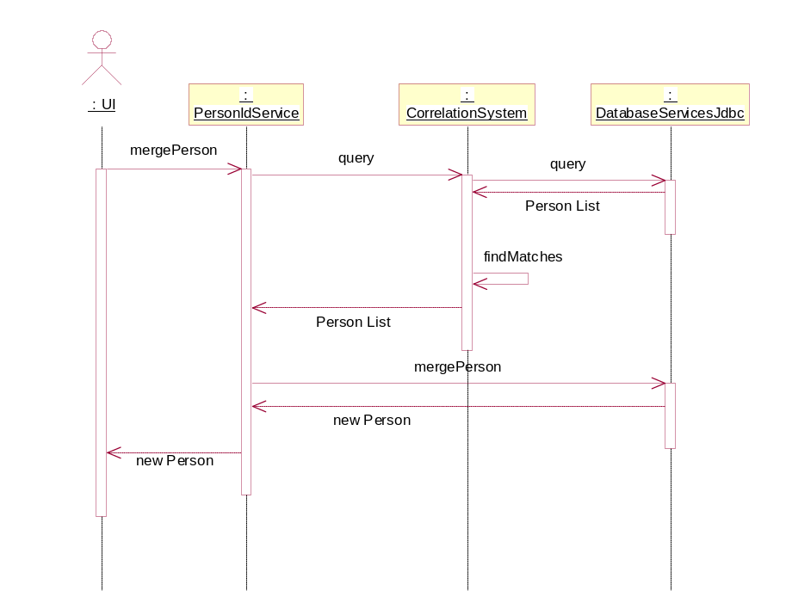

User Interface Mockups

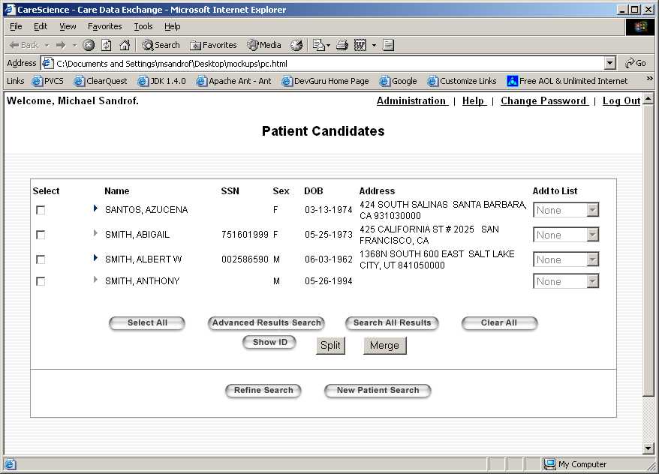
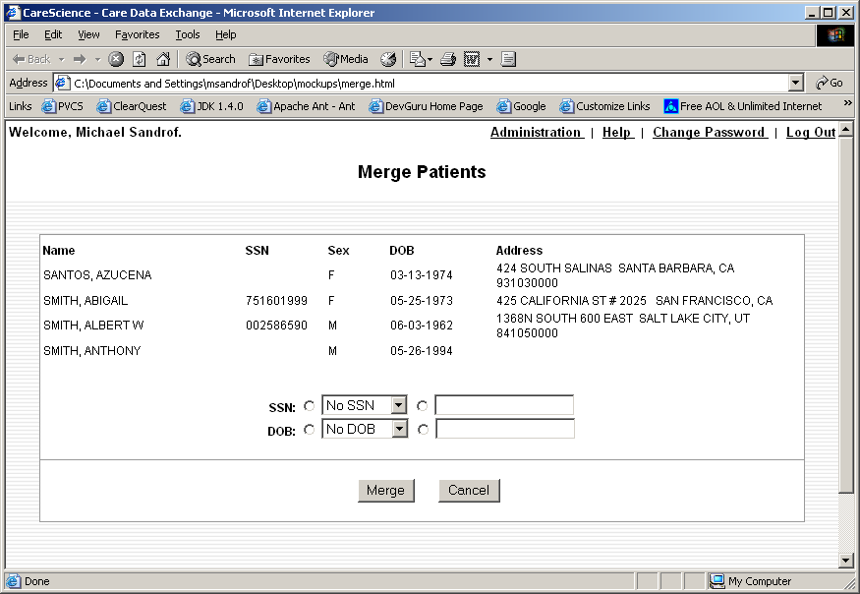

Changes

Java
New PersonIdService.mergePersons(), DatabaseServices.mergePersons()

JSPs
New MergePersons.jsp, changes to PatientResults.jsp.

JavaScript
New merge validation methods.

Command-line interface
New script for merge person functionality.
New script for merge person using a batch file.

Logical Database Model

Manual Splitting of Persons

UML

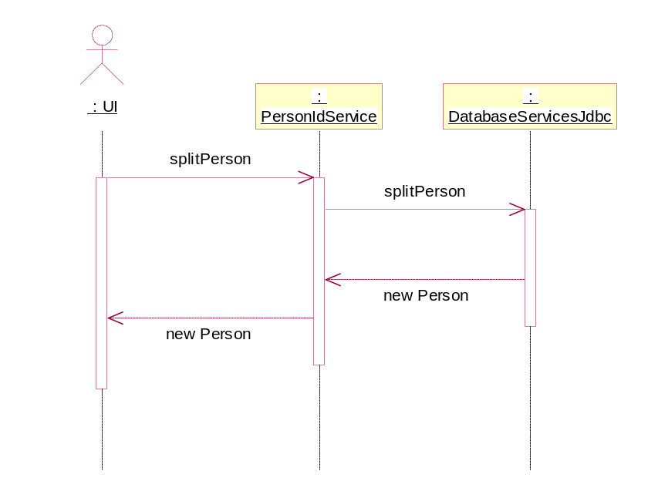

User Interface Mockups
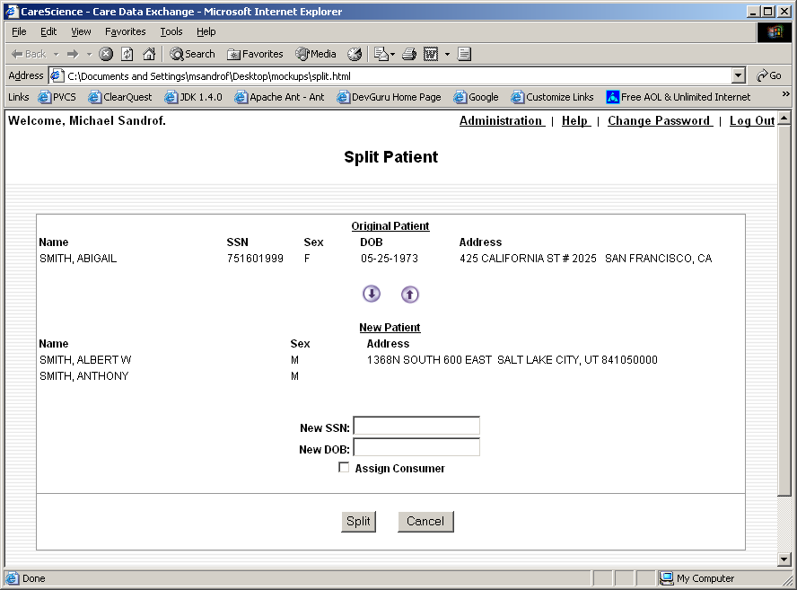

Changes

Java
New methods PersonIdService.splitPerson(), DatabaseServices.splitPerson()

JSPs
New SplitPerson.jsp, changes to PatientResults.jsp

JavaScript
New merge validation methods

Logical Database Model

Logging
There are several options as to which logging system to use for this task:
- Syslog – used extensively throughout CDE
- Database logging, which involves creating a class for this task (similar to ConsentLog and ViewLog)
- Jim Mangione’s logging package

UML

User Interface Mockups

Changes

Java
Add calls to logging methods within merge, split and edit.
Depending on which logging option chosen, we may be required to create logging classes for this task.

JSPs

JavaScript

Logical Database Model

Scope

Task Estimates
Create MergePerson.jsp – 8 hours (new JSP, low complexity)
Create SplitPerson.jsp – 16 hours (new JSP, medium complexity)
Modify PatientResults.jsp – 8 hours (updated JSP, low complexity)
JavaScript validation methods – 12 hours (new methods, low complexity)
Add merge and split methods to PersonIDService and DatabaseServices classes – 32 hours (updated class, medium complexity)
Add calls to logging methods within PersonIDService merge, split and update methods – 8 hours (updated class, low complexity)
Create command-line interface scripts – 8 hours (new scripts, low complexity)
New UI elements (for designer) – 8 hours (new elements, low complexity)

ICS Tracing and Auditing

UML
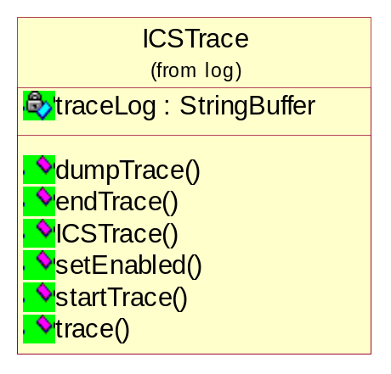
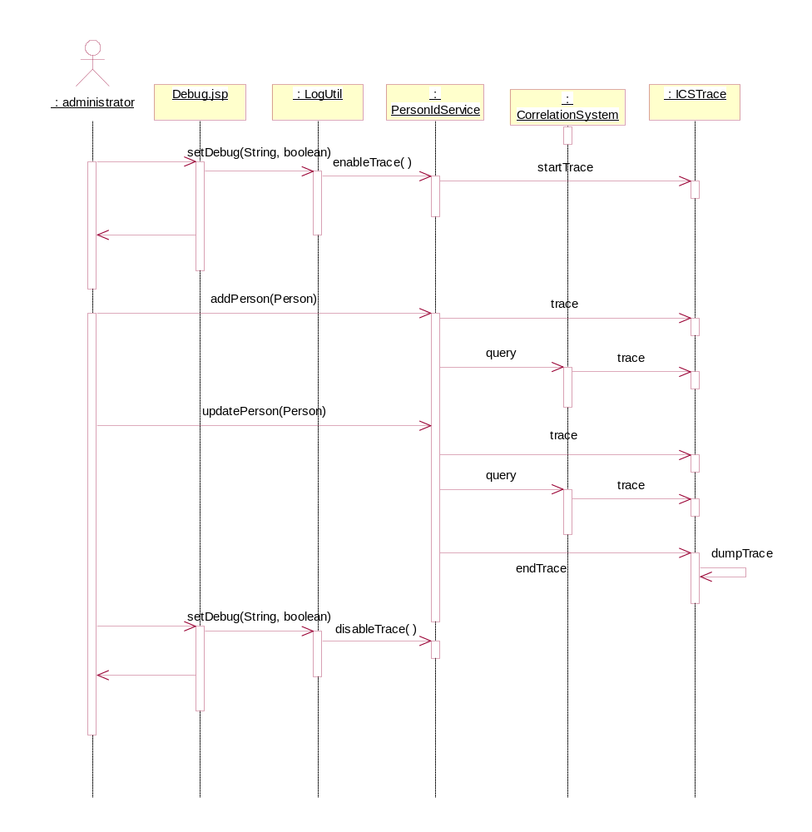

User Interface Mockups

Changes

Java
New ICSTrace class
Add tracing logic to PersonIdService, CorrelationSystem.

JSPs
Modify Debug.jsp to enable/disable this feature.

JavaScript

Logical Database Model
For now, no changes required. Trace logs will be logged to a file.

Scope

Task Estimates
Create ICSTrace class – 12 hours (new class, medium complexity)
Add tracing logic to PersonIDService, CorrelationSystem classes – 6 hours (updated classes, medium complexity)
Update Debug.jsp to enable/disable tracing – 2 hours (updated JSP, low complexity)

System Log Monitoring

UML

User Interface Mockups

Changes

Java

JSPs

JavaScript

Logical Database Model

Scope

Task Estimates
Ops has tools for log monitoring, discuss with Ops setup and determine initial set of stuff to watch for. (medium complexity)

ICS Person Field Validation
Determine where this logic should go: CIA, ICS, or DB. If ICS, this check should be added to Person and DB classes.

UML
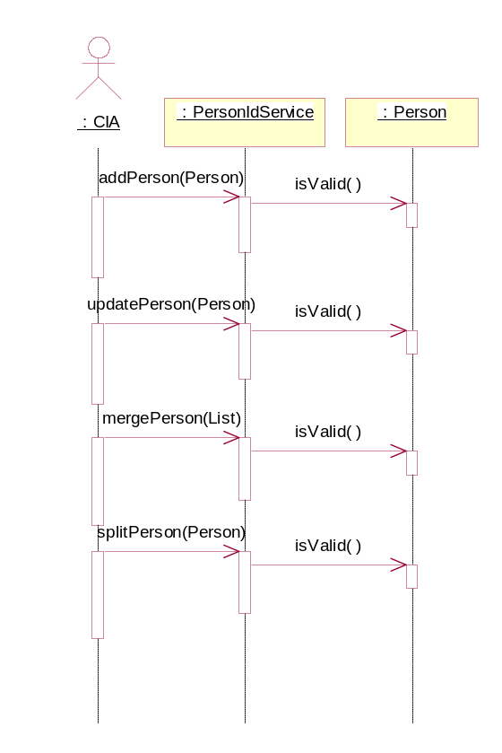

User Interface Mockups

Changes

Java
Add Person.isValid() method to verify internal consistency of any given Person object.

JSPs

JavaScript
Add validation methods to prevent bad SSNs, etc. in the UI.

Logical Database Model

Scope

Task Estimates
Add Person.isValid() method – 6 hours (updated class, medium complexity)
Add JavaScript validation methods – 6 hours (new methods, low complexity)

ICS Performance

Correlation Performance
Most recent production performance analysis has ICS updatePerson() at 176ms/call and addPerson() at 342ms/call. This means we’re currently at 5.66 updatePerson() per second and 2.9 addPerson() per second. We are presently comfortably between the average and peak for updatePerson() but just barely above average for addPerson().

PersonIDService.addPerson() breakdown of time spent
- CorrelationSystem.query: 39%
The vast majority of this call is spent doing two queries, one for SSN matches and one for Name Search Key matches. Combining these into a single query and using PreparedStatements are areas for improvement. DBA analysis of the queries should be performed.
- PersonIdServiceImpl.updatePerson: 3%
- PersonIdServiceImpl.searchByPID: 29%
The bulk of this call is purely database. Use of PreparedStatements and query analysis are areas for improvement.
- DatabaseServicesJdbc.addPerson: 8%
- Unknown: 21%
Determine where the rest of the time has gone.

PersonIDService.updatePerson() breakdown of time spent
- PersonIdServiceImpl.updatePerson: 10%
- PersonIdServiceImpl.addPerson: 21%
Recursive call to addPerson(). Speeding up addPerson() will also improve updatePerson().
- PersonIdServiceImpl.searchByPID: 55%
The bulk of this call is purely database. Use of PreparedStatements and query analysis are areas for improvement.
- Unknown: 14%
Determine where the rest of the time has gone.

Call to addPerson() where new ICS Person is created:
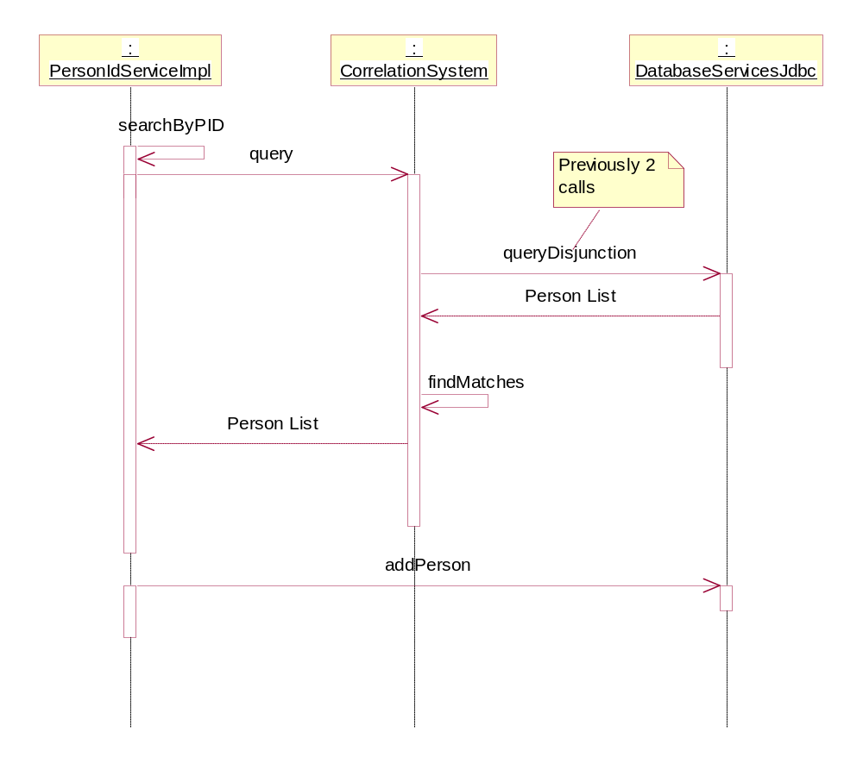

Call to addPerson() where existing Person is found and must be updated:
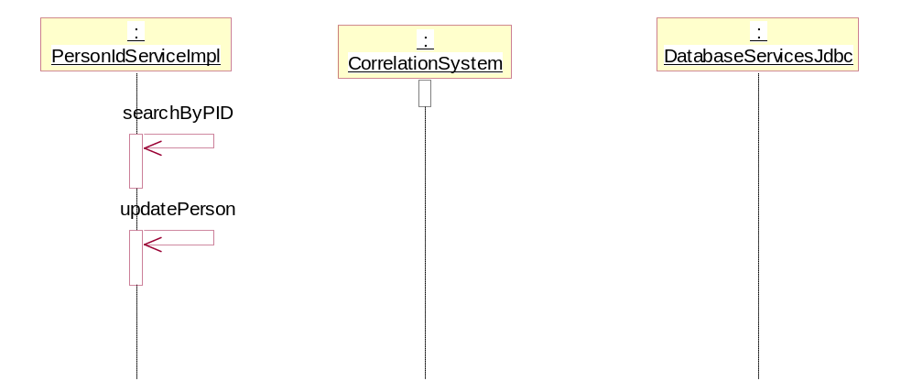

Call to updatePerson() where no update is detected and New Person must be created:
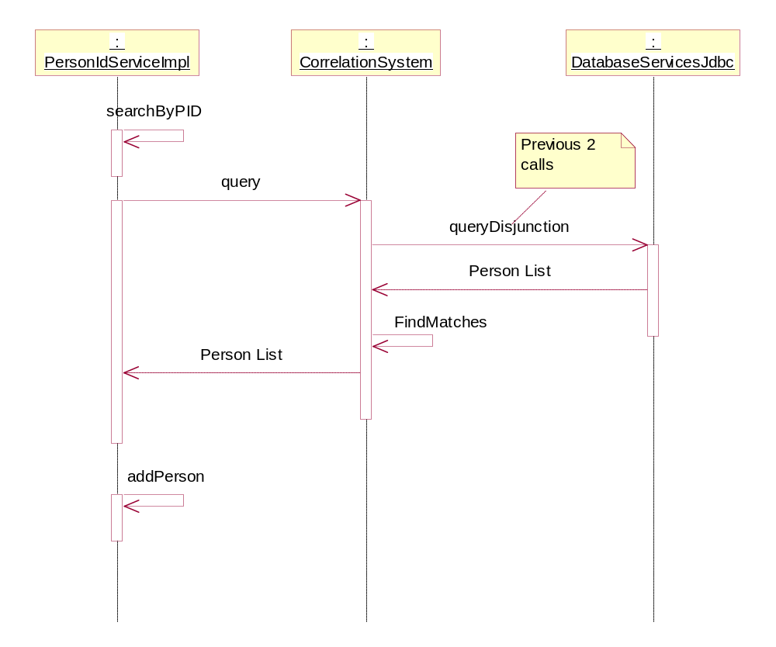

Call to updatePerson() to update specific Person:
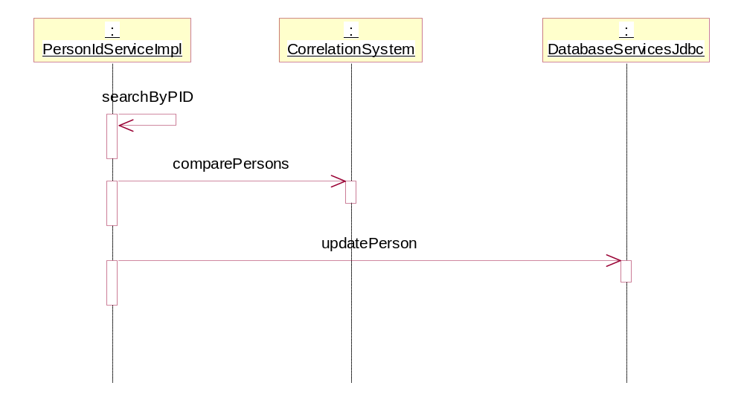

Search Performance
Searching performance issues are caused when a user enters too broad a set of search criteria as far as the system is concerned. The CorrelationSystem.lookup() method is used for this purpose and it creates a list of candidate persons based on the SSN entered (if any) and also using the name search key generate from the name entered. This latter search has the potential of returned a huge number of Persons and this will only get worse as the database grows. Current lookup() behavior is to combine the results of the name and ssn searches into a single list and then post process them to remove any names that aren’t correlatively significant. The upshot is that even if you specify and exact name and ssn to search, the system may still end up processing thousands of candidate Persons, using up a significant amount of memory, only to throw most of them out during post processing.
The correction for this involved modifying the database access methods that lookup() uses to retrieve persons. Rather than making two calls to DatabaseServicesJdbc.query() for the ssn and name keys search returning huge lists, a new method will be added that uses an Iterator to return one person at a time to lookup() for processing. Lookup will immediately check each Person for correlative quality and either keep it or discard it. Additionally, lookup() will stop processing when it reaches the predefined limit that the UI specifies. Currently, this limit is 25. So once 25 qualified Persons are found, the query end.
This solution is not a panacea. If out of the thousands of candidate persons that last 25 are qualified, we still would have had to examine all previous Persons before we get to this point. We won’t, however, need to store them all in memory during this process. On average, we should see better performance for most searches.
A more comprehensive solution would require significant architectural and tool changes to implement. At issue is that we only query the database for exact SSN match and name search keys. The later is a key range generated by the Intelligent Search Technologies (IST) toolkit. We would need to augment or replace this functionality to get better-refined searches, or add search keys for other data that might be entered by the user. Address is a likely candidate for this. Any such changes would dramatically impact the functioning of the correlation system as a whole, including the Person Id Services, and shouldn’t be attempted without more clear requirements for correlation.

IdentitySevice.findCandidates():
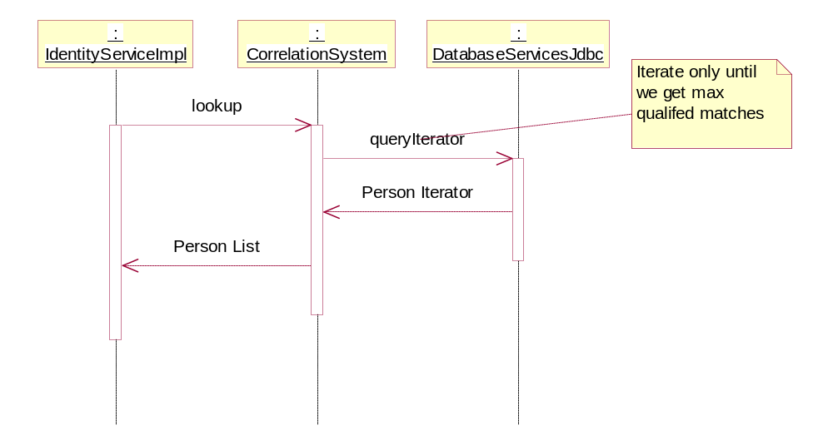

Changes

Java
Modify DatabaseServices class to support disjunction queries, PreparedStatements and Person iterator.
Modify ICS classes to use new DatabaseServices features.
Remove serialization from ICS and DatabaseService classes.

JSPs
TBD w/Andrea, Mike – UI changes (stepping thru results JSP)

JavaScript

Logical Database Model

Scope

Task Estimates

Create benchmarks – 16 hours (new benchmarks, high complexity)

DatabaseServices
Add methods to support disjunction queries and support Person iterator - 32 hours (updated class, high complexity)
Make sure everything uses PreparedStatements – 16 hours (updated class, low complexity)

CorrelationSystem
Modify to use new DatabaseServices features – 4 hours (updated class, low complexity)

PersonIdService
Modify to use new DatabaseServices features – 4 hours (updated class, low complexity)

IdentityService
Modify to use new DatabaseServices features – 4 hours (updated class, low complexity)

Investigate parallelizing ICS requests for better throughput.
Removing serialization – 1 hour (updated class, low complexity)
Setting up parallelizing test – 7 hours (updated class, medium complexity)

