Special thanks to Dr. McGaugh who created the basis for this handout!

By the end of the unit you should be able to:
- Define stretching as a mode of exercise, including the targeted tissue response to the applied load, and identify indications and contra-indications for inclusion into a patient centered plan of care.
- Prescribe a patient specific exercise intervention, including mode, intensity, duration, and frequency to reduce pain and improve range of motion and mobility of the spine and/or lower extremity.
- Adjust the intensity and volume of intervention to achieve the target physiological adaptation based on patient response.

Lab Activity 1: Review of Common Lower Extremity Stretching Exercises
Be sure to watch and practice the videos to demonstrate manual stretching in addition to the self-stretching shown below.
Stretching and Mobility exercises for the LE
Impairment:
Loss of hip extension (hip flexor shortness)

Prone Press Up  Stabilization: femur  Mobilization force/direction: pelvis in a posterior direction  Tissue(s) being stretched: hip flexors  Safety considerations: facet joint compression | 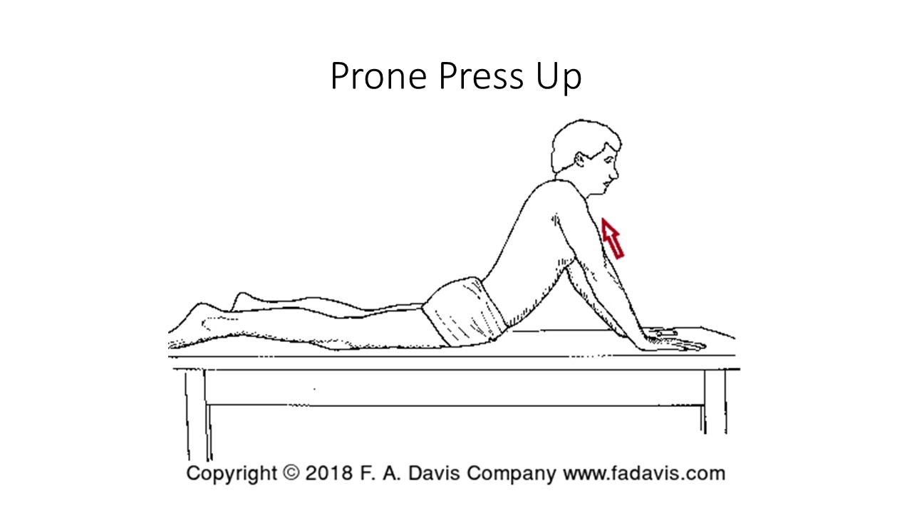
Thomas test position stretch  Stabilization: pelvis  Mobilization force/direction: femur into extension (knee position/femur position modifications)  Tissue(s) being stretched: hip flexors, quadricep, TFL  Safety considerations: | 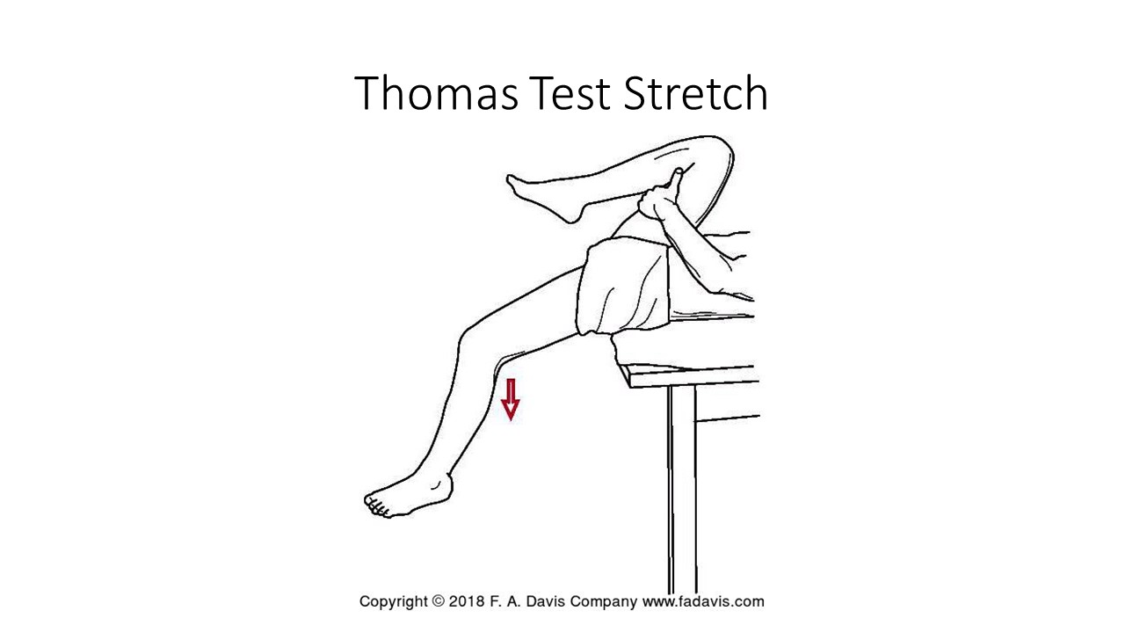
Side lying Hip Extension (manual stretch)  The videos show prone, which may be easier for you to control. Try both and decide which you like better. Both are fine!  Stabilization: pelvis  Mobilization force/direction: femur into extension (knee position/femur position modifications)  Tissue(s) being stretched: hip flexors, rectus femoris, TFL  Safety considerations: | 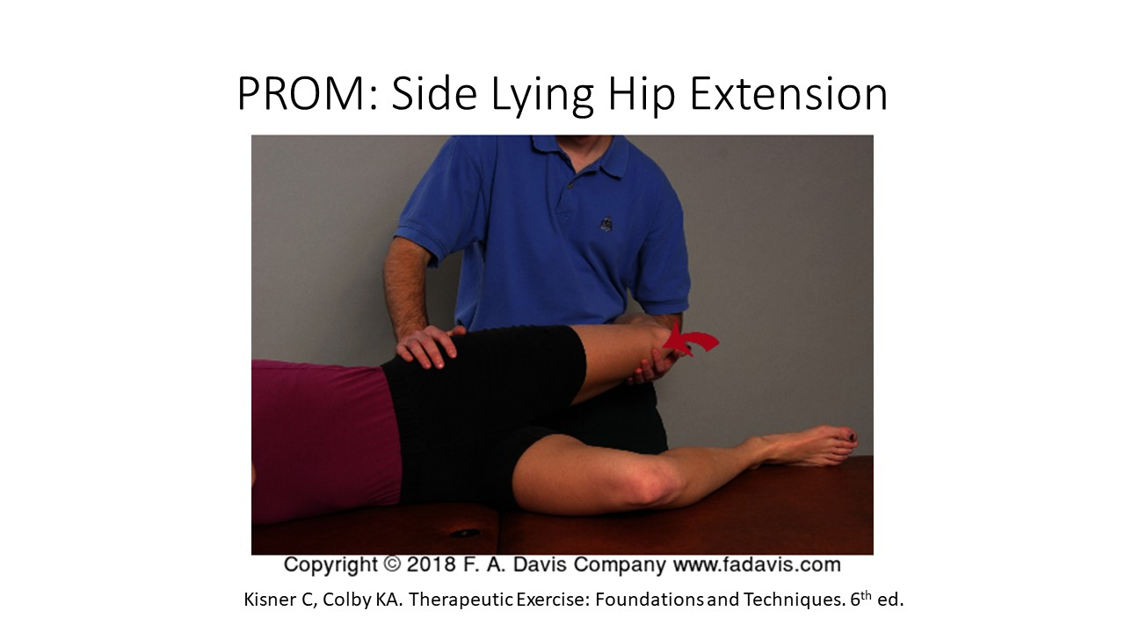
Supine Glut Bridge  Stabilization: pelvis through abdominal bracing  Mobilization force/direction: femur into extension (knee position/femur position modifications)  Tissue(s) being stretched: hip flexors, rectus femoris, TFL  Safety considerations: | 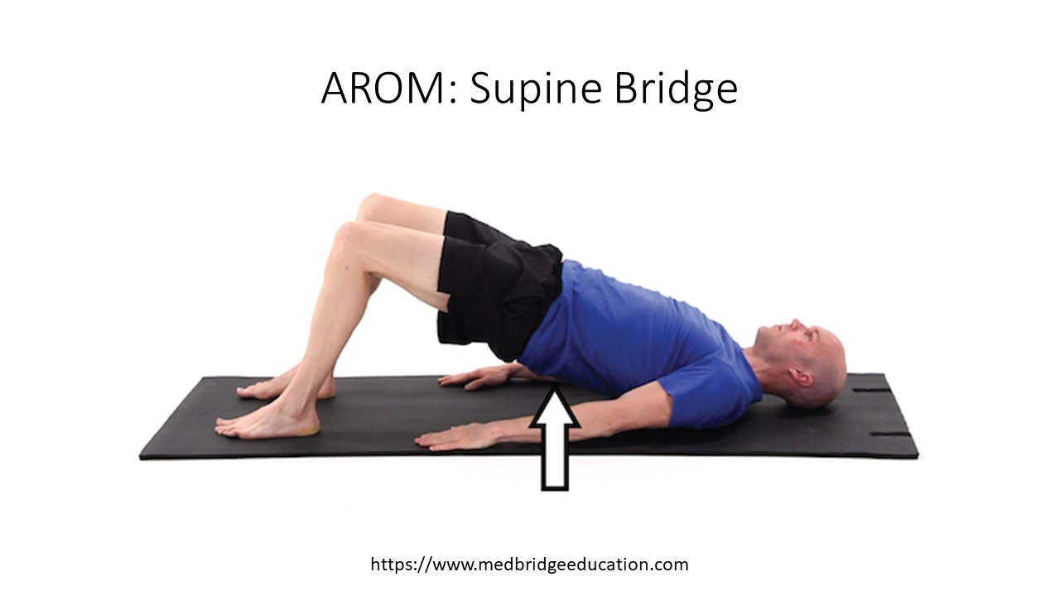
Modified Fencer Stretch  Stabilization: pelvis  Mobilization force/direction: femur into hip extension  Tissue(s) being stretched: hip flexors  Safety considerations: WB load to the joint | 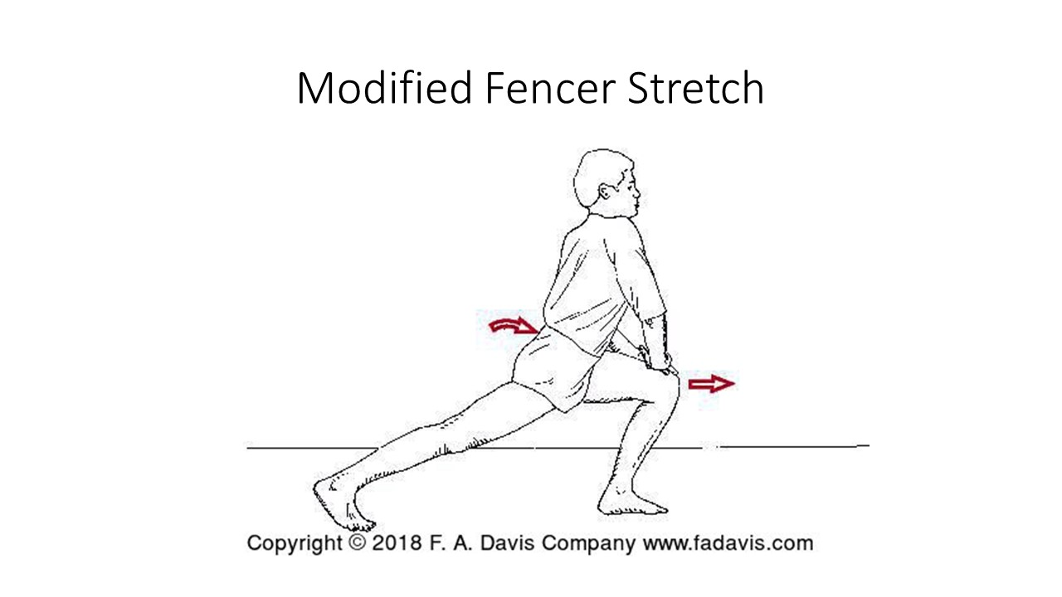
Loss of hip flexion (hip extensor tightness)
Single Knee to Chest  Stabilization: Pelvis  Mobilization force/direction: Movement of femur into flexion  Tissue(s) being stretched: hip extensors  Safety considerations: | 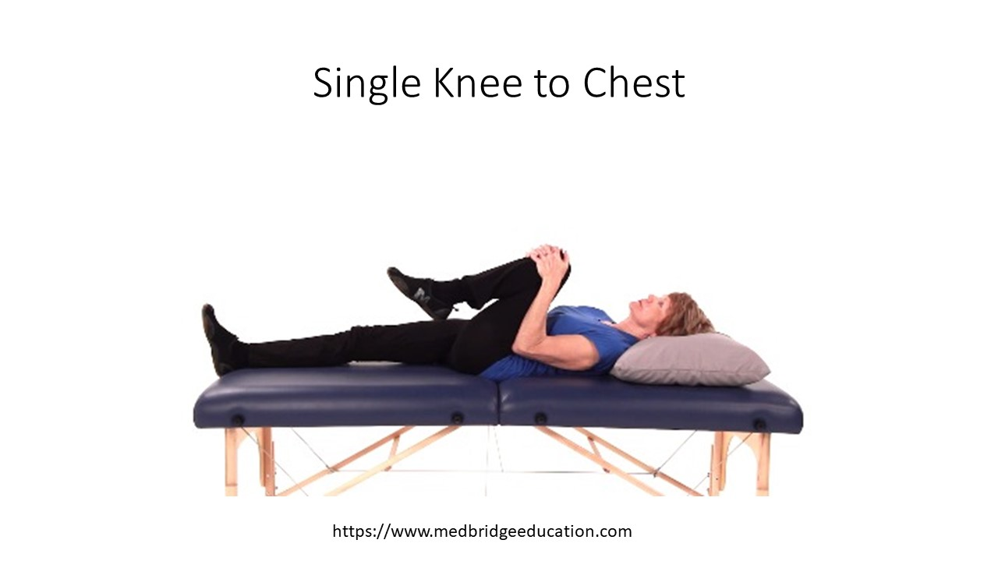
Quadruped rocking backward  Stabilization: Pelvis  Mobilization force/direction: Movement of femur into flexion  Tissue(s) being stretched: hip extensors  Safety considerations: | 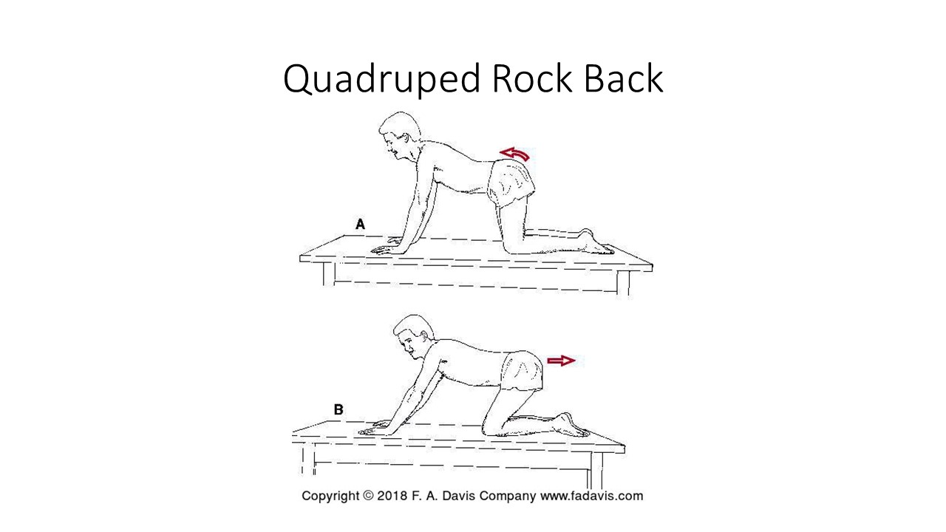
Hip adductor muscle shortness

Supine hip abduction against wall with hips flexed to 90 degrees  Stabilization: pelvis  Mobilization force/direction: femur into abduction  Tissue(s) being stretched: hip adductors (knee is extended)  Safety considerations: this is a gravity assisted stretch | 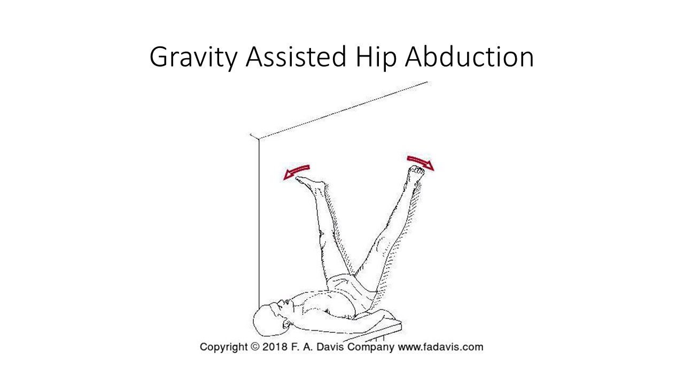
Figure 4 butterfly stretch (hip abduction/ER)  Stabilization: pelvis  Mobilization force/direction: femur into ER and abduction (knee flexed)  Tissue(s) being stretched: hip adductors, anterior joint capsule  Safety considerations: | 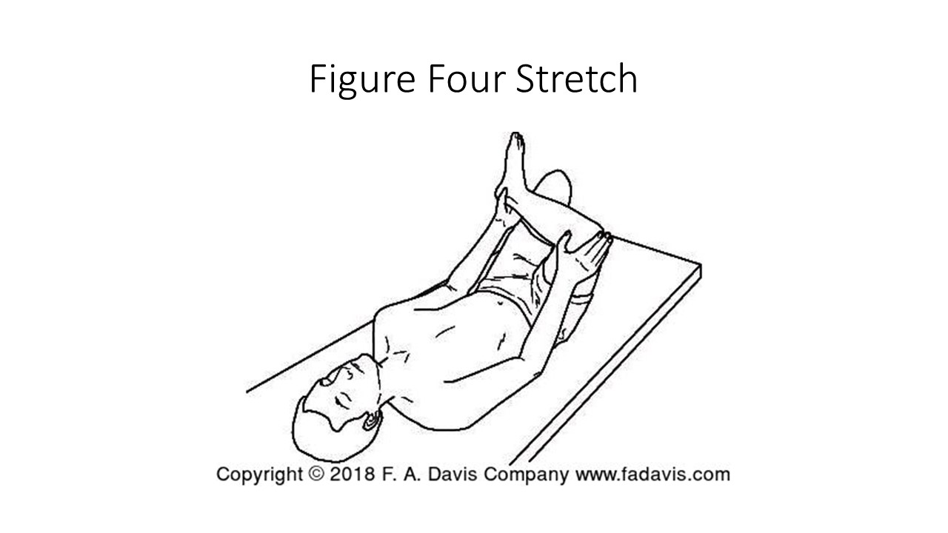
Rectus femoris shortness
Prone Knee Bend  Stabilization: pelvis and femur  Mobilization force/direction: knee into flexion  Tissue(s) being stretched:  Safety considerations: | 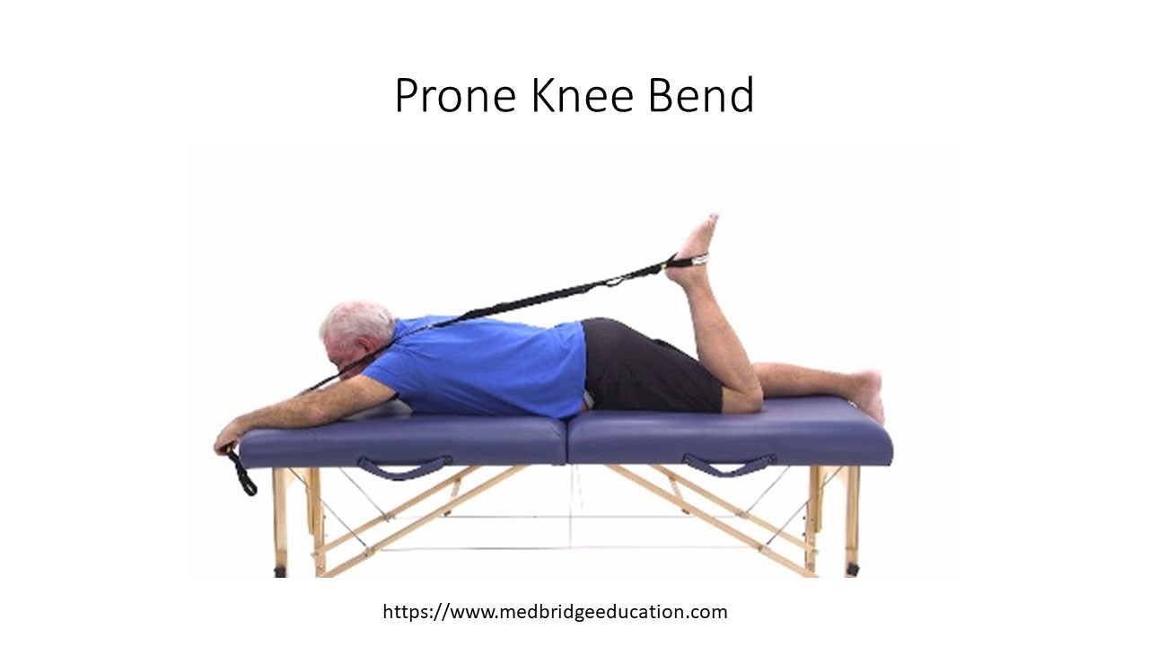
Side Lying Knee Flexion  Stabilization: pelvis  Mobilization force/direction: femur into extension with knee flexed  Tissue(s) being stretched:  Safety considerations: | 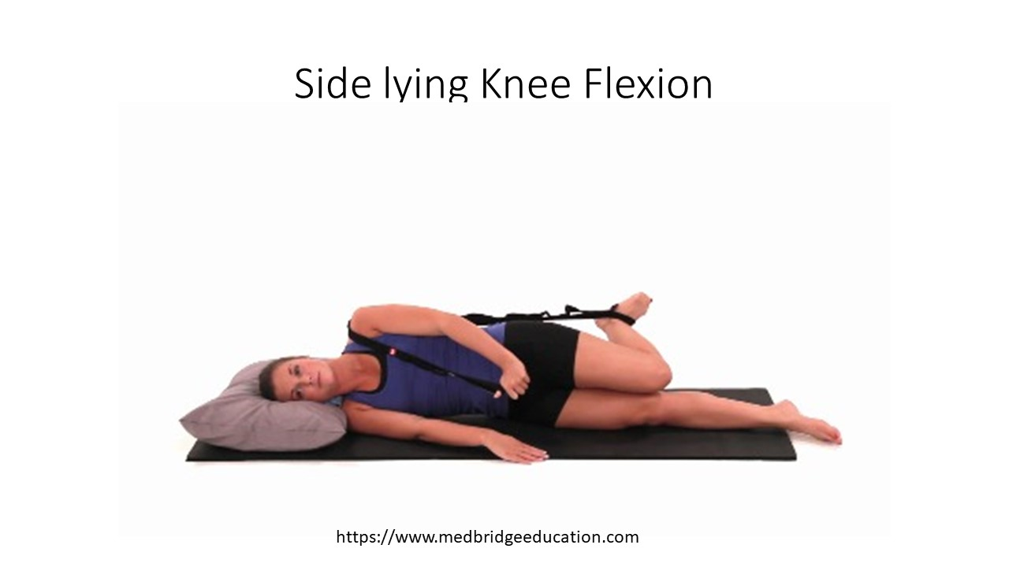
Standing Knee Flexion  Stabilization: Pelvis  Mobilization force/direction: femur into extension and knee into flexion  Tissue(s) being stretched:  Safety considerations: balance? | 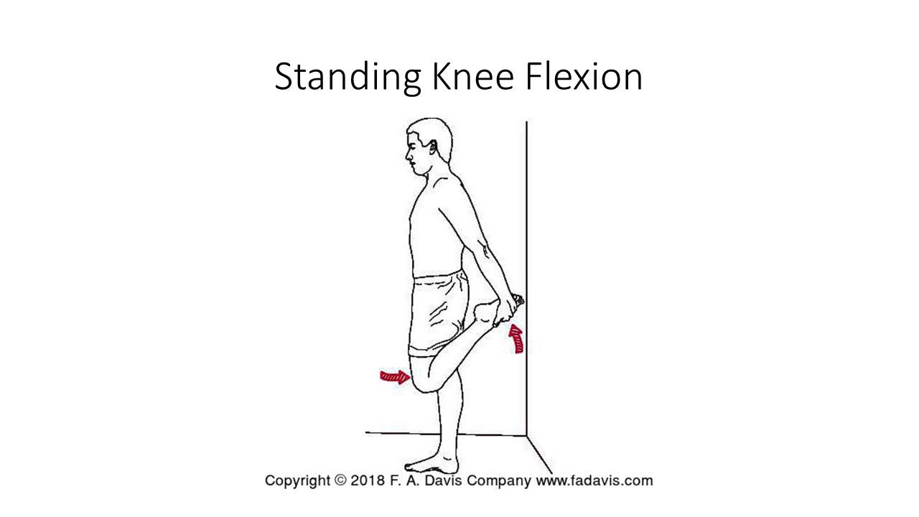
Hamstring Shortness
Straight leg raise  Stabilization: Pelvis with knee in extension  Mobilization force/direction: hip flexion  Tissue(s) being stretched:  Safety considerations: | 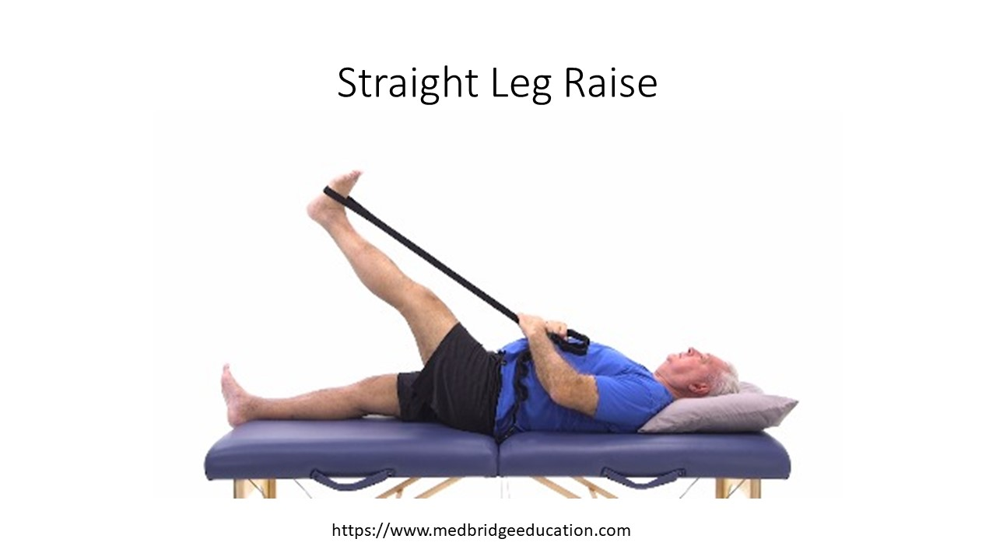
90/90 stretch  Stabilization: pelvis and femur in 90 degrees hip flexion  Mobilization force/direction: knee into extension  Tissue(s) being stretched:  Safety considerations: | 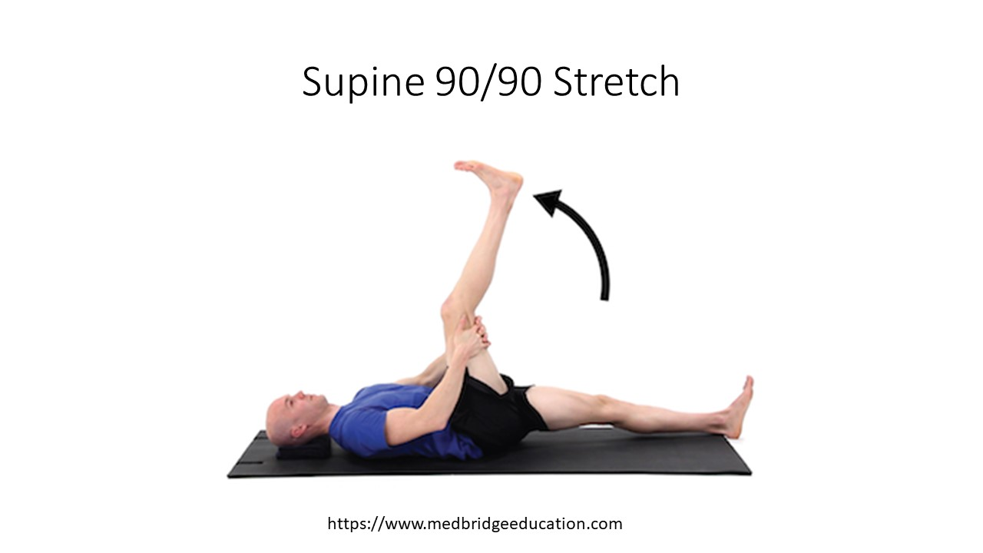
Long Sit Stretch  Stabilization: femur in flexion and knee in extension  Mobilization force/direction: trunk and pelvis into flexion  Tissue(s) being stretched:  Safety considerations: | 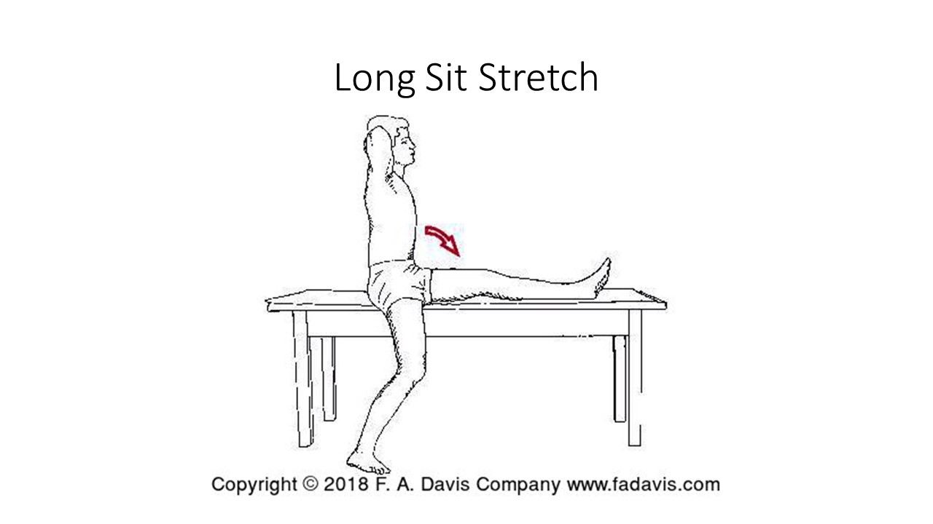
Seated Hamstring Stretch  Stabilization: femur in flexion and knee in extension  Mobilization force/direction: trunk and pelvis into flexion  Tissue(s) being stretched:  Safety considerations: | 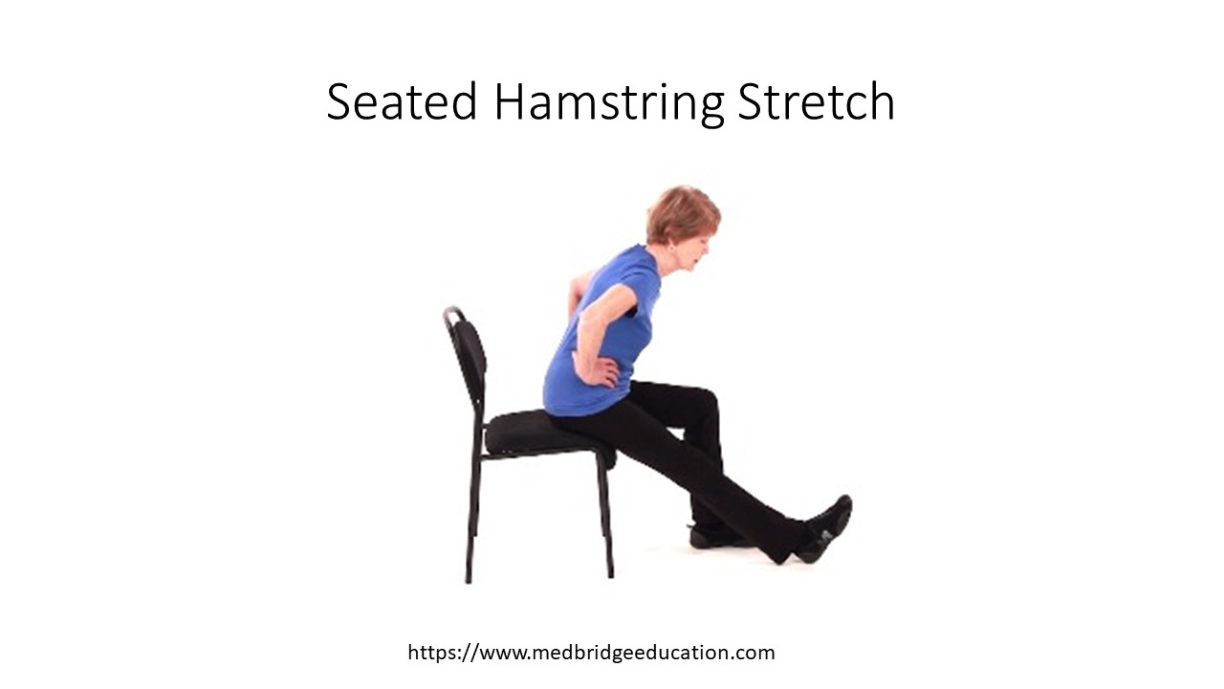
Forward Flexion (toe touch)  Stabilization: femur and knee in extension  Mobilization force/direction: trunk and pelvis motion into flexion  Tissue(s) being stretched:  Safety considerations: | 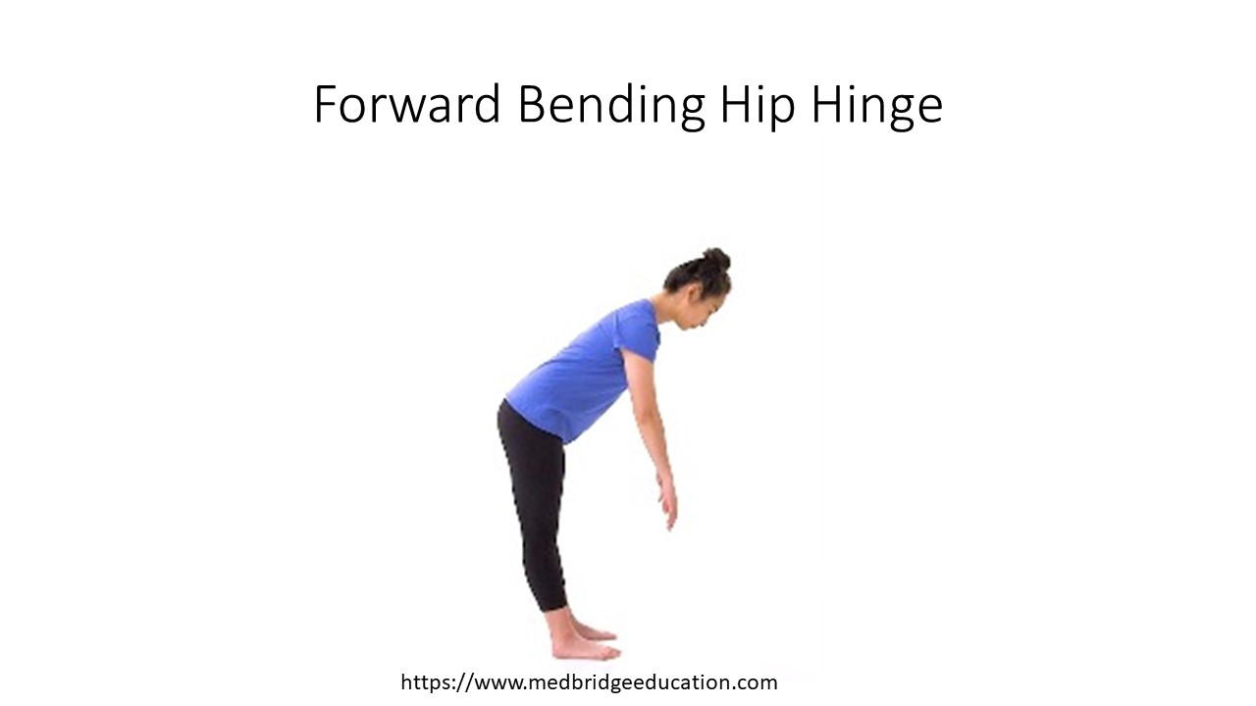
Downward Dog | 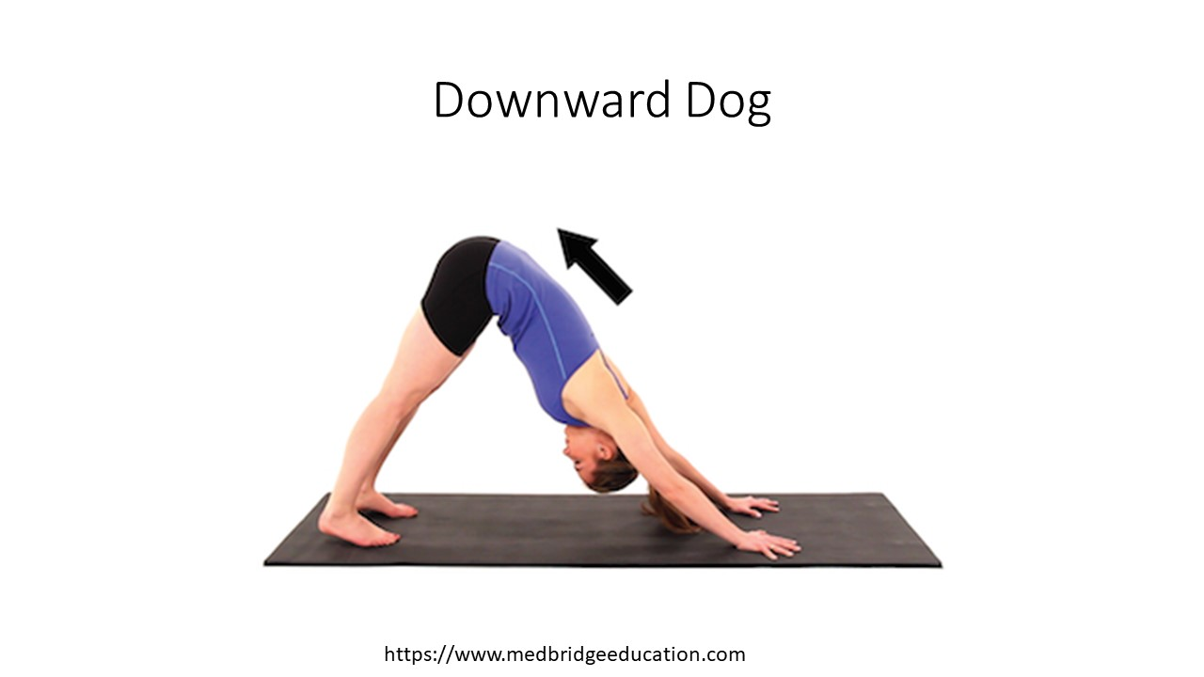
IT Band (actually TFL) shortness
Supine hip adduction stretch

Side Lying ITB Stretch  Stabilization: pelvis  Mobilization force/direction: femur into adduction  Tissue(s) being stretched:  Safety considerations: | 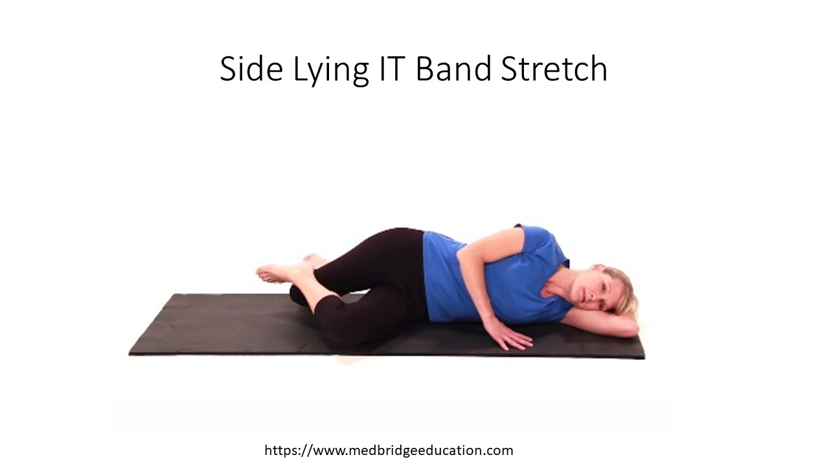
Supine IT Band Stretch  Stabilization: pelvis, hip can be in extension or flexed to 90 degrees. Hip extension targets TFL, flexion targets gluteus maximus.  Mobilization force/direction: femur into adduction  Tissue(s) being stretched: with hip flexed emphasizing glut max and IT band  Safety considerations: | 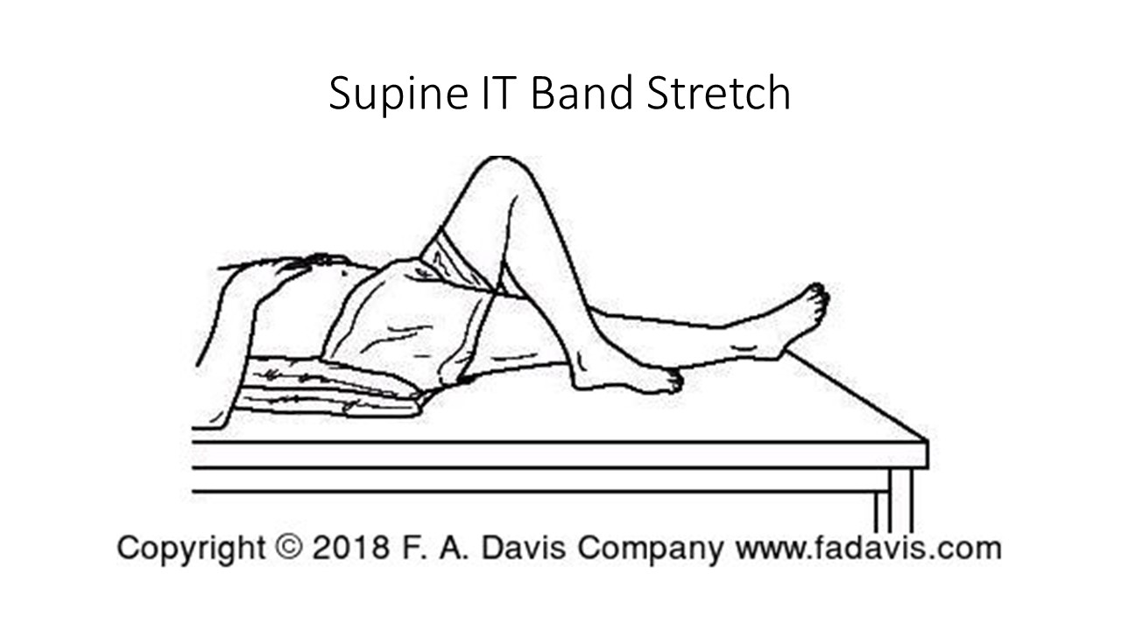
Standing Trunk Side Flexion Stretch  Stabilization: femur fixed into adduction  Mobilization force/direction: pelvis motion increases hip adduction/trunk into side flexion  Tissue(s) being stretched:  Safety considerations: | 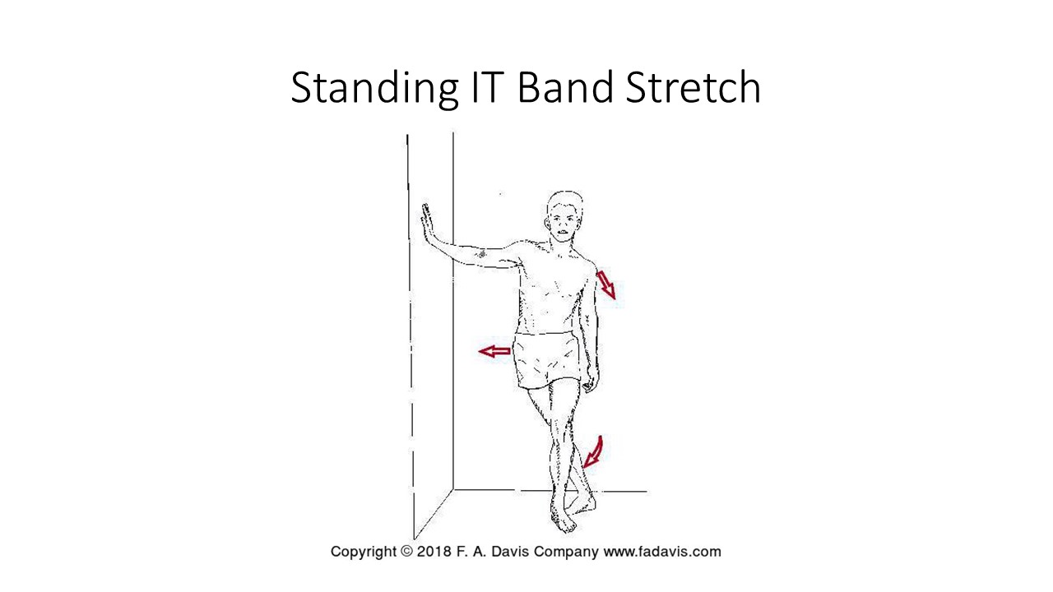
Shortness of distal hamstring/posterior capsule of knee
Supine Heel Prop  Stabilization: femur  Mobilization force/direction: knee into extension  Tissue(s) being stretched:  Safety considerations: | 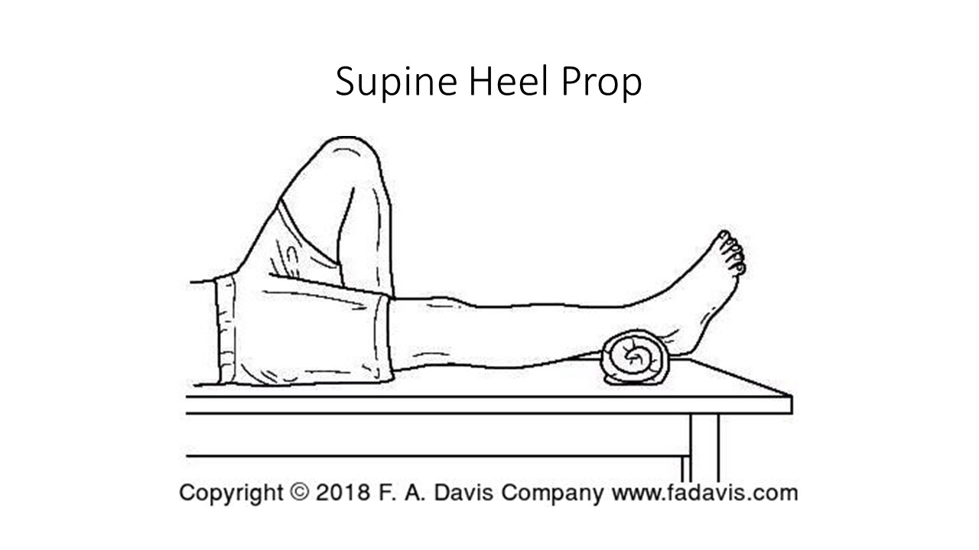
Prone Knee Hang  Stabilization: pelvis and femur  Mobilization force/direction: knee into extension  Tissue(s) being stretched: posterior capsule of knee  Safety considerations: | 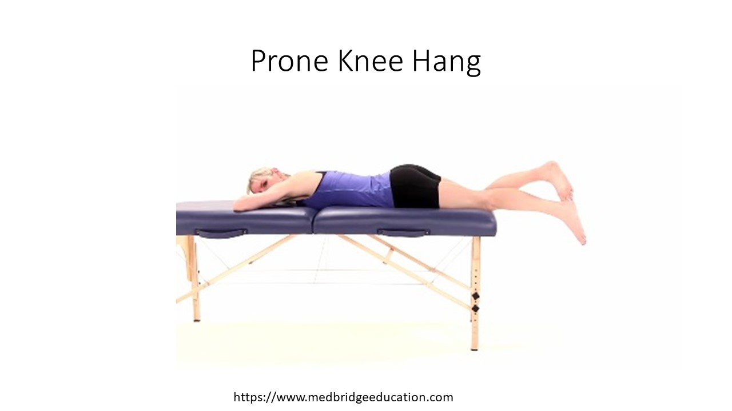
Shortness of anterior capsule of knee
Gravity assisted supine wall slide  Stabilization: primary motion is knee flexion, position stabilizes the trunk  Mobilization force/direction: knee into flexion  Tissue(s) being stretched:  Safety considerations: | 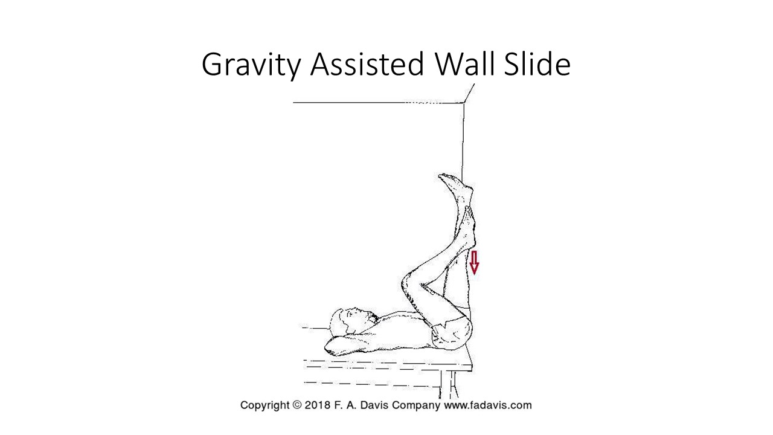
Sitting self stretch  Stabilization: pelvis and femur (pelvis due to sitting on a chair), stabilization is not as critical for anterior capsule of the knee  Mobilization force/direction: knee moving into flexion  Tissue(s) being stretched:  Safety considerations: | 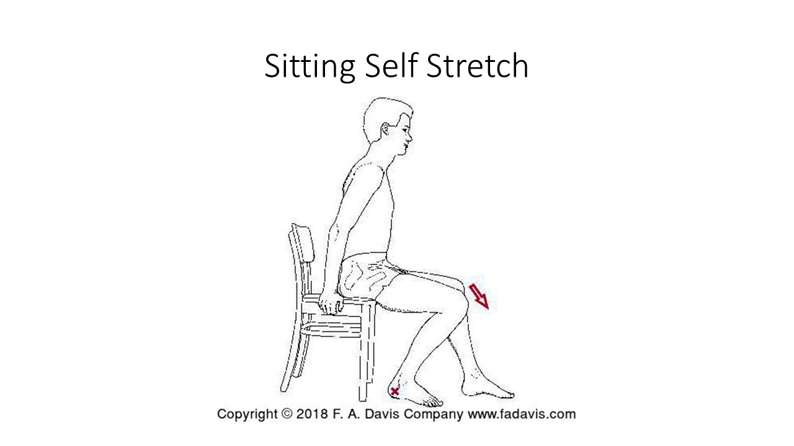
Standing Self Stretch | 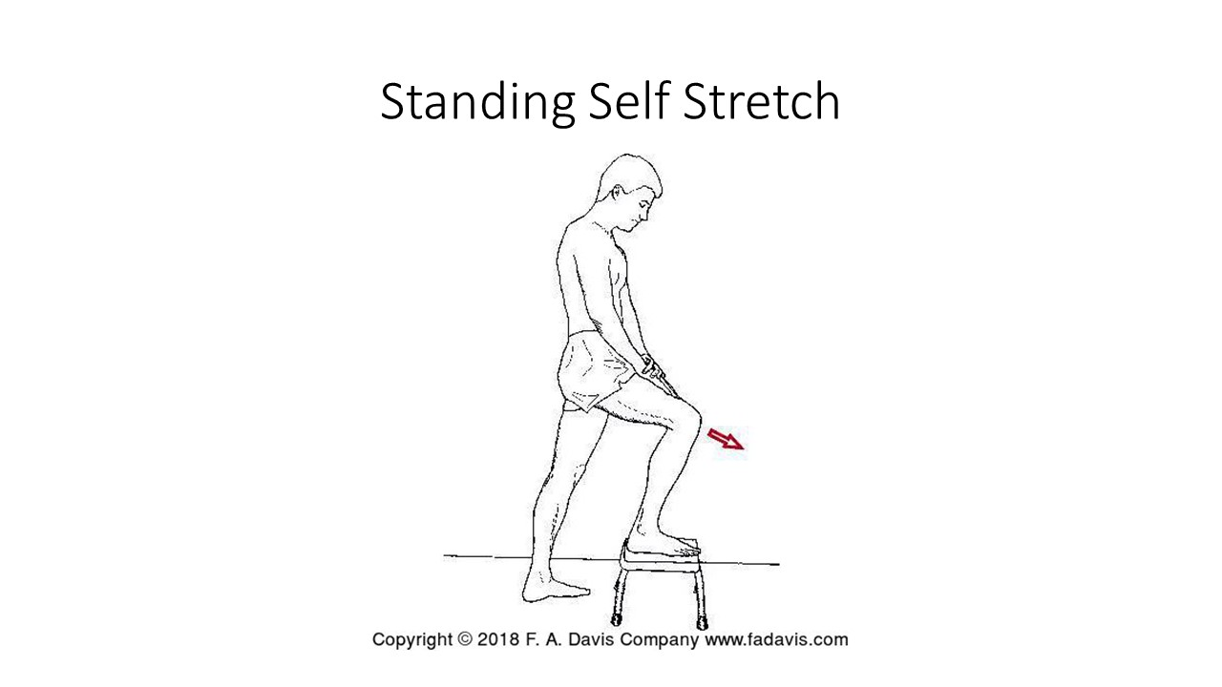
 | 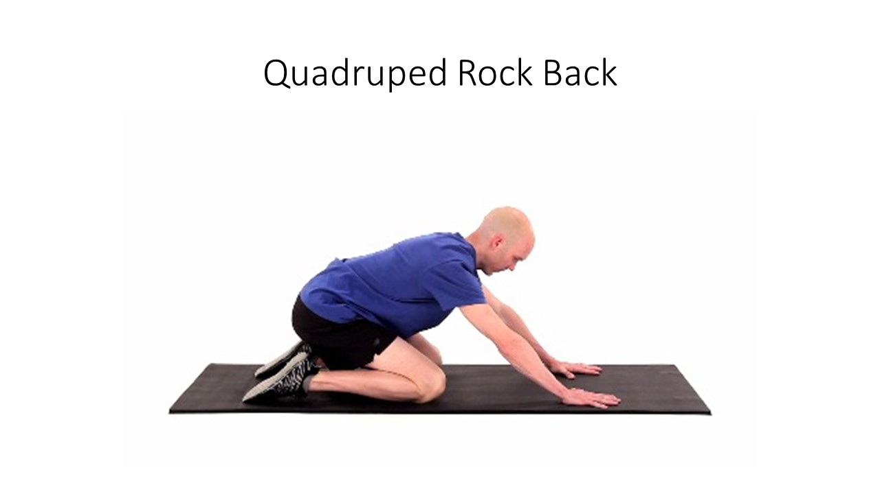
Loss of dorsiflexion due to soleus/capsule shortness
Unloaded self stretch  Stabilization: knee position, need to support midfoot  Mobilization force/direction: ankle into dorsiflexion  Tissue(s) being stretched: depends on the position of the knee, if knee extended gastroc emphasis, if knee flexed soleus/posterior capsule emphasis  Safety considerations: need to support midfoot through inversion | 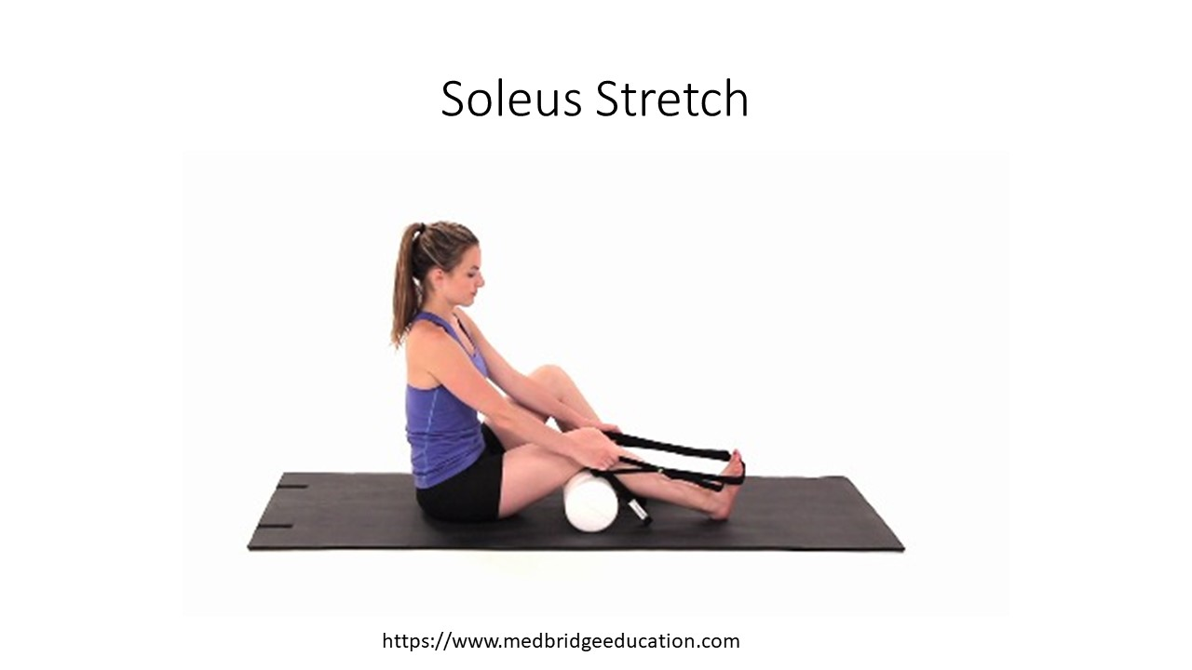
Loaded self stretch  Stabilization: ankle, knee is flexion  Mobilization force/direction: movement of tibia anteriorly  Tissue(s) being stretched:  Safety considerations: need to support midfoot to prevent unwanted stretching of posterior tib/medial arch supporters | 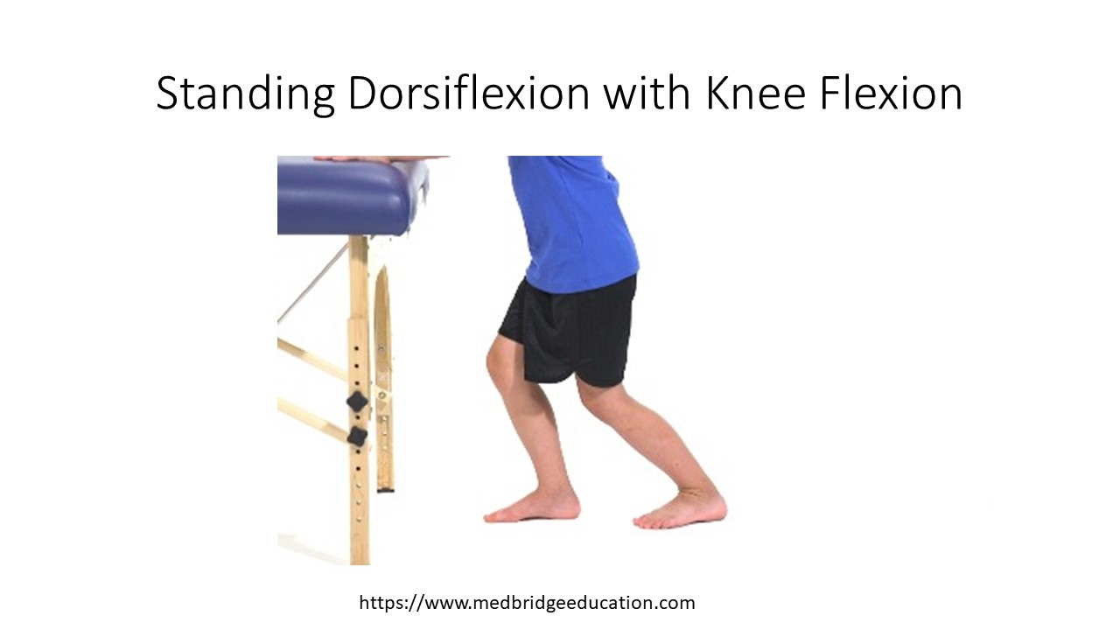
Loss of dorsiflexion due to gastroc tightness
Unloaded self stretch  Stabilization: knee position, need to support midfoot  Mobilization force/direction: ankle into dorsiflexion  Tissue(s) being stretched: depends on the position of the knee, if knee extended gastroc emphasis, if knee flexed soleus/posterior capsule emphasis  Safety considerations: need to support midfoot through inversion | 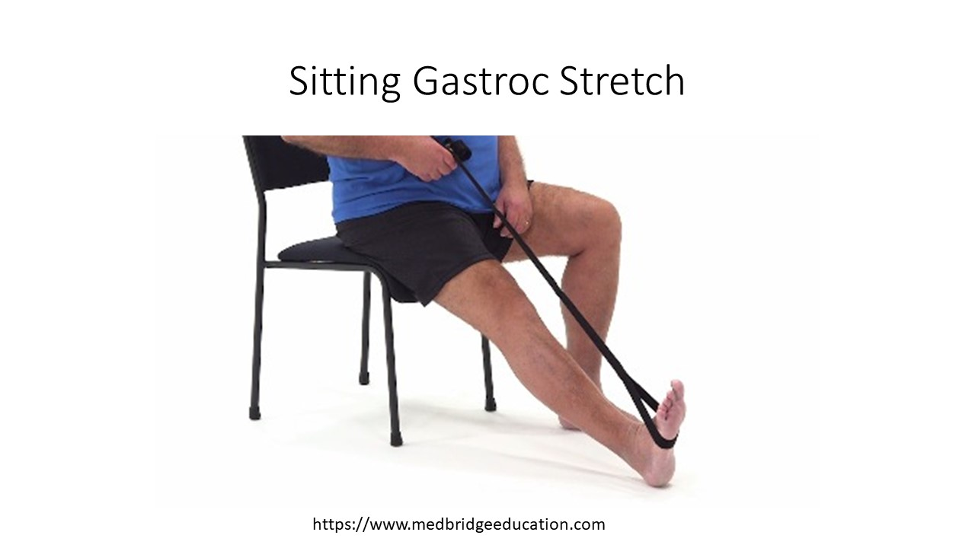
Loaded self stretch  Stabilization:  Mobilization force/direction:  Tissue(s) being stretched:  Safety considerations: | 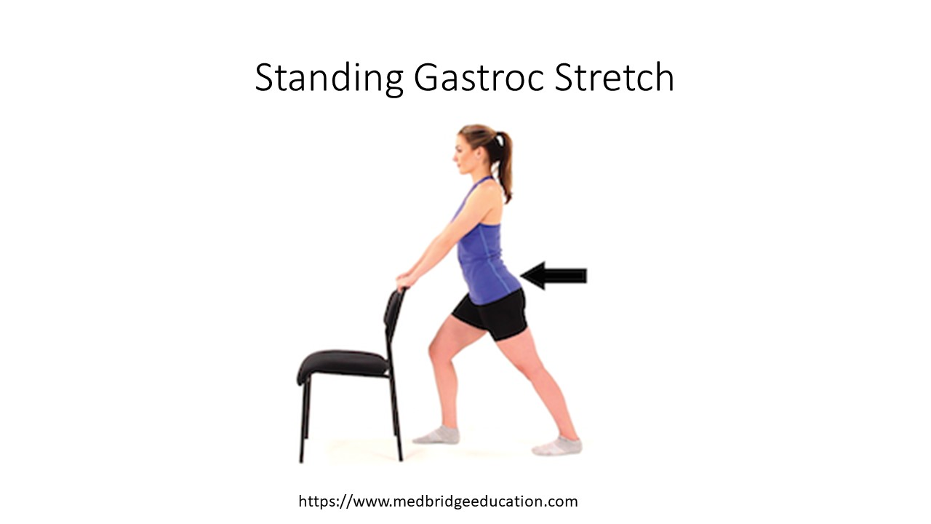
Standing Heel Drop | 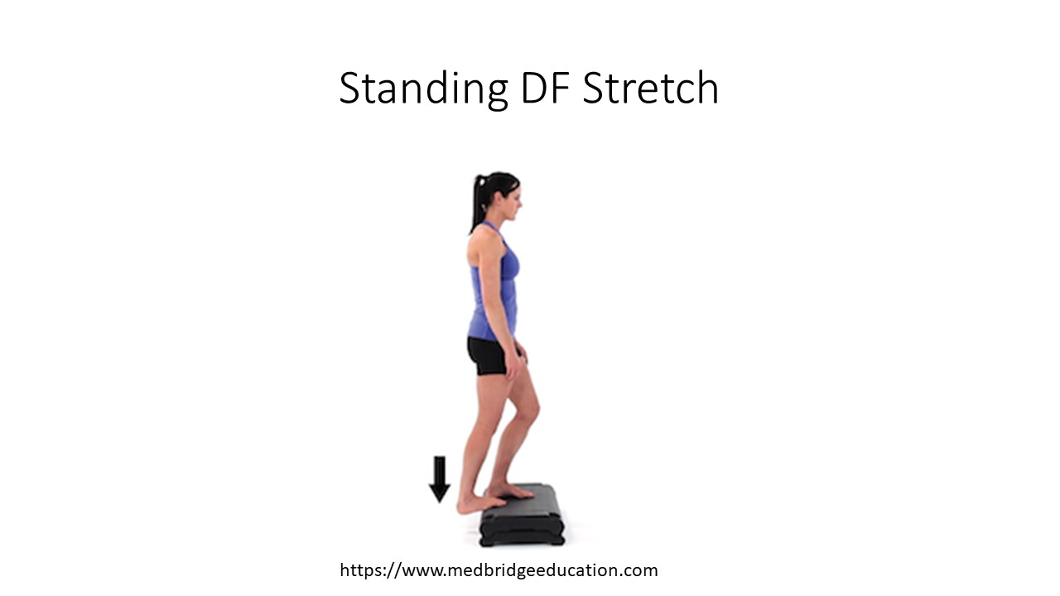
Questions:
- Identify the different soft tissue structures that could affect hip extension range of motion and describe how you would differentiate which tissue is restricting the motion?

- Mia is a 16 year old patient who is 5 days post ACL reconstruction with a hamstring tendon graft. Her knee AROM is 30 degrees to 90 degrees. What phase of healing is her donor graft site in? How will this affect the prescription of your prone knee hang exercise?

- Mathis is a 22 year old patient with limited dorsiflexion. His AROM is to 4 degrees with the knee flexion and he can get to neutral with the knee extended. You also notice that his navicular appears to be low, especially with WB. What precautions do you need to consider when prescribing a gastroc stretch for this patient?

Lab Activity 2: Consider the role of stretching exercises in postural impairment
Identify an exercise intervention that addresses the musculoskeletal impairments associated with the specific postural alignment deviations.
Impaired posture
Lordotic Posture:  Increase in lumbosacral angle > 30 degrees | Potential muscle impairments: | Exercise intervention to address:
 | Shortness of hip flexors (iliopsoas; TFL; rectus femoris); | Intensity: Moderate sensation of stretch  Duration and frequency: 4 * 30 to 60 seconds  Stabilization: Spine and pelvis (knee)
 | Shortness of spinal extensors | Intensity: Moderate sensation of stretch  Duration and frequency: 4* 30 to 60 seconds  Stabilization: Trunk
Questions:
- What is the physiological goal of the stretching exercise intervention on a cellular level?

- How can you assure that you are accomplishing the goal of increasing muscle length (what objective test/measure could you use)?

Slouched “Swayback” Posture: typically a combination of hip extension with thoracic flexion | Potential muscle impairments: | Exercise intervention to address:
 | Shortness of hip extensors: | Intensity: moderate sensation of stretch  Duration and frequency: 4 * 30 to 60 seconds  Stabilization: pelvis

Treatment of Scoliosis
Practice instructing and performing the following exercise interventions. Answer the questions provided.
Scoliosis: (structural versus functional)
Potential muscle impairments: | Exercise intervention to address:
Unilateral tightness of thoracic extensors (frontal plane deviation)  (example: figure 16.16; figure 16.18; figure 16.19; figure 16-20) | 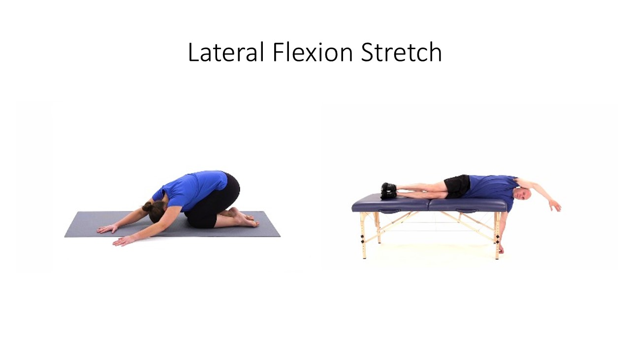  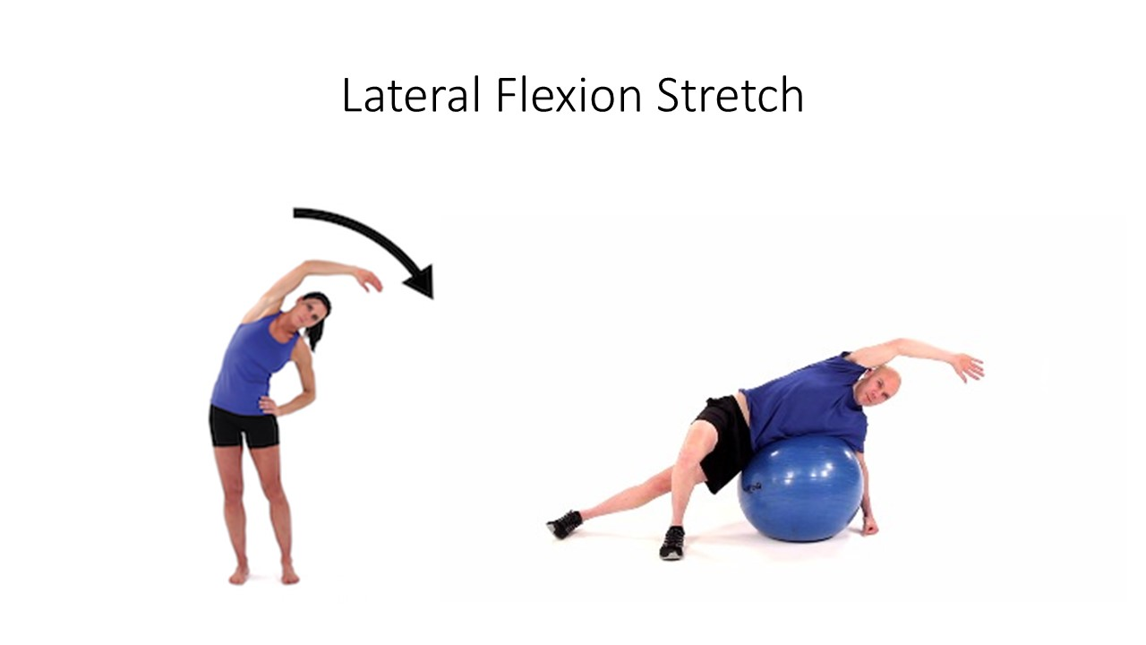
Activity:
The two exercises above address adaptive muscle tightness that is often associated with scoliosis. In addition to increasing and maintain available motion, a key component of scoliosis rehab is to address curve correction through muscle contraction.
- Identify muscle groups that could assist in stabilizing the spine and correcting spinal alignment if the patient and explain the mechanism by which the muscle would provide stability or correction to the spine.

