*Special thanks to Dr. Janna McGaugh, whose prior work and creativity in Exercise and Manual Techniques this work is based on.

By the end of the unit you should be able to:
- Define stretching as a mode of exercise, describe the target tissue adaptation to the applied load, and identify indications and contra-indications for inclusion into a patient centered plan of care.
- Prescribe a patient specific exercise intervention, including mode, intensity, duration, and frequency to reduce pain and increase range of motion and mobility of the cervical spine and upper extremity.
- Adjust the intensity and volume of intervention to achieve the target physiological adaptation based on patient response.

Lab Activity 1: ROM exercises
Be sure to watch the lab videos for review of manual stretching interventions!

ROM exercises to maintain mobility:
Precautions and contraindications to ROM exercises:
- A bony block limits the motion (hard end feel)
- Recent fracture or incomplete bony union
- Signs of acute inflammation (acute phase of healing) or hematoma/bleeding
- Presence of sharp acute pain with movement/stretch
- Hypermobility or stiffness is providing functional strength/stability
Indications:
- Signs of mobility deficits due to soft tissue stiffness
Shoulder Flexion Stretching Exercises
Supine Wand Exercises  Target Tissue: lengthening of shoulder extensors/GHJ posterior (inferior) capsule  Intensity: defined by sensation of stretch and amount of overpressure  Duration:  Frequency: | 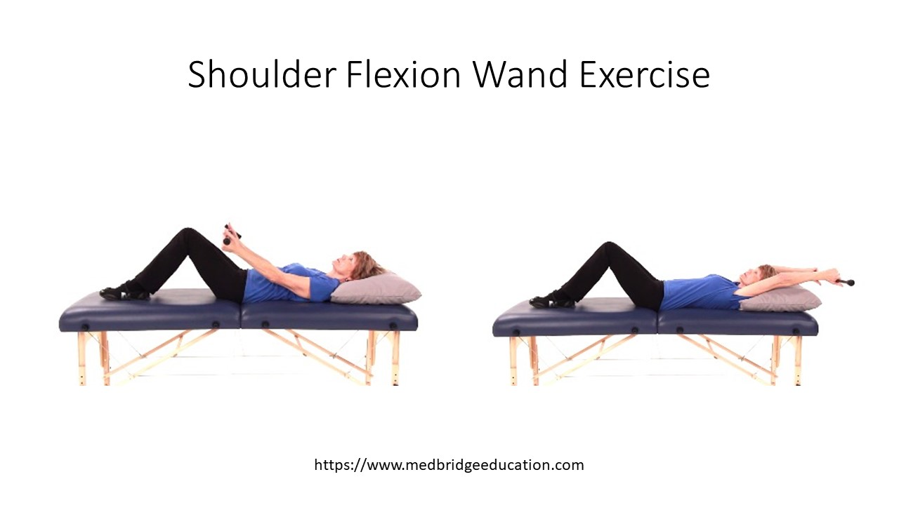
Self Stretching Table Slide for Shoulder Flexion  Target Tissue: lengthening of shoulder extensors/GHJ posterior (inferior) capsule  Intensity: defined by sensation of stretch and amount of overpressure  Duration:  Frequency: | 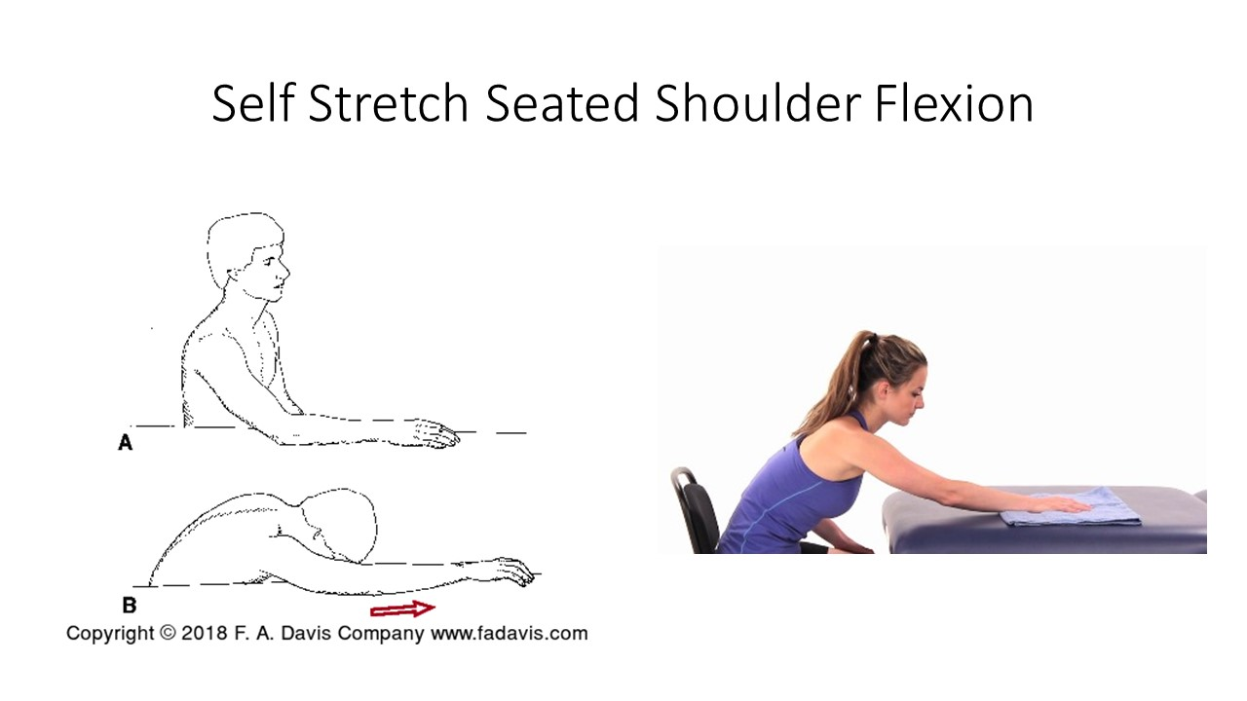
Self Stretch Standing Shoulder Flexion Wall Slide  Target Tissue: lengthening of shoulder extensors/GHJ posterior (inferior) capsule  Intensity: defined by sensation of stretch and amount of overpressure, this is an active elevation using the shoulder flexors  Duration:  Frequency: | 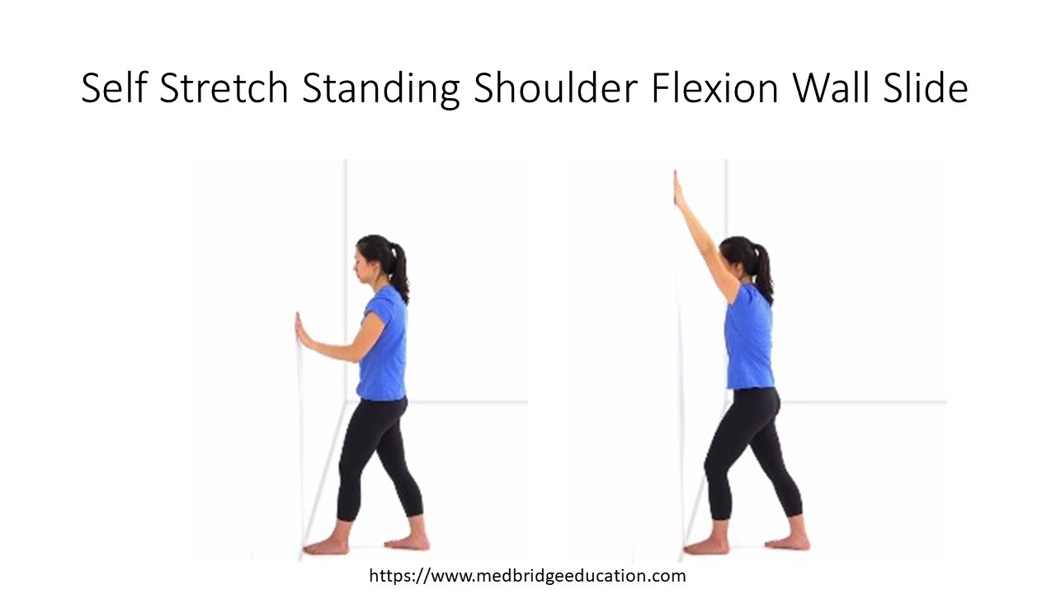
Quadruped Rock Back  Target Tissue: lengthening of shoulder extensors/GHJ posterior (inferior) capsule  Intensity: defined by sensation of stretch and amount of overpressure, gravity assisted closed chain movement  Duration:  Frequency: | 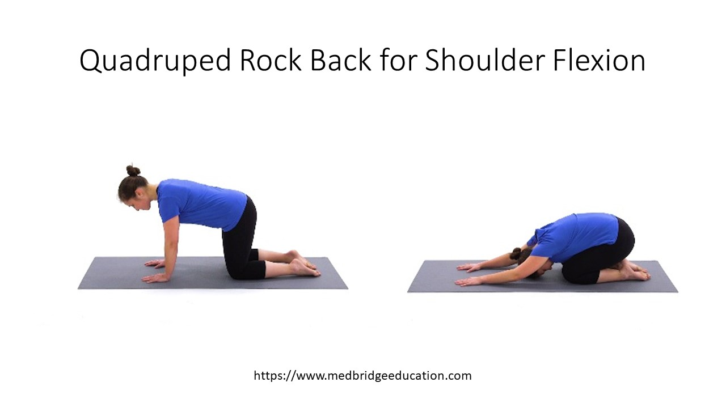
Standing Shoulder and Trunk Flexion at Table  Target Tissue: lengthening of shoulder extensors/GHJ posterior (inferior) capsule  Intensity: defined by sensation of stretch and amount of overpressure, gravity assisted  Duration:  Frequency: | 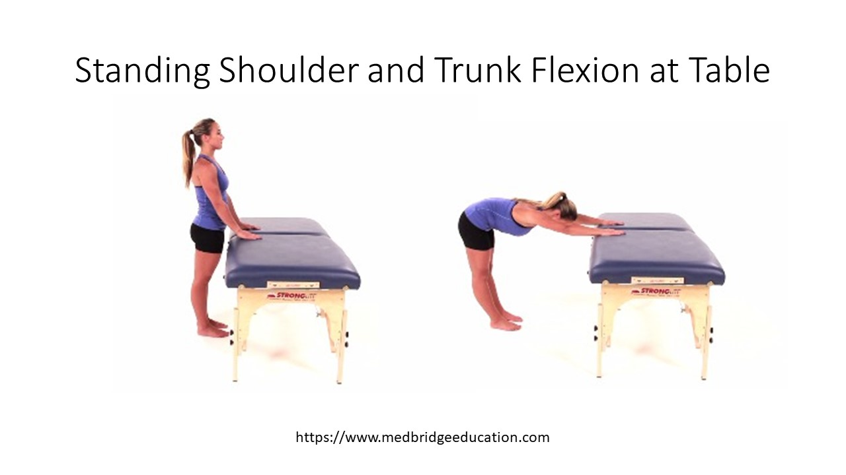
Downward Dog  Target Tissue: lengthening of shoulder extensors/GHJ posterior (inferior) capsule (ROM of UE impacted by ROM of LE)  Intensity: defined by sensation of stretch and amount of overpressure, UE involved in supporting body weight in a closed chain  Duration:  Frequency: | 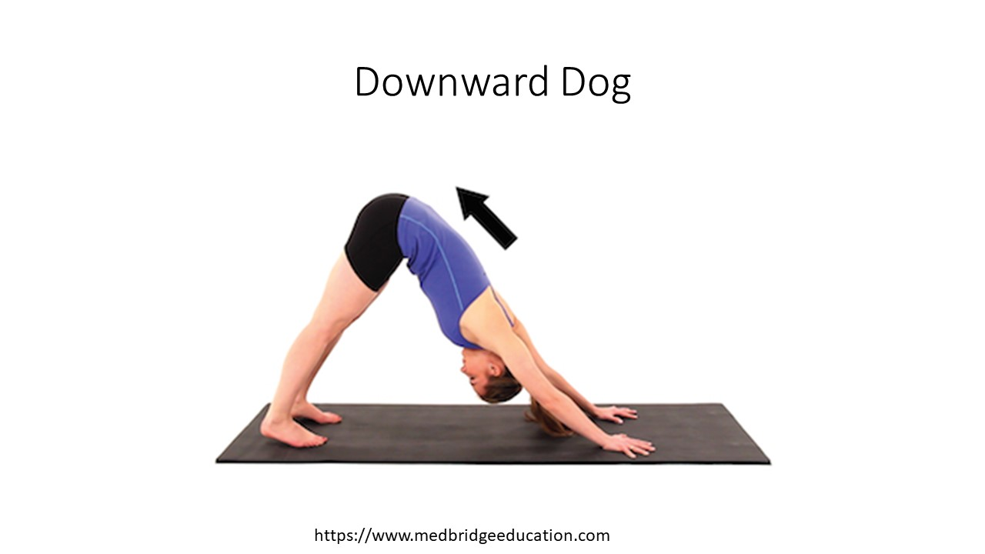
Shoulder Abduction Stretching Exercises:
Supine (standing) Wand Exercise  Target Tissue: lengthening of shoulder adductors/GHJ inferior capsule  Intensity: defined by sensation of stretch and amount of overpressure  Duration:  Frequency: | 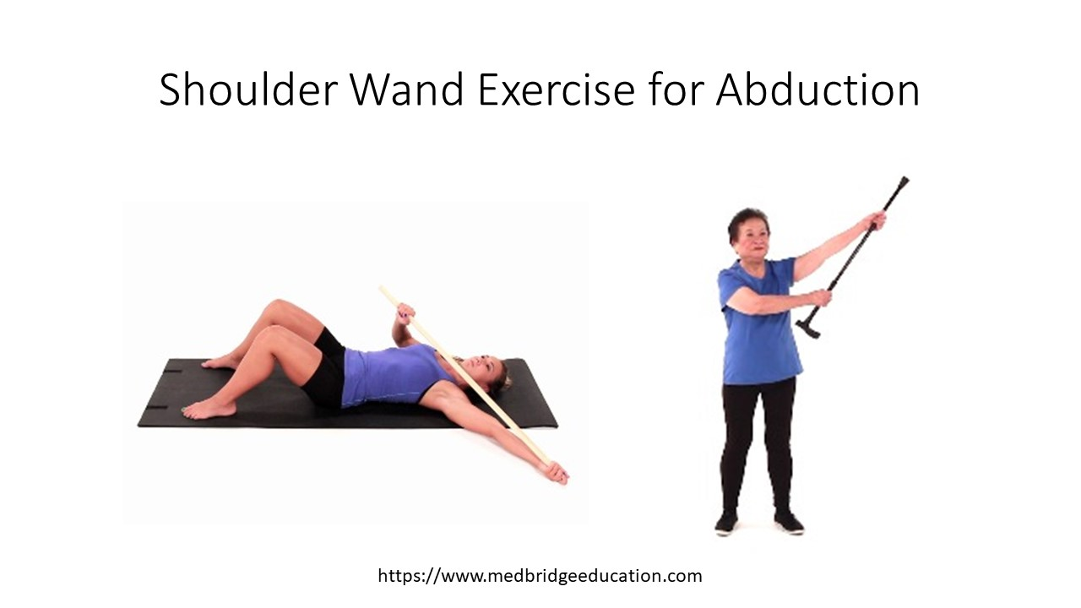
Self Mobilization Inferior Glide | 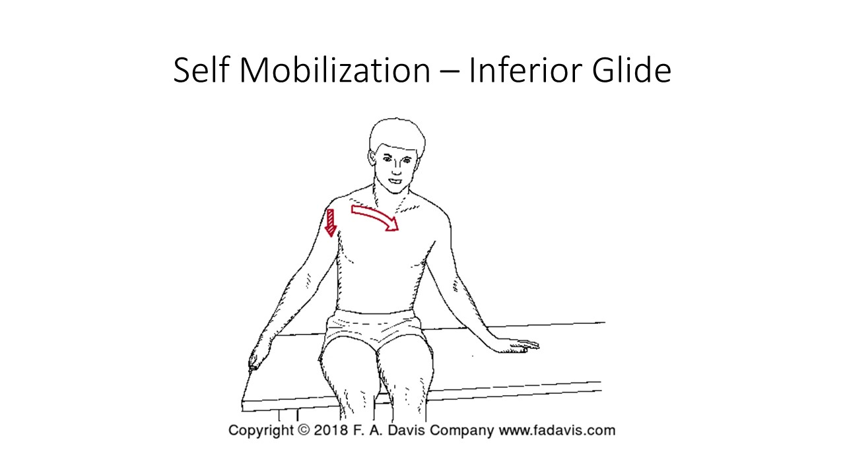
Self Stretch Seated Abduction  Target Tissue: lengthening of shoulder adductors/GHJ inferior capsule  Intensity: defined by sensation of stretch and amount of overpressure, body weight/gravity assisted  Duration:  Frequency: | 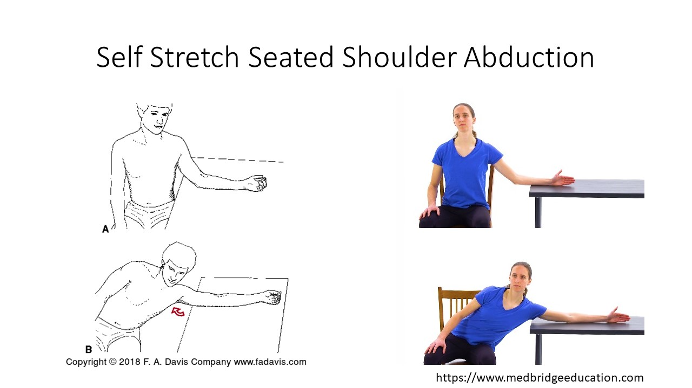
Shoulder External Rotation Stretching Exercises
Wand Exercise  Target Tissue: lengthening of shoulder internal rotators/GHJ anterior capsule. Position of the shoulder impacts tension of superior or inferior GHJ capsule.  Intensity: defined by sensation of stretch and amount of overpressure  Duration:  Frequency: | 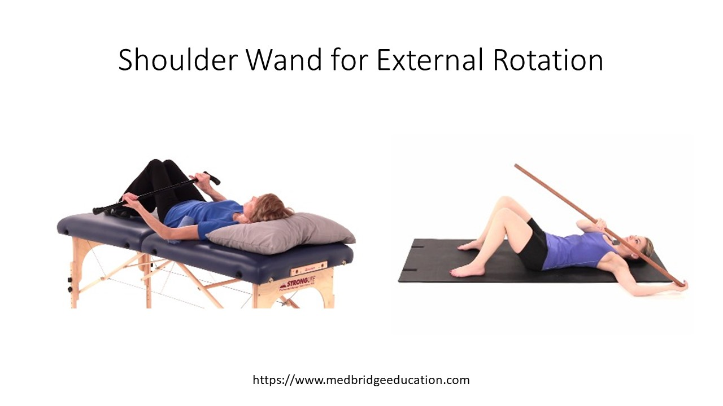
Seated Self Stretch for External Rotation  Target Tissue: lengthening of shoulder internal rotators/GHJ anterior capsule  Intensity: defined by sensation of stretch and amount of overpressure, body weight/gravity assisted  Duration:  Frequency: | 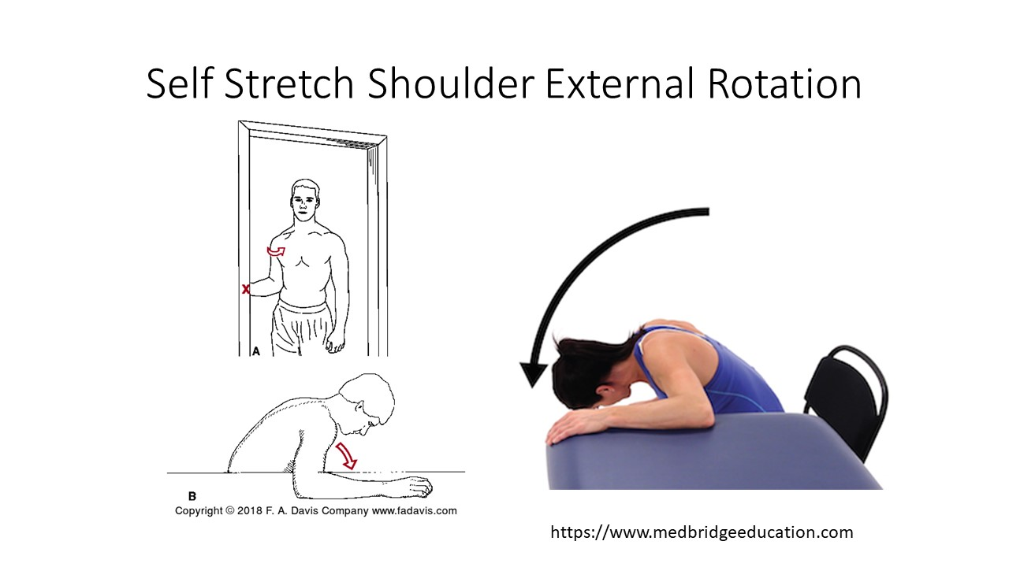
Supine Active Shoulder ER (corrective exercise)  Target Tissue: lengthening of shoulder internal rotators/GHJ anterior capsule  Intensity: defined by sensation of stretch, eccentric lengthening of internal rotators gravity assisted  Duration:  Frequency: | 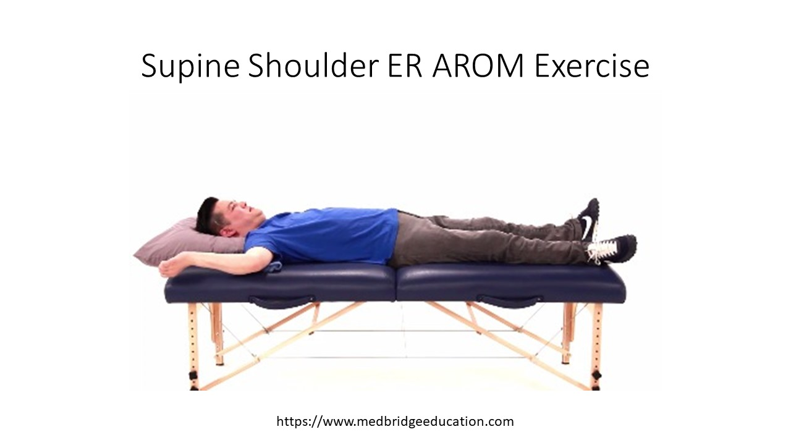
Shoulder Internal Rotation Stretching Exercises
Supine Active Internal Rotation  Target Tissue: lengthening of shoulder external rotators/GHJ posterior capsule  Intensity: defined by sensation of stretch and amount of overpressure, eccentric lengthening of shoulder ER’s gravity assisted  Duration:  Frequency: | 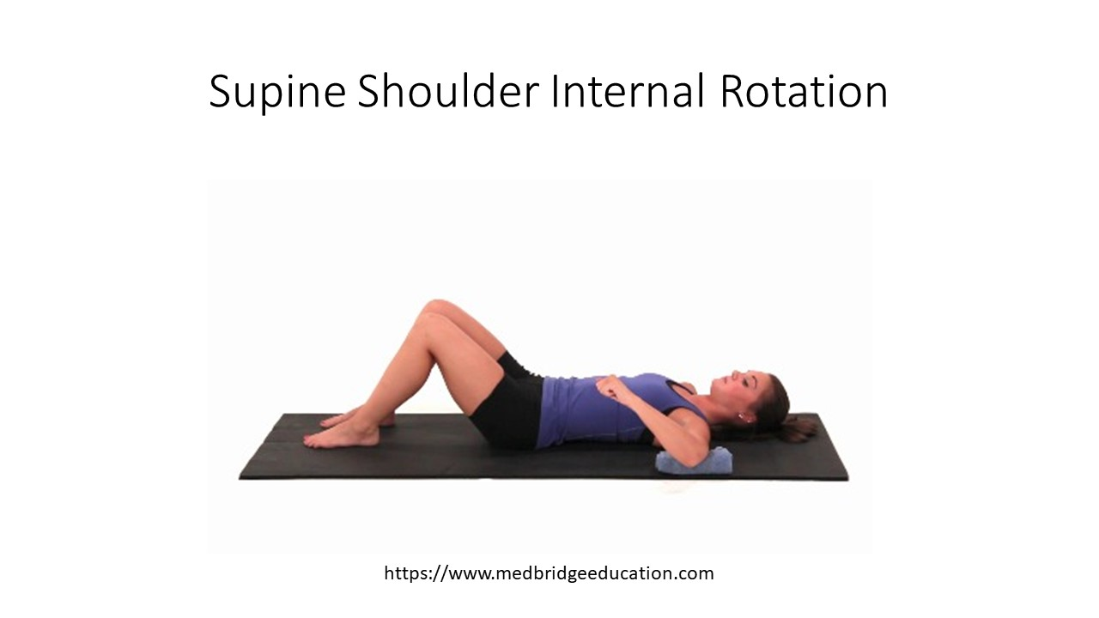
Standing Unilateral Internal Rotation Wand Exercise  Target Tissue: lengthening of shoulder external rotators/GHJ posterior capsule  Intensity: defined by sensation of stretch and amount of overpressure  Duration:  Frequency: | 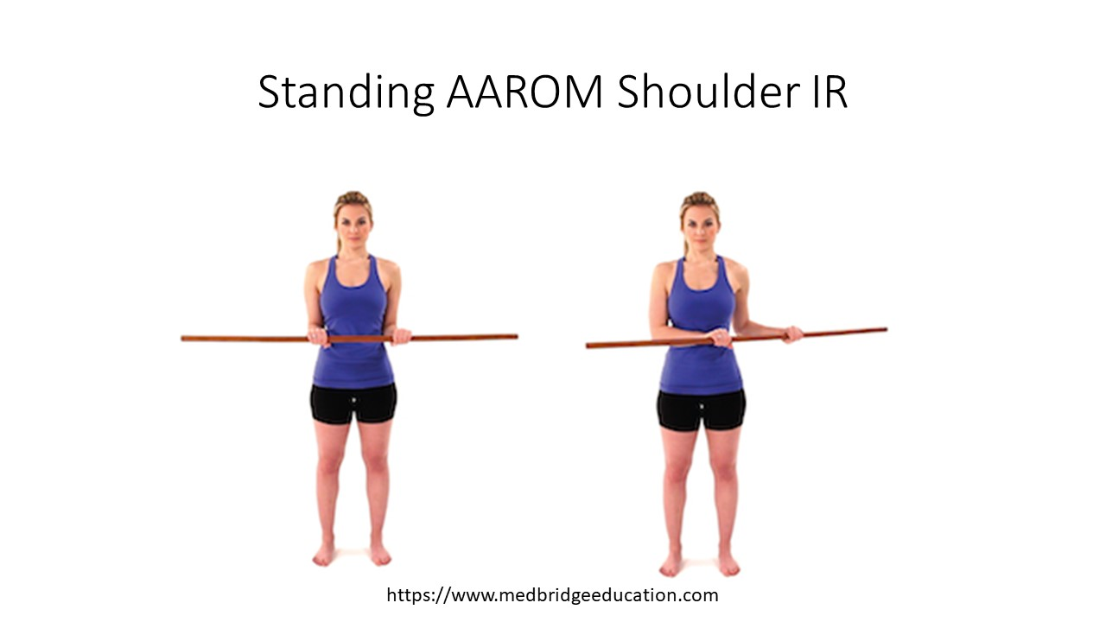
Standing Extension + IR Towel Stretch  Target Tissue: lengthening of shoulder abductors/GHJ superior capsule  Intensity: defined by sensation of stretch and amount of overpressure, force generated by other UE  Duration:  Frequency: | 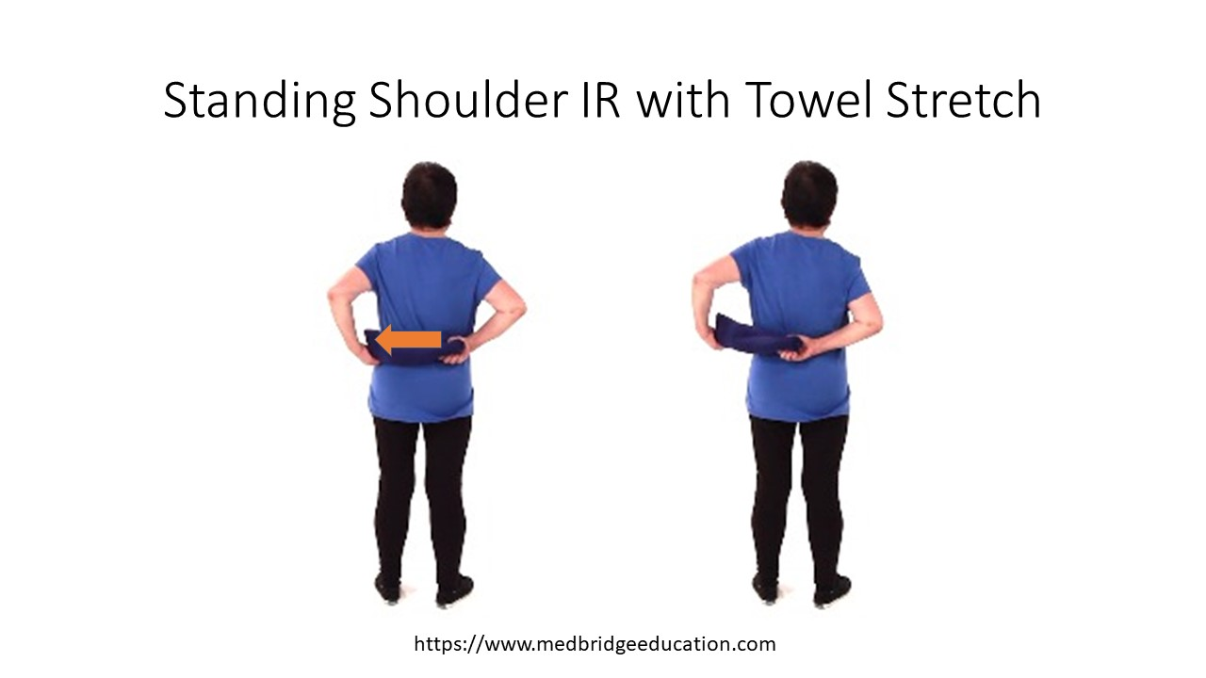
Side Lying Sleeper Stretch  Target Tissue: lengthening of shoulder external rotators/GHJ posterior capsule  Intensity: defined by sensation of stretch and amount of overpressure  Duration:  Frequency: | 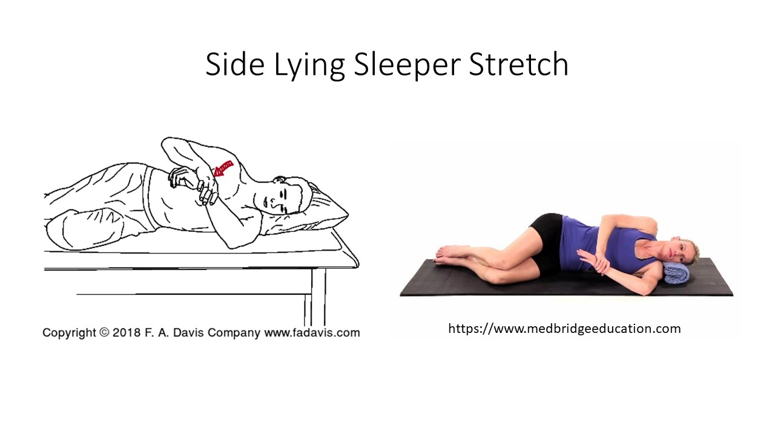
Shoulder Horizontal Adduction Exercises
Supine Horizontal Adduction (Abduction)  Target Tissue: lengthening of shoulder horizontal abductors/GHJ posterior capsule  Intensity: defined by sensation of stretch and amount of overpressure, gravity assisted eccentric lengthening of posterior deltoid  Duration:  Frequency: | 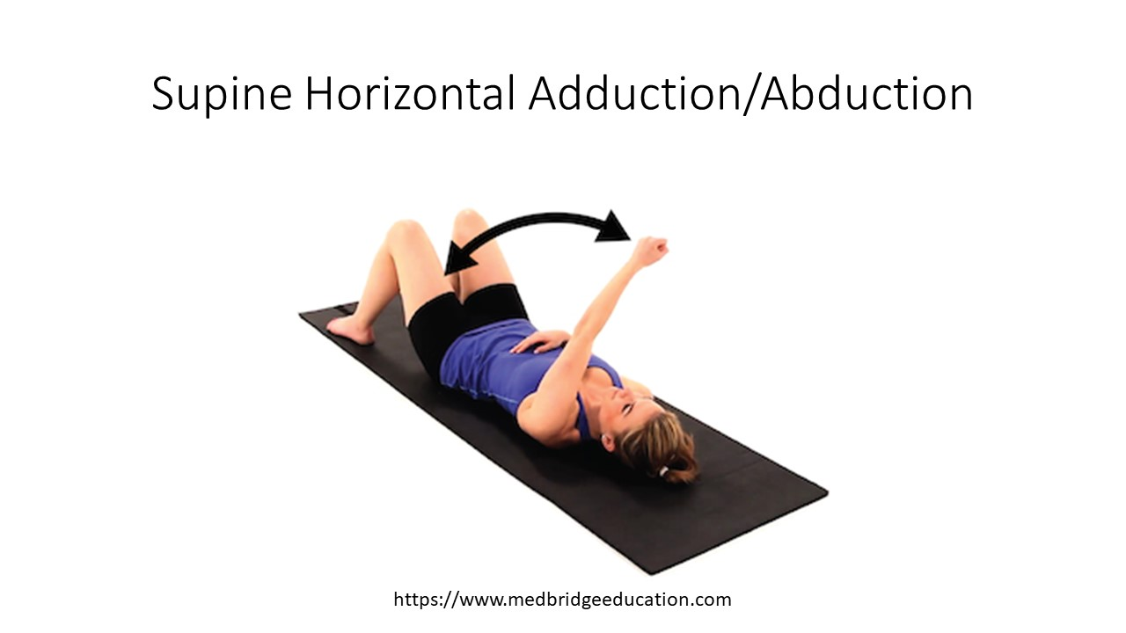
Sitting/Standing Horizontal (Cross Body) Adduction  Target Tissue: lengthening of shoulder horizontal abductors/GHJ posterior capsule  Intensity: defined by sensation of stretch and amount of overpressure  Duration:  Frequency: | 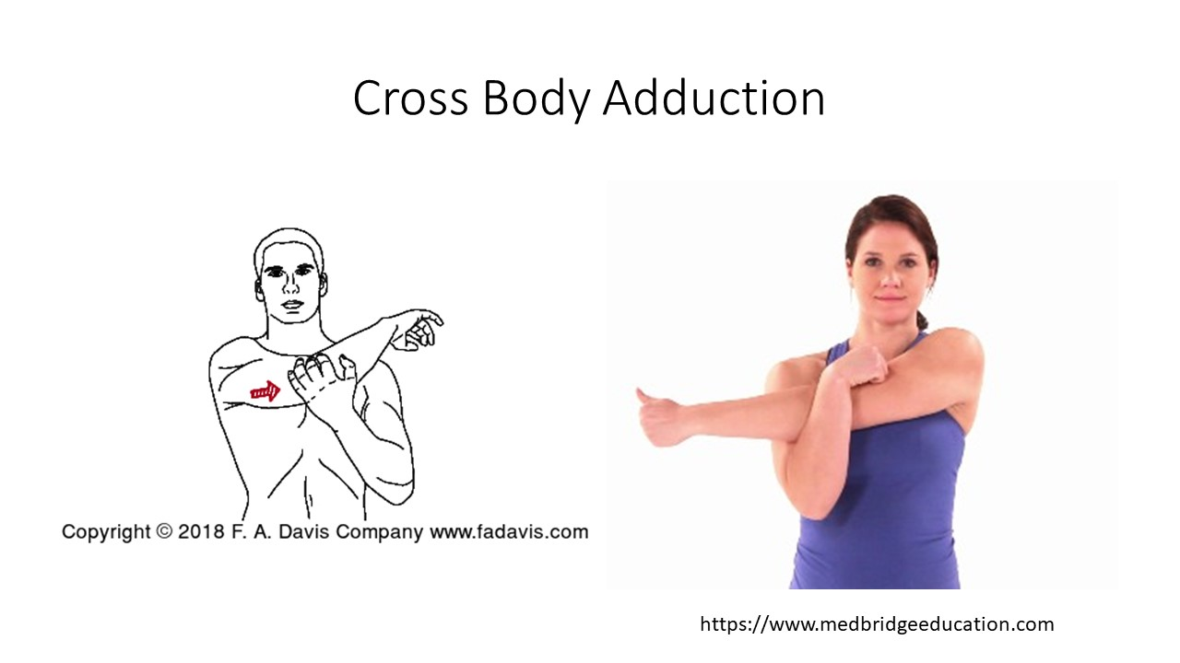
Side Lying Horizontal (Cross Body) Adduction  Target Tissue: lengthening of shoulder horizontal abductors/GHJ posterior capsule  Intensity: defined by sensation of stretch and amount of overpressure  Duration:  Frequency: | 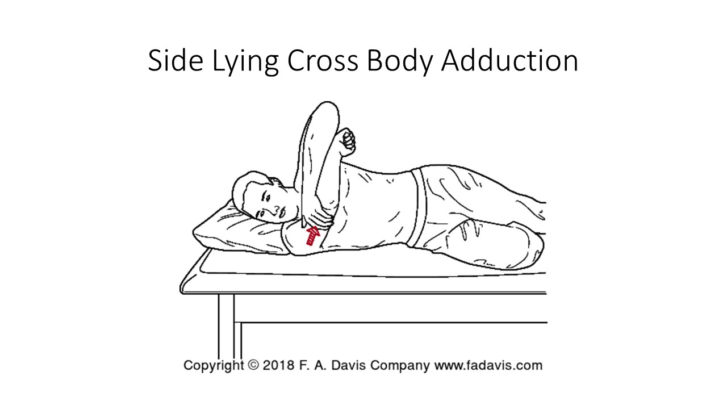
Shoulder Horizontal Abduction (Pec Stretch) Exercises
Supine Open Book Stretch  Target Tissue: lengthening of shoulder horizontal adductors (anterior chest wall)/GHJ anterior capsule  Intensity: defined by sensation of stretch and amount of overpressure, gravity assisted eccentric lengthening  Duration:  Frequency: | 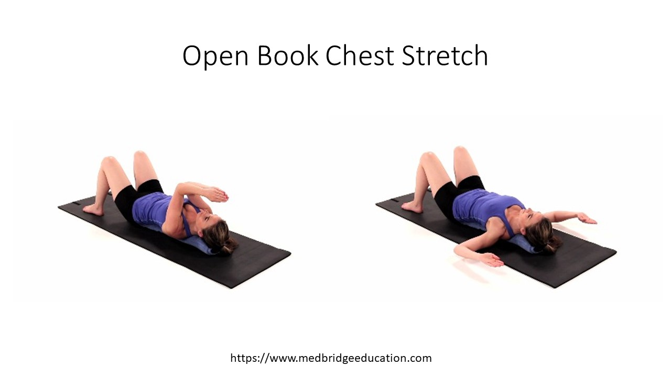
Supine Horizontal Abduction  Target Tissue: lengthening of shoulder horizontal adductors/GHJ anterior capsule  Intensity: defined by sensation of stretch and amount of overpressure, gravity assisted eccentric lengthening  Duration:  Frequency: | 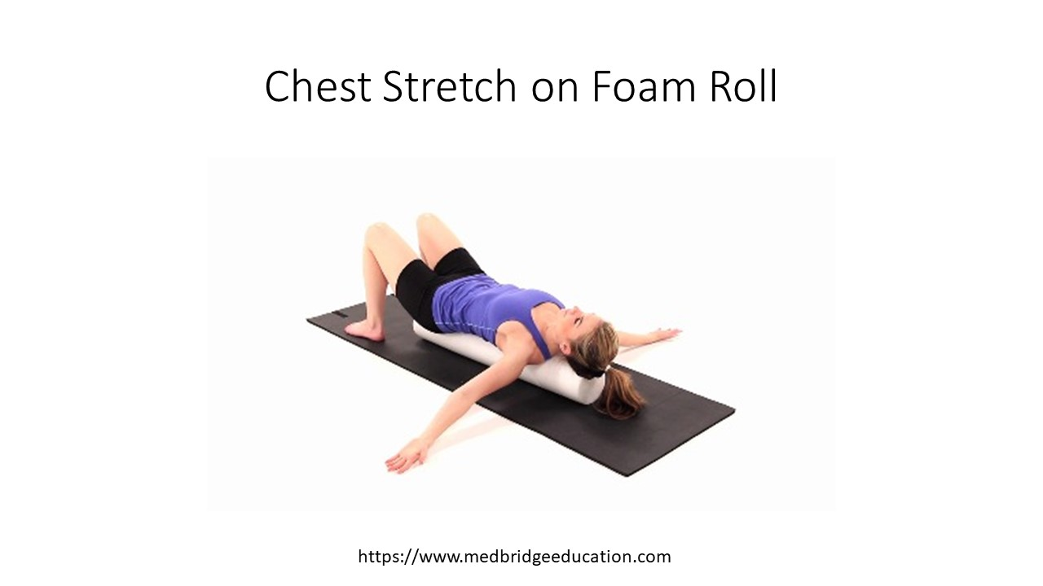
Supine Chest Stretch with Elbows Bent  Target Tissue: lengthening of shoulder horizontal adductors/GHJ anterior capsule  Intensity: defined by sensation of stretch and amount of overpressure, gravity assisted eccentric lengthening, but can also be active from scapular retractors  Duration:  Frequency: | 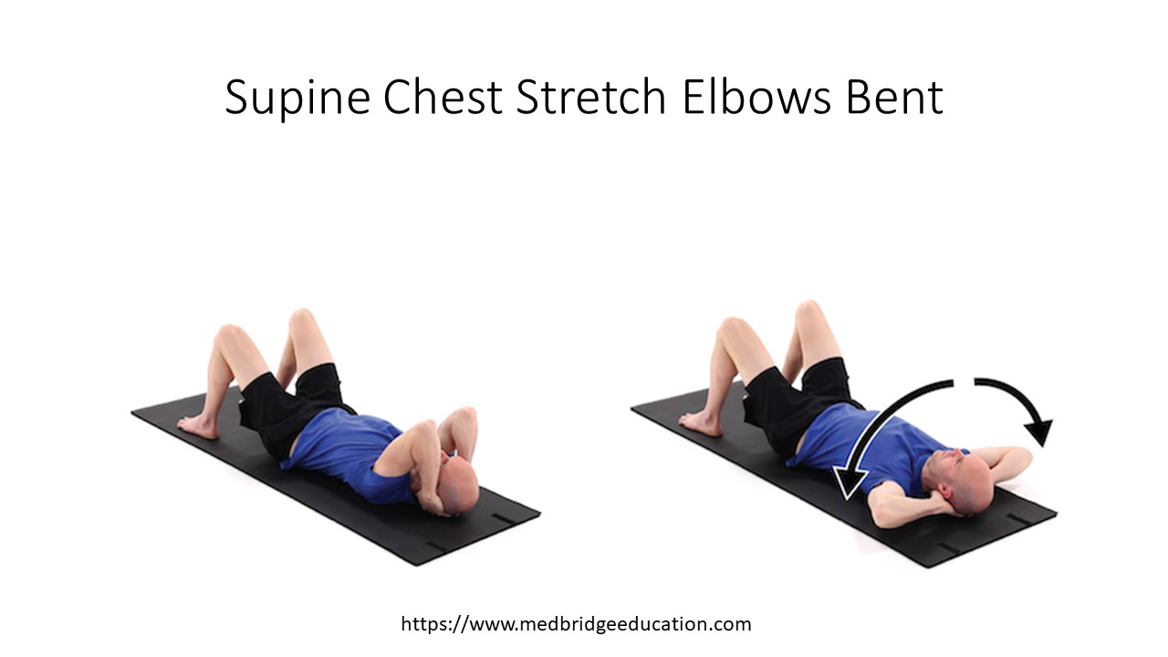
Standing Pec Minor Stretch  Target Tissue: lengthening of pec minor  Intensity: defined by sensation of stretch and amount of overpressure, motion generated by scapular retractors, shoulder horizontal abductors  Duration:  Frequency: | 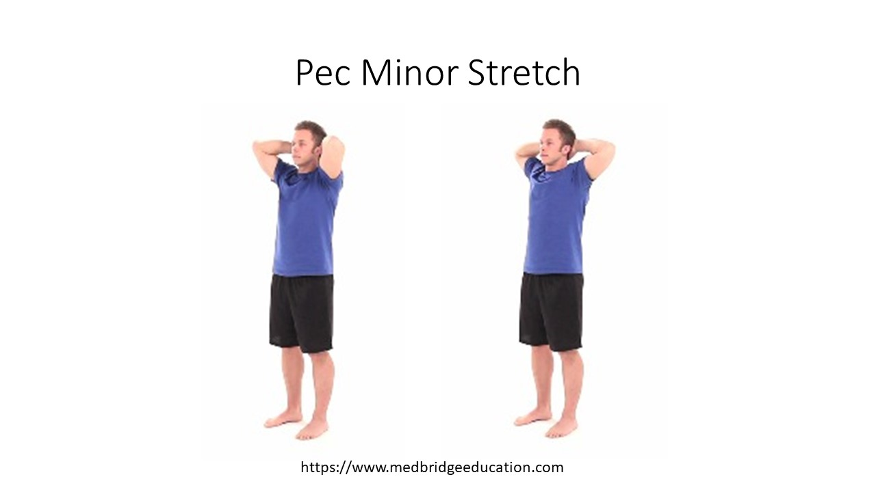
Corner Stretch Elbows Bent  Target Tissue: lengthening of shoulder horizontal adductors/GHJ anterior capsule  Intensity: defined by sensation of stretch and amount of overpressure, body weight assisted  Duration:  Frequency: | 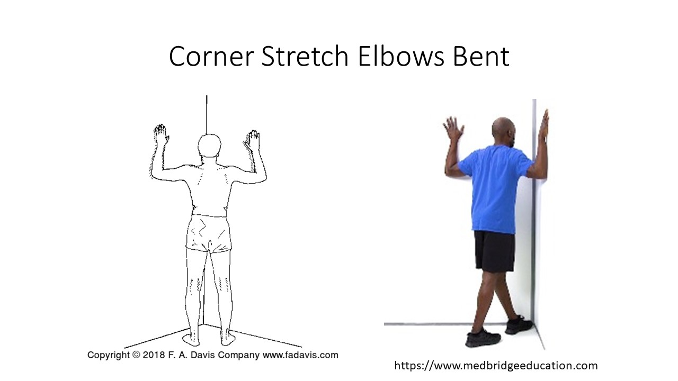
Corner Stretch Elbows Extended  Target Tissue: lengthening of shoulder horizontal adductors/GHJ anterior capsule  Intensity: defined by sensation of stretch and amount of overpressure, body weight assisted  Duration:  Frequency: | 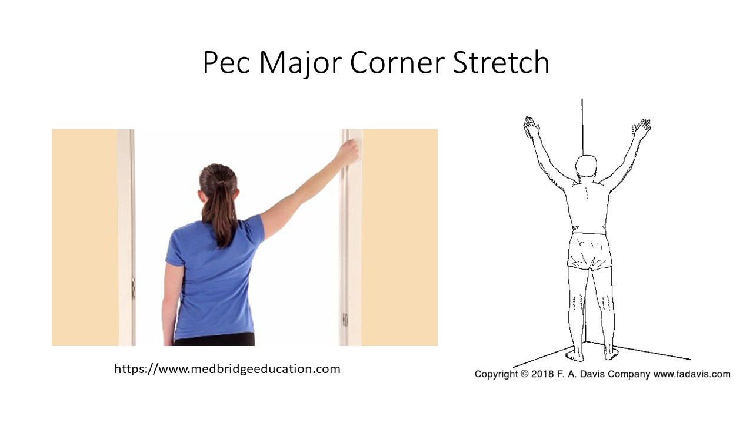
Shoulder Extension Exercises:
Shoulder Extension Stretch  Target Tissue: lengthening of shoulder flexors/GHJ anterior capsule  Intensity: defined by sensation of stretch and amount of overpressure, body weight/gravity assisted  Duration:  Frequency: | 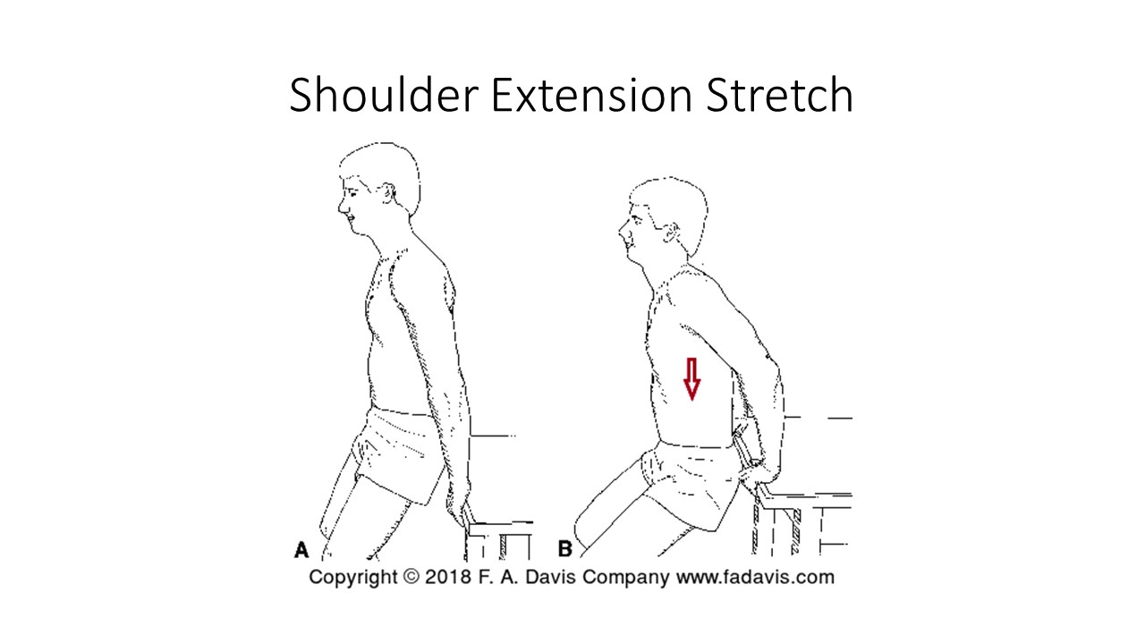
Stretching Exercises for Elbow Flexion
Supine PROM into Elbow Flexion  Target Tissue: lengthening of elbow extensors/posterior capsule  Intensity: defined by sensation of stretch and amount of overpressure  Duration:  Frequency: | 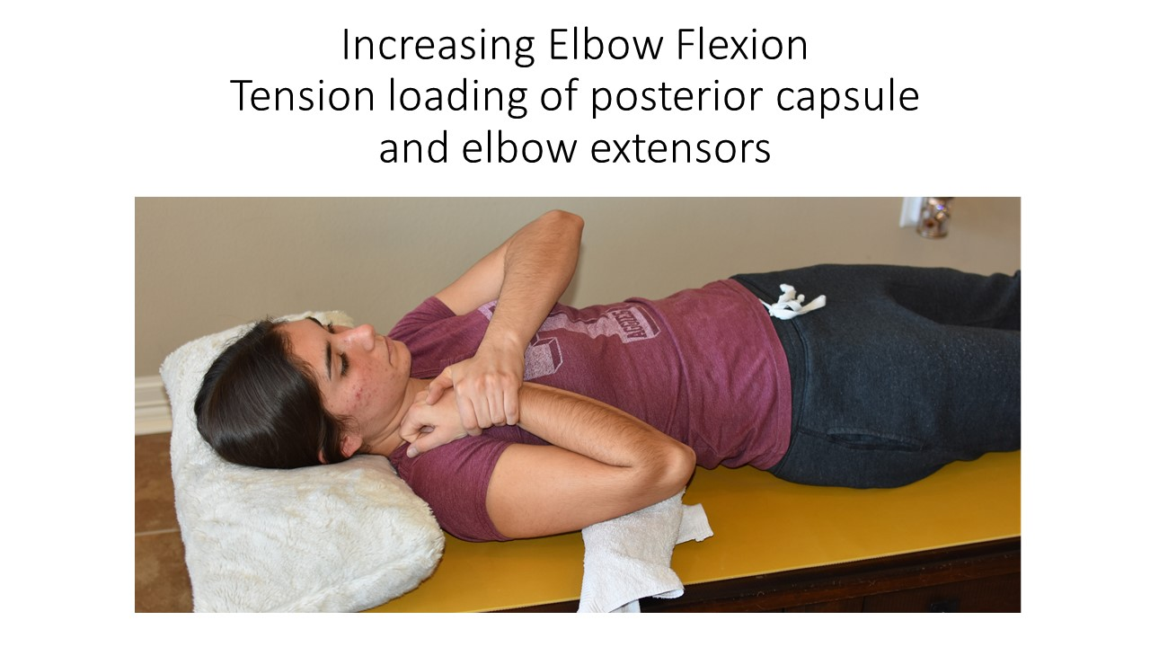
Sitting PROM into Elbow Flexion  Target Tissue: lengthening of elbow extensors/posterior capsule  Intensity: defined by sensation of stretch and amount of overpressure  Duration:  Frequency: | 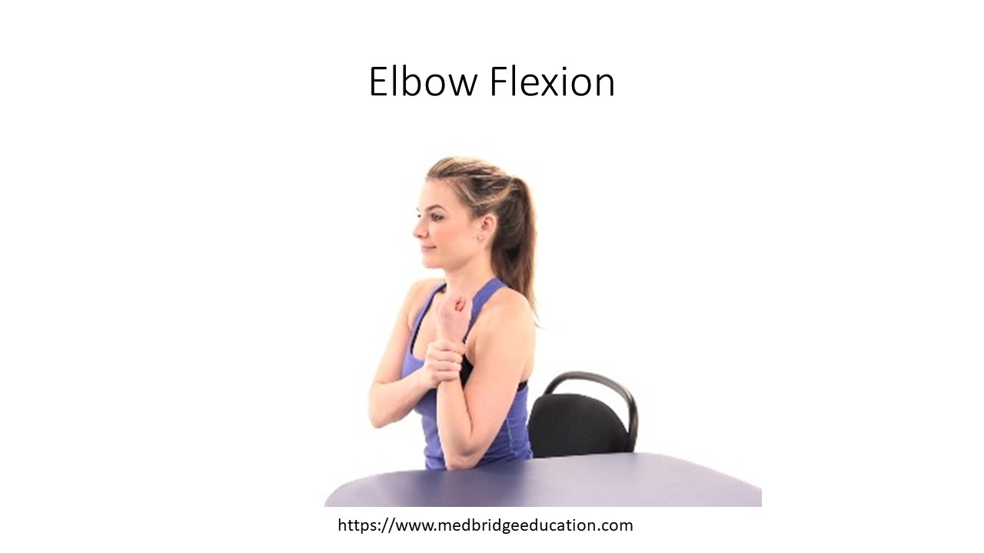
Tricep Stretch  Target Tissue: lengthening of triceps  Intensity: defined by sensation of stretch and amount of overpressure  Duration:  Frequency: | 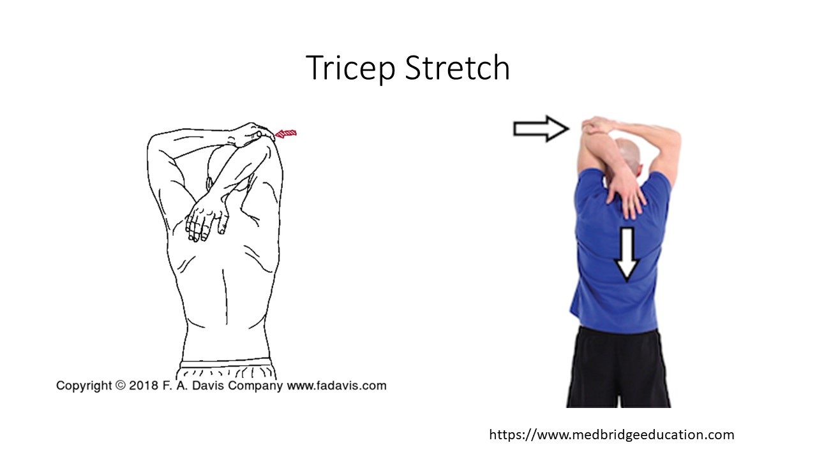
Exercises for Elbow Extension
PROM into Elbow Extension  Target Tissue: lengthening of elbow flexors/anterior capsule  Intensity: defined by sensation of stretch and amount of overpressure, target is a mild sensation of stretch (low load)  Duration: 10 – 15 minutes (long duration)  Frequency: | 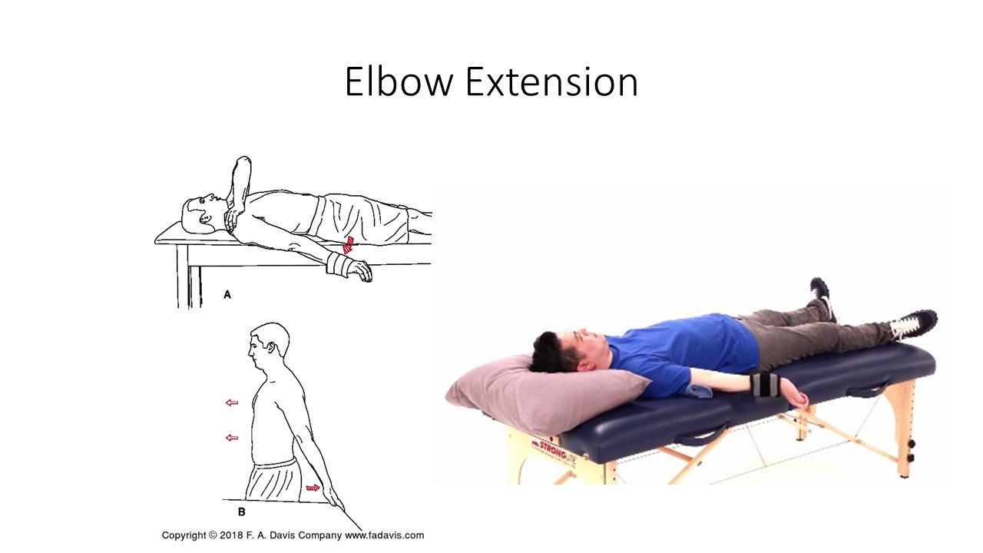
Exercises for Pronation/Supination
Forearm Supination  Target Tissue: lengthening of forearm pronators  Intensity: defined by sensation of stretch and amount of overpressure  Duration:  Frequency: | 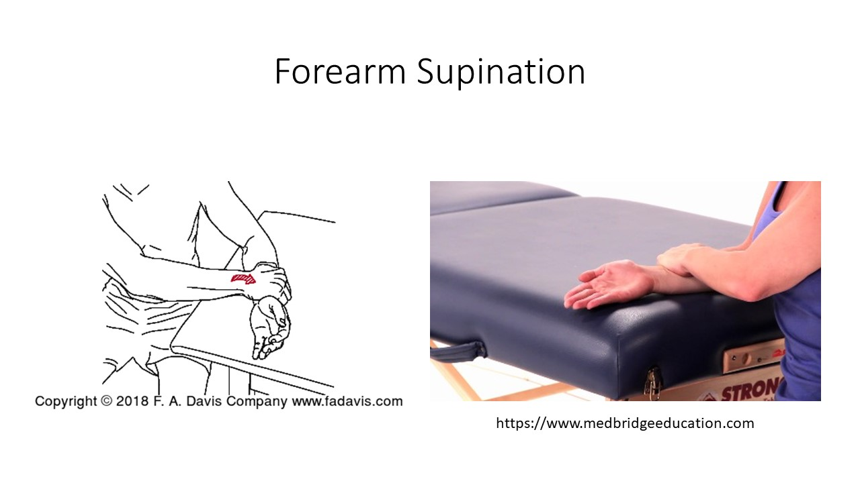
Forearm Pronation  Target Tissue: lengthening of forearm supinator(s)  Intensity: defined by sensation of stretch and amount of overpressure  Duration:  Frequency: | 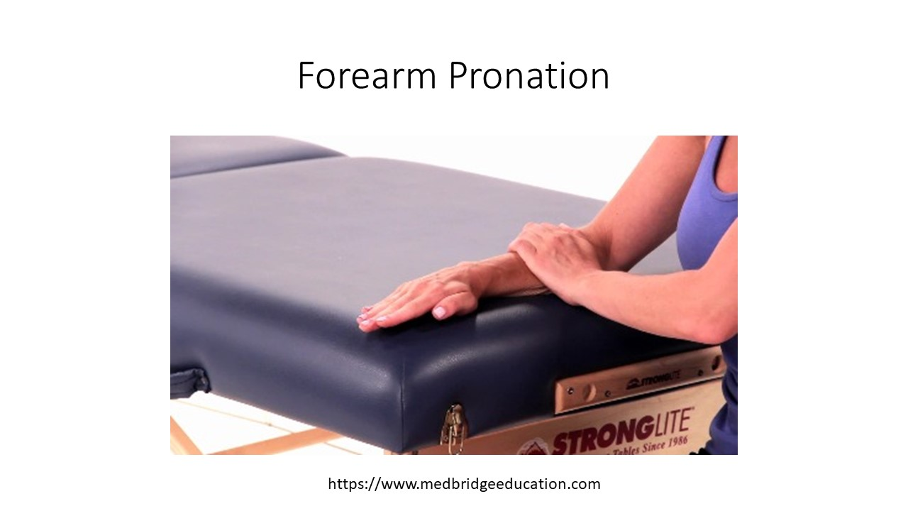
Wrist Flexion and Extension Exercises
Lengthening of wrist extensors  Support humerus with arm in 90 degrees of flexion, forearm in pronation, with wrist pre-positioned into flexion, move the elbow into and out of elbow flexion/extension | 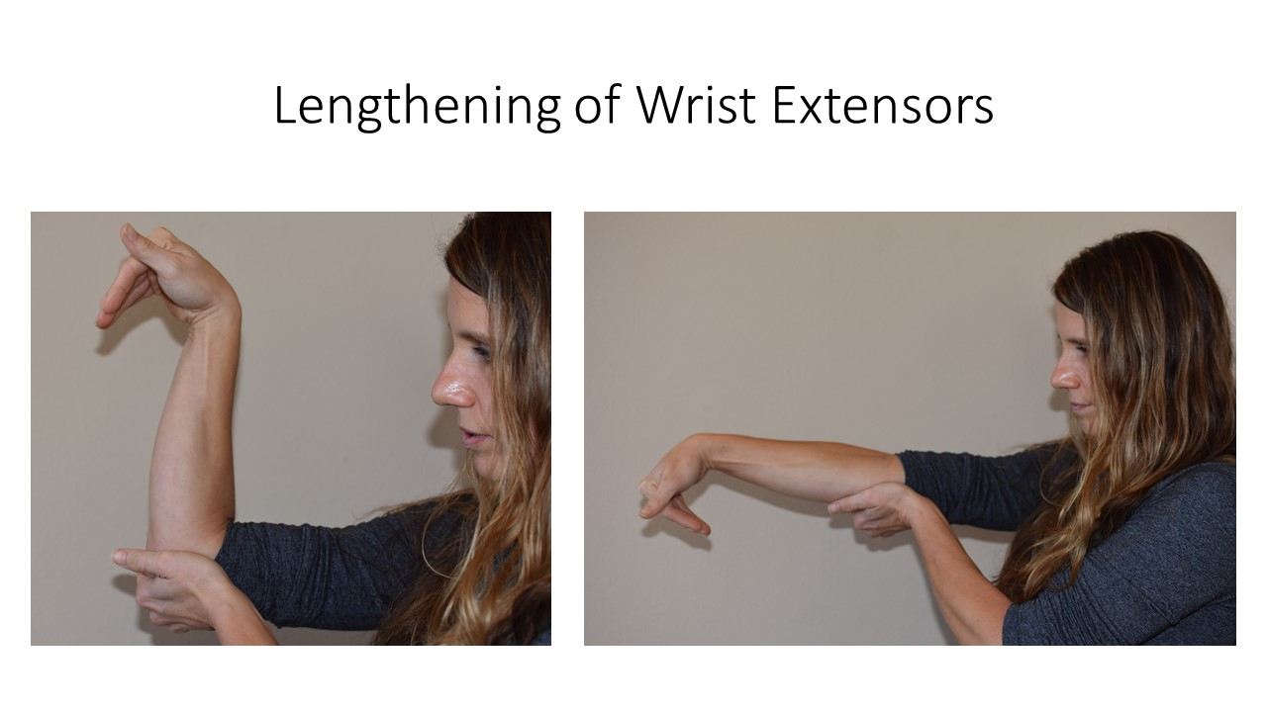
Lengthening of finger extensors  Support humerus as above, forearm in pronation, and with the wrist/hand in a fist (fingers and wrist prepositioned into flexion), move the elbow into and out of elbow flexion/extension) | 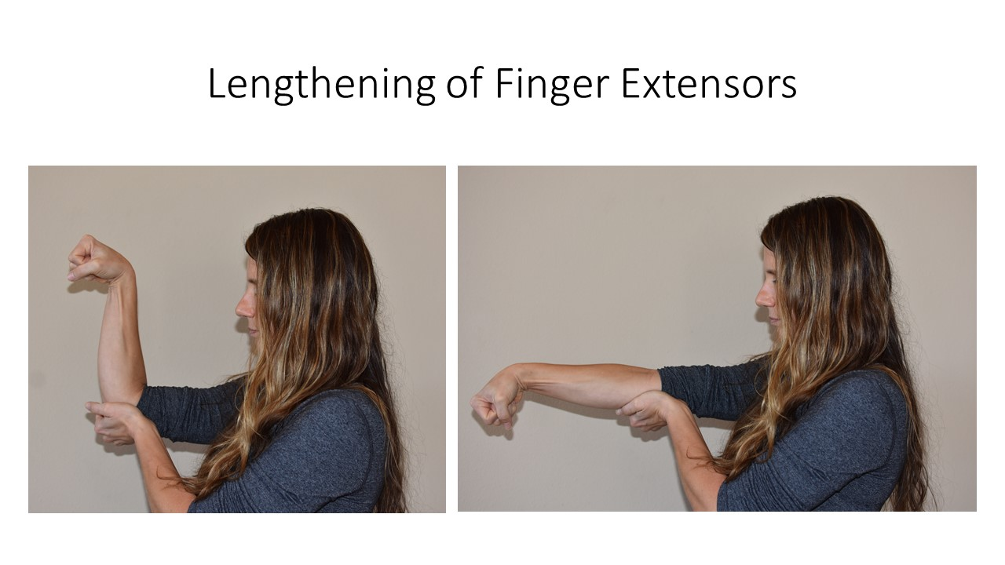
Lengthening of finger flexors OKC –  Support the humerus in 90 degrees of shoulder flexion, forearm in supination, wrist prepositioned into extension, move the elbow into and out of elbow flexion/extension. | 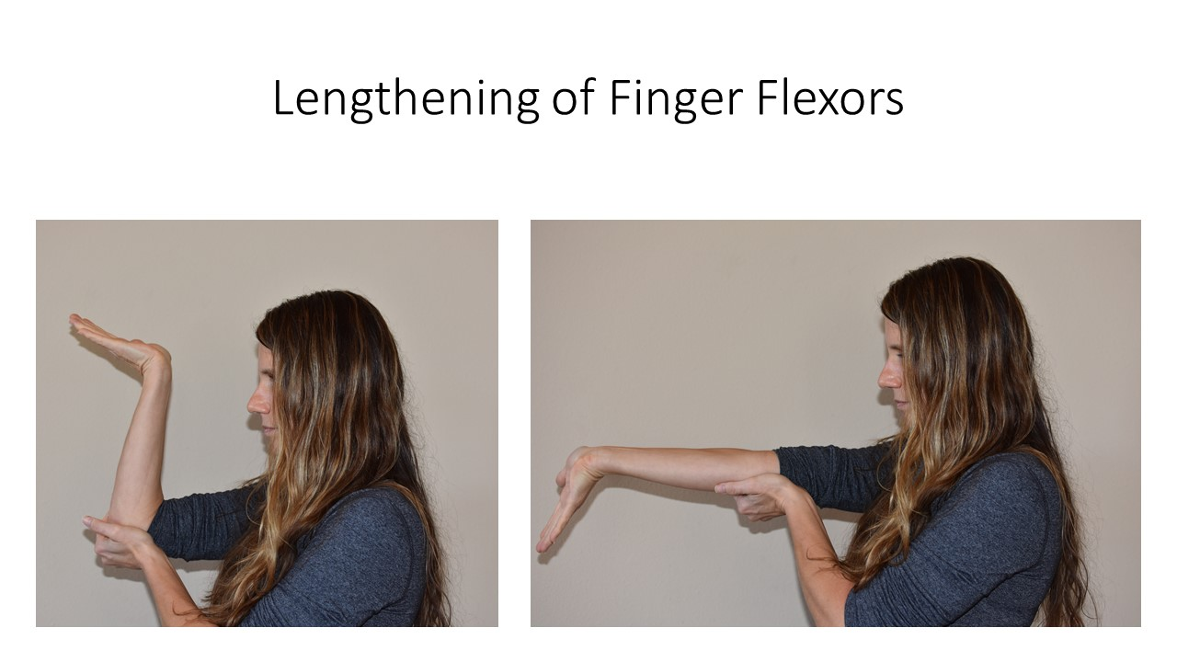
Lengthening finger flexors CKC –  with the hand resting on the mat, wrist and fingers in full extension, forearm pronated, lean forward on the wrist increasing wrist flexion through shoulder extension | 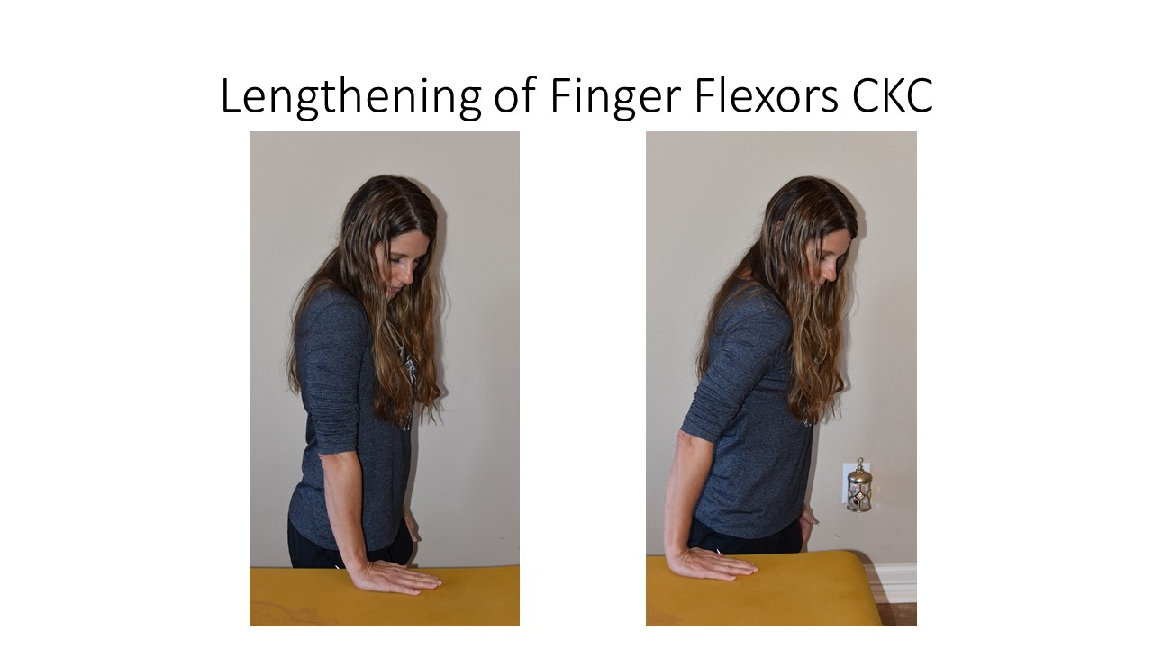
Questions:
- How would you determine the range of motion you would passively or actively take the patient through for the exercise?

Lab Activity 2:

Melissa is a 16 year old volleyball player with complaints of right shoulder pain. She presents with anterior tipping and slight winging of the scapula. In addition her scapula appears to be protracted and slightly downwardly rotated.
Based on the information provided, identify which of the following stretching exercises would be included in her plan of care.

Stretching Exercises
Shortness of suboccipitals | Mode/Exercise: Stretching exercise  Stabilization: neck/C2  Movement direction: Slowly nod the head into flexion (capital flexion)  Intensity: moderate sensation of stretch  Duration: 30 to 60 seconds * 4 repetitions  Frequency: Daily
Shortness of upper trapezius | Mode/Exercise: Stretching exercise  Stabilization: scapula (through depression)  Movement direction:  Intensity: moderate sensation of stretch  Duration: 30 to 60 seconds * 4 repetitions  Frequency: Daily
Shortness of scalene | Mode/Exercise: Stretching exercise  Stabilization: first rib  Movement direction: Side bend away and slightly rotate toward  Intensity: moderate sensation of stretch  Duration: 30 to 60 seconds * 4 repetitions  Frequency: Daily
Shortness of levator scapulae | Mode/Exercise: Stretching exercise  Stabilization: scapula through upward rotation or depression  Movement direction: rotate away and flex  Intensity: moderate sensation of stretch  Duration: 30 to 60 seconds * 4 repetitions  Frequency: Daily
Shortness of Pectoralis Major | Mode/Exercise: Stretching exercise  Stabilization: Trunk/sternum  Movement direction: In horizontal abduction at 60 degrees, 90 degrees, or 120 degrees  Intensity: moderate sensation of stretch  Duration: 30 to 60 seconds * 4 repetitions  Frequency: Daily
Shortness of Pectoralis Minor | Mode/Exercise: Stretching exercise  Stabilization: Trunk/sternum  Movement direction: Coracoid into scapular depression/retraction  Intensity: moderate sensation of stretch  Duration: 30 to 60 seconds * 4 repetitions  Frequency: Daily
Shortness of Latissimus dorsi | Mode/Exercise: Stretching exercise  Stabilization: Trunk/pelvis  Movement direction: Into GHJ elevation with the humerus in ER  Duration: 30 to 60 seconds * 4 repetitions  Frequency: Daily
Short biceps brachii | Mode/Exercise: Stretching exercise  Stabilization: Humerus into extension  Movement direction: Elbow extension  Intensity: Low load long duration stretch (mild, barely a sensation of stretch)  Duration: 15 minute hold  Frequency: Daily

