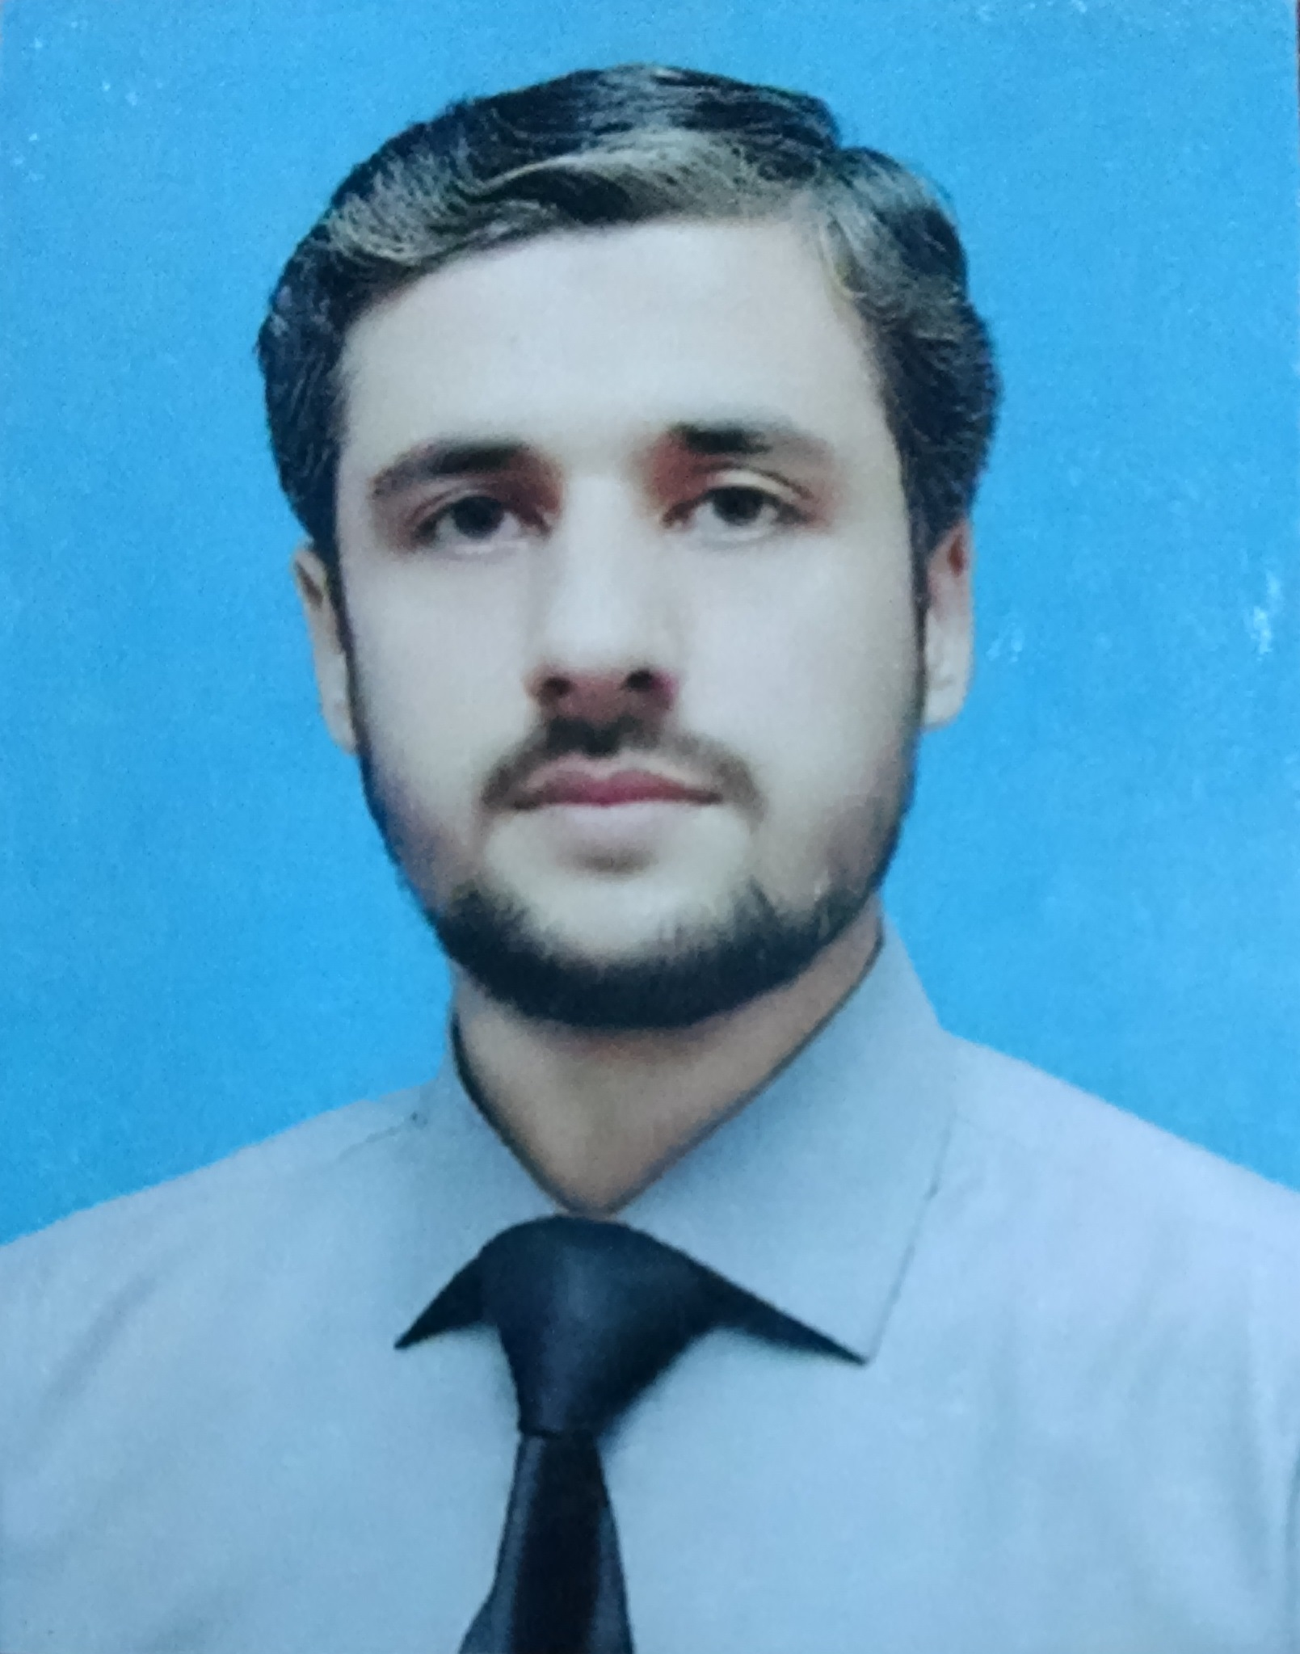
SHAMEEL IQBAL
Apartment No. 02, Anjum Mansion,
A.M.1, Burns Road Karachi, Pakistan-74200
Residence: +9221-32637834
Cell: +92345-3040689
Email: shamyel@live.com
Skype ID: shameel.iqbal1

CAREER OBJECTIVE
Seeking a position where extensive experience will be further developed & utilized.

PROFESSIONAL EXPERIENCE

QUETTA TEXTILE MILLS LIMITED (Sr. Accounts Executive) Sep 2015 - Present
- Prepares asset, liability, and capital account entries by compiling and analyzing account information.
- Responsible for all accounting work necessary to insure Accounts Payable are processed in a timely and efficient manner.
- Responsible for the maintenance of the accounts payable ledgers by checking invoices, requisitions, accounts, orders, and the distribution of charges.
- Prepare monthly Accounts Payable reports.
- Responsible for the maintenance of the accounts receivable ledgers by checking invoices, input receipts and adjust withholding taxes.
- Ensure all staff related payments that require adjustment to payroll are recorded accurately in a timely manner and processed through the monthly payroll.
- Update and prepare monthly FBR portal withholding tax detail.
- Prepares routine journal entries and year end accrual entries for processing.
- Submission of weekly withholding taxes on supplies, services, rents to government treasury.
- Manage and process petty cash and its vouchers.
- Process rental payment for Office Premises.
- Performs related work as may be required.

ARTISTIC DENIM MILLS LIMITED (Accounts Officer) Sep 2014 – Sep 2015
- Responsible for overall administration of Accounts Payable & Receivables section.
- Preparing monthly balance sheet schedules such as AP accruals schedules and other accruals schedules.
- Preparing monthly vendor reconciliation.
- Ensure the accuracy of calculations, check that all supporting documents are attached and appropriate GL accounts have been used.
- Handling all vendors’ correspondence and queries.
- Receiving the list of the suppliers to be paid.
- Processing petty cash advances, petty cash expenses and adjustment payments.
- Record all cheques.
- Keeping the track of all cheques which are sent for signatures.
- Coordination of audit and tax matters with external auditors.
- Maintain banks’ reconciliations.
- Posting of staff & workers’ salaries.
- Make Full & Final settlement of resigning employees.

AL BARAKA BANK PAKISTAN LTD. (Finance Officer) Oct 2012 – Sep 2014
- Proper book keeping of payment vouchers.
- Posting all types of expenses and centralized payments which included suppliers, services, brokerage & commission and branches rental.
- Withholding Tax deduction of u/s 153, 155, 231A, 231AA, 233.
- Processing construction, security, transportation, maintenance & other contract related payments.
- Processing travel related advances, hotel charges, ticket charges visa charges etc. and adjustments.
- Maintaining GL’s of advances and suspense accounts.
- Processing staff related advances adjustments and reimbursements and other staff related payments.
- Update MIS Tax portal on monthly basis.

MUSHTAQ & CO. Chartered Accountants (Audit Executive) Jan 2009 – Jun 2012
- Assisting on audits, mainly at client sites e.g. cash, fixed assets, trade payables and receivables;
- examining company accounts and financial control systems
- Assist in assuring audit practices conform to department and professional standards.
- Researching potential clients while in the office;
- Checking that financial reports and records are accurate and reliable.
- Ensuring procedures, policies, legislation and regulations are correctly followed and complied with.
- Performs related works as and when assigned.

EDUCATION

QUALIFICATION | INSTITUTE | YEAR | GRADE / DIVISION
MBA (Finance) | KASBIT | Feb-2019 | 3.38 CGPA
CPA (Pak.) | ICPAP | 2019 | In-progress
CA (Foundation) | ICAP | 2015 | passed
M.A. (Economics) | University of Karachi | Jan-2013 | 2nd
B.com | University of Karachi | Jul-2008 | 2nd
H.S.S.C | Bahria College | 2004 | B
S.S.C | A.B.C Public School | 2002 | A

SKILLS & LANGUAGES

- Certificate of Computer Practical Training (CAMS – from Oct-2005 to Mar-2006)
- Complete hand on ERP (Sidat Hyder)
- English
- Urdu

PERSONAL DATA

Father’s Name: Muhammad Iqbal
Date of Birth: 23-11-1984
Nationality: Pakistani
N.I.C. # 42301-2433301-1
Religion: Islam
Marital Status: Single
Gender: Male

REFERENCES

- Muhammad Salman Arif, ACA
Manager Accounts
Artistic Denim Mills Limited
Plot No. 5-9 & 23-26; sector 16 Korangi Industrial Area, Karachi.
Tel: 9221-111-236-236
Cell: 92323-2199935
E-mail: admaccounts@admdenim.com

- Amir Zaheer
Manager Finance
Quetta Textile Mills Limited
Nadir House, I.I Chundrigar Road, Karachi.
Tel: 9221-32414334
Cell: 92322-2003960
E-mail: amir@quettagroup.com

- Muhammad Shakeel ur Rehman
Senior Vice President, Finance Department
Al Baraka Bank Pakistan Limited
162 Banglore Town, Main Shahrah-e-Faisal, Karachi.
Tel: 9221-34315851
Cell: 92333-4397717
E-mail: muhammad.shakeel@albaraka.com.pk

