Setting Up QUARC Software

Software Sources
QUARC Real-Time RapidControl: https://www.quanser.com/products/quarc-real-time-control-software/
Our software license covers up to version 4.2.65535.65535 (Quarc 2022 SP1).
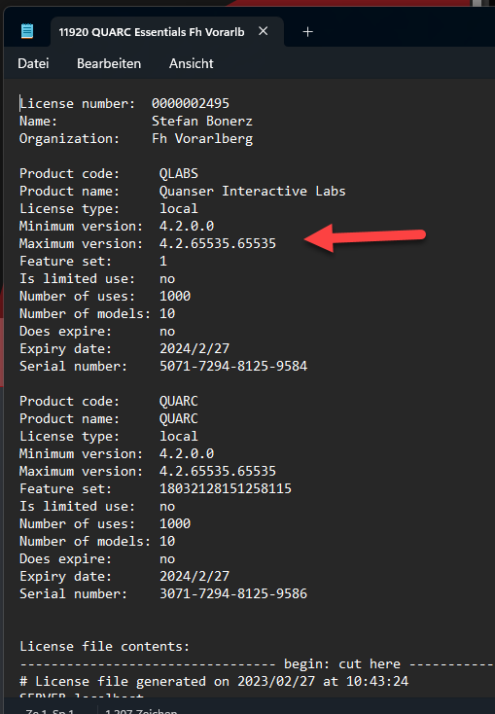
NI Compact RIO (Maximum version 18.0 or 19.6): https://www.ni.com/de/support/downloads/drivers/download.ni-compactrio.html#
Visual Studio Community: https://visualstudio.microsoft.com/de/vs/community/

Installation (in this exact order)
- Install Matlab with Simulink. Matlab must be version 2022b at most. For newer versions, a newer Quarc license is required. Simply install all components. License code is in the file FIK.txt and the network license file is network.lic.
- 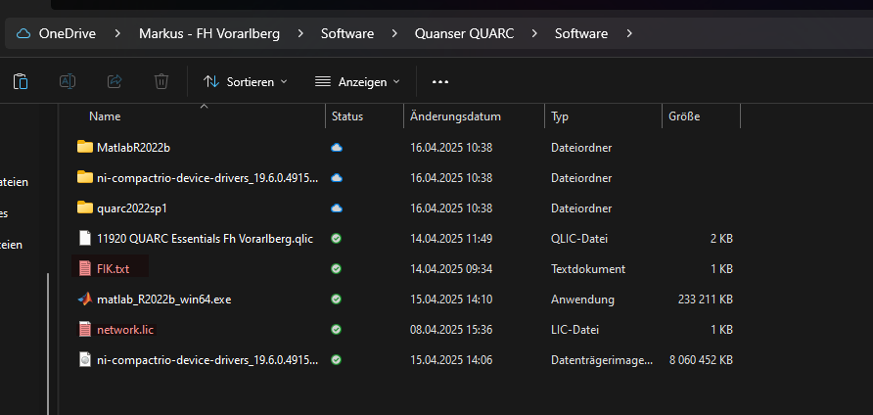
2. Install Visual Studio Community for C++ Desktop (Version 17 was used).
3. Run the command 'mex –setup' in the command line for Matlab integration.
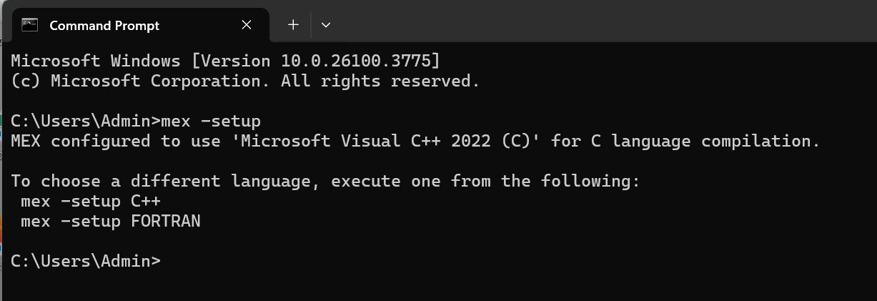
4. Install NI Compact RIO (Maximum version 18.0 or 19.6). Install completely.
5. Install QUARC Real-Time RapidControl Software (Quarc 2022 SP1). If the installation order was not followed, please perform the steps under 'Quarc_library not found' to register the library.
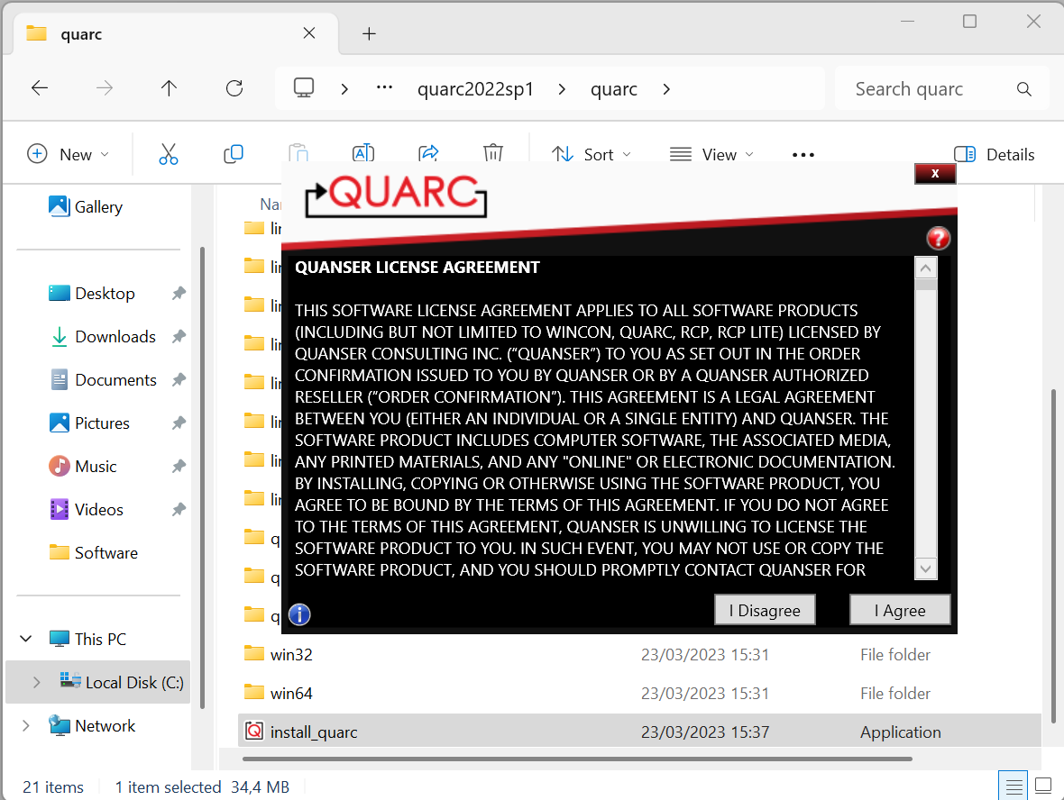
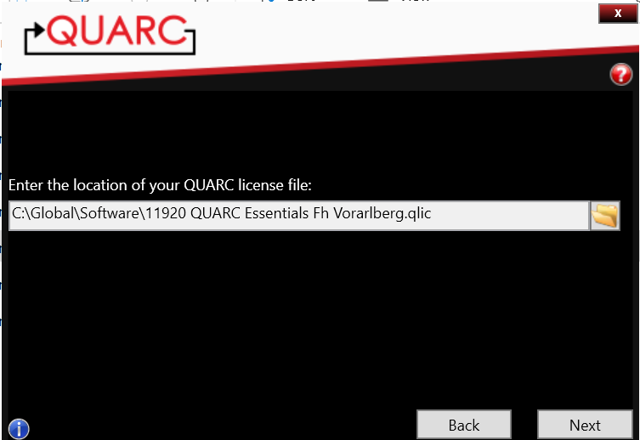

If the above order is followed, all dependencies should be fulfilled.
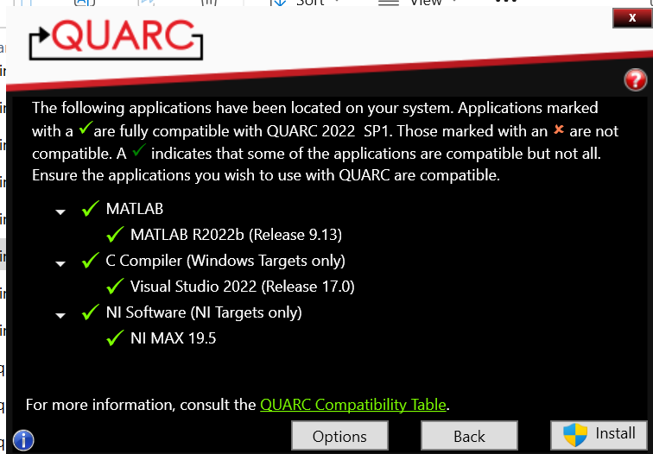
After successful installation, the included sample project in Simulink should look like this:
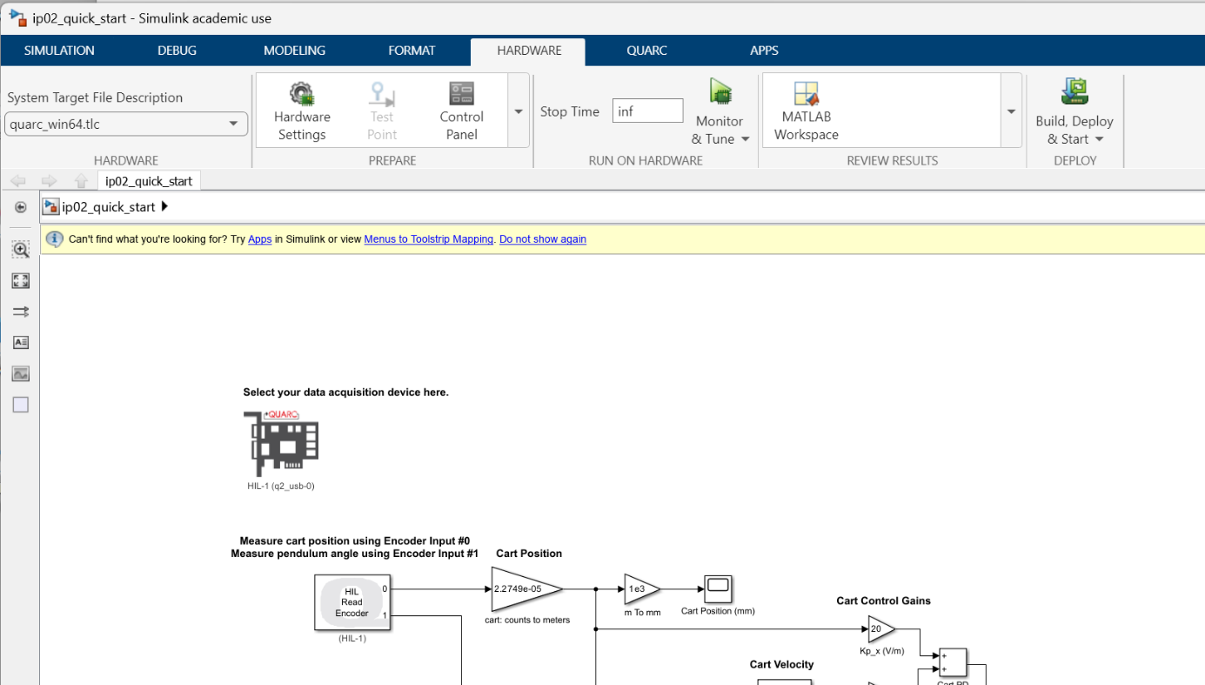

Troubleshooting

'Quarc_library' not found
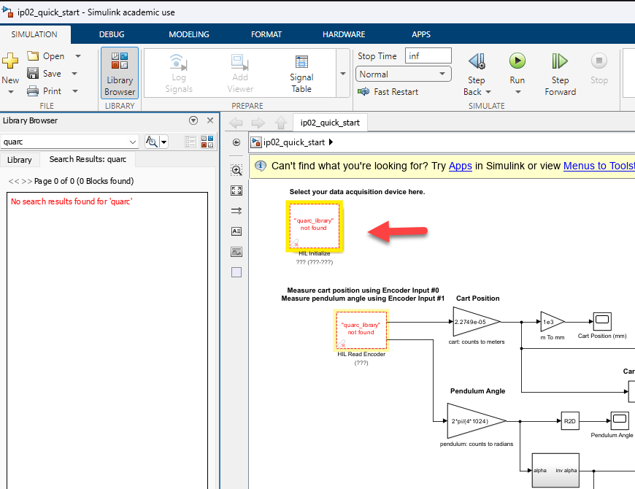
Solution according to: https://www.quanser.com/faq/im-getting-a-quarc_library-not-found-error-in-my-simulink-blocks/
The QUARC Real-Time Control software may not be installed or QUARC may have been installed before MATLAB. If QUARC was not installed, then close MATLAB and install the QUARC Real-Time Control software as instructed in the Quick Installation Guide. If QUARC was installed and MATLAB was installed after, then run the following commands:
cd(fullfile(getenv('QUARC_DIR'), 'quarc'));
quarc_setup;
This function adds the QUARC Targets library to the MATLAB path and updates the MATLAB documentation. It also performs other setup tasks to make QUARC fully functional in MATLAB and Simulink.

