

Operation Guide: Linear Pendulum Gantry

Control Engineering - Semester Project

*This guide assumes installations are done beforehand and only considers basic understanding of the setup without control methods*

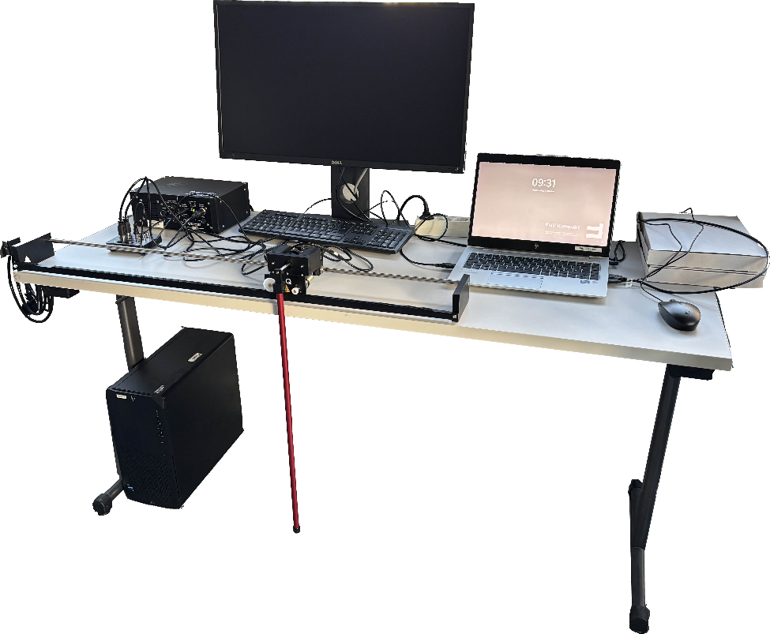Setup

Ensure the necessary parts   
are available:

* Quanser VoltPAQ-X1  
  (Linear Voltage Amplifier)
* Quanser Q2-USB (USB   
  Data Acquisition Board)
* Gantry with Cart and Pendulum
* Laptop:
* With MATLAB R2022b
* Signal connections:
* Encoder 0 (Q2-USB) $↔$ CART ENC (Cart backside)
* Encoder 1 (Q2-USB) $↔$ PEND ENC (Cart backside)
* DAC 0 (Q2-USB) $↔$ Amplifier Command (VoltPAQ-X1)
* Q2-USB Port $↔$ Laptop USB Port

As of writing this guide the computer setup is with the monitor connected to both   
the stationary computer using DisplayPort *(not used)* and the **laptop using HDMI, which can be used for operation of the system if desired.**

$↑$ Switch by pressing 2nd button from the left (bottom of monitor) twice, then select desired port

**Operation Procedure**

1. Log onto laptop with FHV student email (*example* [*fhv1234@students.fhv*](mailto:fhv1234@students.fhv)*)*
2. Connect to Wi-Fi with personal student credentials
3. Open MATLAB R2022b
   * If windows open that cannot be moved with the cursor, press ALT+spacebar, then m. After this you can move it with the arrow keys.
4. A close-up of a machine

   AI-generated content may be incorrect.Verify 1x amplifier gain is selected (not 3x) with the physical switch on the front of the voltage amplifier (Quanser VoltPAQ X-1)
5. Keep the rack secure with clamps (not shown in image above, but in the small image to the right).   
   Due to the limited space in the aLab, this is only done at the left end plate as it would obstruct the workspace of the pendulum on the right
6. Turn on voltage amplifier with the switch in the back  
   (triangle LED turns green while active)
7. Check analog read/write with **Quarc Read/Write Demo**
   1. Open quarc_read_write_demo_TLS.slx

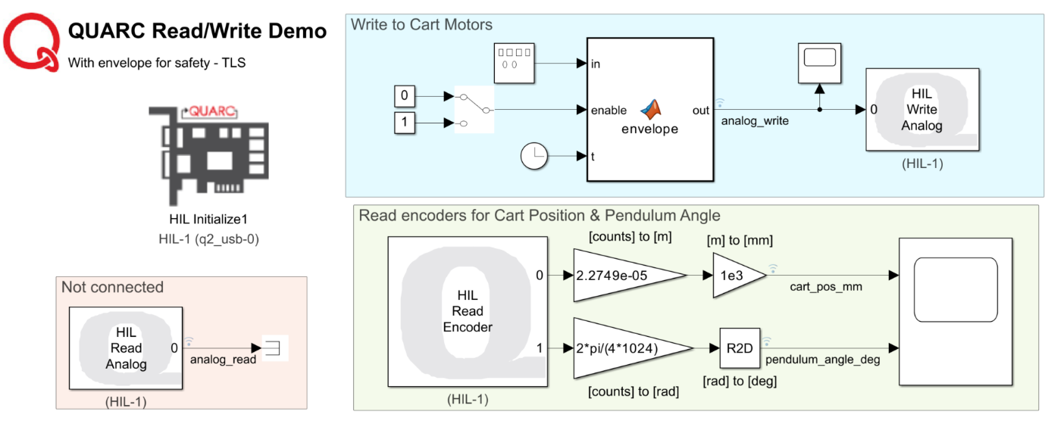

* + - This is a basic model without control, used to test analog outputs (cart motors) and encoder inputs (cart position and pendulum angle)
    - *An envelope was implemented for safety regulations as the system is slow and often unresponsive for the first seconds during startup. This prevents step inputs by multiplying the signal generator with a scalar going smoothly from 0 to 100%, and can be cancelled anytime by setting the manual switch to 0*
    - Original Quarc demos can be found by running qc_show_demos in MATLAB terminal (take care as these do not have the same safety measures as the envelope function)
  1. Ensure correct board type in the “HIL Initialize” block: q2_usb
  2. Observe signals in either of the following (during/after simulation):
     + Scope
     + Simulation $→$ Data Inspector
  3. Start with manual switch (software) at 0
  4. **Start simulation:**  
     HARDWARE $→$ RUN ON HARDWARE $→$ Monitor & Tune
  5. Configure desired values in “Signal Generator” block:

Input values range from -10 [V] to +10 [V]  
(be careful: start small, e.g. amplitude = 1 [V] and frequency = 1 [Hz])

* 1. Flip manual switch to 1 when ready to test signal
  2. Stop the current output value by toggling the manual switch to 0 again.
  3. Continue testing with steps 7f to 7h until satisfied
  4. **Stop simulation:** HARDWARE $→$ RUN ON HARDWARE $→$ Stop

1. With the “Quarc Read/Write Demo” complete, the student should have a basic understanding of the systems inputs/outputs and can move on to control engineering tasks.