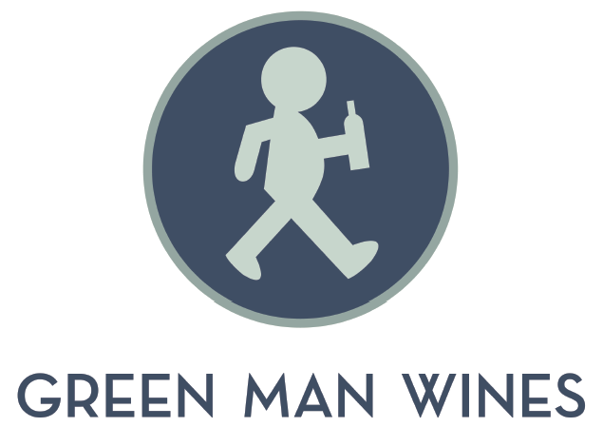
Food Menu

Smaller Plates
Mixed olives €4
Manchego w/ honey €5.50
Pintxo of smoked chicken breast w/ sun-dried tomato pesto €6
Smoked duck magret w/ paprika €7.50
Comte w/strawberry jam €7.50
Gambas w/ aioli €12

Bigger Plates
½ Fuet w/ olives & bread €6.50
Breads & dips €7
(hummus, pesto, aubergine & red pepper pate)
½ Spicy chorizo w/ olives & bread €7
Chicken liver pâté w/ bread & fig chutney €10.50
Cheese board €16
Charcuterie board €16
Smoked fish board €16

Hot Plates
Chistorra €7.50
Spicey Spanish Chorizo €8.50
Spanish Chorizo €8.50
Morcilla €8.50

Sweet Plates
Tiramisu €5.50
Chocolate and Orange Mousse €5.50

Please let us know if you have any food intolerances/allergies
Last food orders 10 pm (8:30 Sunday)
All our beef is 100% Irish,Our eggs are Irish Free range.

