PRD & Technical Design
Auth Service SNAP Keamanan

Portfolio Payment Platform — Java Spring Boot, MySQL, Docker
Generated: 2026-04-30

Dokumen ini dibuat sebagai baseline PRD, HLD, System Design, LLD, ERD, business logic, test case, dan Postman Collection untuk auth-service berbasis SNAP Keamanan. Dokumen menggunakan Payment_Platform_Documentation.docx sebagai konteks project portfolio dan halaman ASPI SNAP Keamanan sebagai acuan security API.

1. Executive Summary
Auth-service adalah service pusat untuk autentikasi dan otorisasi partner/merchant dalam payment platform portfolio. Fokus MVP adalah implementasi Access Token B2B sesuai pola SNAP Keamanan, termasuk validasi signature asymmetric SHA256withRSA, penerbitan Bearer token, audit log, dan standar response code SNAP.
Area | Keputusan
Primary use case | Merchant/partner meminta access token B2B sebelum hit API payment, inquiry, callback verification, atau status check.
MVP | Access Token B2B, JWT issuance, signature validation, client onboarding data model, audit log, Postman test collection.
Non-MVP / phase 2 | B2B2C authorization code/refresh token lengkap, dashboard admin, key rotation UI, rate limiter distributed Redis.
Core value portfolio | Menunjukkan kemampuan payment security, system design, auditability, testability, dan implementasi backend production-like.

2. Analisa SNAP Keamanan
Berdasarkan halaman SNAP Keamanan, area yang perlu diturunkan ke auth-service adalah sebagai berikut.
Section | Analisa untuk Auth Service
Overview | SNAP Keamanan menekankan standar keamanan akses API, authentication, authorization, signature, access token, dan struktur response code. Auth-service harus menjadi boundary pertama untuk partner yang membutuhkan token dan validasi signature.
Guides | Guides memisahkan pola signature auth, signature service, access token B2B, dan B2B2C. Untuk MVP portfolio, prioritas adalah Access Token B2B dan signature auth. Signature service dapat dibuat sebagai internal utility/helper untuk service lain.
Code Snippets | Code snippets menunjukkan contoh pembentukan signature dan request SNAP. Implementasi Java harus memisahkan utility signing/verifying agar bisa dites unit secara deterministik.
Response Code | Response code dibentuk dari HTTP status code + service code + case code. Untuk Access Token B2B service code yang dipakai adalah 73, sehingga success menjadi 2007300.

3. Product Requirements

3.1 Goals
- Menyediakan token endpoint yang dapat digunakan oleh merchant/partner untuk mendapatkan Bearer token.
- Memvalidasi X-CLIENT-KEY, X-TIMESTAMP, dan X-SIGNATURE sesuai pola SNAP.
- Menyimpan audit trail tanpa menyimpan raw secret, raw token, atau private key partner.
- Menyediakan struktur kode yang mudah dikembangkan ke B2B2C, introspection, dashboard admin, dan key rotation.
- Menyediakan Postman Collection dan test cases sehingga recruiter/klien dapat mencoba flow secara langsung.

3.2 Non-Goals
- Tidak mengimplementasikan core transaction payment pada auth-service.
- Tidak menyimpan private key milik partner.
- Tidak menjadikan endpoint dev utility signature aktif di production.
- Tidak menggantikan API Gateway/WAF; auth-service bekerja di belakang perimeter tersebut.

3.3 Actors
Actor | Role
Merchant / Partner | Meminta access token dan menggunakan token untuk API payment platform.
Backoffice Admin | Melakukan onboarding client, public key, scope, status, dan IP policy.
Core Payment Service | Memvalidasi JWT atau melakukan introspection saat memproses API payment.
Ops / Security | Melihat audit log, response code, error spike, signature failure, dan suspicious replay.

4. Rekomendasi Dependencies Spring
Dependency | Alasan Digunakan
spring-boot-starter-web | Membuat REST API token, introspection, utility, dan actuator exposure melalui Spring MVC.
spring-boot-starter-validation | Validasi DTO/header/body seperti grantType, timestamp, clientId, format request, dan mandatory fields.
spring-boot-starter-security | Filter chain, authentication entry point, protected internal endpoint, password/secret encoder, dan hardening default security.
spring-boot-starter-oauth2-resource-server | Validasi JWT Bearer token untuk endpoint internal/protected dan integrasi decoder berbasis Nimbus.
spring-boot-starter-data-jpa | Persistence untuk client, key, scope, token metadata, audit log, dan response code mapping.
mysql-connector-j | Driver koneksi MySQL untuk auth_db.
flyway-core + flyway-mysql | Schema migration versioned agar ERD/DDL dapat direproduksi di local, CI, dan deployment Docker.
spring-boot-starter-actuator | Health check, readiness/liveness, metrics, dan observability production-like.
micrometer-registry-prometheus | Expose metrics ke Prometheus/Grafana.
springdoc-openapi-starter-webmvc-ui | Swagger/OpenAPI documentation untuk portfolio dan testing manual.
caffeine | Cache public key/client config dan replay cache lokal untuk mengurangi query berulang.
lombok / mapstruct | Opsional: mengurangi boilerplate DTO/entity dan mapping response.
testcontainers-mysql, spring-security-test, rest-assured | Integration test realistis dengan MySQL container, security context, dan API-level assertion.

Catatan security: credential database, JWT private key, dan client secret tidak disimpan di application.properties repository. Gunakan environment variable, Docker secret, Jenkins credential, atau secret manager.

5. ERD
ERD berikut menjaga pemisahan konfigurasi client, public key, token metadata, audit log, dan response code mapping. Semua table memiliki minimal id, created_at, updated_at, created_by, dan updated_by.
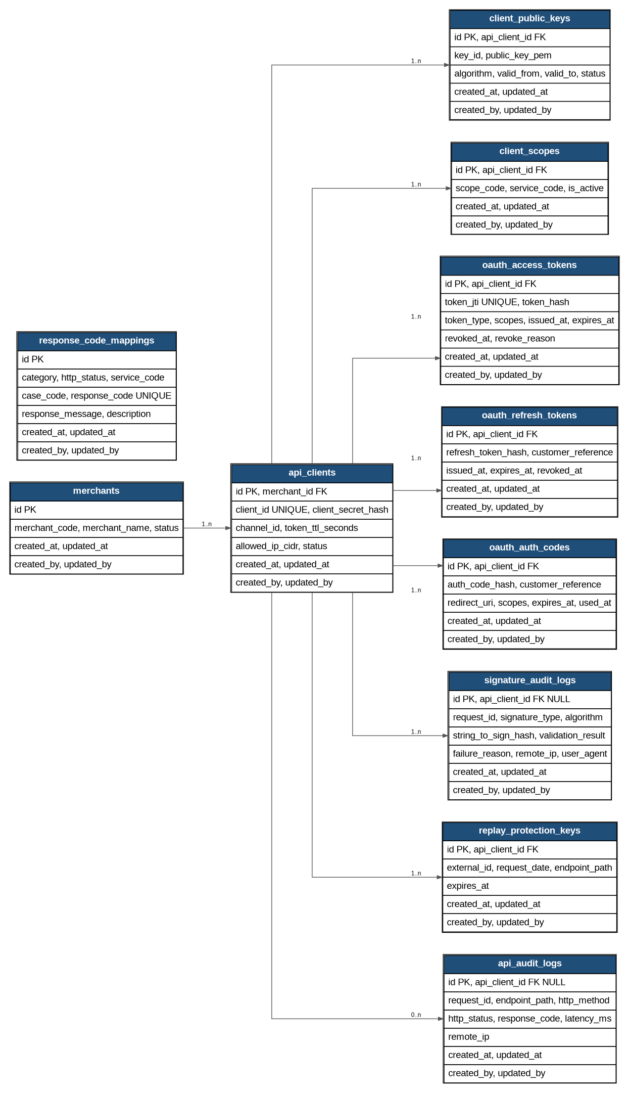

5.1 Tabel Utama
Table | Purpose | Kolom penting
merchants | Master merchant/partner owner | merchant_code, merchant_name, status
api_clients | Credential logical client per merchant | client_id, client_secret_hash, channel_id, allowed_ip_cidr, token_ttl_seconds, status
client_public_keys | Public key partner untuk verify X-SIGNATURE | key_id, public_key_pem, algorithm, valid_from, valid_to, status
client_scopes | Authorization scope/API access | scope_code, service_code, is_active
oauth_access_tokens | Metadata token yang diterbitkan | token_jti, token_hash, scopes, expires_at, revoked_at
oauth_auth_codes | Phase 2 B2B2C authorization code | auth_code_hash, customer_reference, redirect_uri, expires_at, used_at
oauth_refresh_tokens | Phase 2 B2B2C refresh token | refresh_token_hash, customer_reference, expires_at, revoked_at
signature_audit_logs | Audit validasi signature | request_id, signature_type, string_to_sign_hash, validation_result, failure_reason
replay_protection_keys | Mencegah replay request dengan external ID | external_id, request_date, endpoint_path, expires_at
api_audit_logs | Audit semua request/response auth-service | request_id, endpoint_path, http_status, response_code, latency_ms
response_code_mappings | Mapping response code SNAP | http_status, service_code, case_code, response_code, response_message

6. High-Level Architecture
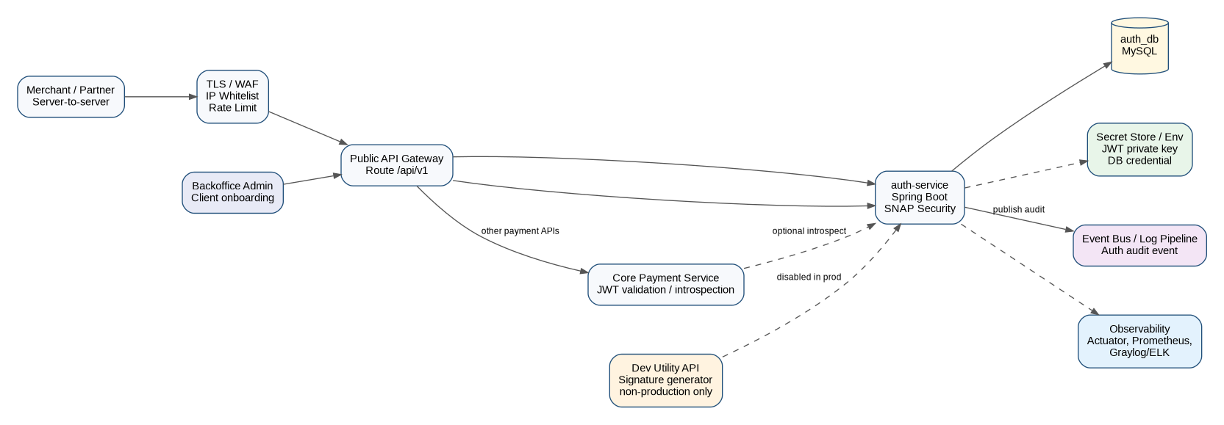
Auth-service berada di belakang API Gateway/WAF. Service ini tidak langsung memproses transaksi; tugasnya menerbitkan token, memvalidasi signature, dan menyediakan data audit/observability untuk kebutuhan operasional.

7. System Design

7.1 Access Token B2B Flow
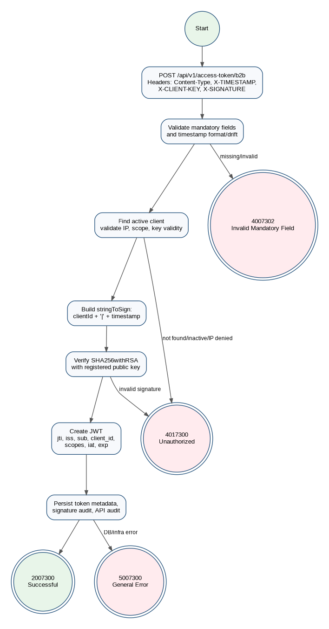

7.2 API Contract MVP
Endpoint | Method | Purpose | Scope
/api/v1/access-token/b2b | POST | Issue Bearer access token untuk partner B2B | Public via gateway
/internal/v1/tokens/introspect | POST | Validasi token oleh internal service | Internal only
/internal/v1/signatures/verify | POST | Verify signature service/HMAC untuk internal service | Internal only
/api/v1/utilities/signature-auth | POST | Generate signature auth untuk testing Postman/dev | Dev profile only
/actuator/health | GET | Health check | Ops

7.3 Request/Response Access Token B2B
Request header wajib: Content-Type=application/json, X-TIMESTAMP, X-CLIENT-KEY, X-SIGNATURE.
Request body:
{
"grantType": "client_credentials",
"additionalInfo": {}
}
Success response contoh:
{
"responseCode": "2007300",
"responseMessage": "Successful",
"accessToken": "<jwt>",
"tokenType": "Bearer",
"expiresIn": "900"
}

8. Business Logic
Step | Logic | Failure Response
1 | Validate Content-Type, body JSON, grantType=client_credentials, X-TIMESTAMP, X-CLIENT-KEY, X-SIGNATURE. | 4007302
2 | Validate timestamp format ISO-8601 with timezone dan toleransi clock skew, misalnya ±5 menit. | 4007302 / 4017300
3 | Load api_client by client_id; pastikan ACTIVE, IP allowed, scope aktif, dan public key belum expired. | 4017300
4 | Build stringToSign = clientId + '|' + X-TIMESTAMP. | 4017300 jika format tidak bisa dibuat
5 | Verify X-SIGNATURE menggunakan SHA256withRSA dan public key partner. | 4017300
6 | Generate JWT dengan jti, issuer, subject/client_id, scopes, channel_id, iat, exp. | 5007300 jika signing key gagal
7 | Hash token/JTI metadata, simpan oauth_access_tokens dan audit logs. | 5007300 jika DB gagal
8 | Return SNAP response code 2007300 dan tokenType Bearer. | -

9. Service Architecture / Layered Architecture
Layer | Package | Responsibility
Interface / Controller | com.portfolio.authservice.interfaces.rest | REST controller, DTO request/response, header binding, request id.
Application | com.portfolio.authservice.application | Use case orchestration: issue token, introspection, signature verify.
Domain | com.portfolio.authservice.domain | Domain model, value object, policy: ClientStatus, TokenPolicy, SignaturePolicy.
Infrastructure | com.portfolio.authservice.infrastructure | JPA repository, DB entity, JWT/Nimbus adapter, crypto adapter, cache adapter.
Common | com.portfolio.authservice.common | Error handling, SNAP response mapper, constants, clock provider, correlation ID.
Config | com.portfolio.authservice.config | SecurityConfig, JwtConfig, OpenApiConfig, Async/Audit config.

10. Low-Level Design (LLD)
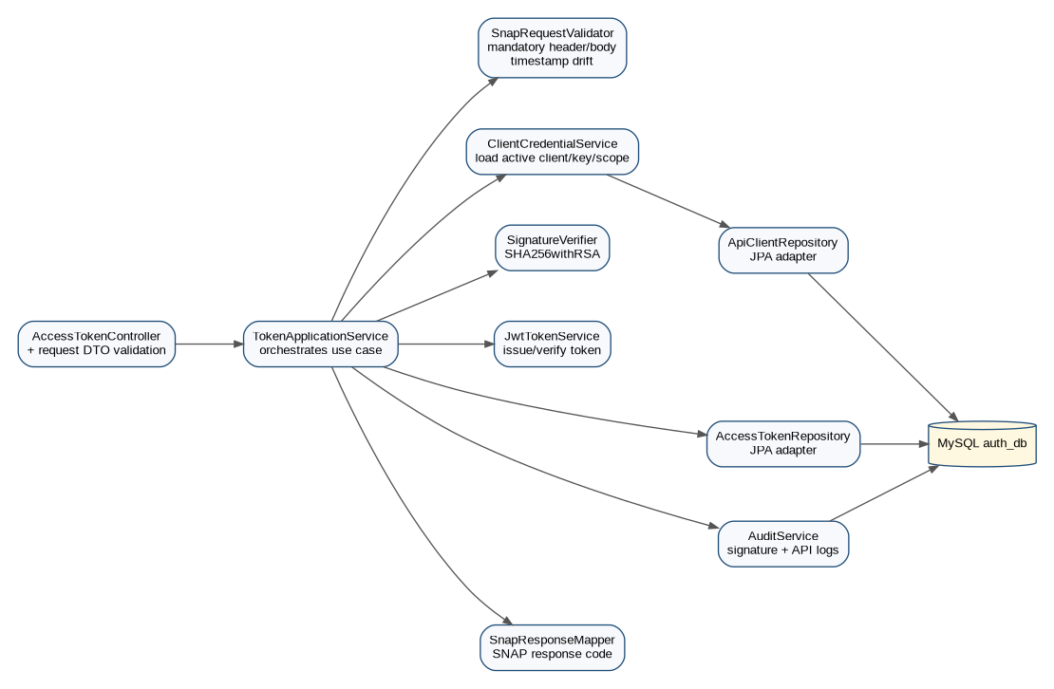

10.1 Package Structure
src/main/java/com/portfolio/authservice
├── AuthServiceApplication.java
├── config
│ ├── SecurityConfig.java
│ ├── JwtProperties.java
│ ├── OpenApiConfig.java
│ └── ClockConfig.java
├── interfaces/rest
│ ├── AccessTokenController.java
│ ├── InternalTokenController.java
│ ├── InternalSignatureController.java
│ ├── DevUtilityController.java
│ └── dto
├── application
│ ├── TokenApplicationService.java
│ ├── SignatureApplicationService.java
│ ├── IntrospectionService.java
│ └── AuditService.java
├── domain
│ ├── model
│ ├── policy
│ ├── exception
│ └── port
├── infrastructure
│ ├── persistence/entity
│ ├── persistence/repository
│ ├── security
│ └── cache
└── common
├── error
├── response
└── util

10.2 Class Responsibility
Class/Component | Method Utama | Responsibility
AccessTokenController | getB2BToken(headers, request) | Bind request, call TokenApplicationService, return SNAP response.
TokenApplicationService | issueB2BToken(command) | Orchestrate validation, client lookup, signature verification, JWT issuance, audit.
SnapRequestValidator | validateMandatoryFields(command) | Validasi mandatory fields, timestamp, grant type, content type.
ClientCredentialService | loadActiveClient(clientId, remoteIp) | Load client, public key, scopes; enforce status/IP/key validity.
SignatureVerifier | verifySha256WithRsa(stringToSign, signature, publicKeyPem) | Verify asymmetric signature for token request.
JwtTokenService | issueAccessToken(client, scopes) | Create JWT signed by service key and calculate expiresIn.
TokenMetadataRepository | save(tokenMetadata) | Persist token hash/JTI for audit and revocation.
AuditService | recordSignature(), recordApi() | Persist request/response audit and failure reason.
SnapResponseMapper | success(), error(exception) | Map exception to responseCode/responseMessage.
GlobalExceptionHandler | handle(Exception) | Ensure all failures return standard SNAP response envelope.

10.3 DTO Design
DTO | Fields
AccessTokenB2BRequest | grantType:String, additionalInfo:Map<String,Object>
AccessTokenB2BResponse | responseCode:String, responseMessage:String, accessToken:String, tokenType:String, expiresIn:String, additionalInfo:Map
TokenCommand | clientId, timestamp, signature, grantType, remoteIp, userAgent, requestId
ClientCredential | id, clientId, merchantCode, channelId, status, tokenTtlSeconds, scopes, publicKeys
TokenMetadata | tokenJti, tokenHash, apiClientId, scopes, issuedAt, expiresAt, revokedAt
SnapErrorResponse | responseCode, responseMessage, additionalInfo

10.4 Pseudocode TokenApplicationService
public AccessTokenB2BResponse issueB2BToken(TokenCommand cmd) {
validator.validateMandatoryFields(cmd);
validator.validateTimestamp(cmd.timestamp(), maxClockSkew);
ClientCredential client = clientCredentialService.loadActiveClient(cmd.clientId(), cmd.remoteIp());
String stringToSign = cmd.clientId() + "|" + cmd.timestamp();
signatureVerifier.verifySha256WithRsa(
stringToSign,
cmd.signature(),
client.activePublicKeyPem()
);
JwtToken token = jwtTokenService.issueAccessToken(client, client.scopes());
tokenMetadataRepository.save(token.toMetadata(client.id()));
auditService.recordSuccess(cmd.requestId(), client.id(), "2007300");
return SnapResponse.successB2BToken(token.value(), token.expiresIn());
}

10.5 Sequence Detail per Failure Path
Failure | Detected By | Handling
Missing header/body | SnapRequestValidator | Throw SnapValidationException -> 4007302
Timestamp expired | SnapRequestValidator | Throw SnapUnauthorizedException or validation exception based on implementation decision -> audit failure
Unknown client | ClientCredentialService | Do not reveal whether client exists; return 4017300
Inactive key | ClientCredentialService | Return 4017300 and audit failure_reason=KEY_INACTIVE
Invalid signature | SignatureVerifier | Return 4017300 and store string_to_sign_hash only
JWT signing failed | JwtTokenService | Return 5007300; alert ops
DB insert audit failed | AuditService/Repository | For token metadata failure return 5007300; for non-critical audit failure use async retry if available

11. Response Code Strategy
Format response code mengikuti pola: HTTP status code + service code + case code. Untuk Access Token B2B, service code adalah 73.
Scenario | HTTP | Service Code | Case Code | Response Code | Message
Success issue token | 200 | 73 | 00 | 2007300 | Successful
Malformed JSON / invalid mandatory field | 400 | 73 | 02 | 4007302 | Invalid Mandatory Field
Invalid client/signature/IP policy | 401 | 73 | 00 | 4017300 | Unauthorized
Token expired/invalid on internal protected endpoint | 401 | 73 | 01 | 4017301 | Invalid Token
Forbidden scope | 403 | 73 | 00 | 4037300 | Forbidden
Duplicate/replay request | 409 | 73 | 00 | 4097300 | Conflict
Unexpected server error | 500 | 73 | 00 | 5007300 | General Error

12. Test Case

12.1 Positive Test
ID | Case | Input | Expected
TC-P01 | Valid Access Token B2B | Header lengkap, client aktif, signature valid | HTTP 200, responseCode 2007300, accessToken terisi
TC-P02 | Public key valid range | valid_from <= now <= valid_to | Token issued
TC-P03 | Multiple scopes | client punya lebih dari satu scope | JWT claim scope berisi semua scope aktif
TC-P04 | Token introspection active | Token belum expired/revoked | active=true
TC-P05 | Health check | DB up | /actuator/health UP

12.2 Negative Test
ID | Case | Input | Expected
TC-N01 | Missing X-SIGNATURE | Header signature kosong | 4007302
TC-N02 | Invalid grantType | grantType selain client_credentials | 4007302
TC-N03 | Malformed JSON | Body tidak valid JSON | 4007302
TC-N04 | Timestamp expired | X-TIMESTAMP di luar toleransi | 4017300/4007302 sesuai mapper
TC-N05 | Unknown client | X-CLIENT-KEY tidak terdaftar | 4017300
TC-N06 | Inactive client | status client INACTIVE | 4017300
TC-N07 | Invalid signature | Signature tidak match stringToSign | 4017300
TC-N08 | Expired public key | valid_to < now | 4017300
TC-N09 | IP not allowed | Remote IP di luar CIDR | 4017300
TC-N10 | DB unavailable | auth_db down | 5007300
TC-N11 | Token expired | Introspection token expired | active=false / 4017301
TC-N12 | Forbidden scope | Token valid tapi scope tidak sesuai | 4037300

13. Postman Collection
File Postman Collection dan Environment disediakan terpisah. Collection mencakup: generate signature auth untuk dev, access token B2B positive, access token B2B invalid signature, token introspection, internal HMAC verification example, dan health check.
Catatan: Postman Sandbox tidak selalu praktis untuk RSA SHA256 signing tanpa library tambahan. Untuk local development, gunakan endpoint dev utility /api/v1/utilities/signature-auth, CLI helper, atau paste signature hasil generate ke variable x_signature_auth. Endpoint utility wajib disabled pada profile production.

14. Observability, Security, and Deployment
Area | Recommendation
Secrets | DB credential, JWT private key, client secret disediakan via env/secret manager; jangan commit ke repository.
Logging | Gunakan correlation/request id. Jangan log raw token, raw secret, raw signature, private key, atau full Authorization header.
Audit | Simpan hash stringToSign dan failure_reason untuk investigasi tanpa membocorkan payload sensitif.
Metrics | Expose count token success/failure, latency p95/p99, invalid signature count, unauthorized count, DB error count.
Deployment | Docker image non-root, readiness/liveness actuator, resource limit, profile-based config.
Database | Gunakan Flyway migration, index pada client_id, token_jti, expires_at, request_id, api_client_id+created_at.
Rate limit | Taruh basic rate limit di API Gateway; phase 2 tambahkan Redis/Bucket4j jika perlu distributed limiter.
Key rotation | Support multiple public keys per client dengan key_id dan valid_from/valid_to.

15. Implementation Roadmap
Milestone | Scope | Output
M1 - Project Bootstrap | Spring Boot, package structure, Docker Compose MySQL, Flyway baseline | Repo running local
M2 - Data Model | Entity, repository, seed merchant/client/key/scope/response code | ERD implemented
M3 - Signature Auth | SHA256withRSA verifier, timestamp validator, unit tests | Signature tests pass
M4 - Token Issuance | B2B endpoint, JWT service, token metadata | Postman positive works
M5 - Error Mapping & Audit | SNAP response mapper, audit log, global exception handler | Negative tests work
M6 - Internal APIs | Introspection and signature verify internal | Core service ready integration
M7 - Observability | Actuator, Prometheus metrics, OpenAPI | Production-like readiness
M8 - Documentation | README, PRD, Postman, test report | Portfolio-ready GitHub

16. Acceptance Criteria
- Access Token B2B dengan signature valid menghasilkan responseCode 2007300.
- Signature invalid, unknown client, inactive key, dan timestamp invalid menghasilkan responseCode yang konsisten serta audit log tercatat.
- Tidak ada raw token/secret/private key yang tersimpan di database atau log.
- Schema dapat dibuat ulang menggunakan Flyway/SQL.
- Postman Collection dapat digunakan untuk demo local.
- README menjelaskan cara run local, generate key pair, seed client, dan test flow.
- Minimal unit test untuk SignatureVerifier, JwtTokenService, SnapResponseMapper, dan TokenApplicationService.

17. References
- Payment_Platform_Documentation.docx — dokumen dasar project portfolio.
- ASPI API Dev Portal — SNAP Keamanan: https://apidevportal.aspi-indonesia.or.id/api-services/keamanan
- Spring Boot Reference — Spring Web MVC, Actuator, SQL Databases.
- Spring Security Reference — OAuth2 Resource Server JWT.
- Spring Data JPA Reference — JPA repositories.

