DBS Lab 2

Name: Russell Schlup

1. Perform a SQL Dump of your example database using Sequel Pro. (1pt)

2. Create a new user (as yourself) by inserting into the users table. As the userId is a varchar, choose a random, but unique value. Paste the SQL below. (1pt)

3. Create 2 new orders for the user created in question 2 by inserting into the orders and orderItem tables. Place at least 1 item per order. Paste the SQL below. (1pt)

4. Assign 2 DVDs to the user created in question 2. Paste the SQL below. (1pt)

5. Assign 2 vehicles to the user created in question 2. Paste the SQL below. (1pt)

6. Write a SQL statement to return the users (userId, firstname, lastname) and their orders (orderId), only for users that have placed an order. Paste the SQL below.(2pt)

7. Write a SQL statement to return all users (limit 200) and orders if available. Paste SQL below. (2pt)

8. Write a SQL statement to return all users (userId, firstname, lastname) who have not placed an order. (limit 200) Paste SQL below. (2pt)

9. Write a SQL statement to return all orders (orderId, orderDate), the information of the user who placed the order (userId, firstName, Lastname), and their items ordered and quantities (itemName, quantity). (limit 200)Paste the SQL below. (2pt)

10. Alter the order table to add a column called “destinationState” and populate the existing orders with state abbreviations from the states table. Paste the alter SQL statement below. (2pt)

11. Create a foreign key between the tables, state and orders. IE: From table states, column state to table order table, column destinationState. FK always point at a FK. Paste SQL (alter table) below. (2pt)

12. Select all users who have a lastname of “Steady” and display their full name as a single field. Paste SQL below and the time the query ran. (2pt)

13. Create an index on the last name column for the users table. Paste SQL below. (2pt)

14. Rerun the query from question 12. Paste SQL below and the time the query ran. (1pt)

15. Get the count of all users with a last name ending in “ing”. Paste SQL and results below. (2pt)

16. Get the count of all users with a first name starting with “J” and who are employed. Users who do not have an occupation are considered unemployed. Paste SQL and results below. (2pt)

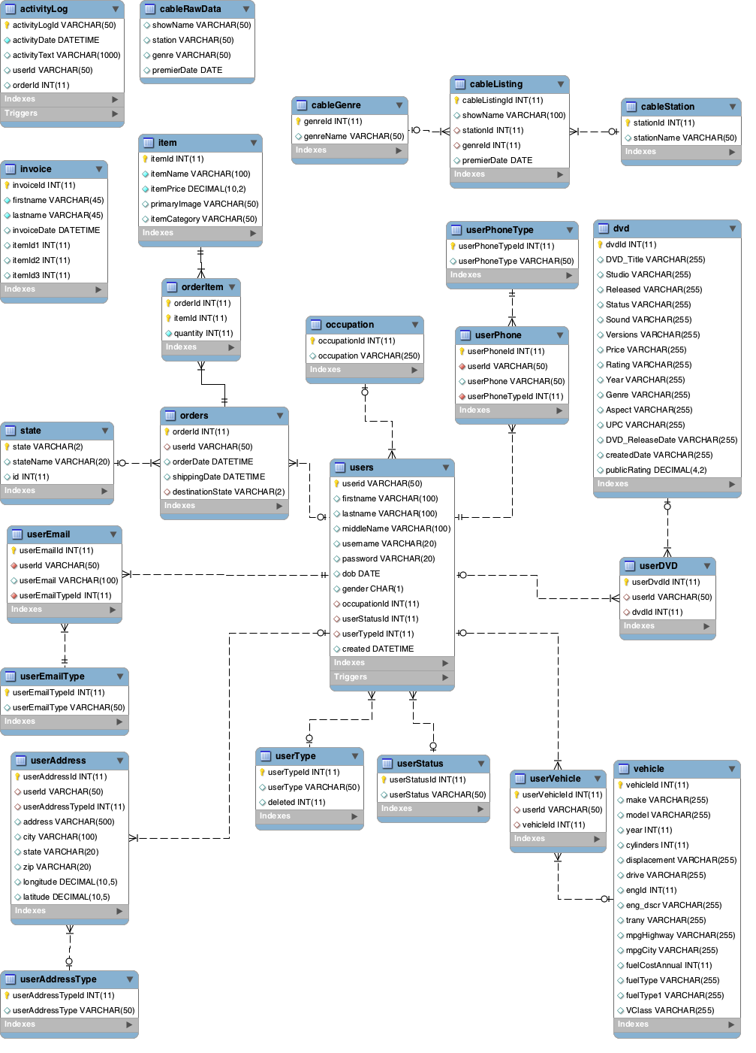
17. Create an ER diagram of the database using MySQL Workbench. Export the diagram as an image. (2pt)
You should be submitting this word doc, an ER Diagram image and a SQL dump.
When submitting this Lab in GitHub, create a directory and place all files inside.

