const int in_1_rud = A0; // PC0 - ADC0 - PCINT8

const int in_2_thr = A1; // PC1 - ADC1 - PCINT9

const int in_3_ele = A2; // PC2 - ADC2 - PCINT10

const int in_4_ail = A3; // PC3 - ADC3 - PCINT11

const int in_5_tbd = 2; // PD2 - INT0 - PCINT18

const int in_6_mode = 3; // PD3 - OC2B - INT1 -PCINT19

const int adc_6 = A6; // ADC6

const int adc_7 = A7; // ADC7

const int out_1_rud = 6; // OCR0A - PD6

const int out_2_thr = 5; // OCR0B - PD5

const int out_3_ele = 9; // OCR1A - PB1

const int out_4_ail = 10; // OCR1B - PB2

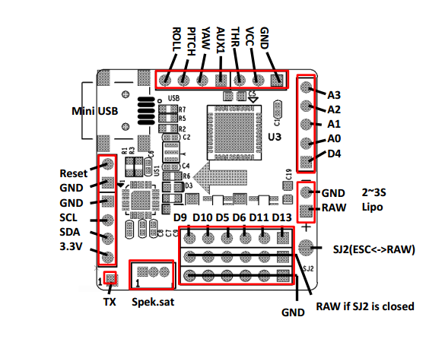

M5 (sv)

M1 (li)

M2 (re)

M3 (hi)