Collecting Details

**Custom Administration Plugin**  
**Purpose:**

The plugin is designed to assist Polarion Admins to check details of all customized objects.   
Instead of the admin having to navigate through each module individually, the plugin consolidates and presents all customized object details in a single module.

**Displaying Customized Object Details In Custom Administration Plugin:**

# User Managment Customization

## Custom Roles

**Description:**

The provided image serves as a reference for displaying custom roles on the Admin Page within a table view. Two attributes, namely roleId and roleName, have been incorporated into the table for this purpose.

​​

[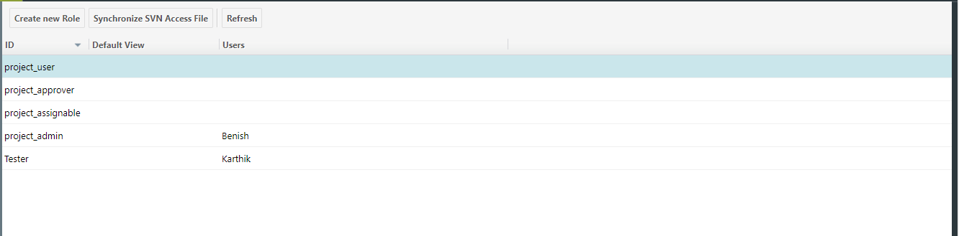](http://denbg0415vm.izd01.in/polarion/module-attachment/TestProject/_default/CollectingDetails/1-screenshot-20240123-110605.png?revision=4179)

**How to Achieve:**

Using the Open Java API, we retrieve all roles, filter out the default roles, and subsequently transmit the roles that have been created.

​​

## Created Users

**Description:**

The provided image serves as a reference for displaying created users on the Admin Page within a table view. Two attributes, namely userId and userName, have been incorporated into the table for this purpose.

[](http://denbg0415vm.izd01.in/polarion/module-attachment/TestProject/_default/CollectingDetails/1-screenshot-20240123-110605.png?revision=4179)  
**How to Achieve:**

Using the Open Java API, we retrieve all user, filter out the default user, and subsequently transmit the user that have been created.

## User Groups details (Users,projects,project roles)

**Description:**

Displaying the Custom User Groups Details like below Image. below image we can see the details of user group, so we need to display those details on administration page. admin can see those details on page.

[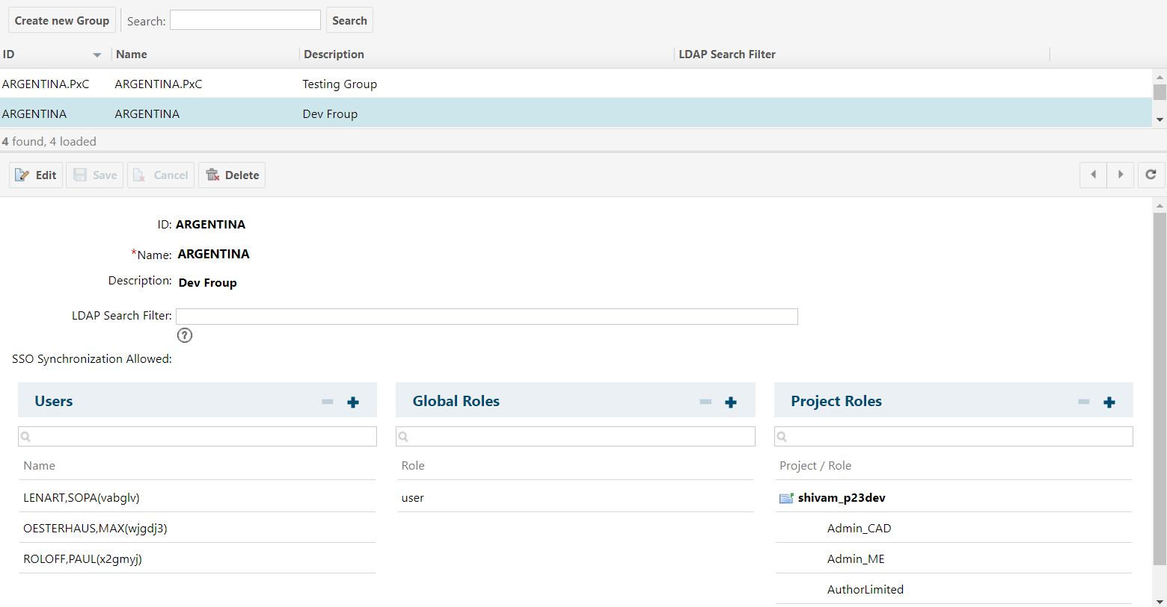](http://denbg0415vm.izd01.in/polarion/module-attachment/TestProject/_default/CollectingDetails/2-screenshot-20240123-173746.png?revision=4185)

**How to Achieve:**

1. First we need to get all details of Group (id,name,description,LDAP search filter).

   Using this api/method we can get the details of group: -[IPObjectList](https://testdrive.polarion.com/polarion/sdk/doc/javadoc/com/polarion/platform/persistence/model/IPObjectList.html)< [IUserGroup](https://testdrive.polarion.com/polarion/sdk/doc/javadoc/com/polarion/alm/projects/model/IUserGroup.html)> getUserGroups()

​​

# WorkItem Customization

## Custom WorkItemType

**Description:**

Display the project configuration type and global configuration in the table below to help identify custom types in the project. When the user clicks "show," redirect to the Work Item Type page, where created custom work item types are presented in a format similar to the table below.

​​

​​

​​

|  |  |
| --- | --- |
| Configuration | Display Custom WorKItem Type Details |
| defaultWorkItemType |  |
| CustomWorkItemType |  |

​​

**CustomWorkItemType**

|  |  |  |
| --- | --- | --- |
| Id | Name | Description |
| vvRequirement | VVRequirement | verification & Validation |
| ​ | ​ | ​ |

**How to Achieve:**

Use the OpenJava API to retrieve both the default work item type and custom types associated with the project.

​​

## WorkItem Type Custom Fields

**Description:**

Retrieve all custom fields for each type and present them in a table format, similar to the screenshot below. In the last column of each type, include a "Show" button. When a user clicks the "Show" button, it redirects to another page where the custom fields for that type are displayed

​​

|  |  |  |  |
| --- | --- | --- | --- |
| **workItemType** | **Configuration** | **Scope** | **Display CustomField Details** |
| Epic | Configuration set | projectConfiguration |  |
| UserStory | Configuration not set | Global Configuration |  |

​​

After clicking the button, the user will be taken to a custom details page where the information will be presented in a table view as shown below.

**Epic**

|  |  |  |  |
| --- | --- | --- | --- |
| **Id** | **Name** | **Type** | **Description** |
| genericTestName | GenericTestName | Enum | To Store the Heading of Generic Document |
| derivativeForm | DerivativeForm | String | ​ |

​​

**How to Achieve**

Utilizing the Open Java API's `getCustomField` method, retrieve all custom fields corresponding to their respective types. Display the details of these custom fields on a page,in table format like above one

​​

## WorkItem Type Custom Enumeration

Present all work item types in a table and showcase the custom enum details for each attribute within each type. Upon user click, redirect to the custom enum details page, displaying all custom enum options corresponding to the type along with their respective attributes.

​​

|  |  |  |  |  |
| --- | --- | --- | --- | --- |
| workItemType | Attribute | Configuration | Scope | Display CustomEnum Details |
| Epic | status resolution | Configuration set | projectConfiguration |  |
| UserStory | severity priority | Configuration not set | Global Configuration |  |

​​

**Epic-status**

|  |  |  |
| --- | --- | --- |
| Id | Name | Description |
| done | Done | ​ |
| verified | Verified | ​ |

​​

**Epic-resolution**

|  |  |  |
| --- | --- | --- |
| Id | Name | Description |
| duplicate | Duplicate | ​ |
| obselete | Obselete | ​ |

​​

​​

## WorkItem WorkFlow

### Script Condition

**Description:**

Show all workflow script condition files on the admin page, categorized by work item type and status. Present the information in tabular form, including the type and status of each work item, along with details on the attached script file for each specific status or action.

**Example:**

|  |  |  |
| --- | --- | --- |
| WorkItemType | Status/Actions | Script file name |
| Task | In-Review | autoAssignee.js |
| Requirement | Completed | autoSignature.js |

**How to Achieve:**

Utilizing the Open Java API to retrieve the script file linked with the workItem workflow action.

​​

|  |
| --- |
| **IWorkflowManager workflowManager = polarionConnector.getWorkflowManager();    IWorkflowScript[] workflowScripts = workflowManager.getAllWorkflowScripts();** |

​​

### Script Function

**Description:**

Show all workflow script function files on the admin page, categorized by work item type and status. Present the information in tabular form, including the type and status of each work item, along with details on the attached script file for each specific status or action.

**Example:**

|  |  |  |
| --- | --- | --- |
| WorkItemType | Status/Actions | Script file name |
| Task | In-Review | autoAssignee.js |
| Requirement | Completed | autoSignature.js |

**How to Achieve:**

Utilizing the Open Java API to retrieve the script file linked with the workItem workflow action.

Below Interface able to get Script Function

|  |
| --- |
| IWorkflowManager workflowManager = polarionConnector.getWorkflowManager();    IWorkflowScript[] workflowScripts = workflowManager.getAllWorkflowScripts(); |

## WorkItem Pre/ Post save Script

**Description:**

Display all the pre-save and post-save scripts in table form on admin page show all script whichever is present in workItemsave Directory

**Example:**

|  |  |  |  |  |
| --- | --- | --- | --- | --- |
| Directory | Project | type | pre-save scripts | post-save scripts |
| polarion/workItemSave | PistonAssembly | task | PistonAssembly-task-pre-save.js | PistonAssembly-task-post-save.js |
| ​ | ​ | ​ | ​ | ​ |

**How to Achieve:**

Retrieve the Polarion Home Directory using System.getProperty and navigate to the workItemsave location. Extract the details from there and render them on the admin page.

​​

# Document Customization

## Custom Document Type

**Description:**

Display the All-custom types of documents when we create the project in polarion that time some default type will created but any case client want custom type at that time we need to create that from administration so that custom types we need to show on admin page.

show all details in table form.(type ID,name and description)

**below image for reference how table will display:**

[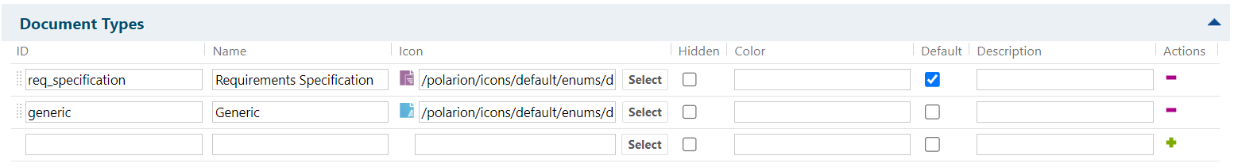](http://denbg0415vm.izd01.in/polarion/module-attachment/TestProject/_default/CollectingDetails/3-screenshot-20240123-180133.png?revision=4198)

**How to Achieve:**

1.

​​

## Document Custom Fields

**Description:**

Display the all document custom fields based on type on admin page whenever we have create any document at that time some default field will creating but whichever custom field user created that we need to show on admin page and that page should only access by admin.

[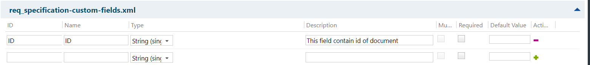](http://denbg0415vm.izd01.in/polarion/module-attachment/TestProject/_default/CollectingDetails/6-screenshot-20240123-184518.png?revision=4203)

**How to Achieve:**

Using below apis or method we can get all document custom fields.

|  |
| --- |
| **$trackerService.getDataService().getCustomFieldService().getDefineCustomFields("document",$contextId),$type;** |

​​

## Document WorkFlow

### Script Condition / Functions

**Description:**

Display all-workflow script condition file on admin page based on document type and status.

show in table form type of document status and which script file is attached into that particular status/Actions.

**Example:**

|  |  |  |
| --- | --- | --- |
| **Document type** | **Status/Actions** | **Script file name** |
| generic | In-Review | incrementVersion.js |
| ​ | ​ | ​ |

**How to Achieve:**

1. First we need to access workflow module from admin then we need to filter out types of workitem and also need to get all status.

2. Also need to filter out how many scripts are applied as condition/function.

3. Using below interfaces we can able to get condition/function scripts

|  |
| --- |
| **IWorkflowManager workflowManager = polarionConnector.getWorkflowManager();      IWorkflowScript[] workflowScripts = workflowManager.getAllWorkflowScripts();** |

## Document Pre/Post Save Scripts

​​

**Description:**

Display all the pre-save and post-save scripts in table form on admin page show all script whichever is present in document Directory

**Example:**

|  |  |  |  |  |
| --- | --- | --- | --- | --- |
| Directory | Project | type | pre-save scripts | post-save scripts |
| polarion/documentSave | PistonAssembly | generic | PistonAssembly-generic-pre-save.js | PistonAssembly-generic-post-save.js |
| ​ | ​ | ​ | ​ | ​ |

**How to Achieve:**

Retrieve the Polarion Home Directory using System.getProperty and navigate to the documentsave location. Extract the details from there and render them on the admin page.

​​

​​

# TestRun Customization

## Test Run Custom Fields

**Description:**

Retrieve testRun custom fields and present them in a table format, similar to the below table.

​​

|  |  |  |  |
| --- | --- | --- | --- |
| Id | Name | Type | Description |
| platform | Platform | Enum | Added Execution Environment Details |
| planScope | PlanScope | String | ​ |

​​

**How to Achieve**

Utilizing the Open Java API's `getCustomField` method, retrieve all custom fields corresponding to their testRun.

​​

## Custom Test Run Workflow

### Script Condition

**Description:**

Show all workflow script condition files on the admin page, categorized by TestRuntype and status. Present the information in tabular form, including the type and status of each TestRun, along with details on the attached script file for each specific status or action.

**Example:**

|  |  |  |
| --- | --- | --- |
| TestRunType | Status/Actions | Script file name |
| Manual | In-Review | autoTesting.js |
| Automated | Completed | autoVerification.js |

**How to Achieve:**

Utilizing the Open Java API to retrieve the script file linked with the workItem workflow action.

​​

|  |
| --- |
| IWorkflowManager workflowManager = polarionConnector.getWorkflowManager();    IWorkflowScript[] workflowScripts = workflowManager.getAllWorkflowScripts(); |

​​

### Script Function

**Description:**

Show all workflow script function files on the admin page, categorized by TestRun type and status. Present the information in tabular form, including the type and status of each work item, along with details on the attached script file for each specific status or action.

**Example:**

|  |  |  |
| --- | --- | --- |
| TestRun Type | Status/Actions | Script file name |
| Manual | In-Review | autoTesting.js |
| Automated | Completed | autoVerification.js |

**How to Achieve:**

Utilizing the Open Java API to retrieve the script file linked with the TestRun workflow action.

Below Interface able to get Script Function

|  |
| --- |
| IWorkflowManager workflowManager = polarionConnector.getWorkflowManager();    IWorkflowScript[] workflowScripts = workflowManager.getAllWorkflowScripts(); |

​​

# Plan Customization

## Plan Custom Fields

​​

**Description:**

Display all custom field whichever user is created in plan below is the format of plan custom fields we need to display in table form all custom field common for every plan types.

[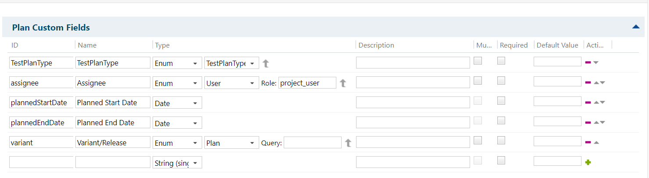](http://denbg0415vm.izd01.in/polarion/module-attachment/TestProject/_default/CollectingDetails/13-screenshot-20240124-125605.png?revision=4223)

​​

**How to Achieve:**

For getting the plan custom field details we need to access plan module using plan apis or method some open apis are there for getting the details of plan module from polarion. below is the apis or method for getting those details

|  |
| --- |
| $trackerService.getDataService().getCustomFieldService().getDefineCustomFields("document",$contextId),$type; |

​​

# Custom Reports Details

**Description:**

  If we select space in drop-down all custom report link should be display in table and when we click on that link that link should be open in new tab.

[](http://denbg0415vm.izd01.in/polarion/module-attachment/TestProject/_default/CollectingDetails/diagram_20240124-1253.20480.mxg.svg?revision=4226)

|  |  |
| --- | --- |
| **Space name** | **Report URL** |
| Default Space | <http://192.168.80.164/polarion/#/project/p23_dev/wiki/backup%20of%20report> |

**How to Achieve:**

We need to get first all spaces and then accordingly filter all reports and show all report url in table form.

​​

​​

​​

​​