
Internet Of Things

Smart Home Automation Report

Fullname | Student ID | Student Email
Lê Hồng Minh | SE196496 | leehongminh004@gmail.com
Lê Trần Trường Hải | SE196504 | ltth3605@gmail.com
Phạm Đinh Gia Phú | SE196506 | giaphuphamdinh082@gmail.com
Nguyễn Trịnh Trí Dũng | SE196498 | dungnnt0910@gmail.com

Contents

Contents
I. Introduction 4
A. The Rise of Smart Home Automation 4
B. The power of IoT for Smart Home Automation 4
C. Project Overview : Smart Home Automation 4
D. Project’s Aims: 5
II. Main proposal 5
A. Systems models and block diagrams 5
B. Components and peripherals devices 6
C. Programing flowchart 7
D. Software Programming 7
1. Esp32 Setup and Configuration 7
2. Data Collection and Transmission 8
3. Actuator Control Logic 11
4. Display and User Interface 13
III. Result and discussion 14
IV. Conclusion 15
V. Reference 16

Abstract
As the demand for automation and safety in residential environments increases, this project introduces an Internet of Things (IoT)-based smart home system designed to enhance convenience, optimize energy usage, and ensure safety. The system integrates motion sensors, gas and temperature sensors to automate household devices such as lights and fans. Key scenarios include remote and local control of lights and fans, automatic lighting at night upon motion detection, smoke detection triggering alarms and visual warnings, presence-based light control in restrooms, and temperature-based fan activation. The system allows for real-time monitoring and control via a mobile application, with user-configurable settings for automation. Emphasizing cost-effectiveness and practicality, the solution utilizes affordable, widely available components and focuses on ease of installation and operation. Testing demonstrates the system’s ability to respond accurately to environmental changes and user interactions, making it a reliable approach to smarter and safer living spaces.

- Introduction

- The Rise of Smart Home Automation
As technology advances, smart home automation is becoming increasingly popular, offering enhanced comfort, safety, and energy efficiency. However, many households still rely on manual control of devices like lights and fans, leading to inconveniences—such as forgetting to turn off appliances or being unable to control them remotely. In terms of safety, traditional homes are also vulnerable to fire hazards caused by short circuits or unattended devices. A smart home system can overcome these issues by integrating sensors that detect abnormalities early and alert users instantly, helping to prevent damage and ensure family safety.

- The power of IoT for Smart Home Automation

The Internet of Things (IoT) plays a crucial role in enabling smart home functionality. IoT connects devices, sensors, and controllers into a unified network, allowing them to collect and exchange data in real time. This connectivity enables smart homes to perform automated tasks based on sensor input—such as turning on lights when motion is detected or activating a fan when temperatures rise. Moreover, IoT empowers users to monitor and control devices remotely using smartphones, providing both convenience and peace of mind. It also supports timely alerts and automation logic, making the system responsive, flexible, and user-centric.

- Project Overview : Smart Home Automation

Our group project proposes an IoT-based smart home system that addresses both everyday convenience and household safety. The system integrates multiple sensors—such as motion, gas, and temperature sensors—with actuators like lights, fans, alarms, and LCD displays. A mobile application allows users to monitor real-time device status, schedule operations, and switch between manual and automatic control modes. The project focuses on cost-effective implementation using widely available hardware components while maintaining flexibility, scalability, and user-friendliness. Through smart automation, we aim to reduce energy waste, improve safety, and enhance the overall quality of life for residents.

- Project’s Aims:

- Control fans and lights in automatic or manual modes through a mobile app or physical switches.
- Automatically turn on lights at night when motion is detected, with customizable scheduling via the app and manual override options.
- Detect smoke and trigger a fire alarm, display a warning on the LCD screen, and activate lighting for emergency awareness.
- Automatically control bathroom lights based on human presence to ensure energy saving and convenience.
- Activate fans automatically when the temperature exceeds 29°C and someone is present, with the option for manual control via the app or switches.

- Main proposal
- Systems models and block diagrams
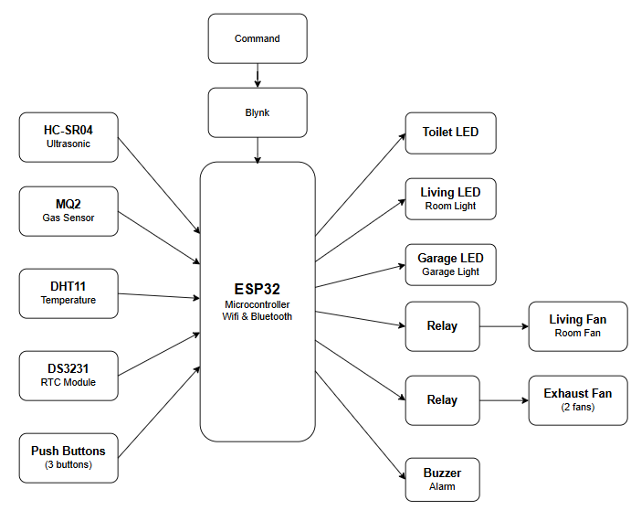
Figure 1. Block diagrams of the Smart Home System

- Components and peripherals devices

Components/Devices | ID/Remarks
NodeMCU ESP32
Liquid-Crystal Display | LCD 16x2
Distance sensor | HC-SR04
Breadboard | MB-102
Timer | DS3231
Button
Led
Fan & Motor
Temperature sensor | DHT11
Gas sensor | MQ02
Relay module | SRD05V
Connecting wires | Jumper MM/MF/FF

- Programing flowchart

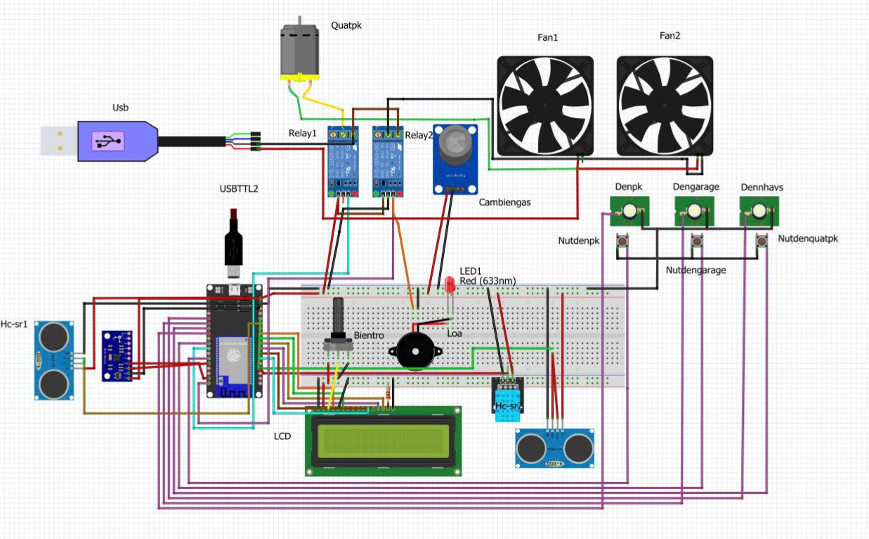
Figure 2. Circuit schematics/hardware interfacing.

- Software Programming
- Esp32 Setup and Configuration
- Initialize Serial and SoftwareSerial for communication.
- Set up Wi-Fi connection using NodeMCU ESP32s.
- Initialize temperature, distance, gas sensors.
- Set up the relay module to control the motor , fan , led , buzzer .
- Set up buttons to control lights and fans.
- Set up connect LCD to Esp32, read and output data

- Data Collection and Transmission
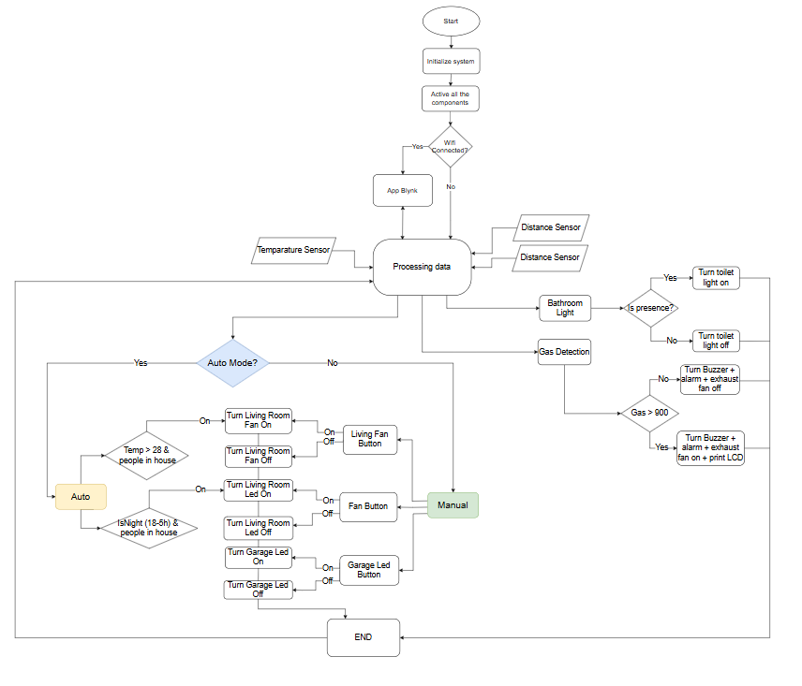
Figure 3. Flow chart of the developed system

ESP32 circuit collects data for processing including:
- Temperature in house
- Gas concentration level in the air
- Presence Detection
Reading Temperature sensor : To measure the ambient temperature, a DHT11 sensor is connected to the ESP32. The sensor provides digital readings of the surrounding air temperature. The DHT library is used to initialize the sensor and retrieve temperature data. If the sensor fails to read properly, a default value of 0.0 is returned.
float readTemperature() {
float temp = dht.readTemperature();
if (isnan(temp)) return 0.0;
return temp;
}

Reading Gas concentration: The system uses a gas sensor (e.g., MQ-2) to detect the presence of harmful gases in the environment. The analog output of the sensor is read via the analogRead() function. If the gas level exceeds a threshold (e.g., 1200), it is considered dangerous, and a buzzer alert is triggered.
int readGasLevel() {
return analogRead(gasSensorPin);
}

bool isGasDetected() {
return readGasLevel() > 1200;
}
Reading Presence Detection in Living Room : An ultrasonic sensor (HC-SR04) is placed in the living room to detect the presence of people. The sensor sends out a pulse and calculates the time for the echo to return. The distance is then used to determine if a person is nearby, typically within 10 cm.

long readCM() {
pinMode(trigechopin, OUTPUT);
digitalWrite(trigechopin, LOW);
delayMicroseconds(2);
digitalWrite(trigechopin, HIGH);
delayMicroseconds(10);
digitalWrite(trigechopin, LOW);
pinMode(trigechopin, INPUT);
echoTime = pulseIn(trigechopin, HIGH, 20000);
return echoTime * 0.034 / 2;
}

bool isSomeonePresentLiv() {
long distance = readCM();
delay(50);
return distance > 1 && distance < 10;
}
Reading Presence Detection in Bathroom : A separate ultrasonic sensor is installed in the bathroom. When someone enters and comes within 7 cm of the sensor, the bathroom light automatically turns on. If the distance increases beyond that, the light is turned off again.
long readDistanceCM() {
pinMode(trigEchoPin, OUTPUT);
digitalWrite(trigEchoPin, LOW);
delayMicroseconds(2);
digitalWrite(trigEchoPin, HIGH);
delayMicroseconds(10);
digitalWrite(trigEchoPin, LOW);
pinMode(trigEchoPin, INPUT);
thoigian = pulseIn(trigEchoPin, HIGH, 20000);
return thoigian * 0.034 / 2;
}

void handleBathroomSensor() {
float distance = readDistanceCM();
if (distance > 0 && distance < 7) {
if (!bathroomLedState) {
bathroomLedState = true;
digitalWrite(bathroomLedPin, HIGH);
}
} else {
if (bathroomLedState) {
bathroomLedState = false;
digitalWrite(bathroomLedPin, LOW);
}
}
}

- Actuator Control Logic
The actuators in the system are used to control the living-room fan, the exhaust fan, the lights, and the gas alarm. Each actuator is governed in two ways: Automatic and Manual.
• Living-Room Fan (GPIO 5)
- Automatic mode: When the system is in AUTO (autoMode = true), presence is detected in the living room, and the temperature exceeds 29 °C, the relay on GPIO 5 closes to turn the fan on.
- Manual mode: The user may override at any time by pressing the push-button on GPIO 2 or toggling the switch in the Blynk app on V3.
- In both modes, each change to fanState is immediately written to the relay pin, synchronized to Blynk V3, and saved to EEPROM so that the chosen state persists across power cycles.
- Automatic only: If the gas sensor reading exceeds the safety threshold, the relay on GPIO 23 closes and the exhaust fan runs; when the gas level falls below threshold (but remains within sensor limits), the relay opens and the fan stops.
- There is no manual override or dashboard control—this relay is fully governed by the gas-detection logic.
• Living-Room & Garage Lights
- Living-Room Light (GPIO 4):
  - Automatic mode: Between the user-set “evening” hours and whenever presence is detected, the relay closes to illuminate the room; outside those hours or if the room is empty, it opens to turn the light off.
  - Manual mode: At any time, the occupant can press the button on GPIO 19 or flip the Blynk switch on V1 to toggle the light.
  - Every state change is stored in EEPROM and pushed to the Blynk dashboard so the UI always reflects reality.
- Garage Light (GPIO 15):
  - Manual only: Responds instantly to the button on GPIO 13 or the Blynk switch on V2. There is no automatic control based on time or sensor.
• Bathroom Light (GPIO 0)
- Automatic only: Driven entirely by its ultrasonic sensor: if the measured distance falls below 7 cm, the relay engages and the light turns on; when the distance is 7 cm or greater, it disengages and the light turns off. No manual override or Blynk control is provided.
• Gas Alarm (Buzzer + LCD Warning)
- Automatic only: Whenever the gas level crosses the safety threshold, the LCD clears and displays “GAS WARNING!” on line 1 while the buzzer on GPIO 23 sounds for 5.5 seconds. Once the gas returns to safe levels, the buzzer silences and the LCD reverts to its normal status display (showing AUTO/MANUAL mode, living-room light state, temperature, and current time).

- Display and User Interface
The system is designed to allow users to interact with, monitor, and control devices through two main methods:
- Control via Blynk Application:
The Blynk app serves as the primary tool for users to remotely control the system through an intuitive interface. The ESP32 connects to Blynk via WiFi using an authentication token and virtual pins. Some key features in the app include:
  - Device control:
    - V1: Controls the living room LED.
    - V2: Controls the garage light.
    - V3: Controls the living room fan.
    - V4: Toggles Auto/Manual mode.
- Control via Physical Buttons:
In addition to the app, physical push buttons are available for local control of devices
  - Living Room LED Button: Turns the living room light on/off.
  - Fan Button: Turns the fan on/off.
  - Garage LED Button: Turns the garage light on/off.
These buttons are designed as one-time press toggles. When a user presses a physical button, the program updates the state on the Blynk app to reflect the change
- LCD Display
A 16x2 LCD screen is integrated into the system to display essential local information, including:
  - Real-time clock, updated continuously.
  - Current temperature indoors.
  - Warning status when gas concentration exceeds safety thresholds.
  - Current operating mode: Auto or Manual.
If dangerous gas levels are detected, the LCD shows clear alerts to warn the user immediately.
- Result and discussion
- Current Situation Without the System
In many traditional households, devices such as lights, fans, and alarms must be manually operated. Several limitations arise from this setup:
- Lack of automation: Users must remember to turn off unused appliances, which can lead to energy waste.
- No real-time monitoring: There is no way to remotely check the status of devices or environmental conditions (e.g., temperature, gas concentration).
- Delayed emergency response: In the case of gas leaks, there is no automatic alert or actuation of exhaust fans, increasing the risk of accidents.
- Inconvenient access: Elderly or physically limited individuals may find it hard to reach switches in certain areas.
- No context-awareness: Devices cannot react to real-world conditions such as human presence, time of day, or dangerous situations.
These shortcomings highlight the need for a smart system that enhances convenience, safety, and energy efficiency.
- Prototype Implementation
The system was built using an ESP32 microcontroller connected to various sensors and electrical devices, including:
- Sensors:
  - A gas sensor detects leaks and triggers both a buzzer and exhaust fan.
  - Ultrasonic sensors in the living room and bathroom detect human presence.
  - A temperature sensor measures indoor conditions.
- Device Control:
  - Lights, fans, and buzzer can be controlled via physical push buttons or the Blynk mobile app.
  - Users can switch between Auto Mode (automatic control based on scenarios) and Manual Mode (full user control).
- User Interface:
  - The Blynk app displays device status and allows remote control.
  - An LCD screen shows real-time clock, temperature, and safety warnings.
The system was tested and performed well according to the predefined scenarios.
- Discussion
The system showed stable operation and quick response to sensor input:
- Effective automation:
  - Lights turn on at night when someone enters.
  - Fan turns on when it’s hot and someone is in the room.
  - Bathroom light turns off when no one is present.
- Safety assurance:
  - The gas detection system automatically activates alarms and ventilation.
- Synchronized control:
  - Users can control devices from either the app or physical buttons.
  - Device states stay consistent between both control methods.
- Conclusion
In conclusion, our project provides an effective solution for automating household devices while prioritizing safety and energy efficiency. By integrating features such as automatic lighting schedules, motion detection, and remote monitoring via smartphones, the system enhances user convenience and ensures better control over household energy usage. Furthermore, its ability to detect gas leaks and fire hazards, combined with immediate alerts and automatic ventilation, significantly reduces the risk of dangerous incidents. Overall, the system not only improves the comfort of daily life but also contributes to a safer and more energy-conscious home environment.

Link Demo

- Reference
- Random Nerd Tutorials. (n.d.). ESP32 Home Automation Projects. Retrieved from: https://randomnerdtutorials.com/projects-esp32/
- Blynk Official Documentation. (n.d.). Getting Started with Blynk for ESP32. Retrieved from: https://docs.blynk.io
- Tech StudyCell. (2022). Home Automation using ESP32 & Blynk 2.0 with Real-Time Feedback : Home Automation using ESP32 & Blynk 2.0 with Real-Time Feedback
- Tech StudyCell. (2023). Home Automation System using ESP32 and Blynk 2.0: Home Automation System using ESP32 and Blynk 2.0
- Instructables – Tech StudyCell. (2021). Smart Home Automation Using Blynk & ESP32 IoT Projects: Smart Home Automation Using Blynk & ESP32 IoT Projects | WiFi & Manual : 16 Steps - Instructables

