Rev 2 Edger white board wiring rev 0.52 11052022

Examine all the photos first to understand part orientations. Notice how wires are dressed out away from the Espressif board so the unused pins can be accessed with jumper wires.

Completed board:

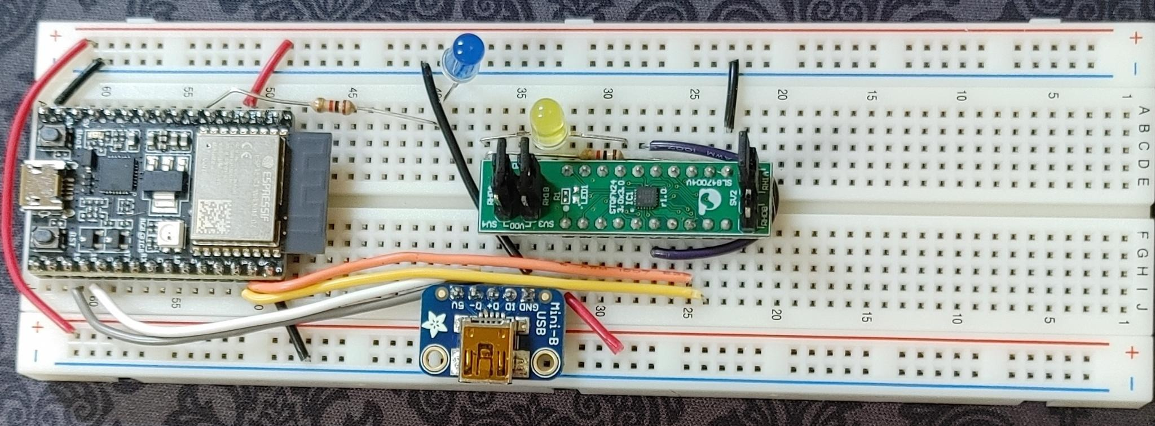

Parts Placement:

Breadboard column number Device Pin number

63 Espressif ESP32-C3-DEVKITC-02 1

38 Adafruit 1764 JTAG USB breakout “5V”

32 Renesas ForgeFPGA SLG47004V-DIP 1

40 Blue LED Anode (long lead)

40 1k resistor -

37 Yellow LED Anode (short lead)

37 1K resistor -

Espressif ESP32-C3-DEVKITC-02 board PHYSICAL PINS:

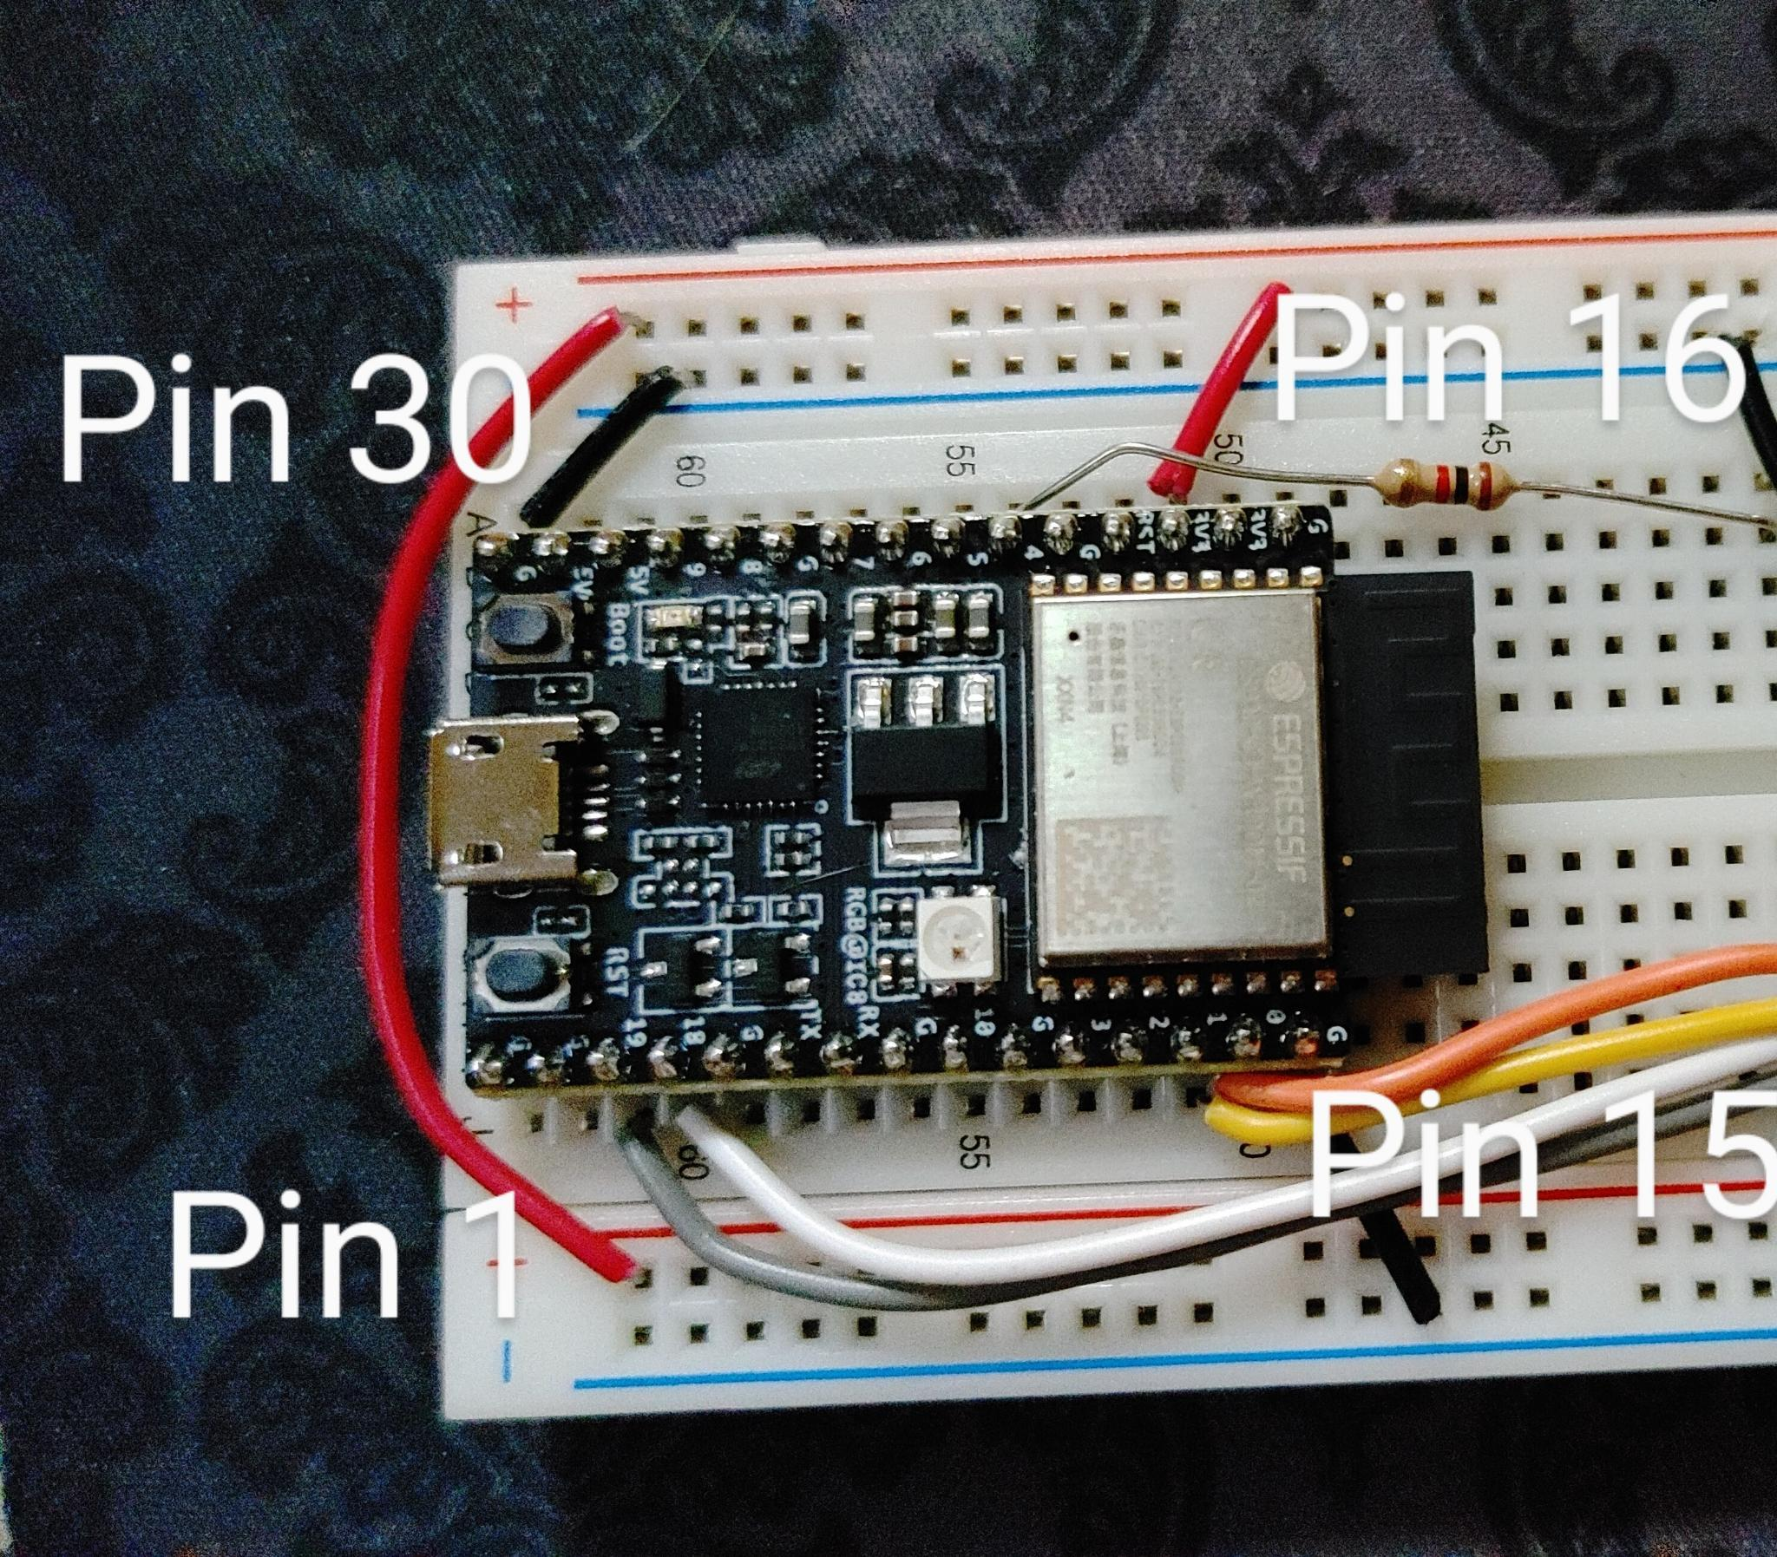

Length (cm) Color From To

2.5 Blk 30 “G” Breadboard ground rail (blue line)

2.5 Red 18 “3.3V” Breadboard power rail (red line)

8.0 Org 14 “0” FPGA physical pin 8 “SCL”

8.1 Ylw 13 “1” FPGA physcial pin 9 “SDA”

7.7 Wht 4 “18” JTAG JTAG USB D- (Adafruit breakout)

8.3 Gry 5 “19” JTAG USB D+ (Adafruit)

2.5 Blk 15 “G” Ground rail (blue line)

Adafruit 1764 USB breakout:

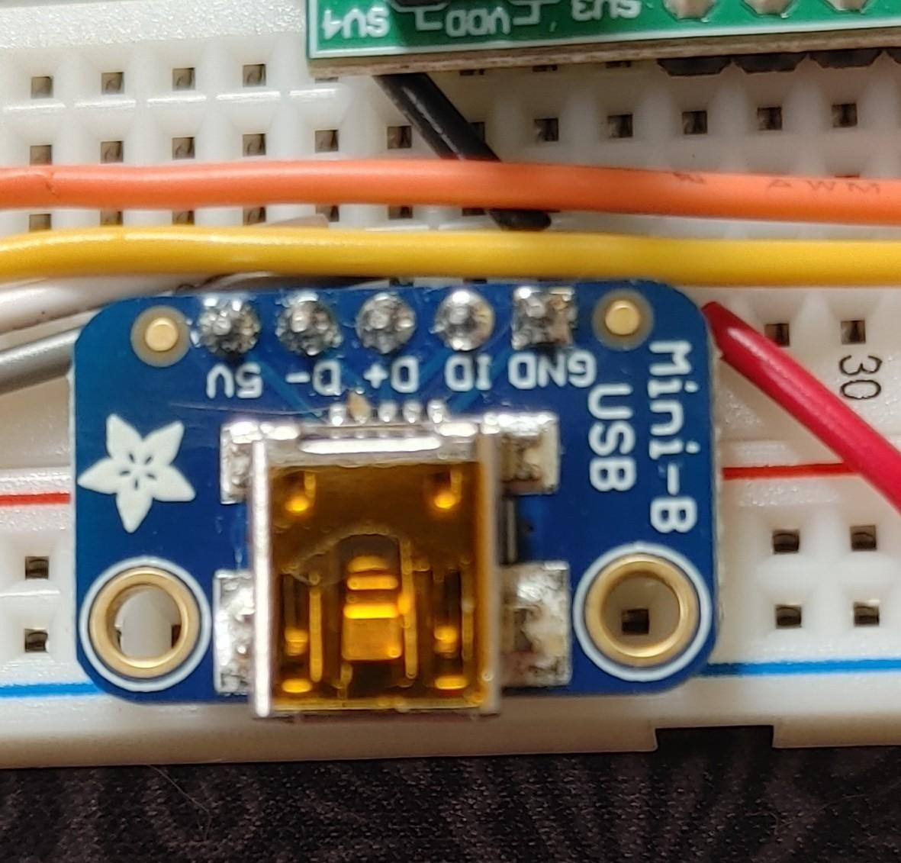

5.0 Blk to Ground rail (blue line) JTAG USB Gnd

Renesas ForgeFPGA SLG47004V-DIP PHYSICAL PINS:

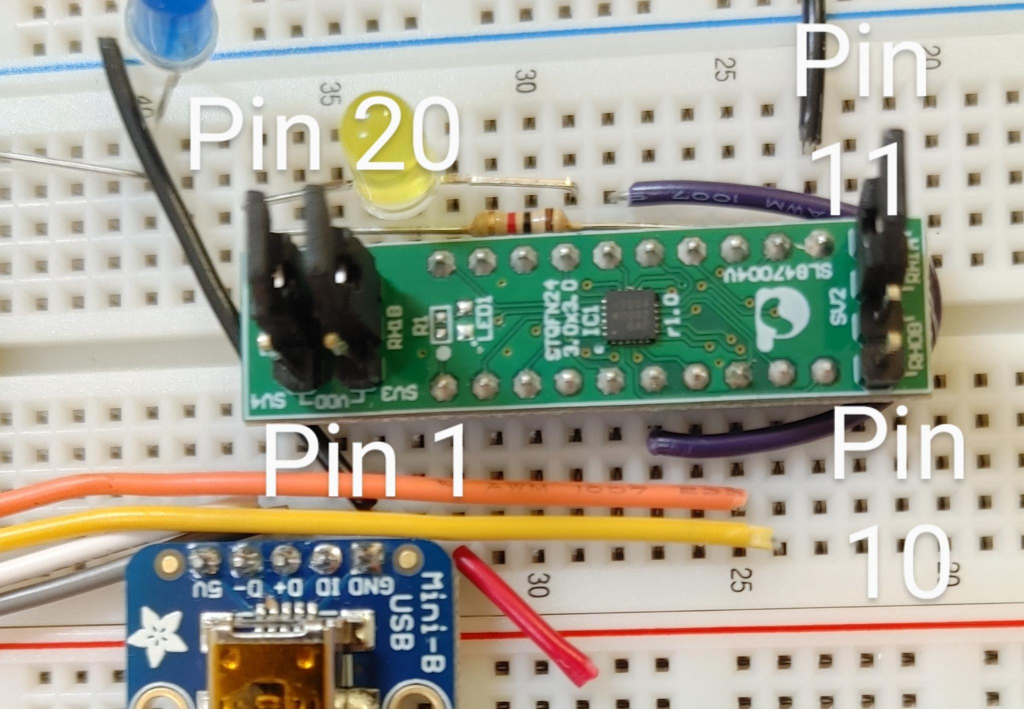

2.5 Red to Power rail (red line) FPGA pin 1 “VDD”

2.5 Blk to Ground rail (blue line) FPGA pin 11 “GND”

5.9 Vio to FPGA pin 6 “GPIO 15” FPGA pin 16 “GPIO 16”

Breadboard:

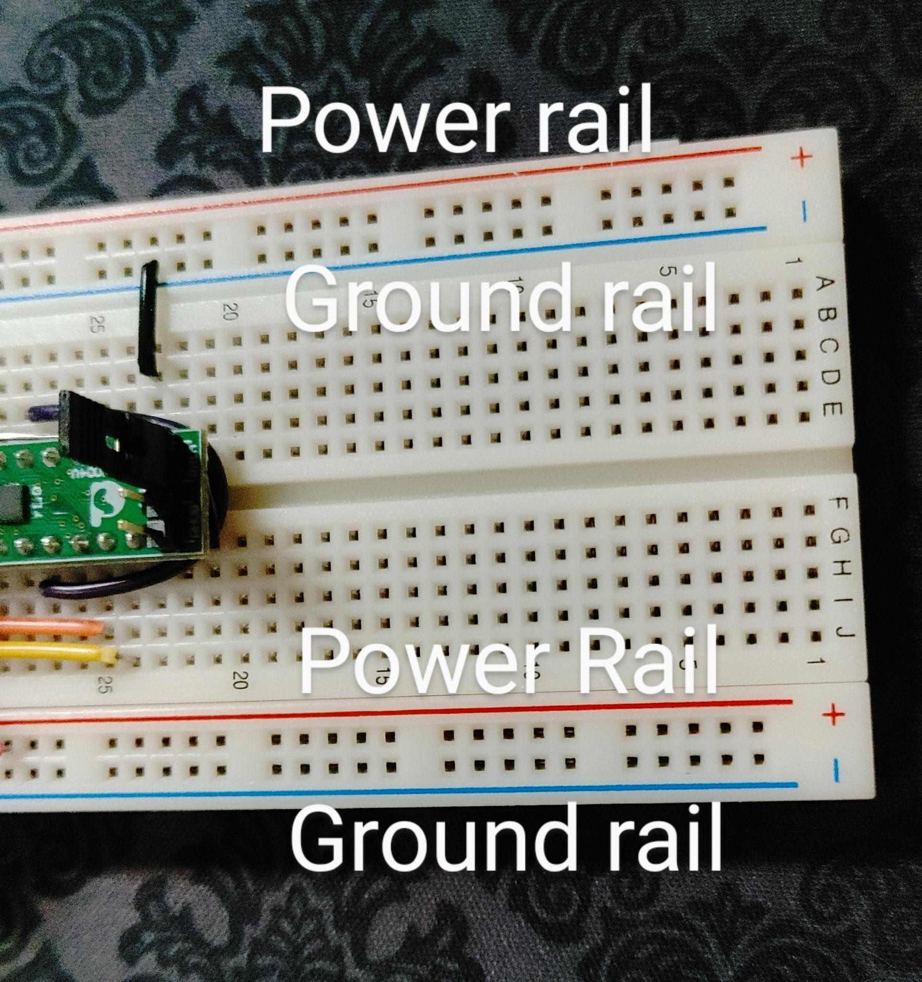

6.8 Red Power rail 1 (red line) to Power rail 2 (red line)