Rev 2 Edger white board wiring rev 0.54 11082022

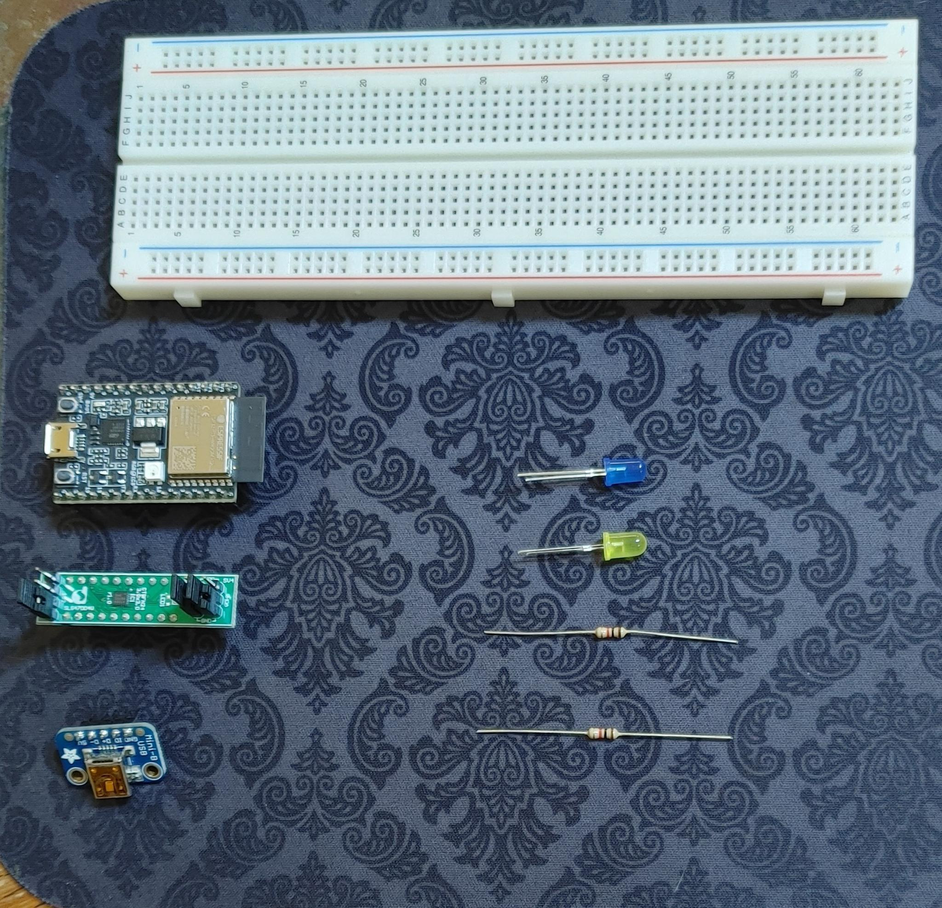
CAPACITORS MISSING WIRES MISSING

Examine all the photos first to understand part orientations. Notice how wires are dressed out away from the Espressif board thing on left side )so the unused breadboard positions can be accessed with jumper wires.

Completed board:

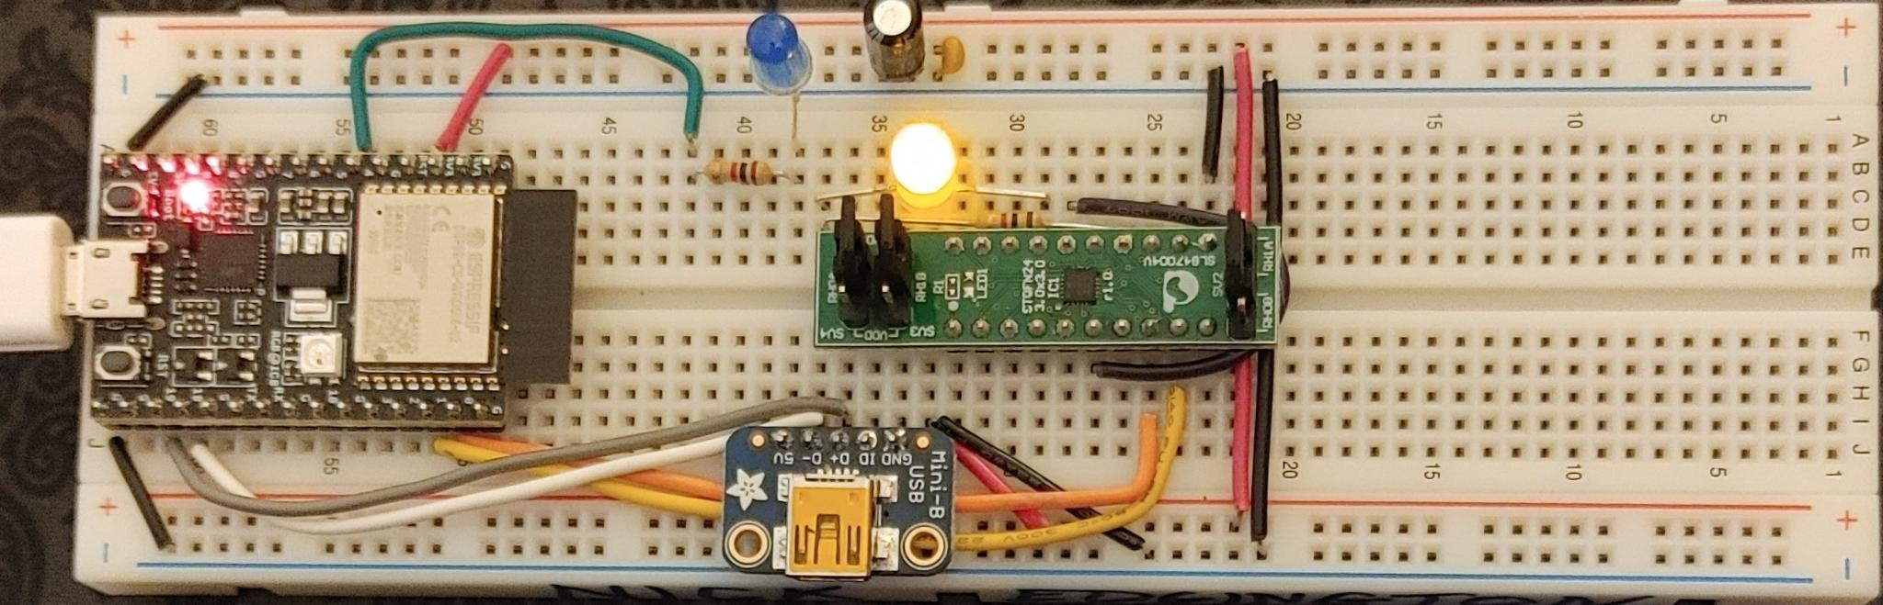

Step One: Where things go on the solderless breadboard. Notice the red line on the top, blue on the bottom. Parts must be placed exactly. Have your neighbor double check your placement.

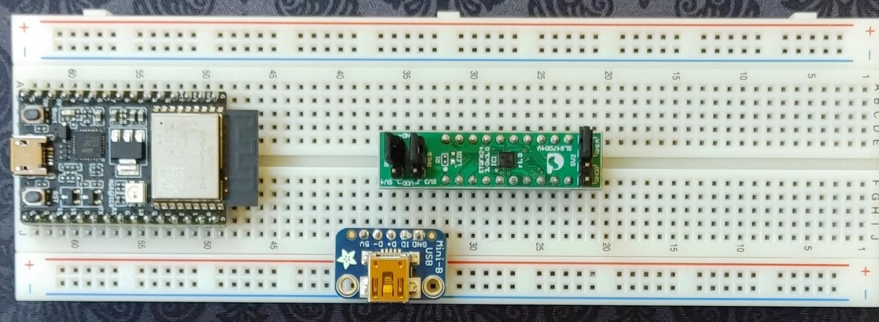
Parts Placement:

Breadboard column number Device Pin number
63 Espressif ESP32-C3-DEVKITC-02 1
38 Adafruit 1764 JTAG USB breakout “5V”
32 Renesas ForgeFPGA SLG47004V-DIP 1
38 Blue LED Anode (long lead)
38 1k resistor -
37 Yellow LED Cathode (short lead)
37 1K resistor -

Step two: Wiring related to Espressif ESP32-C3-DEVKITC-02 board PHYSICAL PINS:
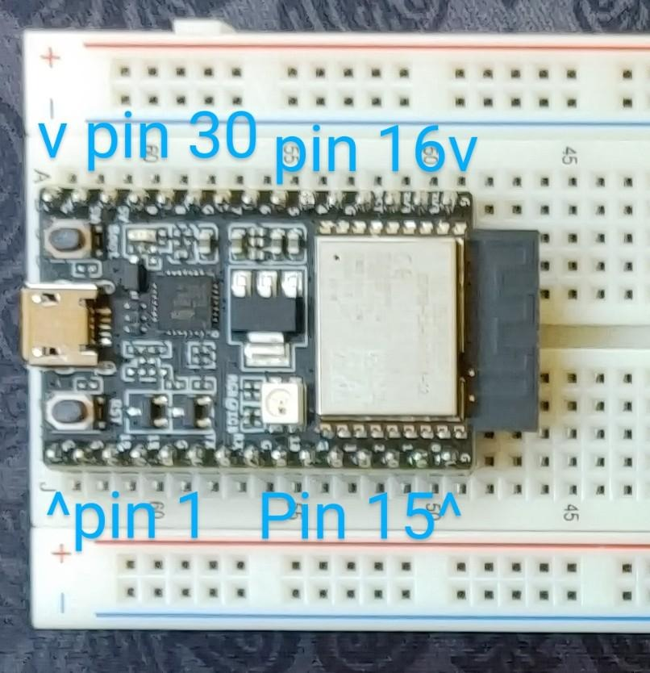

Length (cm) Color From To
2.5 Blk 30 “G” Breadboard ground rail (blue line)
2.5 Red 18 “3.3V” Breadboard power rail (red line)
8.7 Org 14 “0” FPGA physical pin 8 “SCL”
9.5 Ylw 13 “1” FPGA physcial pin 9 “SDA”
7.7 Wht 4 “18” JTAG JTAG USB D- (Adafruit breakout)
8.3 Gry 5 “19” JTAG USB D+ (Adafruit)
2.5 Blk 15 “G” Ground rail (blue line)
6.3 Grn 21 “4” Breadboard column 42

Step three: Wiring related to the Adafruit 1764 USB Breakout board:

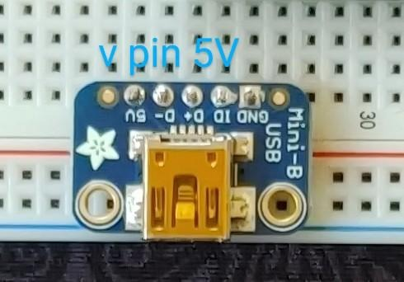

3.0 Blk Ground rail (blue line) to JTAG USB Gnd

Step 4: Wiring related to Renesas ForgeFPGA SLG47004V-DIP PHYSICAL PINS:

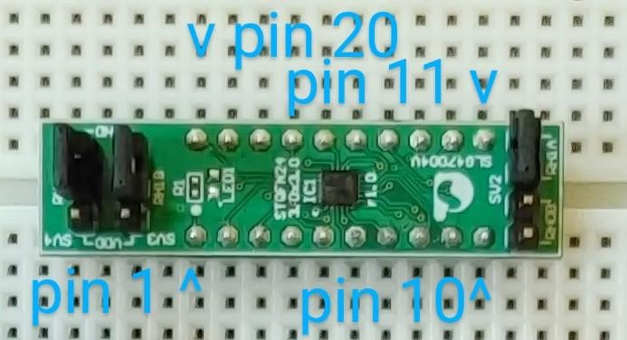

2.5 Red Power rail (red line) to FPGA pin 1 “VDD”
2.5 Blk Ground rail (blue line) to FPGA pin 11 “GND”
5.9 Vio FPGA pin 6 “GPIO 15” to FPGA pin 16 “GPIO 16”
- resistor FPGA pin 11 “GND” to breadboard column 37
- ylw LED LONG FPGA pin 17 “GPIO 18” to (short) breadboard column 37

Step 5: Wires related to solderless breadboard:

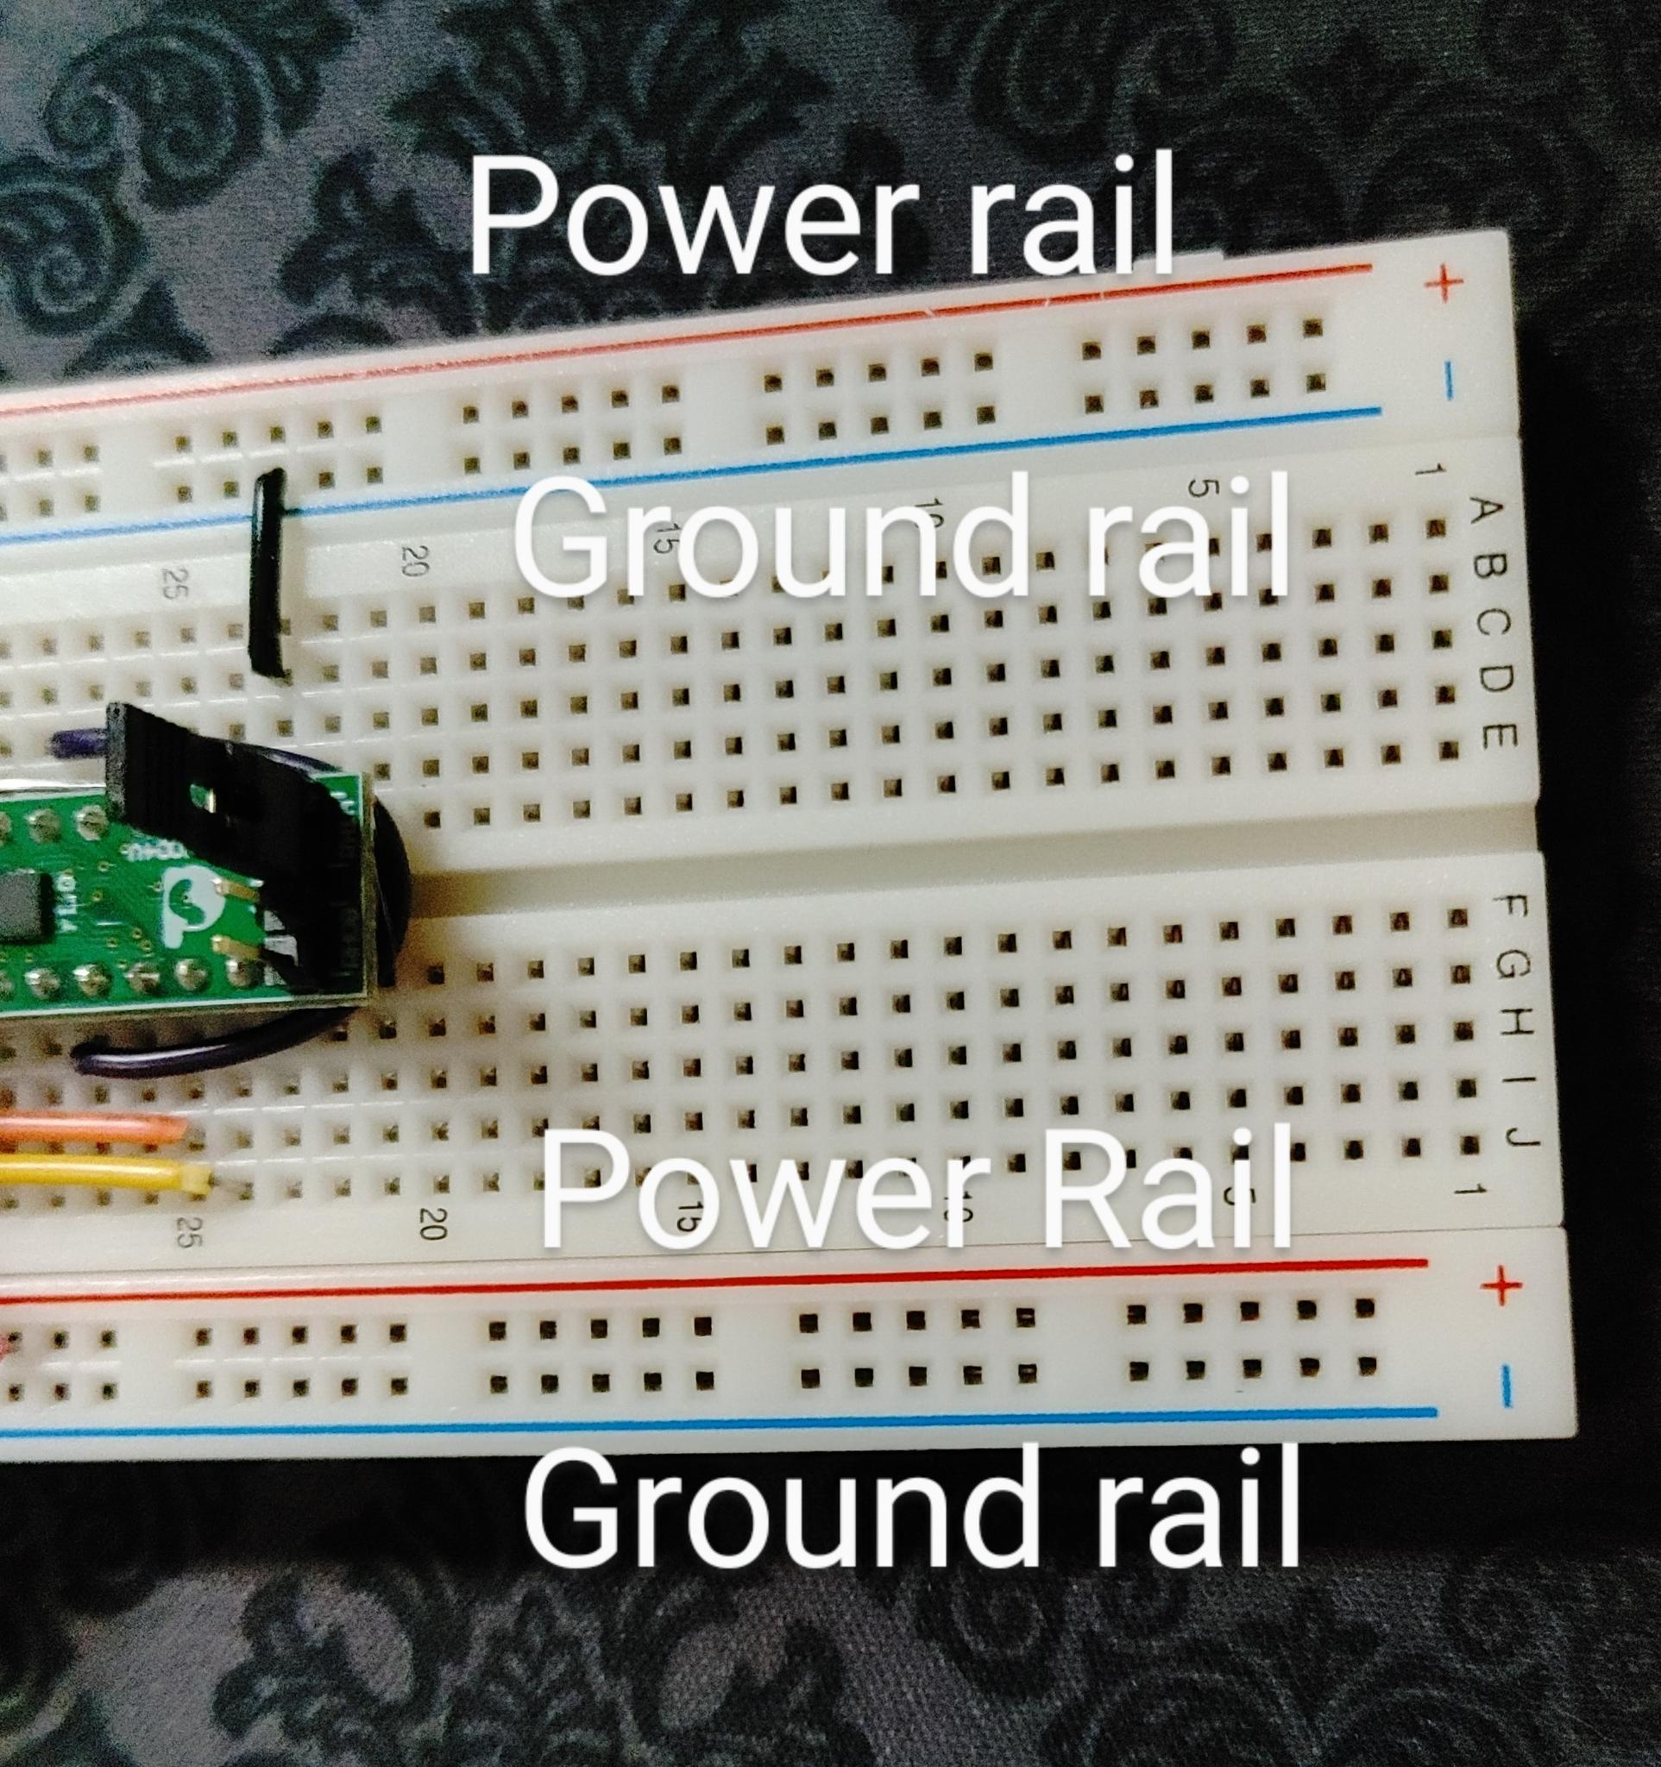

5.8 Red Power rail 1 (red line) to Power rail 2 (red line)
5.8 Blk Ground rail 1 (blue line) to Ground rail 2 (blue line)
- Big black cap Power rail 1 to Ground rail 1
- Little ylw cap Power rail 1 to Ground rail 1
- Blu LED LONG breadboard column 38 to Breadboard ground rail 1 (blue line)
- resistor breadboard column 38 to Breadboard column 42

