Part ID: 02293501-005

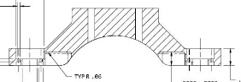

Part 2 of 8
10.2 x 1.625 x 2.22 in

Work Order # | Due Date | Material Dims: | Sign:
260622-01 | 7/7/26

Customer PO # | Part Name | Quantity
PO34916 | 02293503-001_01.stp | 20

Finish | Inserts | Material
Hard Anodize, Deep Red | No | Aluminum 6061-T6x

Inspection | Part Marking | Certificates And Supplier Qualifications
Formal Inspection with  Dimensional Report | None | ITAR/EAR Registration, Finishing Cert., DFARS Material Full Traceability

Notes
None

