

**HAIR SALON BOOKING APP**

**Software Requirement Specification**

|  |  |
| --- | --- |
| Group Members |  |

**record of changes**

|  |  |  |  |
| --- | --- | --- | --- |
| **Date** | **A* M, D** | **In charge** | **Change Description** |
|  |  |  |  |
|  |  |  |  |
|  |  |  |  |
|  |  |  |  |
|  |  |  |  |
|  |  |  |  |
|  |  |  |  |
|  |  |  |  |
|  |  |  |  |
|  |  |  |  |
|  |  |  |  |
|  |  |  |  |

*A - Added M - Modified D - Deleted

**Table of Contents**

I. Overview 4

1. Introduction 4

2. System Functions 5

3. Entity Relationship Diagram 6

II. Functional Requirements 7

1. <<Feature Name 1>> 7

a. <<Function Name 1>> 7

b. <<Function Name 2>> 7

2. <<Feature Name 2>> 7

# I. Overview

## 1. Introduction

The Hair Salon Booking App is a software system that connects customers and hair salon, meets the customer demand to search, book, and experience hair salon services easily and conveniently. The system is expected to handle the difficulty in searching and booking at hair salons to streamline operations and enhance customer satisfaction.

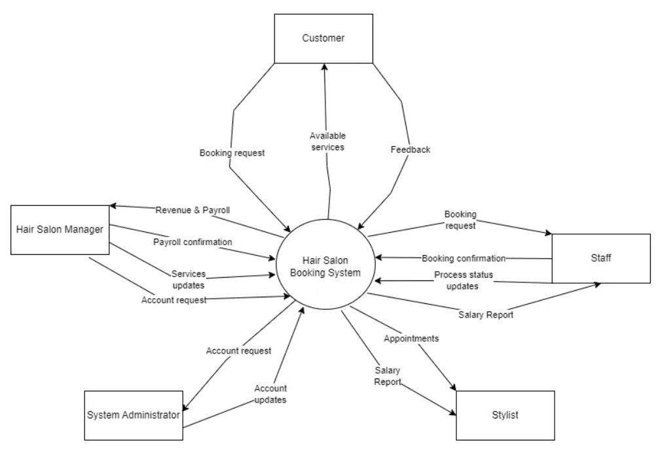

## 2. System Functions

#### Screen Flow

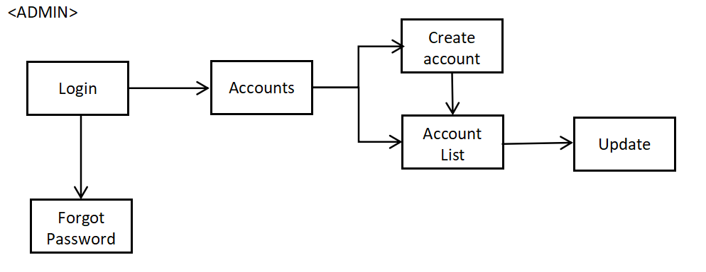

#### Screen Details <Admin>

*[Provide the descriptions for the screens in the Screens Flow above]*

|  |  |  |  |
| --- | --- | --- | --- |
| **#** | **Feature** | **Screen** | **Description** |
| 1 | Login | Login | Verify account identity and log in to the internal system. |
| 2 | Forgot Password | Login | Set new password after verifying identity. |
| 3 | Manager Account | Accounts | Overview of the system and active accounts on the system. |
| 4 | Create Account | Accounts | Create new account for Staff, Manager, Stylist or Customer. |
| 5 | Account List | Accounts | Lists detail all account on System. |
| 6 | Update Account | Accounts | Update Status, Roles, Information for Accounts. |

#### Screen Flow

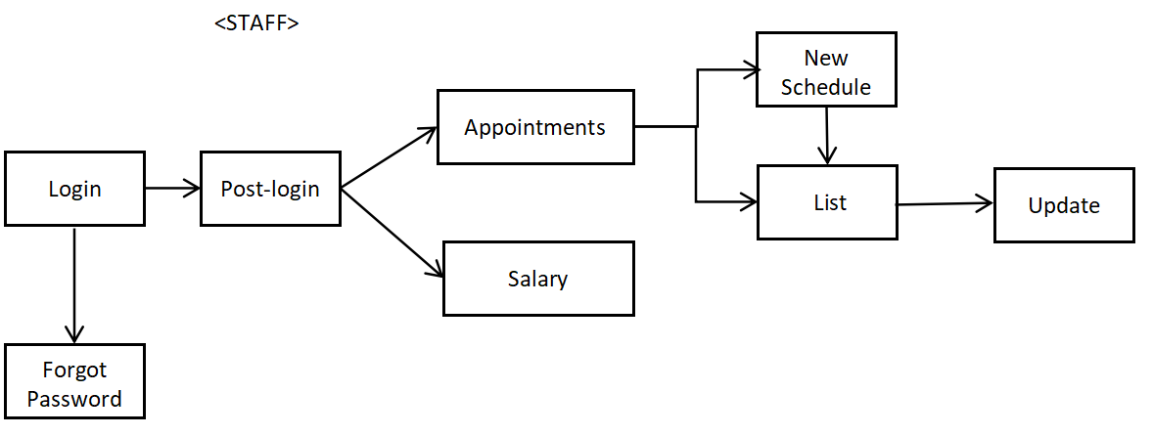

#### Screen Details <Staff>

*[Provide the descriptions for the screens in the Screens Flow above]*

|  |  |  |  |
| --- | --- | --- | --- |
| **#** | **Feature** | **Screen** | **Description** |
| 1 | Login | Login | Verify account identity and log in to the internal system. |
| 2 | Forgot Password | Login | Set new password after verifying identity. |
| 3 | Appointments | Appointments | Overview about all Appointments available. |
| 4 | New Schedule | Appointments | Create new Appointments for Customer. |
| 5 | List Appointments | Appointments | List detail all Appointments available. |
| 6 | Update Appointments | Appointments | Update Status for Appointments (Cancel, Done,….) |

#### Screen Flow

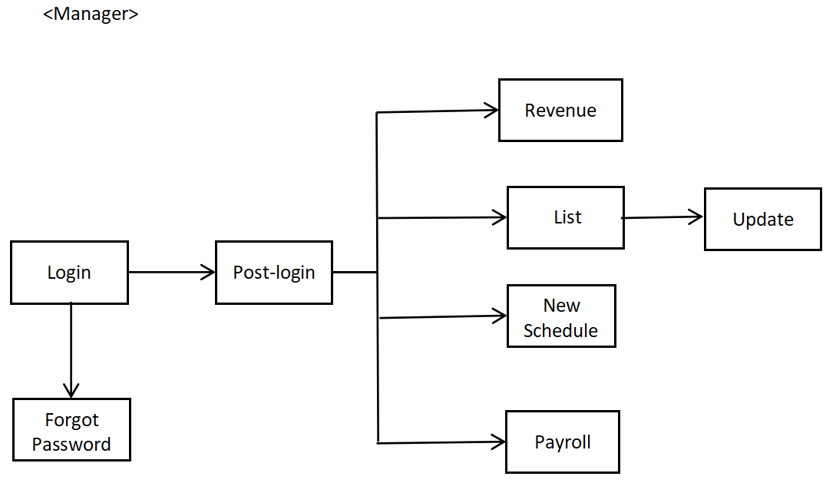

#### Screen Details <Manager>

*[Provide the descriptions for the screens in the Screens Flow above]*

|  |  |  |  |
| --- | --- | --- | --- |
| **#** | **Feature** | **Screen** | **Description** |
| 1 | Login | Login | Verify account identity and log in to the internal system. |
| 2 | Forgot Password | Login | Set new password after verifying identity. |
| 3 | Revenue | Revenue | Financial and revenue reports |
| 4 | List Blog, Services | **List (nhớ sửa)** | List all Blog, Services Salon already update for Customer. |
| 5 | Add new Blog, Services | **List (nhớ sửa)** | Add new or Update Blog, Services Salon have now. |
| 6 | New Schedule | Appointments | Create new Appointments for Customer. |
| 7 | Payroll | Payroll | Manage Salary for all role in Salon |

#### Screen Flow

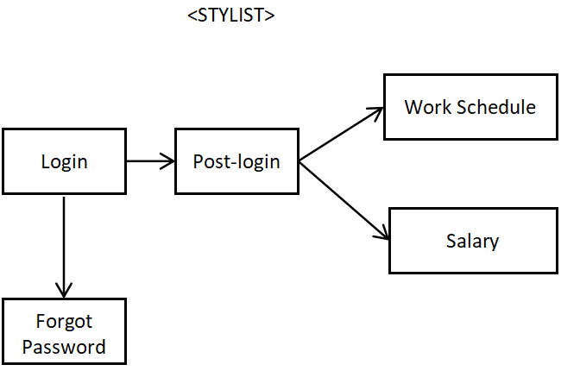

#### Screen Details <Stylist>

*[Provide the descriptions for the screens in the Screens Flow above]*

|  |  |  |  |
| --- | --- | --- | --- |
| **#** | **Feature** | **Screen** | **Description** |
| 1 | Login | Login | Verify account identity and log in to the internal system. |
| 2 | Forgot Password | Login | Set new password after verifying identity. |
| 3 | Work Schedule | Schedule | Can view available appointments and accept them. |
| 4 | Salary | Salary | View user’s salary. |

#### Screen Flow

<CUSTOMER>

Cancel

History Haircut

Home Page

Forgot password

Service Detail

Blog Detail

Services List

Blogs List

Registerer

Successful Page

Login

Booking page

#### Screen Details <Staff>

*[Provide the descriptions for the screens in the Screens Flow above]*

|  |  |  |  |
| --- | --- | --- | --- |
| **#** | **Feature** | **Screen** | **Description** |
| 1 | Login | Login | Verify account identity and log in to Salon Page for more Services. |
| 2 | Forgot Password | Login | Set new password after verifying identity. |
| 3 | Register | Login | Create new Account to Login. |
| 4 | Booking page | Booking page | Make a new appointment or view history appointments |
| 5 | Services List | Home Page | Can view Availbe Services salon have. |
| 6 | Blogs List | Home Page | Can view some Blogs posted by salon on Page. |
| 7 | Services Detail | Services | Can view Detail and Price for Service user click. |
| 8 | Blogs Detail | Blogs | Can view Detail what blog have. |

#### c. User Authorization

*[Provide the system roles authorization to the system features (down to screens, and event to the screen activities if applicable) in the table form as below – replace Role1, Role2,… with the specific system user role names]*

|  |  |  |  |  |  |
| --- | --- | --- | --- | --- | --- |
| **Screen** | **Role1** | **Role2** | **Role3** | **Role4** | **Role5** |
| <<Login >> | X | X | X | X | X |
| Login to System | X | X | X | X | X |
| Register new Account |  |  |  |  | X |
| Forgot Password | X | X | X | X | X |
| <<Home Page>> |  |  |  |  |  |
| View Availble Services |  |  |  |  | X |
| View Blog |  |  |  |  | X |
| Booking New Appointment |  | X | X |  | X |
| History HairCut |  |  |  |  | X |
| <<Internal Page System>> |  |  |  |  |  |
| Create Blog And Services |  | X |  |  |  |
| Revenue |  | X |  |  |  |
| Manager Payroll |  | X |  |  |  |
| Account List and Update | X |  |  |  |  |
| Update Appointments |  | X | X |  |  |
| View Salary |  | X | X | X |  |

In which:

* Role1: Admin System
* Role2: Manager
* Role3: Staff
* Role4: Stylist
* Role5: Customer

## 3. Entity Relationship Diagram

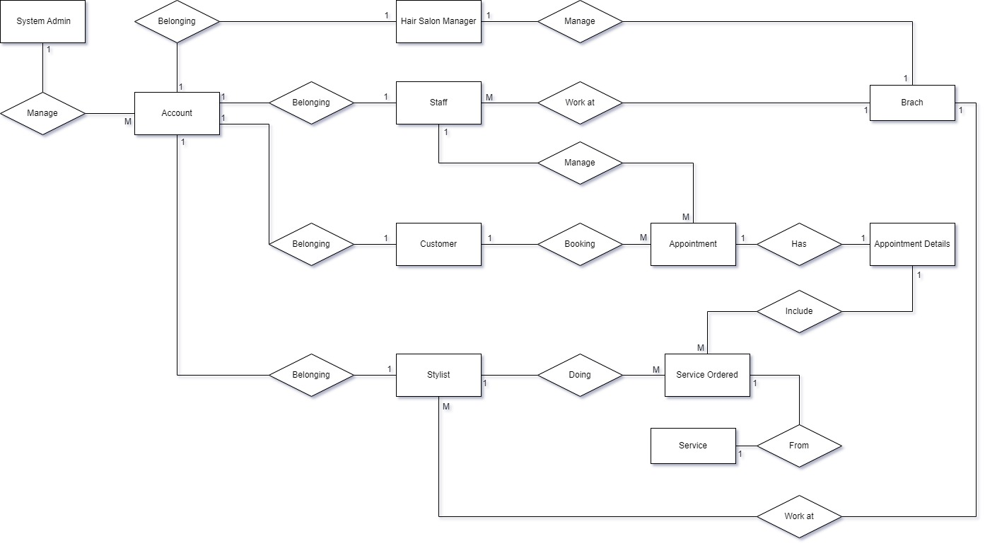

**Entities Description**

|  |  |  |
| --- | --- | --- |
| **#** | **Entity** | **Description** |
| 1 | System Admin | Represents the system administrator who manages and oversees the system's users. |
| 2 | Account | Represents the user accounts in the system, which could belong to different types of users such as *System Admin, Hair Salon Manager, Staff, Customer,* and *Stylist.* |
| 3 | Hair Salon Manager | Represents the manager who oversees a specific branch. |
| 4 | Staff | Represents the general staff members working in the salon, not specifically stylists. |
| 5 | Customer | Represents the customers who book appointments and receive services from the salon. |
| 6 | Stylist | Represents the stylists who provide hair services to customers. |
| 7 | Appointment | Represents the booking or appointment that a customer makes for services. |
| 8 | Appointment Details | Stores details about specific appointments. |
| 9 | Branch | Represents different branches of the hair salon. |
| 10 | Service Ordered | Represents the specific services ordered by a customer during an appointment. |
| 11 | Service | Represents the different types of services offered by the salon, such as haircuts, |

### 1. ****Platform Access****

#### 1.1 ****Web and Mobile Access****

**Function Trigger**:

* + Users access the application via a web browser or by installing and opening the app on a mobile device.

**Function Description**:

* + **Actors/Roles**: Customers, Salon Staff, Salon Owners, System Administrators.
  + **Purpose**: To provide users with easy access to the platform from any device.
  + **Interface**: User interface on the web and mobile app with a main menu to navigate to different features.
  + **Data Processing**: The system authenticates users based on login information and provides appropriate access based on roles.

**Screen Layout**:

* + Login page with fields for email/username and password.
  + Main navigation menu after successful login.

**Function Details**:

* + **Validation**: Check the user's login information. If incorrect, display an error message and prompt for re-entry.
  + **Business Logic**:
    - If the user forgets their password, provide a "Forgot Password" option to send a reset email.
    - The user will be redirected to the homepage or main screen after successful login.
  + **Normal Cases**:
    - The user logs in successfully and gains access to the platform.
  + **Abnormal Cases**:
    - Incorrect login information, the system displays an error message and prompts for re-entry.

### 2. ****Appointment Booking and Management****

#### 2.1 ****Booking an Appointment****

**Function Trigger**:

* + The user accesses the "Book Appointment" section and selects a service from the list.

**Function Description**:

* + **Actors/Roles**: Customers, Salon Staff.
  + **Purpose**: To allow customers to select a service, choose a stylist, and book an appointment.
  + **Interface**: A screen displaying a list of services, options to select a stylist, and choose appointment date and time.
  + **Data Processing**: The system checks the availability of the service and stylist, then confirms the appointment.

**Screen Layout**:

* + Service list with information about prices and service descriptions.
  + Calendar to select date and time slots.
  + "Confirm" button to complete the booking.

**Function Details**:

* + **Validation**: Ensure that the customer selects a service and stylist before confirming the appointment.
  + **Business Logic**:
    - Check the availability of the service and stylist before confirmation.
    - If the service is unavailable, display a message and prompt the customer to choose again.
  + **Normal Cases**:
    - The appointment is booked successfully, and the customer receives a confirmation via email or notification.
  + **Abnormal Cases**:
    - The service or stylist is unavailable, requiring the customer to choose again.

#### 2.2 ****Managing Appointments****

**Function Trigger**:

* + Salon staff access the "Manage Appointments" section to view and manage booking requests.

**Function Description**:

* + **Actors/Roles**: Salon Staff, System Administrators.
  + **Purpose**: To allow salon staff to view, accept, or reject booking requests, and track service status.
  + **Interface**: A screen displaying a list of booking requests with "Accept" or "Reject" options.
  + **Data Processing**: The system updates the status of the appointment and notifies the customer when a request is accepted or rejected.

**Screen Layout**:

* + List of booking requests with detailed information about the customer, service, and time.
  + "Accept" or "Reject" buttons next to each request.

**Function Details**:

* + **Validation**: Ensure that salon staff process booking requests within a reasonable timeframe.
  + **Business Logic**:
    - When a request is accepted, the system sends a confirmation notification to the customer.
    - If rejected, the customer is prompted to choose a different time or service.
  + **Normal Cases**:
    - The salon staff accepts the booking request, and the system updates the status.
  + **Abnormal Cases**:
    - The request is rejected due to the unavailability of the stylist or service, prompting the customer to choose again.

### 3. ****Feedback and Rewards****

#### 3.1 ****Providing Feedback****

**Function Trigger**:

* + After using the service, the customer receives a notification requesting feedback on their experience.

**Function Description**:

* + **Actors/Roles**: Customers.
  + **Purpose**: To allow customers to provide feedback on their service experience.
  + **Interface**: A screen displaying a questionnaire or a text field for entering feedback.
  + **Data Processing**: The system records the feedback and rewards loyalty points based on customer engagement.

**Screen Layout**:

* + Questionnaire with rating options and a text field for detailed comments.

**Function Details**:

* + **Validation**: Ensure that the customer fills out the necessary information before submitting feedback.
  + **Business Logic**:
    - The system accumulates loyalty points for the customer based on their level of interaction and the quality of feedback.
    - Loyalty points can be used for future services.
  + **Normal Cases**:
    - The customer submits feedback successfully and earns loyalty points.
  + **Abnormal Cases**:
    - The customer does not complete the feedback or encounters a technical issue, prompting the system to request re-submission.

### 4. ****Revenue and Earnings Tracking****

#### 4.1 ****Tracking Earnings****

**Function Trigger**:

* + Salon owners or managers access the "Track Earnings" section to monitor income.

**Function Description**:

* + **Actors/Roles**: Salon Owners, System Administrators.
  + **Purpose**: To track earnings from services provided and manage financial transactions.
  + **Interface**: A screen displaying charts and detailed reports on revenue.
  + **Data Processing**: The system aggregates data from services provided and calculates earnings.

**Screen Layout**:

* + Charts showing revenue by day, week, or month.
  + Detailed reports with a list of transactions and total earnings.

**Function Details**:

* + **Validation**: Ensure that revenue data is continuously and accurately updated.
  + **Business Logic**:
    - The system automatically calculates and aggregates data from transactions to generate earnings reports.
    - Reports can be exported as CSV or PDF files for storage or email distribution.
  + **Normal Cases**:
    - The salon owner views the revenue report and stores or exports the file.
  + **Abnormal Cases**:
    - Technical error or inaccurate data, the system alerts the user to check the data again.

### 5. ****Commission and Salary Management****

#### 5.1 ****Managing Stylist Salaries****

**Function Trigger**:

* + The salon manager accesses the "Manage Salaries and Commissions" section.

**Function Description**:

* + **Actors/Roles**: Salon Managers, System Administrators.
  + **Purpose**: To manage monthly fixed salaries and commissions based on the revenue generated by each stylist.
  + **Interface**: A screen displaying a list of stylists with their fixed salary and commission details.
  + **Data Processing**: The system calculates salaries and commissions based on monthly revenue data.

**Screen Layout**:

* + List of stylists with columns displaying fixed salary, commission, and total earnings.
  + Option to export salary reports for each stylist.

**Function Details**:

* + **Validation**: Ensure that salaries and commissions are accurately calculated before processing payments.
  + **Business Logic**:
    - The system automatically sums up commissions based on the revenue generated by each stylist during the month.
    - Once salaries are finalized at the end of the month, the system sends notifications to each stylist detailing their salary and commission.

**Normal Cases**:

* + Salaries and commissions are calculated correctly and paid on time to each stylist.

**Abnormal Cases**:

* + Errors occur during the calculation or payment process, and the system notifies the manager to address the issue.

### 6. ****Support and Assistance****

#### 6.1 ****Customer Support****

**Function Trigger**:

* + Users access the "Support" section in the application to request assistance with an issue they are facing.

**Function Description**:

* + **Actors/Roles**: Customers, Technical Support Staff.
  + **Purpose**: To provide user support related to technical issues or appointment-related inquiries.
  + **Interface**: A screen with support request options where users can describe the issue and choose a contact method.
  + **Data Processing**: The system records the request and forwards it to the technical support staff for resolution.

**Screen Layout**:

* + Support request form with fields for customers to describe the issue and select a contact method (email, phone).
  + "Submit Request" button to send the information to the support system.

**Function Details**:

* + **Validation**: Ensure that users fill out all required information before submitting a support request.
  + **Business Logic**:
    - The system automatically categorizes and prioritizes support requests based on the severity of the issue.
    - Technical support staff receive notifications and begin addressing the request.
  + **Normal Cases**:
    - The support request is handled promptly, and the user receives feedback via email or phone.
  + **Abnormal Cases**:
    - The request is missed, or the system encounters an issue, and the user is notified of the delay and given instructions to contact support directly.

### 7. ****System Maintenance and Security****

#### 7.1 ****System Security Management****

**Function Trigger**:

* + The system administrator performs regular maintenance or when a security issue is detected.

**Function Description**:

* + **Actors/Roles**: System Administrators.
  + **Purpose**: To ensure the system operates safely and stably, protecting user data and preventing security vulnerabilities.
  + **Interface**: A security management interface with options to update the system, monitor activity, and manage access rights.
  + **Data Processing**: The system stores and encrypts sensitive information, monitors access activities, and reports unusual behavior.

**Screen Layout**:

* + Security management dashboard with options like "System Update," "Access Management," "Activity Monitoring."
  + Charts and reports on security events.

**Function Details**:

* + **Validation**: Ensure that system updates and changes are thoroughly tested before implementation.
  + **Business Logic**:
    - Administrators can schedule regular maintenance and receive alerts about suspicious security events.
    - The system automatically performs daily data backups and continuously monitors for security threats.
  + **Normal Cases**:
    - The system operates stably and securely, with no security breaches occurring.
  + **Abnormal Cases**:
    - A security threat or technical issue is detected, and the administrator is notified to respond promptly.