Credentialing App Changes 10/15/2026

Bulk Import-
- There is the last column in both templates for Password- Which password needs to go in this field.

Facilities
Bulk import> Facilities > Template:- Need more columns to preload all the information needed on Edit practice Page.
Addition: Currently only Primary location address is mapped, also need Alternative address(Location), Mailing Address, Billing Address, Bank details And facility addresses as well (up to 5).

Providers

Bulk import> Providers > Template:- Need more columns to preload all the information needed on Edit provider Page.
Addition: DOB, SSN, Degree, Type of provider, Home address.
Removal: Pecos Id, Pecos Enrolled, Board certification, board Cert expiry, license number, license state, license expiry.

Providers Tab-

Providers> Edit Provider > Malpractice & Board Certification >
Remove- Board certification from this section(title and fields- Board certification, board Cert expiry)
Add: Attach document with Malpractice

Providers> Edit Provider > License & Credentials >
Remove License & Credentials Entire section.

Providers> Edit Provider > Upload Document section>
Need to add
- CDS
- CP-575 / IRS
- Education Certificate/ Degree

Providers> Edit Provider > Provider logins> Add login
Need a field to capture ID/ Assigned number approx. 8-15 digits alphanumeric. And that field should also populate in the provider login overview section.

Link Location: Providers> Edit Provider > Provider practice location> Add location> still showing limited location in Dropdown, need Alternate address (location, Billing address & Mailing address) added under practice populated (Reference Dummy Provider 9).

Practice
Practice> Edit Practice> License & Documents>
Currently only able to upload 1 document, uploading another replaces the older file, need multiple files managed in this section.
Not able to delete uploaded documents, need list of documents populated in this window with key details like name, number expiration etc. just like we have in Provider documents section under providers> Edit provider.
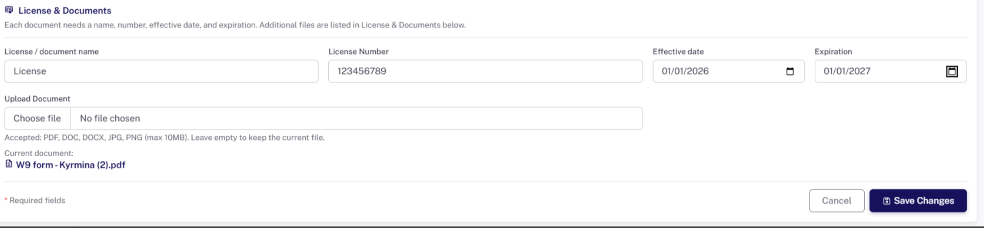

Credentialing Tracker

Credentialing Tracker> New Application > Case assignment>
- Remove State

Credentialing Tracker> New Application > Need Edit application ability to make changes to existing applications information.

Credentialing Tracker> View application > Notes window should be larger and should not have scroll across to review entire note, enable wrap and increase field size(including placement if needed, since there will be multiple followup notes for each application,

Additonal documents Tab: Credentialing Tracker> New & View application > Need a section for uploading payer correspondence, additional info request letters, submission proofs etc,
These documents should be liked with practice and/or Providers.

Question:- what happens after we escalate any application, what are the actions triggers after this, and where to setup who gets these escalations.

