Practice Section
In Practice > Practice Details > Client Code: Unable to enter more than 3 digits, and numeric codes are not accepted.
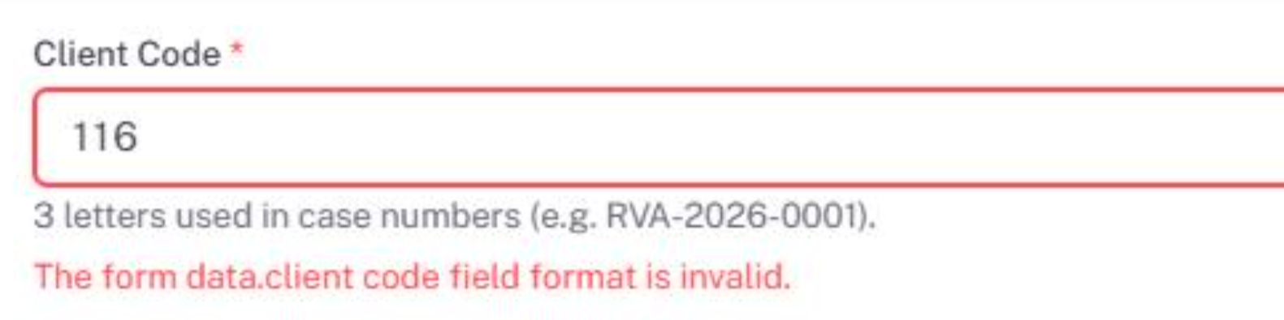

Client portal account:
Need to move this portal account section to admin setting as discussed in last meeting.
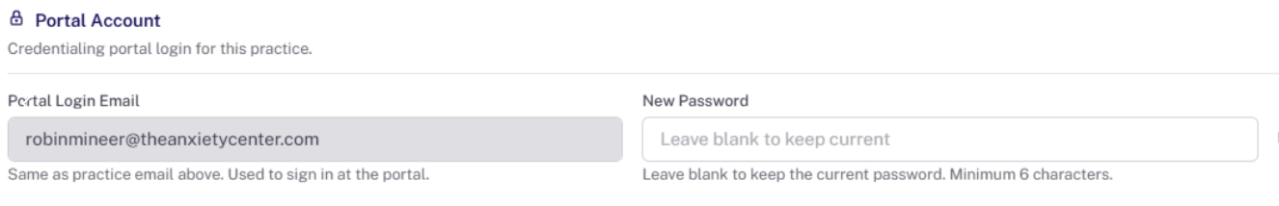

Practice Documents: Unable to save the document, getting error
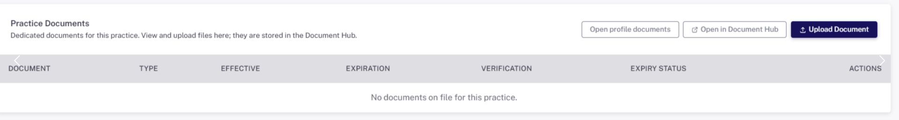

Practice Documents: Unable to upload and download the document.
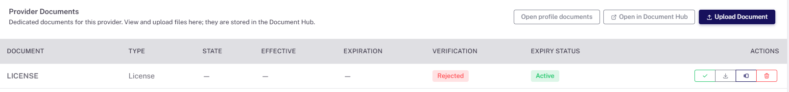
Provider Section
Providers > Edit Provider > Practice and Location
Only populating the facility Location option to select the address. We need the access for all available addresses added under Practice. (Primary Location Address, Alternative Address (Location), Mailing Address, Billing Address, all facility Locations).
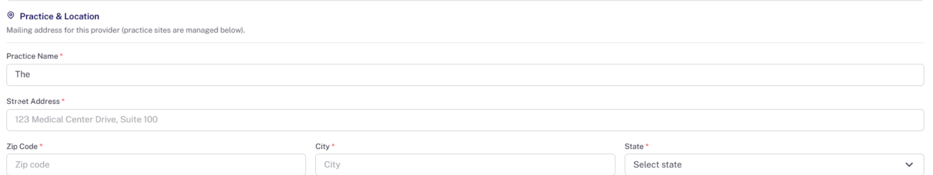

Providers

Provider > Provider Logins: We need the password to be visible so we can verify whether the entered password is correct. Also, after entering the password, if we edit the section later, the password field appears blacked out.

Provider Documents: Once we upload a document, we are unable to download it later and receive an error message when attempting to do so.


Providers > State License & Registration: Remove this section as Provider Document section is more suitable and accessible with required information.
Edit provider> Licenses & Credentials
The section should have editable sections for license and other credentials. For regular maintenance.

Document Repository >>
• Document search: The Document Repository is not searching or returning documents when using the Practice Name. Need search option by Client code and Payer.

Credentialing Tracker
- Need direct access to open any application by one click on Case number:
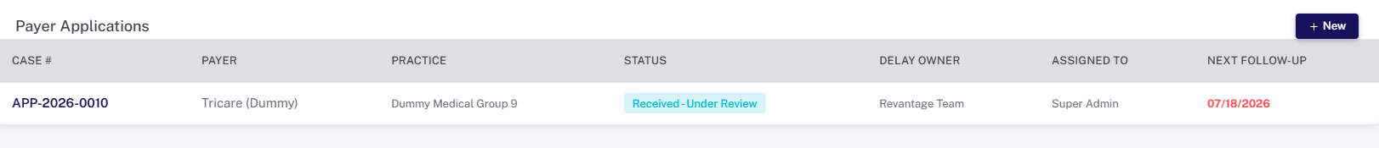

Credentialing tracker tab:-
Kpi card(Active application) Hyperlink not working.

