Programming with ComputerCraftEdu

ComputerCraftEdu will allow for kids to start doing programming with ComputerCraft without needing to learn the Lua programming language right away. Instead it uses a nice Graphical User Interface (GUI) that makes things so much easier. There will be plenty of time to learn Lua, but first let's get used to the Turtlebots. Hopefully, this will give you enough to get you started.

Getting Started
The first thing you need know is where do the Turtlebots come from. These will be made available from a Minecraft mod, called ComputerCraftEdu. ComputerCraftEdu is intended to be used in a special server, but you can install the mod separately. First, you will need to have installed the Forge Mod Loader and then you will need to have installed the ComputerCraftEdu mod.

Once the Forge Mod Loader the ComputerCraftEdu have been installed in your Minecraft, then you will be able to start playing with your Turtlebot. You can check to make sure everything was installed by clicking on the Mods button on the main Minecraft Launcher, and you should see something like what is shown below:

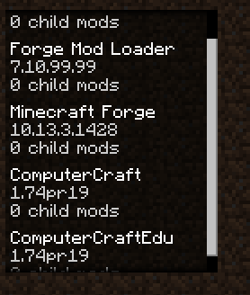

Getting to Know Your Turtle
Okay, so now you are ready start doing stuff! The first thing you need to know is where to get your Turtlebot in the game. Assuming that you are in Creative mode, if you are not please change to it now, you will find some additional Inventory menus, go the second one, and then click on the ComputerCraftEdu tab, as shown below. The inventory items in here are for ComputerCraftEdu. For now let's keep things simple, go ahead and get the following

- Beginner's Turtle - the first green box
- Turtle Remote Control - the last white box

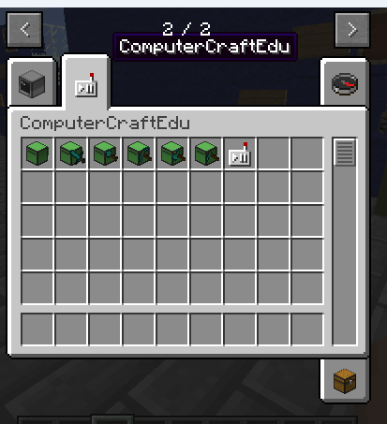

Next, you will need to place your Turtlebot on the ground. You will need to know what is the front and what is the back of your Turtlebot

The front of your Turtlebot is shown below.

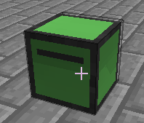

The back of your Turtlebot is shown below.

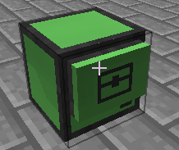

Turning On Your Turtle
After placing your Turtlebot on the ground, it will not do anything until you first turn it on and then tell it to do something. So let's turn it on, so we can go do some cool stuff!

Have the Turtle Remote Control, shown below, in the Inventory bar and make sure it is currently in your hand, then right-mouse click on the Turtlebot



After clicking, the remote control will move out of your hand and appear in a new, tenth box in the Inventory bar, as shown below.

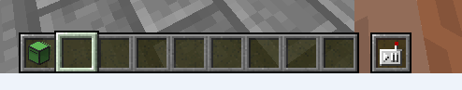

Okay, now your Turtlebot is ready to start getting and doing commands. If you right-mouse click on your Turtlebot, the control GUI will appear, as shown below.

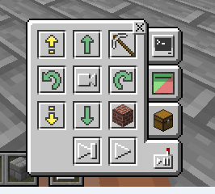

This is where you will control your Turtlebot, as you can see there are four tabs in the GUI. The first tab looks like a computer and this is where you can program your Turtlebot. The second tab is where you can change what your Turtlebot looks like. The third tab is a chest and this is where you give/take inventory items to/from your Turtlebot. The fourth and currently selected tab is the manual controls of your Turtlebot. The manual controls can be clicked upon to make your Turtlebot do things immediately.

There is one button in the fourth tab that needs special attention. This is the Turtle Vision button, shown below. This one is in the center and its pretty cool. It will let you see what the Turtlebot sees. You can turn it on by clicking on it, and turn it off by clicking on it. It's kind of fun to be able to see what your Turtlebot is seeing, especially at times when you can't follow your Turtlebot.

Moving the Turtle
Okay so next you are going to want to move your Turtlebot around.

This will move your Turtlebot one block forward, if there is nothing in front.

This will move your Turtlebot one block backward, if there is nothing behind.
This will turn your Turtlebot to the left.
This will turn your Turtlebot to the right.
This will move your Turtlebot up one block, if there is nothing there, it will still be able to go up, which is really nice, meaning your Turtlebot can kind of fly.
This will move your Turtlebot down one block, if there is nothing there. If there is already a block there, then this does nothing.

Now, if you ask your Turtlebot to do something it can't, such as move forward when there is already a block in front of it, then the program that the Turtlebot is running will get stuck, and you will need to stop the program and try again.

Running Programs
Okay, so now let's find out how to run a program. Go to the control GUI, and select the programming tab that looks like a little computer, shown below

The programming UI is really three parts. The squares on the left side are used for your program steps, starting in the upper left corner. On the right side, the top is the different commands that you can run, and then bottom is where you can save your program to the little disk after giving it a name.

All you need to do is drag and drop commands from the right side onto the squares on the left. It really is that easy. Now getting your Turtlebot to do exactly what you want it to do might take a little bit of practice, but you will find it pretty easy, once you get used to it. If you want to delete commands, all you need to do is drag them back into the area on the right side.

This simple example program is telling a Turtlebot to move four blocks forward.

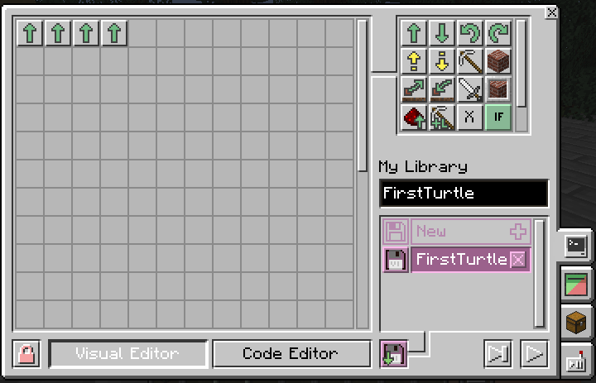

In the lower right side of the window, will see a button that looks like an arrow, shown below. This is where you will start the program. All you need to do is click on it.

After you start the program, the button will change from an arrow to a box, and you can use this to stop a running program.

Placing Blocks
The next thing you are going to want to do is to have your Turtlebot place blocks. But before your Turtlebot can place any blocks, you will need to give it some blocks to place. Below this Turtlebot has been given 32 blocks of Dirt to use. The commands to place blocks are described below.

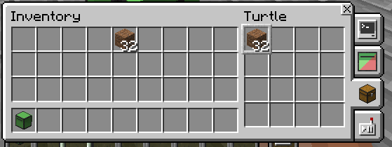

This will place a block in front of the Turtlebot. If you do this, remember to move up in the next command.

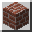

This will place a block directly below the Turtlebot.



This will place a block directly above the Turtlebot.



Code View
CodeView is a nice thing that will let you started using Lua, while still being able to use the GUI. On the bottom of the window, you can see two buttons: Visual Editor and Code Editor. These buttons allow you to change between using the GUI and Lua. Below is an example of a simple program that uses a loop to make a Turtlebot move four blocks forward in both Visual and Code Editor modes.

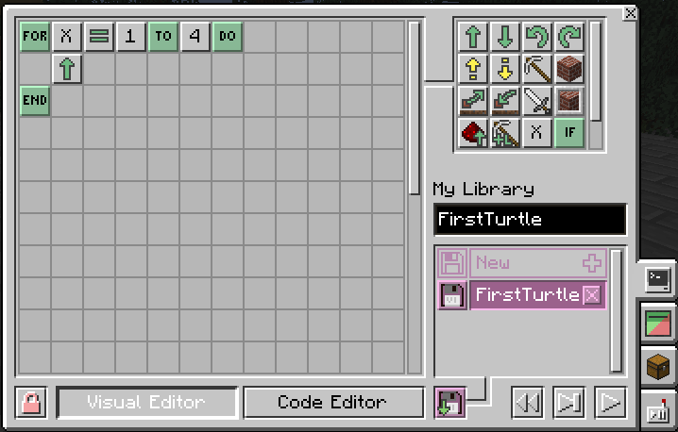

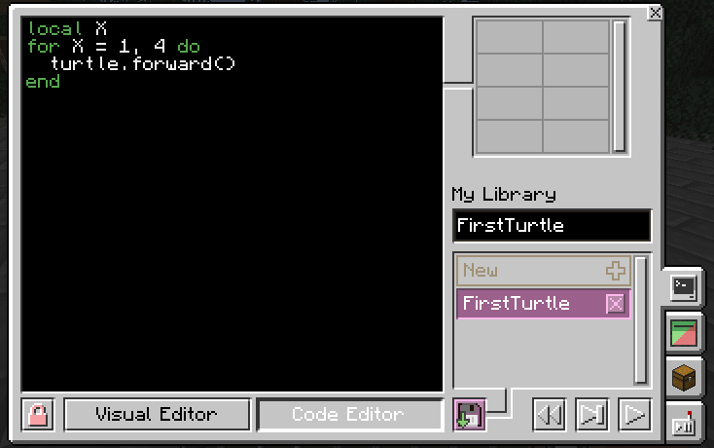

What is Next

Okay, so at this point you are ready to be turned loose with your Turtlebot. We have only talked about the basic Turtlebot, but you can use what you have learned here with the different kinds of ComputerCraftEdu Turtlebots:

- Melee - used to fight
- Digging - used to dig
- Mining - used to mine
- Felling - used to chop down trees
- Farming - used to farm

Be Cool! Have Fun!

