Lab – How Connected are You?

1. Objectives

Survey 3 or 4 people: family, colleagues, and friends. Determine how many hours they are "connected" via any device during each day.

1. Background / Scenario
2. It is important to understand that most people born in the 1990s, will have grown up in a primarily digital world. Computers, the Internet, mobile phones, texting, social networking are all second nature to members of this group. This survey will help you to recognize how much of the day is actually spent “connected”. This will help us to see the impact this generation will have on business and the economy.
3. Required Resources

* 3 or 4 people (friends, family, colleagues)
  1. Create a spreadsheet similar to the one below.
     1. Add extra rows for more information if needed.

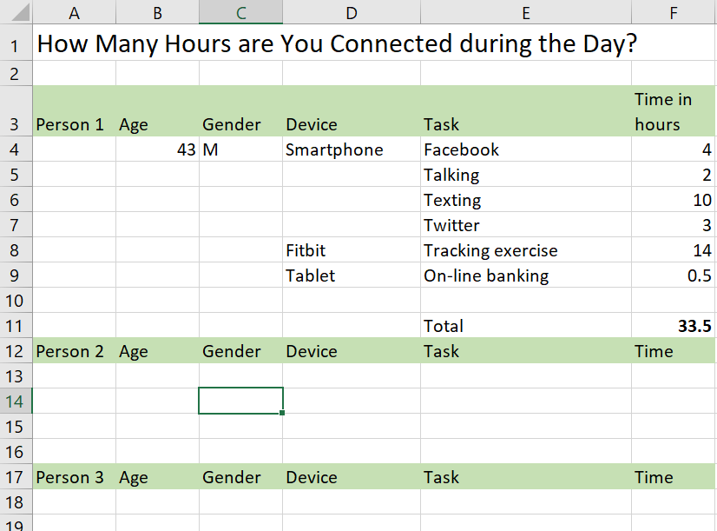

* 1. Summarize findings.

1. What was the average amount of time spent “connected” by all of your interviewees?  
     
   Khoảng từ 10 đến 14 tiếng ____________________________________________________________________________________
2. How many people were connected on more than one device at a time?  
     
   1 người sử dụng nhiều hơn 1 thiết bị. ____________________________________________________________________________________
3. Did age make a difference to the amount of “connected” time during a day? If yes, what do you think is the reason?  
     
   Vì khoảng cách thế hệ nên thường người lớn sẽ có thời gian kết nối ít hơn so với lớp trẻ được tiếp cận với công nghệ thông tin sớm như hiện nay____________________________________________________________________________________
4. Did gender make a difference to the amount of “connected” time during the day? If yes, what do you think is the reason?  
     
   Thời gian kết nối của nam và nữ không chênh lệch nhau mấy. ___________________________________________________________________________________
5. How might this information affect the way businesses address their processes?  
     
   Giúp cho các doanh nghiệp, tổ chức có thể cung cấp cho người dùng cái họ cần. ____________________________________________________________________________________