RETAIL SALES ANALYTICS & BUSINESS INTELLIGENCE DASHBOARD
Project Report

1. Executive Summary
This project demonstrates how transaction-level retail data can be transformed into a business intelligence dashboard. The application presents KPIs, trends, category and regional comparisons, product performance, and follow-up actions using Python, Streamlit, Pandas, and NumPy. The accompanying CSV is a synthetic educational dataset.

2. Problem Statement
Retail transaction tables can be difficult for decision-makers to interpret quickly. This project organizes sales and profitability measures into an interactive dashboard to support exploration and identify areas for further investigation.

3. Objectives
Summarize sales, profit, order count, average order value, and profit margin; compare trends, categories, regions, and customer segments; identify products for further review; and translate descriptive analysis into cautious follow-up actions.

4. Dataset Description
The project includes `retail_sales_dataset.csv` with 1,800 simulated transaction rows and 12 columns. Dates span 2023-01-02 to 2025-12-31. Columns include order ID/date, region, segment, category, product, quantity, discount, sales, and profit. The dataset is generated specifically for this educational project using a fixed random seed and is stored as a separate CSV that the application reads at runtime.

5. Tools and Technologies
Python for application logic; Streamlit for the interactive web dashboard; Pandas for tabular manipulation; NumPy for numerical calculations; Matplotlib for report charts.

6. Methodology
Load the CSV dataset; validate required columns and parse dates and numeric fields; derive month and profit margin; allow filtering by date, category, region, and segment; calculate KPIs; aggregate metrics; visualize performance; and present decision-support recommendations.

7. Key Performance Indicators
Total sales: $962,302.12. Total profit: $144,350.97. Unique orders: 1,800. Average order value: $534.61. Profit margin: 15.00%. These values describe the included synthetic dataset only.

8. Exploratory Analysis
In the included synthetic dataset, Technology has the highest total sales, North has the highest total profit, and West has the lowest total profit. These are descriptive outcomes of simulated data, not real-world business findings.

9. Business Insights and Recommended Actions
Review Technology product mix and stock availability before increasing promotional spend. Investigate differences between North and West using order mix, discount, and cost data. Track margin alongside sales because high revenue does not automatically imply high profitability. Validate actions with real operational data before making decisions.

10. Application Workflow
Keep `retail_bi_dashboard.py` and `retail_sales_dataset.csv` in the same folder. Install dependencies with `pip install -r requirements.txt`, then run `streamlit run retail_bi_dashboard.py`. Use sidebar filters and review KPI cards, charts, the product table, and decision-support notes.

11. Limitations
The CSV contains synthetic data; profit uses assumed category margins and discount effects rather than real cost records; the dashboard is descriptive rather than predictive; and recommendations are prompts for further investigation.

12. Future Scope
Replace the synthetic CSV with a permitted public dataset, add data-quality tests and CSV upload, support filtered exports and automated reports, and consider forecasting only after selecting and validating suitable data.

13. Conclusion
The project demonstrates a clear BI workflow: load a dataset, calculate KPIs, examine trends, identify areas for investigation, and translate observations into possible actions. A separate CSV file makes the data source explicit and keeps the application reproducible.

7A. KPI Summary
KPI | Synthetic result | Definition
Total sales | $962,302.12 | Sum of sales after simulated discount
Total profit | $144,350.97 | Sum of simulated profit
Unique orders | 1,800 | Count of unique order IDs
Average order value | $534.61 | Sales divided by unique orders
Profit margin | 15.00% | Profit divided by sales

8A. Visualizations
Figure 1. Monthly sales trend
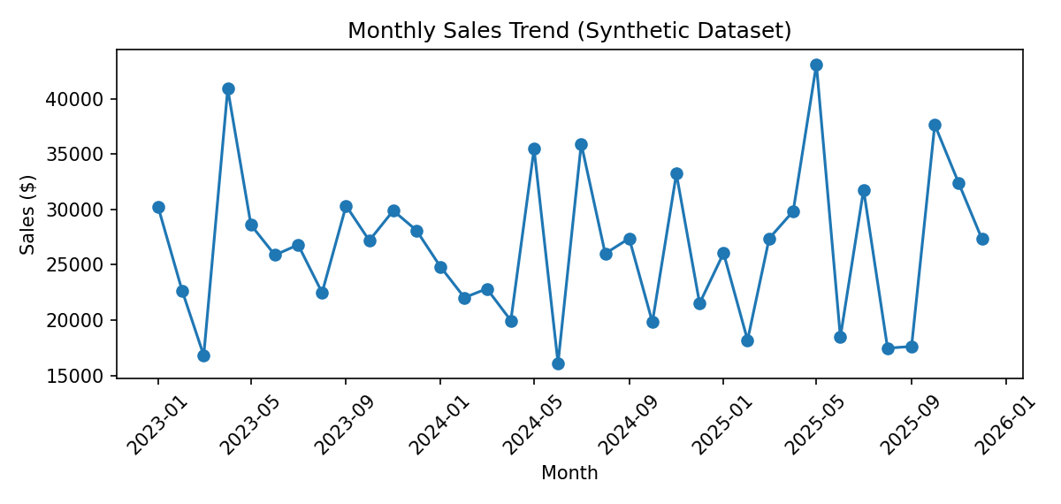
Figure 2. Sales by product category
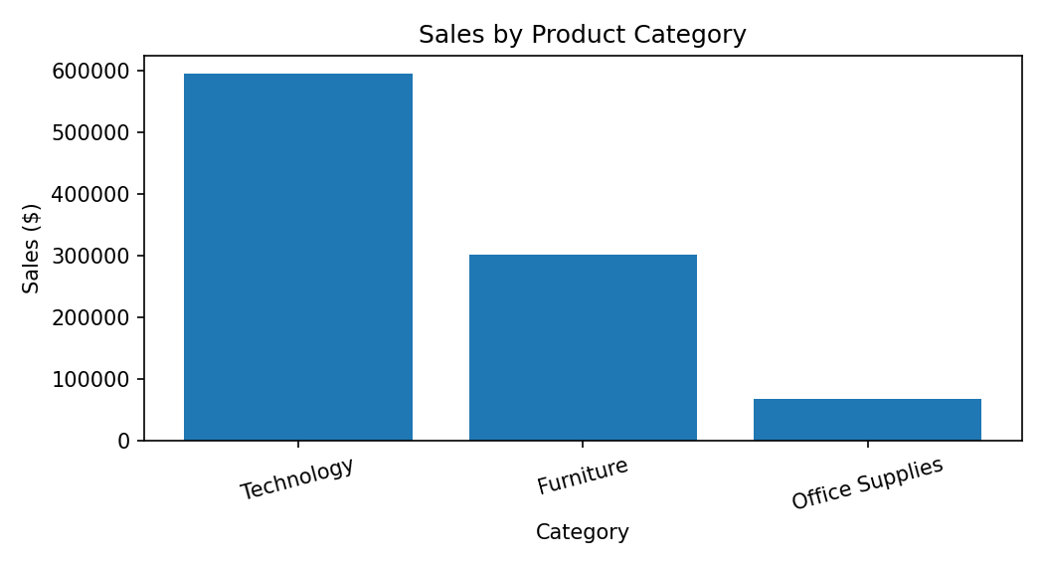
Figure 3. Profit by region
