ΠΑΝΕΠΙΣΤΗΜΙΟ ΙΩΑΝΝΙΝΩΝ
ΤΜΗΜΑ ΜΗΧ. Η/Υ & ΠΛΗΡΟΦΟΡΙΚΗΣ

ΑΝΑΠΤΥΞΗ ΛΟΓΙΣΜΙΚΟΥ

ΠΡΟΓΡΑΜΜΑΤΙΣΤΙΚΗ ΕΡΓΑΣΙΑ για το ακαδημαϊκο έτος
2021-2022
ΟΜΑΔΑ 2528-4001-4052
πουρναρας αλεξανδρος , ΑΜ:2528
σολδατου χριστινα ολυμπια, αμ4001
τριανταφυλλενια δουμανη,
ΑΜ:4052

αρχικη ΑΝΑΦΟΡΑ

ΝΟΕΜΒΡΊΟΣ 2021

ΙΣΤΟΡΙΚΟ ΕΚΔΟΣΕΩΝ ΤΗΣ ΠΑΡΟΥΣΑΣ ΑΝΑΦΟΡΑΣ
Ημερομηνία | Έκδοση | Περιγραφή | Συγγραφείς
19/11/2021 | v.01 | Οργάνωση απαιτήσεων σε use cases, ΟREOS για τα test cases και σχεδίαση UML διαγραμμάτων | 2528-4001-4052

Ανάλυση Απαιτήσεων – Use Cases
Στην παρούσα ενότητα, παρατίθενται οι περιγραφές των use cases με βάση τις καταγεγραμμένες απαιτήσεις.

RegistrationOfAStructuredDataFile

ID: UC 1

Description and Goal
The use case «RegistrationOfAStructuredDataFile» begins when the analyst registers the structured data file in the system.

Actors (esp. primary actor)
Τhe analyst.

Preconditions
The structured data file exists.

Basic Flow
1.The UC starts when the analyst registers the structured data file in the system.

Extensions / Variations

-

Post conditions
The structured data file is registered in the system.

RetrieveMetadata

ID: UC 2

Description and Goal
The use case «RetrieveMetadata» begins when the analyst retrieves the list of the field names of a structured data file.

Actors (esp. primary actor)
Τhe analyst.

Preconditions
The structured data file exists.

Basic Flow
1. The UC starts when the analyst retireves file’s metadata the system

Extensions / Variations
The structured file data is empty.

Post conditions
A field names list is retrieved.

FilterTheData

ID: UC 3

Description and Goal
The use case «FilterTheData» begins when the analyst sets filters on the structured data files.

Actors (esp. primary actor)
Τhe analyst.

Preconditions
The filter’s fields exist.

Basic Flow
1. The UC starts when the analyst sets the filters on the structured data files.
2. The analysts can choose a specific filter or a combination of filters.

Extensions / Variations
If the analyst asks for more filters than the existing ones the system displays a message.

Post conditions
The filtered subset of the structured data file is displayed.

PrintTheResultInAFile

ID: UC 4

Description and Goal
The use case «PrintTheResultInAFile» begins when the analyst chooses to print the result to another file.

Actors (esp. primary actor)
Τhe analyst.

Preconditions
The system allows the analyst to print the result to another file.

Basic Flow
1. TThe UC starts when the analyst chooses to print the result to another file..
2. The analysts chooses the type of the new file.

Extensions / Variations
If the creation of the new file fails, throw an info message

Post conditions
A new file has been created.

DisplayTheResultIntoAChart

ID: UC 5

Description and Goal
The use case «DisplayTheResultIntoAChart» begins when the analyst chooses to display the result into a chart.

Actors (esp. primary actor)
Τhe analyst.

Preconditions
The new file has been successfully created.

Basic Flow
1. The UC starts when the analyst chooses to display the result into a chart.
2. The analyst chooses the axes of the chart.
3. The analyst chooses the type of the chart.
4. The analyst chooses if the result should be saved in a jpg file.

Extensions / Variations
If the filtered file is empty throw an info message.

Post conditions
The charts have been successfully created.

Σχεδίαση Ελέγχων
Οι έλεγχοι που σχεδιάσθηκαν και εντάχθηκαν στην υλοποίηση περιγράφονται παρακάτω. Εδώ, ως υπόδειγμα: το project με την διάσπαση χρονοσειράς σε φάσεις.

Ελεγχος use cases via system tests

Use case UC1: Registration Of Astructured Data File
Test cases

ID | T1_V0_01 | HappyDayScenario for StucturedDataRegistration()
Description | ON | any context
 | RECEIVING | The file path of a file with the data
 | ENSURE | That the System
 | OUTPUTS | The correct formatting of the file
 | SUCH THAT | The file exists in the Metadata list.
Pre-cond. |  | No specific precondition
Input |  | The file path of the file
Output |  | The structured data is registered in the system.
Post-cond. |  | The data has been registered correctly
Method To test |  | StucturedDataRegistration()

Involved methods
MainEngine.loadData()
StucturedDataRegistration()

Use case UC2: Retrieve metadata
Test cases

ID | T2_V0_01 | HappyDayScenario for RetrieveMetadata()
Description | ON | Any context
 | RECEIVING | The loaded data and the aggregation type
 | ENSURE | That the System
 | OUTPUTS | A list of the field names
 | SUCH THAT | The field name list is retrieved.
Pre-cond. |  | Data must have been loaded first.
Input |  | The loaded data and the data list.
Output |  | The organized field name list.
Post-cond. |  | The field name list is retrieved.
Method To test |  | Retrievator.retrieveMetadata()

Involved methods
Retrievator.retrieveMetadata()
MainEngine.retrieveMetadata()

Use case UC3: Filter the data
Test cases

ID | T3_V0_01 | HappyDayScenario for FilterTheData()
Description | ON | The filters in the structued file data
 | RECEIVING | The list
 | ENSURE | That the System
 | OUTPUTS | Displays the set of filters that are chosen
 | SUCH THAT | The state is intact.
Pre-cond. |  | Data must have been loaded first.
Input |  | The loaded data and the filters
Output |  | The filters
Post-cond. |  | The filter subset of the data file is displayed.
Method To test |  | FilterTheData()

Involved methods
Filterer.filterTheData()
MainEngine.filterTheData()

Use case UC4: Print the result In a file
Test cases

ID | T4_V0_01 | HappyDayScenario for printResultInFile()
Description | ON | A file with the set of results of a filter
 | RECEIVING | The file and the output location
 | ENSURE | That the System
 | OUTPUTS | The result of the analyst's question
 | SUCH THAT | The state is intact
Pre-cond. |  | Data must have been loaded first
Input |  | The output directory
Output |  | The results of the question
Post-cond. |  | A new file has been created
Method To test |  | printResultInFile()

Involved methods
ResultPrinter.printResultInFile()
MainEngine.printResultInFile()

Use case UC5: DISPLAY THE RESULT INTO A CHART
Test cases

ID | T5_V0_01 | HappyDayScenario for displayIntoChart()
Description | ON | A chart created from the results
 | RECEIVING | The file with results
 | ENSURE | That the System
 | OUTPUTS | The chart
 | SUCH THAT | The state is intact
Pre-cond. |  | The new file has been succefully created
Input |  | The output directory
Output |  | The final chart
Post-cond. |  | The chart have been successfully created
Method To test |  | displayIntoChart()

Involved methods
Displayer.displayIntoChart()
MainEngine.displayIntoChart()

Traceability Matrix
Η αντιστοίχιση use cases σε id’s φαίνεται στον Πίνακα 1:
UC1 | RegistrationOfAStructuredDataFile
UC2 | RetrieveMetadata
UC3 | FilterTheData
UC4 | PrintTheResultInAFile
UC5 | DisplayTheResultIntoAChart
Πίνακας 1 Σύνοψη use cases και των id’s τους

Ο Πίνακας 2 είναι ο traceability matrix για τους ελέγχους μας. Στη συνέχεια, οι έλεγχοι επεξηγούνται πιο αναλυτικά.

 | UC1 | UC2 | UC3 | UC4 | UC5
T1_V0_01 | X
T2_V0_01 |  | X
T3_V0_01 |  |  | X
T4_V0_01 |  |  |  | X
T5_V0_01 |  |  |  |  | X

ΕΚΚΡΕΜΟΤΗΤΕΣ (ToDo)
Εκκρεμούν μη υλοποιημένοι έλεγχοι ως ακολούθως
- Unit tests are missing for several classes, both at the model and at the business logic level, specifically

Σχεδίαση Λογισμικού

Διαγράμματα ΠΑΚΕΤΩΝ / υποσυστημάτων
Η ανάλυση του κώδικα σε υποσυστήματα και πακέτα έχει νόημα μόνο όταν το μέγεθος και η πολυπλοκότητα του κώδικα επιτάσσουν την εν λόγω διαίρεση.
To διάγραμμα των πακέτων του συστήματος ακολουθεί στο Σχ. 1.
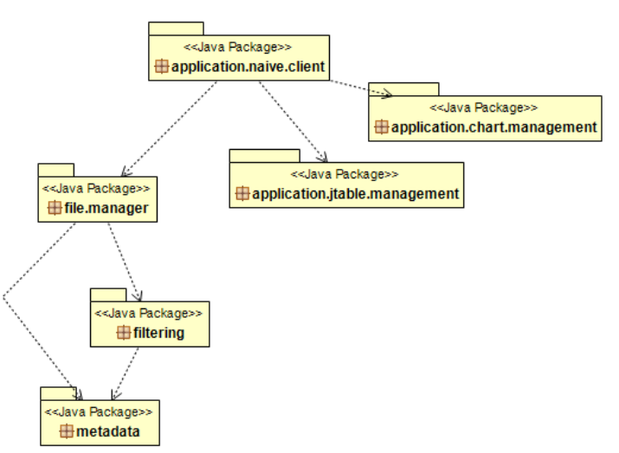
Σχήμα 1. Διάγραμμα πακέτων (εδώ: από την αξιολόγηση εστιατορίου)
Ακολουθεί μια συνοπτική περιγραφή των πακέτων του συστήματος.

ΠΑΚΕΤΑ ΤΟΥ ΣΥΣΤΗΜΑΤΟΣ
application.naive.client | Επικοινωνια με το backend του συστήματος μέσω ενος application controller. Περιέχει την main του προγράμματος.
Application.jtable.management | Προβολή φιλτραρισμένων αποτελεσμάτων σε JTable.
Application.chart.management | Προβολή φιλτραρισμένων αποτελεσμάτων σε LineChart ή ένα BarChart
filtering | Φιλτραρισμα και επιστροφή φιλτραρισμένων εγγραφών.
File.manager | Διαχείριση αρχέιων.
metadata | Επιστροφή μεταπληροφορίας ήδη κατανεμημένων αρχείων.
Πίνακας 1. Συνοπτική περιγραφή πακέτων συστήματος (εδώ: από την αξιολόγηση εστιατορίου)

Διαγράμματα Κλάσεων

package filtering;

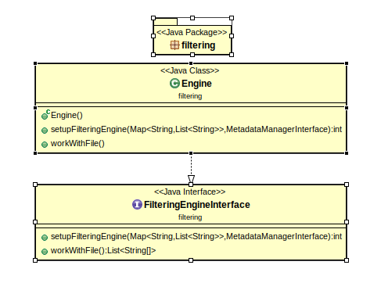

package file.manager

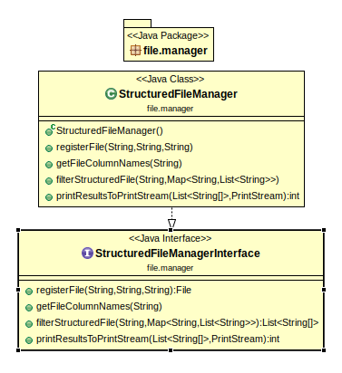

package metadata

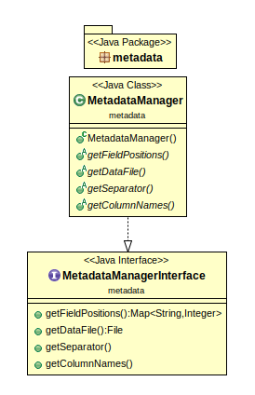

package application.naive.client

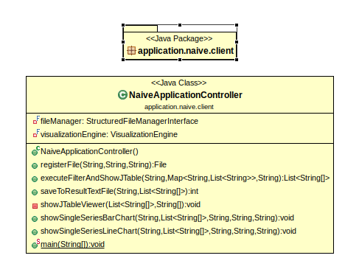

package application.jtable.management

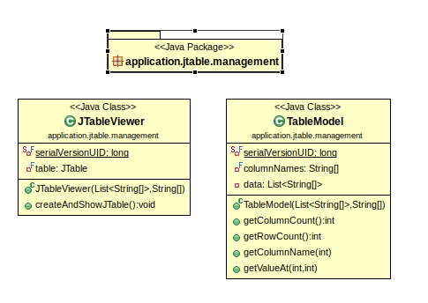

package applicarion.chart.management

