PRANARA
Munnar Travel & Tourism Platform
Category: Travel & Tourism
Services: UI/UX Design • Web Design • Frontend Development
Year: 2026
Live Project → https://www.pranaramunnar.com/

Overview
PRANARA is a modern travel and tourism platform designed to help users discover, explore, and plan trips around Munnar, Kerala.The website focuses on presenting destinations, travel experiences, and tour packages through a clean and engaging digital experience.

Objective
The main goal was to create a visually appealing and easy-to-use platform that allows users to:
- Explore Munnar destinations
- Discover travel experiences
- View tour packages
- Learn about destinations
- Plan and enquire about trips
- Access important travel information
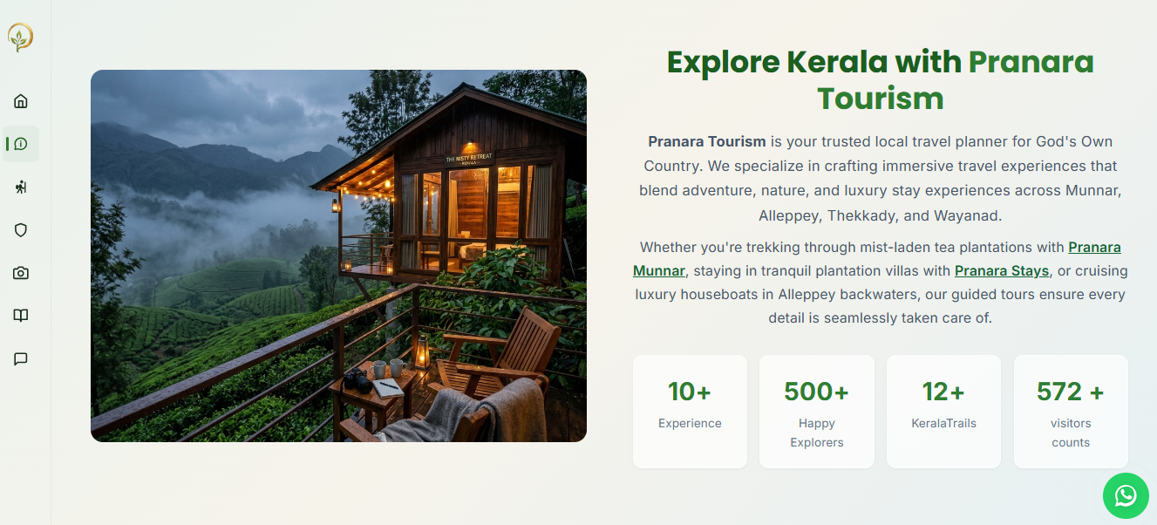

Design Approach
The design combines a modern travel aesthetic with a simple user experience.
Key design principles:
- Clean and spacious layouts
- Strong visual storytelling
- Nature-inspired visual language
- Clear navigation
- Mobile-responsive experience
- Simple booking/enquiry flow
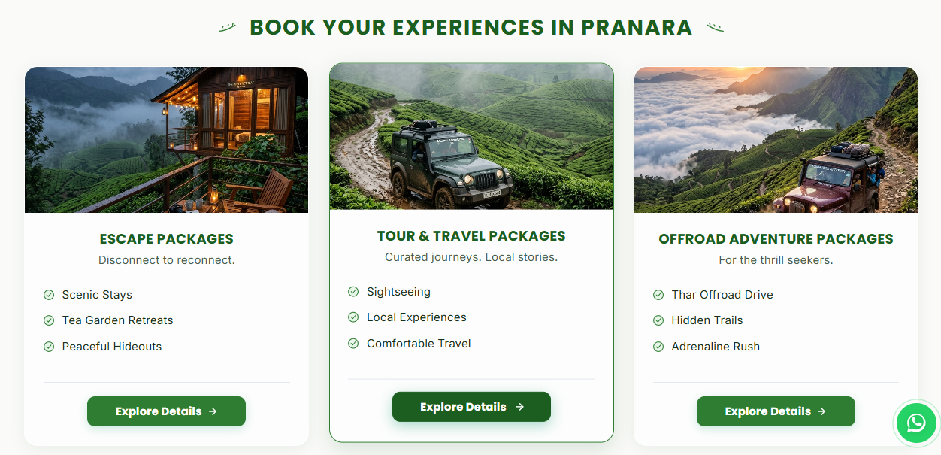

Key Sections
- Home
- About PRANARA
- Destinations
- Tour Packages
- Travel Experiences
- Destination Details
- Gallery
- Contact / Enquiry

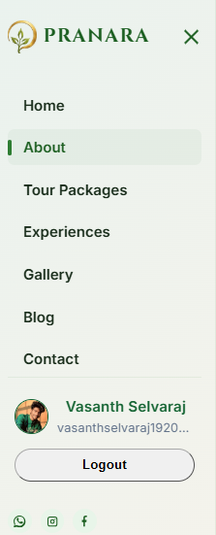
Technology
Design: Figma
Frontend: HTML / CSS / JavaScript
Development: Web-based responsive implementation
Deployment: Vercel and hostinger (with domain)

Outcome
PRANARA delivers a modern digital presence for the travel brand while making it easier for users to discover destinations and explore travel offerings.
Live Project → https://www.pranaramunnar.com/

