VISITMAX
Field Visit Management Application Design
Category: Healthcare • Mobile Application
Services: UI/UX Design • Mobile App Development
Year: 2025
Live Design : https://www.figma.com/design/KOfwcWwrgEqqUZwfbwfHiq/visitmax?node-id=0-1&p=f&t=b5PNiqgyHCgXPBaQ-0

Overview
VisitMax is a mobile application designed for healthcare marketing executives to manage and track their daily visits to clinics, hospitals, and healthcare partners.The application simplifies visit recording, evidence collection, location validation, and report management in one platform.

Objective
The main goal was to create a simple mobile experience that helps field executives:
- Manage daily visits / Record visit details
- Validate their location
- Upload visit evidence
- Track completed and pending visits
- Generate and view reports
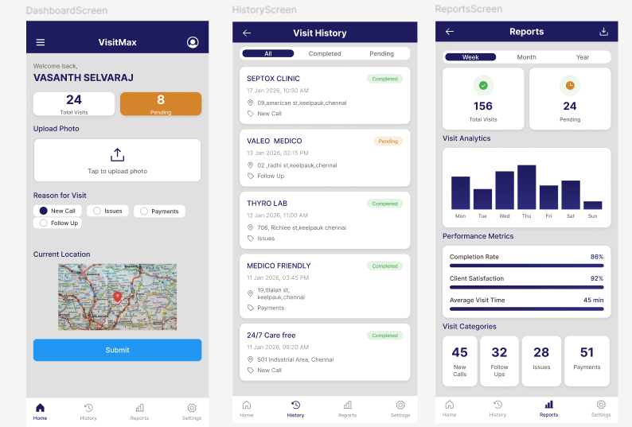
Key Features
- Login & OTP Authentication
- Dashboard / Visit Tracking
- GPS Location Validation
- Evidence Photo Upload
- Visit Reason Selection
- Visit History / Reports
- Profile Management
- Settings
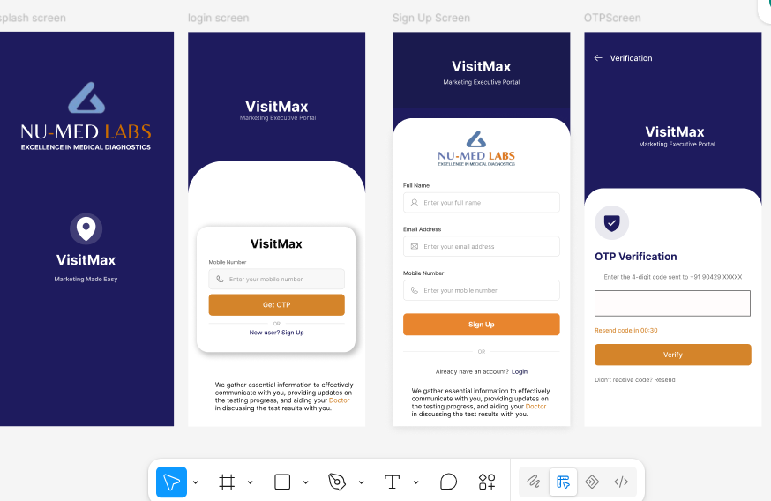
Design Approach
The interface was designed with a focus on simplicity, accessibility & quick field usage.
Key principles:
- Clean mobile-first interface
- Simple navigation and Clear information hierarchy
- Quick-access actions
- Consistent UI components
- Minimal steps for recording a visit

Technology
Design: Figma
Mobile: React Native
Backend: Web API
Database: MySQL
Development: Android Studio / VS Code

Outcome
VisitMax provides a centralized mobile solution for managing healthcare field visits, reducing manual tracking and making visit reporting more structured and efficient.
Live Design : https://www.figma.com/design/KOfwcWwrgEqqUZwfbwfHiq/visitmax?node-id=0-1&p=f&t=b5PNiqgyHCgXPBaQ-0

