Wireshark HTTP/HTTPS Lab Answer

Difference between HTTP and HTTPS
HTTP (HyperText Transfer Protocol) sends data in plain text. Any packet sniffer such as Wireshark can easily read usernames, passwords, form fields, cookies, and message content if the traffic is not protected.
HTTPS (HyperText Transfer Protocol Secure) uses SSL/TLS encryption. The data exchanged between client and server is encrypted before transmission. Even if packets are captured in Wireshark, the actual credentials and content are not visible in readable form.
Main differences:

HTTP | HTTPS
Data is unencrypted | Data is encrypted using SSL/TLS
Uses port 80 | Uses port 443
Vulnerable to sniffing | Safer against sniffing and attacks
Easy to read in Wireshark | Packet content is mostly unreadable

Impact of HTTP vs HTTPS on the Results
The difference between HTTP and HTTPS directly affected the sniffing results.

For the HTTP website, the login credentials and form data were visible in plain text inside the HTTP POST packets.
For HTTPS websites, the captured packets only showed encrypted TLS application data. Wireshark could show:
  - Source IP address
  - Destination IP address
  - Packet length
  - TCP port numbers
  - TLS handshake information
  - Server Name Indication (SNI) in some cases

However, the actual username and password were not readable.

Thus, HTTP traffic allowed complete visibility of credentials, while HTTPS protected the credentials from being exposed.

Plain Text HTTP POST Message Information
For the HTTP website:

  - Website: http://www.techpanda.org
  - HTTP Method: POST
  - Credentials entered in the login form were visible in plain text.
  - Example fields visible in Wireshark:
    - username=email@example.com
    - password=yourpassword Typical HTTP POST packet format:
POST /customer/account/loginPost/ HTTP/1.1 Host: www.techpanda.org
Content-Type: application/x-www-form-urlencoded

login[username]=example@gmail.com login[password]=mypassword123

For Facebook and Gmail:

  - The POST request body was encrypted.
  - Only encrypted TLS packets were visible.
  - Username and password fields were not readable.

Could You Sniff the Credential Information for All Websites?
No, credentials could not be sniffed for all websites.

Results
  - TechPanda (HTTP): Yes, credentials were visible.

  - Facebook (HTTPS): No, credentials were encrypted.
  - 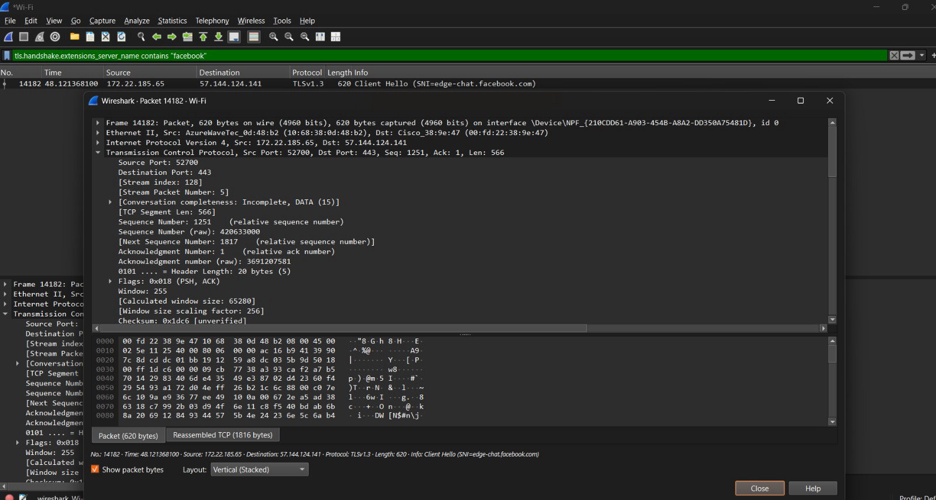
  - Gmail (HTTPS): No, credentials were encrypted.
  - 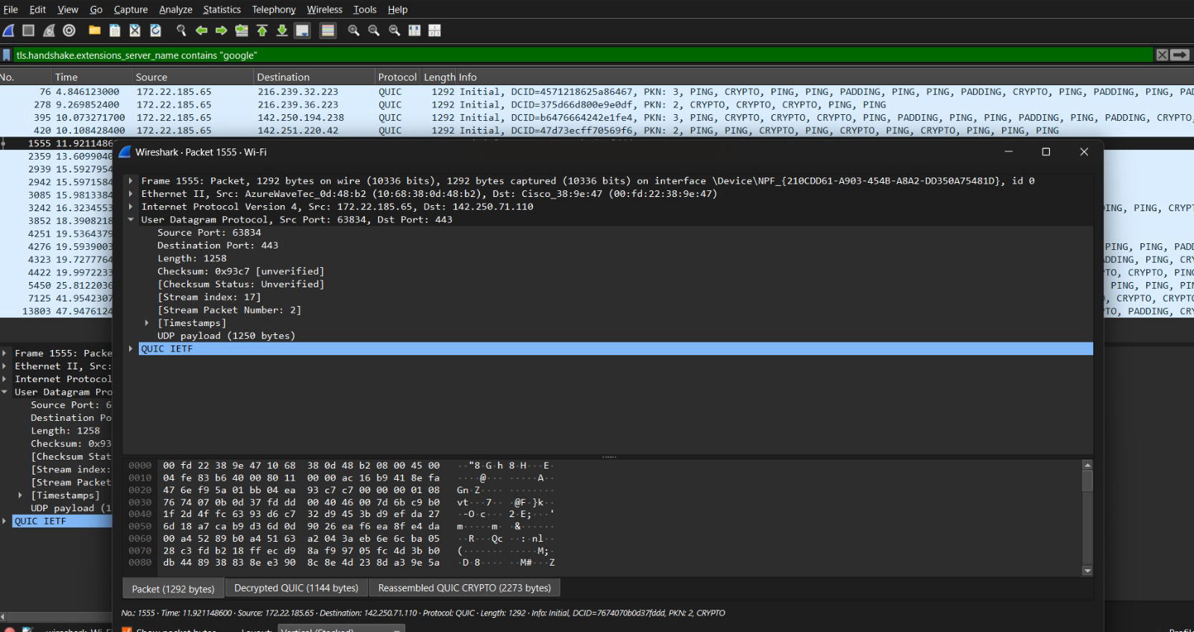

Reason
HTTP does not encrypt traffic, so Wireshark can capture the login form fields directly.

HTTPS encrypts the communication using SSL/TLS. Therefore, even though packets are captured, the contents remain unreadable.

Protocols Encountered During Sniffing and Their Functionalities
During packet capture, multiple protocols may appear.

ARP
Address Resolution Protocol is used to find the MAC address corresponding to an IP address in the local network.

DNS
Domain Name System converts domain names such as facebook.com into IP addresses.

TCP
Transmission Control Protocol provides reliable communication between sender and receiver. It handles sequencing, acknowledgements, retransmissions, and connection setup.

HTTP
HyperText Transfer Protocol is used for transferring web pages and form data without encryption.

HTTPS
HTTPS is the secure version of HTTP and uses TLS encryption.

TLS/SSL
Transport Layer Security provides encryption, authentication, and integrity for HTTPS communication.

UDP
User Datagram Protocol provides fast but connectionless communication. DNS commonly uses UDP.

ICMP
Internet Control Message Protocol is used for error reporting and network diagnostics such as ping.

DHCP
Dynamic Host Configuration Protocol assigns IP addresses to devices automatically.

Conclusion
The Wireshark experiment clearly demonstrates that HTTP traffic is insecure because credentials can be read directly from captured packets. HTTPS significantly improves security because it encrypts the communication and prevents attackers from reading sensitive information such as usernames and passwords.

