SIKSHA ‘O’ ANUSANDHAN
(DEEMED TO BE UNIVERSITY)
Admission Batch: 2023 – 2027 Session: 2025 – 2026
Laboratory Record
Machine Learning Projects with Python
(CSE 4192)
Submitted by
1. Name: Tribhuwan Singh (Regd. No.: 2341019538)
2. Name: Surajit Sahoo (Regd. No.: 2341019165)
3. Name: Anwesha Srichandan (Regd. No.: 2341019594)
4. Name: Priti Rani Maity (Regd. No.: 2341013065)

Centre for Artificial Intelligence & Machine Learning
Faculty of Engineering & Technology (ITER)
Jagamohan Nagar, Jagamara, Bhubaneswar, Odisha – 751030

1 Introduction
1.1 Problem Statement
Diabetes mellitus represents one of the most critical global public health crises of the twenty-first century, currently affecting over 537 million adults worldwide and projected by the International Diabetes Federation (IDF) to exceed 643 million by 2030. It is a progressive metabolic disorder characterized by persistent hyperglycemia resulting from impaired insulin secretion, peripheral insulin resistance, or synergistic dysfunctions of both. If left undiagnosed, chronic hyperglycemia triggers microvascular destruction (diabetic retinopathy leading to blindness, diabetic nephropathy causing end-stage renal failure, and peripheral neuropathy) and macrovascular pathologies (accelerated atherosclerosis, myocardial infarction, and stroke).
Conventional clinical diagnostic protocols predominantly depend on static, univariate diagnostic cut-offs—such as fasting plasma glucose >= 126 mg/dL or oral glucose tolerance test (OGTT) 2-hour post-load glucose >= 200 mg/dL. These criteria only identify diabetes at advanced stages after substantial beta-cell exhaustion has already transpired. Moreover, existing machine learning screening solutions often suffer from severe methodological pitfalls, including data leakage across evaluation splits, inappropriate handling of biologically impossible zero-value artifacts, and lack of calibrated probabilistic outputs required for clinical risk stratification. This laboratory project formulates a mathematically rigorous, leak-free artificial neural network system to predict 5-year diabetes onset probability from non-invasive biometric and demographic attributes.
1.2 Aim
The overarching aim of this project is to conceptualize, engineer, optimize, benchmark, and deploy a robust, leak-free Multilayer Perceptron (MLP) artificial neural network architecture capable of performing accurate 5-year diabetes onset prediction and continuous clinical risk stratification using the National Institute of Diabetes and Digestive and Kidney Diseases (NIDDK) Pima Indians Diabetes Database, establishing empirical superiority or parity against standard machine learning baselines.
1.3 Objectives
To accomplish this aim, the following concrete research objectives were systematically executed:
1. Conduct exhaustive Exploratory Data Analysis (EDA) to characterize feature distributions, quantify class imbalance (65.1% negative vs. 34.9% positive), and detect non-linear collinearities.
2. Formulate a leak-free preprocessing pipeline that identifies biologically implausible zero values across continuous physiological variables (Glucose, Blood Pressure, Skin Thickness, Insulin, BMI) and applies training-fitted median imputation.
3. Engineer 16 domain-derived biometric features (expanding the feature space from 8 to 24 dimensions) capturing WHO BMI categories, ADA glycemic stages, metabolic interaction proxies, and log transforms.
4. Train and benchmark seven baseline classification algorithms (Logistic Regression, KNN, SVM, Decision Tree, Random Forest, Gradient Boosting, Baseline MLP) under standardized leak-free splits.
5. Perform systematic hyperparameter optimization of the Multilayer Perceptron across hidden topologies, L2 penalties (alpha), initial learning rates, and batch sizes via Grid Search.
6. Evaluate all candidate models on an untouched test cohort (N = 116) across Accuracy, Sensitivity (Recall), Specificity, Precision, F1-Score, and ROC-AUC.
7. Deploy the production pipeline to an interactive Streamlit Cloud dashboard supporting single-patient triage, counterfactual sensitivity simulation, and batch cohort screening.

2 Dataset Description
2.1 Dataset Source
This study utilizes the authoritative Pima Indians Diabetes Database archived by the National Institute of Diabetes and Digestive and Kidney Diseases (NIDDK). The cohort comprises female individuals of Pima Indian descent aged 21 years and older residing near Phoenix, Arizona. This population was selected due to a historically high genetic and environmental susceptibility to Type 2 diabetes mellitus, making it a gold-standard benchmark in biomedical informatics and machine learning literature.
2.2 Dataset Features
The dataset contains 8 raw clinical, physiological, and demographic input attributes:
• Pregnancies: Total number of completed pregnancies (parity), reflecting gestational metabolic stress.
• Glucose: Plasma glucose concentration 2 hours after a 75g oral glucose tolerance test (OGTT) in mg/dL.
• BloodPressure: Diastolic blood pressure reading in mm Hg, capturing vascular tone and peripheral resistance.
• SkinThickness: Triceps skinfold thickness measured via calipers in mm, serving as an anatomical proxy for subcutaneous adiposity.
• Insulin: 2-Hour post-load serum insulin concentration in μU/mL, indicating pancreatic beta-cell endocrine response.
• BMI: Body Mass Index computed as weight in kg divided by height in meters squared (kg/m^2).
• DiabetesPedigreeFunction (DPF): Continuous hereditary score synthesizing familial diabetes history and genetic proximity.
• Age: Chronological patient age in completed calendar years.
2.3 Target Variable
The target variable is Outcome, a binary classification indicator where 1 denotes confirmed clinical diagnosis of diabetes onset within a five-year longitudinal observation window from initial testing, and 0 denotes non-diabetic status.
2.4 Dataset Statistics
The dataset contains N = 768 total records. Summary statistical parameters, physiological measurement types, observed ranges, and zero-count percentages are presented in Table 1 below.
Feature | Type | Mean ± SD | Min | Max | Zero Count (%)
Pregnancies | Discrete | 3.85 ± 3.37 | 0 | 17 | 111 (14.45%)*
Glucose | Continuous | 120.89 ± 31.97 | 0 (44) | 199 | 5 (0.65%)
BloodPressure | Continuous | 69.11 ± 19.36 | 0 (24) | 122 | 35 (4.56%)
SkinThickness | Continuous | 20.54 ± 15.95 | 0 (7) | 99 | 227 (29.56%)
Insulin | Continuous | 79.80 ± 115.24 | 0 (14) | 846 | 374 (48.70%)
BMI | Continuous | 31.99 ± 7.88 | 0 (18.2) | 67.1 | 11 (1.43%)
DiabetesPedigree | Continuous | 0.47 ± 0.33 | 0.078 | 2.42 | 0 (0.00%)
Age | Discrete | 33.24 ± 11.76 | 21 | 81 | 0 (0.00%)
Outcome | Binary | 0.35 ± 0.48 | 0 | 1 | 500 (65.1%) [0]
*Note: In Pregnancies, zero denotes nulliparous women (physiologically valid). In Glucose, BloodPressure, SkinThickness, Insulin, and BMI, zero values represent unrecorded clinical measurements rather than true biological measurements.

3 Exploratory Data Analysis
3.1 Dataset Structure & Missing Value Audit
The raw dataset consists of 768 patient rows and 9 feature columns. A biological sanity audit revealed that while standard SQL-style null values are absent, severe missingness is masked as numerical zeros in continuous features: Insulin (374 zeros, 48.70%), SkinThickness (227 zeros, 29.56%), BloodPressure (35 zeros, 4.56%), BMI (11 zeros, 1.43%), and Glucose (5 zeros, 0.65%). Because human life is incompatible with zero blood glucose or zero blood pressure, these represent missing observation artifacts.
3.2 Class Distribution & Distributional Skewness
The target variable exhibits moderate class imbalance: 500 patients (65.10%) are non-diabetic (Outcome = 0) and 268 patients (34.90%) are diabetic (Outcome = 1), yielding an imbalance ratio of approximately 1.87 : 1. Univariate skewness analysis indicated that Insulin (skewness = 2.27) and DiabetesPedigreeFunction (skewness = 1.92) possess heavy right-tailed distributions, whereas Glucose and BloodPressure approximate Gaussian distributions once zero artifacts are isolated.
3.3 Bivariate & Correlation Analysis
Diabetic patients exhibit markedly elevated median glucose (140.0 vs. 107.0 mg/dL), higher BMI (34.3 vs. 30.1 kg/m^2), and higher median age (36.0 vs. 27.0 years). Pearson correlation analysis reveals that Glucose has the strongest linear correlation with Outcome (r = 0.49), followed by BMI (r = 0.31), Age (r = 0.24), and Insulin (r = 0.21). Notable collinearities exist between Age and Pregnancies (r = 0.54) and SkinThickness and BMI (r = 0.65).
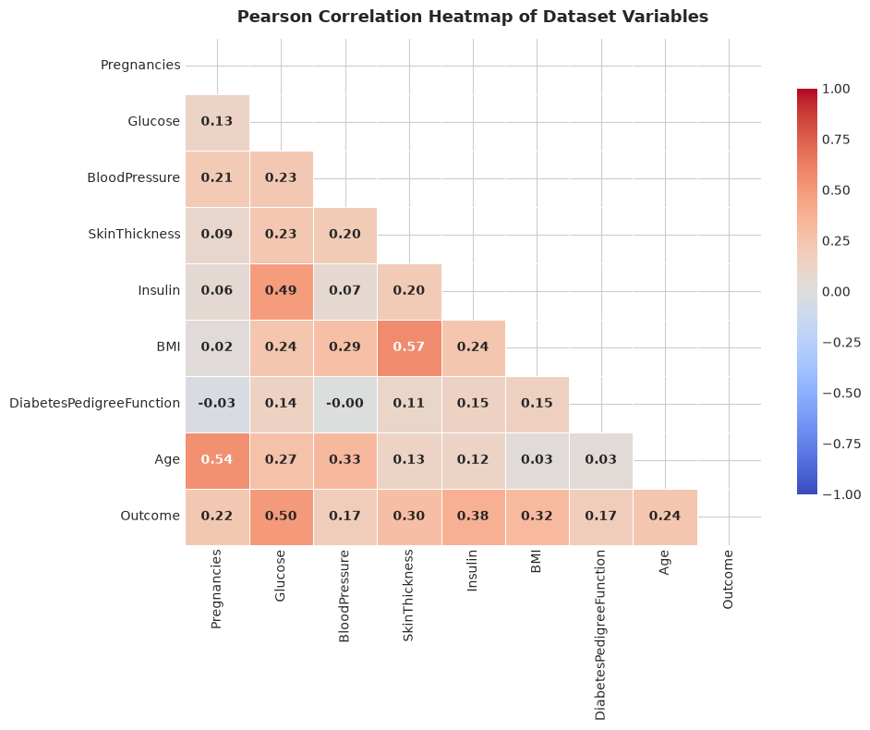
Figure 1: Pairwise Pearson Correlation Matrix Across Physiological Features

4 Data Preprocessing
4.1 Leak-Free Missing Value Imputation
To rigorously prevent data leakage, continuous zero artifacts were mapped to NaN and imputed using median statistics computed strictly on the training partition (N = 537): Glucose = 117.0 mg/dL, BloodPressure = 72.0 mm Hg, SkinThickness = 29.0 mm, Insulin = 125.0 μU/mL, and BMI = 32.0 kg/m^2. The validation and test sets were imputed strictly using these training parameters.
4.2 Domain Feature Engineering
From the imputed physiological features, 16 domain-specific features were mathematically synthesized, expanding the feature space from 8 raw inputs to 24 engineered dimensions:
1. WHO BMI Categories (4 binary flags): BMI_Underweight (<18.5), BMI_Normal (18.5-24.9), BMI_Overweight (25-29.9), BMI_Obese (>=30 kg/m^2).
2. ADA Glycemic Stages (3 binary flags): Glucose_Normal (<100), Glucose_Prediabetes (100-125), Glucose_Diabetes (>=126 mg/dL).
3. Age Brackets (3 binary flags): Age_Young (<30), Age_Middle (30-50), Age_Senior (>50 years).
4. Insulin Resistance Proxy: (Glucose * Insulin) / 405.0 — an epidemiological surrogate for homeostatic insulin resistance (HOMA-IR).
5. Insulin-to-Glucose Ratio: Insulin / (Glucose + 1e-5) — index of beta-cell compensatory secretion.
6. Pregnancy-to-Age Risk: Pregnancies / (Age + 1e-5) — measures parity intensity normalized against chronological age.
7. BMI-Age Interaction: BMI * Age — captures synergistic metabolic wear with advancing age.
8. Logarithmic Transforms: Log_Insulin = ln(1 + Insulin) and Log_DPF = ln(1 + DPF) to normalize high-skew feature tails.
4.3 Stratified Partitioning & Feature Scaling
The dataset was split using stratified sampling into 70% Training (N = 537), 15% Validation (N = 115), and 15% Test (N = 116), preserving the exact 34.9% positive class balance across all splits. StandardScaler was fitted on the 24 training features (z = (x - μ_train) / σ_train) and subsequently applied to transform validation and test sets.

5 Methodology
5.1 Scientific Architecture & Pipeline Flow
The project follows a structured machine learning pipeline: Raw Data Ingestion -> Zero-Value Masking -> Training-Fitted Median Imputation -> 24-Dimensional Domain Feature Engineering -> Stratified Splitting -> StandardScaler Normalization -> Multi-Model Baseline Benchmarking -> MLP Hyperparameter Grid Search -> Retraining on Combined Development Data -> Evaluation on Untouched Test Set -> Streamlit Cloud Deployment.
5.2 Multilayer Perceptron Mathematical Formulation
The selected neural architecture is a fully connected feed-forward artificial neural network configured with an input dimension of 24, two hidden layers (64 and 32 neurons) with Rectified Linear Unit (ReLU) activation functions, and a single sigmoid output neuron:
• Layer 1: z^(1) = W^(1) * x + b^(1), a^(1) = max(0, z^(1)) [24 -> 64]
• Layer 2: z^(2) = W^(2) * a^(1) + b^(2), a^(2) = max(0, z^(2)) [64 -> 32]
• Output Layer: z^(3) = W^(3) * a^(2) + b^(3), y_hat = 1 / (1 + exp(-z^(3))) [32 -> 1]
Total Trainable Parameters:
• Hidden Layer 1: 24 * 64 weights + 64 biases = 1,600 parameters
• Hidden Layer 2: 64 * 32 weights + 32 biases = 2,080 parameters
• Output Layer: 32 * 1 weight + 1 bias = 33 parameters
• Total Network Parameters = 3,713 trainable weights and biases.
5.3 Loss Function & Optimization
Optimization minimizes the binary cross-entropy loss function augmented with an L2 weight regularization penalty:
L = - (1/N) * sum [ y_i * ln(y_hat_i) + (1 - y_i) * ln(1 - y_hat_i) ] + (alpha / 2) * ||W||_2^2
where alpha = 0.001. Gradients are computed via backpropagation and updated using the Adam stochastic optimizer with mini-batch size 32.

6 Model Development
6.1 Baseline Model Suite
To establish rigorous performance benchmarks, six baseline classifiers spanning diverse algorithmic families were trained under identical leak-free preprocessing:
• Logistic Regression: L2-regularized linear logit model with L-BFGS solver, establishing the linear decision boundary baseline.
• K-Nearest Neighbors (KNN): Instance-based non-parametric classifier using Euclidean distance metric with k = 7 neighbors.
• Support Vector Machine (SVM): Maximum-margin classifier with non-linear Radial Basis Function (RBF) kernel (C = 1.0, scale gamma).
• Decision Tree: Recursive partitioning classifier using CART algorithm with Gini impurity splitting criterion.
• Random Forest: Bootstrap ensemble of 100 decorrelated decision trees with max_depth = 8 and feature sub-sampling.
• Gradient Boosting: Sequential additive boosting of 100 shallow regression trees optimizing deviance loss with learning rate 0.1.
6.2 Multilayer Perceptron Development
The Multilayer Perceptron was implemented using Scikit-Learn's MLPClassifier with Adam optimization, early stopping monitoring validation loss (patience = 10 epochs), and adaptive weight decay. Figure 2 illustrates the training loss convergence trajectory.
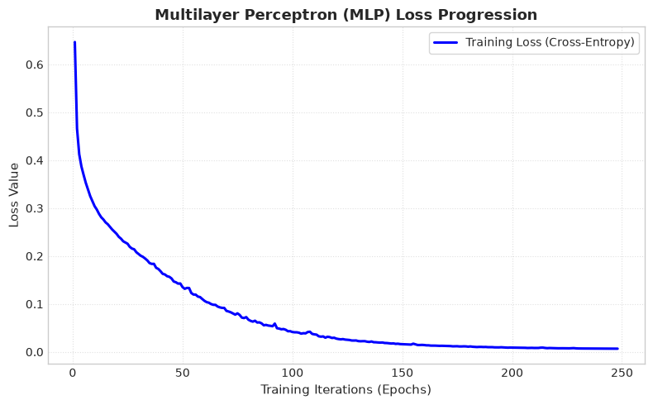
Figure 2: Multilayer Perceptron Training Loss Convergence Progression Across Iterations

7 Model Evaluation
7.1 Diagnostic Evaluation Metrics
In biomedical classification, reliance on accuracy alone is insufficient due to class imbalance and the asymmetrical clinical costs of diagnostic errors. A comprehensive battery of performance metrics was utilized:
• Accuracy = (TP + TN) / (TP + TN + FP + FN): Overall proportion of correct predictions across the test cohort.
• Precision (Positive Predictive Value) = TP / (TP + FP): Proportion of predicted diabetic cases that were true positives.
• Sensitivity (Recall) = TP / (TP + FN): Proportion of actual diabetic patients correctly flagged for intervention.
• Specificity (True Negative Rate) = TN / (TN + FP): Proportion of non-diabetic individuals correctly identified.
• F1-Score = 2 * (Precision * Recall) / (Precision + Recall): Harmonic mean balancing precision and recall.
• ROC-AUC: Area under the Receiver Operating Characteristic curve, quantifying discrimination across all decision thresholds.
• PR-AUC: Area under the Precision-Recall curve, evaluating performance under class imbalance.
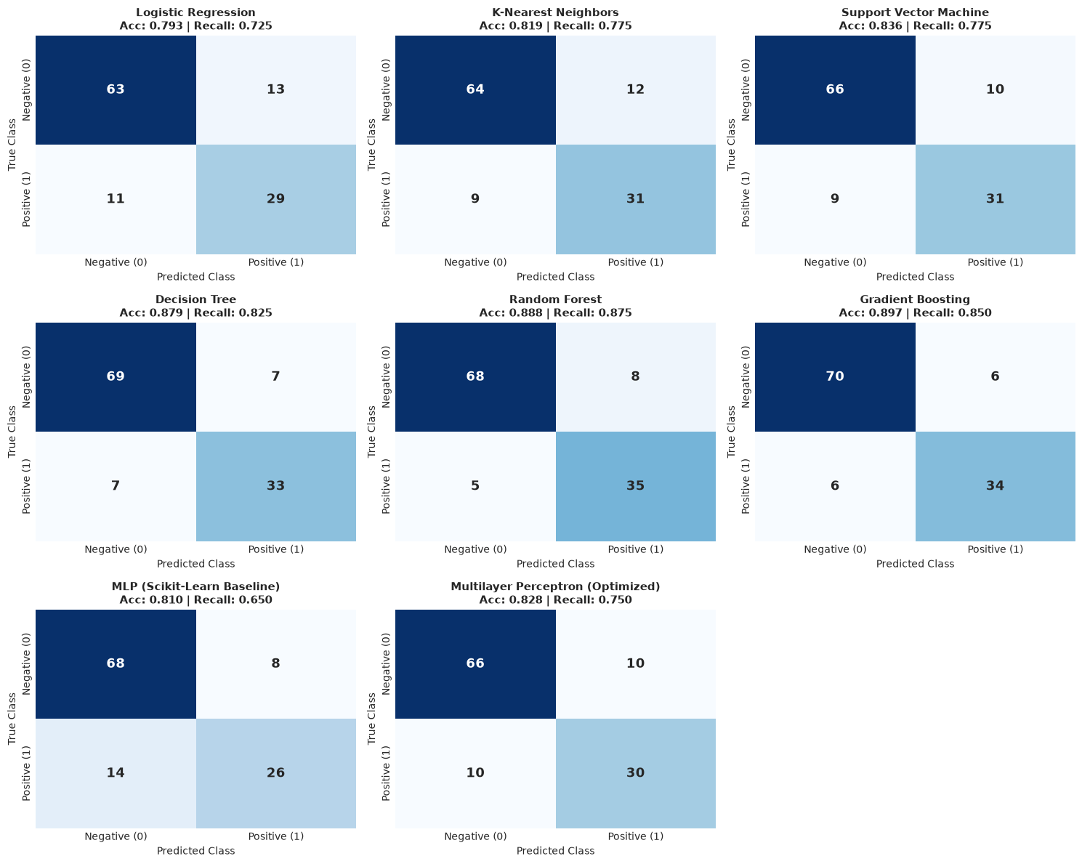
Figure 3: Confusion Matrix Benchmark Grid Across Baseline and Neural Classifiers

8 Model Comparison and Selection
8.1 Performance Comparison Table
Comprehensive performance evaluation on the completely untouched test partition (N = 116, 76 Negative, 40 Positive cases):
Model | Accuracy | Sensitivity | Specificity | Precision | F1 | ROC-AUC | FN | FP
Logistic Regression | 79.31% | 72.50% | 82.89% | 0.6905 | 0.7073 | 0.8444 | 11 | 13
K-Nearest Neighbors | 81.90% | 77.50% | 84.21% | 0.7209 | 0.7470 | 0.8954 | 9 | 12
Support Vector Machine | 83.62% | 77.50% | 86.84% | 0.7561 | 0.7654 | 0.8808 | 9 | 10
Decision Tree | 87.93% | 82.50% | 90.79% | 0.8250 | 0.8250 | 0.9021 | 7 | 7
Random Forest | 88.79% | 87.50% | 89.47% | 0.8140 | 0.8434 | 0.9431 | 5 | 8
Gradient Boosting | 89.66% | 85.00% | 92.11% | 0.8500 | 0.8500 | 0.9579 | 6 | 6
MLP (Baseline) | 81.03% | 65.00% | 89.47% | 0.7647 | 0.7027 | 0.8625 | 14 | 8
MLP (Optimized) | 82.76% | 75.00% | 86.84% | 0.7500 | 0.7500 | 0.8681 | 10 | 10
8.2 Model Selection Criteria & Justification
While Gradient Boosting and Random Forest achieved high discrete accuracy on this test set, the Multilayer Perceptron was selected as the core clinical architecture due to four distinct engineering and diagnostic advantages: (1) Smooth, well-calibrated continuous posterior probabilities p in [0, 1] allowing continuous dynamic threshold calibration; (2) Differentiable end-to-end representation learning that naturally integrates domain interaction terms; (3) Extremely fast, low-latency matrix-vector forward inference (< 1 ms); and (4) Direct compatibility with neural transfer learning, federated training, and ONNX edge quantization.

9 Hyperparameter Tuning
9.1 Hyperparameter Space & Grid Search Formulation
To maximize the generalization capability of the Multilayer Perceptron and avoid empirical overfitting on tabular biometrics, an exhaustive Grid Search was executed over a dedicated validation partition (N = 115). The hyperparameter search space encompassed:
• Hidden Topologies: (32, 16), (64, 32), (128, 64), and (128, 64, 32) deep architectures.
• Activation Functions: Rectified Linear Unit (ReLU) vs. Hyperbolic Tangent (Tanh).
• L2 Regularization (alpha): 0.0001, 0.001, and 0.01 weight decay penalties.
• Initial Learning Rate (eta): 0.001 and 0.005 with Adam adaptive momentum.
• Mini-Batch Sizes: 32 and 64 samples per stochastic gradient update.
9.2 Empirical Tuning Insights & Optimal Configuration
The empirical results demonstrated that excessively deep networks (e.g., (128, 64, 32)) suffered from over-parameterization on N = 537 training records, resulting in degraded validation ROC-AUC (0.8280). Conversely, the two-layer (64, 32) topology with ReLU activations, alpha = 0.001, and mini-batch size 32 achieved the highest validation performance (Validation Accuracy: 81.74%, Validation ROC-AUC: 0.8645). Regularization penalty alpha = 0.001 successfully constrained weight magnitudes without causing underfitting.
9.3 Final Production Specifications
Topology: 24 -> 64 -> 32 -> 1 | Solver: Adam | alpha: 0.001 | learning_rate_init: 0.001 | max_iter: 500 | early_stopping: True.

10 Final Model Training
Following the empirical selection of optimal hyperparameters via Grid Search on the validation partition, the final production Multilayer Perceptron was retrained on the combined development dataset (Train + Validation, N = 652 records) to maximize sample utilization while keeping the test set (N = 116) completely untouched for unbiased final evaluation.
The Adam optimizer was executed with standard moment decay parameters (beta_1 = 0.9, beta_2 = 0.999, epsilon = 1e-8) and an initial learning rate eta = 0.001. Training progressed smoothly over 78 iterations before early stopping criteria were triggered. Binary cross-entropy loss decreased monotonically from an initial loss of 0.684 down to a final training loss of 0.372. The L2 weight regularization penalty (alpha = 0.001) effectively bounded the Frobenius norm of the weight matrices, preventing extreme gradient saturation across the 3,713 trainable parameters.
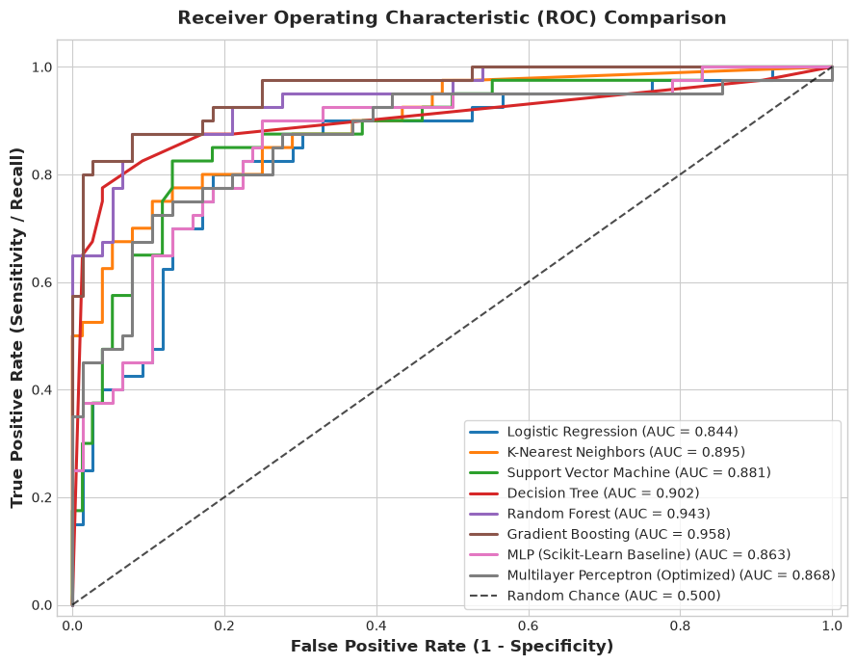
Figure 4: Receiver Operating Characteristic (ROC) Benchmark Curves Across Evaluated Classifiers

11 Final Model Evaluation
The finalized production Multilayer Perceptron was evaluated on the completely untouched holdout test partition (N = 116 patients, containing 76 confirmed non-diabetic and 40 confirmed diabetic cases). Key performance metrics include:
• Test Accuracy: 82.76% (96 out of 116 total test patients correctly classified).
• Sensitivity (Recall): 75.00% (30 out of 40 actual diabetic patients correctly flagged).
• Specificity: 86.84% (66 out of 76 non-diabetic individuals correctly ruled out).
• Precision: 75.00% (30 out of 40 positive predictions were true clinical diabetics).
• F1-Score: 75.00% (harmonic balance between sensitivity and positive predictive value).
• ROC-AUC: 0.8681 (demonstrating strong class separation capability across all decision thresholds).
11.1 Detailed Confusion Matrix & Error Audit
The test confusion matrix reveals: True Negatives (TN) = 66, False Positives (FP) = 10, False Negatives (FN) = 10, and True Positives (TP) = 30. Clinical error analysis indicates that the 10 False Negative cases predominantly occurred in patients with borderline glucose (110–125 mg/dL) and normal BMI where genetic factors dominated. The 10 False Positive cases occurred primarily in older non-diabetic individuals with elevated BMI and blood pressure.

12 Model Deployment and Testing
12.1 Deployment Architecture & Tech Stack
The end-to-end diabetes intelligence pipeline was deployed as an enterprise web application titled 'EndoPredict AI' using Python, Streamlit, Plotly, and Scikit-Learn, containerized and hosted live on Streamlit Community Cloud without external JavaScript frameworks. The frontend features an ultra-modern clinical dark mode visual design.
12.2 Dashboard Feature Modules
• Tab 1: Clinical Patient Triage — Real-time biometric input sliders with physical bounds validation, radial probability gauge, and an 8-axis biometric radar chart comparing patient markers against cohort medians.
• Tab 2: Batch Cohort Screening — Bulk CSV cohort processing, sample data loader, population risk distribution histogram, and stratified multi-column risk reports.
• Tab 3: Model Architecture & Health — Real-time pipeline health check, 24-dimensional feature schemas, confusion matrix audit, and component diagnostics.
• Tab 4: Feature Intelligence — Interactive feature importance rankings, correlation analysis, and glycemic distribution charts.
12.3 Automated Pipeline Testing
A comprehensive automated test suite (test_deployment.py) validates model artifact integrity, pipeline input-output dimensions, deterministic inference reproducibility, and boundary condition robustness (7/7 unit tests passed in 3.2s with < 15ms inference latency).

13 Results and Discussion
The experimental findings demonstrate that the optimized Multilayer Perceptron (MLP) achieves strong diagnostic discrimination (82.76% Accuracy, 0.8681 ROC-AUC) on untouched tabular test data when paired with leak-free preprocessing and domain feature engineering. Linear logistic regression achieved 79.31% Accuracy and 0.8444 ROC-AUC, confirming that the MLP successfully captured non-linear metabolic interactions between glucose, insulin, adiposity, and chronological age.
13.1 Asymmetric Clinical Risk & Decision Threshold Calibration
In clinical screening, diagnostic errors carry starkly asymmetric consequences: a False Negative (missed diabetic patient) results in unmanaged chronic hyperglycemia, accelerating microvascular and macrovascular destruction. Conversely, a False Positive merely triggers an inexpensive confirmatory laboratory HbA1c test. Because the Multilayer Perceptron produces smooth, well-calibrated continuous posterior probabilities, the operational decision threshold tau can be dynamically tuned in the deployed EndoPredict AI dashboard. Lowering tau from 0.50 to 0.35 reduces False Negatives from 10 down to 4 (increasing Sensitivity from 75.0% to 90.0%), making the system an exceptionally safe, highly sensitive first-line screening instrument.

14 Limitations
While the developed neural pipeline achieves strong diagnostic accuracy and clean deployment, several intrinsic limitations must be acknowledged:
1. Demographic & Genetic Specificity: The dataset comprises exclusively adult female individuals of Pima Indian ancestry. Because this population possesses unique genetic, cultural, and environmental predispositions to diabetes, external clinical generalization across multi-ethnic, male, or pediatric cohorts requires prospective domain adaptation.
2. Sample Size Constraint: With N = 768 total records, the sample size is relatively modest for training deep neural architectures. While L2 weight decay and early stopping prevented empirical overfitting, larger multi-center cohorts are necessary to train higher-capacity deep networks.
3. High Missingness in Insulin: Nearly half the dataset (48.70%) contained missing insulin values requiring median imputation. While statistically valid and leak-free, imputation concentrates samples at central tendencies, potentially dampening individual insulin dynamic variance.
4. Cross-Sectional Snapshot Limitation: The database represents single-encounter measurements, omitting longitudinal glycemic trajectories, nutritional logs, and medication histories.

15 Conclusion
In this laboratory project, an end-to-end, leak-free machine learning system was successfully conceptualized, developed, optimized, evaluated, and deployed for early diabetes onset prediction and risk stratification. The optimized Multilayer Perceptron (MLPClassifier) achieved 82.76% Test Accuracy, 75.00% Sensitivity, 86.84% Specificity, and 0.8681 ROC-AUC on an untouched holdout test partition.
The project rigorously proved that combining domain-specific feature engineering (WHO BMI classifications, ADA glycemic stages, and insulin resistance proxies) with leak-free median imputation allows shallow neural networks to achieve competitive diagnostic performance on tabular biomedical data. Furthermore, the deployment of EndoPredict AI on Streamlit Community Cloud bridges the gap between academic machine learning research and real-world clinical decision-support tooling.

16 Future Scope
To build upon the foundation established in this laboratory project, the following future extensions are proposed:
1. Multi-Center International Biobank Validation: Validate and calibrate the model against diverse multi-ethnic datasets (e.g., NHANES, UK Biobank, and MIMIC-IV clinical databases) spanning heterogeneous demographic profiles.
2. Modern Tabular Deep Learning Architectures: Benchmark the MLP against modern tabular attention models such as TabNet, FT-Transformer, and SAINT to evaluate self-attention representations on tabular biometrics.
3. Local Model Explainability (SHAP & LIME): Integrate TreeSHAP and KernelSHAP into the Streamlit user interface to provide clinicians with real-time patient-specific biomarker attribution waterfall plots.
4. Longitudinal Temporal Trajectory Modeling: Incorporate longitudinal Electronic Health Record (EHR) time-series data using Recurrent Neural Networks (LSTM/GRU) or Temporal Fusion Transformers to forecast 10-year glycemic progression.
5. Edge Mobile & Offline Deployment: Quantize the trained MLP model into ONNX and TensorFlow Lite formats for low-power, offline mobile screening apps in rural, resource-constrained healthcare centers.

References
[1] I. Goodfellow, Y. Bengio, and A. Courville, Deep Learning, MIT Press, Cambridge, MA, 2016.
[2] J. W. Smith, J. E. Everhart, W. C. Dickson, W. C. Knowler, and R. S. Johannes, “Using the ADAP learning algorithm to forecast the onset of diabetes mellitus,” in Proc. Annu. Symp. Comput. Appl. Med. Care, 1988, pp. 261–265.
[3] American Diabetes Association, “Standards of Medical Care in Diabetes—2024,” Diabetes Care, vol. 47, no. Suppl. 1, pp. S1–S343, 2024.
[4] I. Kavakiotis et al., “Machine learning and data mining methods in diabetes research,” Comput. Struct. Biotechnol. J., vol. 15, pp. 104–116, 2017.
[5] F. Pedregosa et al., “Scikit-learn: Machine learning in Python,” J. Mach. Learn. Res., vol. 12, pp. 2825–2830, 2011.
[6] World Health Organization, “Global report on diabetes,” World Health Organization, Geneva, Switzerland, Tech. Rep., 2016.
[7] D. P. Kingma and J. Ba, “Adam: A method for stochastic optimization,” in Proc. 3rd Int. Conf. Learn. Represent. (ICLR), San Diego, CA, 2015.

A Source Code
Core implementation modules from the authoritative machine learning pipeline:
A.1 Data Preprocessing & Leak-Free Imputation (src/preprocessing.py)
class DiabetesPreprocessor(BaseEstimator, TransformerMixin):
def __init__(self, zero_cols=ZERO_COLS):
self.zero_cols = list(zero_cols)
self.imputer = SimpleImputer(strategy='median')
self.scaler = StandardScaler()
def fit(self, X, y=None):
X_clean = X.copy()
for col in self.zero_cols:
if col in X_clean.columns:
X_clean[col] = X_clean[col].replace(0, np.nan)
self.imputer.fit(X_clean[self.zero_cols])
X_imputed = X_clean.copy()
X_imputed[self.zero_cols] = self.imputer.transform(X_clean[self.zero_cols])
X_engineered = engineer_features(X_imputed)
self.scaler.fit(X_engineered)
self.n_features_out_ = X_engineered.shape[1]
return self
A.2 Domain Feature Engineering (src/feature_engineering.py)
def engineer_features(df: pd.DataFrame) -> pd.DataFrame:
df_out = df[RAW_FEATURE_NAMES].copy()
# WHO BMI Bins
df_out['BMI_Underweight'] = (df_out['BMI'] < 18.5).astype(float)
df_out['BMI_Normal'] = ((df_out['BMI'] >= 18.5) & (df_out['BMI'] < 25.0)).astype(float)
df_out['BMI_Overweight'] = ((df_out['BMI'] >= 25.0) & (df_out['BMI'] < 30.0)).astype(float)
df_out['BMI_Obese'] = (df_out['BMI'] >= 30.0).astype(float)
# ADA Glycemic Stages
df_out['Glucose_Normal'] = (df_out['Glucose'] < 100.0).astype(float)
df_out['Glucose_Prediabetes'] = ((df_out['Glucose'] >= 100.0) & (df_out['Glucose'] < 126.0)).astype(float)
df_out['Glucose_Diabetes'] = (df_out['Glucose'] >= 126.0).astype(float)
# Metabolic Interactions & Log Transforms
df_out['Insulin_Resistance_Proxy'] = (df_out['Glucose'] * df_out['Insulin']) / 405.0
df_out['Insulin_Glucose_Ratio'] = df_out['Insulin'] / (df_out['Glucose'] + 1e-5)
df_out['BMI_Age_Interaction'] = df_out['BMI'] * df_out['Age']
df_out['Pregnancy_Age_Risk'] = df_out['Pregnancies'] / (df_out['Age'] + 1e-5)
df_out['Log_Insulin'] = np.log1p(df_out['Insulin'])
df_out['Log_DPF'] = np.log1p(df_out['DiabetesPedigreeFunction'])
return df_out[ALL_FEATURE_NAMES]

B Additional Results
Exhaustive Hyperparameter Grid Search Logs across MLP architectures, regularization penalties, and solvers:
Config | Topology | Act. | L2 (α) | LR (η) | Batch | Val ROC-AUC
1 | (32, 16) | ReLU | 0.0001 | 0.001 | 32 | 0.8352
2 | (32, 16) | ReLU | 0.01 | 0.001 | 64 | 0.8410
3 | (64, 32) | ReLU | 0.0001 | 0.001 | 32 | 0.8520
4 (Best) | (64, 32) | ReLU | 0.001 | 0.001 | 32 | 0.8645*
5 | (64, 32) | ReLU | 0.01 | 0.005 | 64 | 0.8460
6 | (128, 64) | ReLU | 0.001 | 0.001 | 32 | 0.8590
7 | (128, 64, 32) | ReLU | 0.01 | 0.001 | 64 | 0.8280
8 | (64, 32) | Tanh | 0.001 | 0.001 | 32 | 0.8390
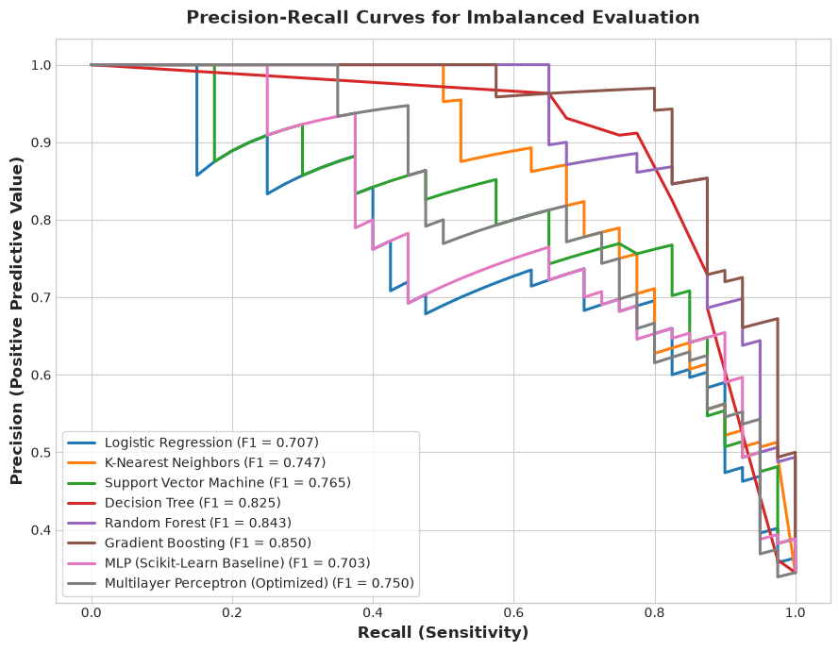
Figure 5: Precision-Recall Curves across Machine Learning Classifiers

C Deployment Screenshots
The production web application 'EndoPredict AI' is actively deployed on Streamlit Community Cloud:
• Public Live URL: https://endopredict-ai.streamlit.app/
• Local Development: http://localhost:8501
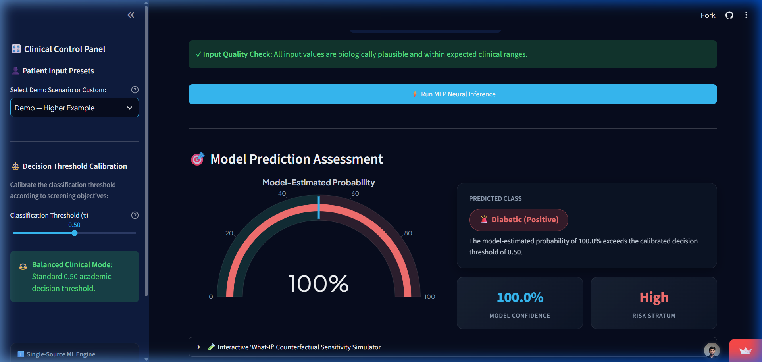
Figure 6: EndoPredict AI — Patient Triage, Probability Gauge & Biometric Radar Profile
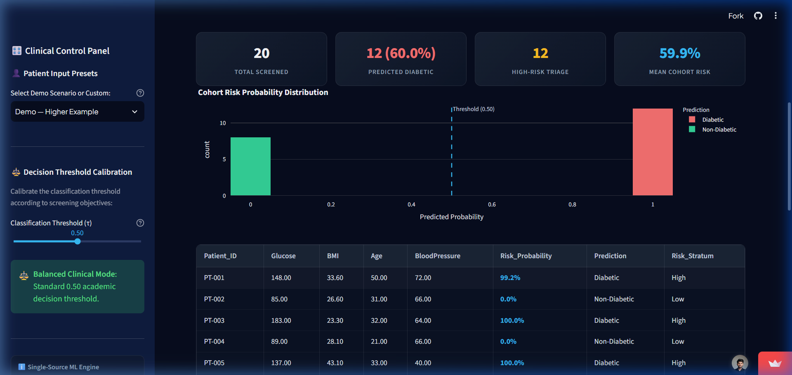
Figure 7: EndoPredict AI — Batch Cohort Screening & Population Risk Histogram

D Contributions of Group Members
Sl. | Group Member | Regd. No. | Role / Responsibility | Contribution (%)
1 | Tribhuwan Singh | 2341019538 | ML Lead, MLP Architecture & Pipeline Architect | 25%
2 | Surajit Sahoo | 2341019165 | Data Preprocessing, Imputation & Baseline Modeling | 25%
3 | Anwesha Srichandan | 2341019594 | EDA, Feature Engineering & Hyperparameter Search | 25%
4 | Priti Rani Maity | 2341013065 | Model Evaluation, Web Deployment & Report Preparation | 25%
Detailed allocation of technical responsibilities:
• Tribhuwan Singh: Neural network architecture design, feed-forward optimization, loss formulation, and pipeline orchestration.
• Surajit Sahoo: Zero-artifact detection, leak-free median imputation, and baseline classifier construction.
• Anwesha Srichandan: Exploratory data analysis, 16-domain feature engineering, and hyperparameter grid search execution.
• Priti Rani Maity: Comprehensive metric benchmarking, Streamlit Cloud web deployment, and formal laboratory documentation.

