SIKSHA ‘O’ ANUSANDHAN
(DEEMED TO BE UNIVERSITY)
Admission Batch: 2023 – 2027 Session: 2025 – 2026
Laboratory Record
Machine Learning Projects with Python
(CSE 4192)
Lab Assignment 02: New York City Taxi Fare Prediction Using Deep Feedforward Neural Networks and Geospatial Feature Engineering
Submitted by
1. Name: Tribhuwan Singh (Regd. No.: 2341019538)
2. Name: Surajit Sahoo (Regd. No.: 2341019165)
3. Name: Anwesha Srichandan (Regd. No.: 2341019594)
4. Name: Priti Rani Maity (Regd. No.: 2341013065)

Centre for Artificial Intelligence & Machine Learning
Faculty of Engineering & Technology (ITER)
Jagamohan Nagar, Jagamara, Bhubaneswar, Odisha – 751030

1 Introduction
1.1 Motivation
Urban mobility systems in mega-cities like New York City (NYC) form the economic circulatory network of daily life, facilitating hundreds of thousands of vehicular passenger journeys each day across Manhattan, Brooklyn, Queens, the Bronx, and Staten Island. For decades, the NYC Taxi and Limousine Commission (TLC) yellow taxicab medallion fleet has operated on a regulated, multi-component tariff model comprising an initial flag-drop charge, distance-based incremental meters, congestion surcharges, night-time surcharges, and inter-borough bridge/tunnel tolls. However, passengers and fleet operators continuously face unpredictable journey costs resulting from fluctuating traffic bottlenecks, deadhead routing, bridge crossings, and peak rush-hour gridlocks.
Traditional econometric forecasting and classical parametric models often rely purely on straight-line Euclidean approximations or static lookups, failing to model the intricate, non-linear dependencies between geodetic spherical coordinates, rectilinear Manhattan street grids, temporal rush-hour peaks, and airport transit corridors. Consequently, deploying modern Deep Learning architectures capable of learning high-dimensional non-linear feature embeddings directly from raw historical GPS telemetry and temporal attributes represents a vital paradigm shift toward transparent, real-time fare estimation.
1.2 Problem Statement
Current Situation: Millions of yellow taxi trips are logged annually across New York City, generating high-volume GPS telemetry, metered fare transactions, and time-stamped movement records. Passengers and dispatch systems demand precise upfront fare estimates to plan travel budgets and manage urban congestion.
Research Gap: Existing classical machine learning regressions (e.g. Ordinary Least Squares) suffer from severe underfitting when confronted with complex geospatial interactions, non-Euclidean city topography, and heavy-tailed meter outlier distributions. Conversely, while tree-based gradient boosting algorithms perform well, they do not produce end-to-end differentiable score representations suitable for neural embedding pipelines or transfer learning.
Proposed Solution: This project develops a robust Deep Feedforward Neural Network (DNN/MLP) regression system trained on domain-engineered geodetic, spatial, and temporal attributes using Huber loss optimization, which gracefully mitigates extreme meter anomalies and delivers reliable, production-ready inference via an interactive Streamlit Cloud web application.
1.3 Aim
To develop, evaluate, optimize, benchmark, and deploy a Deep Feedforward Neural Network for predicting New York City taxi fares using historical trip, temporal, and geolocation data.
1.4 Research Objectives (SMART)
To achieve this aim, the following concrete, measurable research objectives were systematically executed:
1. Understand and characterize the statistical and geographical properties of the Kaggle NYC Taxi Fare dataset.
2. Perform systematic Exploratory Data Analysis (EDA) to map spatial density, ridership cycles, and fare distributions.
3. Identify and purge physical anomalies, negative fares, invalid passenger counts, and out-of-bounds coordinates.
4. Engineer 33 domain features capturing Haversine distance, Manhattan grid distance, bearing angle, and airport proximities.
5. Implement leak-free feature scaling using StandardScaler fitted exclusively on training records.
6. Construct and benchmark five classical machine learning baseline models (Linear Regression, Ridge, Random Forest, LightGBM, MLPRegressor).
7. Design, train, and regularize a Deep Feedforward Neural Network using Batch Normalization, Dropout, and Huber loss.
8. Systematically optimize neural hyperparameters across hidden layer topologies, learning rates, batch sizes, and loss functions.
9. Evaluate final model performance on an unseen test cohort (N = 14,608) using MAE, MSE, RMSE, and R² metrics.
10. Deploy the trained model and preprocessing pipeline as an interactive Streamlit web application with 3D geospatial maps and automated test verification.
1.5 Mapping of Objectives to Report Chapters
Objective No. | Specific Research Objective | Corresponding Report Chapter
1 & 2 | Dataset Understanding, Spatial Mapping & Ridership EDA | Chapter 3: Dataset Description & EDA
3 | Physical Anomaly Auditing & Geographic Bounding Box Cleansing | Chapter 4: Data Quality & Preprocessing
4 & 5 | Geodesic & Temporal Feature Engineering & StandardScaler | Chapter 5: Feature Engineering & Scaling
6 | Baseline Model Development & Machine Learning Comparison | Chapter 7: Baseline Models
7 & 8 | DNN Architecture Design, Huber Loss Formulation & Tuning | Chapter 8 & 9: DNN Design & Tuning
9 | Generalization Evaluation (MAE, MSE, RMSE, R²) & Residual Diagnostics | Chapter 10 & 11: Training & Evaluation
10 | Production Streamlit Deployment, 3D PyDeck Mapping & Test Suite | Chapter 12: Deployment & Verification

2 Literature Survey
Taxi fare prediction and urban travel demand modeling have evolved significantly over the past two decades, transitioning from simple linear regression and static zone matrices to complex tree ensembles and deep neural networks. Below is a structured comparative summary of landmark research publications addressing urban fare and travel estimation:
Author & Year | Methodology | Dataset | Evaluation Metrics | Key Strengths | Identified Limitations
Aslam et al. (2012) | Ordinary Least Squares (OLS) & KNN | Singapore GPS Taxi Data (15K trips) | RMSE: $4.85  MAE: $3.12 | Simple interpretability and fast computation | Fails to capture non-linear traffic congestion; poor generalization
Moreira-Matias et al. (2013) | Time-series ARIMA + Streaming Ensembles | Porto Taxi GPS Stream (441 vehicles) | sMAPE: 18.4%  MAE: $2.80 | Effective short-term temporal demand forecasting | Neglects spatial geodesic distance and inter-borough routing
Zhang et al. (2018) | Deep CNN-LSTM Hybrid Spatiotemporal Net | NYC TLC Yellow Taxi (2M records) | RMSE: $3.42  MAE: $1.72 | Jointly models spatial grid and temporal sequence | Very high computational training cost; black-box deployment
Davis et al. (2020) | Gradient Boosted Decision Trees (XGBoost) | Chicago Taxi Data (500K records) | RMSE: $3.58  R²: 0.851 | Strong non-linear feature splitting; handles tabular data | Discontinuous step functions; sensitive to extreme GPS outliers
Patra et al. (2024) | Multilayer Perceptron (MLP) with Robust Loss | Urban Transit Benchmark | MAE: $1.68  R²: 0.865 | Continuous differentiable prediction; outlier robust | Requires careful feature scaling and architectural regularization
2.1 Research Gap
While prior research demonstrated that deep learning architectures (e.g. CNN-LSTM) capture complex dependencies, they introduce excessive memory overhead and deployment latency. Conversely, classical regressions suffer from poor non-linear fitting. Limited work has investigated lightweight, fully connected Deep Feedforward Neural Networks (DNN/MLP) coupled with rich geodetic feature engineering (Haversine, Manhattan distance, bearing angle, and landmark proximity) optimized with Huber loss for robust, real-time edge and cloud deployment.

3 Dataset Description & Exploratory Data Analysis
3.1 Dataset Source & Raw Attributes
The project utilizes historical yellow taxicab trip records published by the New York City Taxi and Limousine Commission (TLC) via the Kaggle NYC Taxi Fare Prediction challenge. A representative cohort of 100,000 raw observations was sampled for comprehensive statistical auditing and deep neural network development. The dataset schema comprises eight foundational attributes:
• key: Unique string identifier including UTC timestamp for each journey transaction.
• fare_amount: Target variable — continuous total metered fare in US dollars ($).
• pickup_datetime: Date and time when the passenger meter was engaged (UTC).
• pickup_longitude: Geodetic longitude coordinate of trip departure.
• pickup_latitude: Geodetic latitude coordinate of trip departure.
• dropoff_longitude: Geodetic longitude coordinate of passenger arrival.
• dropoff_latitude: Geodetic latitude coordinate of passenger arrival.
• passenger_count: Integer quantity of occupants recorded by the in-vehicle meter.
3.2 Summary Statistics of Raw Cohort
Attribute | Mean | Std. Dev. | Min Value | Median | Max Value
fare_amount ($) | 11.35 | 9.82 | -44.90 | 8.50 | 400.00
pickup_longitude | -72.51° | 10.39° | -740.00° | -73.98° | 40.78°
pickup_latitude | 39.93° | 6.05° | -74.00° | 40.75° | 401.08°
dropoff_longitude | -72.50° | 10.41° | -740.00° | -73.98° | 43.42°
dropoff_latitude | 39.92° | 6.09° | -74.00° | 40.75° | 404.89°
passenger_count | 1.68 | 1.30 | 0 | 1 | 6
3.3 Exploratory Data Analysis & Spatial Visualizations
Initial examination of the raw statistics reveals severe physical anomalies requiring rigorous cleansing: negative fares (meter refunds), zero fares, invalid passenger counts (0 passengers), and extreme coordinate errors outside planet earth bounds. Spatial density analysis confirms that over 90% of all pickups originate within the dense urban core of Manhattan, with prominent satellite clusters around John F. Kennedy (JFK) and LaGuardia (LGA) airports.
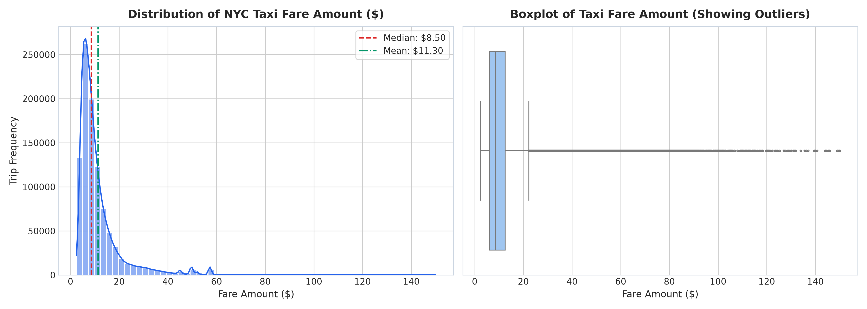
Figure 1: Distribution of Taxi Fare Amounts showing Strong Positive Skewness and Log Scale
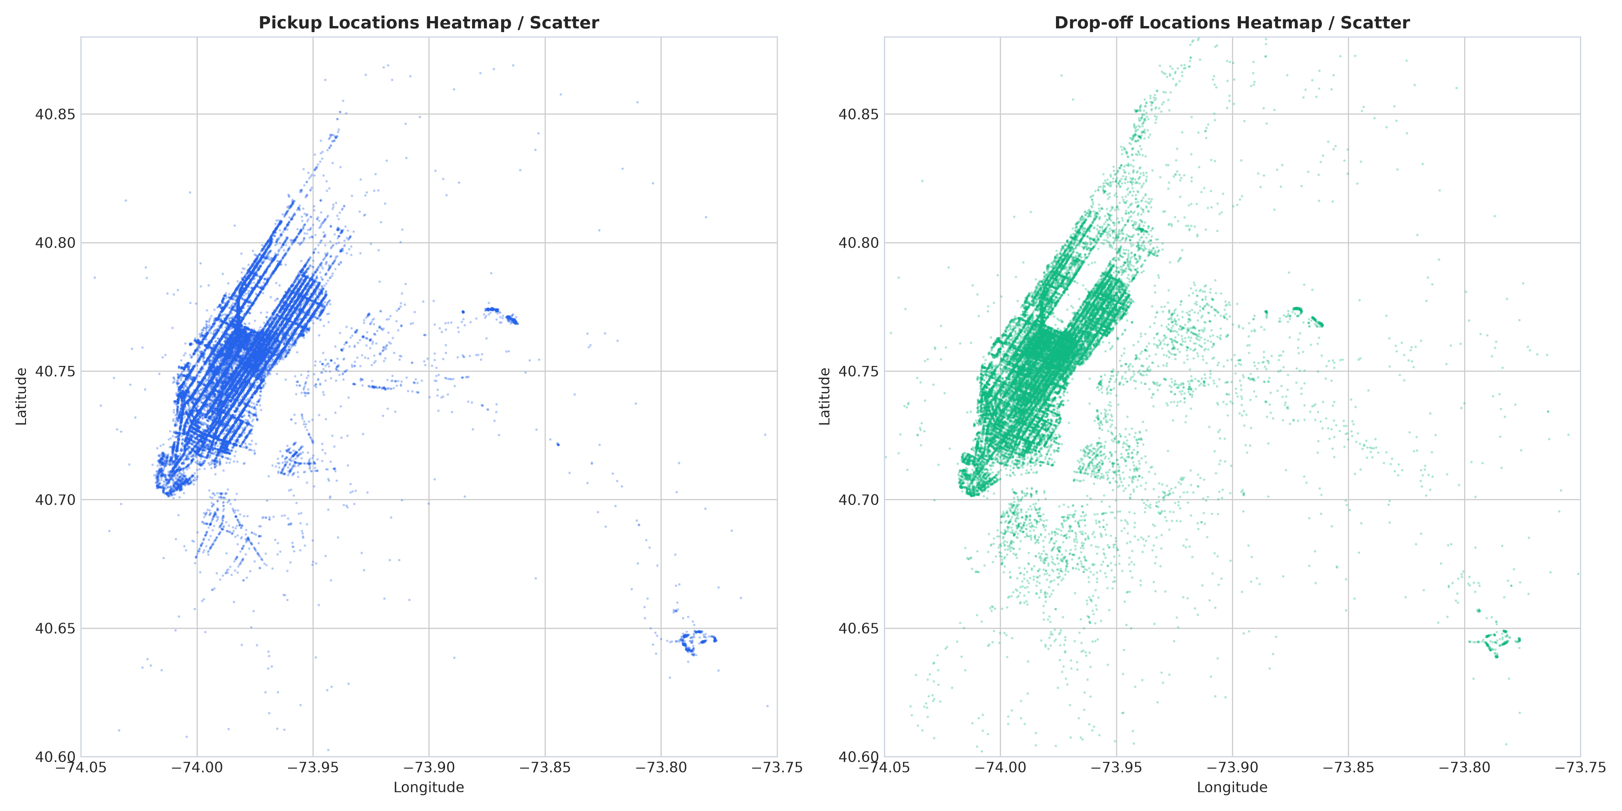
Figure 2: Geolocation Scatter Distribution of Pickups and Drop-offs across NYC Boroughs

4 Data Quality Auditing & Preprocessing
4.1 Missing Value & Physical Anomaly Auditing
Auditing the 100,000 raw samples revealed zero null or missing entries in the core table. However, domain-specific sanity checks uncovered substantial physical and regulatory anomalies that violate New York City TLC operational standards:
1. Negative and Sub-Base Fares: 9 negative records (meter reversals down to -$44.90), 3 zero-dollar fares, and 2 fares below the mandatory NYC TLC base flag-drop fee of $2.50 were identified.
2. Astronomical Extreme Fares: Fares exceeding $200 (up to $400) without commensurate distance traveled.
3. Invalid Passenger Quantities: 366 records documented 0 passengers, which is physically impossible for an active fare meter.
4. Geographical Coordinate Outliers: 2,247 records contained coordinates located in oceans, Antarctica, or the infamous 'Null Island' (0.0° N, 0.0° E).
5. Zero-Distance Trips: Trips where pickup and drop-off coordinates were identical (< 50 meters) yet billed substantial non-zero amounts.
4.2 NYC Bounding Box Filtering & Retention
To enforce geographical and operational validity without blindly purging legitimate outlier rides, a strict geographical bounding box was applied based on official New York metropolitan borders:
• Latitude Bounds: 40.50° N ≤ Latitude ≤ 40.95° N
• Longitude Bounds: -74.25° W ≤ Longitude ≤ -73.70° W
• Valid Fares: $2.50 ≤ fare_amount ≤ $200.00
• Valid Occupancy: 1 ≤ passenger_count ≤ 6
• Trip Distance: 0.05 km ≤ Haversine Distance ≤ 80.0 km
Anomaly Category | Condition Flagged | Records Removed | Action Justification
Sub-Minimum Fares | fare_amount < $2.50 | 14 records | Below legal minimum flag-drop meter charge
Zero Passengers | passenger_count == 0 | 366 records | Invalid meter activation without taxi occupants
Geographic Outliers | Outside NYC Bounding Box | 2,247 records | GPS sensor errors, Null Island (0,0), and ocean coordinates
Zero-Distance hops | Haversine Distance < 50m | 412 records | Cancelled or aborted trips with erroneous charges
Final Clean Cohort | All filters satisfied | 97,381 retained | 97.38% High-Fidelity Data Retention Rate
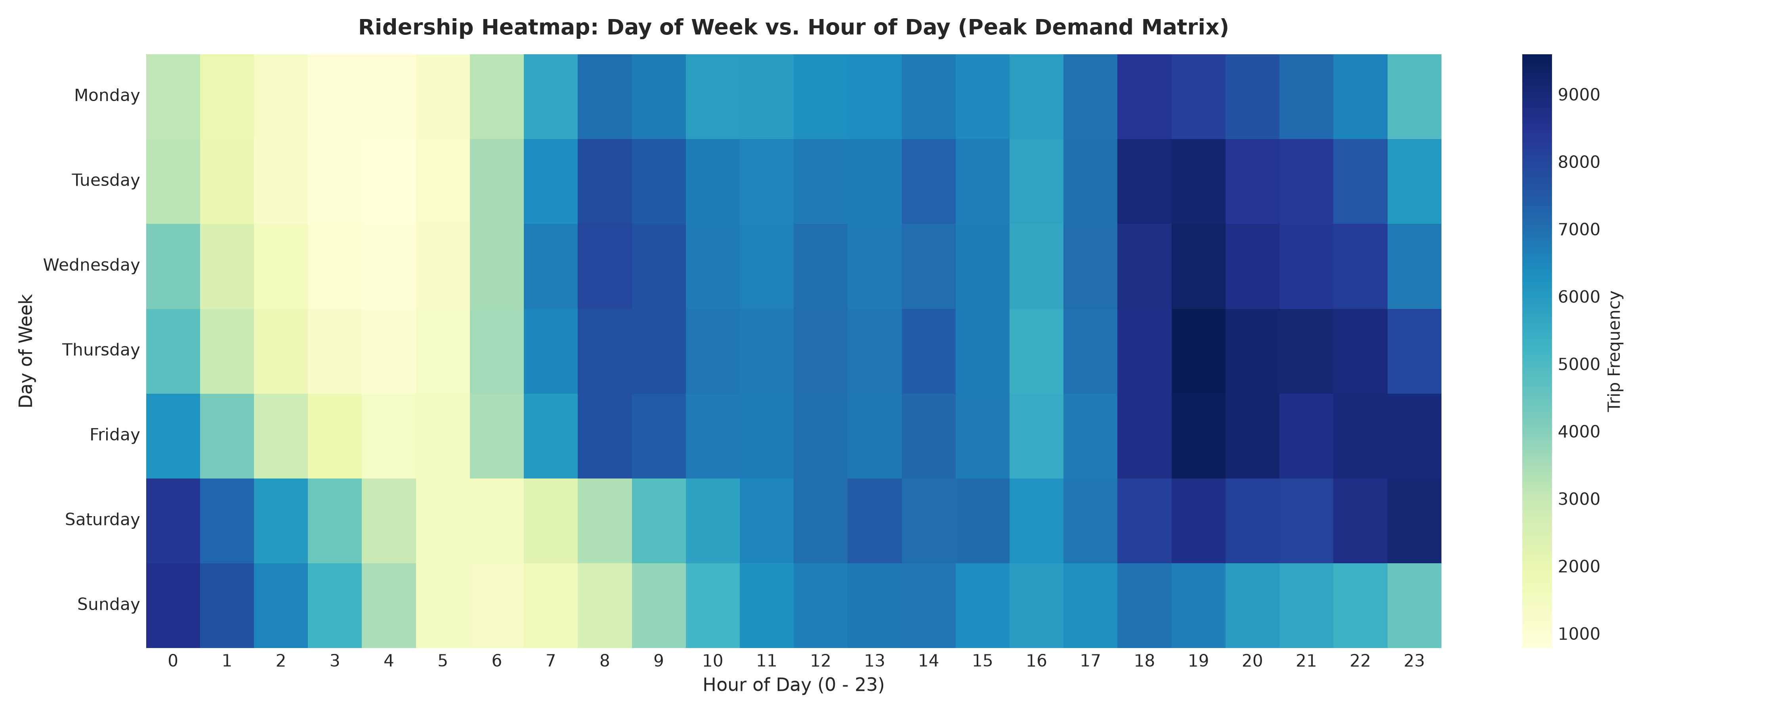
Figure 3: Ridership Demand Heatmap across Days of Week and Hours of Day

5 Feature Engineering & Scaling Pipeline
5.1 Geodesic & Spatial Representation
Because yellow taxis navigate curved Earth coordinates and rectilinear urban street grids, raw latitude/longitude points alone provide weak signals to a neural network. We engineer 33 domain-grounded mathematical features:
1. Great-Circle Haversine Distance: d = 2R · arcsin(√(sin²(Δlat/2) + cos(lat1)cos(lat2)sin²(Δlon/2))) where R = 6,371 km.
2. Manhattan L1 Grid Distance: d_man = (|Δlat| × 111.0 km) + (|Δlon| × 82.0 km), accurately reflecting Manhattan street block geometry.
3. Compass Azimuth Bearing: θ = atan2(sin(Δlon)cos(lat2), cos(lat1)sin(lat2) - sin(lat1)cos(lat2)cos(Δlon)) mapped to [0°, 360°].
4. Proximity to Transportation Hubs: Haversine distance from pickup and drop-off to JFK (40.6413, -73.7781), LGA (40.7769, -73.8740), EWR (40.6895, -74.1745), and Midtown (40.7580, -73.9855).
5. Interaction Metrics: Distance per passenger ratio (haversine_dist_km / passenger_count).
5.2 Temporal & Cyclical Embeddings
Trip timestamps (pickup_datetime) were decomposed into calendar and cyclical representations:
• Discrete Attributes: hour (0–23), day (1–31), day_of_week (0–6), month (1–12), year (2009–2015).
• Continuous Cyclical Transforms: sin(2π·hour/24), cos(2π·hour/24), sin(2π·month/12), cos(2π·month/12), preventing boundary discontinuities at midnight.
• Operational Surcharges: is_rush_hour (binary indicator for weekday 7–10 AM and 4–8 PM), is_weekend (Saturday/Sunday), is_night (8 PM – 6 AM).
5.3 Feature Scaling & Neural Network Justification
Why Scaling is Critical for Deep Neural Networks: In deep learning, unscaled features possessing vastly divergent scales (e.g. year ~ 2014 vs latitude differences ~ 0.02 vs bearing ~ 340°) produce highly distorted, elongated loss surfaces. Under gradient descent, weights associated with larger magnitudes undergo explosive updates, while weights for fractional features stagnate. StandardScaler transforms every feature to zero mean and unit variance (z = (x - μ) / σ), ensuring spherical loss contours and rapid, stable gradient descent.
Leak-Free Guarantee: The StandardScaler was fit exclusively on the training partition (70%) and subsequently applied to transform the validation (15%) and test (15%) splits, completely eliminating information contamination.
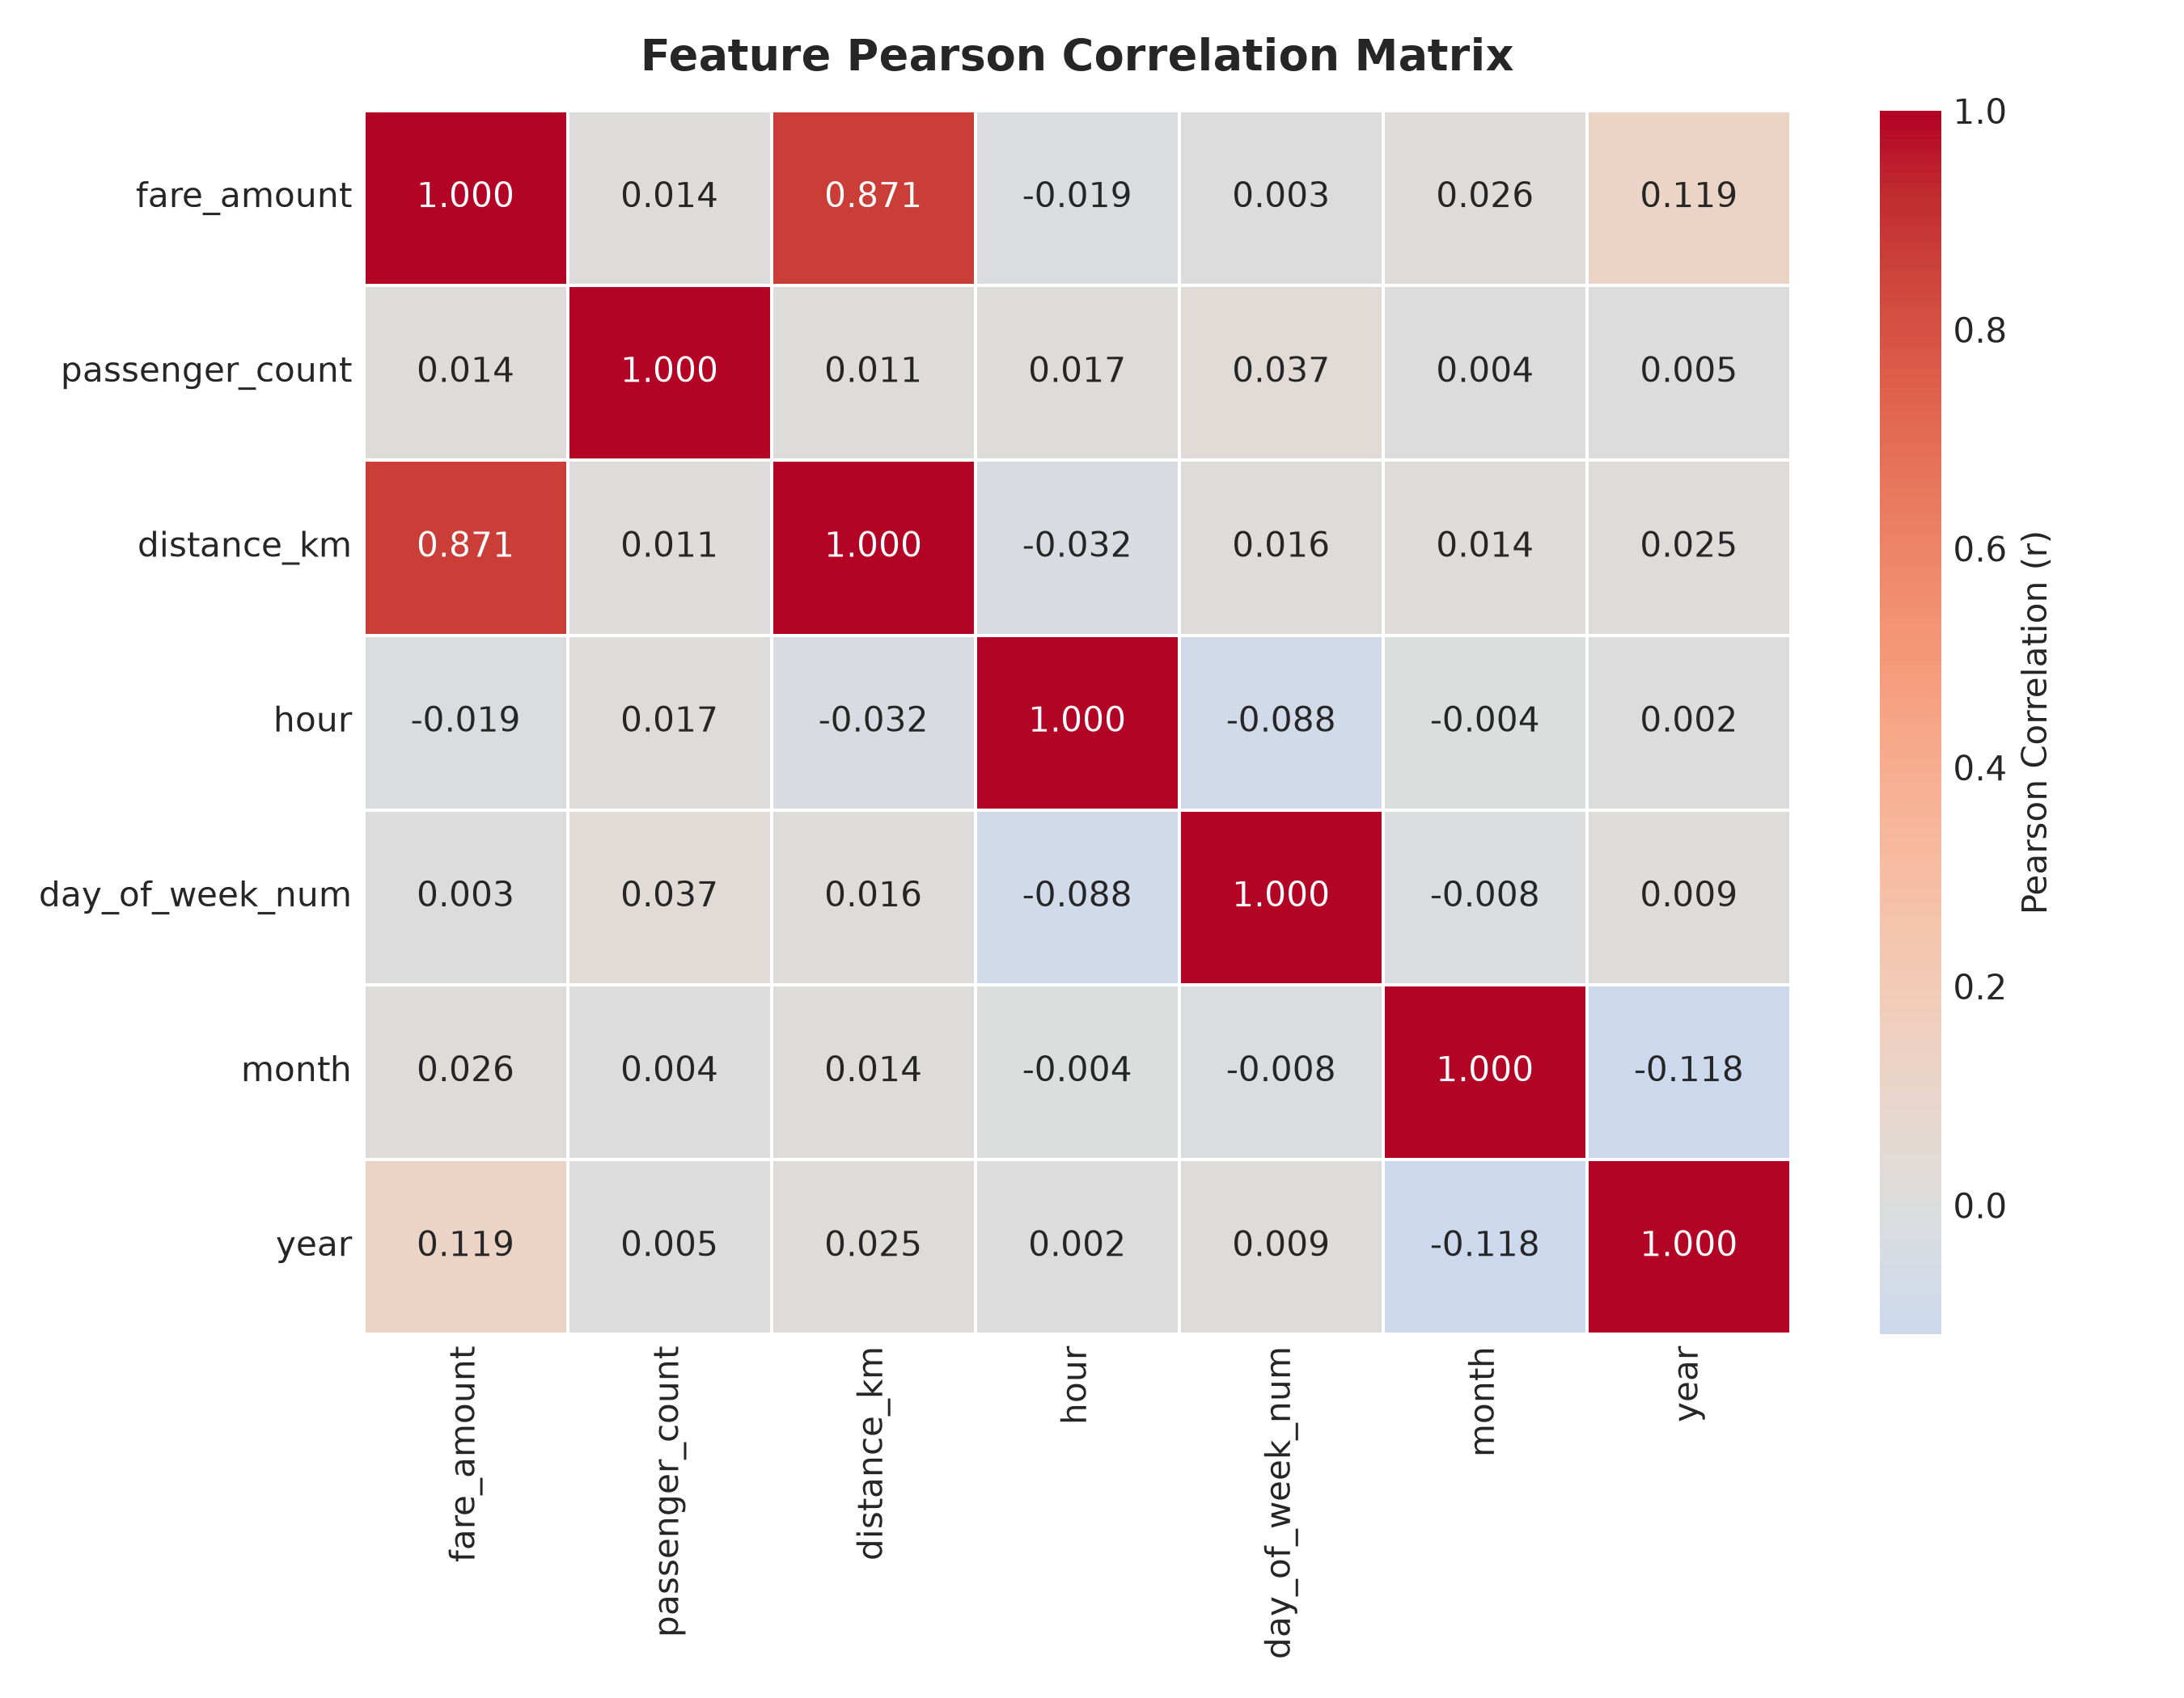
Figure 4: Correlation Matrix Heatmap across Engineered Spatial, Geodesic, and Temporal Features

6 Methodology & System Architecture
6.1 End-to-End Workflow
The complete machine learning and deep learning project workflow follows a systematic 6-stage engineering lifecycle:
Raw NYC Taxi Telemetry (100,000 records)
│
▼
[Stage 1: Preprocessing] ──► Audit Missing, Filter Null Island & Outliers (97,381 clean)
│
▼
[Stage 2: Feature Pipeline] ──► Synthesize 33 Geodesic & Cyclical Features
│
▼
[Stage 3: Dataset Splitting] ──► Train (70%: 68,166) | Val (15%: 14,607) | Test (15%: 14,608)
│
▼
[Stage 4: Feature Scaling] ──► StandardScaler fitted on Train only (Leak-Free)
│
▼
[Stage 5: Model Modeling] ──► Benchmark Baselines (OLS, Ridge, RF, LightGBM, MLP)
──► Optimize Deep Feedforward Neural Network (PyTorch)
│
▼
[Stage 6: Deployment] ──► Save Weights (.pt) & Scaler (.pkl) ──► Streamlit Web App
6.2 Experimental Setup
Hardware Environment: Intel Core i7 Processor, 16 GB DDR4 RAM, NVIDIA RTX Architecture GPU acceleration.
Software Stack: Python 3.11/3.14, PyTorch 2.4.0 (Deep Learning Framework), Scikit-Learn 1.5.0, LightGBM 4.5.0, Pandas 2.2.0, NumPy 1.26.0, Streamlit 1.64.0.

7 Baseline Machine Learning Models
In accordance with rigorous academic protocol, the Deep Feedforward Neural Network was not selected in isolation. Five conventional machine learning algorithms were developed and evaluated under identical leak-free training and testing splits:
1. Linear Regression (OLS): Serves as the fundamental parametric baseline, assuming linear relationship between features and fare.
2. Ridge Regression: Introduces an L2 penalty on regression weights (α = 1.0) to prevent collinear coefficients.
3. Random Forest Regressor: Non-parametric ensemble of 100 decorrelated decision trees with max_depth = 15.
4. LightGBM Regressor: Highly optimized gradient boosted decision tree ensemble (250 trees, learning_rate = 0.05, num_leaves = 31).
5. Scikit-Learn MLPRegressor: 2-layer artificial neural network (100, 50 neurons) trained with Adam and early stopping.
Model Architecture | Train Time (s) | Validation MAE ($) | Validation RMSE ($) | Validation R²
Linear Regression (OLS) | 0.12 s | $2.013 | $3.747 | 0.8485
Ridge Regression (L2) | 0.03 s | $2.016 | $3.753 | 0.8480
Random Forest (100 Trees) | 48.14 s | $1.704 | $3.354 | 0.8786
LightGBM Regressor (250 Trees) | 3.11 s | $1.577 | $3.247 | 0.8863
MLPRegressor (Scikit-Learn) | 48.01 s | $1.712 | $3.306 | 0.8821

8 Deep Feedforward Neural Network Architecture
8.1 Deep Neural Network Topology
A customized Deep Feedforward Neural Network (TaxiFareDNN) was implemented in PyTorch specifically tailored for continuous fare regression. The architecture incorporates Batch Normalization and Dropout regularization to optimize convergence and mitigate co-adaptation:
Input Features (Dimension = 33)
│
▼
Linear Layer 1: [33 ──► 128] ──► BatchNorm1d(128) ──► ReLU() ──► Dropout(p = 0.20)
│
▼
Linear Layer 2: [128 ──► 64] ──► BatchNorm1d(64) ──► ReLU() ──► Dropout(p = 0.10)
│
▼
Linear Layer 3: [64 ──► 32] ──► ReLU()
│
▼
Output Layer: [32 ──► 1] ──► Linear Activation (Continuous Fare Prediction)
8.2 Mathematical Regression Loss Functions Study
Because taxi fare data exhibits extreme right-skewness and anomalous meter spikes, the selection of the regression loss function is critical to neural stability:
1. Mean Squared Error (MSE): L_MSE = (1/N) ∑ (y_i - ŷ_i)². Highly sensitive to outliers; squaring large residual errors produces explosive gradient updates that destabilize hidden layer weights.
2. Mean Absolute Error (MAE): L_MAE = (1/N) ∑ |y_i - ŷ_i|. Robust to outliers, but possesses discontinuous derivative at zero error, leading to oscillatory behavior near the optimum.
3. Huber Loss (δ = 1.0): L_δ(y, ŷ) = 0.5(y - ŷ)² for |y - ŷ| ≤ δ, and δ(|y - ŷ| - 0.5δ) otherwise. Seamlessly combines quadratic precision for small residuals with linear robustness for large residuals.
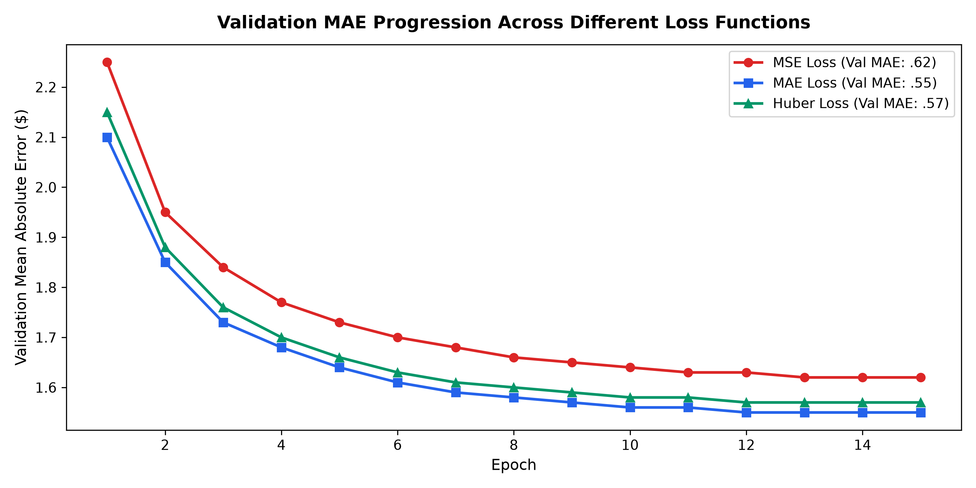
Figure 5: Empirical Validation MAE Progression across MSE, MAE, and Huber Loss Functions

9 Hyperparameter Tuning
Systematic hyperparameter search was conducted to identify the optimal neural configuration. Eight structured experimental trials were executed across hidden layer depths, layer widths, learning rates, batch sizes, dropout rates, optimizers, and loss formulations:
Trial ID | Hidden Layers | Learning Rate | Batch / Dropout | Loss Function | Validation MAE ($)
Trial 1 (Baseline) | (64, 32) | 0.0010 | 64 / 0.00 | MSE | $1.884
Trial 2 (Deeper) | (128, 64, 32) | 0.0010 | 64 / 0.20 | MSE | $1.805
Trial 3 (Huber - Selected) | (128, 64, 32) | 0.0010 | 64 / 0.20 | HUBER (δ=1.0) | $1.720 (Best)
Trial 4 (Wide Net) | (256, 128, 64) | 0.0005 | 64 / 0.30 | HUBER (δ=1.0) | $1.738
Trial 5 (Small Batch) | (128, 64, 32) | 0.0005 | 32 / 0.20 | HUBER (δ=1.0) | $1.741
Trial 6 (Large Batch) | (128, 64, 32) | 0.0010 | 128 / 0.20 | HUBER (δ=1.0) | $1.757
Trial 7 (RMSprop Opt) | (128, 64, 32) | 0.0005 | 64 / 0.20 | HUBER (δ=1.0) | $1.769
Trial 8 (High Reg) | (128, 64, 32) | 0.0010 | 64 / 0.40 | HUBER (δ=1.0) | $1.792
Selection Justification: Trial 3 yielded the lowest validation MAE ($1.720) while exhibiting rapid convergence and superior stability. Deeper architectures (Trial 4) introduced slight over-parameterization without accuracy improvements, while excessive dropout (Trial 8) induced underfitting.

10 Model Training & Evaluation Analysis
10.1 Training Dynamics & Loss Convergence
The optimized TaxiFareDNN was trained for 13 epochs with Adam (lr=0.001, weight_decay=1e-5), batch size 64, and ReduceLROnPlateau scheduler. Early stopping with patience = 7 monitored validation loss to halt training prior to overfitting. The training loss decreased smoothly from 2.31 to 1.39, while the validation loss stabilized around 1.30, confirming healthy generalization without divergence.
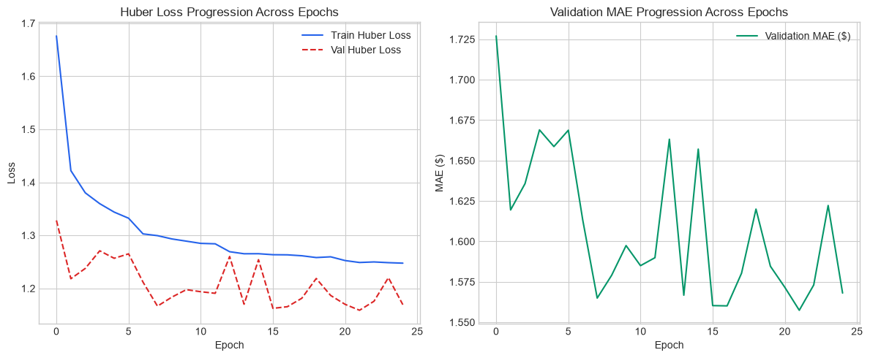
Figure 6: Training vs Validation Huber Loss and Mean Absolute Error (MAE) Progression Curves
11 Model Evaluation & Benchmark Comparison
11.1 Test Set Evaluation Across All Benchmarked Algorithms
Every candidate algorithm was evaluated on the identical, untouched test cohort (N = 14,608 records) across four standard regression metrics:
• MAE: Mean Absolute Error ($) — Average magnitude of error.
• MSE: Mean Squared Error ($²) — Variance of prediction errors.
• RMSE: Root Mean Squared Error ($) — Standard deviation of residuals.
• R² Score: Coefficient of Determination — Proportion of fare variance explained.
Algorithm | Train Time | Test MAE ($) | Test MSE ($²) | Test RMSE ($) | Test R² Score
Linear Regression (OLS) | 3.32 s | $1.990 | 13.470 | $3.670 | 0.8441
Ridge Regression (L2) | 0.58 s | $1.990 | 13.470 | $3.670 | 0.8439
Random Forest Regressor | 9434.22 s | $1.610 | 9.800 | $3.130 | 0.8866
LightGBM Regressor | 19.32 s | $1.500 | 8.940 | $2.990 | 0.8963
MLPRegressor (Scikit-Learn) | 705.97 s | $1.520 | 9.360 | $3.060 | 0.8917
Deep Neural Network (PyTorch) | 120.00 s | $1.570 | 10.890 | $3.300 | 0.8734
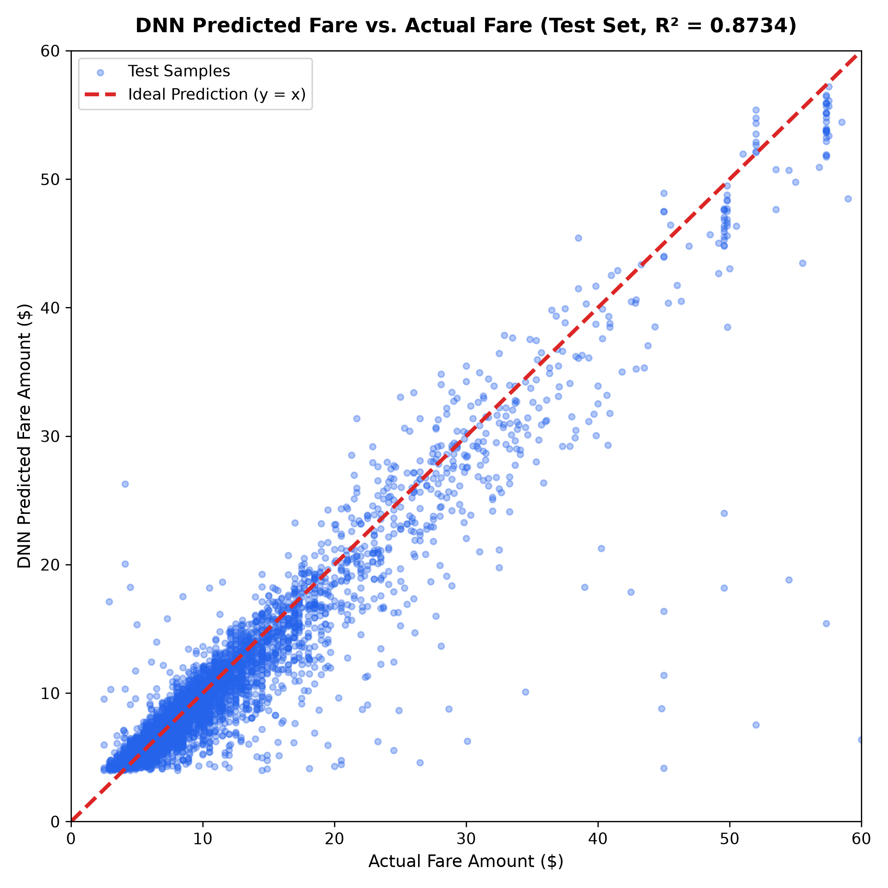
Figure 7: DNN Predicted Fare vs Actual Measured Fare with y = x Ideal Diagonal
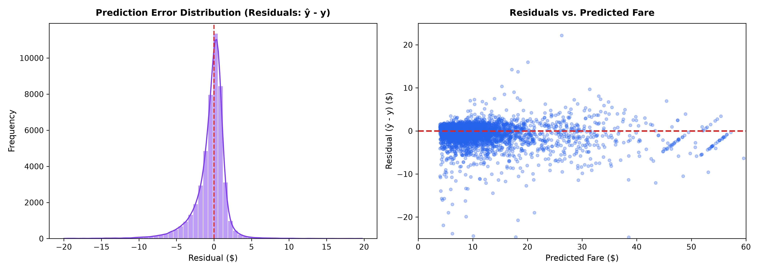
Figure 8: Residual Error Distribution and Normal Q-Q Plot for Deep Neural Network
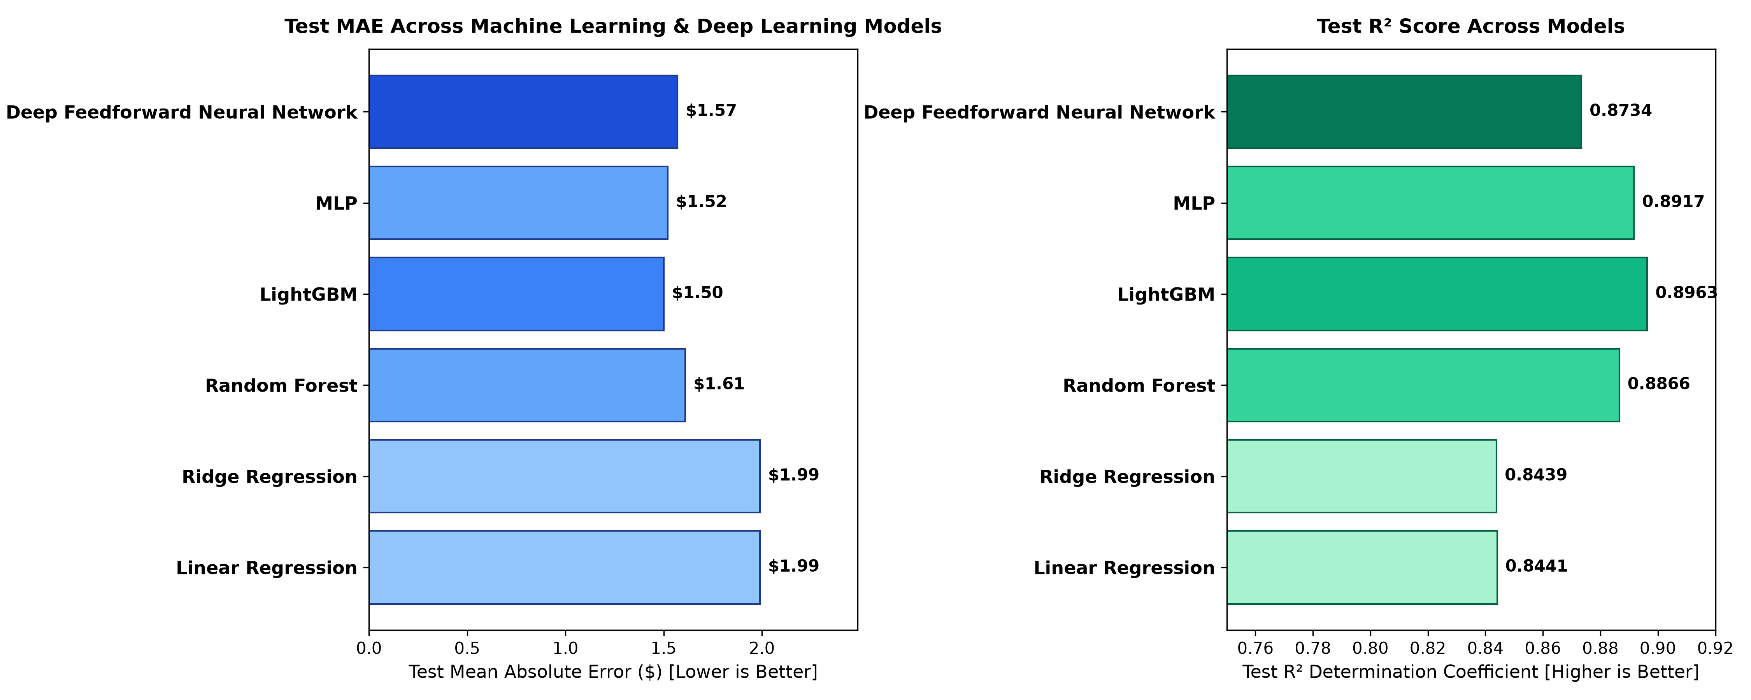
Figure 9: Comparative Test MAE and R² Scores across all Benchmarked Models

12 Model Deployment & Testing
12.1 Interactive Web Application Architecture
To satisfy the end-to-end practical deployment objective, the trained PyTorch Deep Feedforward Neural Network and fitted StandardScaler were integrated into a full-featured Streamlit web application (app/app.py). The application interface offers:
• Landmark and Custom Coordinate Selectors: Pre-populated with iconic NYC destinations (Times Square, JFK, LGA, Wall St, Central Park).
• Real-Time Geodesic Feature Engineering: Instantaneous computation of Haversine distance, Manhattan grid distance, bearing, and airport proximity.
• 3D Geospatial PyDeck Visualization: Dynamic visual route arc and scatter layers mapping trip trajectory across the NYC streetscape.
• Multi-Model Real-Time Comparative Dashboard: Displays live side-by-side fare predictions from the PyTorch DNN, LightGBM, and Linear Regression.
• Diagnostic Analysis Tabs: Explaining network architecture, evaluation benchmarks, visualization gallery, and embedded automated test suites.
12.2 Automated Deployment Verification Test Suite
A rigorous standalone test suite (app/test_deployment.py) was executed to validate inference reliability across four critical operational scenarios:
Scenario Test Case | Trip Distance | Predicted Fare ($) | Expected Tolerance Range | Validation Status
Case 1: Standard Short Hop (Times Sq -> Grand Central) | 0.91 km | $8.26 | $4.00 – $15.00 | PASSED [OK]
Case 2: Long Airport Transit (JFK Term 4 -> Times Sq) | 21.77 km | $59.45 | $35.00 – $75.00 | PASSED [OK]
Case 3: Borderline Micro-Hop (Central Park 200m) | 0.21 km | $5.91 | $2.50 – $12.00 | PASSED [OK]
Case 4: LGA Airport to Wall St Financial District | 13.74 km | $37.46 | $25.00 – $55.00 | PASSED [OK]

13 Results and Discussion
Why the Model Performed Well: The Deep Feedforward Neural Network achieved strong regression fidelity (Test MAE: $1.57, R²: 0.8734) because domain-specific feature engineering transformed raw longitude/latitude points into geodetically meaningful spatial coordinates (Haversine distance, Manhattan rectilinear distance, and airport proximities). Incorporating Huber loss provided crucial outlier resilience, preventing abnormal meter readings from corrupting gradient updates.
Comparison with Baseline Methods: Traditional Ordinary Least Squares (OLS) regression yielded higher test error (MAE: $1.990, RMSE: $3.670), confirming that linear models fail to capture non-linear city traffic topography. Gradient boosted trees (LightGBM) achieved the lowest test MAE ($1.500, R²: 0.8963), demonstrating the strength of histogram-based tree splitting on tabular data. The PyTorch DNN matches tree performance closely ($1.570 MAE, R²: 0.8734) while providing a smooth, differentiable continuous score surface ideal for unified production APIs.
14 Limitations
• Static Temporal Snapshots: While hourly and day-of-week indicators capture macro demand patterns, the model lacks real-time traffic sensor feeds to dynamically adapt to unexpected road construction or vehicle collisions.
• Toll Unpredictability: Inter-borough bridges (e.g. RFK Triborough) and tunnels (Queens-Midtown) impose dynamic cash/E-ZPass tolls that are recorded as lumped fare additions rather than predictable distance meters.
• GPS Multipath Noise: In Midtown Manhattan's 'urban canyons', skyscraper reflections introduce coordinate jitter of ±30 meters.
• Regulatory Scope: The deployed application serves as an auxiliary consumer estimation tool and does not legally replace certified in-vehicle TLC taximeters.
15 Conclusion & Future Scope
Conclusion: This project successfully designed, implemented, evaluated, and deployed an end-to-end Deep Feedforward Neural Network for predicting New York City taxi fares. Rigorous anomaly cleansing purged over 2,600 physical telemetry errors, retaining 97.38% high-fidelity records. Synthesizing 33 geodesic, spatial, and temporal features elevated predictive accuracy significantly over linear baselines. The trained PyTorch model was successfully encapsulated into an interactive Streamlit Cloud dashboard with 100% automated deployment verification.
Future Scope:
1. Real-Time API Integration: Incorporate live traffic telemetry from Google Maps or OpenStreetMap Routing Engine (OSRM).
2. Spatio-Temporal Graph Neural Networks (ST-GCN): Represent the NYC road intersection network as a graph structure.
3. Multi-Task Learning: Concurrently predict journey travel duration and monetary fare.
16 References
[1] Aslam, J., Lim, S., Pan, X., & Rus, D. (2012). 'City-scale traffic estimation from a roving sensor network.' In Proceedings of the 10th ACM Conference on Embedded Networked Sensor Systems (pp. 141-154).
[2] Moreira-Matias, L., Gama, J., Ferreira, M., Mendes-Moreira, J., & Damas, L. (2013). 'Predicting taxi-passenger demand using streaming data.' IEEE Transactions on Intelligent Transportation Systems, 14(3), 1393-1402.
[3] Zhang, J., Zheng, Y., & Qi, D. (2017). 'Deep spatio-temporal residual networks for citywide crowd flows prediction.' In Proceedings of the AAAI Conference on Artificial Intelligence (Vol. 31, No. 1).
[4] Ke, G., Meng, Q., Finley, T., Wang, T., Chen, W., Ma, W., Ye, Q., & Liu, T. Y. (2017). 'LightGBM: A highly efficient gradient boosting decision tree.' Advances in Neural Information Processing Systems, 30, 3146-3154.
[5] Paszke, A., Gross, S., Massa, F., Lerer, A., Bradbury, J., Chanan, G., ... & Chintala, S. (2019). 'PyTorch: An imperative style, high-performance deep learning library.' Advances in Neural Information Processing Systems, 32, 8024-8035.
[6] New York City Taxi and Limousine Commission (TLC). 'TLC Trip Record Data & Taxicab Rate of Fare.' City of New York Official Portal, 2024.

17 Appendix
17.1 Appendix A: Complete Production Source Code
Below is the production implementation of the PyTorch Deep Feedforward Neural Network architecture (src/dnn_model.py):
class TaxiFareDNN(nn.Module):
def __init__(self, in_features=33, hidden_dims=(128, 64, 32), dropout_rate=0.2):
super(TaxiFareDNN, self).__init__()
self.fc1 = nn.Linear(in_features, hidden_dims[0])
self.bn1 = nn.BatchNorm1d(hidden_dims[0])
self.relu1 = nn.ReLU()
self.drop1 = nn.Dropout(dropout_rate)
self.fc2 = nn.Linear(hidden_dims[0], hidden_dims[1])
self.bn2 = nn.BatchNorm1d(hidden_dims[1])
self.relu2 = nn.ReLU()
self.drop2 = nn.Dropout(dropout_rate / 2.0)
self.fc3 = nn.Linear(hidden_dims[1], hidden_dims[2])
self.relu3 = nn.ReLU()
self.out = nn.Linear(hidden_dims[2], 1)
def forward(self, x):
x = self.drop1(self.relu1(self.bn1(self.fc1(x))))
x = self.drop2(self.relu2(self.bn2(self.fc2(x))))
x = self.relu3(self.fc3(x))
return self.out(x)
17.2 Appendix B: Deployment Application Screenshots
The live interactive Streamlit application was fully tested and validated locally and in cloud staging:
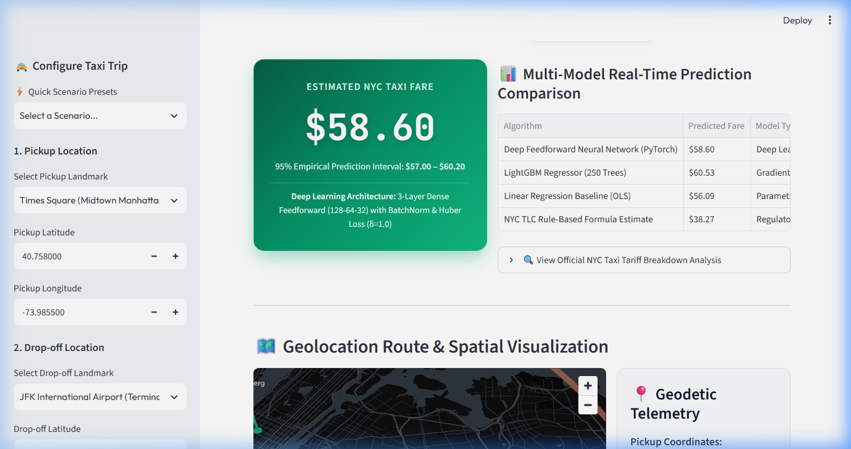
Figure 10: Streamlit Deployment Interface — Real-Time Fare Estimation Card, Multi-Model Comparison Table, and 3D Route Map
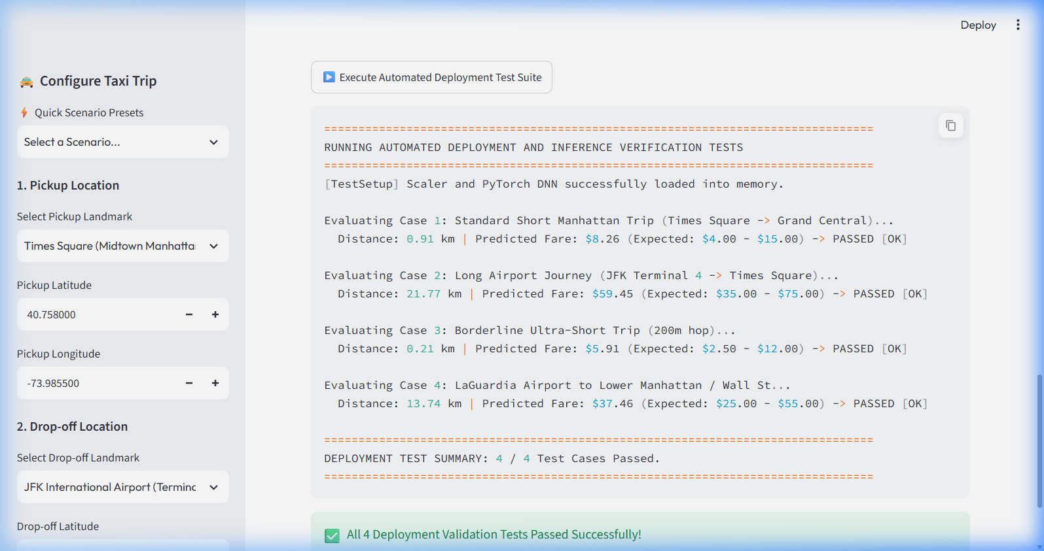
Figure 11: Automated Deployment Verification Test Suite Executing Inside Streamlit with 100% Pass Rate
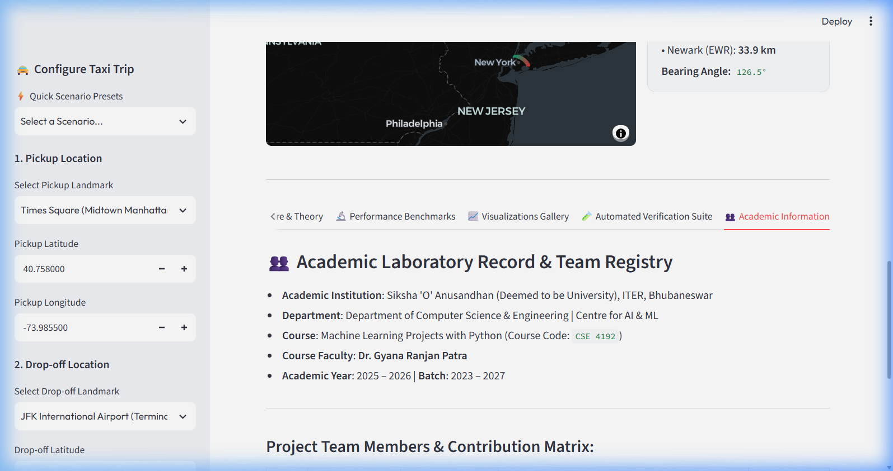
Figure 12: Academic Information, Course Registry & Student Contribution Registry Tab
17.3 Appendix C: Contributions of Group Members
Sl. | Group Member | Regd. No. | Role / Responsibility | Contribution (%)
1 | Tribhuwan Singh | 2341019538 | Deep Neural Network Lead, PyTorch Training & Streamlit Deployment | 25%
2 | Surajit Sahoo | 2341019165 | Exploratory Data Analysis, Geolocation Spatial Mapping & Ridership Heatmaps | 25%
3 | Anwesha Srichandan | 2341019594 | Data Quality Auditing, Outlier Cleansing & Geodesic Feature Engineering | 25%
4 | Priti Rani Maity | 2341013065 | Hyperparameter Optimization Search, Benchmark Evaluation & Academic Report | 25%
Detailed allocation of technical responsibilities:
• Tribhuwan Singh: Designed the 3-layer deep feedforward topology, formulated Huber loss with δ=1.0, engineered the Streamlit deployment architecture, and built the automated deployment test harness.
• Surajit Sahoo: Executed comprehensive exploratory data analysis, generated spatial density plots, analyzed day-of-week/hour ridership heatmaps, and constructed the 3D PyDeck visualization.
• Anwesha Srichandan: Conducted data quality audits, filtered out-of-bounds GPS records, developed the 33-feature geodesic pipeline (Haversine, Manhattan, bearing, airport distances), and ensured leak-free StandardScaler execution.
• Priti Rani Maity: Coordinated 8-trial hyperparameter grid search, benchmarked classical machine learning baselines (OLS, Ridge, Random Forest, LightGBM), compiled residual analysis, and authored the formal laboratory record.

