**The Cleansing of Lodz**

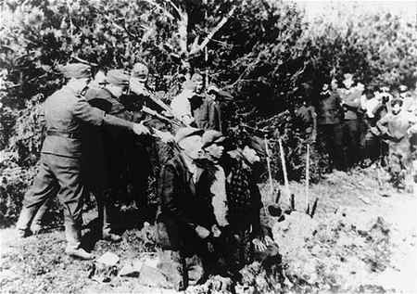

After struggling with the scum that are known as the Polish Army, we have successfully brought the state of Lodz under righteous Prussian Control. As per usual policy, Task groups were dispatched to all known villages, towns, and centers of human habitation, and all Slavic-speaking peoples were registered, and summarily executed. Apart from a few cases of refusal, most of these orders were carried out without hesitation. Although some small groups of undesirables still roam the countryside, most urban centers have been purified of Slavs.

**Another Glorious Victory for Prussia.**

**\*\*\*\*\*\*\*\*\*\*\*\*\*\*\*\*\*\*\*\*\*\*\*\*\*\*\*\*\*\*\*\*\*\*\*\*\*\*\*\*\*\*\*\*\*\*\*\*\*\*\*\*\*\*\*\*\*\*\*\*\*\*\*\*\*\*\*\*\*\*\*\*\*\*\*\*\*\*\*\*\*\*\*\*\***

**The Cleansing of Plock**

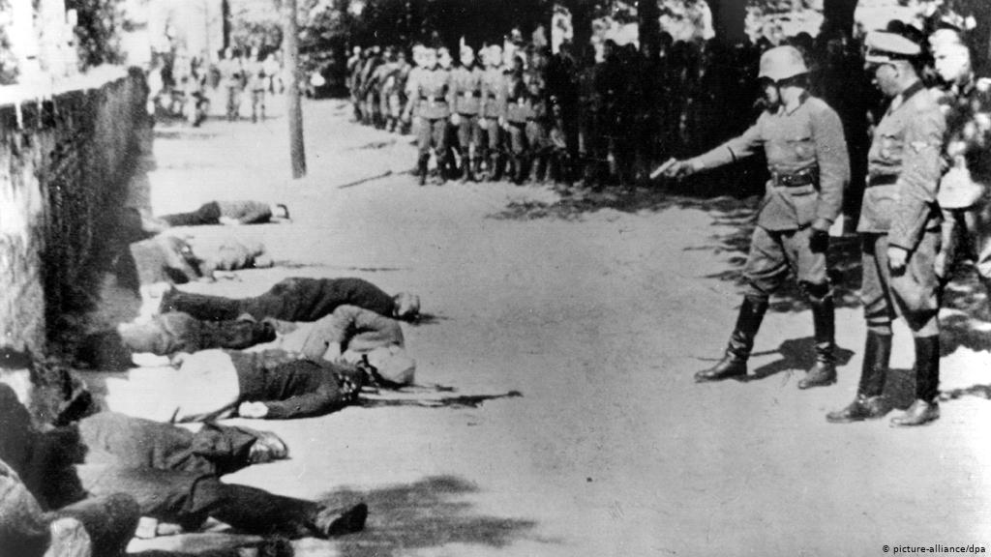

After struggling with the scum that are known as the Polish Army, we have successfully brought the state of Plock under righteous Prussian Control. As per usual policy, Task groups were dispatched to all known villages, towns, and centers of human habitation, and all Slavic-speaking peoples were registered, and summarily executed. Apart from a few cases of refusal, most of these orders were carried out without hesitation. Although some small groups of undesirables still roam the countryside, most urban centers have been purified of Slavs.

**Another Glorious Victory for Prussia.**

**The Cleansing of Kielce**

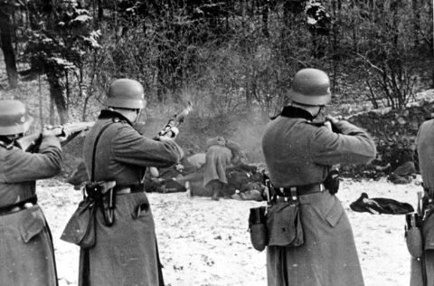

After struggling with the scum that are known as the Polish Army, we have successfully brought the state of Kielce under righteous Prussian Control. As per usual policy, Task groups were dispatched to all known villages, towns, and centers of human habitation, and all Slavic-speaking peoples were registered, and summarily executed. Apart from a few cases of refusal, most of these orders were carried out without hesitation. Although some small groups of undesirables still roam the countryside, most urban centers have been purified of Slavs.

**Another Glorious Victory for Prussia.**

**The Rape of Krakow**

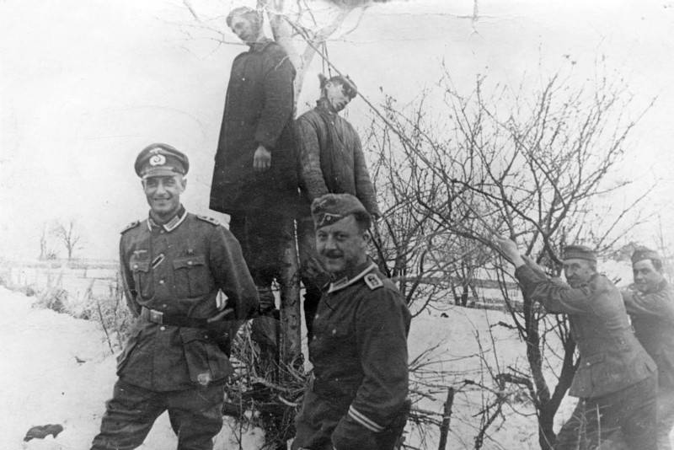

We have pacified the Polish Province of Krakow, but unfortunately our valiant soldiers became slightly overzealous upon reaching the city of Krakow. Although our extermination orders were carried out with no complaints, pillaging and the rape of young women were a frequent occurrence within the city, along with the mass killings of young children.

**Inconsequential in the Drive to the East.**

**The Rape of Warsaw**

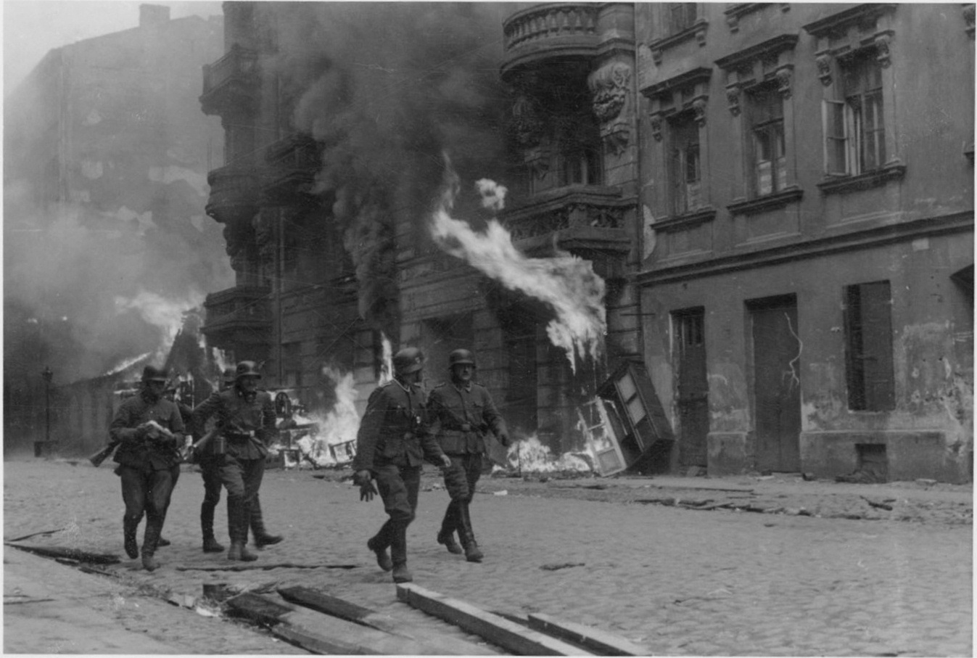

Our conquest of the Polish Province of Warszawa has led to the fall of the Polish Capital of Warsaw. Our troops enjoyed their stay by cleaning the rightful German land of Slavs, who were summarily executed. Buildings were put to the torch, and women and children alike were indiscriminately murdered and raped. Truly a glorious day for Prussia and the German people, and the dream of Drang Nacht Osten grows ever nearer.

**Heil Guderian! Preußen uber Alles!**