1. MobaXterm无法链接

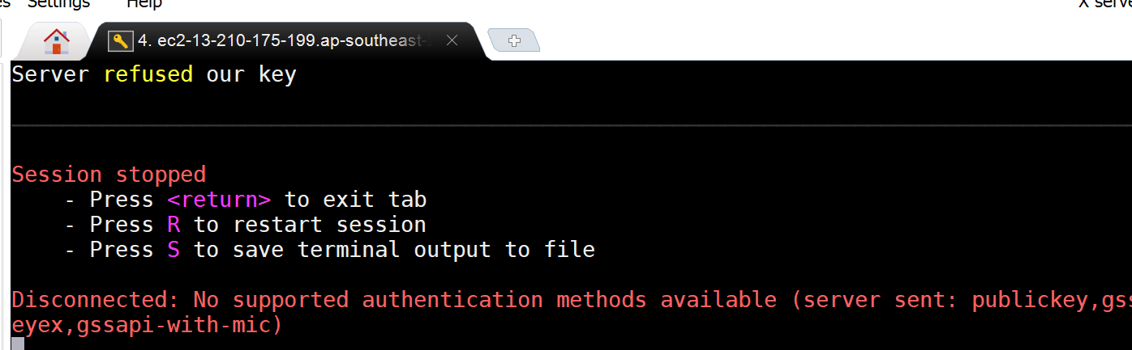

INSTANCE INFO: ec2-13-210-175-199.ap-southeast-2.compute.amazonaws.com

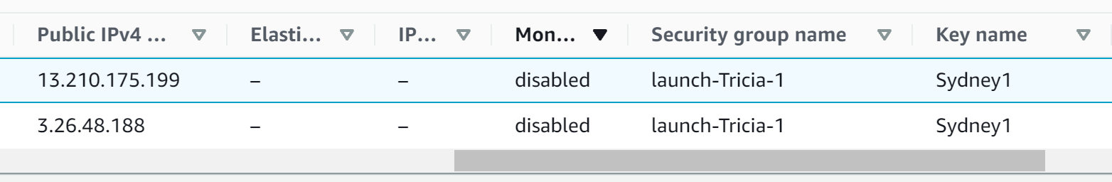

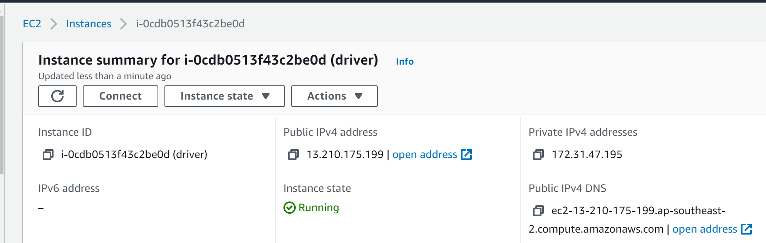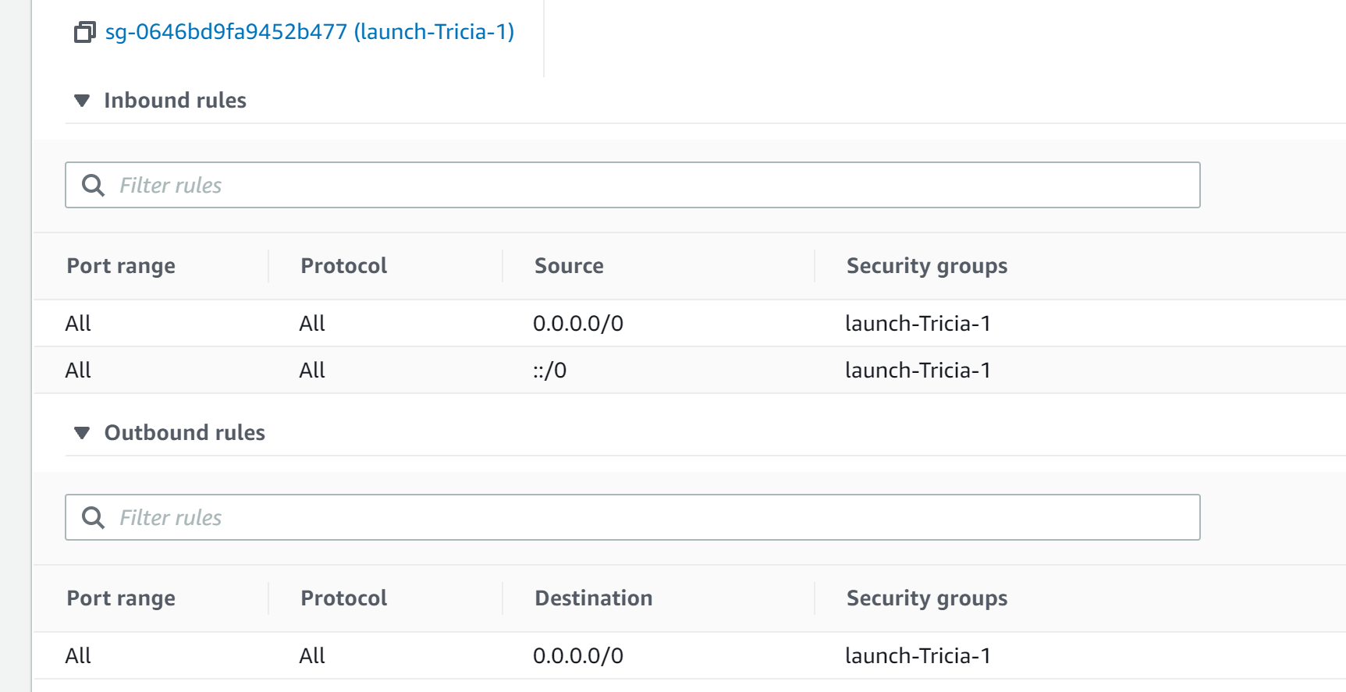

Moba:

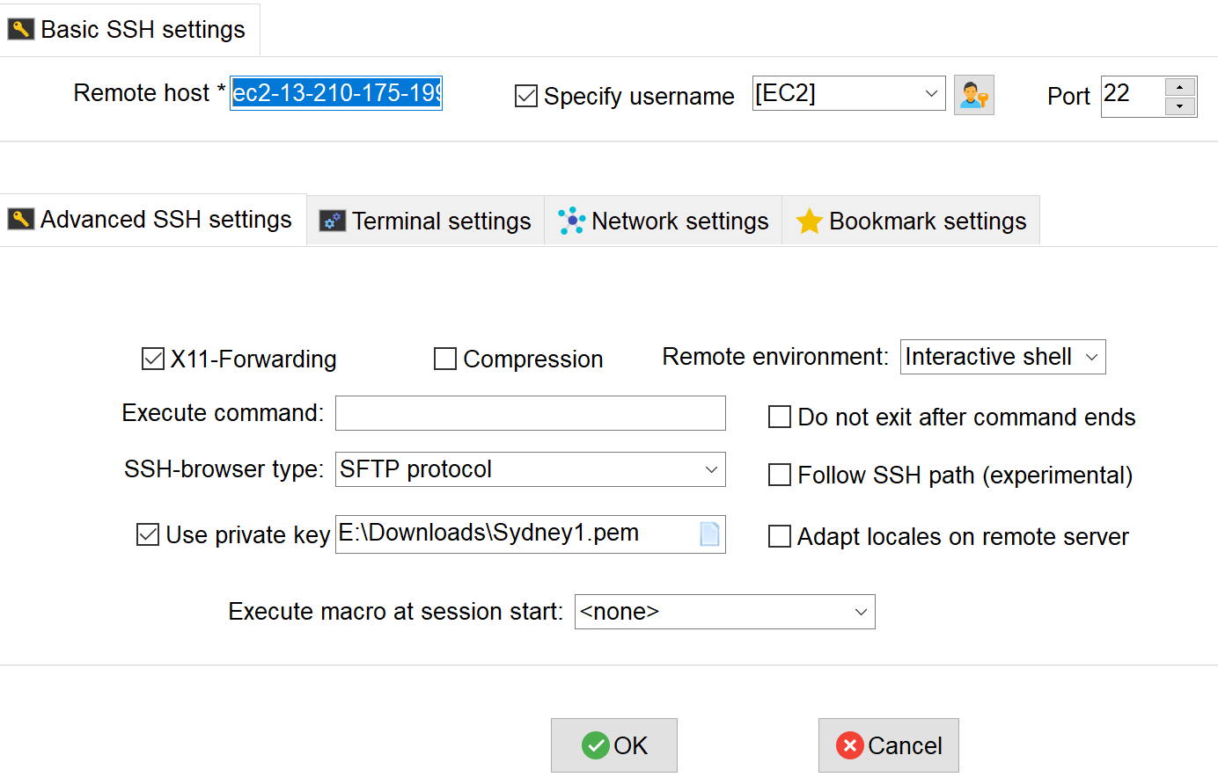

解决：WIN未解决；**通过MAC ssh 接入， 或EC2 instance connect**

1. 浏览器接入jupyter失败，更改了security的规则也不行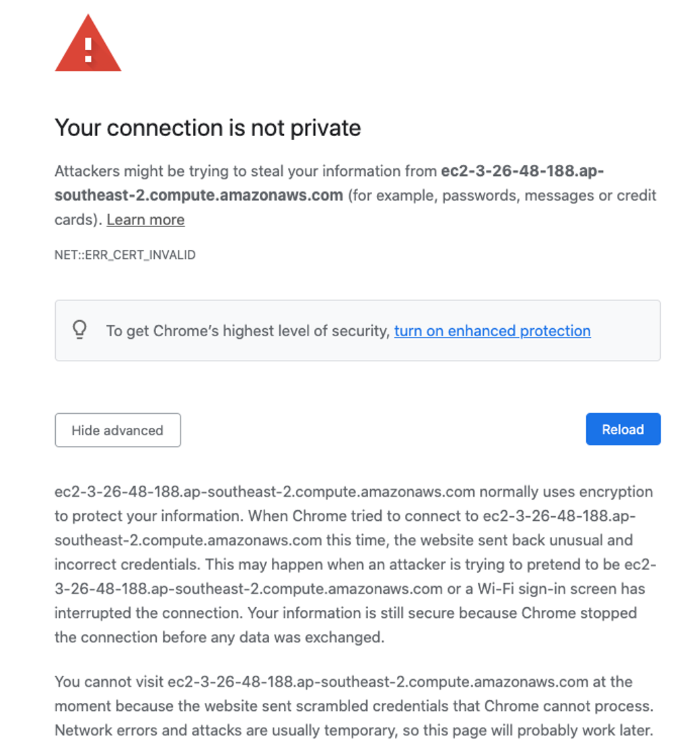

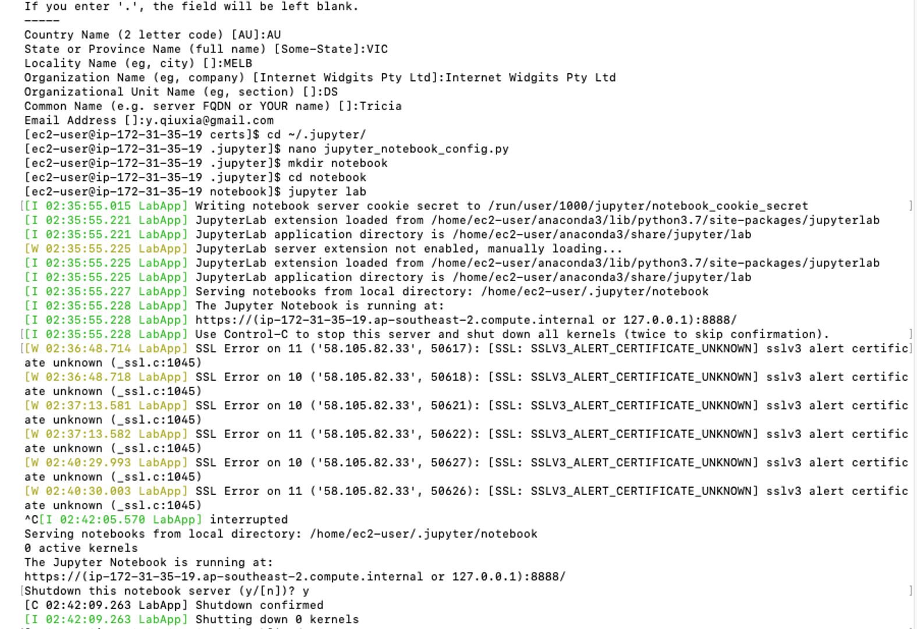

1. Install spark: what to do for

*You can add them into ~/.bashrc to get spark home set when the server start*

1. Spark cluster:

In your driver node:

– cd $SPARK_HOME/sbin

– ./start-master.sh

在driver node，/sbin下没有这个.sh文件，同样的安装步骤，worker node中却有这个文件，且两个node中$SPARK_HOME/sbin 中的文件非常不一样：

Driver node:

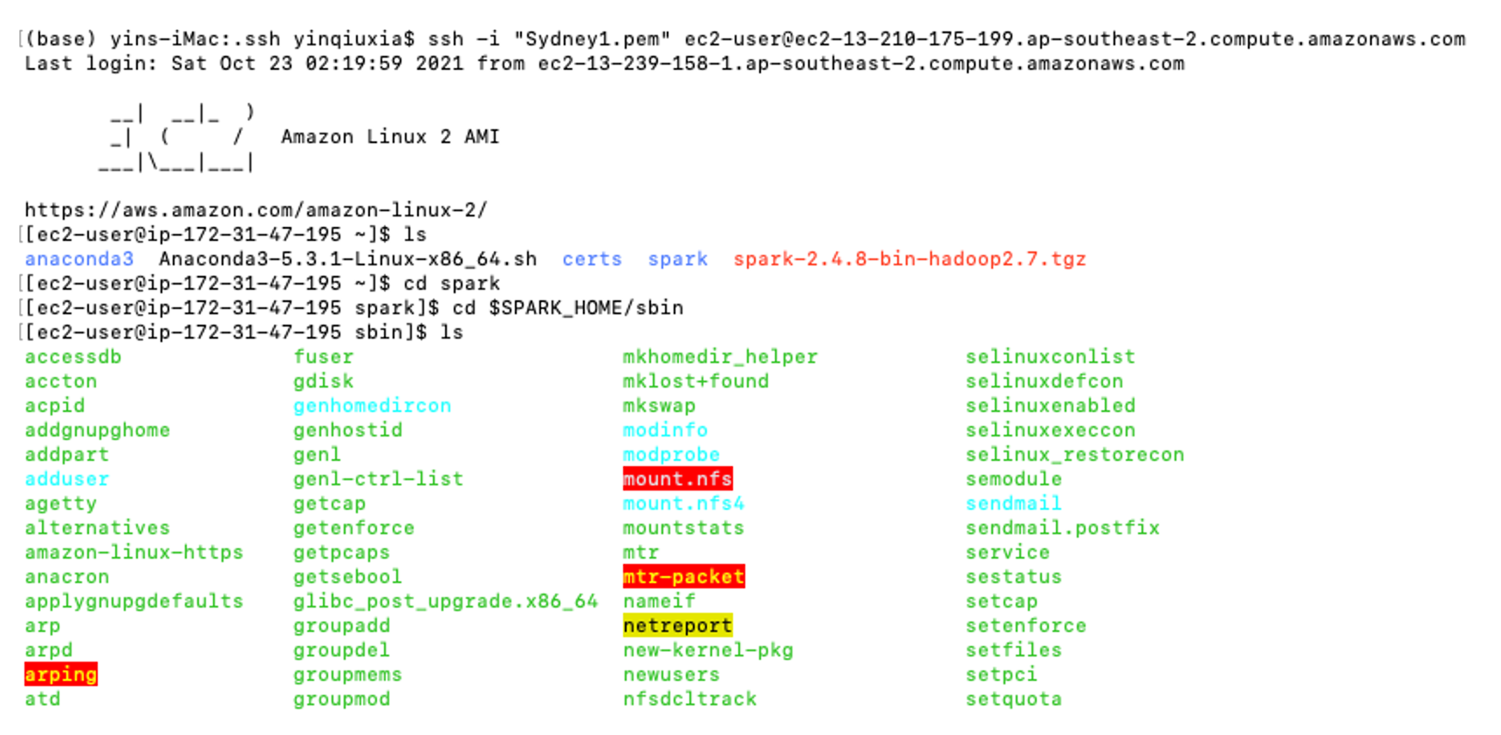

Worker node:

