p8157_LDA_hw1

Chunxiao Zhai cz2544

Part B

tlc = read.table("TLC.dat")  
colnames(tlc) = c("id", "trt", "week0", "week1", "week4", "week6")  
# matplot(t(tlc), type = "l")  
tlc_df = as.data.frame(tlc) %>%   
 pivot_longer(  
 week0:week6,  
 names_to = "visit_time",   
 values_to = "serum_lead")   
   
tlc_p1 = tlc_df %>%   
 ggplot( aes(x=visit_time, y = serum_lead, group = id, color = trt))+  
 geom_line()  
  
tlc_p2 = tlc_df %>% group_by(trt) %>%   
 ggplot( aes(x=visit_time, y = serum_lead, color = trt))+  
 geom_violin()  
  
tlc_p1+tlc_p2

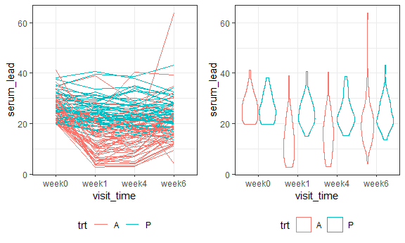

dental = read.table("dental.dat")  
colnames(dental) = c("id", "gender", "8", "10", "12", "14")  
dtl_df = as.data.frame(dental) %>%   
 pivot_longer(  
 "8":"14",  
 names_to = "age",   
 values_to = "pt_pm_dis") %>%   
 mutate(age = as.numeric(age))   
  
dtl_p1 = dtl_df %>%   
 ggplot( aes(x=age, y = pt_pm_dis, color = gender))+  
 geom_point()  
   
dtl_p2 = dtl_df %>%   
 ggplot( aes(x=age, y = pt_pm_dis, group = id, color = gender))+  
 geom_line()  
  
dtl_mean = dtl_df %>% mutate(age=as.factor(age)) %>%   
 group_by(age,gender) %>% mutate(grp_mean=mean(pt_pm_dis)) %>% ungroup()  
dtl_p3 = dtl_mean %>% mutate(id=as.factor(id)) %>%   
 ggplot( aes(x=age, y = pt_pm_dis-grp_mean,group = id, color = id))+  
 geom_line()+ facet_grid(~gender) +  
 labs( title = "tandarized growth line" ) +   
 viridis::scale_color_viridis(  
 name = "id",   
 discrete = TRUE)+  
 theme(legend.key.size = unit(.25, "cm"))+  
 guides(col = guide_legend(ncol=14))  
  
  
dtl_p1+dtl_p2

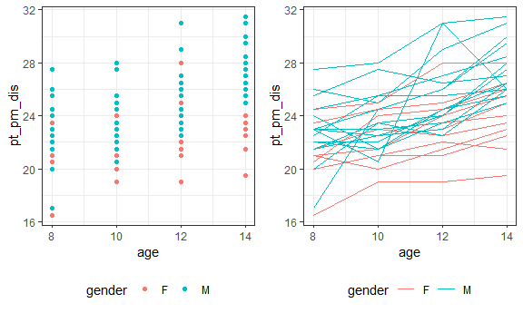

dtl_p3

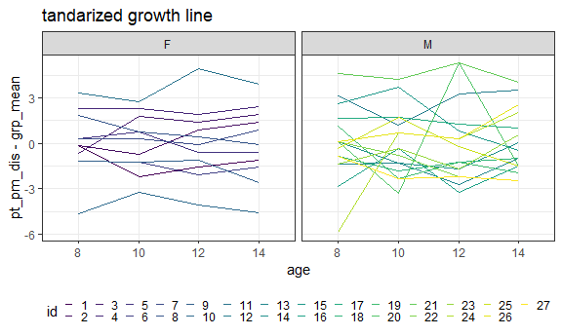

zeb = read.table("ZERBE2.DAT")  
colnames(zeb) = c("grp","id", "0", "0.5", "1", "1.5","2","3")  
  
#EDA  
zeb_df = as.data.frame(zeb) %>%   
 pivot_longer(  
 "0":"3",  
 names_to = "time",   
 values_to = "serum_pip") %>%   
 mutate(grp = factor(grp, labels=c("ctl","ob")))  
  
zeb_p1 = zeb_df %>%   
 ggplot( aes(x = time, y = serum_pip, color = grp))+  
 geom_boxplot()  
   
zeb_p2 = zeb_df %>%   
 ggplot( aes(x = time, y = serum_pip, color = grp, group = id))+  
 geom_line()+ facet_grid(~grp)  
  
# Hotelling test  
zeb_h01 = cbind(zeb[1],zeb[3:8])  
colnames(zeb_h01) = c("grp", "t0", "t0.5", "t1", "t1.5","t2","t3")  
fit_a = hotelling.test(.~grp, data = zeb_h01)  
fit_a

## Test stat: 8.5531   
## Numerator df: 6   
## Denominator df: 26   
## P-value: 3.495e-05

# reject H0 (a) at 0.05 alpha level  
  
zeb_h02 = zeb_h01 %>% mutate(it1=t0.5-t0, it2=t1-t0.5,   
 it3=t1.5-t1, it4=t2-t1.5,   
 it5=t3-t2) %>% select(grp,it1:it5)  
fit_b = hotelling.test(.~grp, data = zeb_h02)  
fit_b

## Test stat: 8.1805   
## Numerator df: 5   
## Denominator df: 27   
## P-value: 8.344e-05

# reject H0 (b) at 0.05 alpha level  
  
fit_c = hotelling.test(it5~grp, data = zeb_h02)  
fit_c

## Test stat: 0.41711   
## Numerator df: 1   
## Denominator df: 31   
## P-value: 0.5231

# can not reject H0 (a) at 0.05 alpha level  
  
# EDA  
mu = apply(zeb[3:8],2,mean)  
res = sweep(zeb[3:8],2,mu)  
cols = rep(1:33,rep(6,33))  
pairs.panels(res,lm=TRUE)

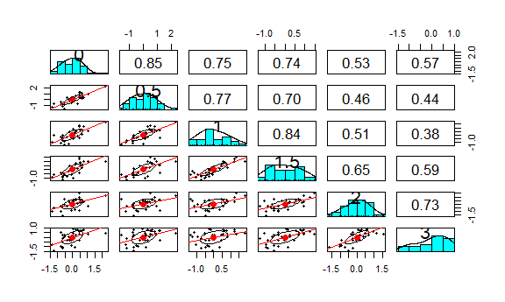

# rev vs mean plot  
plot(as.vector(t(res)), col=cols, pch=19)

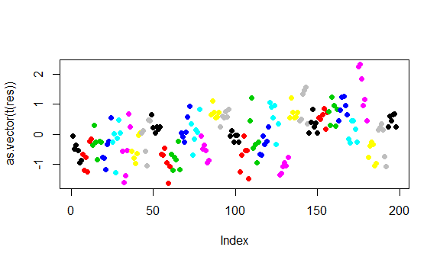

# rev vs median plot  
mpolish = medpolish(zeb[3:8])

## 1: 64  
## 2: 60.5  
## Final: 60.05

plot(as.vector(t(mpolish$residuals)), col=cols,pch=19)

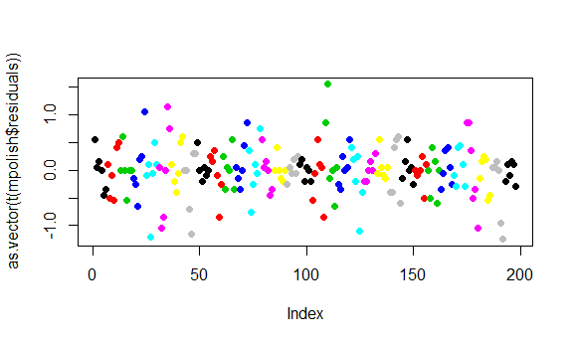

# subject vs median  
plot(mpolish$row, col=zeb$grp)

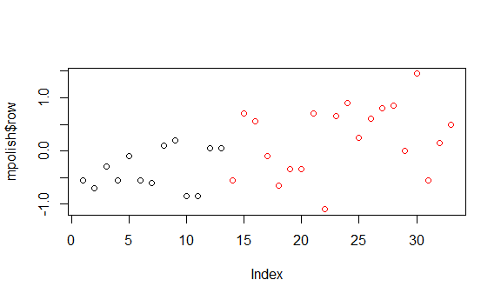

# ACF  
acf(as.vector((t(mpolish$residuals))))

