**INTELLIMODZ USER MANUAL**

Contents

[**FAQs: Essential Items Every User Must Know** 2](#_Toc5635420)

[**Models** 2](#_Toc5635421)

[**Modules** 3](#_Toc5635422)

[**Hierarchy** 3](#_Toc5635423)

[**Header section** 4](#_Toc5635424)

[**Models** 4](#_Toc5635425)

[**Replica** 5](#_Toc5635426)

[**Preferences** 5](#_Toc5635427)

[**Bookmarks** 8](#_Toc5635428)

[**Doc Library** 9](#_Toc5635429)

[**Employee** 12](#_Toc5635430)

[**Reports** 15](#_Toc5635431)

[**Help** 17](#_Toc5635432)

[**Find** 17](#_Toc5635433)

[**Messaging** 18](#_Toc5635434)

[**Sign Out** 22](#_Toc5635435)

[**Bread Trail** 22](#_Toc5635436)

[**Module Indicator** 22](#_Toc5635437)

[**General Items** 23](#_Toc5635438)

[**Left Side Navigation Bar** 23](#_Toc5635439)

[**Module Bar** 24](#_Toc5635440)

[**Pin** 24](#_Toc5635441)

[**Tabs** 24](#_Toc5635442)

[**Submodules** 24](#_Toc5635443)

[**Workflow** 27](#_Toc5635444)

[**Connections** 31](#_Toc5635445)

[**Documents** 32](#_Toc5635446)

[**Strategy tab** 34](#_Toc5635447)

[**Assessment** 33](#_Toc5635448)

[**Performance** 35](#_Toc5635449)

[**Collaboration Tab** 38](#_Toc5635450)

[**Details tab** 39](#_Toc5635451)

**Quick Start Guide:**

# FAQs: Essential Items Every User Must Know

1. What is a module? See [Modules](#_Modules)
2. How do I add a new module? See [Adding Modules](#_Module_Tab_Features)
3. Can modules be reorganized? See [Moving Modules](#_Moving_Modules)
4. How does Intellimodz help me structure information? See [Hierarchy](#_Hierarchy)
5. Where can I put information that relates to a module? See [Tabs](#_Tabs)
6. How can I communicate with other users? See [Messaging](#_Messaging)

### Models

Models allow a Company or Entity to create any number of hierarchical organizational structures, made up of Modules to represent most any organizational or departmental need. These are separate and distinct structures which allow for separation as needed. Model structures can be created to “physically” separate out data where a logical separation within a Model structure is not desired. New Models can also be used to experiment with design structures.

### Modules

A module is an entity or object in or outside the enterprise which the user wishes to define. Stored within a module are any and all relevant information about it, including information about submodules that comprise it, and relationships to other modules. A module is independent from all other modules in a given model, though relationships to other modules can be described.

Within an enterprise model, modules are designated by a unique name, identification number, and vital information, such as owner, goals, etc. Visual representations may also show what level of the hierarchy the module resides and may include numerical data about how many submodules exist beneath it.

#### Modules

Modules can be used to organize information about any number of business domains. For example, some of the following generic modules may be established:

* Projects
* Clients
* Competitors
* Technology
* Competencies
* Vendors

### Hierarchy

Hierarchies are powerful tools for simplifying and representing complex systems. Comprehensive or even partial enterprise models may be developed using the principles of modularity, modular decomposition, and hierarchical organization. Through the process of decomposition, hierarchies of modules are formed. It is the layering of modules into a hierarchy that provides users the ability to see both broad and more detailed views of the enterprise, and drill down from higher to lower levels of detail, or move up the hierarchy to see how things roll up.

All of the modules developed to represent a business enterprise may be cleanly organized into a layered, hierarchical format. The top levels of the hierarchy provide a broad view of the enterprise. Lower levels provide a more detailed view.

The top level of a hierarchy is called the enterprise module or enterprise view. It is the sum of all modules and subcomponents below it. Therefore, information about the system below may be rolled up and/or summarized at this level.

The top of any pyramid of modules is called a parent module. The submodules of a parent – those modules that make up the parent, are called the children. Each child module may, in turn, become a parent module as it is further decomposed into smaller submodules.

Modules in the hierarchy may be easily moved up or down levels or reordered within a level using drag and drop or cut and paste functionality.

# Header section

## **Models**

Intellimodz may be used to generate an infinite number of models. It can be used to develop an enterprise-wide model or it can be used to model subcomponents of the business, such as for an organization division or department. Alternative models may be set up to experiment with different organization strategies. Models may be set up for any domain of interest.

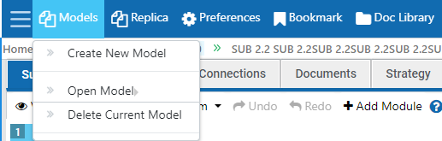

Models drop down menu allows the user to create new models from scratch, open an existing model, or delete a model. When creating a new model group of 4 general modules are provided. These may be used as is or deleted. Users may add additional module categories by adding modules and naming them as they see fit.

## **Replica**

The Replica button opens an identical version of the selected enterprise model so the user may compare and contrast different locations of the same model simultaneously or explore where to move modules within a model.

## **Preferences**

The Preferences button may be used to increase the speed of navigation once model development is no longer a priority. Users can also assign default modules here.

**General**

First check box is used to open the module based on “Single” or “Double Click”. Check box checked is to open the modules from submodule tab on single click, Uncheck will used to open the modules on double click. Drag and drop feature is enabled. To hide the left side module list done by selecting the second check box. Uncheck will automatically enabled the left side module list.

By using date format dropdown, user can manage the date format to display in all features.

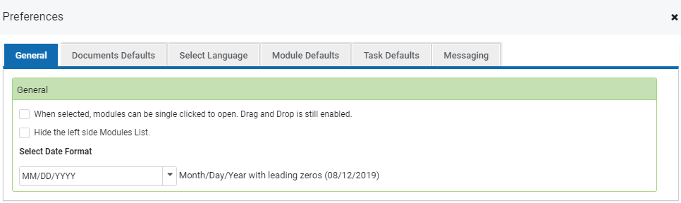

**Document Defaults**

**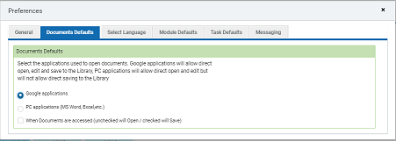**

Document default is used to open or save the document based on the preference document defaults setting. In which the on selecting Google application the documents will allow direct open edit and save to the library. On selecting the PC application it will allow direct open and edit but will not allow to direct saving to the library. The third check box Uncheck will used to open the document based on the user selected application.

**Select Language**

Select the origin language for the Intellimodz that you want to translate.

**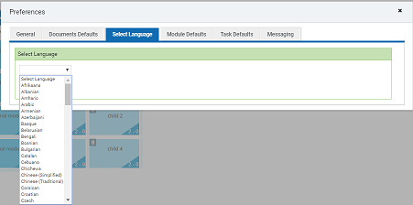**

**Module Defaults**

**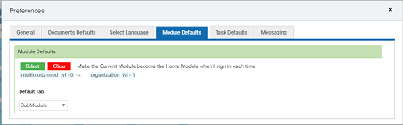**

**Module Defaults**

Click on select button to add the selected module as default module. Next time login the selected module is set as default module

**Default Tab**

Select the default tab option which should redirect to the selected tab at the time of login or by clicking on home button

**Home**

This identifies the module a user will default to when they sign in, it is also a location that can be clicked on at any time to be taken back Home. Home is defined in the Preferences/Module Defaults page

**Task Default**

**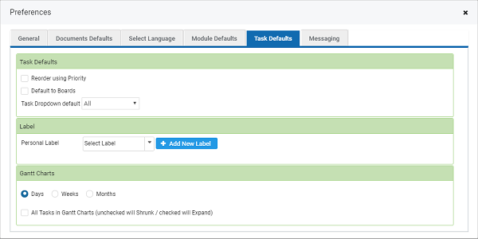**

Display the task list order using priority in workflow/Tasks

Default to boards is used to set Board is the default tab on clicking workflow tab

Task Dropdown default is selected to list the tasks in the selected order

**Label**

**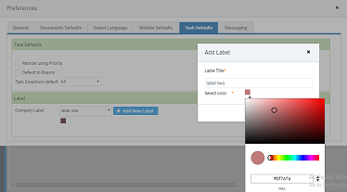**

Label section is to add the company label or choose the default label to show the label across all modules and Tasks.

New label can be added by clicking on “Add New Label” button on which popup screen appears with Label title and color picker. In that add the label text and choose any of the color and click “Save” button to add the labels and the created Label can be viewed in the drop-down.

**Gantt Charts**

Gantt Charts is a horizontal bar chart used in project management as a tool for graphically representing the schedule of a set of specific activities or tasks. The horizontal bars indicate the length of time allocated to each activity, so the x-axis of a Gantt chart is subdivided into equal units of time, as days/weeks/months. This can be set to display the gantt chart based on the radio button selection.

Check-box checked will expand all the tasks and sub task in the Gantt chart and uncheck will shrunk.

**Messaging**

**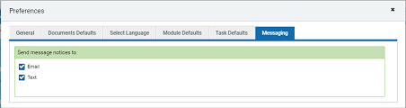**

This UP section is intended to allow the user the ability to decide how they want to receive alerts, either by Email, Text, or Both. This allows them to decide which the best way for them to get notices is.

When the “Text Checkbox” is checked a text will be send when a person is added to a Card.

When the “Email Checkbox” is checked an Email will be send when a person is added to a Card.

## **Bookmarks**

Home is defined by the Home icon on the top left of the popup, this identifies the module a user will default to when they sign in, it is also a location that can be clicked on at any time to be taken back Home. Home is defined in the Preferences/Module Defaults page

The following method may be used to create a **bookmark**. Navigate to the page you'd like to **bookmark,** If user click the add bookmark button the current page is automatically added as bookmark and bookmark page name is display in drop down. User can navigate to the bookmark page by clicking on the drop down, user can also delete the bookmark by using delete icon.

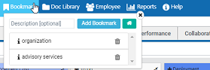

## 

## **Doc Library**

The Documents Library default function is View Documents which allows the user to see a list of all documents added to the model. From this module users can also add documents, delete documents, change versions and view document folders. A search function is provided for quick access to documents when a large number are added.

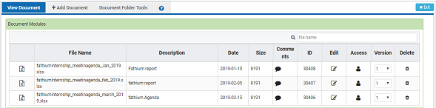

Documents can be dragged in dropped into folders for agile sorting. Click and hold the document icon and drag it with your mouse to the desired folder. The document remains in the Master Documents List and the document will also be included in the appropriate folder.

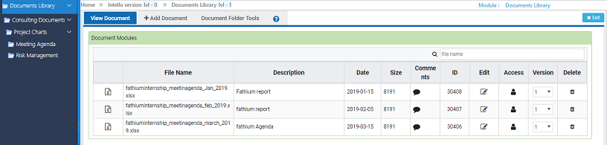

**Document Folder Tools**

**Adding, Renaming, Deleting a Folder**

Navigate to the Folder in document folder tools where you want to create the folder. Right click on the folder the context menu with Add Folder, Rename Folder and Delete Folder option will appear. In that click on “Add folder” option. Popup appears with text box Enter your desired folder name and click add new Folder is created and shown in document folder tools.

For Renaming Folder in context menu select the “Rename folder” option in which popup appears with text box, enter your desired folder name and click save the modified folder name will shown.

For deleting Folder click “Delete Folder” option in context menu the confirmation message shown click yes to delete the selected folder.

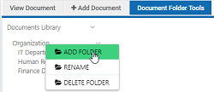

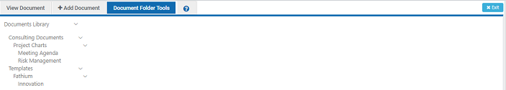

**Add Document**

Click the “Choose File” button to add a document. Once a file is selected the path will appear to the right of the button. After files are selected the user can add a description in the text field at the top and comments (at the bottom) to supplement the upload. A reference to document will be made by selecting the modules from right side module tree list and by Click the “Save” button to add the document and its content to the Documents Library. A reference to the document will be made available in the documents tab for the module in which the document is linked.

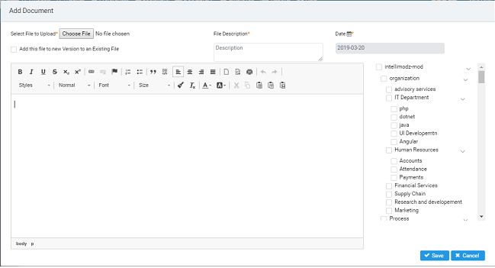

**Versions of Documents**

 Automated versioning capabilities, every document maintain a complete version history which includes all changes made to the content, metadata or workflow state of the document. These versions are created and updated automatically by selecting the version check box at the time of adding document.

**Linking to Modules**

 Document linking to modules is done by selecting the modules list from the choosing Add or Edit Document from document library. Modules tree structure is shown in right-side of the Add/Edit Document popup in that user can Link the document to modules by selecting the checkbox in the modules list and click save button. Reference to the document will be made available in the documents tab for the module in which the document is linked.

## **Employee**

The Employees module provides a list of employees that are currently enrolled in the company. A search function is provided so that employees may be found quickly.

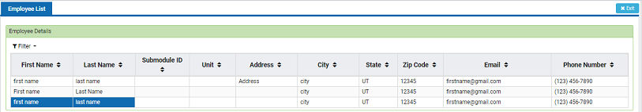

Employee tabs contain information specific to each employee such as positions held, skills, reporting information and other details related to the specific work they do within the company. Employees can use this tab to create linkages to documents and modules they use in their daily activities.

**Employee Information**

Clicking an employee’s name allows users to view the details tab for each employee. All other employee tabs are restricted. The user that is logged in or Manger only can access to their profile.

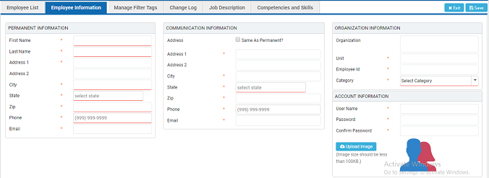

**Reporting**

Employee’s Direct reporting manager information is shown in this tab. Reporting manager can be added using by clicking on “->” button near right side Name text box, popup appears with list of Employee, In that select the reporting person for the employee. Reporting manger will automatically assign for the selected employee.

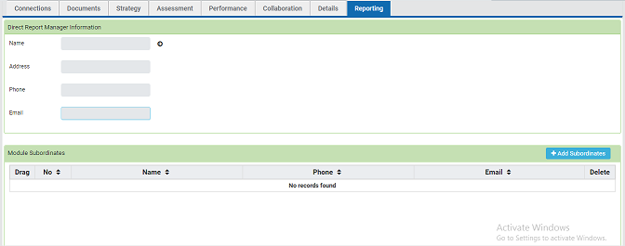

**Job Description**

A simple, organized and brief statement in written form, containing a list of all the essential requirements of the job, along with a summary of duties and responsibilities to be performed by the jobholder is known as Job Description. It is the immediate and the primary output of Job Analysis. In short, it is a statement that captures all the relevant facts related to a specific job. Manager can able to change the competencies and skills for selected employee. Other employee’s are restricted.

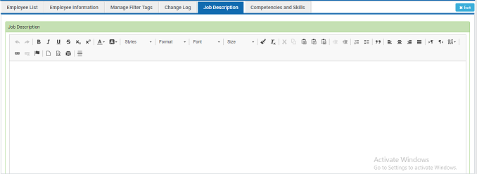

**Competencies and Skills**

A cluster of related abilities, commitments, knowledge, and skills that enable an employee (or an organization) to act effectively in a job. Manager can able to change the competencies and skills for selected employee. Other employee’s are restricted.

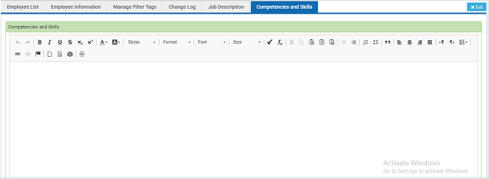

**Strategy**

The strategy tab is designed to capture information about the purpose and future intensions of a specific employee, such as mission, vision, goals and objectives. All employees have this tab, which means goal- related information can be defined for any and all aspects of the employees. This can be changed only by the logged in employee, others restricted. Manager can only able to view.

**Assessment**

The Assessment tab contains any and all information that seeks to evaluate the quality, Improvements, Achievement, and performance of a employee. It provides the organization with the ability to perform analysis on every employee. Manager can have rights to modify. Other employees are restricted to view other employee’s assessment.

**Performance**

A performance metric measures an employee behavior, activities, and performance. It assesses how well employee are doing their respective tasks and how companies are accomplishing their objectives. Manager can have rights to modify. Other employees are restricted to view other employee’s assessment.

**Documents**

The Documents tab shows all documents that are linked or associated with a specific Employee. The Documents tab may be used to show the documents directly tied to logged in Employee.

## **Reports**

Reports are used for monitoring information about the tasks, modules and responsibilities. In this three types of reports are used.

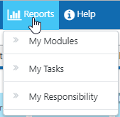

**My Modules**

Modulesmay be used to capture information about the organization structure, business operations, such as process goals, inputs and outputs and their related documents.

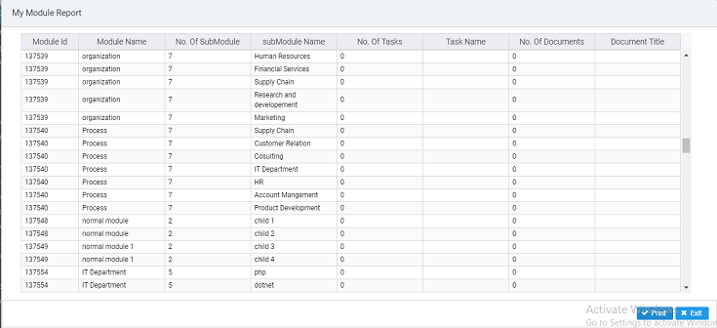

**My Tasks**

The Task Reports view lists for each task the resources assigned to it and the amount of work that each resource has performed. With their sub task and the responsibility user.

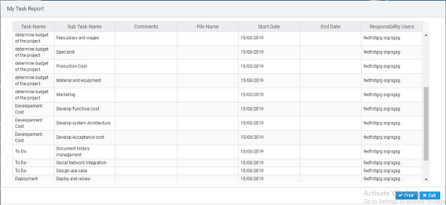

**My Responsibility Report**

The Responsibility Reports view lists for each responsibility user assigned to it and the amount of work that each resource has performed. Such as work, start and finish dates, work allocation, and work availability.

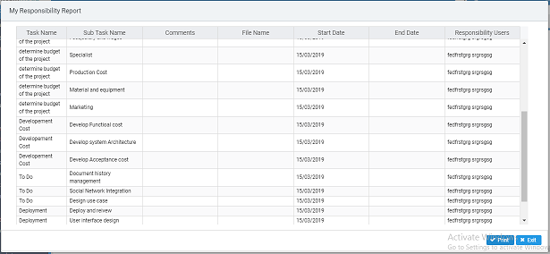

## **Help**

Technical communication document intended to give assistance to User using Intellimodz.

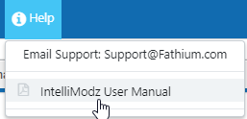

## **Find**

The search field, located in the upper right corner of the User Interface, can be used to search for existing modules (organizations, processes, projects etc.) as well as virtually any aspect of the business (strategies, metrics, SWOT analysis, employees etc.).

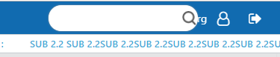

To utilize the search function the user can enter data they wish to find and use the search function. Once the initial search is made the search functions user interface will appear in the main panel.

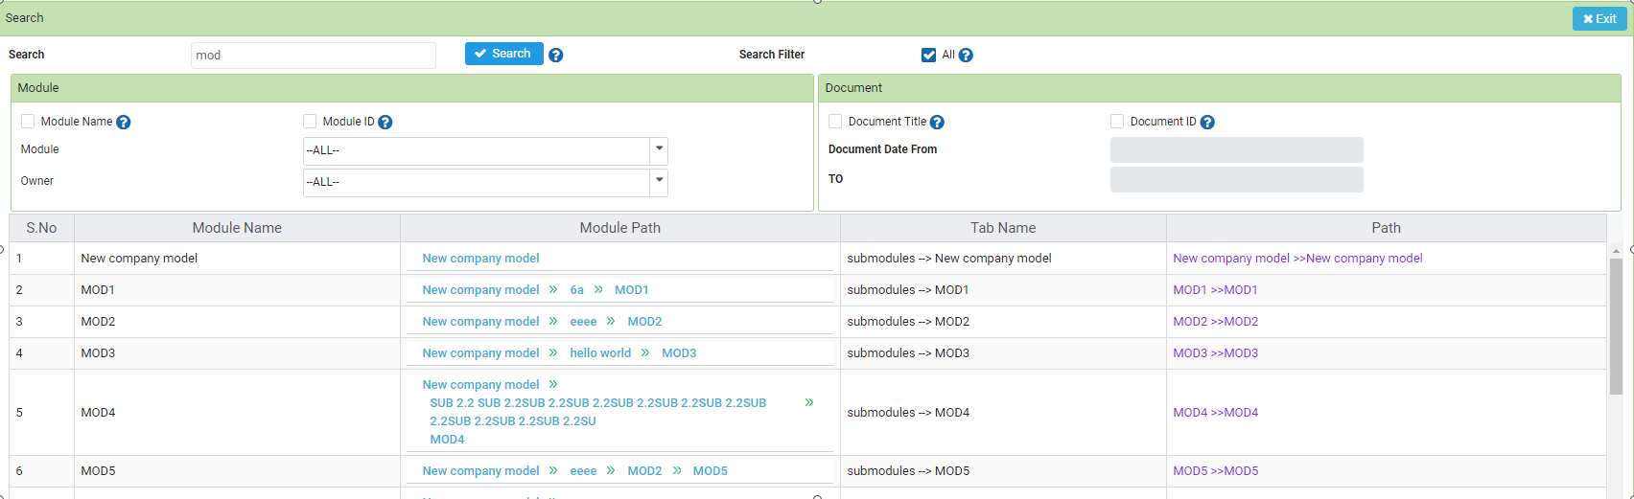

The search function user interface allows the user to define search criteria to narrow the results.

## **Messaging**

**Chat Application**



**Private chat Tab**

You can perform the individual chat with others. All employees will be listed in left side panel and user can select opponent and do private chat.

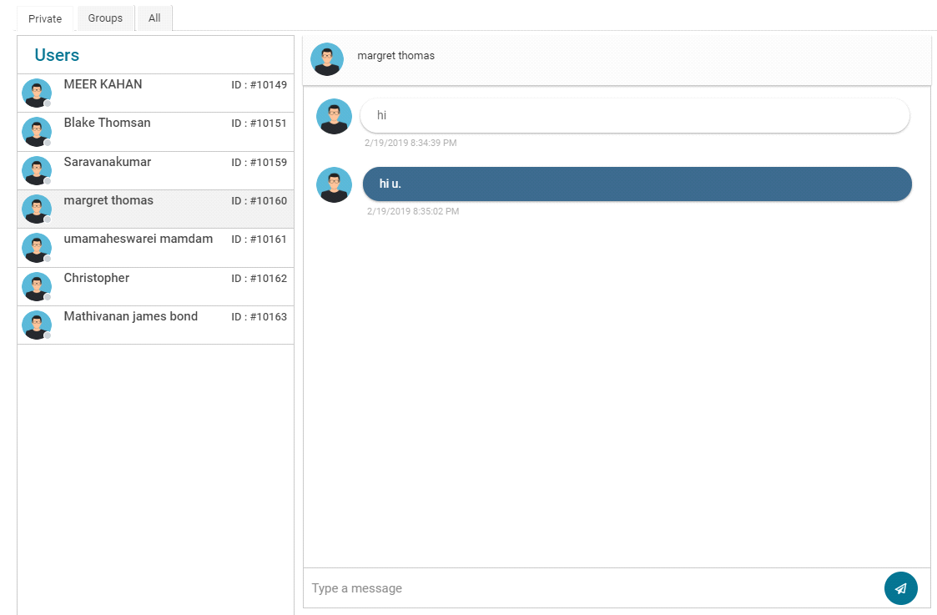

**Group chat**

You can create a group and include the members in this group. All group member can send and receive the messages.

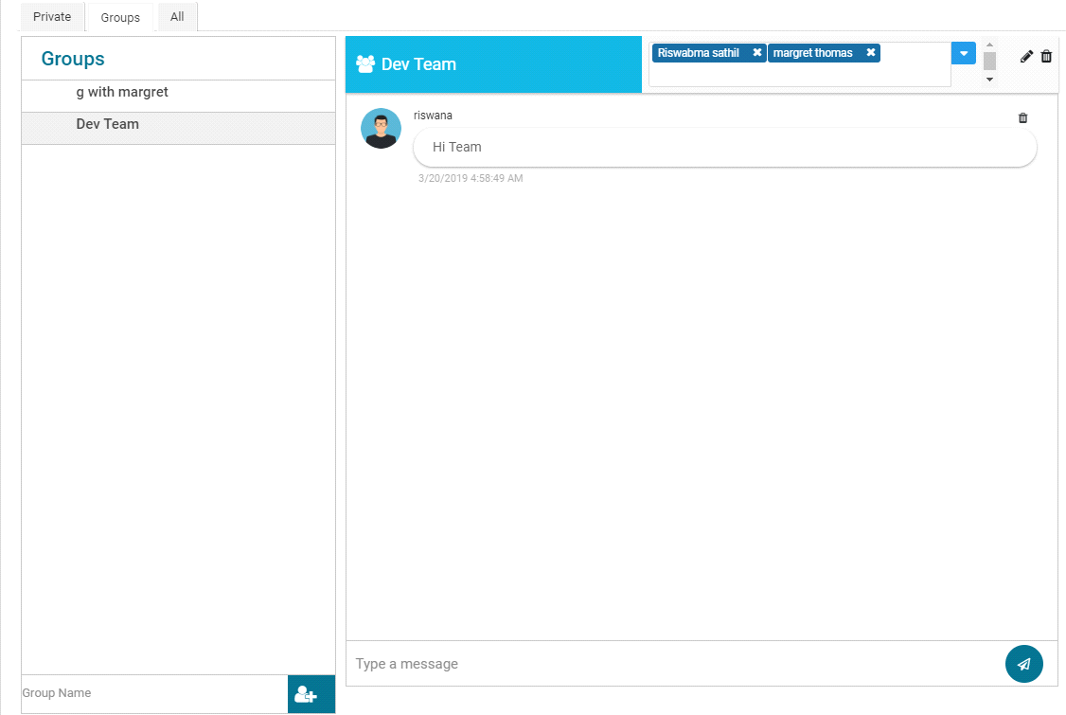

**All chat**

All the tabs against the selected module are listed in left side "message bar" then user can interact with messages and you can switch to other tabs. These messages are available to all users

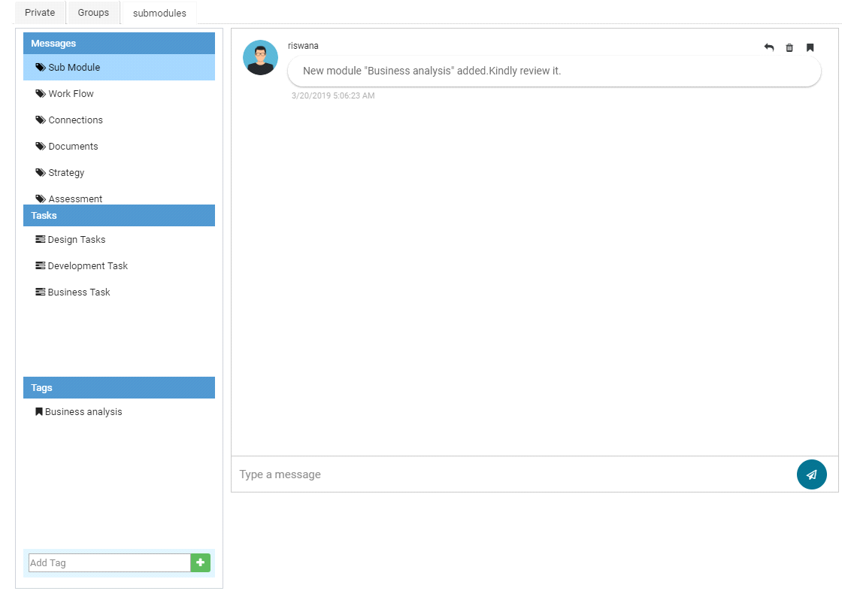

All the tasks against the selected module are listed in left side "Tasks bar" then user can interact with messages and you can switch to other tasks.

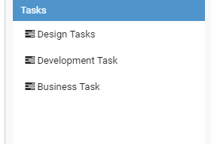

For easy message filter, user can create tags individually and add message to the tags.

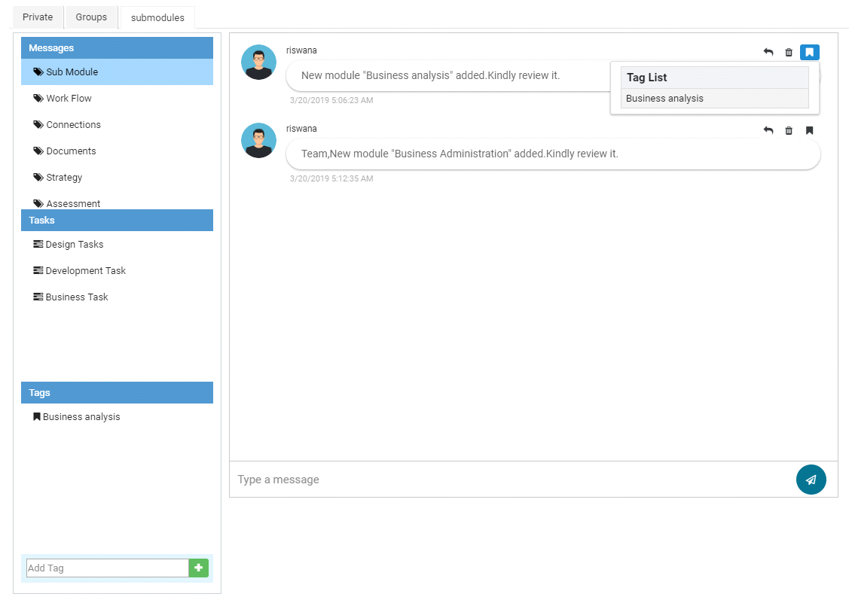

**Reply to message**

User can select a message and can reply to specific message, this will act like a topic discussion.

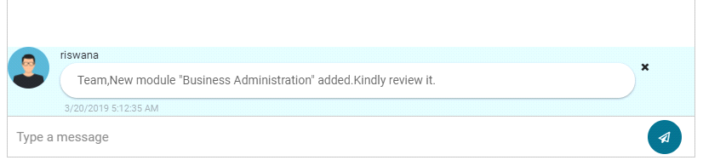

## **Sign Out**

Logging out helps prevent other users from accessing the system without verifying their credentials. It also helps protect the current user's access or prevent unauthorized actions on the current login session and is thus an important part of security. Logging out ensures that user access and user credentials are safe after the login session.

If currently logged in user wish to end the session by clicking on Sign Out button in Top right side corner

C:\Users\Administrator\Desktop\mathi\usermanual_screenshot\logout.png

## **Bread Trail**

Used to navigate to the particular module by Clicking on the module name in the bread trail

## C:\Users\Administrator\Desktop\mathi\usermanual_screenshot\breadtrail.png

## **Module Indicator**

Display the selected module name in top right side from bread trail

## C:\Users\Administrator\Desktop\mathi\usermanual_screenshot\moduleindicaor.png

# General Items

## **Left Side Navigation Bar**

The navigation bar, located on the left side of the Intellimodz User Interface, allows users to quickly navigate between modules or move across module categories.

As you can see from the images above the navigation bar follows a hierarchical structure in which “parent” modules are created at a high level and contain “submodules” or “child” modules. Once a system is created the navigation bar will reflect the structure providing an endless level of transparency.

**Right click to select Icon**

Right click to Select Icon on the modules select icon options appear in that select that option the popup with the icon list shown in that select the icon the and click “save”. All sub-modules icons are changed.

**Add Icon to the Icon Library**

User can add their own icon by adding the icons in the popup list and click save to add the icon in icon Library.

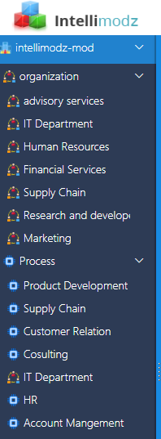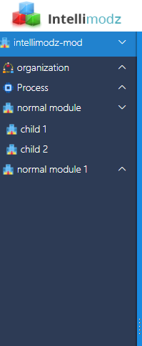

## **Module Bar**

All of the information pertaining to a specific module is organized into tabs for easy access. The tabs of modules are standardized and identical in functionality, though they can be used to hold unique forms of data.

## **Pin**

The simplest way to customize your module is by pinning selected module and creates shortcuts in users PC’s to it through clicking on the “Pin” option in the module bar. A short cut for selected module is created automatically and user can access that particular module by clicking on short cut created in the desktop.

# Tabs

## **Submodules**

The Modules tab shows all of the submodules within a selected module. The modules tab is used as your primary modeling canvas allowing you to convert your business into manageable chunks or modules that can be dragged and dropped to meet your organizations structure.

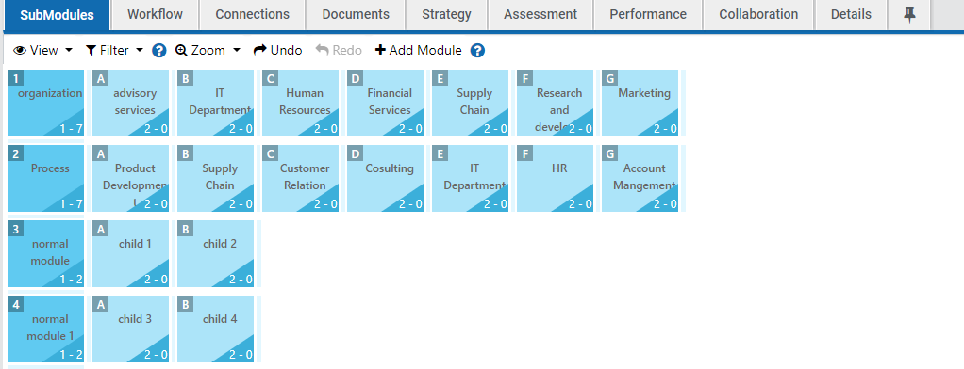

#### Module Tab Features

**Adding Modules**

There are 2 ways this can happen

Click the “Add Module” at the top of the screen, this will add a module at the bottom of the module list where you can name it and move it as desired

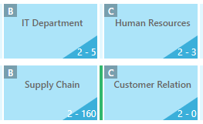Add a module to a specific location:

1. Added Modules by clicking between existing modules.
2. When done correctly, a cursor will appear.
3. Right click the cursor
4. A dropdown menu will appear allowing users to add modules

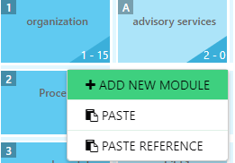

#### Module Features:

To access module features, right click on the module, a menu opens:

1. Open
2. Rename
3. Cut
4. Copy
5. Delete

#### Reference Modules

Reference modules are used when a specific module needs to reside in more than 1 location. A reference module has a doted border to indicate it is a reference module. Reference modules are pointers or references to the Original module, they do not hold their own information, they reference the Original module. For this reason, data in the tabs can’t be change, users must go to the Original module to make any changes and reference modules will reflect all data and changes.

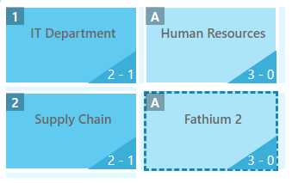A reference module can be created for any module by:

1. Selecting “Copy”
2. Moving to the desired location and clicking between the modules to get the cursor
3. Right click on the cursor and select “Past Reference”
4. A reference module will be pasted into the desired location

#### Moving Modules

Modules can be easily moved or reordered using the process of dragging and dropping the icons. This feature can come in handy when the user desires to order modules based on any type of vertical or horizontal logic, such as ordering process modules using a supply chain perspective (e.g., identify recruiting needs -> advertise position -> select potential candidates -> interview candidate -> hire new employee).

Modules can also be dragged and dropped between levels of the model that are displayed. Parent modules can be dragged into a child position. Child modules can be dragged into a parent position. Parent or child modules can be reordered with ease.

#### Changing Views

The Modules tab provides four fundamental views for the user.

The **Rows** view shows parent modules on the left with child modules on the right, organized horizontally in rows. This view shows two levels of the model in a multi-matrix format.

The **Columns** view places the parent modules along the top and child modules underneath in columns. This view shows two levels of the model in a multi-matrix format.

The **Outline** view is the typical representation of modules in a format based on levels. It looks and operates much like the way electronic files are organized in a folder.

#### Filtering

The Filter feature may be used to show only those modules that have been tagged a certain way. For example, if several modules have been tagged “customer facing,” then the filter feature can be used to display only those module that are tagged. Filtering is a fast and easy way to display what is of interest to a user.

## **Workflow**

The workflow tab is designed to allow users to add workflow to processes. The workflow of a process is comprised of the steps taken to complete the particular process and includes information about who is responsible for each step, comments and reference documents needed to complete the steps.

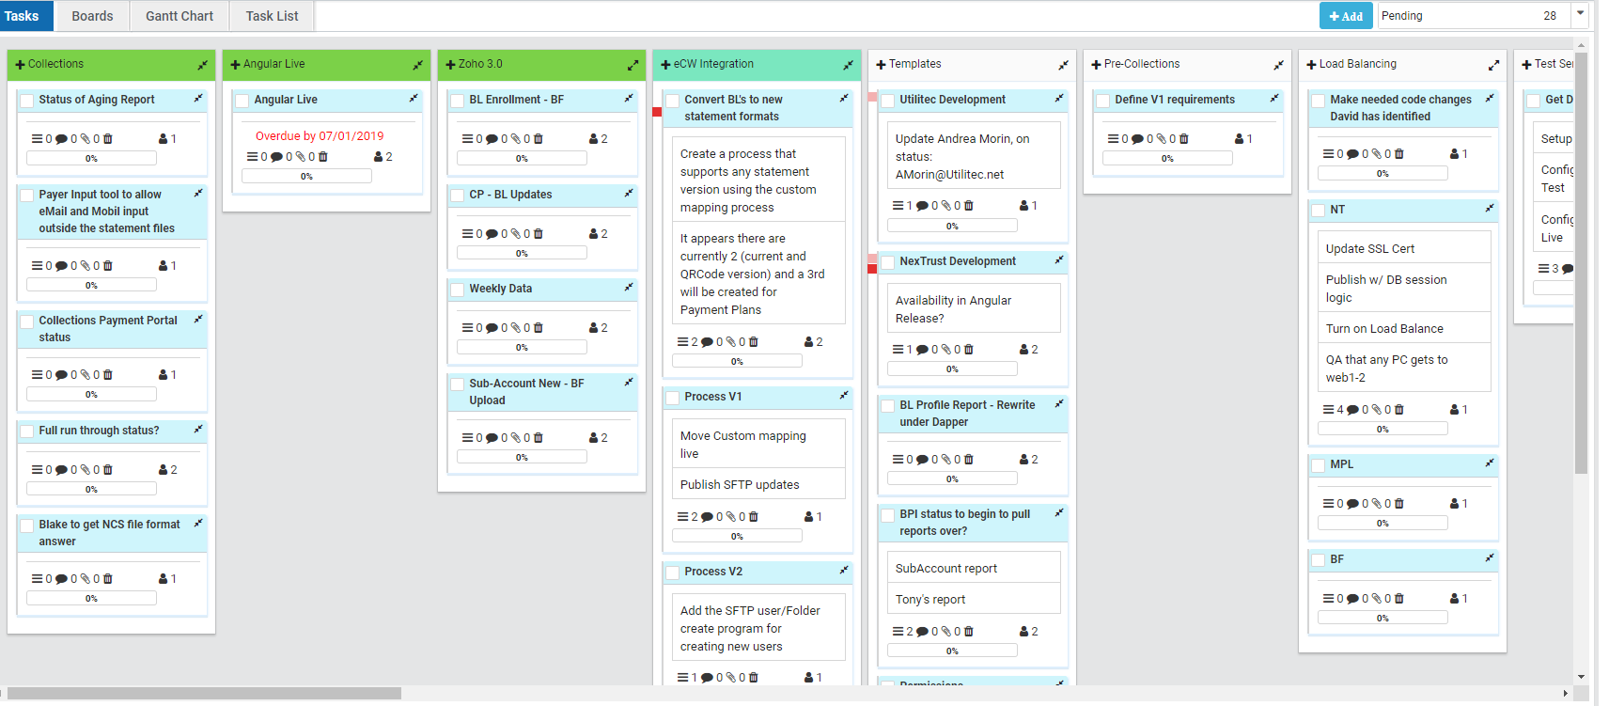

To add workflow steps, responsibility, comments and upload reference documents, click the “Add” button on the left side of the UI. If you want to add references, comments or responsibility to existing steps click the “Edit” button that corresponds to the appropriate step. Once steps are added they can be reordered using the drag and drop feature and clicking save. The screenshot below shows the UI the user would see after clicking the “Add” or “Edit” buttons.

#### Filter Dropdown

By using filter dropdown which is place in top right side in task tab, tasks can be categorized like All tasks,pending,completed,archived and my tasks. Also Count will be displayed.

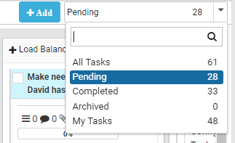

#### Right click options

By right click on task bar various options will be listed like Rename,Delete,Copy,Archive this section, link to Board,Collpase All, Expand All, Auto Completion and Add/Remove Gantt Chart.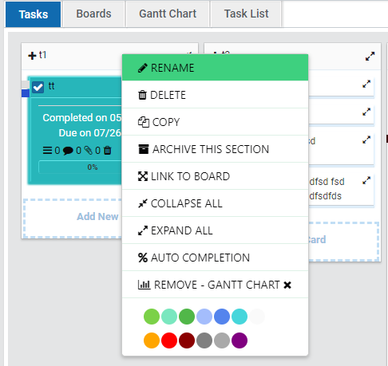

You can rename the task name by click on Rename options, Delete option provide to delete the task.

Copy option provides copy the task to task list and optionally you can link the task to any board.

Once user click on “Archive this section” task will be placed under the archive task category. “Link to board” used to link to the task to board at selected task position. “Collapse All” option used to collapse the task and their cards(Sub-Tasks). “Expand All” option used to Expand the task and their cards (Sub-Tasks).

When “Auto Completion” feature is checked, then the % Complete will automatically adjust using the Beginning date and Due date, application will use the current date to calculate the % of time between the Beginning date and Due date, and this becomes the "Completed" %.

When “Add – Gant Chart” feature is clicked, then this task will be show in Gantt chart feature.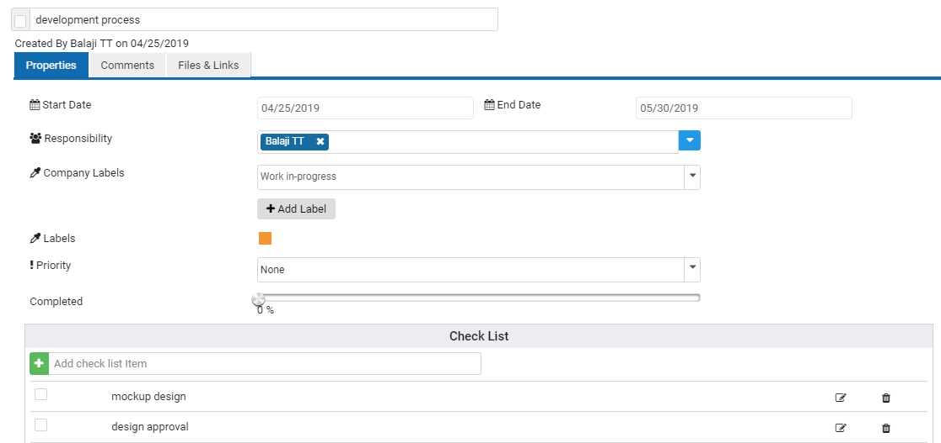

Add known information to the corresponding text field. You can use the edit feature to complete the remaining fields as information is released.

When add the user to card using responsibility dropdown, the corresponding responsible user can able to receive email or text notification or both.

Note: To receive text/email notification, messaging options should be checked which is available in preference setting under messaging tab.

To define a unique label for the card, you can add Label and each label having its own unique color and unique title. You can select one or more of these unique labels for the card.

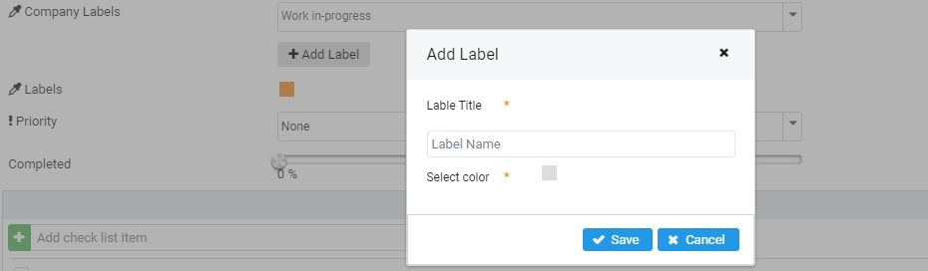

#### Boards

#### Create a board is by clicking on “+ Create new board” button in top right side corner card with text box created enter the name for the board and press enter. Board created successfully

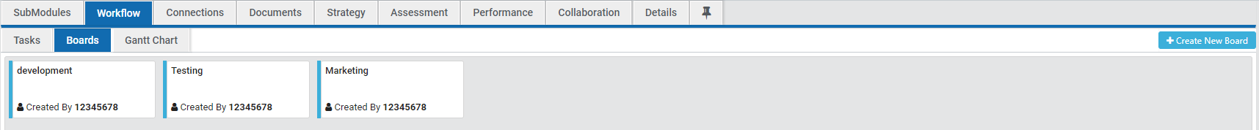

To rename or delete simply right click on the board which you want to change the rename and delete option appears in that choose rename option textbox enabled in that change the name you want. If wish to delete click on delete option the board is automatically removed.

Another option is mouse over to the boards edit and delete icon appears in that click the edit icon to rename or click delete icon to delete the selected board.

In workflow/tasks right click on the task the list of options appears, In that select the “Link to Board” option the popup appears with list of board name in drop down in that select the board name and click Link button to link the task to board. Go to workflow/boards click new tab with board name opens with list of task link to that board.

#### Gantt Chart

Gantt chart provides a graphical illustration of a schedule that helps to plan, coordinate, and track specific tasks in a project.  View the chart based on days, Weeks and Months. Export to pdf option is available for download the Gantt Chart. Collapse All and Expand all is used to shrunk and expand the task list

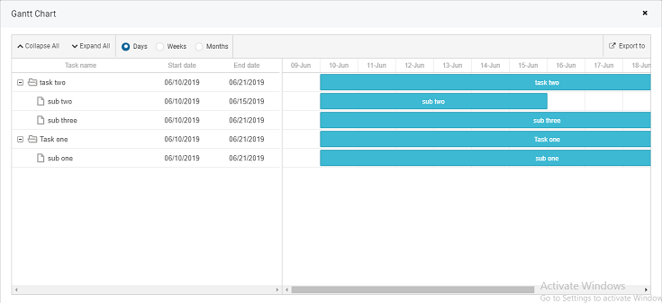

## **Connections**

Connection is graph visualization library include: process diagrams, workflow and BPM visualization, flowcharts, traffic or water flow, database and mapping applications and GIS, UML diagrams, Flow charts and cause-effect relationships and organizational charts.

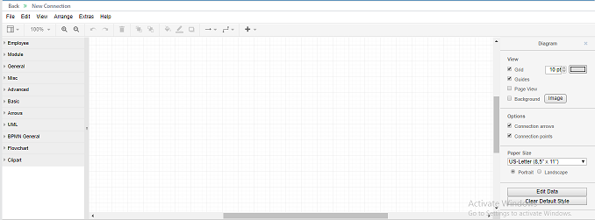

## **Documents**

The Documents tab shows all documents that are linked or associated with a specific module. The Documents tab may be used to show the documents directly tied to a module as well as the documents that are associated with its submodules.

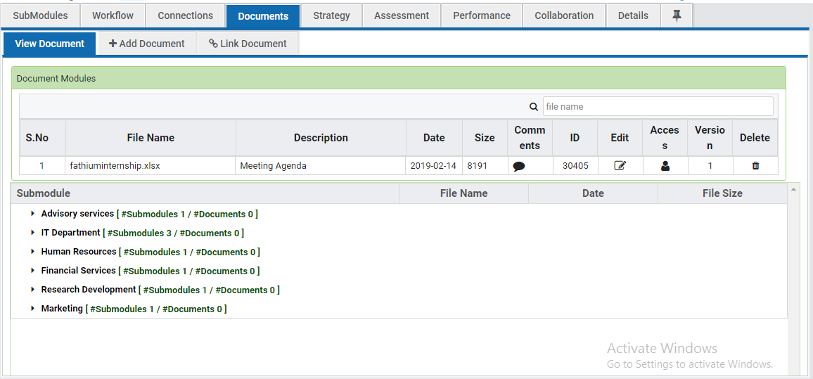

#### Documents Tab Features

#### Add Documents

Click the “Choose File” button to add a document. Once a file is selected the path will appear to the right of the button. After files are selected the user can add a description in the text field at the top and comments (at the bottom) to supplement the upload. Click the “Save” button to add the document and its content to the Documents Library. A reference to the document will be made available in the documents tab for the module in which the document is linked.

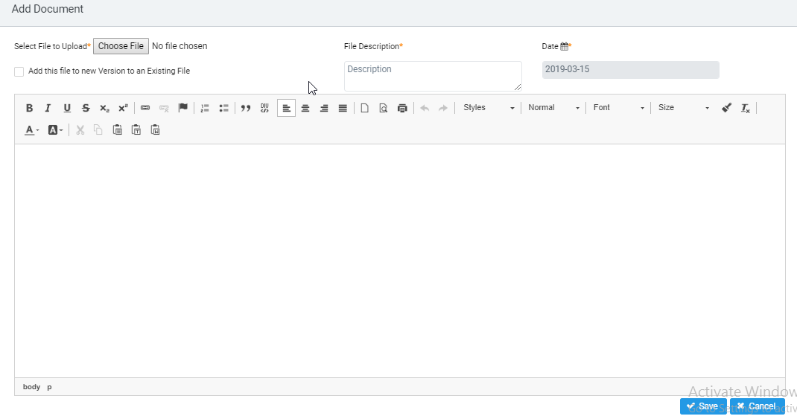

**Link Documents**

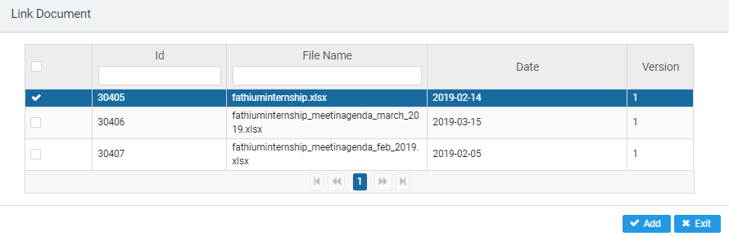

Select the box next to the document(s) you wish to link and click the “Save” button to link the document to the module you are in. The “Search” function can be used to quickly find documents by “Document Name” or “Document ID”.

## 

## **Strategy tab**

The strategy tab is designed to capture information about the purpose and future intensions of a specific module, such as mission, vision, goals and objectives. All modules have this tab, which means goal- related information can be defined for any and all aspects of the enterprise, including projects, process, and organization units.

The default screen, pictured below, for the Strategy Tab is the summary of all strategy-related information.

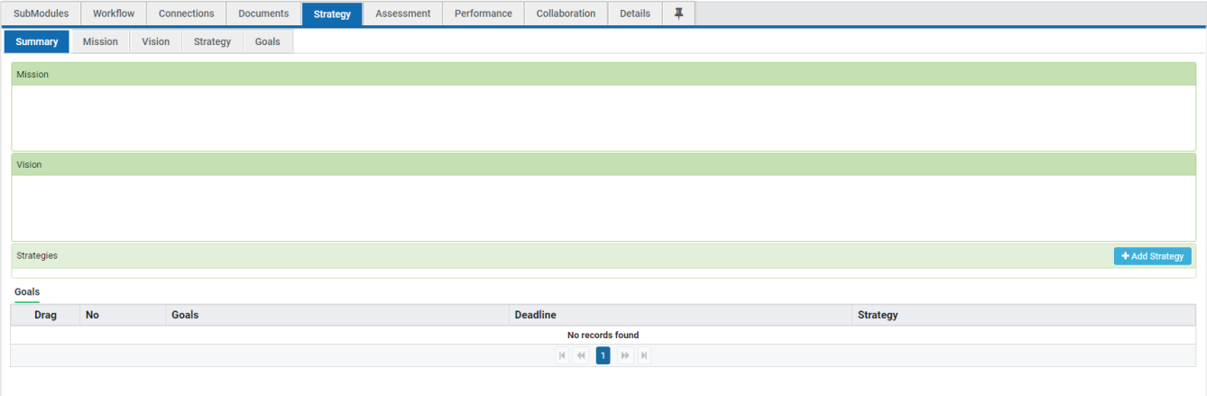

The summary sub tab is read only. To add information click the sub tab appropriate for the information being added. Below is an example of what happens when a user clicks the Mission sub tab to enter an Organization’s Mission.

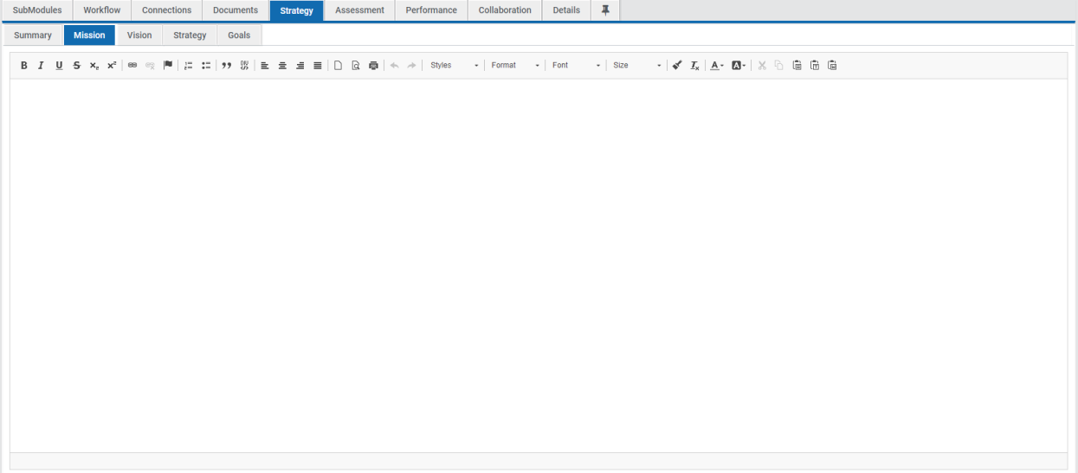

**Strategy Tab Features**

**Mission**

A mission statement is used to clarify purpose and often provides information related to goals, stakeholders, and how the company, organization, process etc. adds value.

**Vision**

A vision is a statement that expresses the future outlook of a company, organization, process etc. and provides information on elements that the subject is striving to obtain. Vision statements are often motivational and informative to employees, stakeholders and future encounters.

#### Strategy

A strategy is a plan of action that is needed to achieve particular goals. Strategy is often involved in many aspects of an enterprise to include their mission and vision as well as their execution of processes and services.

#### Goals

Goals are small elements or objectives used to implement a particular strategy or to reach larger goals. Goals should be to some extent attainable and measurable.

## **Assessment**

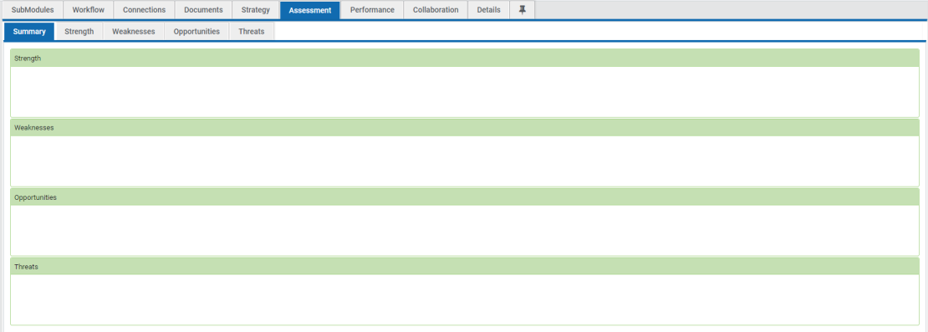The Assessment tab may contain any and all information that seeks to evaluate the quality, nature, and performance of a given module. It provides the user with the ability to perform a SWOT analysis on every module.

The default screen, pictured below, for the Assessment Tab is the summary of all SWOT analysis-related information.

The summary sub tab is read only. To add information click the sub tab appropriate for the information being added. Below is an example of what happens when a user clicks the Opportunities sub tab to enter the Opportunities for a specific organization.

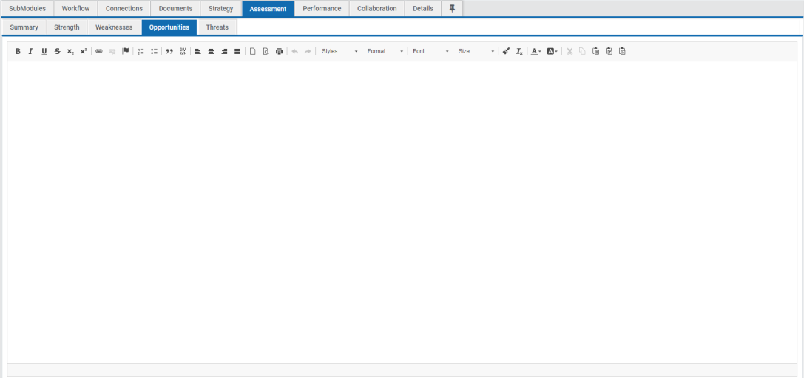

**Assessment Tab Features**

**Strengths**

Strengths are internal characteristics of the enterprise, organization, process etc. that give it an advantage over others.

**Weaknesses**

##### Weaknesses are internal characteristics that place the enterprise, organization, process etc. at a disadvantage relative to others.

**Opportunities**

Opportunities are any external elements that give the enterprise, organization, process etc. a chance to improve performance. Opportunities can relate to revenue, efficiency or any other company defined performance increase.

#### Threats

Threats are any external elements that are a risk to the enterprise, organization, process etc. in terms of performance or any element that hinders the ability to accomplish tasks.

## **Performance**

Intellimodz allows users to establish metrics and performance dashboards for all enterprise

assets. Performance metrics can also be pushed and pulled from module to module or wherever users need to see them.

#### Performance Tab Features

#### Metrics

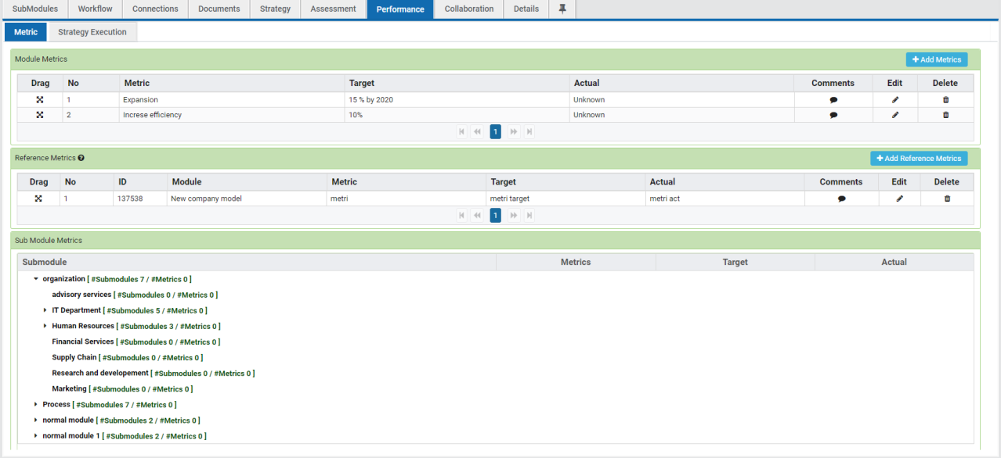

**Module Metrics**

Performance metrics can be added to each module by accessing the performance tab from the module you wish to add metrics to. If the metrics feature is enabled you will see the Module Metrics section at the top of the User Interface. The user can click the “+Add” button on the Module Metrics Bar to add metrics.

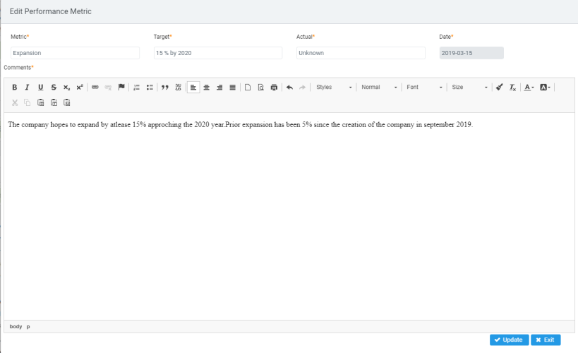

#### Reference Metrics

The reference metrics feature allows the user to add reference metrics to a module that have been previously created in other modules. To add miscellaneous metrics as references in the module click the “+Add Reference” button located on the Reference Metrics bar.

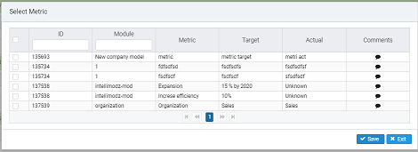

#### Submodule Metrics

The submodule metrics feature provides a hierarchical structure so that the user can reference metrics that have been added to other modules and their submodules. To view submodule metrics click the show button on the submodule metrics bar and expand the areas you wish to view.

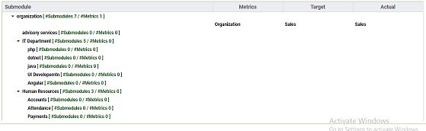

#### Strategy

The Strategy feature allows the user to add comments and status updates about Mission, Vision, Strategy and Goals created in the Strategy Tab.

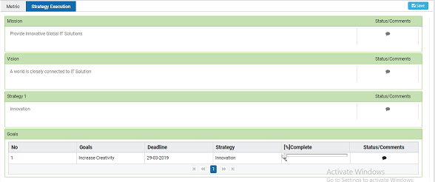

To add comments or status updates click the comment feature on the right of the strategy element you wish to comment on and click the save button located on the tab bar. To add statistics on completion percentage, access the goals tab, enter the completion statistics and click the save button located on the tab bar.

## **Collaboration Tab**

The collaboration tab is designed to allow users to share information in a common workspace. The

Features of the collaboration tab include a notes section, and a method of emailing the module owner.

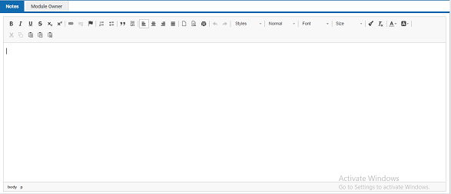

## **Details tab**

The Details tab contains basic background information about a module, such as who owns (or is

Accountable for) the module and summary information about submodules contained within the module. Other features include the ability to manage tags for filtering, the ability to restrict access rights to the module or its tabs, and a reference to what changes have been made recently. Each of these features can be accessed in all types of modules. The details tab differs slightly depending on the type of module (Organization, Process, Employee or Generic). The features below reference the details tab as it appears at the Top Level.

#### Details Tab Features

#### Employee List

List of employee can be added to the selected module by clicking on “Add” button Employee list popup appears in that select the Employees and click save. Saved employee list will display as like the screen below. The user can remove the employee from the list or user can add the employee they want.

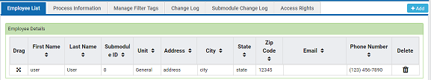

#### Process Information

The Process Information is the default function of the details tab and is intended to allow users to view module details such as Module Name, Module ID and how many employees use a particular module. Module owners are also defined here.

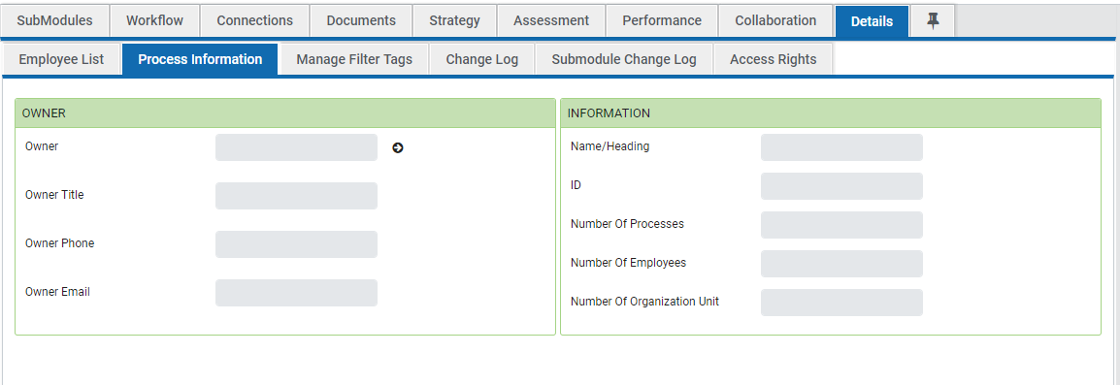

#### Managing Filter Tags

Tags for filtering can be added by clicking the “+Add” button, typing the filter name in the text field, and clicking save. Newly added filter tags will be added to the tag list and do not automatically link to the module you created them in. To link a tag to a module so that it can be filtered you must check the tag in the tag list and click the save button on the Tag bar. Tags are created to be used in the module tab to find modules that meet a specific criteria noted by the tags associated with it.

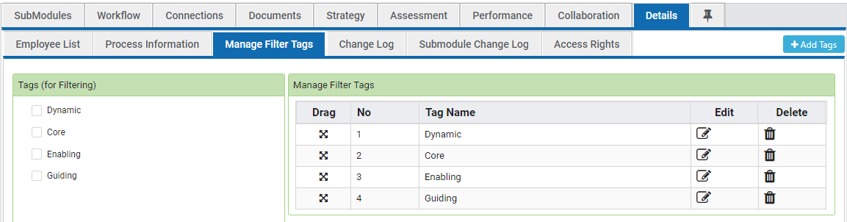

When the “+Add” button is clicked the user will see the following interface.

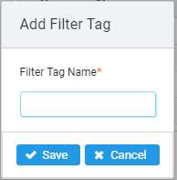

**Change Log**

The Change Log displays recent changes made to the module. The intent of the change log is to notify users what areas have changed, specific information and details are not disclosed here.

**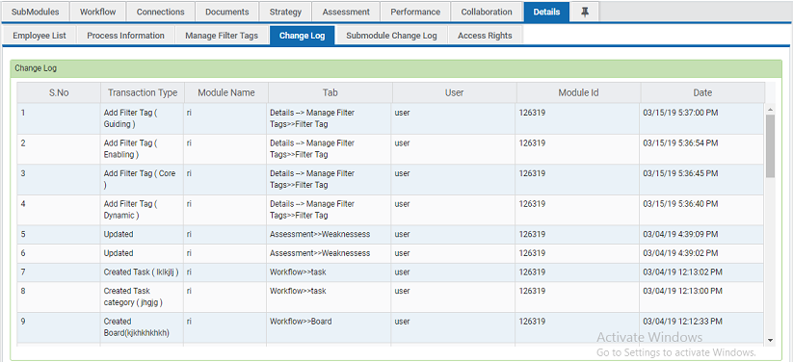**

#### Submodule Change Log

The Submodule Change Log displays recent changes made to the module. The intent of the Submodule change log is to notify users about the module changes like drag drop, newly added module, deleted module. Updated module etc, specific information and details are not disclosed here.

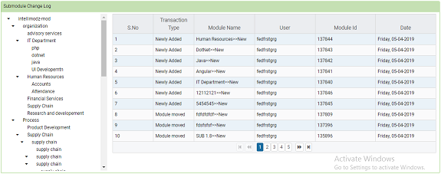

#### Access Rights

Each module comes equipped with its own security settings. From the Top Level enterprise module on down, module owners may decide what can and can’t be viewed and/or edited by other users in the system. The following Access Rights are available.

**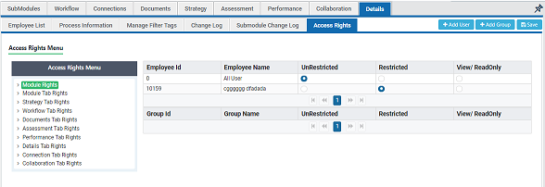**

* **Unrestricted -** Modules given the unrestricted setting allow all users to see and edit its contents.
* **View / Read Only -** This access setting allows designated users to view, but not edit, the content of a module.
* **Restricted -** This setting allows users to see a module in the enterprise model, but not open or view its contents.
* **Add Group –** Once created the groups and users assigned to this group for selected modules in master panel, and then that group can be assigned in multiple tab rights.

For each tab rights, you can assign multiple groups so that corresponding rights will be assigned to the users who assigned to this group. If rights added individually for particular employee even the same employee added in group, the individual rights will be considered to avoid the rights conflict.