**PCB Processing Requirements**

**PCB Requirements:**

* PCB Name : RD_T20_BULL_V1.0
* PCB size : 110mm X 76mm (excluding process edges)
* PCB Layers : 6 Layers Through Hole
* PCB Thickness : 1.6mm+/-10%
* PCB board: FR-4(TG=140)
* PCB Copper Thickness: 1OZ (Requirement to complete copper thickness 1oZ)
* Silkscreen color: white
* Process Requirements : (1) Immersion gold for the whole board (2) **Black soldermask** (3) No logo (4) All holes are fully plugged with soldermask (5) Increase the process edge by 5mm <long edge> and add mark points and locating holes on the process edge.
* Processing cycle : 7 days
* Processing quantity: 20 Pcs
* Stacking structure : Please send back the final stacking structure for confirmation.
* Impedance Requirements:

1. The white highlighted alignment (layer 1) in the figure below is referenced to layer 2 differential 100Ω impedance match (W=5mil).

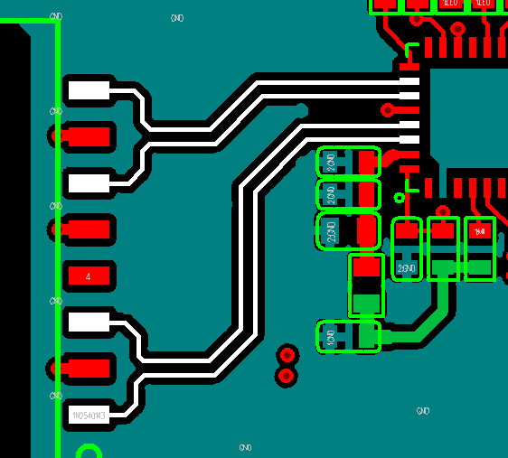

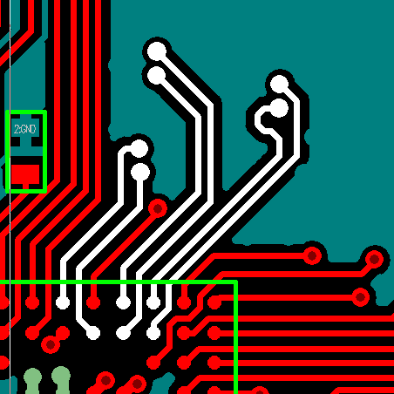

2. White highlighted alignment (layer 1) in the figure below references layer 2 differential 90Ω impedance match (W=5 mil, S=10 mil)

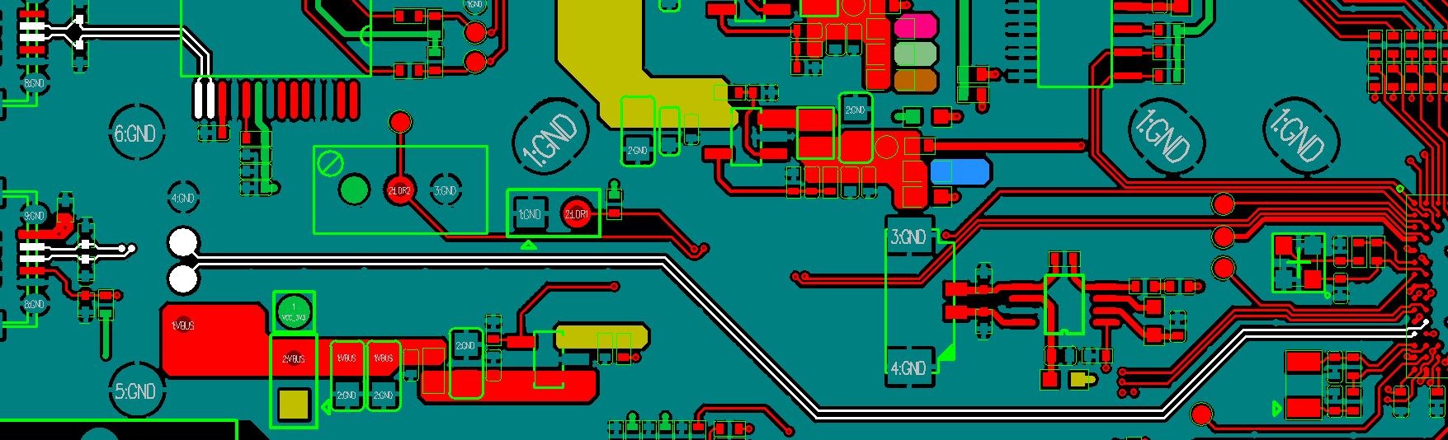

3. The white highlighted alignment (layer 3) in the figure below is referenced to layer 2 and layer 4 differential 100Ω impedance matching (W=5mil, S=10mil).

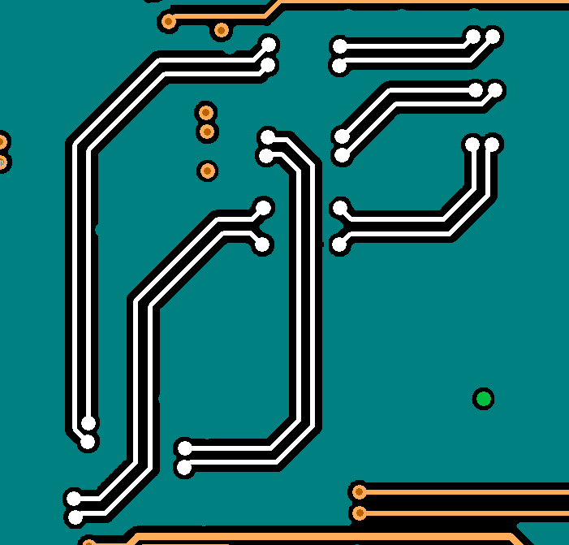

4. The white highlighted alignment (layer 6) in the figure below is referenced to layer 5 differential 90Ω impedance match (W=5mil, S=10mil).

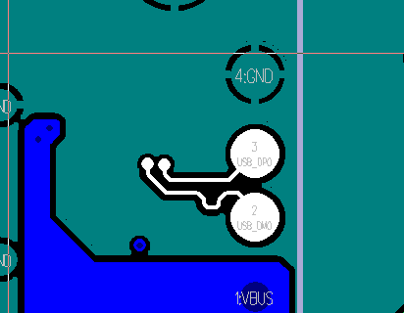

**Tuesday, September 13, 2016**