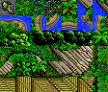
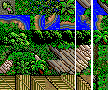
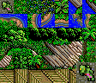
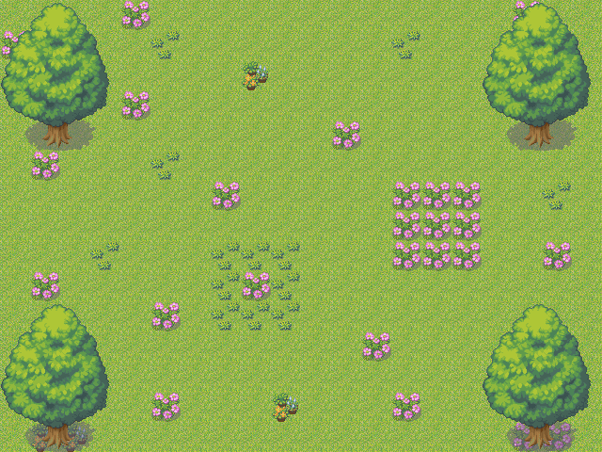
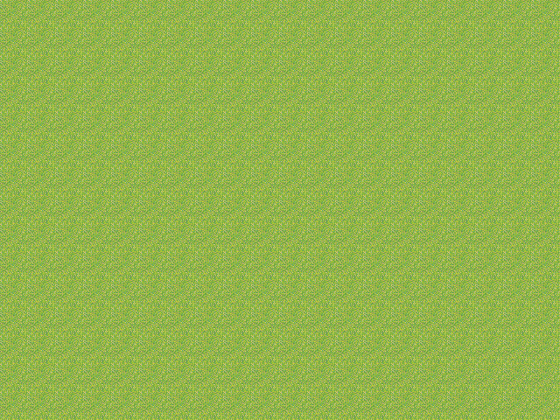
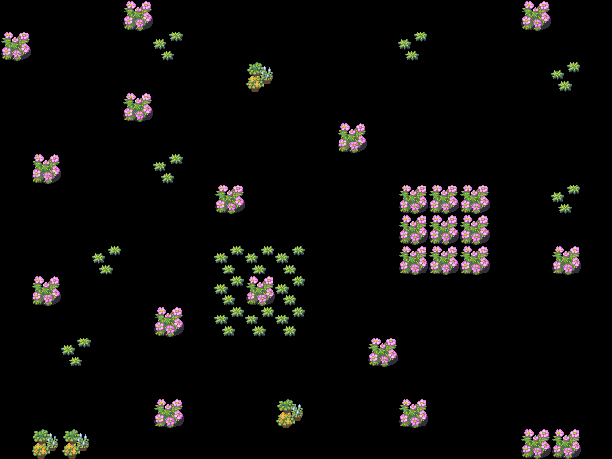
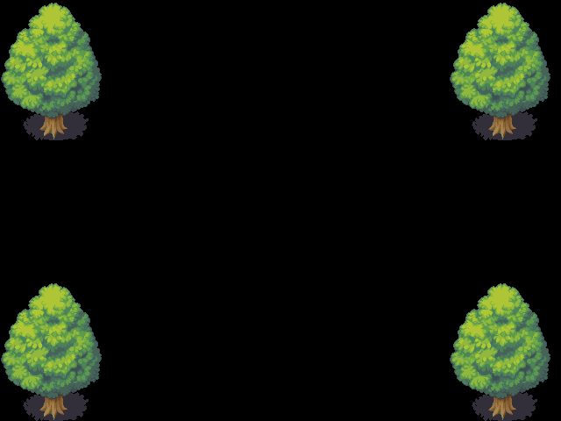
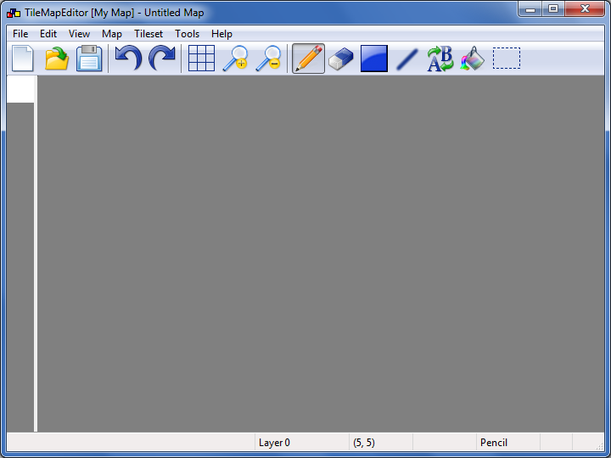
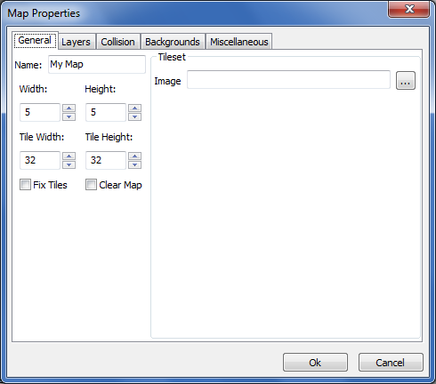
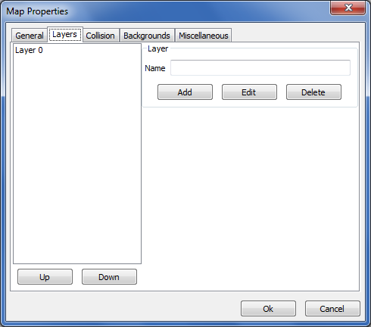
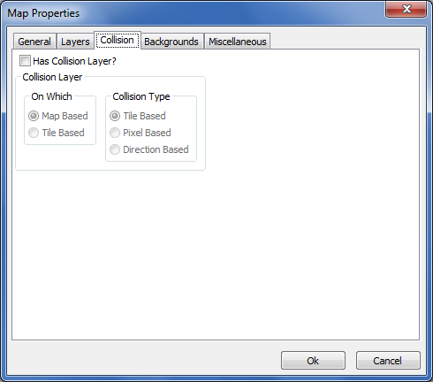
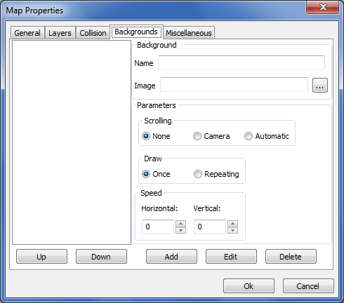

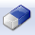



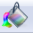
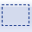

User Manual
Tile Map Editor

Version 1.1
Table of Contents
Introduction 3
System Requirements 3
Features 4
About Tilesets 8
About Maps 8
Program Usage 10
Tools 12
Exporting and Importing 14
FAQ 15
Menu Options 17
Technical Information 19

Introduction

This program is designed to make maps for any purpose. This program allows you to create a map and load a tileset with it. You can then place tiles on the map. The program is designed to be relatively easy to use if you are familiar with other image editing programs, for example, Microsoft Paint. The terms used in the program are similar to other map making programs, such as: Mappy, Tiled, MapEd, and RMXP/VX. The maps made with this program can be used for any purpose, mainly, game making. The export format for this program is its own format specifically designed for this program; however, it can export into other formats as well.

System Requirements
- The program currently only runs on Windows based systems
- About 11mb disk space for the program
  - More disk space for the maps you save.
- At least 64 MB RAM
  - If working with big maps you will need more
- A relatively fast processor (>1 gHz)
- Any graphics card
  - The program is designed to run on any graphics card.

Features

Here is a list of features and planned stuff for the program.
Any feature marked in blue is partially complete any feature marked in red is not implemented

- Map System
  - Ability to load/save maps
  - Ability to export/import maps
    - GBA (Export Only)
    - Text
    - Code (Export Only)
    - XML
    - Image(s) (Export Only)
  - Ability to change map properties ex. width, height, tile dimensions
  - Map types
    - Rectangular
    - Isometric
    - Hexagonal
  - Maps are editable by layer (and may have "infinite" layers)
  - Map backgrounds are editable (and may scroll)
  - Support for animated tiles
  - Support for "auto tiles"
  - Backgrounds can
    - Move
      - Not at all
      - With the camera position.
      - Automatically
    - Draw
      - Once
      - Repeating
  - Support for collision information
    - Types (Where defined)
      - Map Based
        - Collision info is defined per each position on map
      - Tileset Based
        - Collision info is defined per each tile in the tileset
    - Types (How defined)
      - Tile Based
        - Tiles have collision info (-1: passable 0: impassable)
      - Direction Based
        - Tiles have collision info for each direction
      - Pixel Based
        - Tiles have rectangles specifying impassable regions
  - Ability to shift map / layers in different directions.
- GUI System
  - Provides WYSIWYG editor
  - Tools
    - Pencil
    - Eraser
    - Line
    - Rectangle
    - Fill
    - Replace
    - Select
  - Eyedropper - Capture an area of the map and then draw with it.
  - Viewing operators
    - Zoom in/out on map and tileset
    - Layer visibility
    - Grid lines (and size)
    - Dim lower layers
  - File: new, save, save as, export, import, recent
  - Edit: Undo, Redo, Copy, Paste, Select All, Cut, Clear
  - Ability to edit map properties, layer, and backgrounds
  - Ability to playtest map.

- Plugin System
  - Plugins may
    - Add data to maps
    - Add new tools
    - Add new menu options
    - New export/import formats
    - Add rendering code
    - Provide GUI screens
  - Plugin Manager allows user to:
    - Add plugins
    - Update plugins
    - Remove plugins
    - Export plugins
    - Download plugins
    - Enable / Disable plugins
  - Plugins have info:
    - Name
    - Author
    - Description
    - Verified
    - Date
    - Version

About Tilesets

Tilesets are one of the main concepts in TileMapEditor. A tileset is an image that contains all of the tiles you will use for your map. The tiles in the tileset are just portions of a bigger image. All tiles in the tileset need to be the same size and nicely aligned. As an additional requirement if you plan to use layers the background color must be transparent, this can be done with many image editors other than MS Paint.

For example:

This tileset is a good one. All tiles are the same size (16x16 pixels) and they are aligned on 16 pixels

The following tileset is a bad one. The tiles are all the same size however the last two columns of tiles are not aligned properly

This tileset is also a bad one. The tiles are not all the same size. The tile in the lower right hand corner is 24x24 not 16x16

About Maps

Maps are another very important concept when learning how to use the program. A map for the purposes of this program can be defined as a list of layers and backgrounds with a tileset associated with it. A layer has a two dimensional area of tile id’s which specify which tile to draw at that location. And a background has a background image associated with it with parameters on how it is drawn to the screen. Here is an example of a map that has 3 layers. (Note, the black on layers 1 and 2 are transparent)

The complete map.

The tiles on layer 0 The tiles on layer 1
The tiles on layer 2
Maps also have properties associated with them such as a width and height that control the map dimensions, a tile width and tile height that control the size of the tiles from the tileset, and a name.

Program Usage

When the program is started you will be presented with our GUI interface
The left pane displays a tileset in its default settings, one 32x32 white tile. The right pane displays the map, which defaults to being empty.

A standard menu is also available. For a reference of the menu, please see page 14.

A common task you would want to do first is load a tileset into the program. This may be done by going into the tileset menu and selecting “Change…”. A dialog box will pop up asking you for the tileset image. When a proper image is selected the program will create the tiles from the tileset and update the tileset pane.

Once a tileset is loaded you may select tiles from the tileset and place them on the map. Just like in paint the program comes with a number of Tools (see section on Tools) which perform operations on the map based on the tiles you select.

If your map has multiple layers and you want to switch between which layer you are currently editing then under the map menu select Layers and then the layer with the name you want to be the current layer.

Another task that is commonly done is changing the map properties such as width, height, and the tile dimensions. This can be done by Selecting Map in the menu and in the submenu choose Properties… This brings up the dialog below

In this dialog you can set many properties about the map, such as: the name the width and height, the tile width and height, and the tileset image the map uses. The fix tiles option shown is only useful if you are switching tilesets where the tiles are of a different size or are changing the tile size. The option will ensure that the correct tiles are chosen when you switch tilesets or change the tile dimensions.

In this screen you can add new layers to the map. The topmost layer is the one that is drawn on the bottom (drawn first). Note that layers can’t have the same name.

In this screen you can create or delete a special type of layer called a collision layer. What a collision layer does is that it tells which tiles are passable by the player. Currently, as of version 1.0, map based Collision Layers with collision info per tile (Map based/Tile based) are supported.

In this screen you can modify the map’s backgrounds much like the layers menu the background on top of the list is the one that is drawn first. You may edit a backgrounds image and name and its parameters such as how it scrolls and how it is drawn. You may also change the speed of how the background scrolls.

Scrolling:
- None: Background does not scroll at all.
- Camera: Scrolling depends on your position in the map, and the speed
- Automatic: Background automatically scrolls based on speed.

Draw:
- Once: The background is only drawn once.
- Repeating: The background is drawn so that it fills the screen.

Tools

The tools provided are the main means of performing operations on the map, just like Microsoft paint where you have a paint brush and a palette of colors. You have tools you can use and a collection of tiles to use. With these tools you can perform operations with a single tile, a rectangular area of tiles gathered by clicking and dragging in the tileset, or you may right click anywhere on the map and form a selection of tiles. Here is a brief overview of all of the tools.

The pencil tool just sets the current tile selection on the current layer.

The eraser tool erases tiles that have been set on the current layer.

The rectangle tool sets a rectangular portion of tiles to the current tile.

The line tool sets a line of tiles on the current layer.

The replace tool allows you to replace one tile with another on the current layer.

The flood fill tool allows you to fill an area on the current layer with tiles.

The select tool allows you to select an area of tiles and move them.

Exporting and Importing

When you are done with your map it is necessary to save it for later editing, use with another program, or a game you are making that uses maps. TileMapEditor allows you to save your map in multiple formats. The export options can be found under the File menu under the submenu Export. Each format is explained in below. For a more detailed explanation of the formats see the Technical Information section.

- Text
  - All of the properties of the map, layer, collision layer, and background are exported to a text file.
- XML
  - The map’s information is saved to an xml file which better explains the data in the file.
- Image
  - A snapshot of the map (without the backgrounds) is saved to an image file.
- Layers as Images
  - Each of the map’s layers is saved as an image.
- Map as Image (GBA)
  - The map is saved as a .c file in Game boy Advance format in Mode0, Mode3, Mode4, or Mode5 format.

It may be necessary to import a map from another format; however, TileMapEditor only supports as of version 1.0 importing from a text file and xml file.

FAQ

Q) Why when I load a tileset it goes back to the default?
A) This means that the image could not be loaded. This can happen in one of many ways
1) Your image is an 8bit image (an image with 256 colors). This can be fixed by converting your image into RGB format with an image editor other than paint
2) Your image is too large. The biggest tileset you can load is dependent upon your graphics card.
3) Image was not found.

Q) Why do some of the tiles in my map disappear when I change the tilesize / tileset when I have my map almost done?
A) This is because if you are on a small tilesize say 16x16 and then you switch to 32x32
you now have fewer tiles to work if you have a tile in the map that uses a tile that is now gone it will disappear as it is an invalid tile. A fix for this is in the Map Properties Dialog make sure there is a check next to Fix Tiles this way it will account for tiles disappearing.

Q) The program runs too slow is there any fix for that?
A) Yes. If you go into the File > Properties menu
In the Spin Control for Update Speed you can change this value to something lower to slow down the frame rate. Likewise if it is too sluggish you can increase the value (I do not recommend setting it above 60). On the default value (30) the program only takes up 2-5% of my CPU (I am running a 2 gHz dual core processor).

Q) I get an assertion failed error / the program just randomly closed?
A) Oops I probably did something careless! If you can, please try to duplicate the error and notify me in a nice manner!

- All bug reports are greatly appreciated! :)

Menu Options

- File
  - New – Creates a new map
  - Open – Opens a saved map
  - Save – Saves map as a .map
  - Save As – Saves map as a .map file (Always brings up Save Dialog)
  - Import – Imports a map from one of the various formats (see pg 12)
  - Export – Exports a map to one of the various formats (see pg 12)
  - Recent – Open recently modified maps.
  - Properties – Modifies application properties.
  - Quit – Quits the program
- Edit
  - Undo – Undoes last action
  - Redo – Redoes last action
  - Cut – Cuts the current selection
  - Copy – Copies the current selection
  - Paste – Pastes the current selection
  - Clear Selection – Clears the current selection
  - Select All – Selects all of the current layer
  - Select None – Cancels the current selection
- View
  - Grid – Toggles displaying a grid.
  - Grid Size – Changes the grid size in tiles
  - Backgrounds – Toggles a backgrounds visibility
  - Layers – Toggles a layers visibility
  - Dim Lower Layers – Any layer below the current layer will be dimmed.
  - Playtest – Plays the map in the MapWalker application.
  - Zoom – Zooming options (In, Normal, Out, Custom, Tileset…)
- Map
  - Properties – Modify map properties (layers, backgrounds, collision layer)
  - Clear - Clears the entire map
  - Shift – Shifts the entire map or a layer.
  - Layers – Changes the current layer you are editing
- Tileset
  - Change – Changes the current tileset
- Tools (see pg 11)
- Help
  - Help – Shows this document which you are reading now.
  - About – Shows information about this application.

Technical Information

For each of the file format examples are the same map just in a different format representation.

A Map with width 1, height 1, and tile dimensions 32x32. Its name is HELLO and it uses image.png as its tileset. It has 1 layer and 1 background. Its layer name is named A and the only data for this layer is 50. The backgrounds name is named B and uses the background image stored in background.png. Its mode is 6 which equates to AUTOSCROLL | REPEATING. Its speed is the vector <2.0 4.0>. There is also a Collision Layer with collision type MapBased / TileBased. The only data here is 0 which means the only tile in the map is not passable.
Binary Map File Format (Version 1.x and up)

This map file format is designed to be more portable across systems and be much more extensible than the previous version of this format. This format now using a chunk or block based format for easily adding new data to the format and still maintaining readability for other programs. To solve the problem of portability across many different machines the values stored in the .map file are always a 32 bit integer unless otherwise specified. The integers are also always written in big endian (network order) to solve the problem of endianness.

The file format follows the format
chunkname chunksize chunkdata

where chunkname is a 4 character string (not zero terminated) that tells the name of the chunk, chunksize is an int telling the size of the data that follows it, and chunkdata is the data of the chunk.

Here are all of the chunks as of Version 1.0 if a chunk is not documented then this means these features are not implemented yet.

The HEAD and MAPP chunks are always the first two chunks in the .map file otherwise it would be hard to read the others.

HEAD – Header chunk has the file formats version and the magic number
byte major
byte minor
byte[14] magic = 54 52 49 43 4b 53 54 45 52 47 55 59 38 37
MAPP – Map properties chunk has information about the map
int width
int height
int tilewidth
int tileheight
int numlayers
int numbackgrounds
int mapnamesize
string mapname
int filenamesize
string filename
LYRS – This chunk contains all of the rectangular layer information
int layer0namesize
string layer0name
int[width*height] layer0data
int layerNnamesize
string layerNname
int[width*height] layerNdata

BGDS – This chunk contains all of the background information
int background0namesize
string background0name
int background0filenamesize
string background0filename
int background0mode
float background0speedx
float background0speedy
int backgroundNnamesize
string backgroundNname
int backgroundNfilenamesize
string backgroundNfilename
int backgroundNmode
float backgroundNspeedx
float backgroundNspeedy
MTCL – Map based tile based collision layer info
int[width*height] collisionlayerdata
MDCL – Map based direction based collision layer info
int[width*height] collisionlayerdata
MPCL – Map based pixel based collision layer info
int numcollisionrects
int collisionrect0x
int collisionrect0y
int collisionrect0width
int collisionrect0height
int collisionrectNx
int collisionrectNy
int collisionrectNwidth
int collisionrectNheight
TTCI – Tileset based tile based collision layer info
TDCI – Tileset based direction based collision layer info
TPCI – Tileset based pixel based collision layer info
ANIM – Animated tiles information
int numanimations
int anim0namesize
string anim0name
int anim0delay
int anim0type
int anim0times
int anim0numframes
int[anim0numframes] anim0frames
int animNnamesize
string animNname
int animNdelay
int animNtype
int animNtimes
int animNnumframes
int[animNnumframes] animNframes
EOM00 – End of Map Chunk must appear last has a size of 0. (note chunk name is 454f4d00 EOM)

Example Binary Map File Format (Version 1.x and up)

HEAD000000100100545249434b535445524755593837MAPP0000003000000001000000010000001000000010000000010000000100000006HELLO000000000aimage.png00LYRS0000000a00000002A0000000032BGDS0000002500000002B000000000fbackground.png00000000062.04.0MTCL0000000400000000EOM0000000000

Binary Map File Format (Version 0.x)

<tilewidth><tileheight><width><height><numlayers><numbackgrounds><mapnamesize><mapname><filenamesize><filename>

<layer0namesize><layer0name><layer0data>
<layer1namesize><layer1name><layer1data>
<layerNnamesize><layerNname><layerNdata>

<background0namesize><background0name><background0filenamesize><background0filename><background0mode><background0speedx><background0speedy>
<background1namesize><background1name><background1filenamesize><background1filename><background1mode><background1speedx><background1speedy>
<backgroundNnamesize><backgroundNname><backgroundNfilenamesize><backgroundNfilename><backgroundNmode><backgroundNspeedx><backgroundNspeedy>

<collisionlayertype><collisionlayerdata>

where everything that sounds like it would be represented with a number is an int (4 bytes)
Exceptions are <backgroundNspeedx> and <backgroundNspeedy> which are floats (4 bytes)
<layerNdata> is an array of ints (4 bytes) which there are width * height of them.
anything else is a character array (ex filename's and names) which the size of the string being the int before it.

Example Binary Map File Format (Version 0.x)

Note: to make it as readable as possible the actual data is here as numbers so for instance the first 001 would be actually stored as 001 000 000 000 on normal 32 bit computer little endian style.
032032001001001001006HELLO000010image.png000002A000050002B000015background.png0000062.04.0000000

Text Map File Format

Properties
<mapwidth> <mapheight>
<tilewidth> <tileheight>
<mapname>
<filename>

Layers
<Layer0Name>
<Layer0Data>

<Layer1Name>
<Layer1Data>

<LayerNName>
<LayerNData>

Backgrounds
<Background0Name>
<Background0Filename>
<Background0Mode>
<Background0SpeedX> <Background0SpeedY>

<Background1Name>
<Background1Filename>
<Background1Mode>
<Background1SpeedX> <Background1SpeedY>

<BackgroundNName>
<BackgroundNFilename>
<BackgroundNMode>
<BackgroundNSpeedX> <BackgroundNSpeedY>

Collision
<CollisionLayerType>
<CollisionLayerData>

Example Text Format

Properties
1 1
32 32
HELLO
image.png

Layers
A
50

Backgrounds
B
background.png
6
2.0 4.0

Collision
0
0

XML File Format

The tags in this example XML document are fairly self explanatory.

XML File Format Example

<?xml version=1.0?>
<Map>
<Properties>
<Dimensions>
<Width>1</Width>
<Height>1</Height>
</Dimensions>
<TileDimensions>
<Width>32</Width>
<Height>32</Height>
</TileDimensions>
<Name>HELLO</Name>
<Filename>image.png</Filename>
</Properties>
<Layer>
<Name>A</Name>
<Data>50</Data>
</Layer>
<Background>
<Name>B</Name>
<Filename>background.png</Filename>
<Mode>6</Mode>
<SpeedX>2.0</SpeedX>
<SpeedY>4.0</SpeedY>
</Background>
<Collision>
<Type>0</Type>
<Data>0</Data>
</Collision>
</Map>

