**WEATHER API – AWS LAMBDA**

AWS Lambda is a serverless computing service provided by Amazon to reduce the configuration of servers, OS.

AWS Lambda lets you run code without provisioning or managing servers—it scales automatically and only charges for the time your code is running

**Where to Use**:

When you want to expose a web endpoint, a stream processor, or a task to cloud depending on server or OS.

**Coding approach:**

**Here instead of exposing endpoint via controller we are exposing the endpoints via Spring cloud function.**

* For that We have defined two Functional method in our class where one is used to insert zip code details for country in dynamo db and the next one is to fetch the details of temperature from dynamo db.

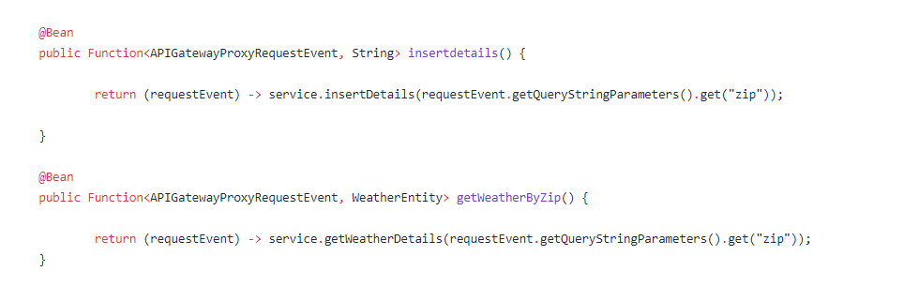

This is same as where we followed the controller approach for normal server deployment (Ec2, EBS etc.)

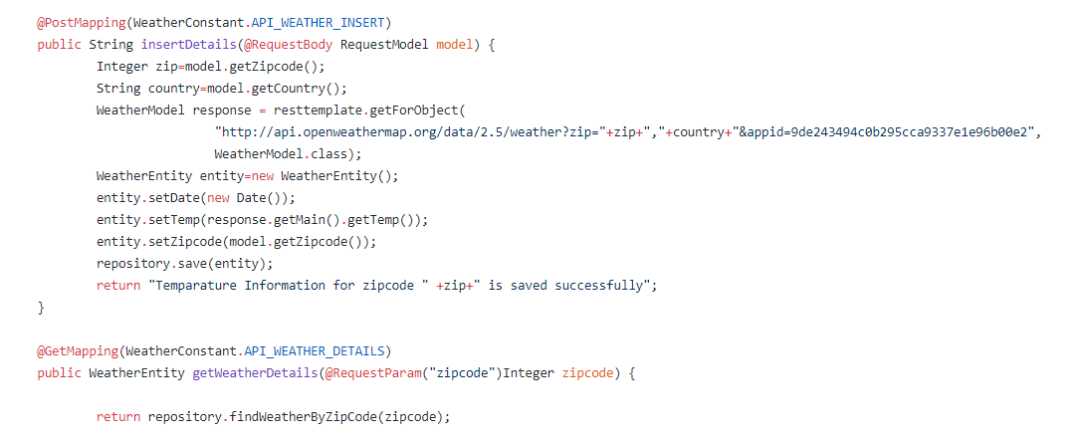

* The second step is we need to create two Handler for these two requests. This is required when we need to define trigger in aws. There we need to mention this handler information so that when the trigger is encounter (either HTTP/REST service), this function will call.

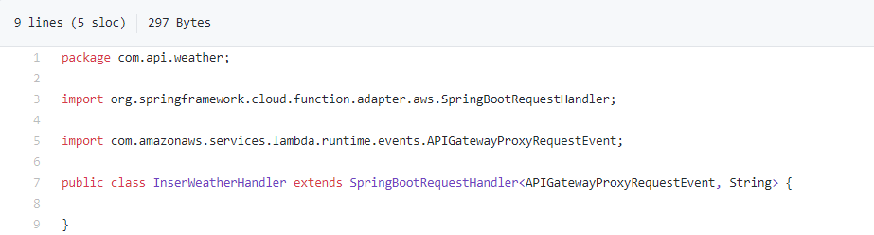

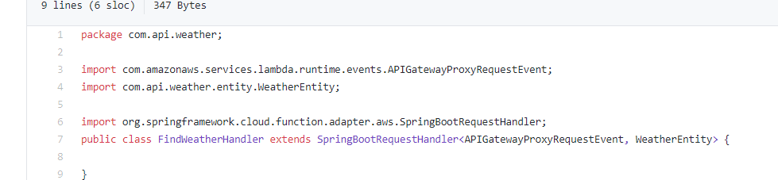

The API Gateway Proxy Request Event is the event that is triggered from the aws end to call this function.

This event will have all the necessary details such as query parameters, path parameters etc.

For example, if any HTTP trigger is defined for this in aws with the endpoint like this <http://aws-portal/weather?zipcode=54321>

Then it will be handled like below:

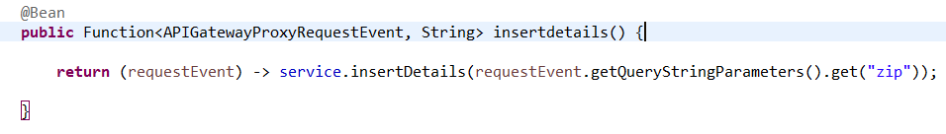

For this changes we need to add the below dependencies in the pom.xml as well:

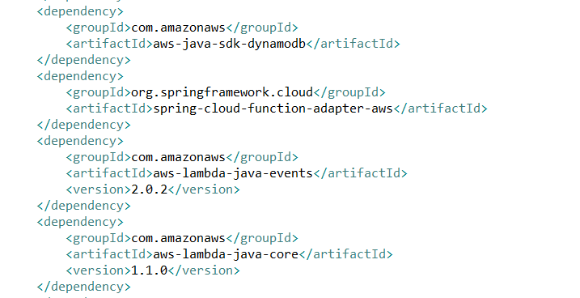

This is all about aws-lambda-functionality.