HTMl all tags and format
HTML tags and their uses
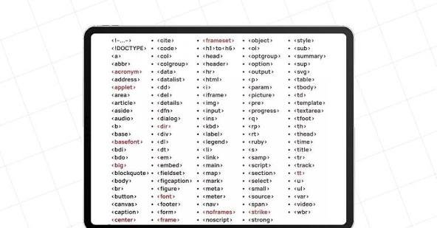
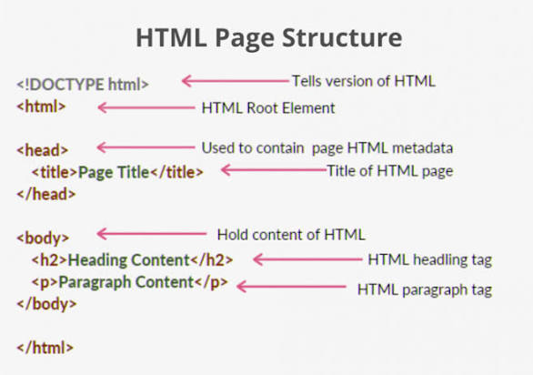
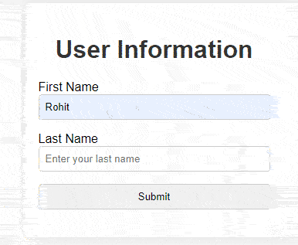
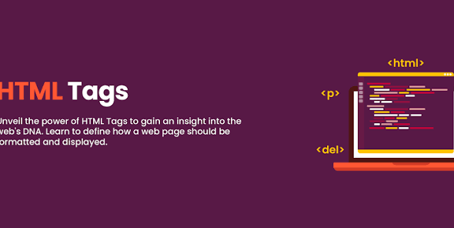
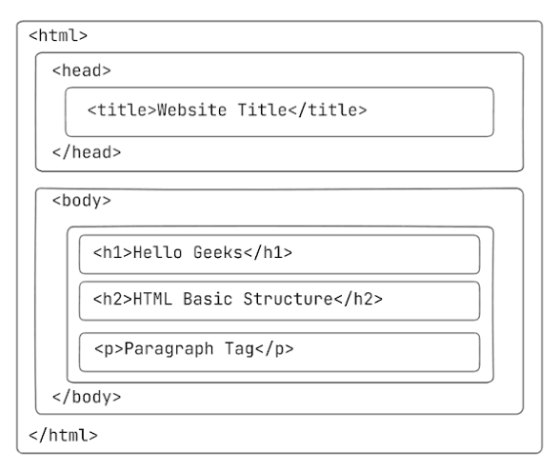
HTML (Hypertext Markup Language) uses tags to define the structure and content of a web page. Tags are keywords enclosed in angle brackets (< >), and they typically come in pairs: an opening tag and a closing tag (which includes a forward slash before the tag name). Some tags are self-closing, meaning they don't require a closing tag, such as <img> and <br>.
Here's a breakdown of common HTML tags and their categories:
1. Document Structure Tags
These tags provide the basic framework for an HTML document.
- <!DOCTYPE html>: Declares the document type, specifying it as an HTML5 document.
- <html>: The root element of an HTML document, enclosing all other HTML elements.
- <head>: Contains metadata about the document, such as the title, character set, and links to stylesheets.
- <title>: Specifies the title of the HTML document, which appears in the browser tab or window title bar.
- <body>: Contains the visible content of the HTML document, including text, images, links, etc.
2. Text Formatting Tags
These tags are used to format and style text within a web page.
- <h1> to <h6>: Define headings of different levels, with <h1> being the most important and <h6> the least important.
- <p>: Defines a paragraph of text.
- <strong>: Indicates strongly important text, typically displayed as bold.
- <em>: Emphasizes text, usually displayed as italic.
- <b>: Visually bolds text without adding semantic importance.
- <i>: Italicizes text without adding semantic importance.
- <u>: Underlines text.
- <mark>: Highlights text with a background color.
- <small>: Displays text in a smaller font size.
- <del>: Indicates deleted text, usually displayed with a strikethrough.
- <ins>: Indicates inserted text, usually displayed with an underline.
- <sup>: Displays superscripted text (e.g., exponents).
- <sub>: Displays subscripted text (e.g., chemical formulas).
- <hr>: Creates a horizontal rule (line) to separate content.
- <br>: Inserts a line break.
3. Link & Anchor Tags
These tags are used to create links between web pages or sections within a page.
- <a>: Defines a hyperlink, allowing users to navigate to other pages or resources.
- <link>: Links external resources, such as stylesheets, to the HTML document.
4. Media Tags
These tags are used to embed multimedia content, such as images, audio, and video, into a web page.
- <img>: Embeds an image in a web page. It's a self-closing tag.
- <video>: Embeds a video file in the document.
- <audio>: Embeds an audio file in the document.
5. List Tags
These tags are used to create organized lists of items.
- <ul>: Defines an unordered (bulleted) list.
- <ol>: Defines an ordered (numbered) list.
- <li>: Represents an individual item within a list.
6. Table Tags
These tags are used to create tables for organizing and displaying data in rows and columns.
- <table>: Defines the overall structure of the table.
- <tr>: Defines a row within the table.
- <th>: Defines a header cell within a table row.
- <td>: Defines a standard data cell within a table row.
7. Form Tags
These tags are essential for creating interactive forms to collect user input.
- <form>: Defines a form that collects user input.
- <input>: Creates various types of input controls (text fields, checkboxes, etc.).
- <textarea>: Creates a multi-line text input field.
- <button>: Defines a clickable button.
- <label>: Defines a label for an input element.
8. Semantic Layout Tags
These tags provide semantic meaning to different sections of a web page, aiding in accessibility and SEO.
- <header>: Represents introductory content for a document or section.
- <nav>: Defines a section containing navigation links.
- <section>: Defines a standalone section within a document.
- <article>: Defines independent, self-contained content, such as a blog post.
- <aside>: Defines content tangentially related to the main content (e.g., a sidebar).
- <footer>: Defines the footer of a document or section.
9. Scripting & Meta Tags
These tags are used for embedding scripts and providing metadata.
- <script>: Embeds client-side script (JavaScript) within the HTML document.
- <meta>: Provides metadata about the HTML document (e.g., character set, description).
- <style>: Defines internal CSS styling rules for the document.
10. Miscellaneous Tags
Other useful HTML tags include:
- <div>: A generic block-level container for grouping content, often used with CSS for layout and styling.
- <span>: A generic inline container for text or other inline elements, often used for applying CSS styles to specific parts of text.
- <iframe>: Embeds another HTML page within the current document.
- <canvas>: Provides a drawing surface for graphics and animations using JavaScript.
- <template>: Defines a container for reusable content fragments that can be cloned and inserted into the document using JavaScript.
Understanding these HTML tags and their proper usage is crucial for structuring web content, ensuring accessibility, improving search engine optimization (SEO), and creating a consistent user experience across different devices.

