 | Strategies

About This Chapter
This chapter provides basic information about methods and how they can be used for effective modeling. This chapter contains the following lessons:

Lesson 1: Introduction to the Object Method 1-2
Lesson 2: Syntax for Writing a Method 1-6
Lesson 3: The Method Debugger 1-11
Lesson 4: Names, Identifiers and Paths 1-15
Lesson 5: Anonymous Indentifiers 1-18
Lesson 6: Scheduling Method Calls 1-23
Lesson 7: Entrance and Exit Controls 1-25
Lesson 7: Attributes 1-36
Lesson 8: Conditional Statements 1-39
Lesson 9: Tables and Global Variables 1-42
Lesson 10: Operations Converting Data Types 1-53
Lesson 11: Loops 1-57
Lesson 12: Conditional Suspensions – waituntil and stopuntil 1-60
Lesson 13: The Contents of an Object Loading and Unloading 1-62
Lesson 14: Calling Methods; Trigger and Frame Controls 1-74
Lesson 15: Resource Objects 1-80
Lesson 16: Miscellaneous Features 1-85
Chapter Summary 1-91

Lesson 1: Introduction to the Object Method

Introduction
A Method is a small program, comparable to a procedure or a function in the programming languages Basic, Pascal or C++.
SimTalk, the programming language of eM-Plant, is based on the programming language Eiffel. It resembles other programming languages.
You can program a Method to read the attributes of the objects you inserted into your model and change these attributes. Select an object and then select Objects > Show Attributes and Methods to show all built-in attributes and methods that object provides.
In addition you can define any number of user-defined, custom attributes. The object Method is fully integrated into the object-oriented concept of eM-Plant. Enter your source code into the object Method. Then the built-in Interpreter processes these statements during the simulation run.
- A Method can:
- React to certain events during a simulation run.
- Get and set conditions.
- Execute statements.
- Modify and extend the behavior of objects.
- Prepare a model for new users with custom dialogs.
- It allows you to:
- Implement different approaches, adapt your model to your needs.
- Increase the efficiency of your simulation model.
- Increase the flexibility of your simulation model

The Object Method
Use the Method to program controls that other objects start and execute during the simulation run.

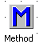
Properties:
- Capacity: 0
- Information flow object
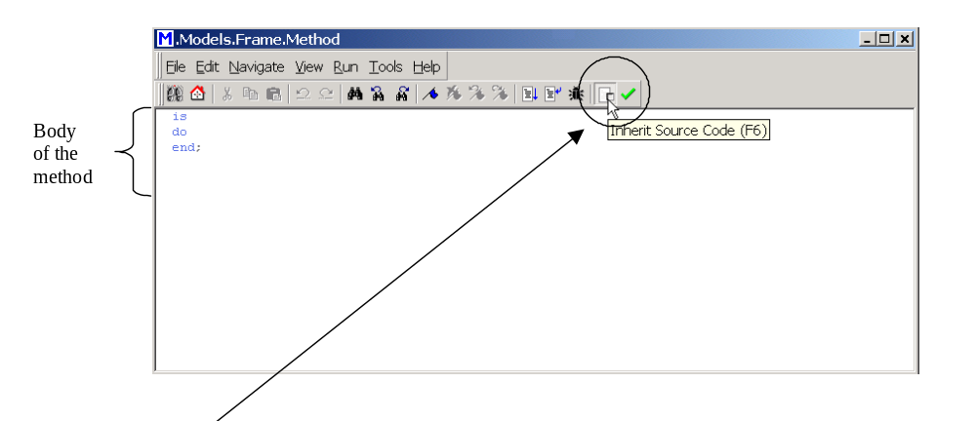 When you insert the instance of a Method into your model, eM-Plant activates Inherit Source Code (from the class). Before you deactivate it, check if you want to change the source code in the class or in the instance.

Toolbar of the method
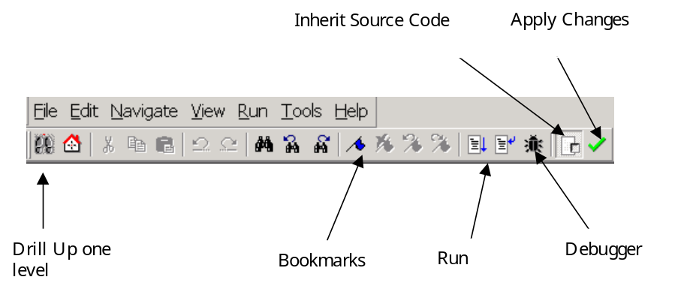Editor
Select Tools -> Options
in the TUNE window to choose settings for the Method Editor.
It is recommend to activate Display line numbers
This allows to quickly change to the line that contains wrong source code in the Method Debugger.
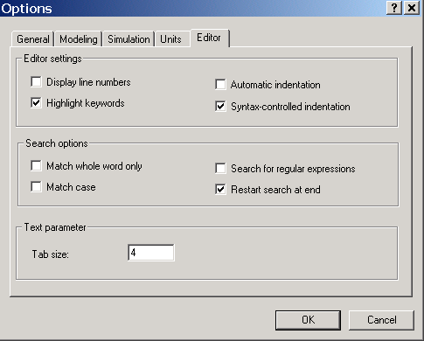

Options- Simulation
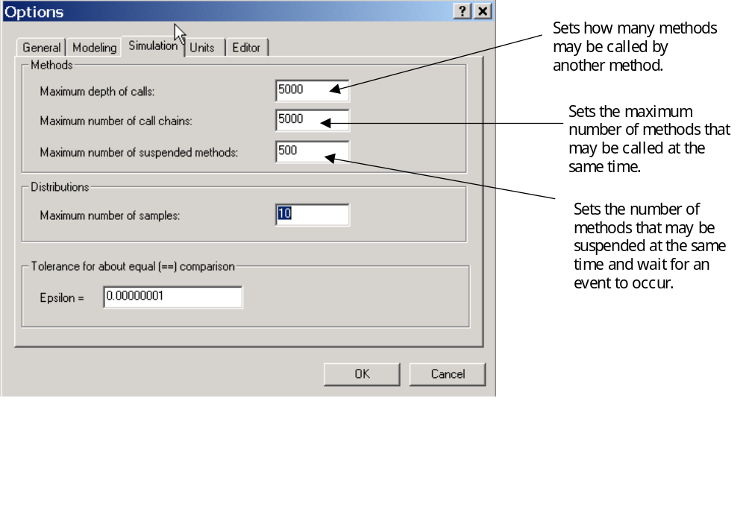

Lesson 2: Syntax for Writing a Method

Structure of a Method
The Method consists of these parts, not all of which are required.
- [Argument]
- Extends the functionality by adding arguments that pass additional information of the caller specifying certain actions. The caller has to pass the same number of arguments as you declared in the method. The data type passed has to be identical with the expected data type.
- [Result]
- Enter the data type of the return value. It has to be assigned to the caller with the keyword result, when it returns a value.
- Is
- Separates the declaration of arguments from the declaration of local variables.
- [Local Variables]
- Local variables can only be accessed in the method in which, it is declared. Use them when you do not need data any longer after the method call.
- Do
- Enter the source code proper after do.
- [Statement]
- Enter the source code, i.e. standard methods, assignments, control structures, method calls, branches, and loops.
- End;
- Designates the end of the source code. After end you can only enter comments.

Syntax of a Method
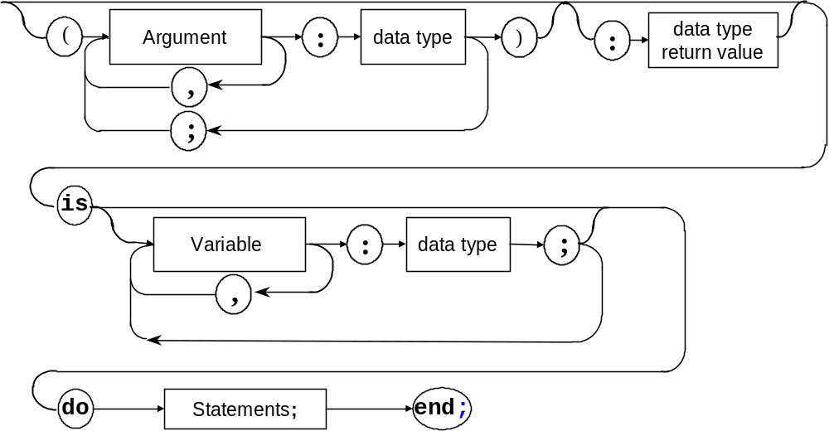

Sample Statements
The following are sample statements used in a method.
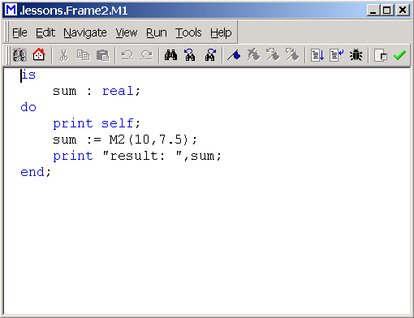
Local variable
Statement:
Method call with arguments passed (M2).
Input argument

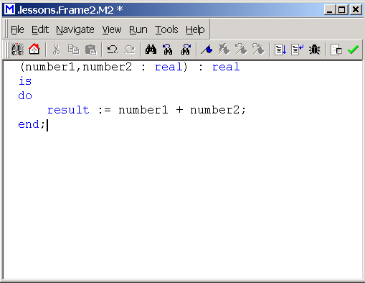
Return argument
Assignment to the keyword result: is required for returning a value to the calling method.

SimTalk Operators
- Assignment Operator

The assignment operator := assigns a new value to a variable.
<variable> := <new value>;
- Arithmetic Operators

Addition, subtraction, multiplication, division (+, –, *, /) and standard functions, such as trigonometric functions, logarithm, and exponential function.
- Relational Operators

Relational operators =, /=, >, >=, <, <=, = = compare two values. The result, TRUE or FALSE, is of data type Boolean.
Boolean operators and, or, not combine expressions.
- Input and Output Operators
Load and save data.

Document Conventions
- Names of attributes begin with an upper-case letter. Each new term after that begins with an upper-case letter, such as GenerationTableActive.
- Names of methods begin with a lower-case letter. Each new term after that begins with an upper-case letter, such as currIcon and absSimTime.
- Methods show keywords in blue (examples are is, do, and end) and comments in green.

Method Templates
EM-Plant has templates availabe for creating methods.

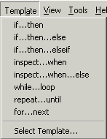
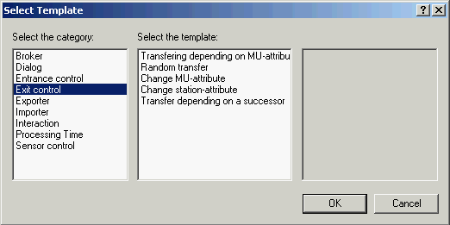

Comments
Comments improve the legibility of a method and help to understand its function.
- Enter two hyphens - - to start a one-lined comment that ends at the end of the line.
- Enter a forward slash and an asterisk (/*) to start a comment line that will cover several lines and an asterisk forward slash (*/) to end the commented lines.

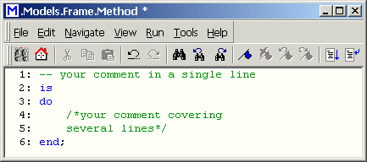

Lesson 3: The Method Debugger

Introduction
eM-Plant automatically runs the debugger when the source code contains errors that prevent the method from being executed. The debugger can also be used to detect errors in the simulation model and can be used to watch how the procedures are executed.
To open the debugger:
- Set breakpoints (F9).
- Select Debugger -> Open Debugger, or press F6, or hold down Shift + Alt + Ctrl while a method is being executed.
Debugger uses:
- Watch local variables, arguments and information about the calling object and the MU that triggers an action in the Watch Window.
- Track how the Method is executed step-by-step.
- Detect errors using the messages the debugger shows.

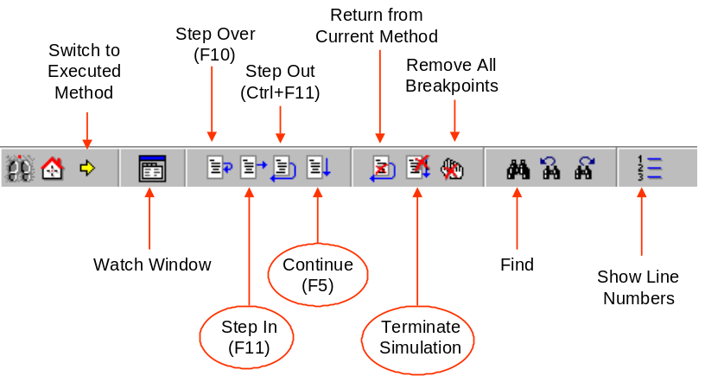
The Debugger Toolbar

Breakpoints executing a method step-by-step
Set breakpoints in the method to watch how it is executed or to execute it step-by-step.
Setting breakpoints:
- Open the Method window.
- Place the curser in the line where the breakpoint is to occur.
- Press F9.
When the source code reaches this line while executing, eM-Plant opens the debugger window and selects the breakpoint.
Click the buttons on the toolbar to continue executing the program or to abort it.
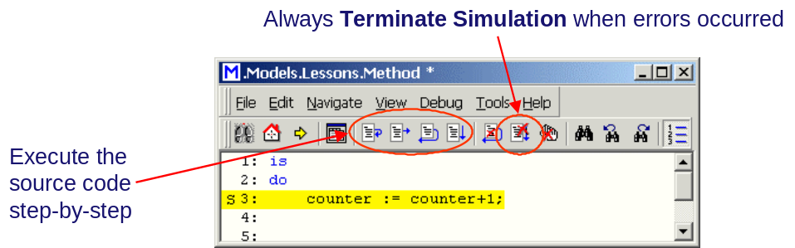

Exercise: Defining a method
Objective: To write a method and view the results in the console.
- Add the frame, Frame_2, to the folder Exercises.
- Insert two Method objects.
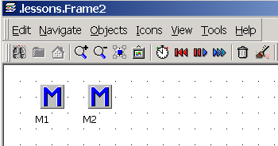
- Enter the source code as displayed in the image below.
For M1:
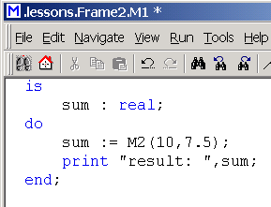
For M2:
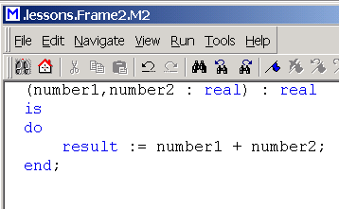
- Start the method M1 with the menu commands of the context menu , or run (F5).
- Run the method step-by-step, open the watch window and watch the values.
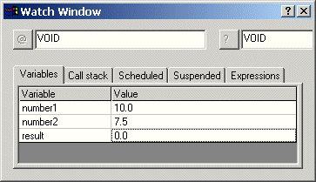
- Set breakpoints and rerun the Method.

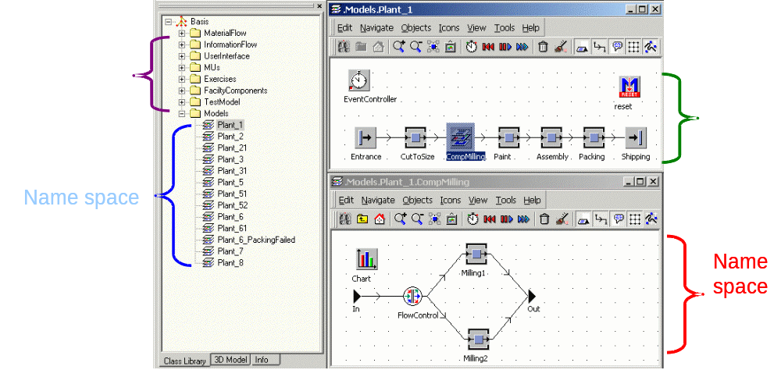
Lesson 4: Names, Identifiers and Paths

Introduction
Each object has an individual address to uniquely identify the object residing in the hierarchy level, within the name space, or within another name space.
The relative path calls the object when it is located within the same name space.
The absolute path calls the object when it is located on another hierarchy level.

Name Space
All objects on the same hierarchy level are located within the same name space.
- Within a name space all objects must have unique names.
- Within different name spaces objects can have the same names.

Absolute Path
Identifies the exact location of an object, irrespective to its hierarchy level within the frame.
- The absolute path is required to call an object located on another hierarchy level.
- The absolute path always starts in the Class Library and then proceeds through the folders and frames to the object.
- The absolute always begins with a period followed by a name, a period, a name, a period until it has reached the name of the object.
.<name>.<name>...<object>
- When you place an object onto another hierarchy level eM-Plant has to rename the absolute path.
Example of the Absolute path to the Milling2 object:
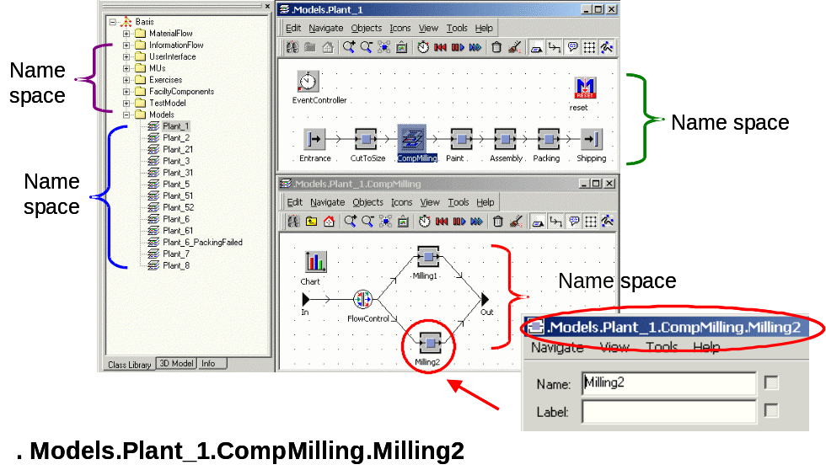

The Relative Path
Calls an object within the same name space without having to enter the hierarchy level.
- Ths path never starts with a period.
- Enables you to fleibly and universally deploy Methods and objects.
- Is correct even after the structure of the model has been changed.
Example of the Relative path to the Milling2 object:
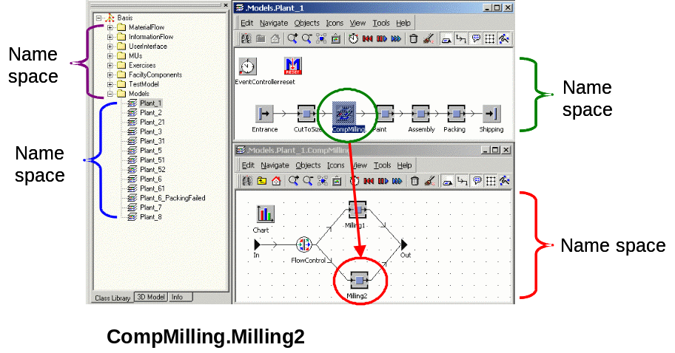

Lesson 5: Anonymous Indentifiers

Introduction
The paths to your objects should be as univeral as possible, to enable you to deploy the called object as flexibly as possible.For this you can employ a number of anonymous identifiers, which serve as placeholders.

Calling the MU Triggering the Method — @

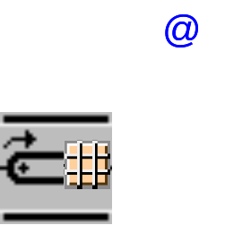
The anonymous identifier @ uniquely identifies the MU, such as table_top:6712, that triggered the Method when entering or exiting the object.
eM-Plant even uniquely assigns the MU, when several controls are triggered. The MU might also be located on another object.

Calling the Active Method – Self
The anonymous identifier self returns the path of the currently executed method.
- Self; returns the path to the name of the Method.
- Self.name; returns only the name of the Method.
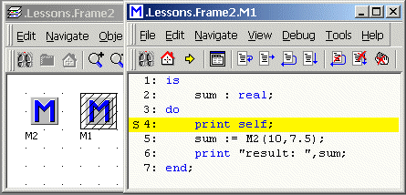

Calling the Object Calling the Method — ?
The anonymous identifier ? is the material flow object or the control (Method) that called the Method. Employing ? allows a Method to be used without modifications by several objects.
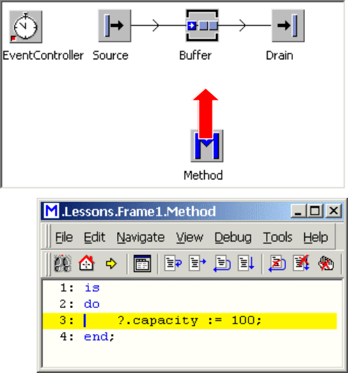

Calling the Active Frame – Current
The anonymous identifier current returns the frame the method object is located in. This is used to enter the location of a frame into tables and lists or passes it as an argument to methods in other frames.

Calling the Location of the Active Frame – Location
The method location returns the object located directly above the object designated by the path. The location of the MU is the object it is currently located on.
- <object>.location returns the path to the frame where the object is located.
- @.location returns the location of the object where the MU is located.
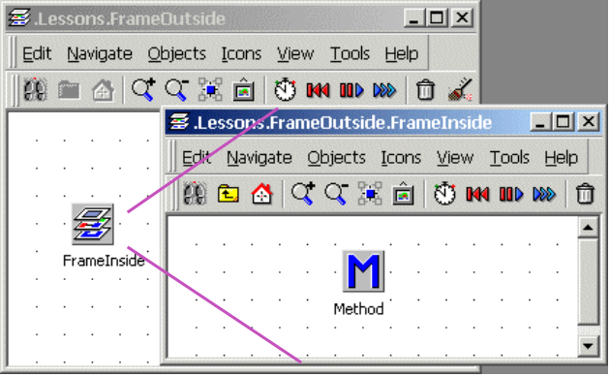

Calling the Topmost Level of the Hierarchy – root
The anonymous identifier root returns the topmost frame in the hierarchy of frames. This identifier is especially useful when you do not know the name of the root frame (the frame located at the top of the hierarchy).
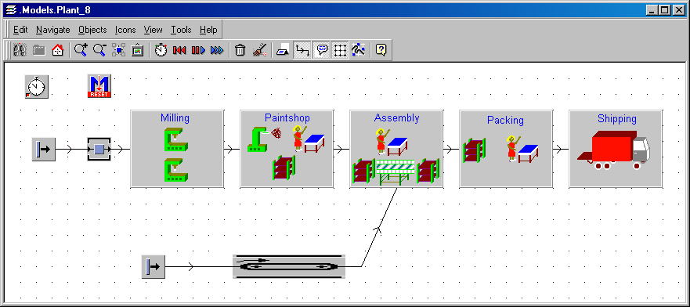

Exercise: Using the Anonymous Identifiers
Objective: To use the anonymous identifiers.
- Add the frame FrameOutside to the Exercises folder.
- Add the frame FrameInside to the same folder.
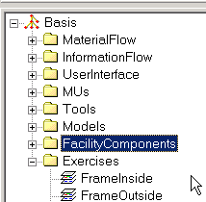
- Insert a method into the frame FrameInside and enter the source code as follows:
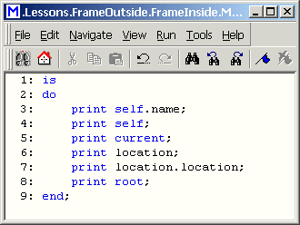
- Open the frame FrameOutside and drag the frame FrameInside into it.
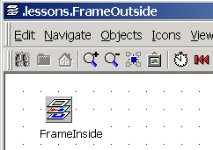
- Run the Method and watch the values in the console.
- Open the Method in the Frame FrameInside, run it step-by-step and watch what the Console displays. You can also use the values in local variables and watch them in the Watch Window of the Debugger.
NOTES:
Nesting the methods demonstrates the hierarchy level of the anonymous identifier.

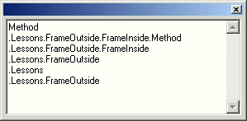

Lesson 6: Scheduling Method Calls

Events in the Model - Calling Methods
An event taking place at a certain time in the model can call a Method:
- Clicking this button of the EventController calls this Method:
- Reset:Calls all Methods named reset located in the open model.
- Init: Calls all Methods named init after resetting the model.
- eM-Plant executes the Method autoexec that has to be located in the class library, when opening the model file.
- eM-Plant calls all Methods named endSim at the end of a simulation run.
- The simulation ends when the EventController has processed all events from the List of Scheduled Events or when eM-Plant reaches the end time you entered in the text box End on the tab Settings.
- The Trigger and the Generator can also call a Method.

The Method Reset


Whenever you click Reset in the EventController, eM-Plant scans the entire model, including all Frames you inserted, for Methods named reset and executes them.
Our reset Method deletes all MUs in the model.
Insert a Method object into your model, and change the name to reset. Enter the text into the method from the following image.
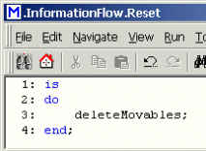

The Method init
Whenever you click Init in the EventController, eM-Plant executes all Methods named init located in the model. Init Methods can initialize your model, for example set the values of variables, place MUs onto material flow objects, etc.
Insert a Method object into your model, and enter init into the text box Name in the dialog Rename. Insert the text as follows:
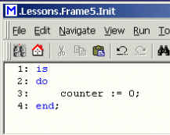

Lesson 7: Entrance and Exit Controls

Introduction
You can program and select an Entrance and/or an Exit control for each material flow object. You might compare them to a photo sensor placed at the entrance/exit of the material flow object.
You can attach a Method to each of these photo sensors that eM-Plant executes as soon as an MU enters or exits the object.
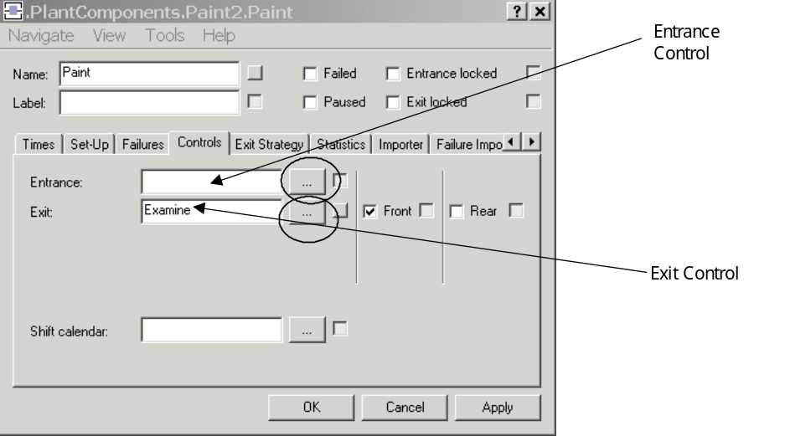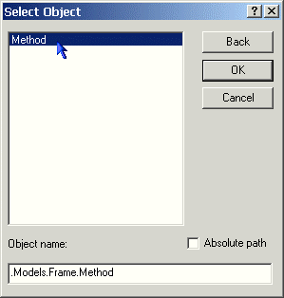
with a method

Entrance Control of Location Oriented Objects

This is activated as soon as an MU enters the object, the MU is located all the way on the object, irrespective to its length.
NOTE
Once set, the time the MU remains on the object cannot be changed, unless a formula is entered as a processing time.

Front-Activated Exit Control of the Location Oriented Objects
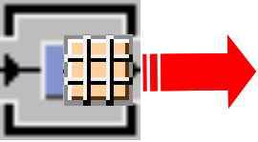
This is called when the MU intends to exit the object. The MU is still located on the object.
The exit control may be activated several times: when the MU cannot exit the object or because the successor is full. eM-Plant calls the exit control again once the successor is unblocked.
NOTE
The front-activated exit control overrides the default exit strategy of eM-Plant, the MUs must be moved manually by methods.

Rear-Activated Exit Control of Location Oriented Objects
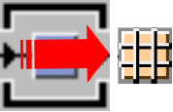
This is called once the MU exits the object. The MU is located on the successor.
NOTE
The rear-activated exit control is called only once and it does not override the default strategy.

Front_Activated Entrance Control of Length Oriented Objects
This is called as soon as an MU wants to enter the object. The front
of the MU is located on the object when the method is called.

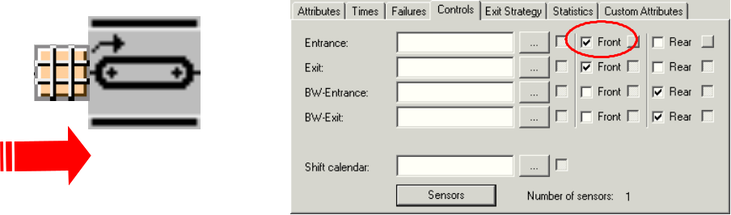
NOTE
Once set, the time the MU remains on the object cannot be changed, unless a formula is entered as a processing time.

Rear-Activated Entrance Control of Length Oriented Objects
This is called once the entire length of the MU is located on the object.
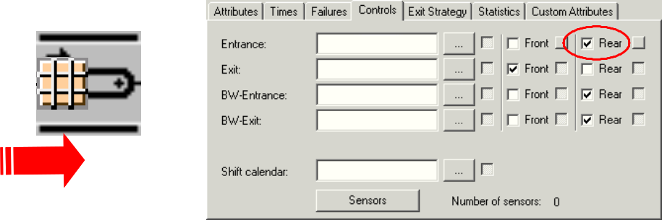
NOTE
The point-in-time the MU enters the object until the point-in-time the rear-activated entrance control is activated is the time the MU needs to entirely move onto the object.

Front_Activated Exit Control of Length Oriented Objects
This is called once the MU intends to exit the object. The MU is located entirely on the object.

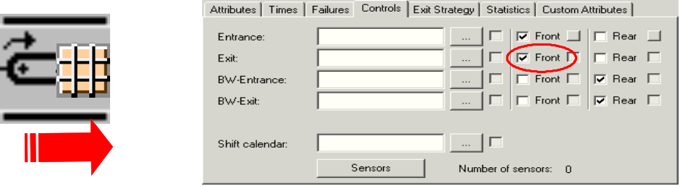

Rear_Activated Exit Control of Length Oriented Objects
This is called once the MU has exited the object. The MU is located on the succeeding object.
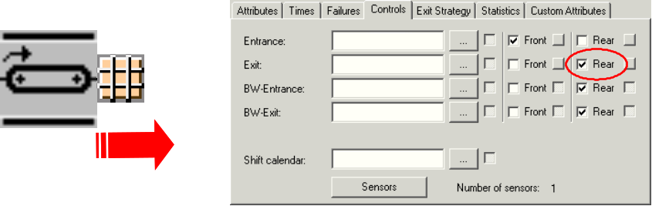

Backward Entrance and Exit Controls
The MU does not change its orientation (i.e. it does not turn around and move with its frint end against the direction of motion of the simulation).
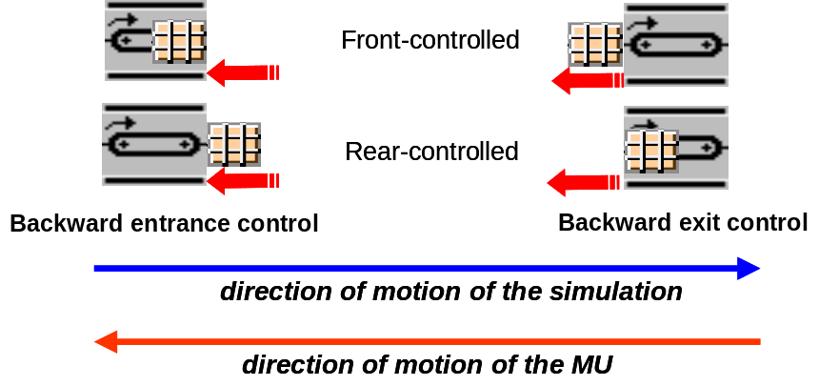

Sensors of Length Oriented Objects
For the length oriented objects you can define sensor controls for any location on them.
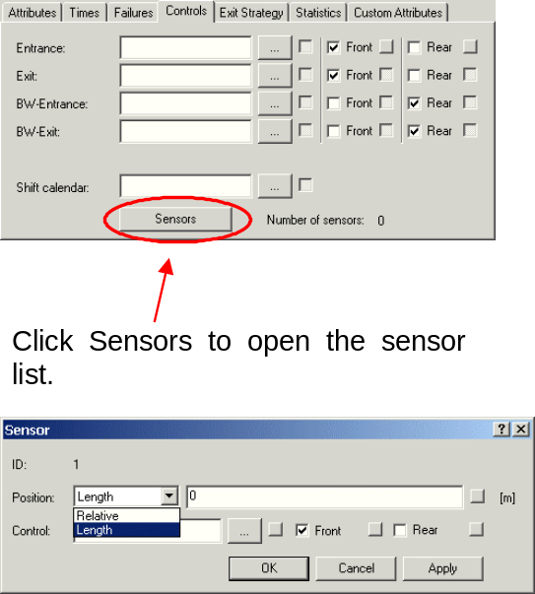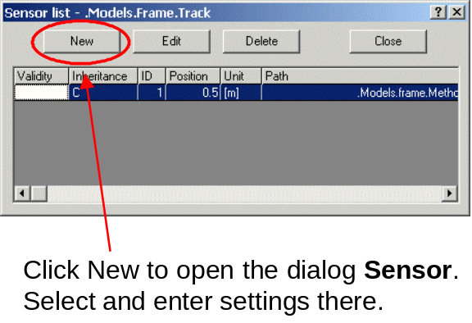

Moving an MU to the Next Object
The method move moves the MU from one object to another object. eM-Plant moves the MU onto a location oriented object with the speed entered.
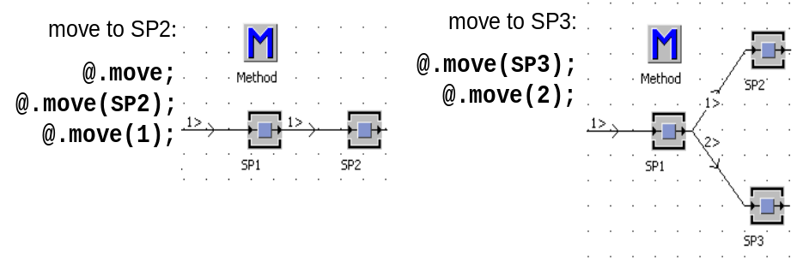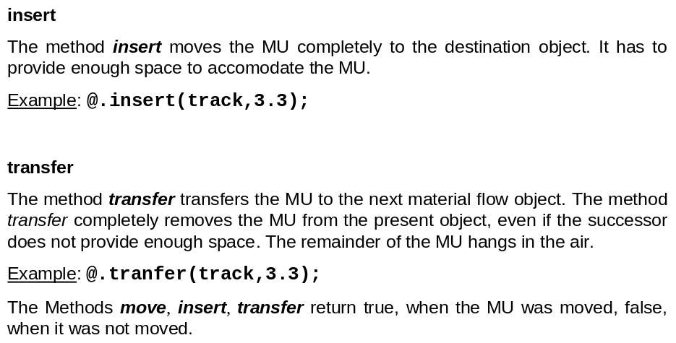

Predecessors and Successors
Use the methods:
- succ(<integer>)
- pred(<integer>)
to check the predecessor and/or successor of an object. This is helpful for modeling an exit strategy.
Starting with the path of the called object the method accesses its successor or predecessor provided the objects are connected. The number is the number of the connector.
Example:
- @.move(source.pred(1));
- @.move(?.succ(1));
- if milling.pred(1).name = „CutToSize“ then...

Exercise 1: Entrance and Exit Control of a SingleProc
Objective: To insert entrance and exit controls in single processes.
- Add the frame Frame_4 to the Exercises folder.
- Add the following objects:
    - a source
    - 3 SingleProc’s
    - a drain
    - an EventController
    - 4 Method objects
- Name each according to the image below:
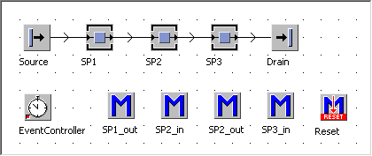
- Enter print self.name into the methods.
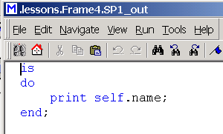
- select the following controls for each method:
- SP1_Out: front-activated exit control.
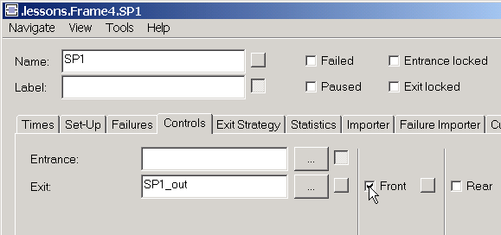
NOTE
Keep in mind how the front activated exit control works.
- SP2_In: front-activated entrance control.
- SP2_Out: rear-activated exit control.
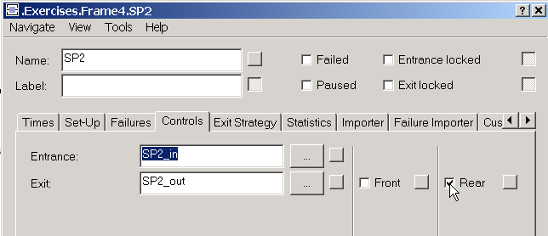
- SP3_In: front-activated entrance control.
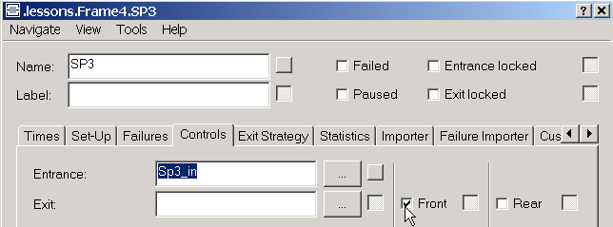
- Run the simulation and observe the console window.

Exercise 2: Entrance and Exit Control of the Line Object
Objective: To view entrance and exit controls on length oriented objects.
- Copy the contents of Frame_4 and paste it into Frame_5.
- Replace the SingleProc’s with Lines
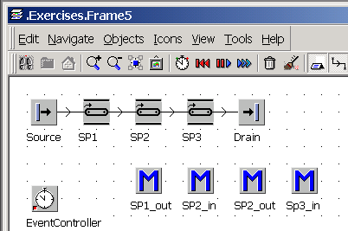
- Insert the controls as follows:
SP1_Out: rear-activated exit control.
SP2_In: rear-activated entrance control.
SP2_out: rear-activated exit control.
SP3_In: front-activated entrance control.
- Run the simulation and observe the console window.

Lesson 7: Attributes

Introduction
The attributes of a class or an instance can be viewed using the Show Attributes and Methods from the context menu.
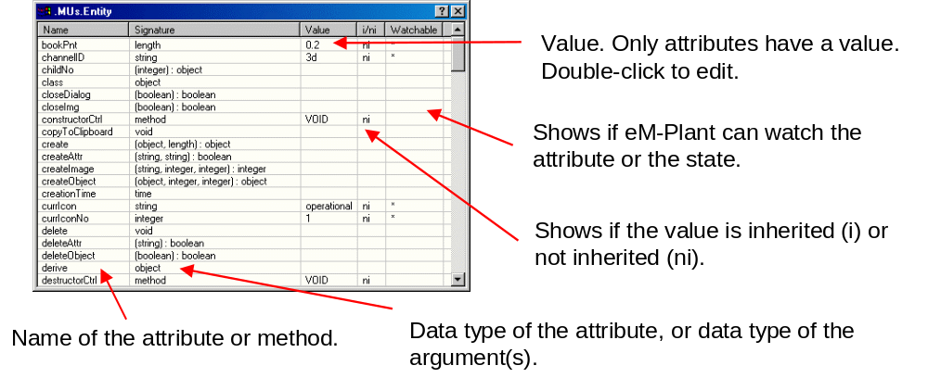

Assigning a Value
A value can be assigned by entering the value to the right of the assignment operator: <expression> := <value>.
Examples: buffer.capacity := 8;
SingleProc.Pause := true;
@.currIcon := „TableTop“;
Use auto-complete when entering source code. Enter the first one or two characters of an object, an attribute or a method and press esc or select Edit -> Auto Complete or hit the keys Ctrl + Space.
eM-Plant completes the word, and if necessary it will add the corresponding characters – period, left parantheses, assignment operator and right parantheses.
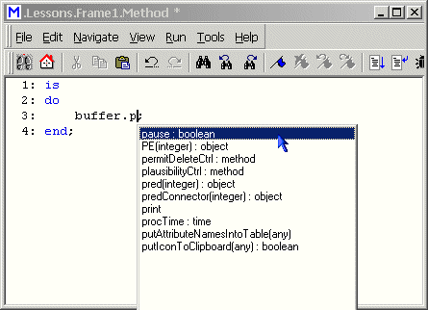
If the name is not unique, eM-Plant opens a window where you select an item, press the up or down arrow to select the desired expression and press enter.

Exercise: Changing the Attributes of an Object with a Method
Objective: to change the attributes of a ParallelProc by using a Method.
- Add the frame Frame_6 to the Exercises folder.
- Insert a ParallelProc and a Method object.
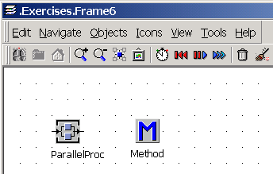
- Change the following attributes using the method and by searching the Show Attributes and Methods window.
- Process time = 120 seconds
- x-dimension = 5
- y-dimension = 3
- Lock the Entrance of the ParallelProc (Entrance Locked)
- Close the Show Attributes and Methods window.
- Run the method.
- Verify the changes in the Show Attributes and Methods window as well as on the ParallelProc object.

Lesson 8: Conditional Statements

Branching using If Then
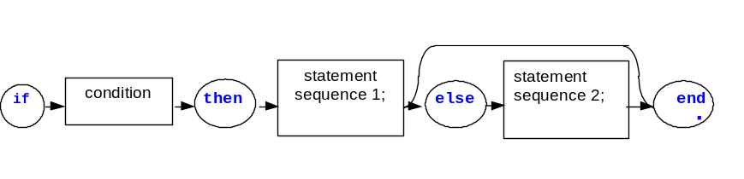Use the if statement to make the execution of a Method depend on the result of a condition.
If the condition returns true, the Method executes statement sequence 1. If the condition returns false, the Method executes statement sequence 2.
If you do not need it, you can also omit the else branch with statement sequence 2.
Example of an If statement:
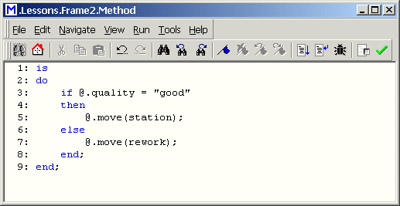

Branching using If Elseif

Using the if then elseif statement, the Method can react to different conditions. eM-Plant analyzes the conditions one after the other until one condition is true. Then it executes the respective statement sequence. If no condition is true, it executes the optional else branch. When the else branch is not present, eM-Plant continues after the final end statement.
Example of an ElseIf statement:
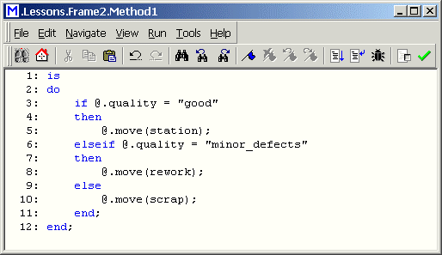

The Inspect Statement
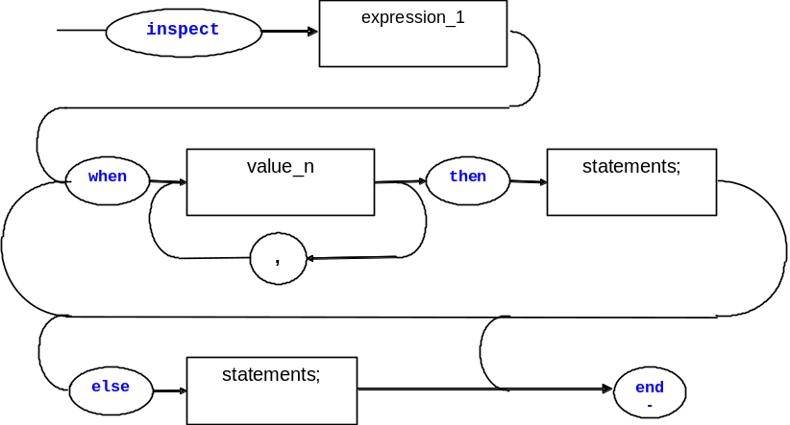
The inspect statement enables eM-Plant to make easier and clearer choices when presented with several possibilities. This way you do not have to use lengthy if-then-elseif-chains.
Example of an Inspect Statement:
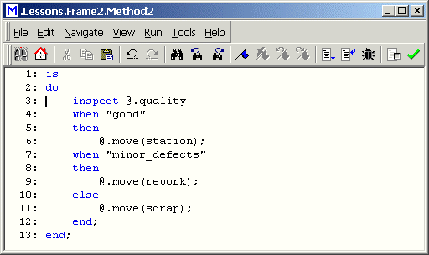

Lesson 9: Tables and Global Variables
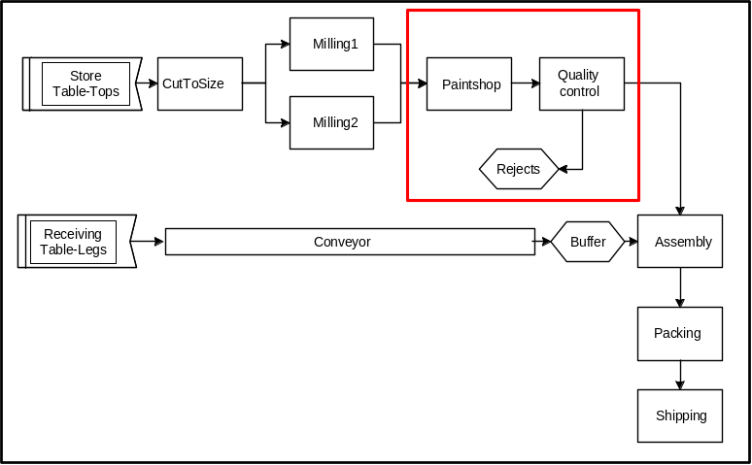

Introduction
The TableFile is a list with several columns that can be modified for content or format by deactivating the inherit commands from the Format menu.

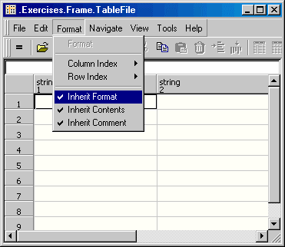

Formatting the TableFile
Before selecting a data type, select the entire table or a column of you choice and select Format -> Format -> Data and select the data type. Enter the dimension of the table:
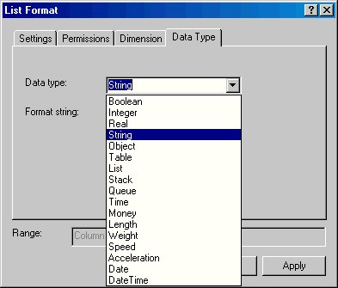
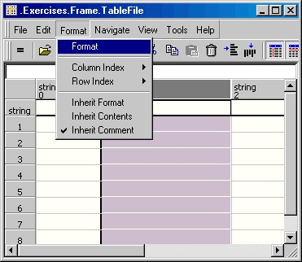
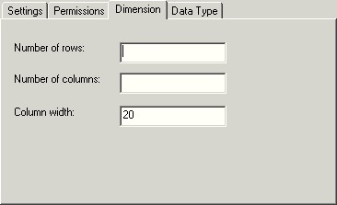

Accessing the TableFile with a Method
When accessing the TableFile, eM-Plant first calls the column and then the row.
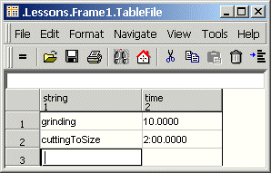
- Reading from a table: print TableFile [1,2]; (column 1 row 2).
- Writing to a table: TableFile [1,3]: = “grinding”;
TableFile [2,3]: = 180;
Here we assign the contents of a cell from the table to a variable, attribute, etc…
- <Object>.procTime: = TableFile [2,1];

Accessing a TableFile Using a Custom Index
You can also call a cell using the column and row index. Here we assign the processing time to a material flow object by using the contents of the cell in column 2, row 1 of the table.
- <Object>.procTime: = TableFile [“time”, “PartA”];
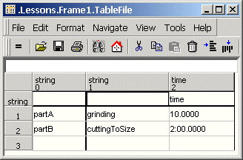

Methods for Lists and Tables

<TableFile>.setCursor(1,1); | Sets the cursor to the designated cell.
<…>.find(‘[1,1]..’[*,*],<value>); | Finds the value in the designated range.
<…>.CursorX;, <…>.CursorY; | Sets the cursor to a column (X) or to a row (Y)
<…>.xDim;, <…>.yDim; | Returns the last column or row with an entry.
<…>.sort(3,”ascending”); | Sorts the table depending on one or several columns in ascending order.
<…>.meanValue(‘[1,*]); | Returns the arithmetic mean of all values of data type real or integer in the range.
<…>.delete(‘[1,1]..[*,1]); | Deletes the range or the entire contents.
<local_variable>.create; | Creates the table as a local variable, without contents.

Searching a TableFile
eM-Plant searches the table starting at the position of the cursor and returns a “true” value when the item is found and places the cursor within that cell. If the item is not found a value of “false” is given
Here is an example of a Method searching a TableFile:
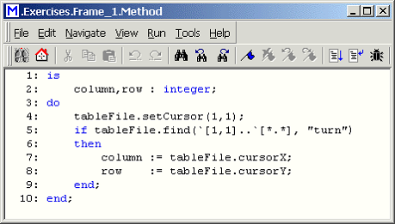

The Variable
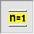
Capacity = 0
Information Flow Object
Use the variable to store values over an extended period of time during your simulation run. You can call it as any other object. The range of values depends on the data type. Other objects or methods can call the Variable.
To reset the value to an initial value during the init phase select the checkbox and enter the initial value.
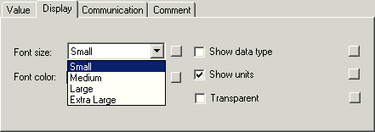

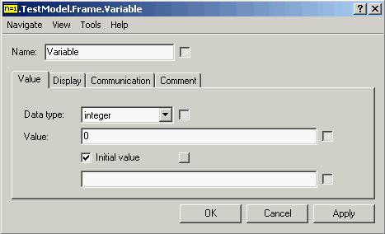

Exercise 1: Painting the TableTops
Objective: To write a method that will paint the TableTops.
- Open the frame CompPaintShop in the FacilityComponents folder and add a TableFile (name it ColorTable) and a Method (named Painting).
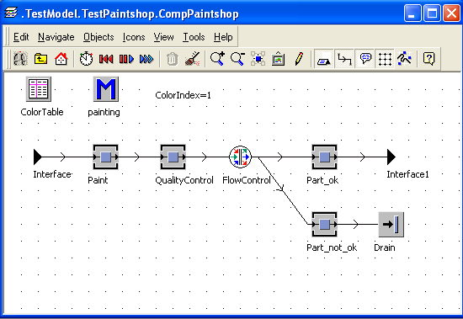
- Enter the colors from the table into the ColorTable.
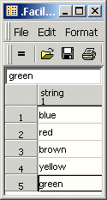
- Into which control do you enter the calling Method?
- Program the method so that eM-Plant paints the TableTops with the colors from the table. Hint: breakdown the problem into small steps.
- If required, insert all objects still missing.

Exercise 2: Test Painting
Objective: To test the new paint shop before inserting it into the project.
- Open the frame TestPaintShop in the TestModels folder. Once you extended the frame PaintShop in the class of he of the frame PaintShop (within the folder FacilityComponents), the test frame TestPaintShop displays those changes.
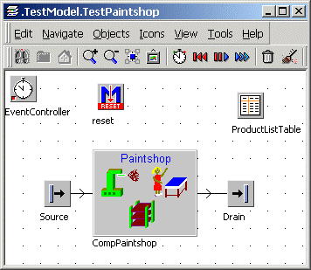
- Start the simulation and watch how the TableTops are painted in the frame.

Exercise 3: The Paint Cycle
Objective: To determine a paint cycle to correct for the “bad” TableTops.
- Open the CompPaintShop.
- Delete the drain and insert a buffer with a capacity of 4.
- Close the cycle to the station QualityControl by inserting a connector (see image below).
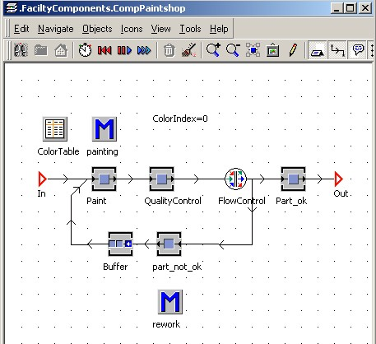
- Insert a method and program it to set the attribute Quality to “good” and change the name to TableTop_good.

Exercise 4: Test and Add the Paint frame to Plant_8
Objective: To test the TestPaintShop for functionality and to insert the new frame into Plant_8.
- Test the PaintShop in the frame TestPaintShop.
- Insert the PaintShop frame into Plant_8.
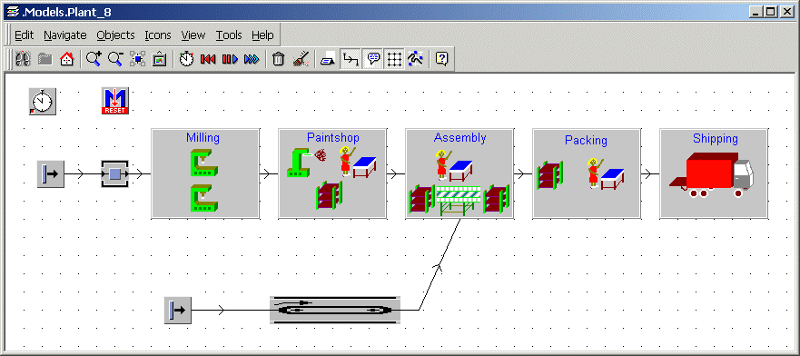

The StackFile, QueueFile and CardFile
The StackFile, QueueFile and CardFile are lists with one column. They cannot have empty cells. They provide different features for reading, inserting and cutting the contents of a cell.
- StackFile (corresponds to the data type stack) inserts entries at the top and removes the contents of the cell added first (the LIFO method: Last In First Out).
- QueueFile (corresponds to the data type queue) saves entries added in the order inserted and removes the element waiting in the queue the longest.
- CardFile (corresponds to the data type list) is accessed in a random manner using the position of the cell, the following cells move up.

Method for Writing into StackFiles, QueueFiles and CardFiles.

<…>.push(<value>); | Inserts the value into the topmost cell of the StackFile or the QueueFile.
<…>.insert (3,<value>); | Inserts the value into the cell in a row (3) of the CardFile and moves the contents of this cell and the following cell down one.
<…>.[]; | Removes the contents of the last cell of the StackFile and removes the contents of the first cell of the QueueFile. The following cells move up one position.
<…>.[3]; | Reads and removes the contents of the cell in a row (3) of the CardFile. The following cells move up one position.
<…>.pop; | Reads the content of the last cell of the StackFile and reads the content of the first cell in the QueueFile and removes them.
<…>.read (3); | Reads the content of a row (3) of the CardFile without removing it.
<…>.dim; | Returns the last row with any entry.

