Are You Interested in Selling Your Property?

Dear (Owner),

Are you interested in selling your property at (Address)?

As a property owner, I realize that there are a number of reasons why someone may be interested in selling:
- Bad Management
- Hassles of being a Landlord
- Divorce
- Death of a loved one
- Bad health
- Retirement
- Move on to another investment
I'm not an agent, so I'm not interested in listing your property but in buying it directly.

If you're interested in selling your property now or in a few months (or are just curious how much your property is worth), please give me a call at 202-643-9566 or email me at trevor.finn1@gmail.com to discuss.

Thanks, and I look forward to hearing from you.

Kind regards,

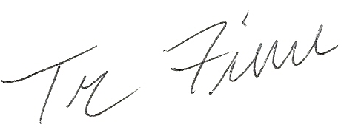

Trevor Finn
https://www.linkedin.com/in/trevorfinn/

P.S. To get the best price for your property, please call me now at 202-643-9566.

