**ASSIGNMENT 1 FRONT SHEET**

|  |  |  |  |
| --- | --- | --- | --- |
| **Qualification** | **BTEC Level 5 HND Diploma in Business** | | |
| **Unit number and title** | **Unit 30: Application Development** | | |
| **Submission date** | 14th, February 2023 | **Date Received 1st submission** |  |
| **Re-submission Date** | 5th, March 2023 | **Date Received 2nd submission** |  |
| **Student Name** | Nguyen Nhat Chinh | **Student ID** | GCC200312 |
| **Class** | GCC0903 | **Assessor name** | Luong Hoang Huong |
| **Student declaration**  I certify that the assignment submission is entirely my own work and I fully understand the consequences of plagiarism. I understand that making a false declaration is a form of malpractice. | | | |
|  |  | **Student’s signature** |  |

**Grading grid**

|  |  |  |  |  |  |
| --- | --- | --- | --- | --- | --- |
| **P1** | **P2** | **P3** | **M1** | **M2** | **D1** |
|  |  |  |  |  |  |

|  |  |  |
| --- | --- | --- |
| **❒ Summative Feedback: ❒ Resubmission Feedback:** | | |
| **Grade:** | **Assessor Signature:** | **Date:** |
| **Internal Verifier’s Comments:** | | |
| **Signature & Date:** | | |

# Assignment Brief 1 (RQF)

## Higher National Certificate/Diploma in Computing

|  |  |
| --- | --- |
| **Student Name/ID Number:** |  |
| **Unit Number and Title:** | **Unit 30: Application Development** |
| **Academic Year:** | **2021 – 2022** |
| **Unit Assessor:** | **Hoang Nhu Vinh** |
| **Assignment Title:** | **Analysis and Design solution for a given problem** |
| **Issue Date:** | **10 May 2022** |
| **Submission Date:** |  |
| **Internal Verifier Name:** |  |
| **Date:** |  |

|  |
| --- |
| **Submission Format:** |
| *Format:* *The submission is in the form of two documents/files*   * An individual SRS document in PDF format. Writing must be professional. * An individual evaluation document in PDF format. Writing must be professional.   *Submission*   * Students are compulsory to submit the assignment on the due date and in a way requested by the Tutor. * The form of submission will be a soft copy posted on <http://cms.greenwich.edu.vn/>. * Remember to convert the word file into a PDF file before the submission on CMS.   *Note:*   * The individual Assignment *must* be your work, and not copied by or from another student. * If you use ideas, quotes, or data (such as diagrams) from books, journals, or other sources, you must reference your sources, using the Harvard style. * Make sure that you understand and follow the guidelines to avoid plagiarism. Failure to comply with this requirement will result in a failed assignment. |
| **Unit Learning Outcomes:** |
| **LO1** Produce a Software Design Document by analyzing a business-related problem and deduce an appropriate solution including a set of initial requirements  **LO2** Use design and development methodologies with tools and techniques associated with the creation of a business application |
| **Assignment Brief and Guidance:** |
| **Scenario**: FPTBook will be a web-based software system to aid book store customers and owners to manage their book purchases and sales about simplifying and speeding up the process of selection, ordering, and purchasing books for customers as well as managing a database of users and a database of products for book store owners. The attached document can view the detailed description of those roles (Requirements.docx).  **Tasks**  You and your teammates (3 members/team maximum) need to prepare a software design document with the following sections:   * A requirement specification that explores the problem by a set of user and system requirements, as well as determines any risks related to the successful completion of your application. You are advised to use an SRS template or modify one to complete this task. * An evaluation section in which you research the use of software development tools and techniques and identify any that have been selected for the development of this application. You should compare them and justify your choices. * A design section in which you use chosen tools from the previous step to produce design diagrams for your solution based on the requirement specification. |

|  |  |  |  |
| --- | --- | --- | --- |
| **Learning Outcomes and Assessment Criteria (Assignment 1):** | | | |
| Learning Outcome | Pass | Merit | Distinction |
| LO1 | **P1** Explore a business-related problem and produce a well-defined Problem Definition Statement supported by a set of user and system requirements.  **P2** Determine any areas of risk related to the successful completion of your application. | **M1** Analyse a business-related problem using appropriate methods and produce a well-structured Software Design Document that defines a proposed solution and includes relevant details on requirements, system analysis, system design, coding, testing and implementation. | **D1** Justify the tools and techniques chosen to realise a custom built website. Justify your preferred selection of tools and techniques in deducing an appropriate solution to a business related problem. |
| LO2 | **P3** Research the use of software development tools and techniques and identify any that have been selected for the development of this application. | **M2** Compare the differences between the various software development tools and techniques researched and justify your preferred selection as well as your preferred software development methodology. |

Contents

Assignment Brief 1 (RQF) 3

Higher National Certificate/Diploma in Computing 3

I. Revisions 9

II. Introduction 9

1. Document Purpose: 9

2. Product Scope: 10

3. Intended Audience and Document Overview: **Error! Bookmark not defined.**

4. Definitions, Acronyms and Abbreviations: 10

III. Overall Description (P1) 10

1. Product Overview: 12

2. Product Functionality: 13

IV. Specific Requirements 14

1. Functional Requirements: (P1) 14

a. The following are some website functional requirements: 14

b.Use Case Model: (P1) 15

c. Wireflow: (P1) 52

V. Risk Assessment (P2) 55

1. Design Tools (P3) 65

a. Visual Studio 2022: 65

b. Draw.io: 68

c. Front End technology stack 69

c. JavaScript: 74

e. Microsoft IIS: 80

f. Windows 10: 83

g. Tools for source control management: 84

2. Software Development Models: 87

References 89

Figure 1 Product Overview 13

Figure 2 Use case guest 17

Figure 3: Owner user case 21

Figure 4 Admin use case 26

Figure 5 Owner user case 29

Figure 6 Admin Page Manage Category 35

Figure 7 Admin Page Manage Account 36

Figure 8 Admin Page 37

Figure 9 Admin Profile 38

Figure 10 Change Password for Admin 39

Figure 11 Owner Page 40

Figure 12 Owner Profile 41

Figure 13 Owner Change Password 42

Figure 14 Owner Manager Book 43

Figure 15 Owner Page Manage Category 44

Figure 16 Owner Page Manage Publisher 45

Figure 17 Use Profile 46

Figure 18 Use Change Password 47

Figure 19 Use Change Password 48

Figure 20 Home Page 49

Figure 21 Register Page 50

Figure 22 Sign In Page 51

Figure 23 Detail Book Page 52

Software Requirements Specification

for

<Project>

Version 1.0

Prepared by

Group Name: KHC IT

|  |  |  |
| --- | --- | --- |
| Vo Huy Hau | GCC200224 | Hauvhgcc200224@fpt.edu.vn |
| Nguyen Nhat Chinh | GCC200312 | chinhnngcc200312@fpt.edu.vn |
| Vo Thanh Kha | GCC200009 | Khavtgcc200092@gmail.com |

|  |  |
| --- | --- |
| Instructor: | Luong Hoang Huong |
| Course: | Application Development |
| Date: | 14/02/2023 |

# I. Revisions

| Version | Primary Author(s) | Description of Version | Date Completed |
| --- | --- | --- | --- |
|  | Nguyen Nhat Chinh |  | 00/00/00 |

# II. Introduction

As assigned, I will design a web-based software system to help customers and shop owners manage and buy and sell books quickly and conveniently, it is known as FPT. Book. My task in this project is to design it and create a complete database to manage users and products of FPT Book.

According to the required scenario, this project I will work with up to 2 other people, but due to time and not being able to find suitable ideas, I will be in charge of this whole project alone. The document below will clearly outline the research process as well as completing the project step by step.

## 1. Document Purpose:

A web-based software program called FPT Book System will assist owners and customers in managing book purchases and sales. With the objective of managing a user database and a product database for owners of book stores, as well as automating and accelerating the process of selecting, ordering, and purchasing books for customers. There are four main jobs with various responsibilities: administrator, storeowner, customer, and visitor.

## 2. Product Scope:

FPT Book System is a system to owners to manage their book purchases and sales.

The system targets a website that can work well on the Desktop and will develop on mobile in the future.

## 3. Definitions, Acronyms and Abbreviations:

|  |  |  |
| --- | --- | --- |
| **No.** | **Abbreviations/Terms** | **Explanation** |
| **1** | **MVC** | Model – View - Controller |
| **2** | **ASP.NET** | Active Server Pages Network |
| **3** | **SRS** | Software Requirement Specification |
| **4** | **ERD** | Entity Relationship Diagram |
| **5** | **DFD** | Data Flow Diagram |
| **6** | **UC** | Use Case |
| **7** | **CRUD** | Create-Read-Update-Delete |

## 4. References and Acknowledgments

Greenwich, 2021. *FLM.* [Online]

Available at: <https://flm.greenwich.edu.vn/gui/role/student/SyllabusDetails?sylID=2520>

[Accessed 2021].

Artūras B., 2023. *hostinger.* [Online]   
Available at: https://www.hostinger.com/tutorials/what-is-css  
[Accessed 5 3 2023].

AUGUST, 2020. *trustradius.* [Online]   
Available at: https://www.trustradius.com/reviews/draw-io-2021-07-29-20-03-03  
[Accessed 5 3 2023].

computerhope, 2020. *computerhope.* [Online]   
Available at: https://www.computerhope.com/jargon/d/drawio.htm  
[Accessed 5 3 2023].

Ekaterina Novoseltseva, 2020. *apiumhub.* [Online]   
Available at: https://apiumhub.com/tech-blog-barcelona/using-github/  
[Accessed 5 3 2023].

Erika Varagouli, 2021. *semrush blog.* [Online]   
Available at: https://www.semrush.com/blog/javascript/?kw=&cmp=AA_SRCH_DSA_Blog_EN&label=dsa_pagefeed&Network=g&Device=c&utm_content=622459218633&kwid=dsa-1753200738893&cmpid=18361936995&agpid=141795410375&BU=Core&extid=60162920499&adpos=&gclid=CjwKCAiAmJGgBhAZEiwA1JZo  
[Accessed 5 3 2023].

Hemant Sharma, 2022. *edureka.* [Online]   
Available at: https://www.edureka.co/blog/what-is-azure/  
[Accessed 5 3 2023].

hostinger, 2023. *hostinger.* [Online]   
Available at: https://www.hostinger.com/tutorials/what-is-html  
[Accessed 5 3 2023].

Hughes, Adam, 2020. *techtarget.* [Online]   
Available at: https://www.techtarget.com/searchdatamanagement/definition/SQL-Server  
[Accessed 2023].

kinsta, 2022. *kinsta.* [Online]   
Available at: https://kinsta.com/knowledgebase/what-is-github/  
[Accessed 5 3 2023].

NANCY JO MELUCC, 2022. *makeuseof.* [Online]   
Available at: https://www.makeuseof.com/visual-studio-2022-vs-2019-should-upgrade/  
[Accessed 5 3 2023].

PHIL VUOLLET, 2018. *stackify.* [Online]   
Available at: https://stackify.com/iis-web-server/  
[Accessed 5 3 2023].

Piyush Singhal, 2022. *scaler.* [Online]   
Available at: https://www.scaler.com/topics/advantages-of-html/  
[Accessed 5 3 2023].

pluralsight, 2020. *pluralsight.* [Online]   
Available at: https://www.pluralsight.com/blog/software-development/everything-you-need-to-know-about-c-  
[Accessed 2023].

Shiklo, Boris, 2022. *scnsoft.* [Online]   
Available at: https://www.scnsoft.com/blog/software-development-models  
[Accessed 5 3 2023].

Stephen J. Bigelow, 2022. *techtarget.* [Online]   
Available at: https://www.techtarget.com/searchcloudcomputing/definition/Windows-Azure  
[Accessed 5 3 2023].

Stephen J. Bigelow, 2022. *techtarget.* [Online]   
Available at: https://www.techtarget.com/searchenterprisedesktop/definition/Windows-10  
[Accessed 4 3 2023].

Study.com, 2022. *Study.com.* [Online]   
Available at: https://study.com/academy/lesson/what-is-an-html-document-structure-types-examples.html#:~:text=There%20are%20three%20categories%20of,documents%20and%20a%20menu%20system.  
[Accessed 5 3 2023].

tutorialspoint, 2022. *tutorialspoint.* [Online]   
Available at: https://www.tutorialspoint.com/javascript/javascript_overview.htm  
[Accessed 5 3 2023].

visualstudio, 2022. *visualstudio.* [Online]   
Available at: https://visualstudio.microsoft.com/fr/  
[Accessed 5 3 2022].

Will Morris, 2022. *Elegant Themes.* [Online]   
Available at: https://www.elegantthemes.com/blog/wordpress/microsoft-iis?utm_source=Blog&utm_medium=Manual+Divi+Targets&utm_campaign=Google+Search&retargeting=off&gclid=CjwKCAiAmJGgBhAZEiwA1JZolhge1SoSaswcIAHm7TsZ4hfD-8oXHTkr8dQdGV-WDT4NDAObwjfpkBoCOIcQAvD_BwE#what-is-  
[Accessed 5 3 2023].

# III. Overall Description (P1)

## 1. Product Overview:

It is clear that the COVID-19 epidemic has limited our ability to participate in social activities like going out. When directive 16 forbade people from going outside and from congregating in public locations, book sales were hindered, especially in terms of income, because it was impossible to acquire and sell books for a large number of consumers. Additionally, the current industrial revolution has motivated people to gradually incorporate technology and scientific research into their lives and, most crucially, their enterprises. FPTBook is the industry's top technological solution since it makes things simpler and costs less to acquire books in bulk.

This brand-new system will take the place of the outdated FPTBook system, which now manages bookstores. Users can better manage their information because of the system's user-friendly interface. It is used in the HR department by administrators, retail owners, and clients. FPT Company will handle customers, store owners, categories, accounts, shopping carts, orders, and search using its web application. (Greenwich, 2021).

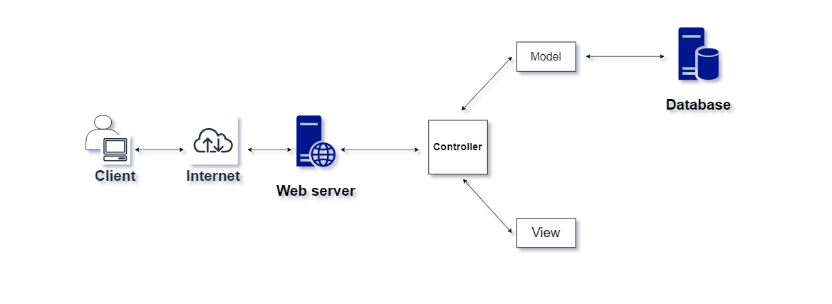

Figure Product Overview

## 2. Product Functionality:

This article section provides a selection of features organized by user role. For the three primary user types, this section outlines the system's general capabilities:

* Admin: A user with this job has access to the system's sign-in and sign-out functions as well as the ability to manage users, storeowners, and categories.
* Owner: The holder of this job has access to the system's sign-in and sign-out functions as well as the ability to manage order records, books, and categories.
* User: Users that have this role can browse books, manage shopping carts, manage accounts, and log in and out of the system.
* Guest: use as registration, view all books, view book details, search books

# IV. Specific Requirements

## 1. Functional Requirements: (P1)

### a. The following are some website functional requirements:

**Customer**:

* Sign in/out
* Manage your profile:
* See your profile to view it.
* Edit your profile to reflect new information.

- Cart management

- Add to cart to purchase the item.

**Guest:**

* Search book by title/ category: use to search for a specific book that have the title relate to the keyword and use to search for a specific book that have the category relate to the keyword.
* View book: This feature allow user to view a specific book.
* Register: this feature allow user to create an account.

**Owner:**

* **Sign in/out**
* **Manage Category for the Shop Owner**: This feature enables the business owner to manage categories and submit requests for the addition of new categories.
* **Manage Book:** This function lets the storeowner handle the books.
* **Add book:** use to add new book.
* **Update book:** use to add new information to a book that is already available.
* **Delete book:** used to remove a book from your library**.**
* **Book search**: use this to look up a specific book.
* **View book:** use this to see a book's details.
* **Manage Order Records:** With this function, storeowners may take control of order records.
* To view the order record, utilize the view order records
* See order records in detail: Use this to see the order records in detail.
* Remove order records: Use this to remove a record of an active order.

**Administrator:**

* **Sign in/out**
* **Manage Users:** This function enables administrators to control user accounts.
* **Update password account:** Use this function to modify a user account's password.
* **View all user account information**: Use this to access all user account information that is available.
* **Manage Shop Owner:** This function enables administration to control storeowner accounts.
* Update a specific password for a storeowner account using this method.
* Create a new account as a storeowner using this method.
* See all available storeowner accounts' information about their accounts by using this tool.
* **Manage Category:** With this tool, administrators can manage categories.
* **Reject category request:** Use this option to turn down a storeowner’s request to add a new category
* **Approve category request:** Use this function to accept a request from the storeowner to add a new category.

### b.Use Case Model: (P1)

|  |  |  |
| --- | --- | --- |
| **Table of Use Case Diagram Symbols** | | |
| **Symbol** | **Name** | **Describe** |
|  | System Boundary | The System Boundary lays out the specifications for the system we are creating. Actors are the additional objects that interact with this system. When complicated systems are divided into smaller ones for analysis and design, the System Boundary will make it simpler for us to comprehend them. |
|  | Extend | Use extends to explain how two use cases are related to one another. When a Use Case is developed to add functionality to an already existing Use Case and is used in a certain circumstance, the Extend connection is used. |
|  | Include | Include denotes a necessary connection between Use Cases. |
|  | Actor | Any object or person that engages in system interaction is referred to as an actor. Each Actor that interacts with your website could be a user, a business, or an outside system. |
|  | Use Case | The use case will be the location in the system where the admin will carry out his functions. |
|  | Association | It is common to use the term "association" to express the connection between an Actor and a Use Case as well as between Use Cases. |

**Guest:**

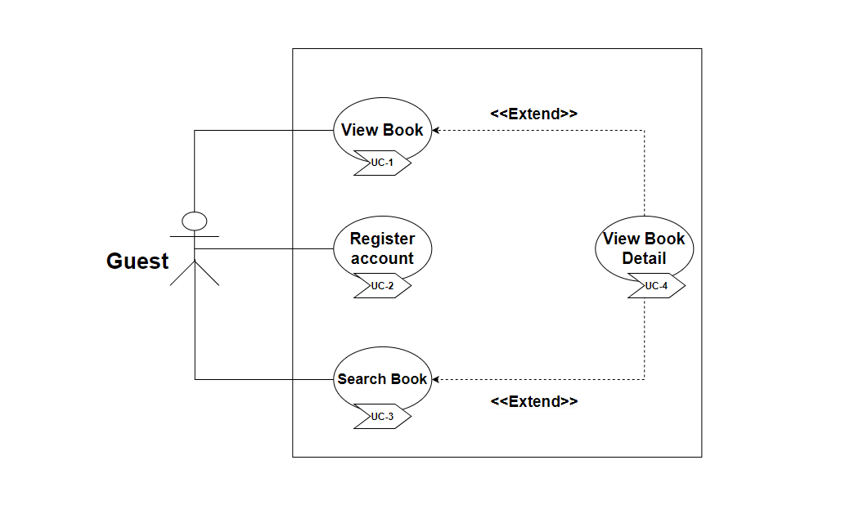

Figure Use case guest

|  |  |  |
| --- | --- | --- |
| **Use Case Name:** View Book | **ID: UC- 1** | **Priority:** High |
| **Actor:** Guest | | |
| **Description:** This use case demonstrates how to view a book using the book view extension's additional details. | | |
| **Trigger:** User want to search book.  **Type:** External | | |
| **Pre-Condition:**  **•** The website is now functioning  **•** The user's device has established a network connection. | | |
| **Alternative Flow**: N/A | | |
| **Post-Condition:**  **•** The user must fill out all of the required information, which will be displayed one by one.  **•** The book that has the pertinent term will be shown**.** | | |
| **Exception:** N/A | | |

|  |  |  |
| --- | --- | --- |
| **Use Case Name:** Register account | **ID: UC-2** | **Priority:** High |
| **Actor:** Guest | | |
| **Description:** This use case demonstrates how a user may create a new account and includes the book view extension as an added detail. | | |
| **Trigger:** The user wants to create a new account and add the book view extension as an additional detail.  **Type:** External | | |
| **Pre-Condition:**  **•** The website is now functioning  **•** The user's device has established a network connection. | | |
| **Normal Course:**  **•** System access for users.  • Choose a registration strategy. | | |
| **Alternative Flow:** N/A | | |
| **Post-Condition:** The user must fill out all of the required information, which will be displayed one by one. | | |
| **Exception:**  If the user enters nothing or enters the incorrect format, a warning message stating "Please enter the right format" will appear. | | |

|  |  |  |
| --- | --- | --- |
| **Use Case Name:** Search Book | **ID: UC-3** | **Priority:** High |
| **Actor:** Guest | | |
| **Description:** This use case demonstrates how a user can search a book. | | |
| **Trigger:** User want to search book.  **Type:** External | | |
| **Pre-Condition:**  **•** The website is now functioning.  **•** The user's device has established a network connection. | | |
| **Normal Course:**  **•** Choose the"Search book by title" option.  **•** Type book into search.  • The View book is show. | | |
| **Alternative Flow:** N/A | | |
| **Post-Condition:**  **•** The user must fill out all of the required information, which will be displayed one by one.  • The book with the relevant keyword entered will be displayed. | | |
| **Exception:** N/A | | |

|  |  |  |
| --- | --- | --- |
| **Use Case Name:** View Book Detail | **ID: UC-4** | **Priority:** High |
| **Actor:** Guest | | |
| **Description:** The user can view book detail using this use case. | | |
| **Trigger:** User desires to examine book details.  **Type:** External | | |
| **Pre-Condition:**  The website is now functioning  **•** The user's device has established a network connection. | | |
| **Normal Course:**  System access for users to the system  **•** User needs to Select Registration | | |
| **Alternative Flow:** N/A | | |
| **Post-Condition:**  **•** Display the page where you can see the book's details and its information. | | |
| **Exception:** N/A | | |

**Customer:**

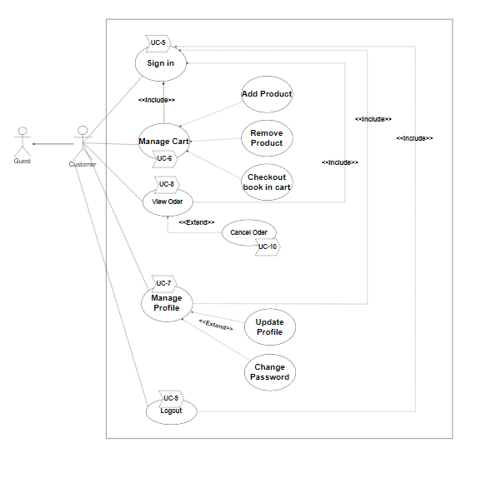

Figure : Owner user case

|  |  |  |
| --- | --- | --- |
| **Use Case Name:** Manage cart | **ID: UC-5** | **Priority:** High |
| **Actor:** Customer |  |  |
| **Description:** The user can access three main options with this use case. | | |
| **Trigger:** User want to access one of the three primary options and use it.  **Type:** External | | |
| **Pre-Condition:**   * There are already user accounts * The user's accounts have been approved. * A network connection has been established by the user's device. * The website is now operational. | | |
| **Normal Course:**  **•** The phrase "Manage cart" appears. | | |
| **Alternative Flow:** N/A | | |
| **Post-Condition:**  **•** A menu with the choices "Update cart," "Payment," and "Delete cart" will appear. | | |
| **Exception:** N/A | | |

|  |  |  |
| --- | --- | --- |
| **Use Case Name:** Manage Cart | **ID: UC-6** | **Priority:** High |
| **Actor:** Customer |  |  |
| **Description:** The use case explains how customers can manage their shopping cart's features.  Add, Remove, and Checkout a Book | | |
| **Trigger:** When the customer wants to manage their cart  **Type:** External | | |
| **Pre-Condition:**   * There are already user accounts * The user's accounts have been approved. * A network connection has been established by the user's device. * The website is now operational. * Customer must be have an account | | |
| **Normal Course:**  **-**Access by customers to the FPTBook website  -Login into their account  -Managing the cart | | |
| **Alternative Flow:** N/A | | |
| **Post-Condition:**  **-**If a customer adds a book to their cart, the book will be included.  I-f a consumer removes a book from their cart, the book will also be removed. | | |
| **Exception:** N/A | | |

|  |  |  |
| --- | --- | --- |
| **Use Case Name:** Manage Profile | **ID: UC-7** | **Priority:** High |
| **Actor:** Customer |  |  |
| **Description:** The use case explains how customers can manage their personal information. Edit, change, or see a profile | | |
| **Trigger:** When the customer wants to manage their profile  **Type:** External | | |
| **Pre-Condition:**   * There are already user accounts * The user's accounts have been approved. * A network connection has been established by the user's device. * The website is now operational. * Customer must be have an account | | |
| **Normal Course:**  **-**Access by customers to the FPTBook website  -Login into their account  -Managing the cart | | |
| **Alternative Flow:** N/A | | |
| **Post-Condition:**  If customer view profile, their information account will be displayed | | |
| **Exception:** N/A | | |

|  |  |  |
| --- | --- | --- |
| **Use Case Name:** View Order | **ID: uc-8** | **Priority:** Medium |
| **Actor:** Customer | | |
| **Description:** The customer wants to view their order | | |
| **Trigger:**  **Type:** External | | |
| **Pre-Condition:**  1. The customer’s devices must connect to internet  2. The FPT Book website must be available for customer  3. Login successfully | | |
| **Normal Course:**  1. Login with their account  2. Click on the View Order on the navigation of the FPT Book website | | |
| **Alternative Flow:** N/A | | |
| **Post-Condition:** N/A | | |
| **Exception:** N/A | | |

|  |  |  |
| --- | --- | --- |
| **Use Case Name:** Cancel Order | **ID:** uc-10 | **Priority:** Medium |
| **Actor:** Customer | | |
| **Description:** The customer wants to cancel the order that they ordered | | |
| **Trigger:**  **Type:** External | | |
| **Pre-Condition:**  1. The customer’s devices must connect to internet  2. The FPT Book website must be available for customer  3. Login successfully | | |
| **Normal Course:**  1. Login with their account  2. Click on the View Order on the navigation of the FPT Book website  3. Click on the Cancel button in each order that they want to cancel | | |
| **Alternative Flow:** N/A | | |
| **Post-Condition:** The message cancel success will be appeared | | |
| **Exception:** N/A | | |

|  |  |  |
| --- | --- | --- |
| **Use Case Name:** Logout | **ID: uc-9** | **Priority:** Medium |
| **Actor:** Customer | | |
| **Description:** The customer wants to log out | | |
| **Trigger:**  **Type:** External | | |
| **Pre-Condition:**  1. The customer’s devices must connect to internet  2. The FPT Book website must be available for customer  3. Login successfully | | |
| **Normal Course:**  1. Login with their account  2. Click on Logout on the navigation of FPT Book website | | |
| **Alternative Flow:** N/A | | |
| **Post-Condition:** N/A | | |
| **Exception:** N/A | | |

**Admin:**

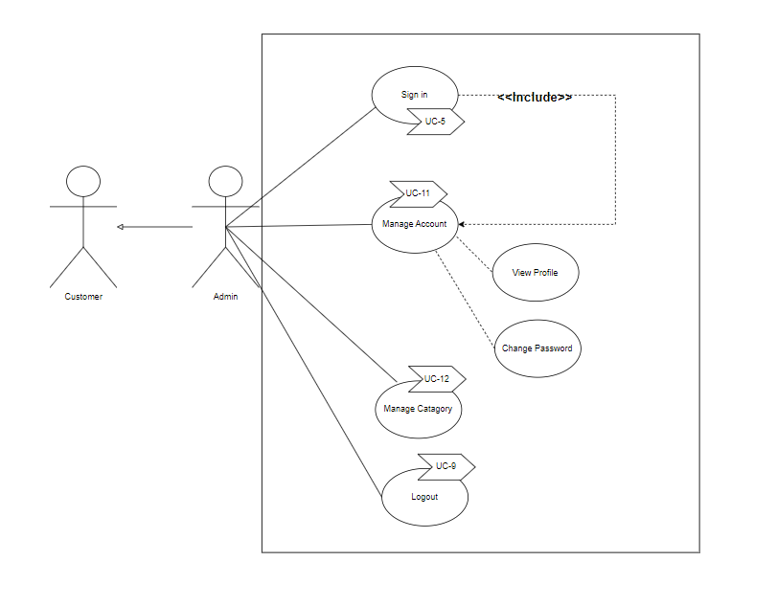

Figure Admin use case

|  |  |  |
| --- | --- | --- |
| **Use Case Name:** Manage Account | **ID: UC-11** | **Priority:** High |
| **Actor:** Admin |  |  |
| **Description: :** The use case describe how to admin manage account about Reset Password/View Account | | |
| **Trigger:** When the customer wants to manage account  **Type:** External | | |
| **Pre-Condition:**   * . Admin’s device must connect to internet * The FPTBook website must be available * Admin logged in their account * The website is now operational. * Admin must be have an account | | |
| **Normal Course:**  **-**Access by admin to the FPTBook website  -Login into their account  -Admin clicks Account in management from navigation of the website  -Action to manage account | | |
| **Alternative Flow:** N/A | | |
| **Post-Condition:**  There is a list information about accounts of customer, store owner, and admin | | |
| **Exception:** N/A | | |

|  |  |  |
| --- | --- | --- |
| **Use Case Name: Manage Category** | **ID: uc-12** | **Priority:** High |
| **Actor:** Admin | | |
| **Description:** In this use case, the admin can manage the category. admin can confirm the category | | |
| **Trigger:** Admin login to FPT Book website  **Type:** External | | |
| **Pre-Condition:**  1. The admin’s devices must connect to internet  2. The FPT Book website must be available for admin  3. The admin must login successfully | | |
| **Normal Course:**  1. Admin login to FPT Book website  2. Click on the Manage Category | | |
| **Alternative Flow:** N/A | | |
| **Post-Condition:** N/A | | |
| **Exception:** N/A | | |

**Owner:**

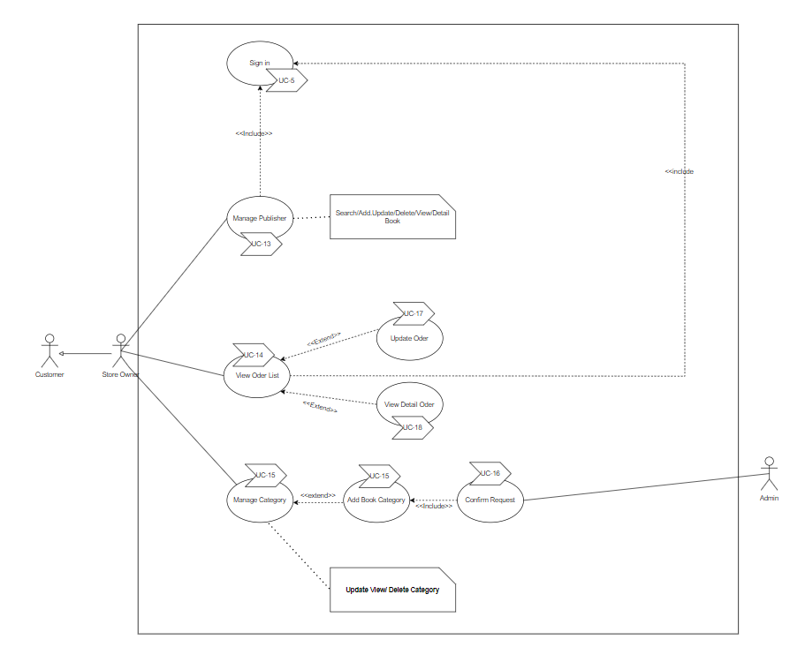

Figure Owner user case

|  |  |  |
| --- | --- | --- |
| **Use Case Name:** Manage Publisher | **ID:** **uc-13** | **Priority:** High |
| **Actor:** Owner | | |
| **Description:** In this use case, the owner can manage the publisher. Owner can add, update, and delete publisher | | |
| **Trigger:** Owner login to FPT Book website  **Type:** External | | |
| **Pre-Condition:**  1. The owner’s devices must connect to internet  2. The FPT Book website must be available for owner  3. The owner must login successfully | | |
| **Normal Course:**  1. Owner login to FPT Book website  2. Click on the Manage Publisher | | |
| **Alternative Flow:** N/A | | |
| **Post-Condition:** N/A | | |
| **Exception:** N/A | | |

|  |  |  |
| --- | --- | --- |
| **Use Case Name:** View Odelish | **ID:** **uc-14** | **Priority:** High |
| **Actor:** Owner | | |
| **Description:** The use case describe how to store owner view order lis | | |
| **Trigger:** When a store owner clicks Order in Management from the website's navigation  **Type:** External | | |
| **Pre-Condition:**  1. The owner’s devices must connect to internet  2. The FPT Book website must be available for owner  3. Store owner logged in their account | | |
| **Normal Course:**  1. Owner login to FPT Book website  2. Click on the Manage Publisher | | |
| **Alternative Flow:** N/A | | |
| **Post-Condition:** N/A | | |
| **Exception:** N/A | | |

|  |  |  |
| --- | --- | --- |
| **Use Case Name: Add Category** | **ID: uc-15** | **Priority:** High |
| **Actor:** Owner | | |
| **Description:** In this use case, the owner can add a new category | | |
| **Trigger:** Owner login to FPT Book website  **Type:** External | | |
| **Pre-Condition:**  1. The owner’s devices must connect to internet  2. The FPT Book website must be available for owner  3. The owner must login successfully | | |
| **Normal Course:**  1. Owner login to FPT Book website  2. Click on the Manage Category | | |
| **Alternative Flow:** N/A | | |
| **Post-Condition:** N/A | | |
| **Exception:** N/A | | |

|  |  |  |
| --- | --- | --- |
| **Use Case Name: Confirm Request** | **ID: uc-16** | **Priority:** High |
| **Actor:** Owner | | |
| **Description:** The admin has the option to accept, refuse, or confirm the category that the user wants to add in this use case. This means that the admin may affirm, refuse, or approve a new category when the owner adds one. The category will be added with the status set to public if the admin agrees. Contrarily, if the administrator rejects, the category will not be introduced and its status will be denied. | | |
| **Trigger:** Owner login to FPT Book website  **Type:** External | | |
| **Pre-Condition:**  1. The owner’s devices must connect to internet  2. The FPT Book website must be available for owner  3. The owner must login successfully | | |
| **Normal Course:**  1. Owner login to FPT Book website  2. Click on the Manage Category  3. To confirm the category, click the Accept or Deny option. | | |
| **Alternative Flow:** N/A | | |
| **Post-Condition:** N/A | | |
| **Exception:** N/A | | |

|  |  |  |
| --- | --- | --- |
| **Use Case Name: View Oder List** | **ID: uc-17** | **Priority:** High |
| **Actor:** Owner | | |
| **Description:** The admin has the option to accept, refuse, or confirm the category that the user wants to add in this use case. This means that the admin may affirm, refuse, or approve a new category when the owner adds one. The category will be added with the status set to public if the admin agrees. Contrarily, if the administrator rejects, the category will not be introduced and its status will be denied. | | |
| **Trigger:** Owner login to FPT Book website  **Type:** External | | |
| **Pre-Condition:**  1. The owner’s devices must connect to internet  2. The FPT Book website must be available for owner  3. The owner must login successfully | | |
| **Normal Course:**  1. Owner login to FPT Book website  2. Click on the Manage Category  3. To confirm the category, click the Accept or Deny option. | | |
| **Alternative Flow:** N/A | | |
| **Post-Condition:** N/A | | |
| **Exception:** N/A | | |

|  |  |  |
| --- | --- | --- |
| **Use Case Name: View Detail Oder** | **ID: uc-18** | **Priority:** High |
| **Actor:** Owner | | |
| **Description:** The use case explains how to view details for store owners. | | |
| **Trigger:** When the store owner clicks Detail button in view order list page  **Type:** External | | |
| **Pre-Condition:**  1. The owner’s devices must connect to internet  2. The FPT Book website must be available for owner  3. The owner must login successfully | | |
| **Normal Course:**  1. Owner login to FPT Book website  2. Click on the Manage Category  3. Shop owner access to the page with the order list  4. On the view order list page, the owner hits the Detail button. | | |
| **Alternative Flow:** N/A | | |
| **Post-Condition:** N/A | | |
| **Exception:** N/A | | |

|  |  |  |
| --- | --- | --- |
| **Use Case Name: View Update Oder** | **ID: uc-19** | **Priority:** High |
| **Actor:** Owner | | |
| **Description:** The use case describe how to store owner update ooder | | |
| **Trigger:** When a store owner selects the Update button on the page for viewing orders  **Type:** External | | |
| **Pre-Condition:**  1. The owner’s devices must connect to internet  2. The FPT Book website must be available for owner  3. The owner must login successfully | | |
| **Normal Course:**  1. Owner login to FPT Book website  2. Click on the Manage Category  3. Shop owner access to the page with the order list  4. Owner selects Update on the page that displays the order list.  5. Type accurate information and press the submit button. | | |
| **Alternative Flow:** N/A | | |
| **Post-Condition:** N/A | | |
| **Exception:** N/A | | |

* **Wireframe:**
* **Admin:**

**Manage Category (Admin):**

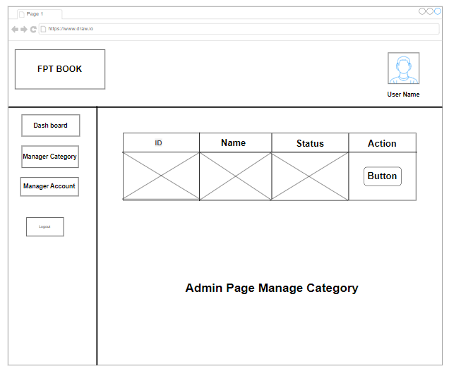

Figure Admin Page Manage Category

**Manage Account Store Owner (Admin):**

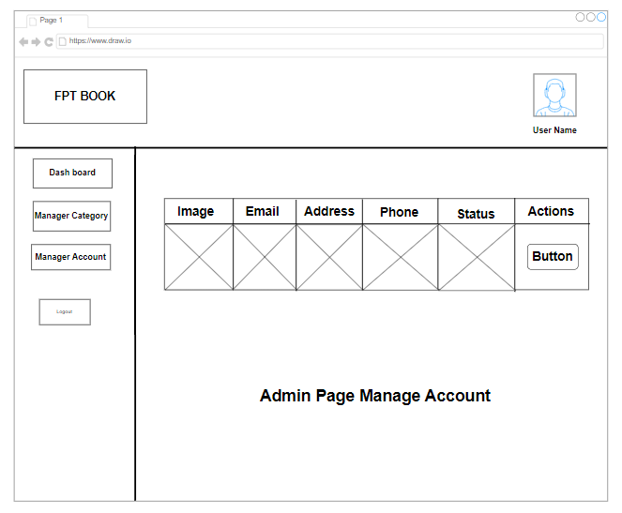

Figure Admin Page Manage Account

**Admin Page:**

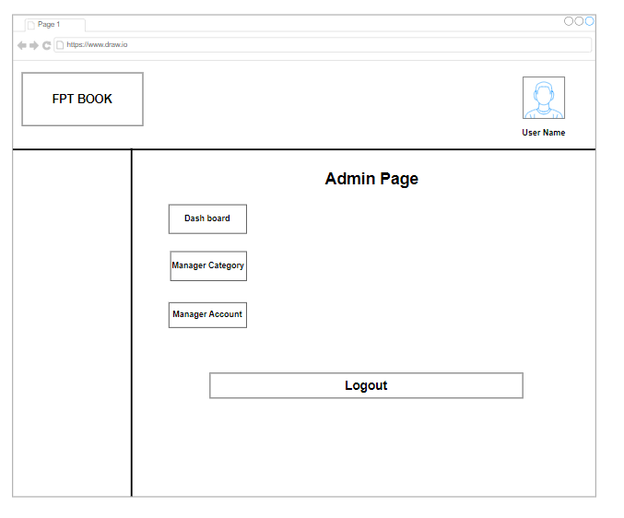

Figure Admin Page

**Update Profile: (Admin)**

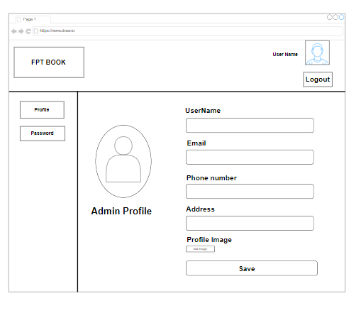

Figure Admin Profile

**Update Password: (Admin)**

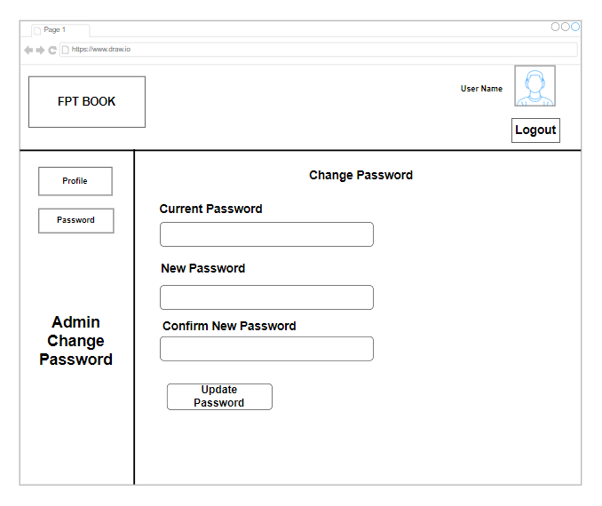

Figure Change Password for Admin

* **Store Owner:**

**Store Owner Page:**

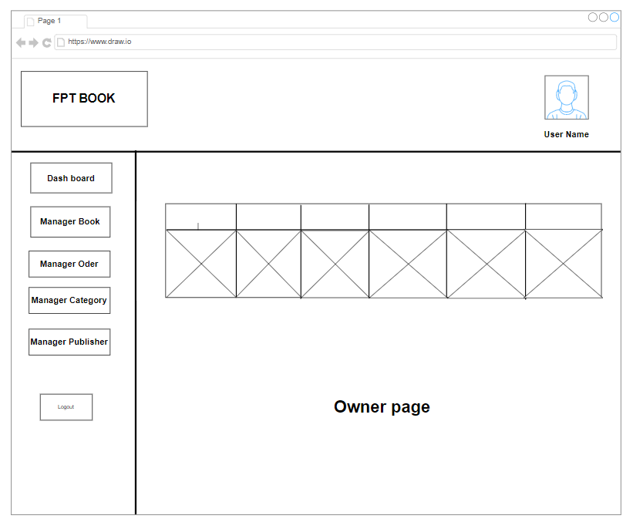

Figure Owner Page

**Profile Store Owner:**

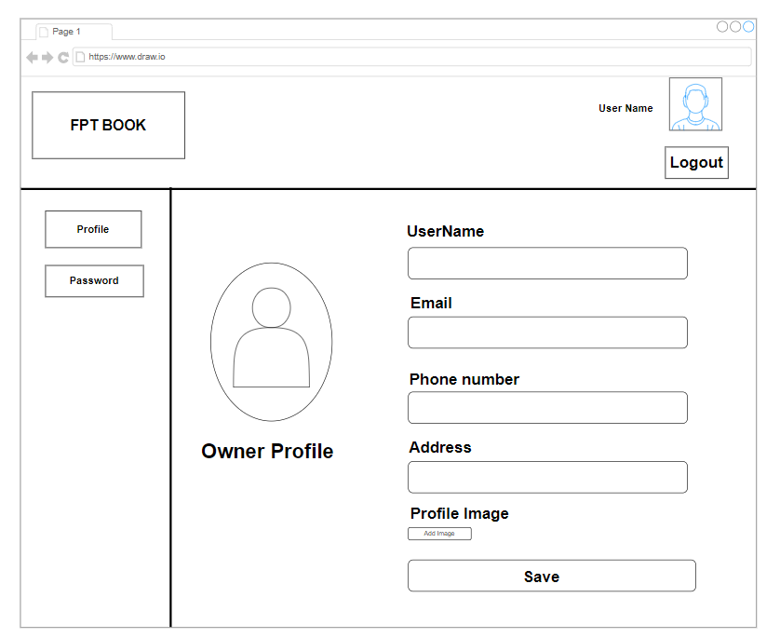

Figure Owner Profile

**Update Password ( Store owner):**

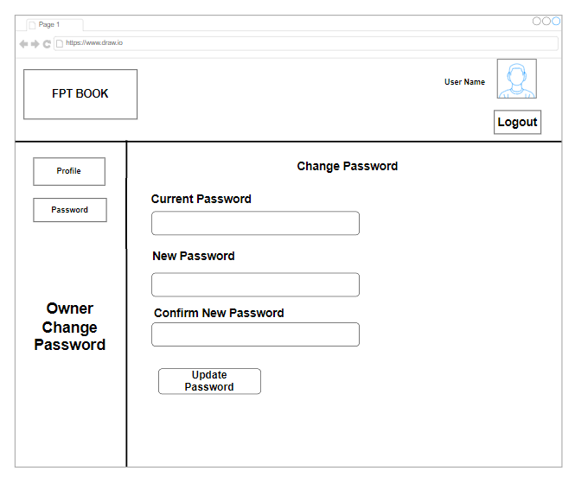

Figure Owner Change Password

**Manager Book (Store owner):**

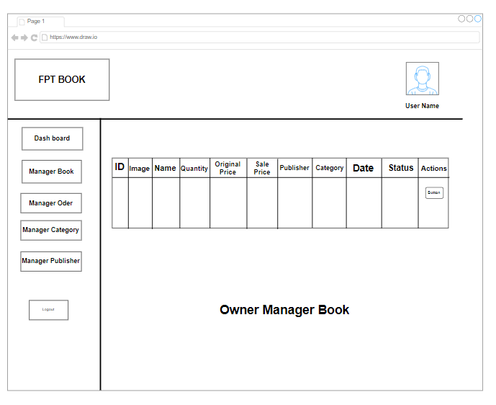

Figure Owner Manager Book

**Manager category (Store owner):**

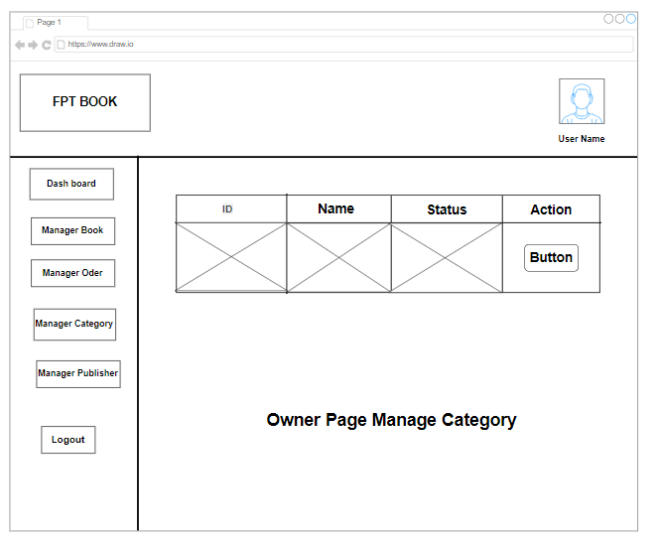

Figure Owner Page Manage Category

**Manager Page Publisher ( Store owner):**

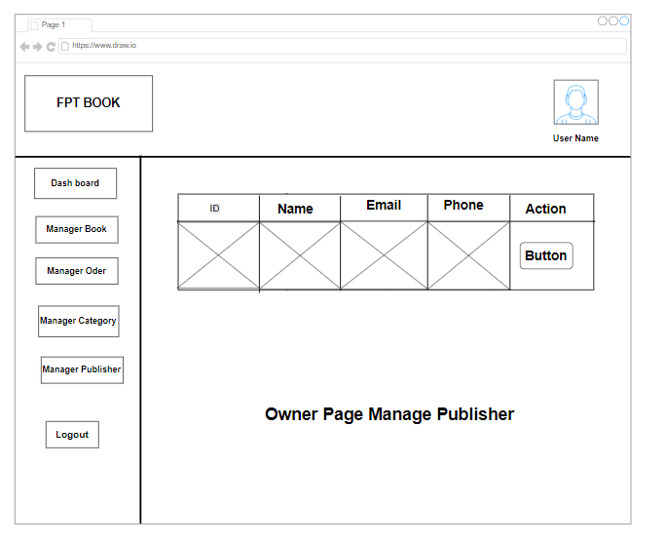

Figure Owner Page Manage Publisher

* **User:**

**User Profile:**

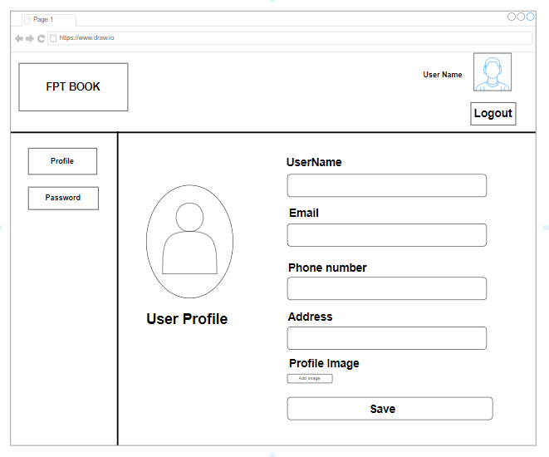

Figure Use Profile

**Change Password (User):**

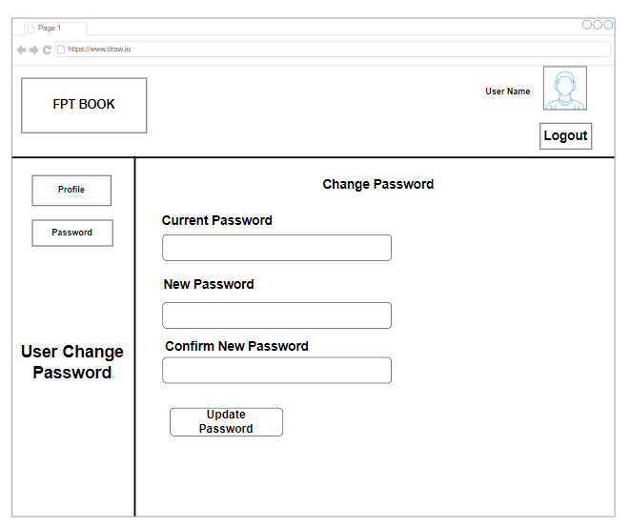

Figure Use Change Password

**Cart Page:**

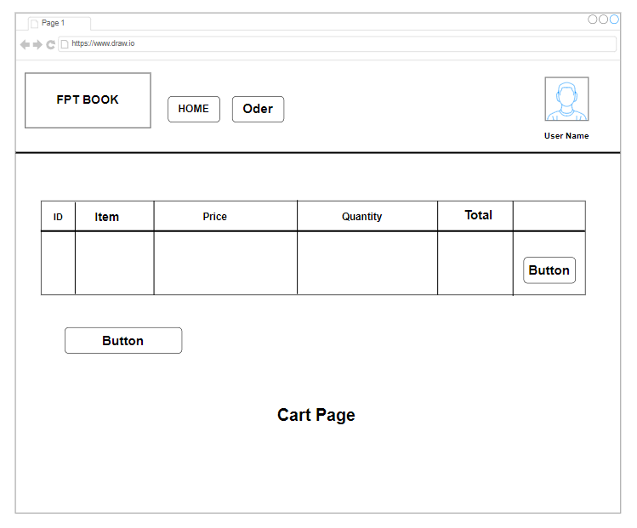

Figure Use Change Password

* **Home Page:**

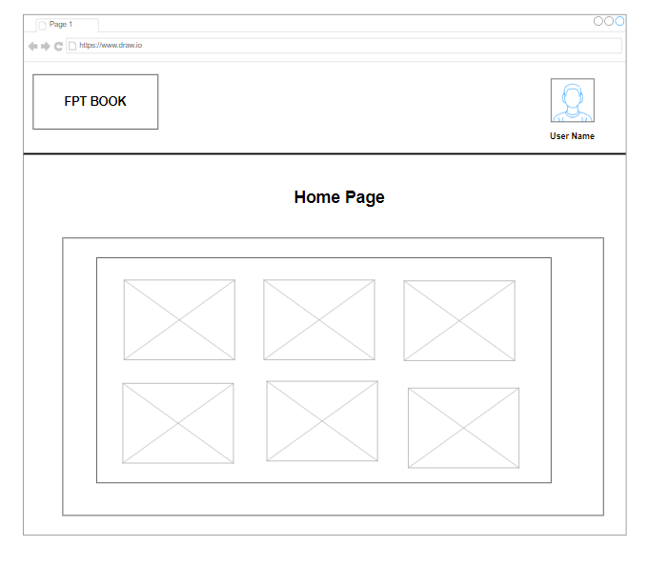

Figure Home Page

**Register Page:**

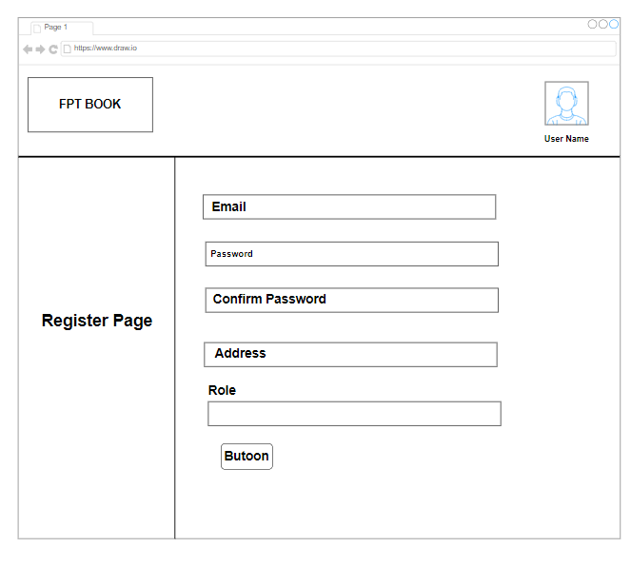

Figure Register Page

**Sign in Page:**

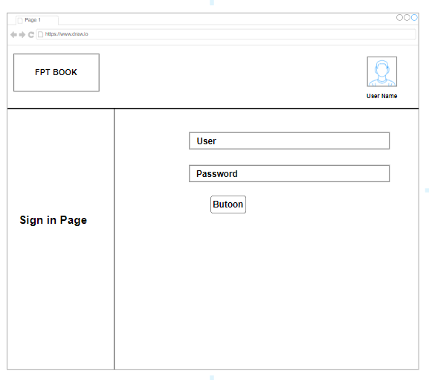

Figure Sign In Page

**Detail book:**

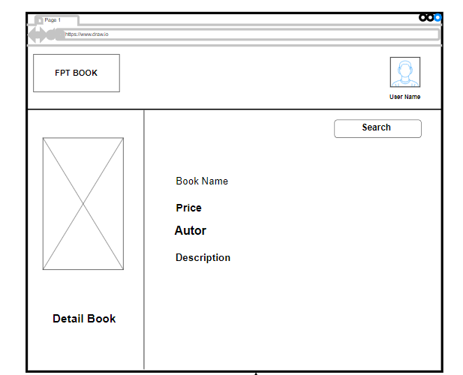

Figure Detail Book Page

### c. Wireflow: (P1)

**Guest:**

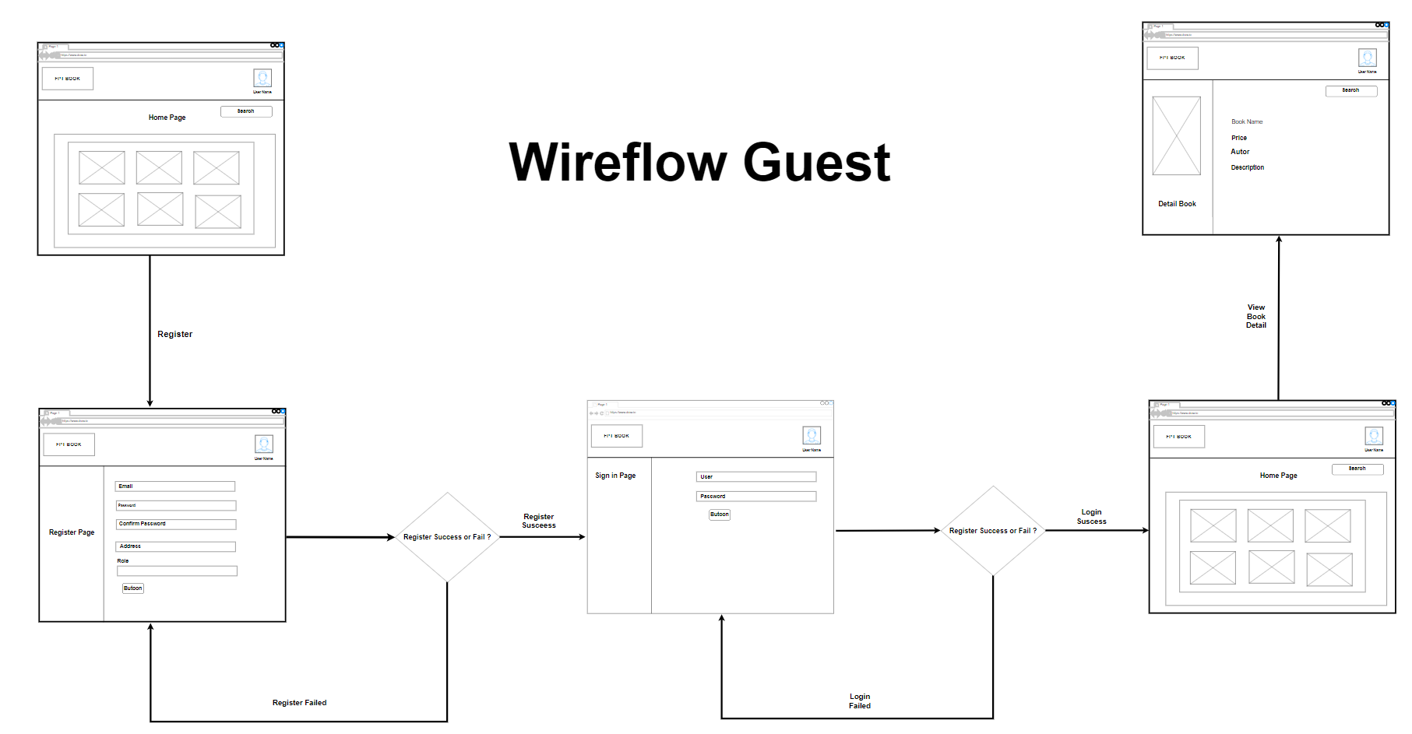

Figure 20 Wireflow Guest

* **Owner:**

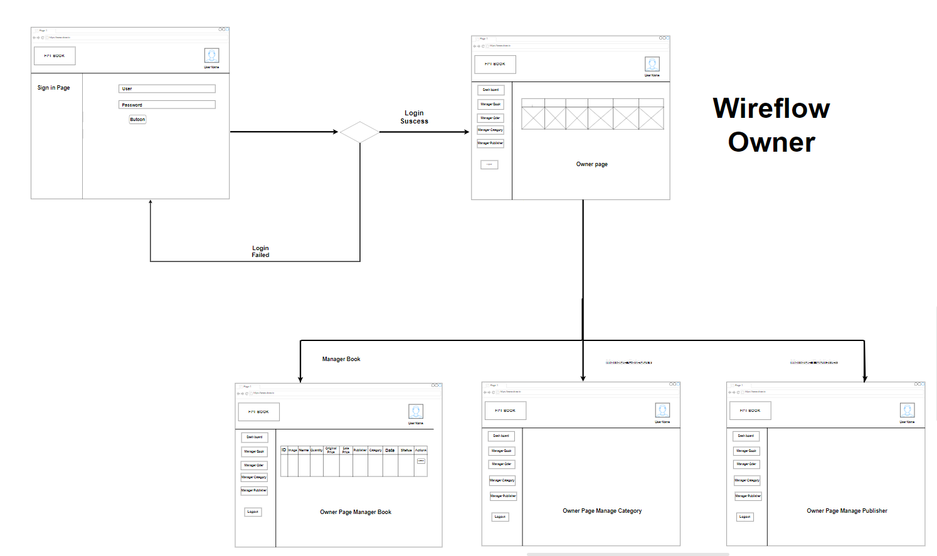

Figure 21 Wireflow Owner

* **Customer:**

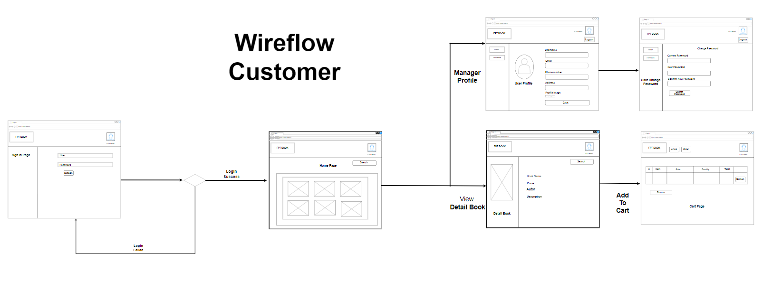

Figure 22 Wireflow Customer

* **Admin:**

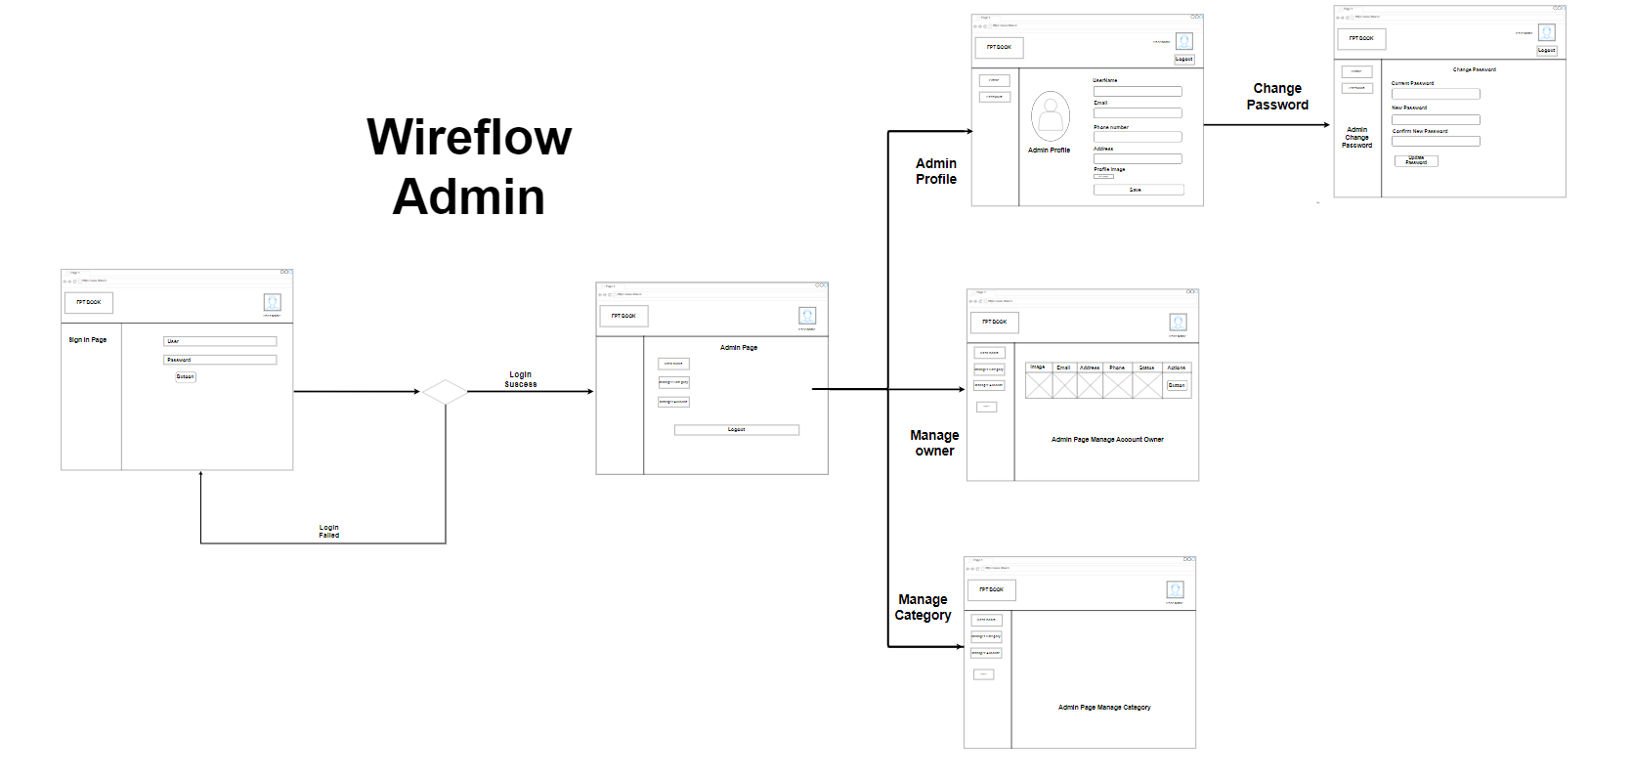

Figure 23 Wireflow Admin

# V. Risk Assessment (P2)

|  |  |  |  |  |  |  |  |  |  |  |  |  |
| --- | --- | --- | --- | --- | --- | --- | --- | --- | --- | --- | --- | --- |
| **NAME** | | | FPTBook's Risk Management Matrix | | | **OBJECTIVE** | | FPT BOOK | | | | |
|  |  |  | |  |  |  |  | |  |  |  |  |
| **REF / ID** | **P R E - M I T I G A T I O N** | | | | | **DEPARTMENT / LOCATION** | **MITIGATIONS / WARNINGS / REMEDIES** | | **P O S T - M I T I G A T I O N** | | | |
| **RISK** | **RISK SEVERITY** | | **RISK LIKELIHOOD** | **RISK LEVEL** | **RISK SEVERITY** | **RISK LIKELIHOOD** | **RISK LEVEL** | **ACCEPTABLE TO PROCEED?** |
|  |  | * ACCEPTABLE * TOLERABLE * UNDESIRABLE * INTOLERABLE | | * IMPROBABLE * POSSIBLE * PROBABLE | **LOW**  **MEDIUM**  **HIGH**  **EXTREME** |  |  | | * ACCEPTABLE * TOLERABLE * UNDESIRABLE * INTOLERABLE | * IMPROBABLE * POSSIBLE * PROBABLE | **LOW**  **MEDIUM**  **HIGH**  **EXTREME** | YES / NO |
| **1** | Lack of internal capacity at an early stage | UNDESIRABLE | | POSSIBLE | **MEDIUM** | Enterprise | Personnel from RSC and Becta are involved to launch the process.  Training the trainers. | | TOLERABLE | IMPROBABLE | **LOW** | **YES** |
| **2** | The customer experience (CX) is everything these days. If our site is slow to load, if visitors can’t find what they’re looking for, our site is difficult to navigate or understand, or if our content (images, descriptions, blogs, etc.) is low-quality, most won’t hesitate to click away and they probably won’t return. | UNDERSIRABLE | | POSSIBLE | **HIGH** | Business analyst | * Invest time and effort into improving your website and store design. * Make sure our eCommerce store is responsive meaning it is mobile friendly and looks and performs the same on any device. * Put our most popular products up front and create landing pages for all our ads. | | TOLERABLE | PROBABLE | **MEDIUM** | **NO** |
| **3** | Failure to achieve consensus on aim among all parties | UNDESIRABLE | | POSSIBLE | **HIGH** | Execute stakeholder | - Defining the needs of the stakeholders and creating a strategy with clear objectives. - Using good project management techniques. | | TOLERABLE | PROBABLE | **MEDIUM** | **NO** |
| **4** | Health and safety risk | ACCEPTABLE | | IMPROBABLE | **HIGH** | IT rooms | An organization's health and safety policies should be reviewed and assessed on a regular basis to identify potential hazards that could lead to costs or penalties. | | ACCEPTABLE | IMPROBABLE | **MEDIUM** | **YES** |
| **5** | Lack of worker commitment and buy-in | TOLERABLE | | IMPROBABLE | **MEDIUM** | Enterprise | - Plan for clear communications. - Staff development event for staff members with encouraged twoway participation. - This incident adds more information to this risk analysis. | | TOLERABLE | IMPROBABLE | **LOW** | **NO** |
| **6** | Not everybody needs to have access to all company files. Unauthorized access accounts for a significant amount of data loss.  Sometimes it’s innocent, sometimes not so much. | INTOLERABLE | | PROBABLE | **HIGH** | Security team | * Restrict access: Employees should only be able to access the files they need. * Use a single-sign-on solution: Single sign-on enables you to restrict and monitor access to company files. * Implement role-based access: | | ACCEPTABLE | IMPROBABLE | **LOW** | **YES** |
| **7** | Time Risk | ACCEPTABLE | | IMPROBABLE | **HIGH** | IT rooms | Sort each component of a schedule into categories based on how unpredictable it is. because using a deterministically irrelevant procedure introduces greater uncertainty. The project management team can provide cost-effective solutions that, among other things, can save costs and improve performance with early detection of this. | | ACCEPTABLE | IMPROBABLE | **MEDIUM** | **YES** |
| **8** | Problems related to human resources | ACCEPTABLE | | IMPROBABLE | **HIGH** | IT rooms | A crucial backup strategy is to create a structure of backup teams that can be used if there is a manpower shortage. | | ACCEPTABLE | IMPROBABLE | **MEDIUM** | **YES** |
| **9** | Conflicting Staff Development plans and / or needs | UNDESIRABLE | | PROBABLE | **MEDIUM** | Executive sponsor | - Examine current staff development programs and look for integration possibilities. - Build FPP into the performance management and appraisal processes (this takes time). - Prioritisation and negotiation. - Bring up any potential conflict during steering board meetings | | TOLERABLE | POSSIBLE | **MEDIUM** | **NO** |

Figure 24 FPTBook's Risk Management Matrix

## 1. Design Tools (P3)

### a. Visual Studio 2022:

An integrated development environment (IDE) made by Microsoft is called Visual Studio. It is employed in the creation of computer programs, websites, web applications, online services, and mobile applications. Microsoft's software development platforms, including Windows Store, Windows Presentation Foundation, Windows API, and Windows Forms, are used by Visual Studio. Both native and managed code may be produced by it.

A code editor that supports code refactoring and IntelliSense (the code completion feature) is a feature of Visual Studio. Both a source-level debugger and a machine-level debugger may be used with the integrated debugger. A code profiler, designer for creating GUI apps, web designer, class designer, and database schema designer are further built-in tools. It accepts plug-ins that add functionality at nearly every level, including support for source control systems (like Subversion and Git) and the addition of new toolkits, such as editors and visual designers for domain-specific languages or toolkits for different stages of the software development lifecycle (such as the Azure DevOps client: Team Explorer).

If a language-specific service is available, Visual Studio enables the code editor and debugger to support (to varied degrees) practically every programming language. It currently supports 36 distinct programming languages. C, C++, C++/CLI, Visual Basic.NET, C#, F#, JavaScript, TypeScript, XML, XSLT, HTML, and CSS are just a few of the built-in languages. Through plug-ins, support for other languages including M, Node.js, Ruby, Python, and others is possible. In the past, Java (and J#) were supported.



(visualstudio, 2022)

**Visual Studio 2022 unique features:**

**Improved Code-Completion Functionality:**

Intellicode in VS 2022 can fill in whole lines of code using an improved understanding of coding context.

In the current preview mode, this works only with C# but Microsoft will be adding additional languages as the official release date approaches.

**More Powerful Debugging Capabilities:**

The core debugger simplifies decompiling code by providing an easier-to-read step-by-step, contingent breakpoint, and flame charts to assist programmers in locating issues with both local and remote code.

**An Improved Programming Interface:**

Visual Studio 2022 offers a more user-friendly and intuitive coding environment.

This includes increased options to customize the look and feel of the IDE (e.g., you can match it to your Windows theme) as well as the ability to deploy a document management system that works for you.

**Improved Accessibility:**

Visual Studio 2019 had several features that improved overall accessibility, and VS 2022 improved and added even more accessibility features.

Instead of relying on plugins or add-ons, users can modify the interface to improve visibility and organization and work better with approved extensions. This is all driven by Microsoft’s ongoing work to make their products natively accessible.

**Improved Support for the Latest Build of C++:**

VS 2022 includes the full suite of tools for C++ 20. That's the language in which Windows is written, so Windows developers should find that a welcome inclusion.

The preview notes for VS 2022 list several important improvements in the latest builds. This should make C++ programming easier in the IDE’s new release with better IntelliSense functionality and more powerful debugging and analysis abilities.

**Improved Windows App Development:**

It's now possible to use Hot Reload (first introduced in VS 2019) to update your app builds in .NET or C++ it's running. Hot Reload is a unique approach to editing your code while debugging.

In other words, it enables you to make code changes without pausing the application or restarting it. All developers have lived through or can imagine situations where this will come in handy!

You'll also find improvements to Git integration, like the ability to work natively with multiple repositories from one local installation of the IDE.

For developers building containerized applications, further capabilities are promised for working on or orchestrating projects using Kubernetes, Docker, and Service Fabric.

The documentation isn't very specific about what these will entail, but there's work underway to improve the application building experience and enhance diagnostics.

(NANCY JO MELUCC, 2022)

### b. Draw.io:

Designed by Seibert Media, draw.io is proprietary software for making diagrams and charts. The software lets you choose from an automatic layout function, or create a custom layout. They have a large selection of shapes and hundreds of visual elements to make your diagram or chart one-of-a-kind. The drag-and-drop feature makes it simple to create a great looking diagram or chart.

Draw.io has options for storing saved charts in the cloud, on a server, or network storage at a data center, depending on your needs. Their prices start at $5.00 per month for ten users, and go up to $577.50 for 5,000 users.



(computerhope, 2020)

|  |  |
| --- | --- |
| **Advantages** | **Disadvantages** |
| Easily produces good quality diagrams | Opening an existing diagram, the view is sometimes in a weird spot - zoomed in on blank space or something - so it can be disconcerting |
| Has a rich set of predefined shapes for all sorts of different diagramming needs | Z order of shapes can be tricky to manage |
| Allows grouping of shapes |  |
| Smart connectors |  |
| Integrates with Google Drive |  |
| Conveniently exports to a variety of formats |  |
| Allows for collaborative development of diagrams |  |

(AUGUST, 2020)

### c. Front End technology stack

* **HTML:**

HTML stands for HyperText Markup Language. It is a standard markup language for web page creation. It allows the creation and structure of sections, paragraphs, and links using HTML elements (the building blocks of a web page) such as tags and attributes.

HTML has a lot of use cases, namely:

Web development. Developers use HTML code to design how a browser displays web page elements, such as text, hyperlinks, and media files.

Internet navigation. Users can easily navigate and insert links between related pages and websites as HTML is heavily used to embed hyperlinks.

Web documentation. HTML makes it possible to organize and format documents, similarly to Microsoft Word.

It’s also worth noting that HTML is not considered a programming language as it can’t create dynamic functionality. It is now considered an official web standard. The World Wide Web Consortium (W3C) maintains and develops HTML specifications, along with providing regular updates.



(hostinger, 2023)

* **Type of HTML:**

The newest version of HTML, which is entering the industry, is HTML 5. HTML can be divided into three categories: transitional, strict, and frameset. These types apply to how HTML is used, not necessarily to the selection of tags.

* **Transitional:**

Transitional is the most common type of HTML. It has a flexible syntax, or grammar and spelling component. Over the years, transitional HTML has been used without syntax restrictions, and browsers support a 'best effort' approach to reading the tags. If tags are misspelled, the browsers do not correct web developers' errors, and they display the content anyway. Browsers do not report HTML errors - they simply display what they can. This is the 'best effort' concept.

* **Strict:**

The strict type of HTML is meant to return rules into HTML and make it more reliable. For example, the strict type requires closing all tags for all opened tags. This style of HTML is important on phones, where the processing power may be limited. A clean and error-free code helps to load pages faster.

* **Frameset:**

Finally, a frameset allows web developers to create a mosaic of HTML documents where multiple documents can be connected into a single screen. This technique is often used to create a menu system. You click on a menu item on the left side of the screen, and only the right side of the screen re-loads. The menu stays in place.

(Study.com, 2022)

* **Advantages of HTML:**

**HTML is completely free:**

One of the biggest advantages of using HTML is that it is free, and no special software is required. HTML does not require any plugins, so one should not have to deal with them when working with any software.

Even with many open-source content management systems, all necessary plugins are not always free. As a result, it is incredibly cost-effective from a per-business standpoint because there is no fee for obtaining the license if the entire website is constructed in HTML.

**Every browser supports HTML**

HTML is supported by nearly all browsers worldwide such as Google, Safari, Opera, etc. So there is no need to be concerned about a website built in HTML for browser support because the website will appear in all browsers if the program remembers to optimize the website for the different browsers.

It is neither difficult nor complex to optimize an HTML-based website for browser compatibility. It gives web developers an easy way to optimize their websites for browsers.

**HTML is the most search engine friendly:**

In comparison to other web programming languages on the market, HTML is one of the most user-friendly search engines (Search Engine friendly means delivering users quality websites with relevant information when searching for a particular one).

HTML is far easier to use than other computer languages for creating SEO-compliant websites. HTML websites are more accessible for web crawlers to read and access, reducing crawling time and page load time and so enhancing website performance.

HTML generates the fewest SEO difficulties and offers the most flexibility when attempting to construct an SEO-compliant website. As long as you verify that your HTML code is clean and validated.

**HTML is Simple to Edit:**

HTML is very simple to edit because it does not require a special interface or platform. It is written in plain Notepad and can thus be easily modified in any text editor such as Notepad, Notepad++, etc.

(Piyush Singhal, 2022)

* **CSS:**

CSS stands for Cascading Style Sheets language and is used to stylize elements written in a markup language such as HTML. It separates the content from the visual representation of the site. The relation between HTML and CSS is strongly tied together since HTML is the very foundation of a site and CSS is all of the aesthetics of an entire website.



**CSS Advantages on Web Pages**

The difference between a web page that implements CSS and one that doesn’t is massive and surely noticeable.

You might have seen a website that fails to load completely and has a white background color with most of the text being blue and black. This means that the CSS part of the web page didn’t load correctly or it doesn’t exist altogether.

That’s what web pages with only HTML look like, and I think you’d agree that that’s not very appealing.

Before using CSS, all of the stylizing had to be included into the HTML markup. This means web developers had to separately describe the background color, font size, alignments, etc.

CSS lets you stylize everything on a different file, thus creating the design there and later on integrating the CSS files on top of the HTML markup. This makes the actual HTML markup much cleaner and easier to maintain.

In short, with CSS features you don’t need to repeatedly describe how individual elements look. This saves time, shortens the code, and makes it not as prone to errors.

CSS lets you have multiple styles on one HTML page, therefore making the customization possibilities almost endless. Nowadays, this is becoming more a necessity than a commodity.

**Internal, External and Inline CSS Styles**

CSS styles done this way are loaded each time an entire website is refreshed, which may increase loading time. Additionally, you won’t be able to use the same CSS style on multiple pages as it’s contained within a single page. However, this also comes with benefits. Having everything on one page makes it easier to share the template for a preview.

The External method might be the most convenient one. Everything is done externally on a .css file. This means you can do all the styling on a separate file and apply the CSS to any page you want. The External style might also improve loading times.

Lastly, we will talk about the Inline style of CSS. Inline works with specific elements that have the <style> tag. Each component has to be stylized, so it might not be the best or fastest way to handle CSS. But it can come in handy. For example, if you want to change a single element, quickly preview changes, or maybe you don’t have access to the CSS files.

(Artūras B., 2023)

### JavaScript:

JavaScript is one of the most-used programming languages. According to Northeastern University, it’s the second-most popular coding language out there. Clearly, JavaScript is an integral part of our daily online lives. But what is JavaScript exactly and what can you use it for?

Together with HTML and CSS, JavaScript is one of the three core components of the internet. Any website you visit is bound to use a combination of these three programming languages, each with its own particular purpose. Let’s have a look at them in more detail.

Hypertext Markup Language (HTML): This basic programming language forms the foundation of all websites. It allows you to create content, put it on a page, and link to other pages.

Cascading Style Sheets (CSS): This scripting language allows you to design the content on your webpage. It’s responsible for text styling, colors, fonts, and so on.

JavaScript (JS): Last but not least, JavaScript allows you to make your website interactive. It allows for all the content you created with HTML and styled with CSS to become more engaging. From clickable buttons to login options, JavaScript is what turns your website from a wall of text into an experience.



**Advantages and Disadvantages:**

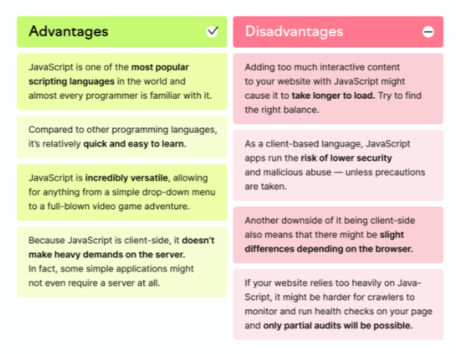

(Erika Varagouli, 2021)

**JavaScript Development Tools:**

One of major strengths of JavaScript is that it does not require expensive development tools. You can start with a simple text editor such as Notepad. Since it is an interpreted language inside the context of a web browser, you don't even need to buy a compiler.

To make our life simpler, various vendors have come up with very nice JavaScript editing tools. Some of them are listed here −

Microsoft FrontPage − Microsoft has developed a popular HTML editor called FrontPage. FrontPage also provides web developers with a number of JavaScript tools to assist in the creation of interactive websites.

Macromedia Dreamweaver MX − Macromedia Dreamweaver MX is a very popular HTML and JavaScript editor in the professional web development crowd. It provides several handy prebuilt JavaScript components, integrates well with databases, and conforms to new standards such as XHTML and XML.

Macromedia HomeSite 5 − HomeSite 5 is a well-liked HTML and JavaScript editor from Macromedia that can be used to manage personal websites effectively.

(tutorialspoint, 2022)

1. **Back End technology stack:**

**Programming Language – C#**

Modern general-purpose programming languages like C# may be used to accomplish a wide range of activities and goals across a wide range of industries. Although it may be used on an open source platform, the Windows.NET framework is where C# is most frequently utilized. This object-oriented programming language (OOP), which is incredibly flexible and relatively new to the scene, is a fan favorite.

C# is often used to develop professional, dynamic websites on the .NET platform, or open-source software. So, even if you’re not a fan of the Microsoft architecture, you can still use C# to create a fully-functional website. Because this language is object-oriented, it is often utilized to develop websites that are incredibly efficient, easily scalable and a breeze to maintain.



**Advantages of C# Programming:**

* C# programming can save you time: The time you can save by utilizing C# instead of another programming language is perhaps the biggest benefit. Users should anticipate spending less time searching through their scripts for minute problems that interfere with the operation of the application because C# is statically typed and simple to read.
* C# is easy to learn: In addition to the time you may save while developing a project, learning C# will take you less time than studying one of the more complex programming languages available. C# has a relatively short learning curve for novices because of its simplicity and user-friendly features.
* C# is scalable and easy to maintain: Programming language C# is incredibly maintainable and scalable. Because static codes must be written strictly, C# programs are consistently consistent, making them significantly simpler to modify and maintain than programs created in other languages.
* C# has a great community: It's impossible to emphasize the value of a supportive community in the field of coding and programming. Programming language platforms and services don't provide convenient IT assistance or a dedicated help line. Programmers must rely on the assistance of colleagues in the same industry who have encountered the same difficulties and annoyances.
* C# is object-oriented: C# is completely object-oriented, which is a rare characteristic for a programming language. Many of the most common languages incorporate object orientation to an extent, but very few have accomplished the magnitude of C# without losing favour from the people.

(pluralsight, 2020)

1. **Database – Microsoft SQL Server:**

A relational database management system (RDBMS) called Microsoft SQL Server serves a wide range of business intelligence, analytics, and transaction processing applications in corporate IT settings. Along with Oracle Database and IBM's DB2, Microsoft SQL Server is one of the three database technologies that dominate the industry.

SQL is a standardized programming language that database administrators (DBAs) and other IT professionals use to administer databases and query the data they contain. Microsoft SQL Server, like other RDBMS software, is built on top of SQL. Transact-SQL (T-SQL), a Microsoft implementation of SQL that enhances the basic language with a number of proprietary programming extensions, is a component of SQL Server.

**SQL Server services, tools and editions:**

Along with SQL Server, Microsoft also includes a number of data management, business intelligence (BI), and analytics tools. The data analysis services include SQL Server Analysis Services, an analytical engine that processes data for use in BI and data visualization applications, and SQL Server Reporting Services, which supports the creation and delivery of BI reports, in addition to the R Services and now Machine Learning Services technology that first appeared in SQL Server 2016.

Microsoft SQL Server comes with SQL Server Integration Services, SQL Server Data Quality Services, and SQL Server Master Data Services for data management. Two sets of tools for DBAs and developers are also included with the DBMS: SQL Server Data Tools for building databases and SQL Server Management Studio for deploying, maintaining, and monitoring databases.

**Advantages of SQL server:**

- Simple and easy: The fact that SQL doesn't need in-depth programming and coding skills is one of the factors contributing to its popularity. Basic SQL keywords like SELECT, INSERT INTO, UPDATE, and others can perform operations. The laws of syntax are straightforward and simple to understand.

- Faster Query Processing: As was already said, SQL is a relational database query language that has been accepted by ISO and ANSI. A significant benefit is the extensive, thorough, and long-standing documentation.

- Portable: It may be utilized in PCs, servers, and standalone laptops running any operating system, including Windows, Linux, and Mac, demonstrating its excellent portability. It may also be integrated into other programs.

- Highly Interactive: As it has simple commands for all purposes, it becomes an interactive language for its users. It easy to understand and the commands are also understandable to the non-programmers.



(Hughes, Adam, 2020)

### e. Microsoft IIS:

Microsoft IIS is a web server software product from Microsoft for Windows systems. It’s one of the most popular web servers, after Apache HTTP Server, NGINX, Cloud flare Server, and LiteSpeed.

You can use this secure and flexible server to host anything on the web, from applications to media streaming. It has an open architecture that makes it scalable and versatile.

IIS Web Server is a unified web platform that integrates IIS, FTP services, PHP, ASP.NET, and Windows Communication Foundation (WCF). You can use it to host your sites and services with maximum security, thanks to automatic application isolation, default sandbox configuration, and a reduced server footprint.

It also includes dynamic caching and enhanced compression to enhance the speed of your website. Additionally, the modular platform enables developers to create custom modules to extend its functionality.



(Will Morris, 2022)

**Advantages of Microsoft IIS:**

- The fact that IIS is free is one of its main benefits. Also, it's simple to set up and use.

- Other Microsoft products like Active Directory, Exchange Server, and SharePoint work nicely with IIS. IIS may also be managed remotely by users utilizing the Microsoft Management Console or the Remote Administration Tools (RAT) (MMC).

(PHIL VUOLLET, 2018)

1. **Azure:**

Microsoft Azure, formerly known as Windows Azure, is Microsoft's public cloud computing platform. It provides a broad range of cloud services, including compute, analytics, storage and networking. Users can pick and choose from these services to develop and scale new applications or run existing applications in the public cloud.

The Azure platform aims to help businesses manage challenges and meet their organizational goals. It offers tools that support all industries -- including e-commerce, finance and a variety of Fortune 500 companies -- and is compatible with open source technologies. This gives users the flexibility to use their preferred tools and technologies. In addition, Azure offers four different forms of cloud computing: infrastructure as a service (IaaS), platform as a service (PaaS), software as a service (SaaS) and serverless functions.

Microsoft charges for Azure on a pay-as-you-go (PAYG) basis, meaning subscribers receive a bill each month that only charges them for the specific resources and services they have used.



(Stephen J. Bigelow, 2022)

**Advantages of Azure:**

* Microsoft Azure is Fast-Paced Across the World: Speed is a major impact in all areas with the main three key elements as the speed of deployment, speed of operation and speed of scalability.
* Not only does ROI rise, but the effectiveness of the business unit and its results do as well. Azure will be more useful for examining the market's seasonal needs and selecting the best option for changes in revenue design.
* The most crucial item that should be provided to every consumer is security. It's not like data protection is solely required for big business. Even for our mobile devices, the data and service should be safeguarded for the small business. All users, even those who interact with consumers and other businesses, are equally protected.
* Azure separates apart from other well-known cloud service providers because to its unrivaled hybrid capabilities. It facilitates simple mobility and creates a solid, trustworthy foundation between users on-premises and the public cloud.

(Hemant Sharma, 2022)

### f. Windows 10:

Windows 10 is a Microsoft operating system for personal computers, tablets, embedded devices and internet of things devices.

Microsoft released Windows 10 in July 2015 as a follow-up to Windows 8. Windows 10 has an official end of support date of October, 2025, with Windows 11 as it's successor.

Anyone adopting Windows 10 can upgrade legacy machines directly from Windows 7 or Windows 8 to Windows 10 without re-imaging or performing intrusive and time-consuming system wipes and upgrade procedures. To upgrade from a previous version of Windows 10, IT or users run the Windows 10 OS installer, which transfers any applications and software on the previous OS, as well as settings and preferences over to Windows 10.

Organizations and users can pick and choose how they will patch and update Windows 10. IT or users can access a Windows 10 upgrade through the Windows Update Assistant to manually begin an upgrade or wait for Windows Update to offer an upgrade when it is set to run.

Windows 10 features built-in capabilities that allow corporate IT departments to use mobile device management (MDM) software to secure and control devices running the operating system. In addition, organizations can use traditional desktop management software such as Microsoft System Center Configuration Manager.



(Stephen J. Bigelow, 2022)

### g. Tools for source control management:

GitHub is a for-profit company that offers a cloud-based Git repository hosting service. Essentially, it makes it a lot easier for individuals and teams to use Git for version control and collaboration.

GitHub’s interface is user-friendly enough so even novice coders can take advantage of Git. Without GitHub, using Git generally requires a bit more technical savvy and use of the command line.

GitHub is so user-friendly, though, that some people even use GitHub to manage other types of projects – like writing books.

Additionally, anyone can sign up and host a public code repository for free, which makes GitHub especially popular with open-source projects.

As a company, GitHub makes money by selling hosted private code repositories, as well as other business-focused plans that make it easier for organizations to manage team members and security.



(kinsta, 2022)

**Advantages of Github:**

* **It makes it easy to contribute to your open source projects:**

To be honest, nearly every open-source project uses GitHub to manage their project. Using GitHub is free if your project is open source and includes a wiki and issue tracker that makes it easy to include more in-depth documentation and get feedback about your project. If you want to contribute, you just fork a project, make your changes and then send them a pull request using GitHub web interface.

* **Documentation:**

By using GitHub, you make it easier to get excellent documentation. Their help section and guides have articles for nearly any topic related to git that you can think of.

* **Showcase your work:**

Are you a developer and wishes to attract recruiters? GitHub is the best tool you can rely on for this. Today, when searching for new recruits for their project, most companies look into the GitHub profiles. If your profile is available, you will have a higher chance of being recruited even if you are not from a great university or college.

* **Markdown:**

Markdown allows you to use a simple text editor to write formatted documents. GitHub has revolutionized writing by channeling everything through Markdown: from the issue tracker, user comments, everything. With so many other programming languages to learn for setting up projects, it’s really a big benefit to have your content inputted in a format without having to learn yet another system.

* **GitHub is a repository:**

This was already mentioned before, but it’s important to note, GitHub is a repository.

What this means that it allows your work to get out there in front of the public. Moreover, GitHub is one of the largest coding communities around right now, so it’s wide exposure for your project.

* **Track changes in your code across versions:**

When multiple people collaborate on a project, it’s hard to keep track revisions—who changed what, when, and where those files are stored. GitHub takes care of this problem by keeping track of all the changes that have been pushed to the repository. Much like using Microsoft Word or Google Drive, you can have a version history of your code so that previous versions are not lost with every iteration.

* **Integration options:**

GitHub can integrate with common platforms such as Amazon and Google Cloud, services such as Code Climate to track your feedback, and can highlight syntax in over 200 different programming languages.

If you are working on an exciting project and you need help with software development, let us know! We would be happy to know more about it!

And if you are interested in software development best practices, I highly recommend you to subscribe to our monthly newsletter by clicking here.

(Ekaterina Novoseltseva, 2020)

## 2. Software Development Models:

**V-model (Validation and Verification model)**

The V-model is another linear model with associated testing activities for each level. Exceptional quality control is implied by such workflow architecture, but it also makes the V-model one of the most costly and time-consuming models. Moreover, modifications throughout development are still expensive and challenging to perform, even when faults in requirements specifications, code, and architecture can be found early. All needs are acquired from the beginning and cannot be modified, much like in the Waterfall scenario.

**Advantages of V-model:**

* Simple and easy to use.
* Testing activities like planning, test designing happens well before coding.
* This saves a lot of time. Hence higher chance of success over the waterfall model.
* Proactive defect tracking – that is defects are found at early stage.
* Avoids the downward flow of the defects.
* Works well for small projects where requirements are easily understood.

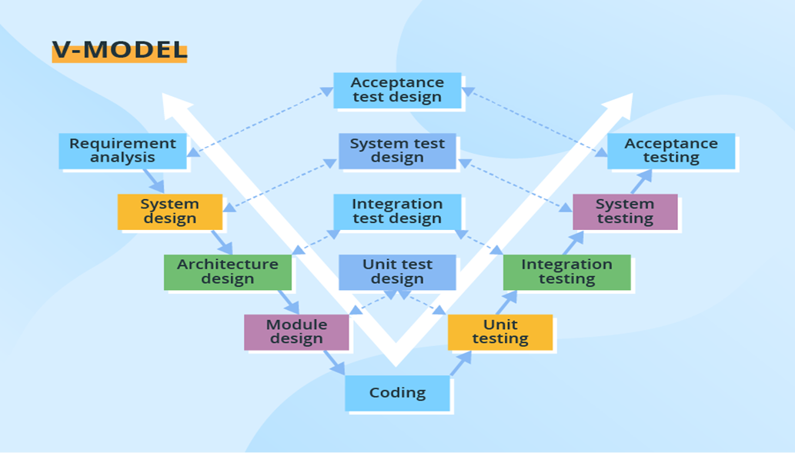

(Shiklo, Boris, 2022)

# References

Greenwich, 2021. *FLM.* [Online]

Available at: <https://flm.greenwich.edu.vn/gui/role/student/SyllabusDetails?sylID=2520>

[Accessed 2021].

Artūras B., 2023. *hostinger.* [Online]   
Available at: https://www.hostinger.com/tutorials/what-is-css  
[Accessed 5 3 2023].

AUGUST, 2020. *trustradius.* [Online]   
Available at: https://www.trustradius.com/reviews/draw-io-2021-07-29-20-03-03  
[Accessed 5 3 2023].

computerhope, 2020. *computerhope.* [Online]   
Available at: https://www.computerhope.com/jargon/d/drawio.htm  
[Accessed 5 3 2023].

Ekaterina Novoseltseva, 2020. *apiumhub.* [Online]   
Available at: https://apiumhub.com/tech-blog-barcelona/using-github/  
[Accessed 5 3 2023].

Erika Varagouli, 2021. *semrush blog.* [Online]   
Available at: https://www.semrush.com/blog/javascript/?kw=&cmp=AA_SRCH_DSA_Blog_EN&label=dsa_pagefeed&Network=g&Device=c&utm_content=622459218633&kwid=dsa-1753200738893&cmpid=18361936995&agpid=141795410375&BU=Core&extid=60162920499&adpos=&gclid=CjwKCAiAmJGgBhAZEiwA1JZo  
[Accessed 5 3 2023].

Hemant Sharma, 2022. *edureka.* [Online]   
Available at: https://www.edureka.co/blog/what-is-azure/  
[Accessed 5 3 2023].

hostinger, 2023. *hostinger.* [Online]   
Available at: https://www.hostinger.com/tutorials/what-is-html  
[Accessed 5 3 2023].

Hughes, Adam, 2020. *techtarget.* [Online]   
Available at: https://www.techtarget.com/searchdatamanagement/definition/SQL-Server  
[Accessed 2023].

kinsta, 2022. *kinsta.* [Online]   
Available at: https://kinsta.com/knowledgebase/what-is-github/  
[Accessed 5 3 2023].

NANCY JO MELUCC, 2022. *makeuseof.* [Online]   
Available at: https://www.makeuseof.com/visual-studio-2022-vs-2019-should-upgrade/  
[Accessed 5 3 2023].

PHIL VUOLLET, 2018. *stackify.* [Online]   
Available at: https://stackify.com/iis-web-server/  
[Accessed 5 3 2023].

Piyush Singhal, 2022. *scaler.* [Online]   
Available at: https://www.scaler.com/topics/advantages-of-html/  
[Accessed 5 3 2023].

pluralsight, 2020. *pluralsight.* [Online]   
Available at: https://www.pluralsight.com/blog/software-development/everything-you-need-to-know-about-c-  
[Accessed 2023].

Shiklo, Boris, 2022. *scnsoft.* [Online]   
Available at: https://www.scnsoft.com/blog/software-development-models  
[Accessed 5 3 2023].

Stephen J. Bigelow, 2022. *techtarget.* [Online]   
Available at: https://www.techtarget.com/searchcloudcomputing/definition/Windows-Azure  
[Accessed 5 3 2023].

Stephen J. Bigelow, 2022. *techtarget.* [Online]   
Available at: https://www.techtarget.com/searchenterprisedesktop/definition/Windows-10  
[Accessed 4 3 2023].

Study.com, 2022. *Study.com.* [Online]   
Available at: https://study.com/academy/lesson/what-is-an-html-document-structure-types-examples.html#:~:text=There%20are%20three%20categories%20of,documents%20and%20a%20menu%20system.  
[Accessed 5 3 2023].

tutorialspoint, 2022. *tutorialspoint.* [Online]   
Available at: https://www.tutorialspoint.com/javascript/javascript_overview.htm  
[Accessed 5 3 2023].

visualstudio, 2022. *visualstudio.* [Online]   
Available at: https://visualstudio.microsoft.com/fr/  
[Accessed 5 3 2022].

Will Morris, 2022. *Elegant Themes.* [Online]   
Available at: https://www.elegantthemes.com/blog/wordpress/microsoft-iis?utm_source=Blog&utm_medium=Manual+Divi+Targets&utm_campaign=Google+Search&retargeting=off&gclid=CjwKCAiAmJGgBhAZEiwA1JZolhge1SoSaswcIAHm7TsZ4hfD-8oXHTkr8dQdGV-WDT4NDAObwjfpkBoCOIcQAvD_BwE#what-is-  
[Accessed 5 3 2023].

Artūras B., 2023. *hostinger.* [Online]   
Available at: https://www.hostinger.com/tutorials/what-is-css  
[Accessed 5 3 2023].

AUGUST, 2020. *trustradius.* [Online]   
Available at: https://www.trustradius.com/reviews/draw-io-2021-07-29-20-03-03  
[Accessed 5 3 2023].

computerhope, 2020. *computerhope.* [Online]   
Available at: https://www.computerhope.com/jargon/d/drawio.htm  
[Accessed 5 3 2023].

Ekaterina Novoseltseva, 2020. *apiumhub.* [Online]   
Available at: https://apiumhub.com/tech-blog-barcelona/using-github/  
[Accessed 5 3 2023].

Erika Varagouli, 2021. *semrush blog.* [Online]   
Available at: https://www.semrush.com/blog/javascript/?kw=&cmp=AA_SRCH_DSA_Blog_EN&label=dsa_pagefeed&Network=g&Device=c&utm_content=622459218633&kwid=dsa-1753200738893&cmpid=18361936995&agpid=141795410375&BU=Core&extid=60162920499&adpos=&gclid=CjwKCAiAmJGgBhAZEiwA1JZo  
[Accessed 5 3 2023].

Hemant Sharma, 2022. *edureka.* [Online]   
Available at: https://www.edureka.co/blog/what-is-azure/  
[Accessed 5 3 2023].

hostinger, 2023. *hostinger.* [Online]   
Available at: https://www.hostinger.com/tutorials/what-is-html  
[Accessed 5 3 2023].

Hughes, Adam, 2020. *techtarget.* [Online]   
Available at: https://www.techtarget.com/searchdatamanagement/definition/SQL-Server  
[Accessed 2023].

kinsta, 2022. *kinsta.* [Online]   
Available at: https://kinsta.com/knowledgebase/what-is-github/  
[Accessed 5 3 2023].

NANCY JO MELUCC, 2022. *makeuseof.* [Online]   
Available at: https://www.makeuseof.com/visual-studio-2022-vs-2019-should-upgrade/  
[Accessed 5 3 2023].

PHIL VUOLLET, 2018. *stackify.* [Online]   
Available at: https://stackify.com/iis-web-server/  
[Accessed 5 3 2023].

Piyush Singhal, 2022. *scaler.* [Online]   
Available at: https://www.scaler.com/topics/advantages-of-html/  
[Accessed 5 3 2023].

pluralsight, 2020. *pluralsight.* [Online]   
Available at: https://www.pluralsight.com/blog/software-development/everything-you-need-to-know-about-c-  
[Accessed 2023].

Shiklo, Boris, 2022. *scnsoft.* [Online]   
Available at: https://www.scnsoft.com/blog/software-development-models  
[Accessed 5 3 2023].

Stephen J. Bigelow, 2022. *techtarget.* [Online]   
Available at: https://www.techtarget.com/searchcloudcomputing/definition/Windows-Azure  
[Accessed 5 3 2023].

Stephen J. Bigelow, 2022. *techtarget.* [Online]   
Available at: https://www.techtarget.com/searchenterprisedesktop/definition/Windows-10  
[Accessed 4 3 2023].

Study.com, 2022. *Study.com.* [Online]   
Available at: https://study.com/academy/lesson/what-is-an-html-document-structure-types-examples.html#:~:text=There%20are%20three%20categories%20of,documents%20and%20a%20menu%20system.  
[Accessed 5 3 2023].

tutorialspoint, 2022. *tutorialspoint.* [Online]   
Available at: https://www.tutorialspoint.com/javascript/javascript_overview.htm  
[Accessed 5 3 2023].

visualstudio, 2022. *visualstudio.* [Online]   
Available at: https://visualstudio.microsoft.com/fr/  
[Accessed 5 3 2022].

Will Morris, 2022. *Elegant Themes.* [Online]   
Available at: https://www.elegantthemes.com/blog/wordpress/microsoft-iis?utm_source=Blog&utm_medium=Manual+Divi+Targets&utm_campaign=Google+Search&retargeting=off&gclid=CjwKCAiAmJGgBhAZEiwA1JZolhge1SoSaswcIAHm7TsZ4hfD-8oXHTkr8dQdGV-WDT4NDAObwjfpkBoCOIcQAvD_BwE#what-is-  
[Accessed 5 3 2023].