**COMP1682.1 Project Proposal**

**Developing a Kidney Stone Diagnosis System Using Machine Learning**

**Tran Phat Trien**

**BSc Hons COMPUTING**

**001353547**

Contents

**1** **Overview** 3

**2** **Aim** 3

**3** **Objectives** 3

3.1 Thorough Analysis of Previous Disease Detection Methodologies 3

3.1.1 Examine using the earlier diagnostic techniques 3

3.1.2 Study the Uses of Machine Learning 4

3.1.3 Assessment of Existing Diagnostic Systems 4

3.2. Analysis: Identify common diagnostic factors for kidney stones 4

3.3 Project Design 4

3.3.1 Wireframes and User Interface Design 4

3.3.2 Dataset Design 5

3.3.3 Design of Recognition Algorithms 5

3.4 Implementation: Develop integrated applications with Java 5

3.5. Evaluation 6

3.5.1 User Feedback Collection 6

3.5.2 Application Testing and Refinement 6

3.5.3 Feedback Analysis 6

3.5.4 Implementing Improvements 7

**4** **Legal, Social, Ethical and Professional** 7

4.1. Legal 7

4.2. Social 7

4.3. Ethical 7

4.4. Professional 8

**5** **Planning** 8

5.1 Starting the project 8

5.2 Planning of the project 8

5.3 Implementation of the project 8

5.4 Monitoring and controlling the project 9

5.5 The Project completion 9

6. Initial References 9

**7** **Appendix A** 10

**Table of figure**

Figure 1 - Gantt chart of project 11

Figure 2 - Survey the related word 11

Figure 3 - Analysis 11

Figure 4 - Product design 11

Figure 5 - Implementation 12

Figure 6 - Evaluation 12

# **1 Overview**

The project titled "Developing a Kidney Stone Diagnosis System Using Machine Learning" represents a promising exploration at the intersection of healthcare and information technology. Kidney stones are a prevalent condition that afflicts millions of people worldwide, causing pain and discomfort. Precise diagnosis and characterization of kidney stones, including their size, location, and type, are crucial for effective treatment. Leveraging machine learning, the kidney stone diagnosis system aims to enhance the accuracy of stone evaluation and classification, offering critical insights for healthcare professionals and researchers to make informed decisions regarding diagnosis and treatment.

With the rapid advancement of technology and the integration of medical data from various sources, machine learning has become a powerful tool in aiding the diagnosis of medical conditions. This project will delve into research and development, employing advanced classification and prediction methods, to create a machine learning-based system that supports kidney stone diagnosis. This system holds the potential to deliver accuracy and efficiency in assessing this ailment, ultimately reducing treatment time and costs while improving the quality of life for patients.

According to (Işıl AKSAKALLI, 2021), The manual process of kidney stone detection in medical images is both time-consuming and subjective, relying on the expertise of physicians. This study aims to automate the classification of individuals as healthy or having kidney stones based on medical images using a range of machine learning techniques and Convolutional Neural Networks (CNNs).

# **2 Aim**

The purpose of the project to develop a kidney stone diagnosis system using machine learning is to improve the accuracy and speed of kidney stone diagnosis in order to provide timely treatment for patients.

# **3 Objectives**

## 3.1 Thorough Analysis of Previous Disease Detection Methodologies

### 3.1.1 Examine using the earlier diagnostic techniques

- Activities: Performing an in-depth analysis of diagnostic methods, with a specific focus on Kidney Stones (Nephrolithiasis), including a comprehensive exploration of traditional methods commonly used to diagnose this condition. Kidney Stones are typically diagnosed using various traditional methods, each of which has its own advantages and limitations. These methods often include medical imaging, such as ultrasound or CT scans, blood and urine tests to assess relevant biological markers, and physical examinations. The primary objective of this detailed analysis is to delve into the effectiveness, accuracy, and practicality of current diagnostic methods in identifying Kidney Ston.

- Result: An in-depth examination of kidney stone diagnostic methods, with an emphasis on Kidney Stone Disease, allows to assess their accuracy, benefits, limits, prices, patient experience, and applicability. The findings of this study are crucial for improving the diagnosis of kidney stones and ensuring that patients receive the most effective and dependable therapy.

### 3.1.2 Study the Uses of Machine Learning

- Activities: Gathering knowledge on machine learning evaluation methods for use in projects related to disease recognition and medical image analysis. Experimenting with and employing Convolutional Neural Networks along with suitable algorithms to identify skin conditions from medical images. Comparing research models with previous studies on non-dermatological disease diagnosis.

- Result: An academic review publication demonstrates the critical relevance of machine learning in healthcare, with a focus on kidney stone detection. A detailed overview discusses notable machine learning models, their architectural complexity, and efficacy in detecting Kidney Stone Disease via medical imaging.

### 3.1.3 Assessment of Existing Diagnostic Systems

- Activities: A comprehensive analysis of kidney stone disease diagnostic systems using Machine Learning necessitates a comparison of their sensitivity, specificity, and overall diagnostic performance. Additionally, factors like cost and accessibility, integration with existing healthcare systems, security, and user feedback should be considered. This aids in determining which system has the potential to provide the most accurate and effective diagnosis in detecting kidney stones.

- Result: The result of this analysis is to determine which Machine Learning kidney stone diagnosis system has the best diagnostic performance based on important factors such as sensitivity, specificity and overall performance. . The analysis also provides information about usability, integration, security, and user feedback, helping to make decisions about system deployment in a healthcare environment.

## 3.2. Analysis: Identify common diagnostic factors for kidney stones

- Activities: Examine scientific and medical literature while consulting healthcare professionals to enhance understanding of critical diagnostic factors related to Kidney Stone Disease, especially focusing on symptoms and diagnostic signs. Assemble a comprehensive list of observable symptoms and diagnostic criteria for Kidney Stones, highlighting those that are both prevalent and essential for early identification. Present these findings in a structured table format for easy reference and seamless integration into the diagnostic system.

- Result: The document has been structured into a detailed table presenting the primary diagnostic factors and relevant information for diagnosing kidney stones. The final list of diagnostic factors will be integrated into the application development process, with the primary focus on the crucial factors for accurate kidney stone detection.

## 3.3 Project Design

### 3.3.1 Wireframes and User Interface Design

- Activities:

Create wireframes for each segment of the kidney stone diagnosis application ensuring full functionality and maximum detail.

To ensure an optimal user experience, organizing interface components is a crucial part of the design process. Thoughtfully and logically arranging interface elements is an essential step in creating an attractive and user-friendly interface.

When selecting color schemes, images, and icons for your application, it's essential to consider how these visual elements align with the app's functionality and overall design concept.

- Result: As a consequence, wireframes and user interface designs have a clear and visually appealing structure, and they match the whole app experience and features properly.

### 3.3.2 Dataset Design

- Activities:

Obtain high-quality X-ray pictures of kidney stones from reputable sources, covering both healthy and kidney stone instances.

Data processing entails a number of responsibilities, such as deleting duplicates, removing low-quality photos, and ensuring that all data types and sizes adhere to the same standards.

Separate the photos into training and validation datasets.

- Result:

A meticulously curated dataset, divided into folders for healthy images and folders showing Kidney Stones. This dataset includes training and validation sets.

### 3.3.3 Design of Recognition Algorithms

- Activities:

Create a categorization model for images using appropriate approaches, such as deep learning with Convolutional Neural Networks (CNN).

Train the model on the dataset, which has been divided into training and testing subsets.

Fine-tune the model on a regular basis to improve diagnostic accuracy.

Create a pseudocode algorithm that can be smoothly integrated into the program.

- Result:

For application deployment, a detailed pseudocode describing the An Pneumonia identification technique.

## 3.4 Implementation: Develop integrated applications with Java

- Activities:

Identify new features or functionalities to be integrated into the application to enhance the diagnosis of kidney stone disease, such as automated disease detection based on X-ray images.

Analyze the needed features: Determine the feasibility of integrating these features to suit the needs of the users.

To incorporate the specified features into the application, develop them using appropriate Java-based technologies and approaches.

Test the integrated features thoroughly to guarantee stability and regular operation.

Increase and optimize the integrated characteristics on a continuous basis to increase the capability of diagnosing kidney stone illness.

- Result: Integrate new features into the program seamlessly, improving the capacity to identify kidney stones using X-ray pictures and meeting user expectations. A complete Java-based application. Multiple features, including image processing methods and kidney stone detection, were successfully implemented.

## 3.5. Evaluation

### 3.5.1 User Feedback Collection

- Activities:

Determine the project's precise aims for gathering user feedback. This involves determining what information or knowledge you want to elicit from consumers.

Create a series of questions or surveys depending on your purpose of getting feedback. Questions should be written in a way that is simple to comprehend and answer, and they should focus on crucial parts of the project.

After gathering feedback, undertake data analysis to identify patterns and trends. This allows you to get useful information from customer input.

- Result: A summary of the valuable user input. This will include their comments on how user-friendly the program is, its accuracy, and general usefulness. A set of ideas for improving the program based on user input.

### 3.5.2 Application Testing and Refinement

- Activities:

Thorough testing of the program is essential to ensuring that all of its features work as planned. Evaluating the application's performance under varied settings is critical to ensuring a consistent user experience and swiftly correcting any issues that arise. Furthermore, it is critical to concentrate on designing user-friendly features that improve the overall usability of the program. Extending the capability of the program not only satisfies user expectations, but also adds value to the user experience, making it more pleasant and appealing to both existing and new users.

- Result:

Summarize test findings and be prepared to make changes if mistakes occur. Improve depending on the best user feedback.

### 3.5.3 Feedback Analysis

- Activities:

Gather user opinions via surveys and comments. Next, divide into several groups to assess the degree of user contentment. Next, suggest ways to enhance in order to satisfy customer requirements.

- Result:

A notable rise in consumer satisfaction may be the outcome. Their input was used to identify and execute specific modifications that improved their experience and made them feel better about the project.

### 3.5.4 Implementing Improvements

- Activities:

Making the necessary changes to your application based on the input you've received is a crucial stage in creating and managing the final product. Based on the data you gather, give special attention to user experience and ideal performance.

- Result:

Thorough report outlining the precise enhancements made to the program. Changing the architecture helps to take the system to a higher level. An overview of the new features and functionalities added to the app.

# **4 Legal, Social,** **Ethical and Professional**

## 4.1. Legal

According to (Da Silva, M., Horsley, T., Singh, D. et al, 2022), demonstrates the necessity of innovative governance, especially in the areas of law, policy, and ethics, to keep up with the quick speed of medical innovation, especially when it comes to artificial intelligence (AI) in the healthcare industry.

## 4.2. Social

According to (Iñigo de Miguel, Begoña Sanz and Guillermo Lazcoz, 2020), Argue that while Data Protection regulations, which include the right not to be subject to a decision based solely on automated processing, can be useful in avoiding the scenario discussed, they are adequate but not sufficient to address the legal, ethical, and social challenges posed by Machine Learning technologies to patients' rights and healthcare providers' capabilities. Therefore, further development of regulations on this topic and the introduction of new actors, such as Health Information Counsellors, will be necessary.

## 4.3. Ethical

According to (Irene Y. Chen, Emma Pierson, Sherri Rose, Shalmali Joshi, Kadija Ferryman, and Marzyeh Ghassemi, 2021), The use of machine learning (ML) in healthcare raises numerous ethical concerns, especially as models can amplify existing health inequities:

- Need to be taken into account when selecting the appropriate project.

- When it comes to data, the information and data source must be carefully chosen.

- Additionally, functional experts' evaluations must be included in the data.

## 4.4. Professional

According to (Hafsa Habehh and Suril Gohel, 2021), Some issues have been identified, requiring specialized organizations to make appropriate selections. Furthermore, continuous updates are necessary to ensure the stability of the functional system. There must be laws in place to protect all patient information and to establish security measures for a safe system

# **5 Planning**

## 5.1 Starting the project

- Gather clinical information from reliable medical sources. Information on the patient, test findings, ultrasound pictures, CT scans, and medical history should all be included in this material.

- Separate the data into test and training sets. The model is trained on the training set, and its performance is assessed on the test set.

- Establish project objectives and gather pertinent data.

- Seek out opportunities to use Python to machine learning tasks.

- Explain the purpose of developing a skin disease detection system and its user interface with Java.

## 5.2 Planning of the project

- Identify the Project's Scope.

- Identify available medical data sources, including patient records, laboratory results, and kidney ultrasound images

- Analyze requirements and Project Objectives.

- Select the appropriate Machine Learning Model.

- To guarantee adherence to project progress, set project milestones.

- Identify project risks.

- Examine the guiding concepts of the Python and Java programming languages utilized in the project.

## 5.3 Implementation of the project

- The project must be carefully developed, tested, implemented and evaluated.

- Create an interface that suits user needs.

- Observe and evaluate the stability of the project.

- Monitor and Maintain to avoid unnecessary risks.

- Optimized and improved according to user comments.

- Report project results to stakeholders, including physicians, medical staff, and regulatory agencies.

## 5.4 Monitoring and controlling the project

- Keep track of all issues, be informed about progress, and keep a close eye out for project faults.

- Distribute, make the necessary plan adjustments, and execute the plan to address variances.

- Make sure the budget alignment stays on course.

- Including data, hardware, software, and human resources, track and manage project resources.

- Regularly assess project procedures and results to ascertain the.

## 5.5 The Project completion

- Make sure that all project deliverables—machine learning models, documentation, and any results unique to the project—are finished and prepared for use.

- Complete the machine learning model's final testing and verification, as well as any necessary software or system testing. Make sure it satisfies the necessary performance and quality requirements.

- Perform a last evaluation and review of the project's performance and outcomes. Compare the actual outcomes to the project's initial objectives and success standards.

# 6. Initial References

Gohel, H. H. a. S., 2021. *Machine Learning in Healthcare.* s.l.:2021.

Iñigo de Miguel, B. S. G. L., 2020. *Machine learning in the EU health care context: exploring the ethical, legal and social issues.* s.l.:2020.

Irene Y. Chen, E. P. S. R. S. J. K. F. a. M. G., 2021. *Ethical Machine Learning in Healthcare.* USA: 2021.

Işıl AKSAKALLI, S. K. Y. S. H., 2021. *Kidney X-ray Images Classification using Machine Learning and Deep Learning Methods.* s.l.:2021.

Michael Da Silva, T. H. D. S. E. D. S. V. L. B. T. R. C. D. K. A. C.-F. S. I. K. W. A. K. &. C. M. F., 2022. *Legal concerns in health-related artificial intelligence: a scoping review protocol.* s.l.:2022.

# **7 Appendix A**

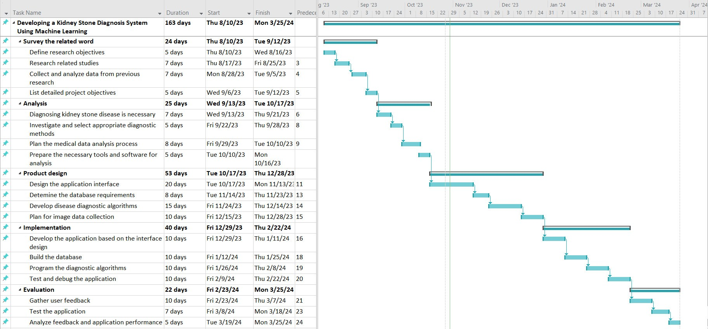

Figure - Gantt chart of project

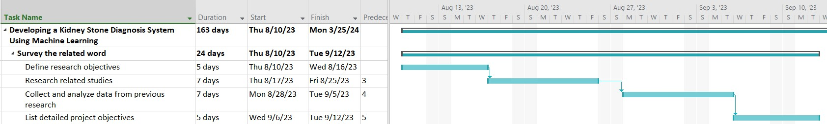

Figure - Survey the related word

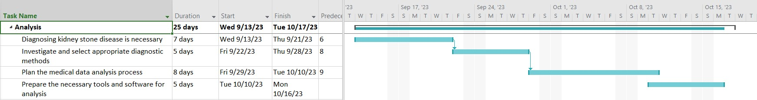

Figure - Analysis

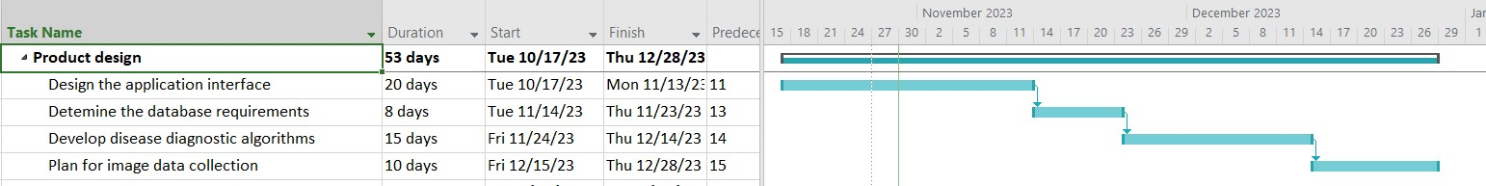

Figure - Product design

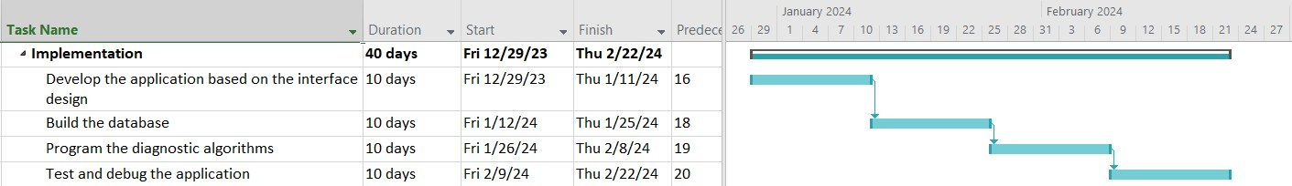

Figure - Implementation

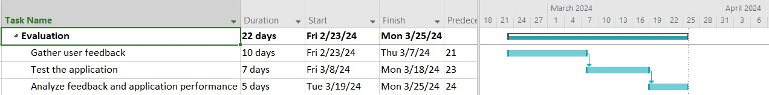

Figure - Evaluation