Permutations n = 3

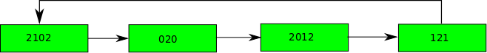

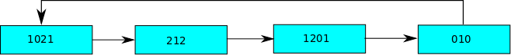

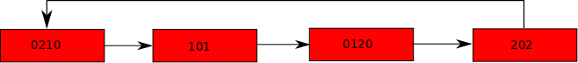

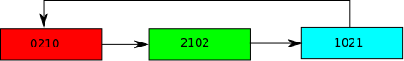

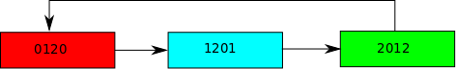

o |  |  |  |  | A | B
 |  |  |  |  | A | B
 |  |  | A | B
 |  | B |  | A
 |  | A | B
A | A |  |  |  | B
B | B |  |  |  |  | A

Permutations for n=4

Color Permutations

Length 4 cycles

Length 3 cycles:

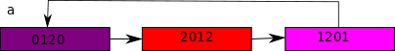

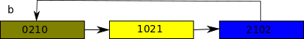

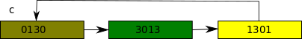

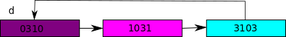

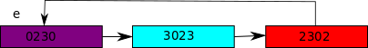

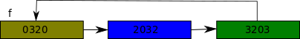

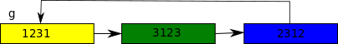

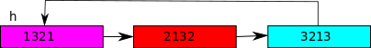

Permutation Tables

o |  |  |  |  |  |  |  |  |  | x | y | z
 |  |  |  |  |  |  |  |  |  | x | y | z
 |  |  | z | y |  |  |  |  | x
 |  | x |  |  |  | y |  | z
 |  | z |  |  | y |  |  | x
 |  |  |  | x |  |  | z |  | y
 |  |  | x |  |  |  | y |  | z
 |  |  |  |  | x | z |  | y
 |  |  | y | z |  |  | x
 |  | y |  |  | z | x
x | x |  |  |  |  |  |  |  |  |  | z | y
y | y |  |  |  |  |  |  |  |  | z |  | x
z | z |  |  |  |  |  |  |  |  | y | x

o |  |  |  |  |  |  |  |  |  | x | y | z | A | B | C | D | E | F | k | l | m | n | o | p
 |  |  |  |  |  |  |  |  |  | x | y | z | A | B | C | D | E | F | k | l | m | n | o | p
 |  |  | z | y |  |  |  |  | x |  |  |  | n | p | l | C | A | B | o | D | k | E | m | F
 |  | x |  |  |  | y |  | z |  |  |  |  | p | o | B | A | m | E | n | k | F | l | C | D
 |  | z |  |  | y |  |  | x |  |  |  |  | k | A | n | o | D | C | B | p | l | F | E | m
 |  |  |  | x |  |  | z |  | y |  |  |  | D | C | o | p | F | m | l | n | E | k | B | A
 |  |  | x |  |  |  | y |  | z |  |  |  | B | k | F | E | o | n | A | m | p | C | D | l
 |  |  |  |  | x | z |  | y |  |  |  |  | E | F | D | l | n | p | m | C | o | A | k | B
 |  |  | y | z |  |  | x |  |  |  |  |  | m | E | A | k | l | D | F | B | C | p | n | o
 |  | y |  |  | z | x |  |  |  |  |  |  | C | l | m | F | B | k | D | E | A | o | p | n
x | x |  |  |  |  |  |  |  |  |  | z | y | l | D | k | B | p | o | C | A | n | m | F | E
y | y |  |  |  |  |  |  |  |  | z |  | x | o | n | E | m | C | l | p | F | D | B | A | k
z | z |  |  |  |  |  |  |  |  | y | x |  | F | m | p | n | k | A | E | o | B | D | l | C
A | A | p | m | n | C | E | D | k | B | o | l | F | z |  |  |  |  |  |  | x |  |  | y
B | B | l | p | C | F | o | E | A | k | D | m | n |  | x |  |  |  |  |  |  | z | y
C | C | n | A | o | m | B | F | D | l | p | E | k |  |  | y |  |  |  | x |  |  |  |  | z
D | D | A | E | k | o | F | p | l | C | B | n | m |  |  |  | x |  |  |  |  | y | z
E | E | B | o | A | D | n | l | m | F | k | C | p |  |  |  |  | y |  | z |  |  |  |  | x
F | F | C | B | D | p | k | n | E | m | l | o | A |  |  |  |  |  | z |  | y |  |  | x
k | k | m | l | F | n | D | o | B | A | E | p | C |  |  | z |  | x |  |  |  |  |  |  | y
l | l | E | n | m | k | p | B | C | D | F | A | o | y |  |  |  |  | x |  |  |  |  | z
m | m | o | C | p | A | l | k | F | E | n | B | D |  | y |  | z |  |  |  |  |  | x
n | n | F | k | E | l | A | C | o | p | m | D | B |  | z |  | y |  |  |  |  | x
o | o | k | D | B | E | C | m | p | n | A | F | l | x |  |  |  |  | y |  | z
p | p | D | F | l | B | m | A | n | o | C | k | E |  |  | x |  | z |  | y

0 | 0 | 1 | 2 | 3 | 4 | 5 | 6 | 7 | 8 | 9 | 10 | 11 | 12 | 13 | 14 | 15 | 16 | 17 | 18 | 19 | 20 | 21 | 22 | 23
0 | 0 | 1 | 2 | 3 | 4 | 5 | 6 | 7 | 8 | 9 | 10 | 11 | 12 | 13 | 14 | 15 | 16 | 17 | 18 | 19 | 20 | 21 | 22 | 23
1 | 1 | 6 | 11 | 10 | 8 | 2 | 0 | 3 | 9 | 4 | 7 | 5 | 21 | 23 | 19 | 14 | 12 | 13 | 22 | 15 | 18 | 16 | 20 | 17
2 | 2 | 9 | 4 | 1 | 0 | 10 | 7 | 11 | 5 | 3 | 8 | 6 | 23 | 22 | 13 | 12 | 20 | 16 | 21 | 18 | 17 | 19 | 14 | 15
3 | 3 | 11 | 7 | 5 | 10 | 0 | 4 | 9 | 1 | 2 | 6 | 8 | 18 | 12 | 21 | 22 | 15 | 14 | 13 | 23 | 19 | 17 | 16 | 20
4 | 4 | 3 | 0 | 9 | 2 | 8 | 11 | 6 | 10 | 1 | 5 | 7 | 15 | 14 | 22 | 23 | 17 | 20 | 19 | 21 | 16 | 18 | 13 | 12
5 | 5 | 8 | 9 | 0 | 6 | 3 | 10 | 2 | 11 | 7 | 4 | 1 | 13 | 18 | 17 | 16 | 22 | 21 | 12 | 20 | 23 | 14 | 15 | 19
6 | 6 | 0 | 5 | 7 | 9 | 11 | 1 | 10 | 4 | 8 | 3 | 2 | 16 | 17 | 15 | 19 | 21 | 23 | 20 | 14 | 22 | 12 | 18 | 13
7 | 7 | 2 | 10 | 11 | 3 | 6 | 9 | 8 | 0 | 5 | 1 | 4 | 20 | 16 | 12 | 18 | 19 | 15 | 17 | 13 | 14 | 23 | 21 | 22
8 | 8 | 10 | 1 | 4 | 11 | 9 | 5 | 0 | 7 | 6 | 2 | 3 | 14 | 19 | 20 | 17 | 13 | 18 | 15 | 16 | 12 | 22 | 23 | 21
9 | 9 | 7 | 6 | 8 | 5 | 4 | 2 | 1 | 3 | 0 | 11 | 10 | 19 | 15 | 18 | 13 | 23 | 22 | 14 | 12 | 21 | 20 | 17 | 16
10 | 10 | 5 | 3 | 2 | 7 | 1 | 8 | 4 | 6 | 11 | 0 | 9 | 22 | 21 | 16 | 20 | 14 | 19 | 23 | 17 | 15 | 13 | 12 | 18
11 | 11 | 4 | 8 | 6 | 1 | 7 | 3 | 5 | 2 | 10 | 9 | 0 | 17 | 20 | 23 | 21 | 18 | 12 | 16 | 22 | 13 | 15 | 19 | 14
12 | 12 | 23 | 20 | 21 | 14 | 16 | 15 | 18 | 13 | 22 | 19 | 17 | 11 | 2 | 1 | 3 | 7 | 0 | 5 | 9 | 8 | 6 | 10 | 4
13 | 13 | 19 | 23 | 14 | 17 | 22 | 16 | 12 | 18 | 15 | 20 | 21 | 1 | 9 | 8 | 0 | 2 | 5 | 3 | 7 | 11 | 10 | 4 | 6
14 | 14 | 21 | 12 | 22 | 20 | 13 | 17 | 15 | 19 | 23 | 16 | 18 | 3 | 1 | 10 | 4 | 0 | 8 | 9 | 6 | 7 | 5 | 2 | 11
15 | 15 | 12 | 16 | 18 | 22 | 17 | 23 | 19 | 14 | 13 | 21 | 20 | 7 | 0 | 3 | 9 | 6 | 4 | 8 | 1 | 10 | 11 | 5 | 2
16 | 16 | 13 | 22 | 12 | 15 | 21 | 19 | 20 | 17 | 18 | 14 | 23 | 2 | 5 | 0 | 7 | 10 | 6 | 11 | 8 | 4 | 1 | 3 | 9
17 | 17 | 14 | 13 | 15 | 23 | 18 | 21 | 16 | 20 | 19 | 22 | 12 | 0 | 8 | 4 | 6 | 5 | 11 | 7 | 10 | 2 | 3 | 9 | 1
18 | 18 | 20 | 19 | 17 | 21 | 15 | 22 | 13 | 12 | 16 | 23 | 14 | 8 | 7 | 11 | 5 | 9 | 3 | 0 | 2 | 1 | 4 | 6 | 10
19 | 19 | 16 | 21 | 20 | 18 | 23 | 13 | 14 | 15 | 17 | 12 | 22 | 10 | 6 | 7 | 8 | 1 | 9 | 4 | 0 | 3 | 2 | 11 | 5
20 | 20 | 22 | 14 | 23 | 12 | 19 | 18 | 17 | 16 | 21 | 13 | 15 | 4 | 10 | 2 | 11 | 8 | 7 | 6 | 5 | 0 | 9 | 1 | 3
21 | 21 | 17 | 18 | 16 | 19 | 12 | 14 | 22 | 23 | 20 | 15 | 13 | 5 | 11 | 6 | 10 | 3 | 1 | 2 | 4 | 9 | 0 | 7 | 8
22 | 22 | 18 | 15 | 13 | 16 | 14 | 20 | 23 | 21 | 12 | 17 | 19 | 9 | 3 | 5 | 2 | 4 | 10 | 1 | 11 | 6 | 8 | 0 | 7
23 | 23 | 15 | 17 | 19 | 13 | 20 | 12 | 21 | 22 | 14 | 18 | 16 | 6 | 4 | 9 | 1 | 11 | 2 | 10 | 3 | 5 | 7 | 8 | 0

 | 0 | 1 | 2 | 3 | 4 | 5 | 6 | 7 | 8 | 9 | 10 | 11
0 | 0 | 1 | 2 | 3 | 4 | 5 | 6 | 7 | 8 | 9 | 10 | 11
1 | 1 | 6 | 11 | 10 | 8 | 2 | 0 | 3 | 9 | 4 | 7 | 5
2 | 2 | 9 | 4 | 1 | 0 | 10 | 7 | 11 | 5 | 3 | 8 | 6
3 | 3 | 11 | 7 | 5 | 10 | 0 | 4 | 9 | 1 | 2 | 6 | 8
4 | 4 | 3 | 0 | 9 | 2 | 8 | 11 | 6 | 10 | 1 | 5 | 7
5 | 5 | 8 | 9 | 0 | 6 | 3 | 10 | 2 | 11 | 7 | 4 | 1
6 | 6 | 0 | 5 | 7 | 9 | 11 | 1 | 10 | 4 | 8 | 3 | 2
7 | 7 | 2 | 10 | 11 | 3 | 6 | 9 | 8 | 0 | 5 | 1 | 4
8 | 8 | 10 | 1 | 4 | 11 | 9 | 5 | 0 | 7 | 6 | 2 | 3
9 | 9 | 7 | 6 | 8 | 5 | 4 | 2 | 1 | 3 | 0 | 11 | 10
10 | 10 | 5 | 3 | 2 | 7 | 1 | 8 | 4 | 6 | 11 | 0 | 9
11 | 11 | 4 | 8 | 6 | 1 | 7 | 3 | 5 | 2 | 10 | 9 | 0

