Colored Cycles
In this document I outline a possible strategy to construct a Hamiltonian path in the innerbox graph Jaco constructed. Lets assume we divide our graph into subgraphs based on the innerbox length (top to bottom). Here I only focus on the bottom two subgraphs (the subgraphs containing the two largest sized innerboxes). The two subgraphs contain the least amount of edges. If we can find a Hamiltonian path through these two subgraphs the assumption is that we can find a way to connect this path to the rest of the graph as the upper subgraphs have way more edges. The details of this procedure is still to be investigated (and whether true is unclear or if different rules have to be established for each two adjacent subgraphs). The observation we used to find a Hamiltonian path is the following (which we tested empirically up to n=4). The bottom two subgraphs contain cycles, but the important observation is that the cycles in these two subgraphs are connected via cycles themselves. We will label the cycles connecting the cycles from the two subgraphs with a color. If we visit each node on the color cycles we also visit each node in the cycles in each subgraph.
Let us start with the easiest case n=2
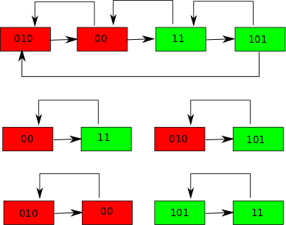

The top graph shows the complete graph for n=2. It contains two colored cycles and one cycle for each subgraph. If we follow the two colored cycles we visit each node, however the colored cycles have to be connected with one another via a “bridge” (in this case the conncetion 00 →11). For n=3 the situation is similar.

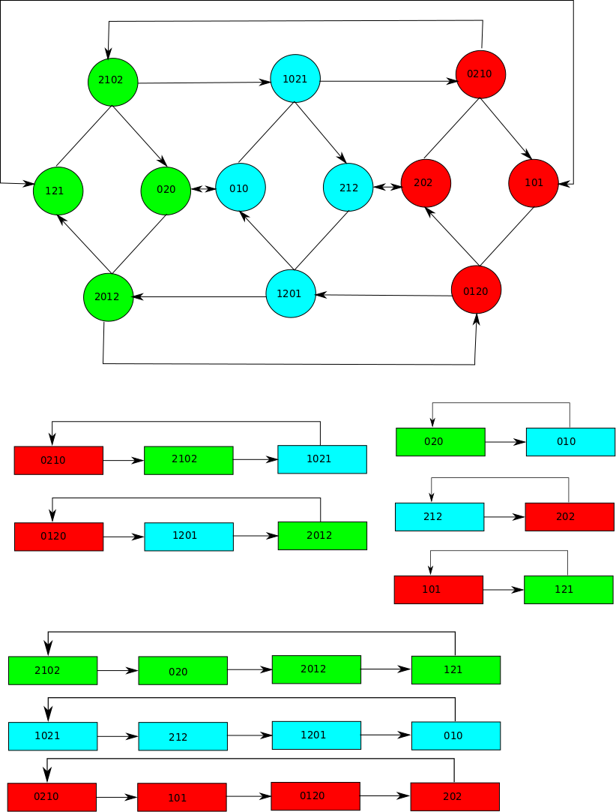

Again we see that if we were able to trace out all the colored rings we would visit every node on the last two subgraphs. The problem is that you cannot find a Hamiltonian path that connects all the colored rings together. For instance if we start at 2012 we get the following cycle:
2012 – 121 – 2102 – 020 – 010 – 1021 – 212 – 1201 – 2012
Try as we might we cannot get onto the red cycle. We therefore need to build a bridge using the upper subgraphs between the cyan cycle and the red cycle. One possible bridge:
1201 – 11 – 00 – 0210
and the red cycle is:
0210 – 101 – 0120 – 202
Now we add 22 to the front of the string to complete the Hamiltonian path:
22 – 2012 – 121 – 2102 – 020 – 010 – 1021 – 212 – 1201 – 11 – 00 – 0210 – 101 – 0120 – 202
Note that there is a Hamiltonian path (in the graph above) which does not require the colored cycles, but I was unsuccessful finding an easy path for n = 4 (mostly because I found it difficult to construct a planar graph in that case). Let us now investigate n = 4. See the graph below, we can construct similar colored cycles that if visited would imply that we visit all the nodes in the bottom two subgraphs. Unfortunately I found it to difficult to draw the entire graph connecting the two bottom layers together, however using the same principle as before we can find a Hamiltonian path for n = 4. Note the following two cycles:
01230 – 2012 (red cycle) – 1201 – 03120 (magenta cycle) – 31203 – 2312 (blue cycle) – 1231 – 30123 (yellow cycle) – 01230
20312 – 3203 (green cycle) – 0320 – 21032 (gold cycle) – 10321 – 3103 (cyan cycle) – 0310 – 12031 (purple cycle) – 20312
We need to build a bridge between these two cycles:
30123 – 33 – 22 – 20312
We can then append the following string which is easily constructed as the upper subgraphs contain many edges:
313 – 202 – 121 – 020 – 323 – 131 – 232 – 030 – 212 – 101 – 303 – 010 – 11 – 00.
Giving us the mrf:
01230 – 2012 (red cycle) – 1201 – 03120 (magenta cycle) – 31203 – 2312 (blue cycle) – 1231 – 30123 (yellow cycle) – 33 – 22 – 20312 – 3203 (green cycle) – 0320 – 21032 (gold cycle) – 10321 – 3103 (cyan cycle) – 0310 – 12031 (purple cycle) – 313 – 202 – 121 – 020 – 323 – 131 – 232 – 030 – 212 – 101 – 303 – 010 – 11 – 00.
The important questions remaining:
- How do we find long chains of colored cycles.
- When building bridges should we use other layers than the upper layer.
- Will it always be easy to find Hamiltonian paths in the upper layers that we can just append or do we have to use similar approaches for every adjacent subgraph pair?
- Will colored cycles work for larger n?

