Properties of G_{n}

To try and find a generation algorithm for LMRFs one avenue to explore is to plot the empirical enumerated LMRFs in an embedded space (in which the distance between the LMRFs are preserved) to investigate if there exists any common strategies for traversing G_{n}. To construct an embedding space one needs to be able to compare the different LMRFs with one another (determine how close two LMRFs are to one another). We propose the following approach. Map each innerbox to a ASCII symbol (A...Z is the obvious starting point but will not work for large n so a good mapping is important). For n = 3, we mapped the innerboxes ordered naturally (00..2102) to A...K. Then extract all 2-shingles (all links traversed in G_{n}) from each LMRF. Then determine the inverse Jaccard index between all LMRF pairs:

In the above equation, A represents the set of all 2-shingles in LMRF w_{A} and B denotes the set of all 2-shingles in LMRF w_{B}. Note that wrapping is applied, in the case that the last innerbox of a word can be connected to the first innerbox that 2-shingle is added to the aforementioned shingle sets. Once we can compare different LMRFs with one another (we are able to determine how similar they are to one another) we can construct a dissimilarity matrix D. Each entry in D is the inverse Jaccard index of two LMRFs. From D we can use Multidimensional scaling (MDS) to map the LMRFs to a two dimensional Euclidean embedded space, which satisfies the dissimilarity matrix D. MDS seeks a low-dimensional representation of the data in which the distances respect well the distances in the original high-dimensional space. We can now plot each LMRF in this space. See the plot below:

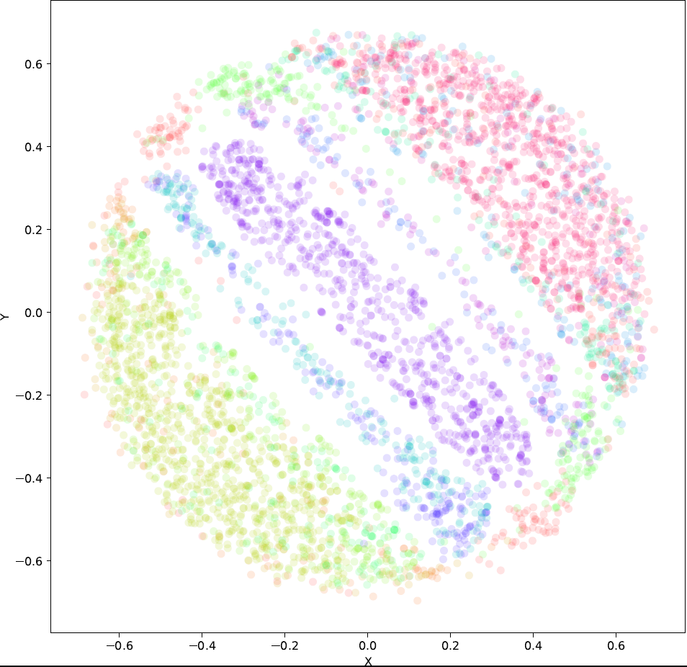
Fig. 1 The LMRFs of n = 3, plotted in an embedded space which satisfies D. There are four regions present, the western hemisphere, the eastern hemisphere, the central region and the two poles. The color legend for this graph is plotted in Fig. 2.
The color legend is plotted below:

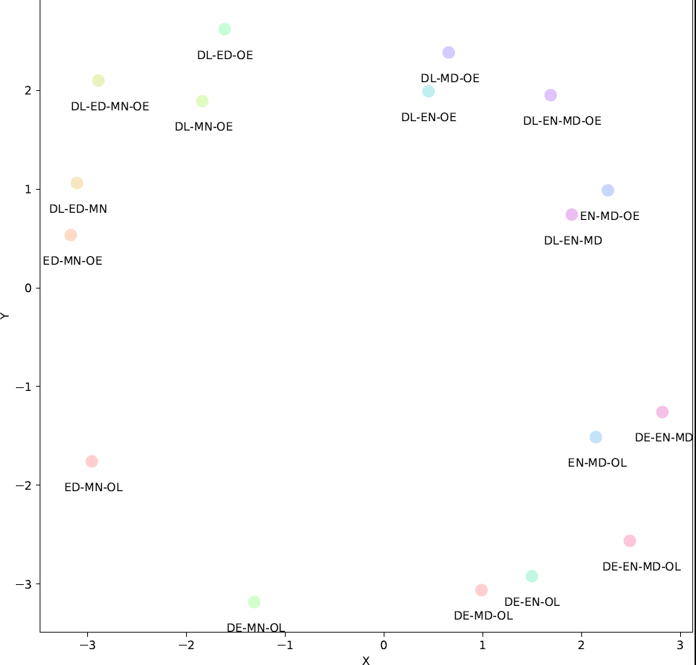
Fig. 2 The legend for Fig. 1 (17 possible configurations of H_{n}).

Each annotated datapoint in Fig. 2 indicates the shingles that must be present in the LMRF to be plotted in that color. Inspecting Fig 1 and 2 reveals, that there are 4 major regions of interest in the LMRF space (4 major strategies of traversing G_{n}):

- We have DL-ED-MN-OE. Deleting only one of these four links gives four extra labels. These 5 categories forms the western hemisphere in Fig 1.
- We have DE-EN-MD-OL. Deleting only one of these four links gives four extra labels. These 5 categories forms the eastern hemisphere in Fig 1.
- We have DL-EN-MD-OE. Deleting any one of these four links (shingles) gives four extra labels. The central ellipse belongs to DL-EN-MD-OE. The bands to the sides of the central ellipse connecting the two poles consist of the remaining four labels (center region).
- We have ED-MN-OL and DE-MN-OL which forms the two poles.

All of these regions can be obtained from a subgraph of G_{n}, lets call it H_{n}. In other words, you can generate all LMRFs for n=3 by starting with one of 17 possible configurations of H_{n}.

We plot H_{n} below.
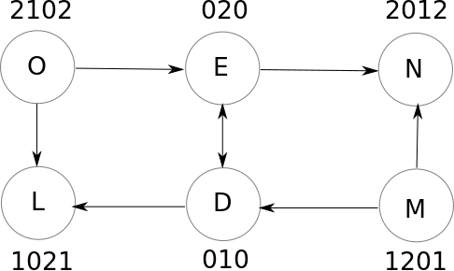

To get one one of the configurations, delete all links not present in one of the labels in Fig 2.
So to further investigate each region’s division, one would use the following algorithm:

- Convert each shingle set into a binary label. Make sure that the digits are ordered according to the popularity of individual shingles (most popular least significant digit).
- Construct a binary tree from these labels (and group LMRFs on each layer of the tree).
- Then look for large nodes on each level (many LMRFs use these same shingles).

