Deploying LAMP services

Prerequesites:
- On AWS EC2 instance, install:
  - git: sudo yum install -y git
  - docker: https://docs.aws.amazon.com/AmazonECS/latest/developerguide/docker-basics.html
  - docker compose: https://docs.docker.com/compose/install/
    - After installing, reboot the instance.

Content:
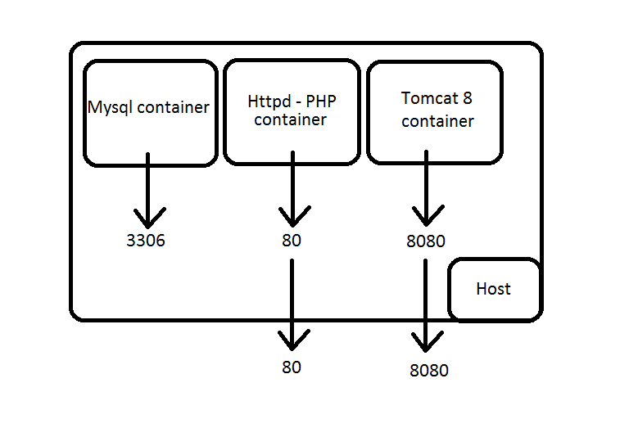
- Get neccessary file: git clone https://github.com/Trieste96/lamp-service
- Rename the newly-cloned folder to a shorter name: mv lamp-service lamp
- Open terminal and change directory to lamp: cd lamp
- Run docker-compose up -d
3 images will be created and 3 containers will be running.
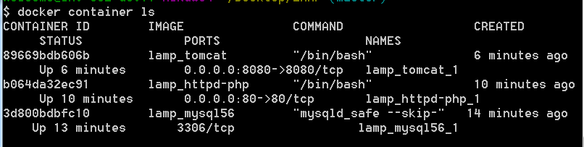
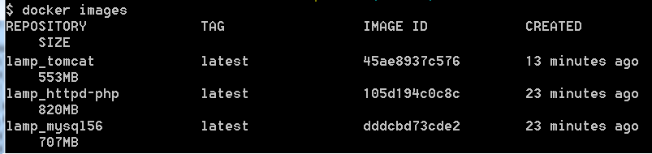
- To go to container's shell console, run docker container exec -it container-name bash
- In Tomcat container:
  - Run "/opt/tomcat/bin/startup.sh" to start Tomcat server on port 8080. Go to localhost:8080 to check.
- In Httpd container:
  - Run "httpd" to start Apache server on port 80. Go to localhost:80 to check.
- In Mysql container:
  - Run mysqld_safe --skip-grant-tables. Exit the container and get back. Run "mysql" to check.
  - Run "hostname -I" to get the IP address.
  - Other containers connect to database in Mysql container via this IP address.

