Deploying Apache 2.4 + PHP 5.6 docker container
- Open the shell console and change directory to this.
- docker build -t 'httpd-php' .
(Notice: the dot at the end points to current directory)
- $ docker container run \
--name httpd-php-container \
-p 80:80
-dit httpd-php
use option –link to link current container with the mysql container.
- docker container exec -it httpd-php-container bash
read the /etc/hosts to check if current container has linked with mysql56-container
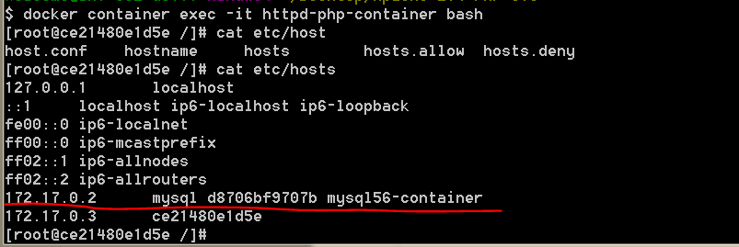
- httpd to run Apache.
References:
  - https://severalnines.com/blog/mysql-docker-containers-understanding-basics

