*Data Structure*

1. *Introduction:*

*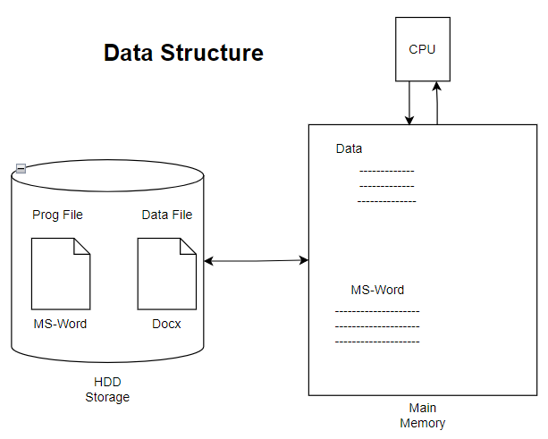*

1. *Stack and Heap Memory (Static and Dynamic Memory):*

*How Program use main memory?*

**

*We cannot access heap memory directly – but we can use pointer to access heap memory.*

*When we allocate*